**DBMS - UE20CS301 Lab**

**Lab 8**

**Name**: Vishwa Mehul Mehta

**Sec**: F

**SRN**: PES2UG20CS389

1.

Code:

DELIMITER $$

CREATE FUNCTION number_of_tickets_booked(no_of_tickets int)

RETURNS varchar(50)

BEGIN

DECLARE err varchar(50);

IF no_of_tickets > 3 THEN

SET err = 'cannot purchase tickets current limit is over';

ELSE

SET err = 'can purchase tickets';

END IF;

RETURN err;

END; $$

DELIMITER ;

Function call query:

SELECT number_of_tickets_booked(COUNT(*)), ticketpassenger.PNR FROM ticketpassenger JOIN ticket WHERE ticketpassenger.PNR = ticket.PNR AND MONTH(ticket.Travel_date) = MONTH(CURRENT_DATE) GROUP BY ticketpassenger.PNR;

Output Screenshots:

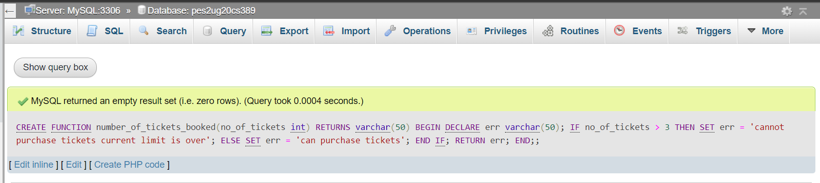

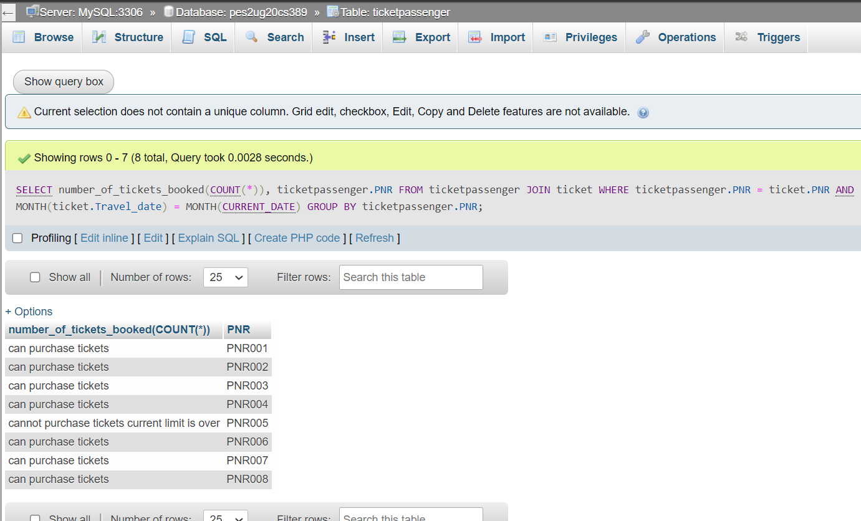

2.

Code:

DELIMITER $$

CREATE procedure age_updation(IN age date)

BEGIN

update users set users.Age = (year(CURRENT_DATE) - year(age)) where users.DOB = age;

END; $$

DELIMITER ;

DELIMITER $$

CREATE PROCEDURE age()

BEGIN

DECLARE dob DATE;

DECLARE is_updated INT DEFAULT FALSE;

DECLARE age_update CURSOR FOR SELECT users.DOB FROM users;

DECLARE CONTINUE HANDLER FOR NOT FOUND SET is_updated = TRUE;

OPEN age_update;

iterate_through_rows:LOOP

FETCH age_update INTO dob;

IF is_updated THEN

LEAVE iterate_through_rows;

END IF;

call age_updation(dob);

END LOOP;

CLOSE age_update;

END; $$

DELIMITER ;

Procedure call query:

CALL age();

Output Screenshots:

