**DBMS - UE20CS301 Lab**

**Lab 9**

**Name**: Vishwa Mehul Mehta

**Sec**: F

**SRN**: PES2UG20CS389

1.

**Trigger Query:**

DELIMITER $$

CREATE TRIGGER before_delete_ticket

BEFORE DELETE

ON ticket FOR EACH ROW

BEGIN

DECLARE err_msg varchar(200);

SET err_msg = ("cannot insert!! pnr not in paymentinfo");

CREATE TABLE IF NOT EXISTS backup (Transaction_id int NOT NULL, Bank varchar(20), Card_no varchar(255), Price float, PNR varchar(255));

IF old.PNR IN paymentinfo.PNR THEN

INSERT INTO backup VALUES (SELECT * FROM paymentinfo WHERE paymentinfo.PNR = old.PNR);

ELSE

SIGNAL SQLSTATE '45000'

SET MESSAGE_TEXT = err_msg;

END IF;

END $$

DELIMITER ;

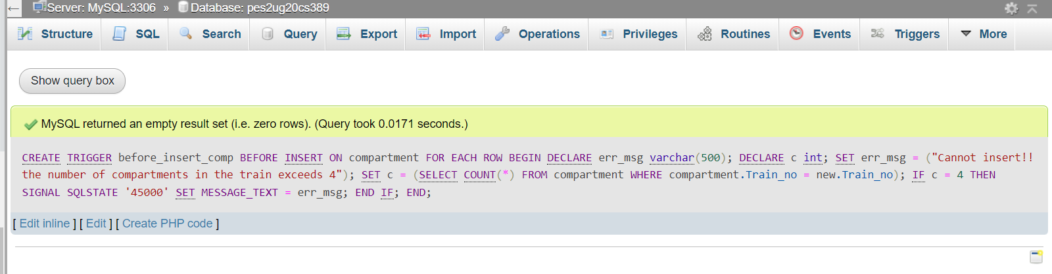

**Original table values:**

Compartment table:

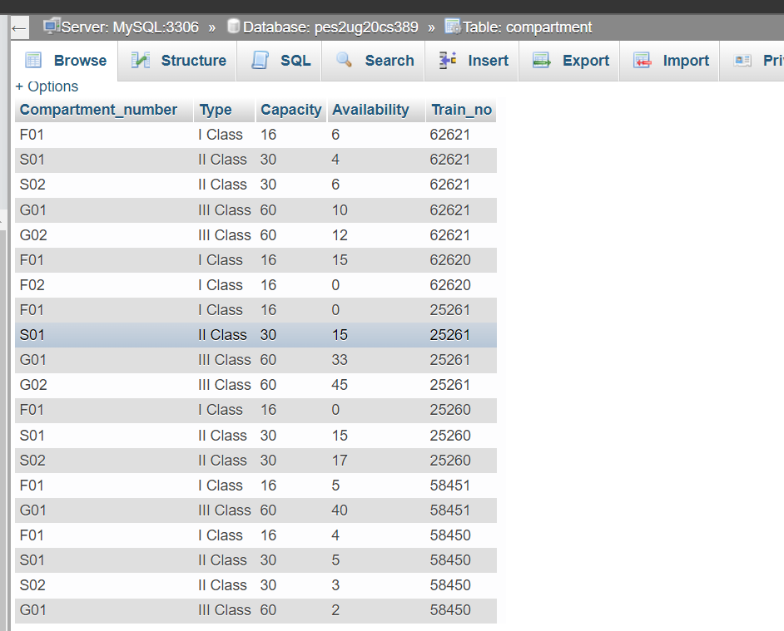

**Insert query:**

**a. Negative test case:**

INSERT INTO compartment VALUES ('G02', 'III Class', 60, 9, 62621);

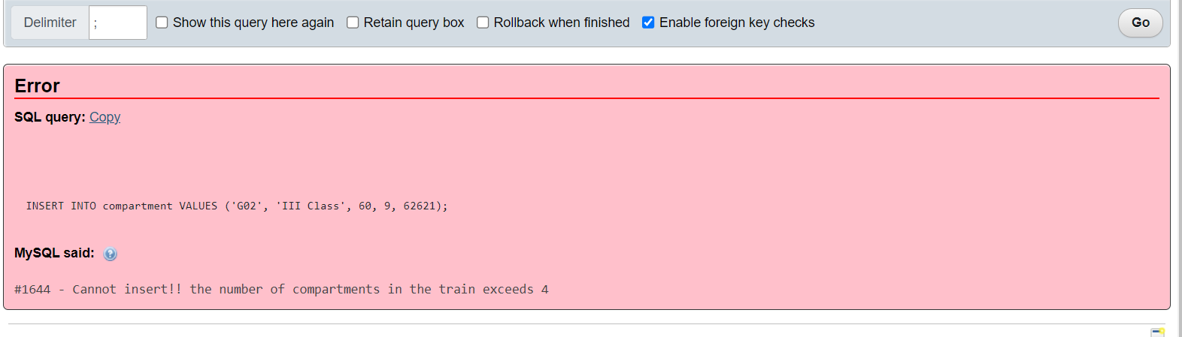

**b. Positive test case:**

INSERT INTO compartment VALUES ('F02', 'I Class', 16, 4, 58451);

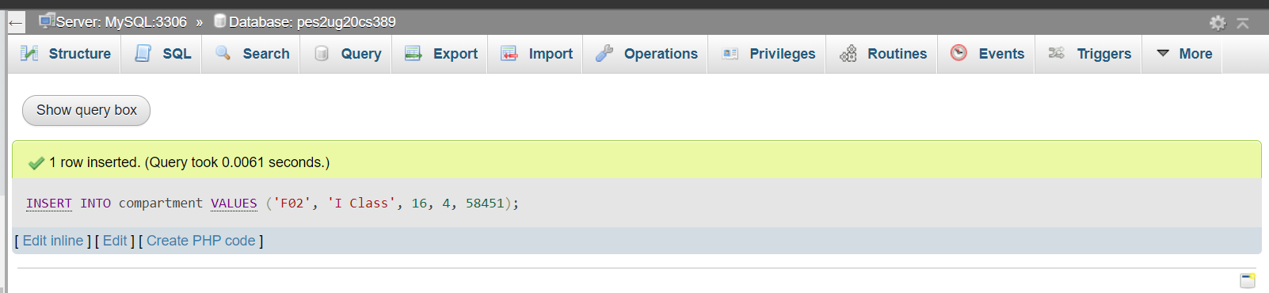

**Modified table after insert:**

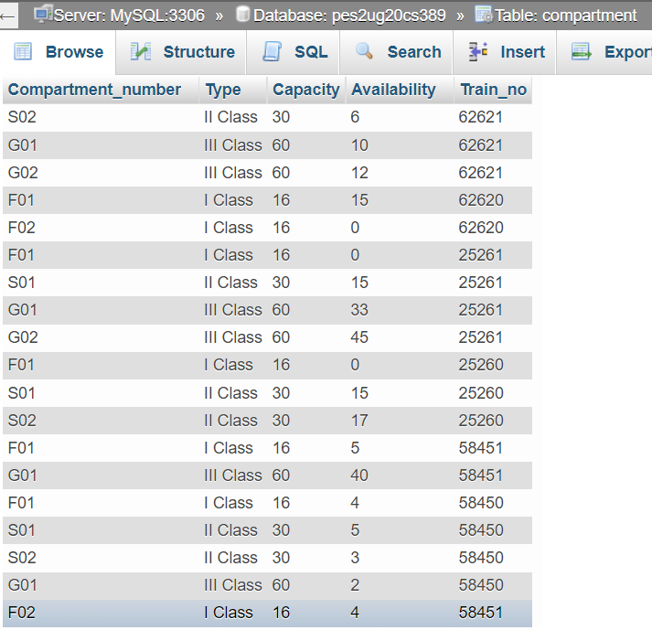

2.

**Create backup table query:**

CREATE TABLE IF NOT EXISTS backup (Transaction_id int NOT NULL, Bank varchar(20), Card_no varchar(255), Price float, PNR varchar(255));

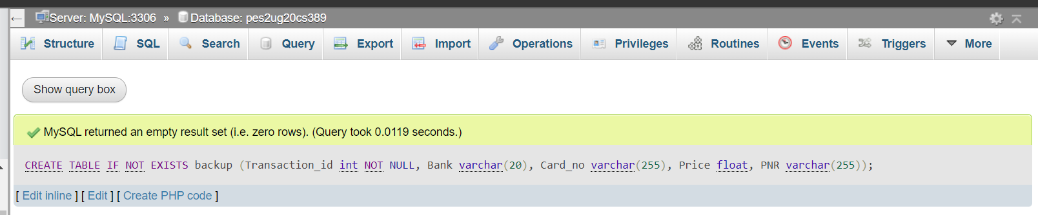

**Trigger query:**

DELIMITER $$

CREATE TRIGGER before_delete_ticket

BEFORE DELETE

ON ticket FOR EACH ROW

BEGIN

DECLARE err_msg varchar(200);

SET err_msg = ("cannot insert!! pnr not in paymentinfo");

IF old.PNR IN (SELECT PNR FROM paymentinfo WHERE paymentinfo.PNR = old.PNR) THEN

INSERT INTO backup (SELECT * FROM paymentinfo WHERE paymentinfo.PNR = old.PNR);

ELSE

SIGNAL SQLSTATE '45000'

SET MESSAGE_TEXT = err_msg;

END IF;

END $$

DELIMITER ;

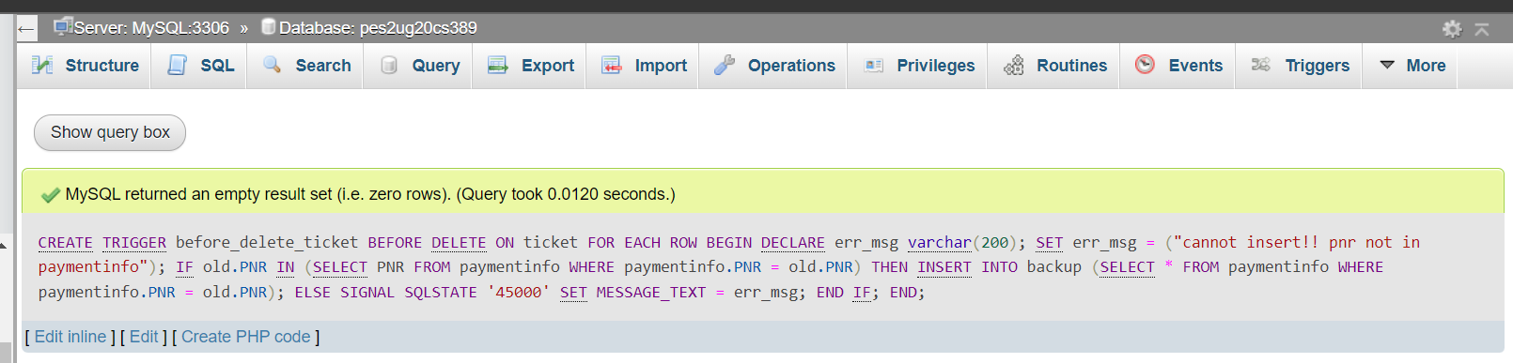

**Original table values:**

Paymentinfo table:

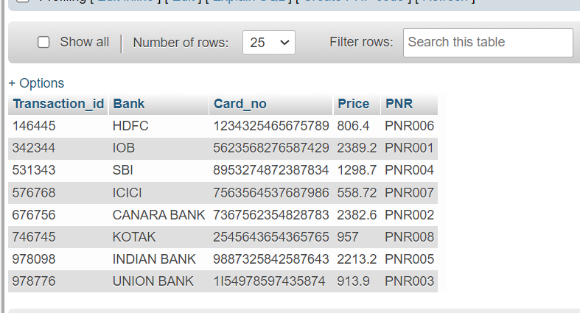

Ticket table:

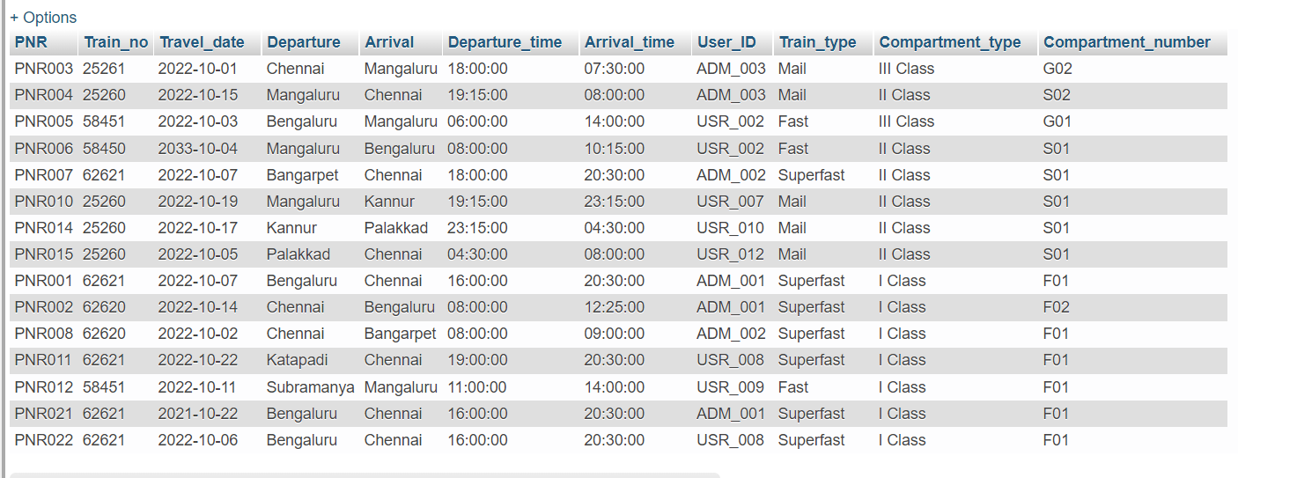

**Delete query:**

**a. Negative test case:**

DELETE FROM ticket WHERE ticket.PNR = ‘PNR021’;

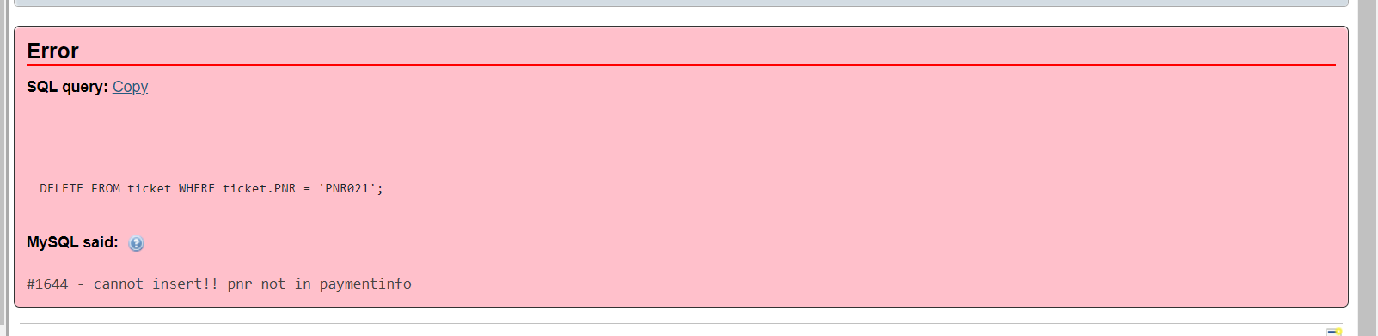

**b. Positive test case:**

DELETE FROM ticket WHERE ticket.PNR = ‘PNR003’;

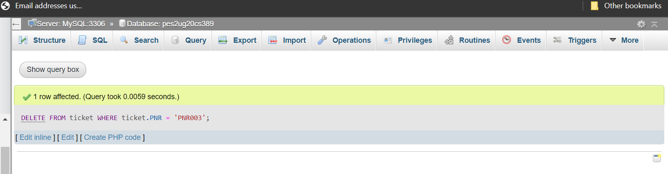

**Modified table values after delete:**

Backup table:

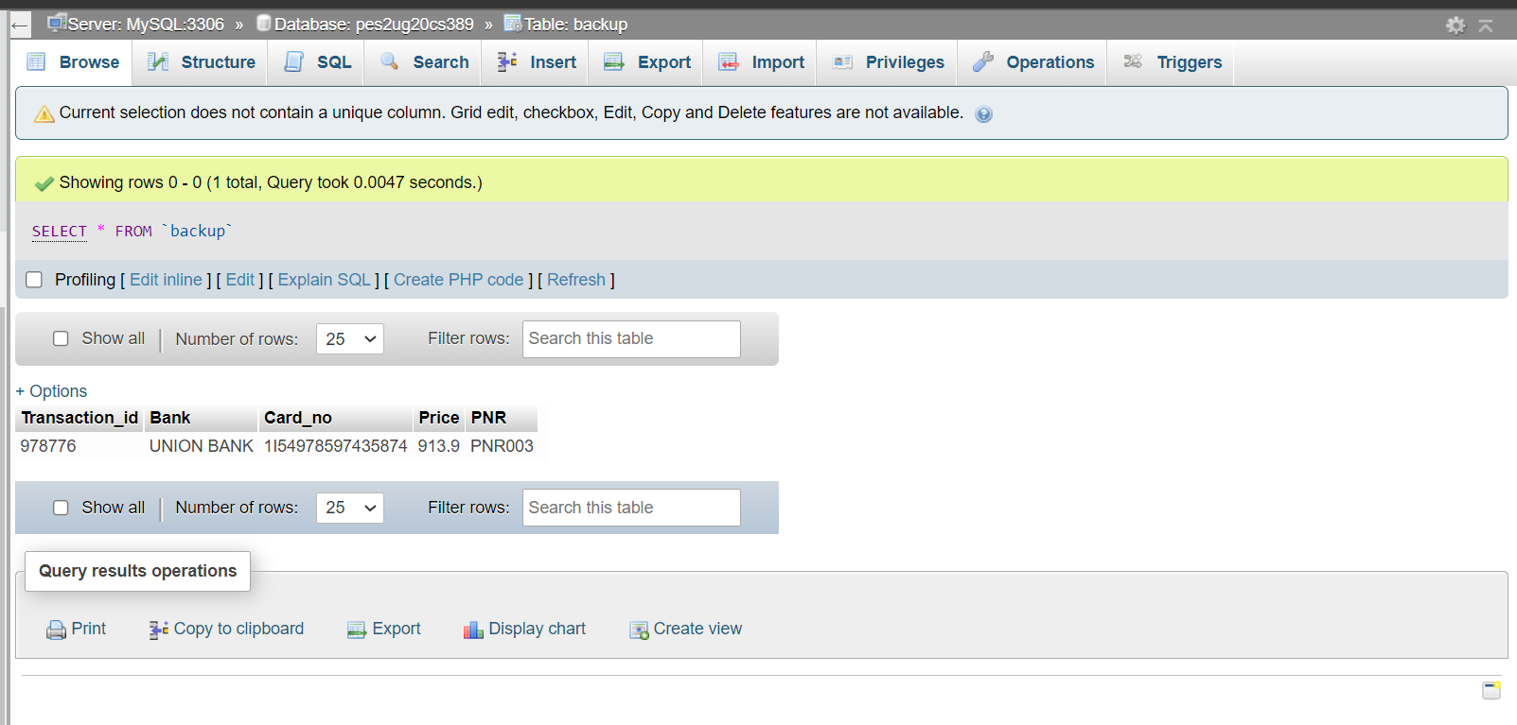

Ticket table:

