**FACE RECOGNITION ATTENDANCE BASED SYSTEM**

**REVIEW OF LITERATURE**

**Machine Intelligence**

**BACHELOR OF TECHNOLOGY**

**Department of Computer Science & Engineering**

**V Semester Section F**

SUBMITTED BY

**Batch No: 20**

Student name 1: Vinti Agrawal SRN: PES2UG20CS385

Student name 2: Vishwa Mehul Mehta SRN: PES2UG20CS389

Student name 3: Vismaya R SRN: PES2UG20CS391

**PES UNIVERSITY**

**(Established under Karnataka Act No. 16 of 2013)**

**100 Feet Ring Road, BSK III Stage, Bengaluru-560085**

**REVIEW OF LITERATURE**

[1] Facial Recognition Attendance System Using Python and OpenCv Dr. V Suresh, Srinivasa Chakravarthi Dumpa, Chiranjeevi Deepak Vankayala, HaneeshaAduri, Jayasree Rapa, Assistant Professor,Information Technology, Anil Neerukonda Institute of Technology and Sciences, Visakhapatnam, India

The paper talks about solving the issues encountered in the old attendance system while reproducing a brand new innovative smart system that can provide convenience to the institution. An application was developed which is capable of recognising the identity of each individuals and eventually record down the data into a database system. Apart from that, an excel sheet is created which shows the students attendance and is directly mailed to the respected faculty. The design part of the attendance monitoring system is divided into two sections which consist of the hardware and the software part. Before the software the design part can be developed, the hardware part is first completed to provide a platform for the software to work. Before the software some libraries must be installed for effective working of the application, OpenCV and Numpy through Python. Process of the software development includes 2 steps:

1. Creation of the face database:

A csv file is created to aid the process of image labelling because there will be more than one portrait stored for each student, thus, in order to group their portraits under the name of the same person, labels are used to distinguish them. After that, those images will be inserted into a recognizer to do its training. Since the training process is very time consuming as the face database grew larger, the training is only done right after there is a batch of new addition of student’s portraits to ensure the training is done as minimum as possible

2. Process of attendance taking:

Access to the website is given and the python script is initiated from a button click action. After this the trained data is loaded which was created during the process of database creation. Following this the portrait of the person in front of the camera is acquired and undergoes pre-processing in order to reach the face detection process. Once the face is recognised the attendance is marked.

Limitations of this method include the storing of data for a large number of students and as images take up large space the implementation must use sufficient storage.

[2] Face Recognition Smart Attendance System using Deep Transfer Learning Khawla Alhanaeea , Mitha Alhammadia , Nahla Almenhalia , Maad Shatnawia * a Deprtment of Electrical Engineering Technology, Higher Colleges of Technology, Abu Dhabi, UAE

Research work:

Face identification has been considered an interesting research domain in the past few years as it plays a major biometric authentication role in several applications including attendance management and access control systems. Attendance management systems are very important to all organization though they are complex and time-consuming for managing regular attendance log. There are many automated human identification techniques such as biometrics, RFID, eye tracking, voice recognition. Face is one of the most broadly used biometrics for human identity authentication. This paper presents a facial recognition attendance system based on deep learning convolutional neural networks. Transfer learning is utilised by using three pre-trained convolutional neural networks and trained them on our data. The three networks showed very high performance in terms of high prediction accuracy and reasonable training time.

Techniques used:

In this work they present a facial recognition attendance system based on deep learning convolutional neural networks (CNN). Transfer learning is done by using three pre-trained convolutional neural networks and trained them on our data which contains 10 different classes where each class includes 20 facial images. The three networks showed very high performance in terms of high prediction accuracy and reasonable training time, AlexNet, GoogleNet and SqueezeNet

Performance parameters:

The dataset is a collection of 200 images that were collected using an iPhone 12 front-facing camera which is a 12-megapixel, f/2.2 lens. The data was classified into 10 classes, each individual class includes 20 images. The collected data is used in a JPG file formatting. The image sizes are ranging between 3.00 MB and 4.00 MB. Each net has different input size. Therefore, the images are resized to the corresponding input dimensions of the network. SqueezeNet and AlexNet uses 227 × 227, while GoogleNet uses 224 × 224. All the images taken are in RGB colors which is good to extract the right features. In these trained networks, data augmentation was used by taking multiple images from different angles, environments and conditions, orientation, location, and brightness.

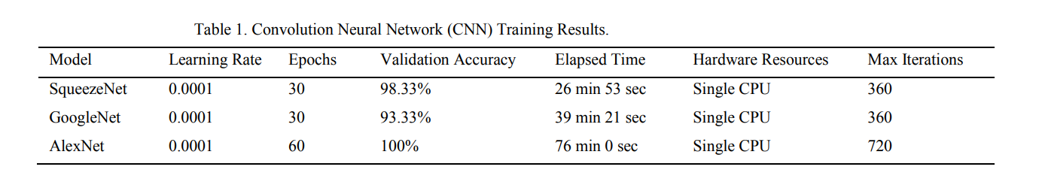

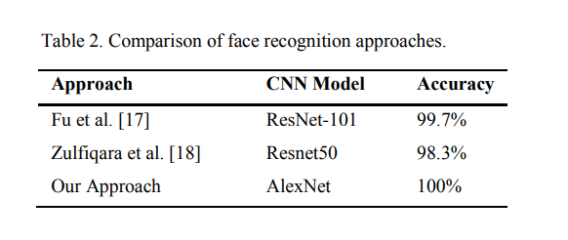

[3] Face Recognition based Attendance System Dhanush Gowda H.L 1 , K Vishal 2 , Keertiraj B. R 3 , Neha Kumari Dubey 4 , Pooja M. R. 5 1,2,3,4 Department of Computer Science and Engineering 5Associate Professor, Department Science and Engineering Vidyavardhaka College of Engineering, Mysuru, Karnataka, India

This system marks the attendance using live video stream. The frames are extracted from video using OpenCV. The main implementation steps used in this type of system are face detection and recognizing the detected face, for which dlib is used. After these, the connection of recognized faces ought to be conceivable by comparing with the database containing student's faces. This model will be a successful technique to manage the attendance of students.

In order to mark attendance, series of steps are followed which include enrolment, face detection, face recognition, and then marking the attendance in a database. Unlike Eigenfaces and Fisherfaces, where in most modern face verification systems, training and enrolment are two different steps. Training is performed on millions of images. On the other hand, enrolment is performed using a small set of images. In case of Dlib, enrolling a person is simply passing a few images of the person through the network to obtain 128- dimensional feature descriptors corresponding to each image. In other words, each image is converted to a feature in a high-dimensional space. In this high dimensional space, features belonging to the same person will be close to each other and far away for different persons.

A. Traditional Image Classification Pipeline Versus Dlib’s Face Recognition Model

1) Deep Metric Learning: Deep Metric Learning is a class of techniques that uses Deep Learning to learn a lower dimensional effective metric space where images are represented by points such that images of the same class are clustered together, and images of different class are far apart.

2) Metric Loss: A new loss function is defined so that the CNN output is a point in this 128-dimensional space. The loss function is defined over all pairs of images in a mini batch. For simplicity, the concept is shown in 2D. The loss is defined in terms of two parameters: 1) Threshold (T) and 2) Margin

3) Hard Negative Mining: In a mini batch, there are many non-matching pairs (images from different classes) than matching pairs (images from the same class). It is important to take this imbalance into account while calculating the metric loss function.

B. Enrolment

For enrolment a smaller ResNet neural network is defined. Training was also done using this network. A persons’ images are who register are then structured.

C. Face Detection and Recognition

Given a new image of a person, it can be verified if it is the same person by checking the distance between the enrolled faces and the new face in the 128-dimensional space. Read name-labels mapping and descriptors from disk. Then read the query image that is an image of classroom with multiple students and convert it from BGR to RGB format. Because Dlib uses RGB as default format.

D. Attendance Marking

For each face detected and matched with enrolled face, the attendance is marked for the corresponding USN in the database. The name of student along with day and time of attendance is also be stored in the database.

Limitation:

Other methods with greater accuracy can be used to build the system.