**Database Technologies – UE20CS343**

**Assignment – 1**

**Name**: Vishwa Mehul Mehta

**SRN**: PES2UG20CS389

**Sec**: F

**Date**: 10-03-2023

**Task 1: Database creation and simple crud operations:**

(a)

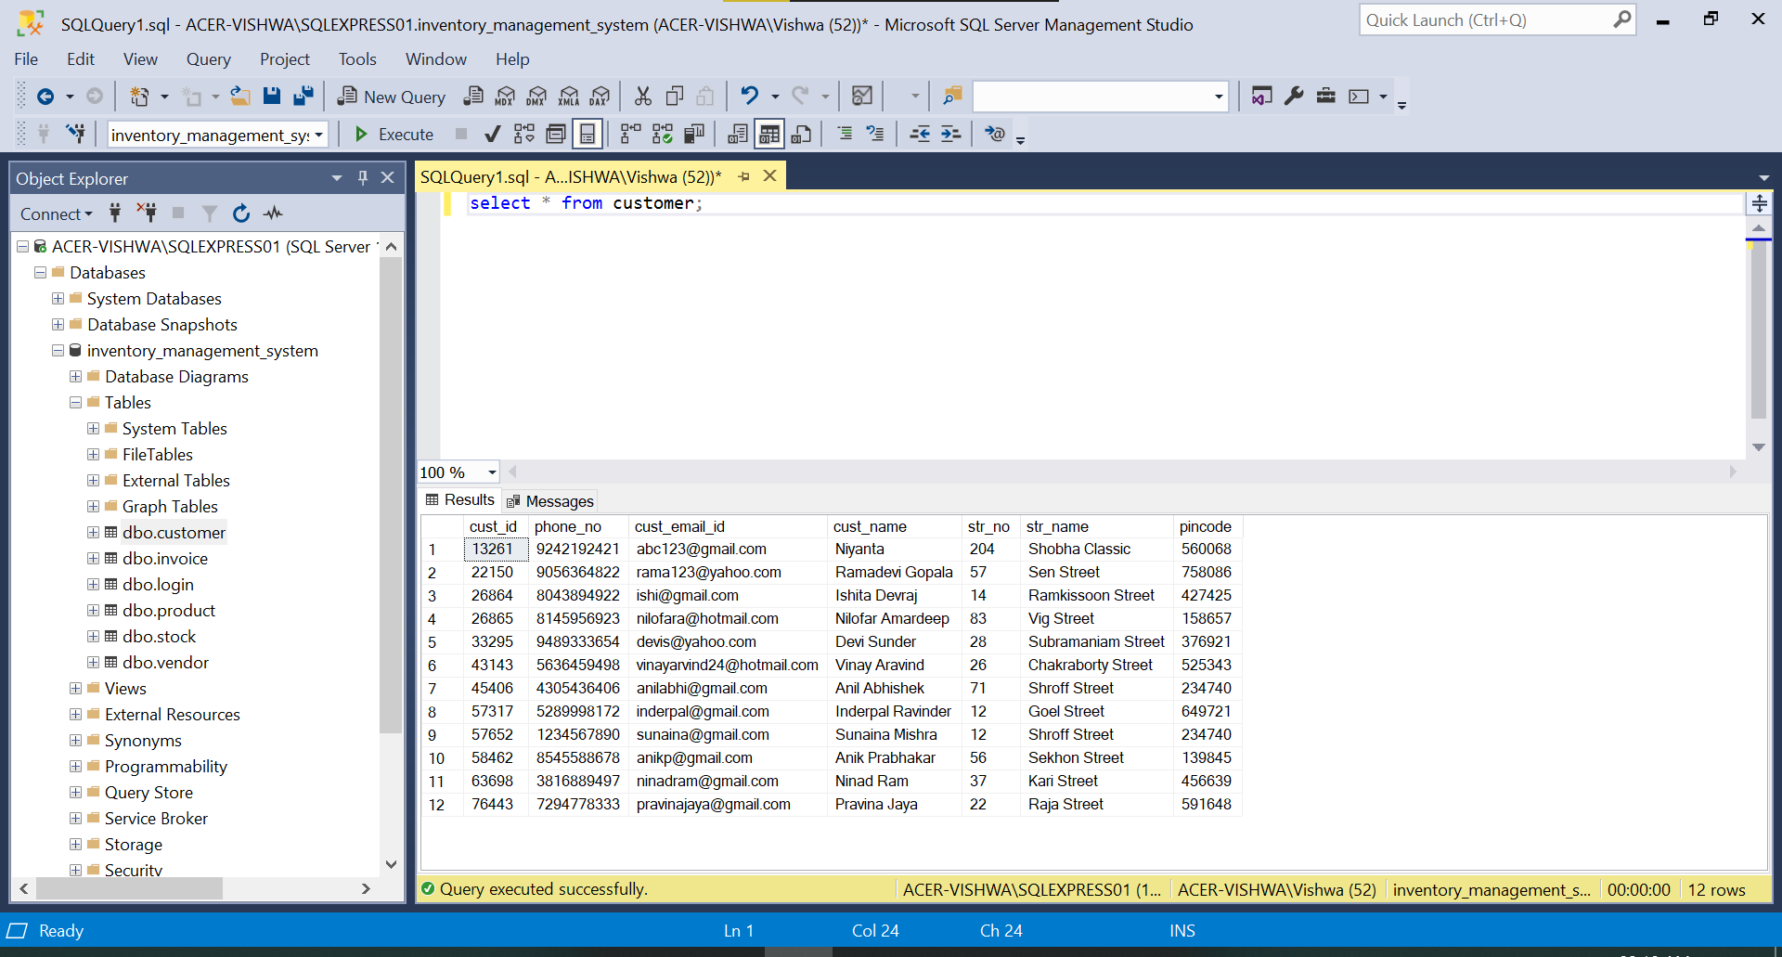

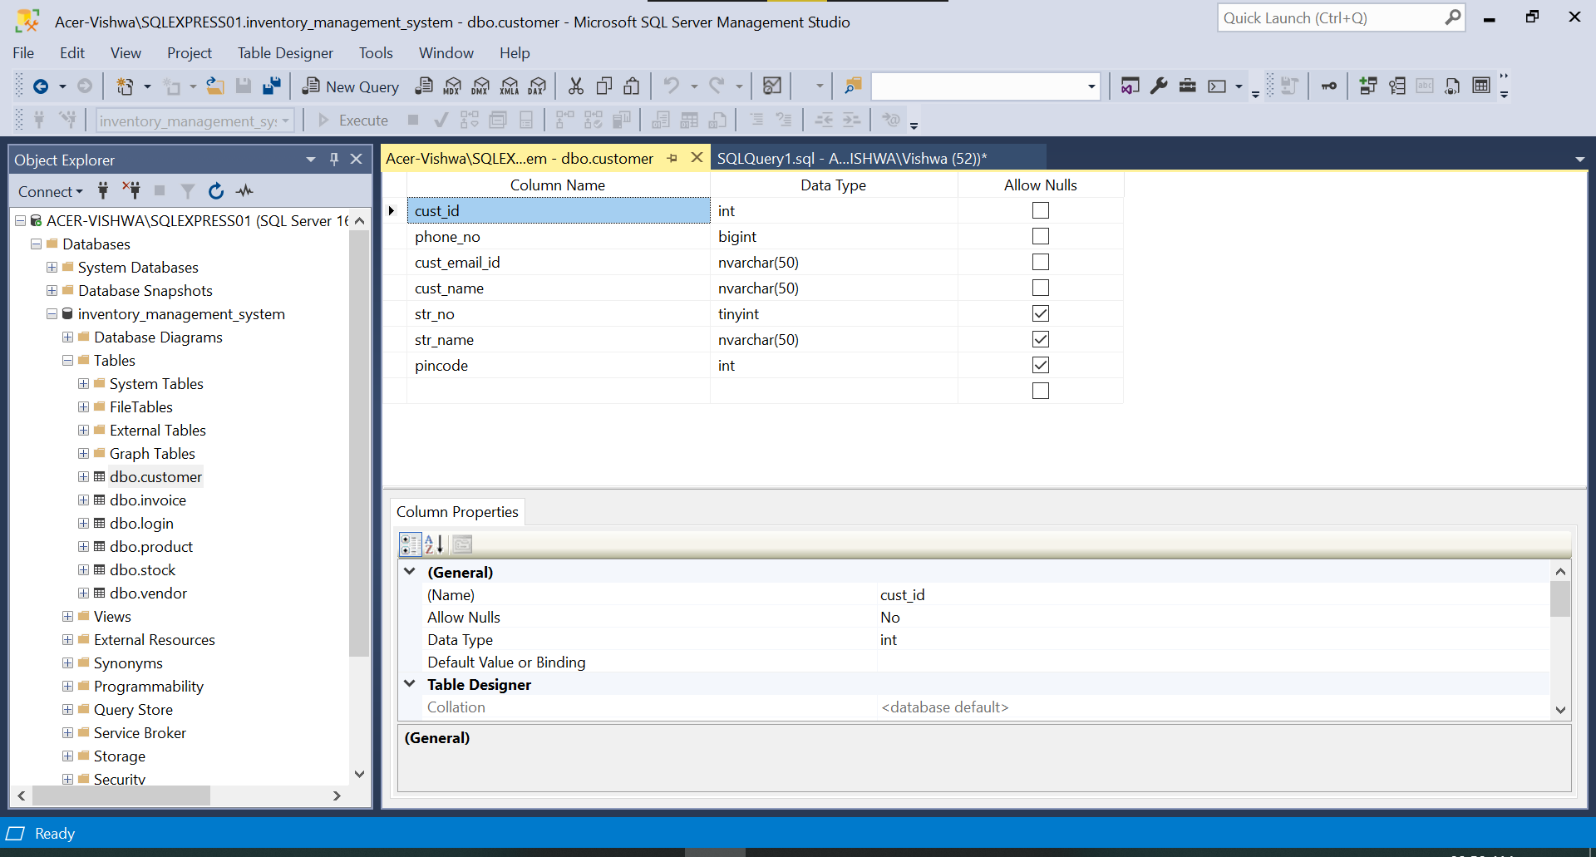

(b)

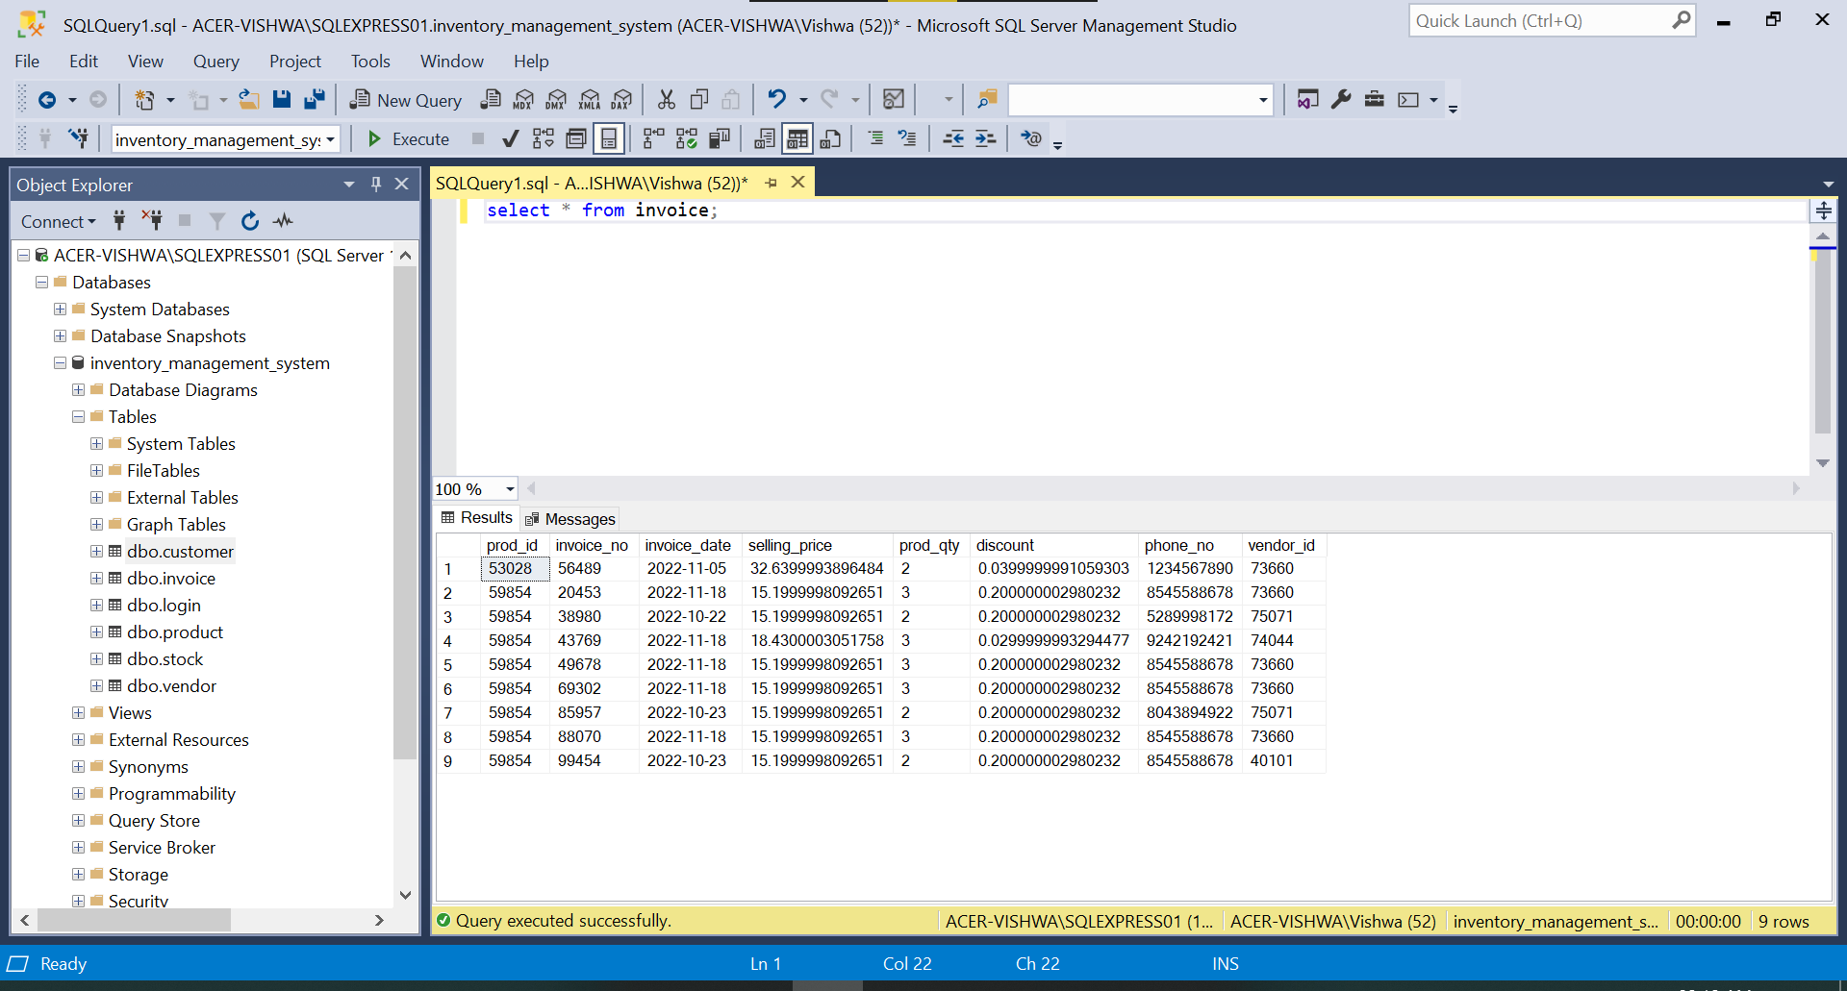

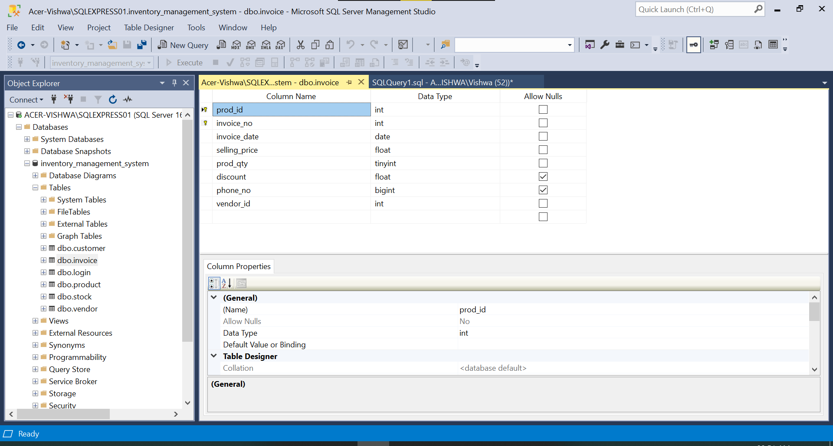

(c)

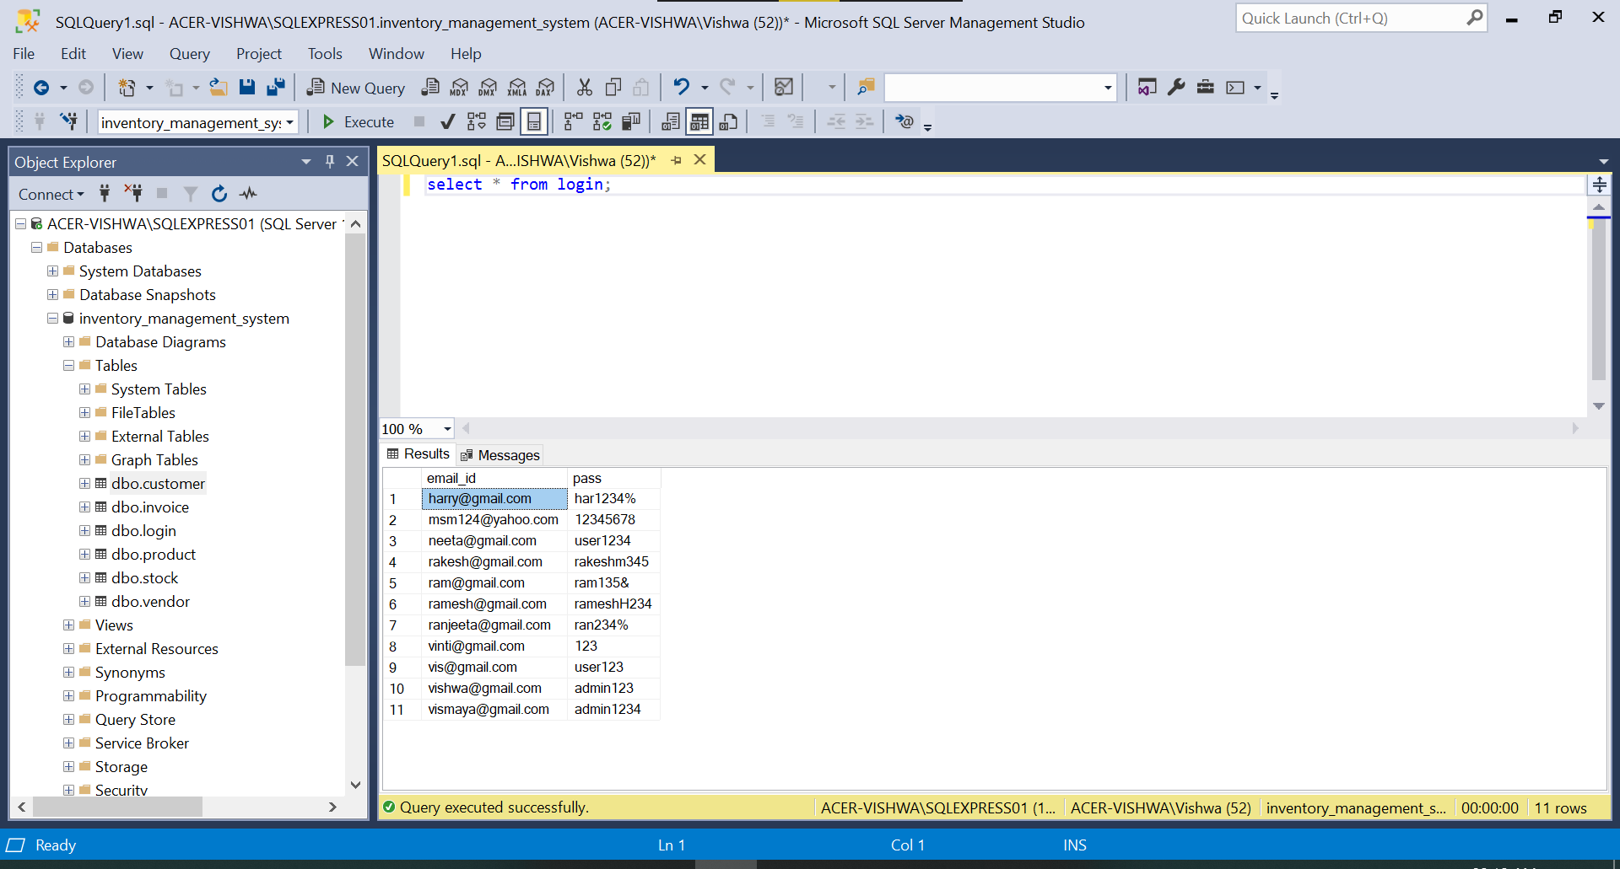

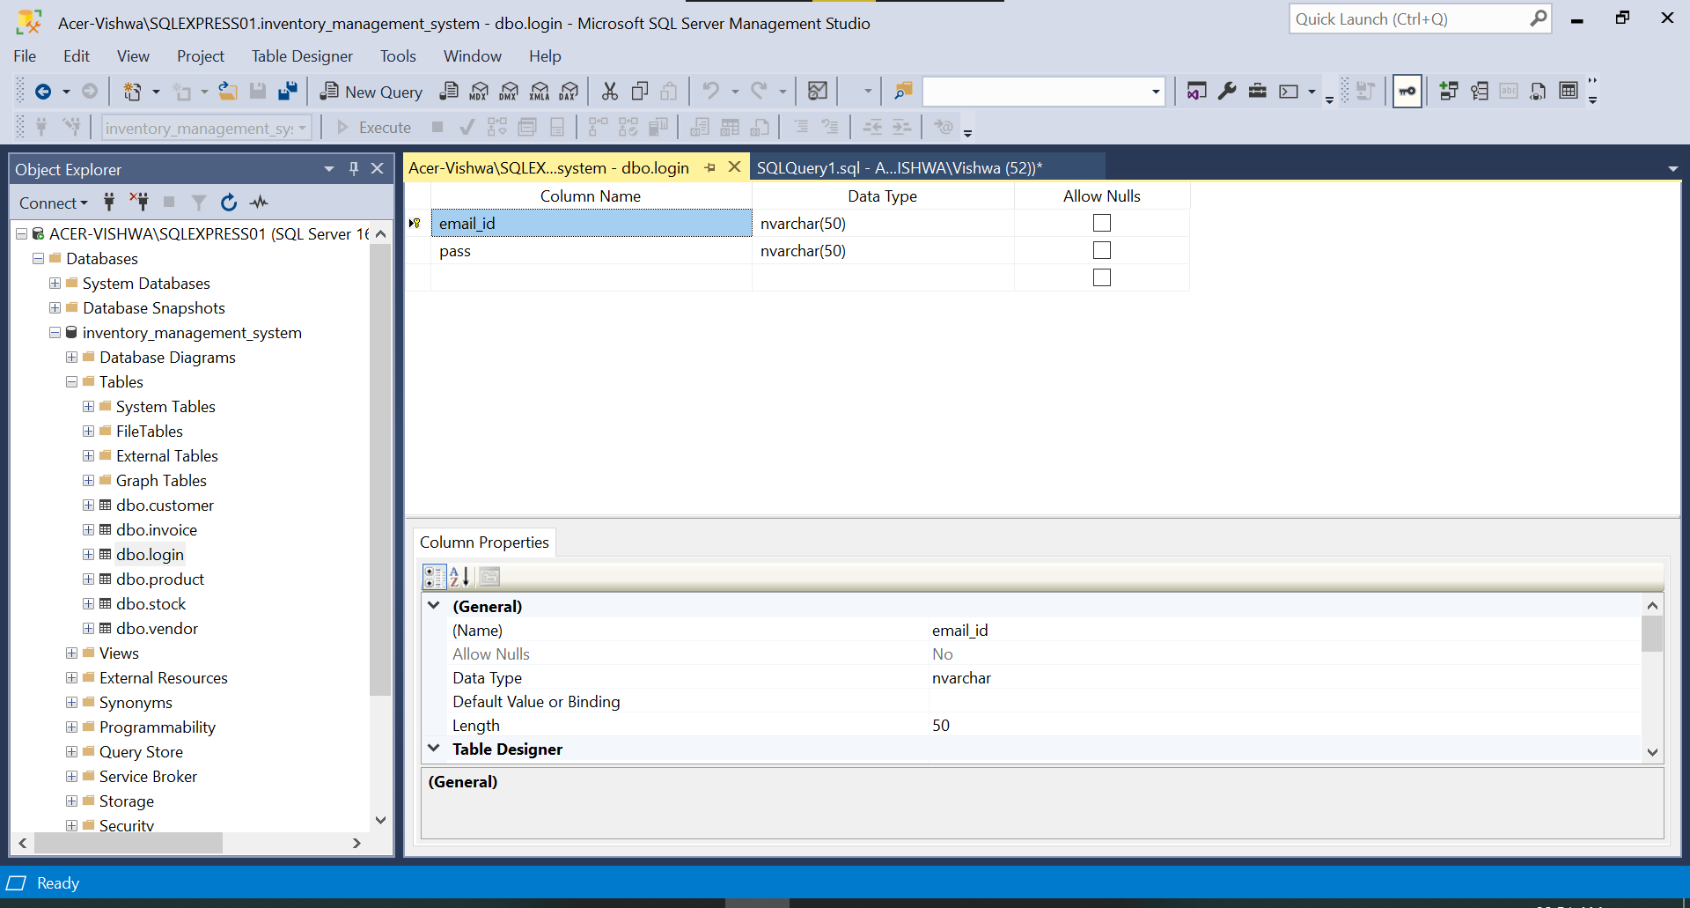

(d)

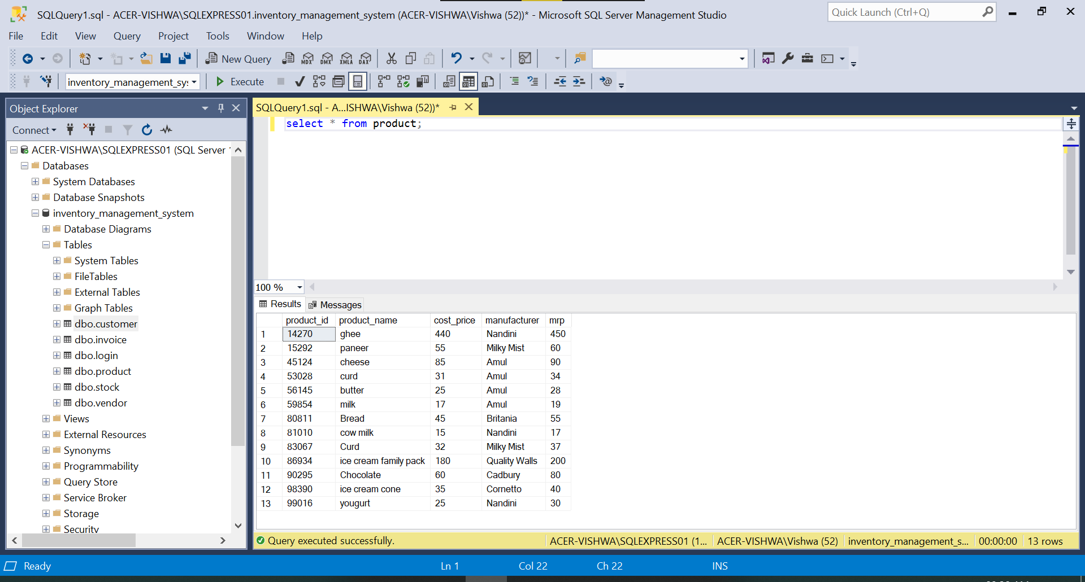

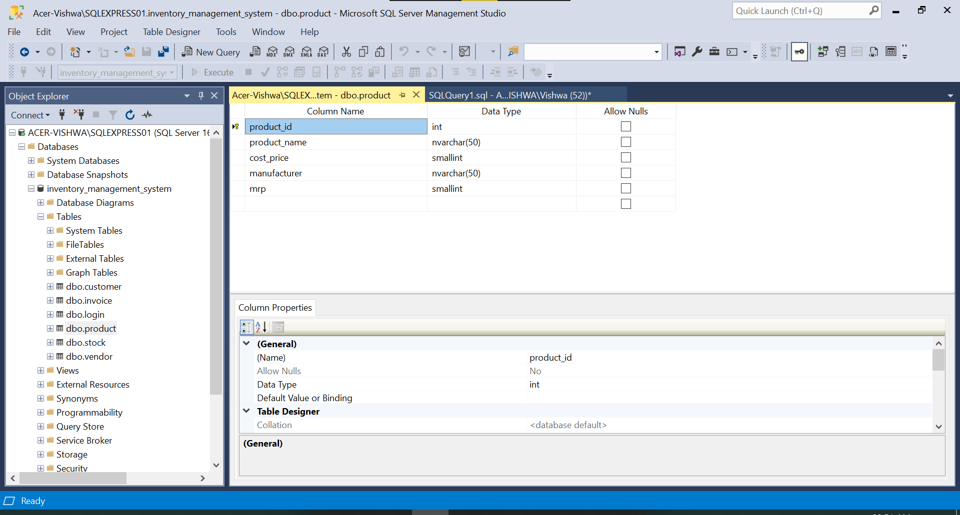

(e)

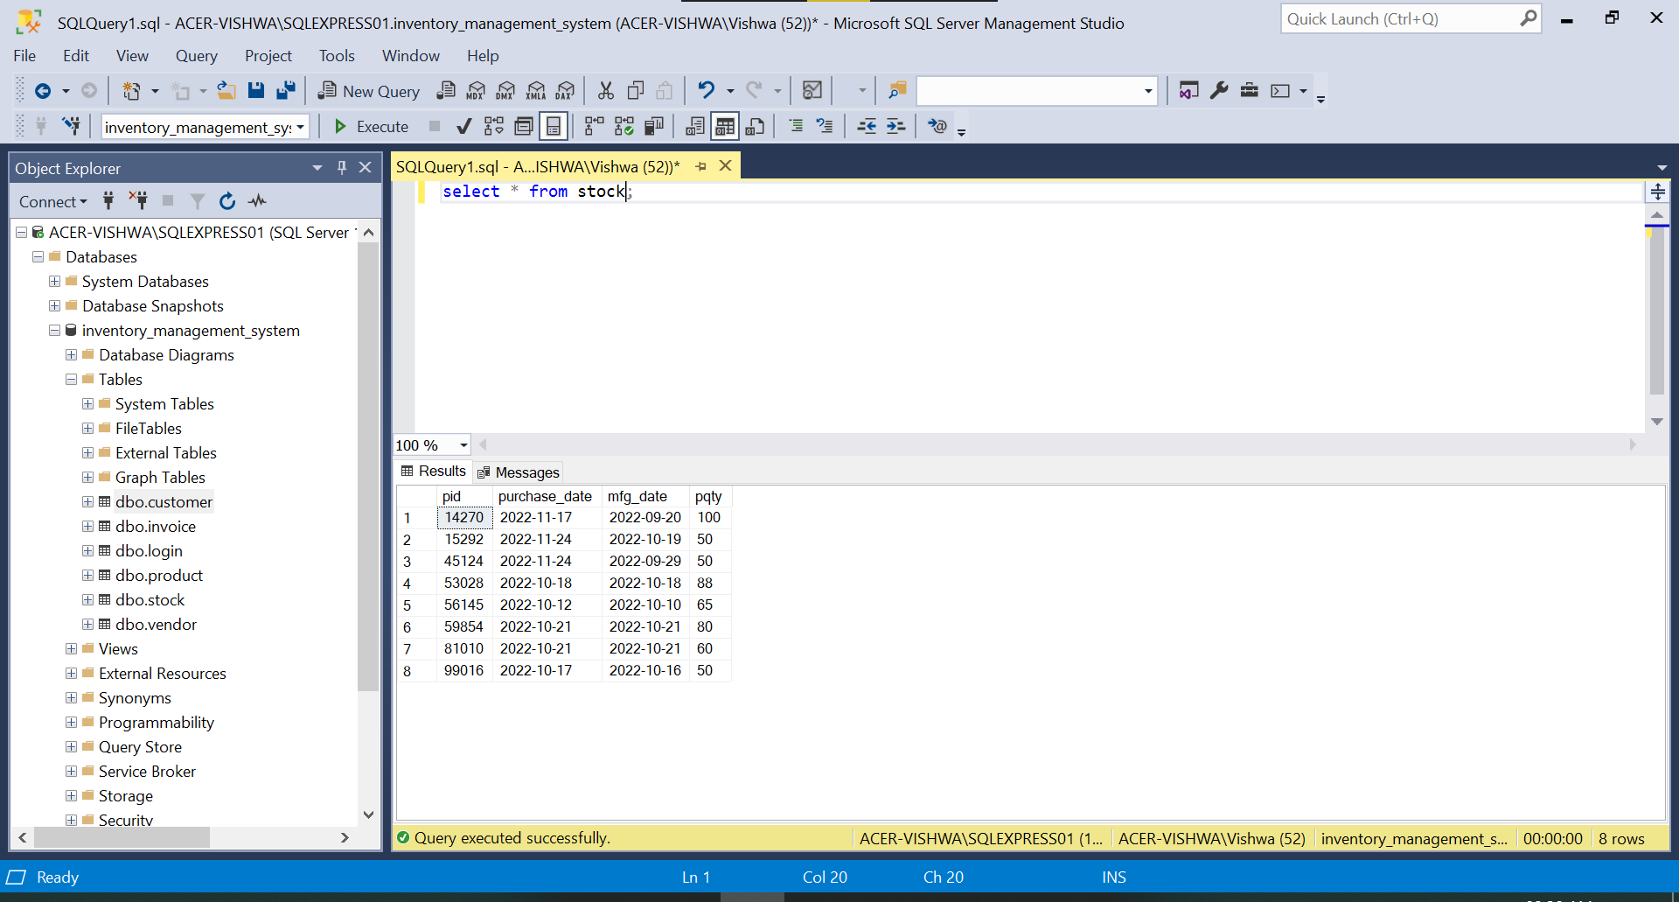

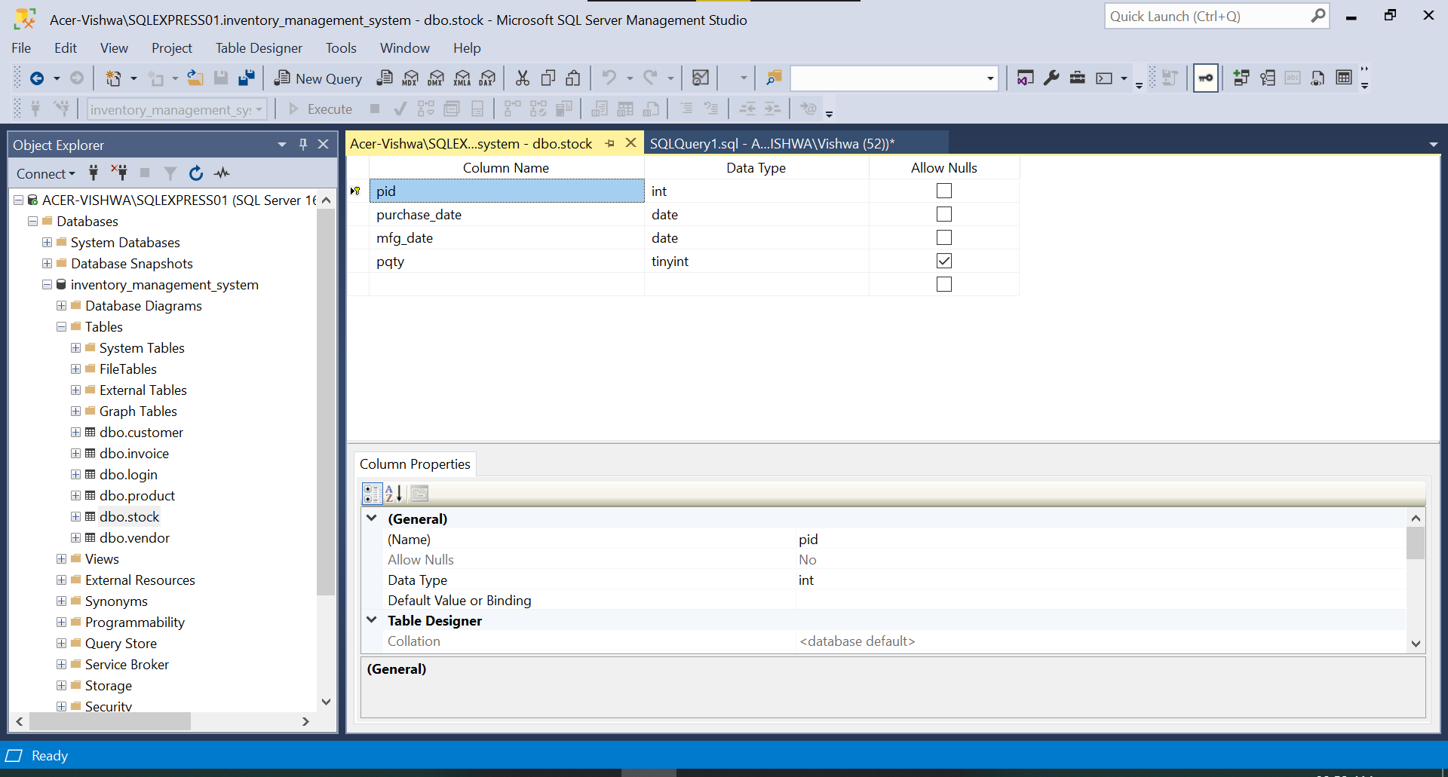

(f)

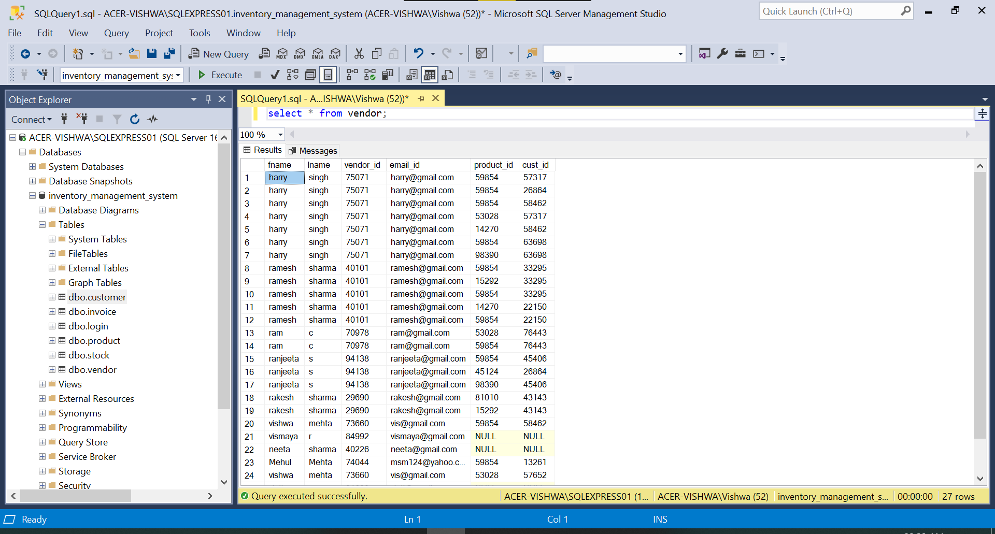

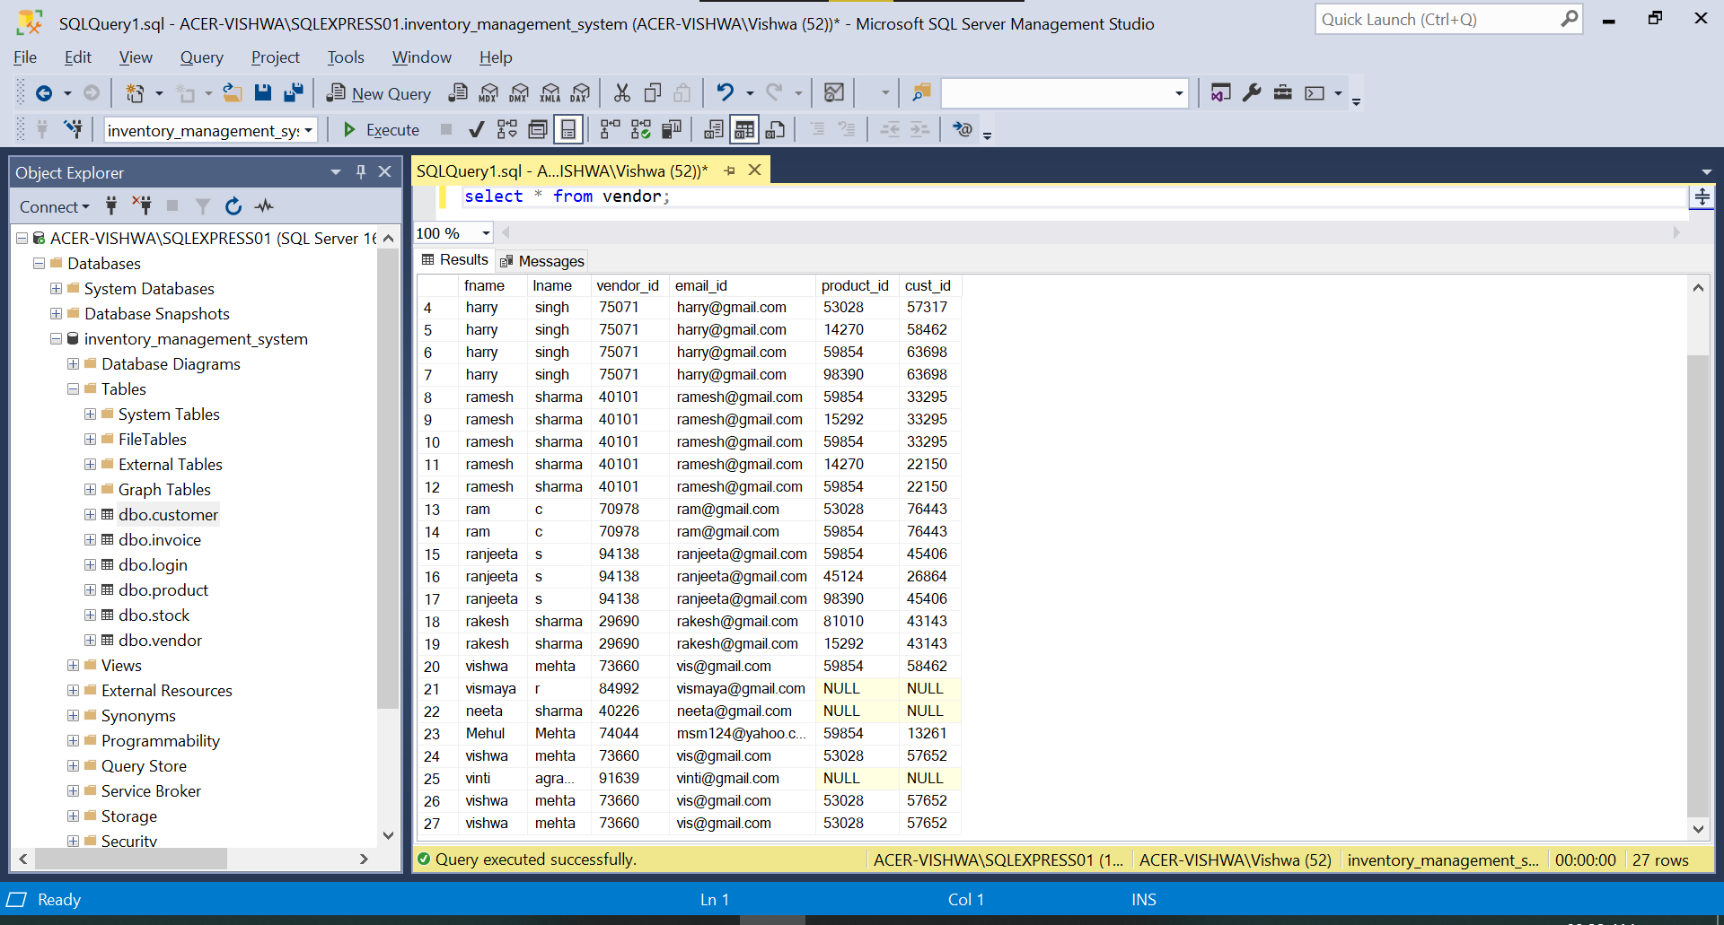

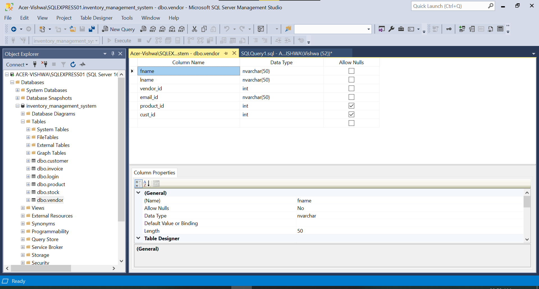

**Task 2: Explain plans**

(a) Table scan:

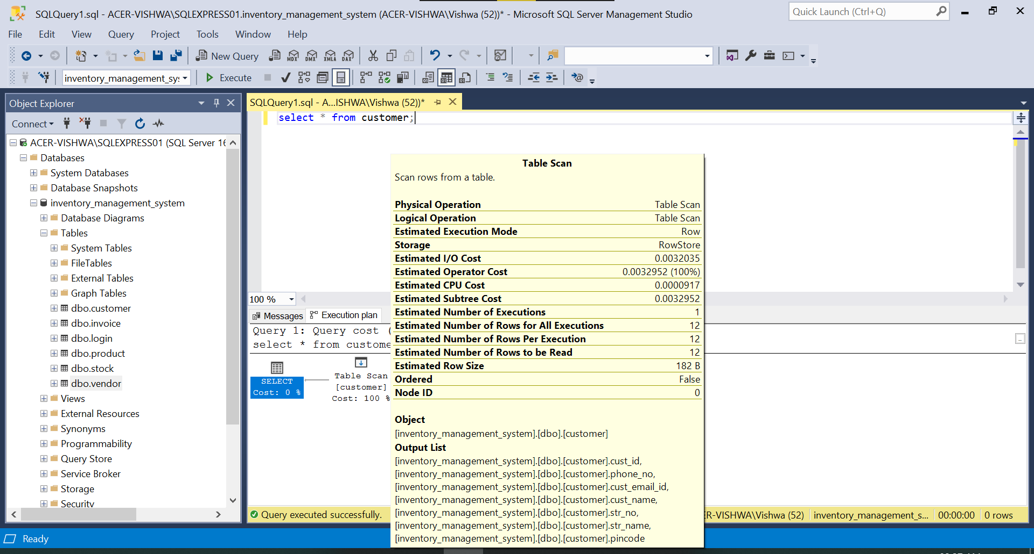

(b) Non-clustered Index Scan:

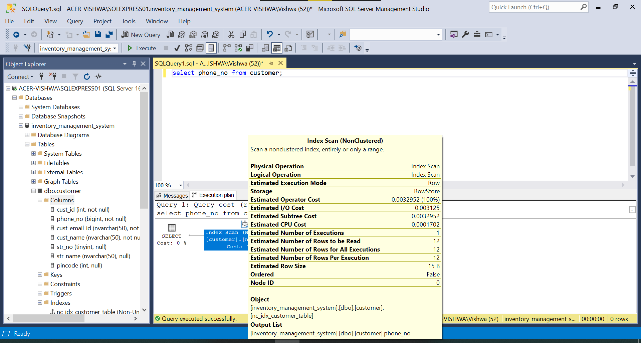

(c) Clustered Index Scan:

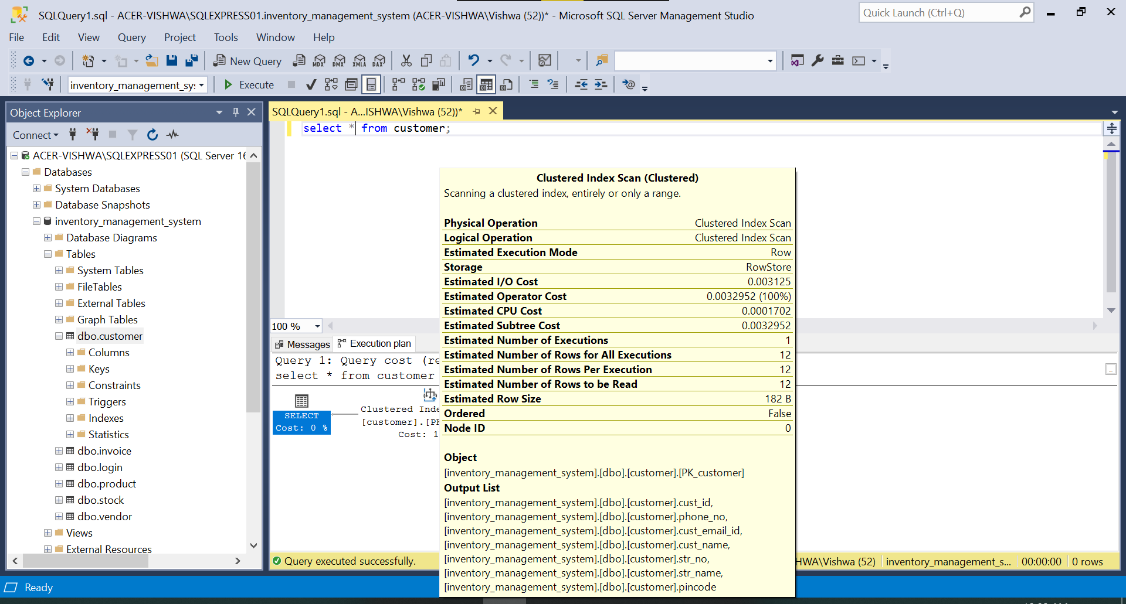

**Task 3: Indexing using joins**

(a) No index on customer and no index on vendor using cross join:

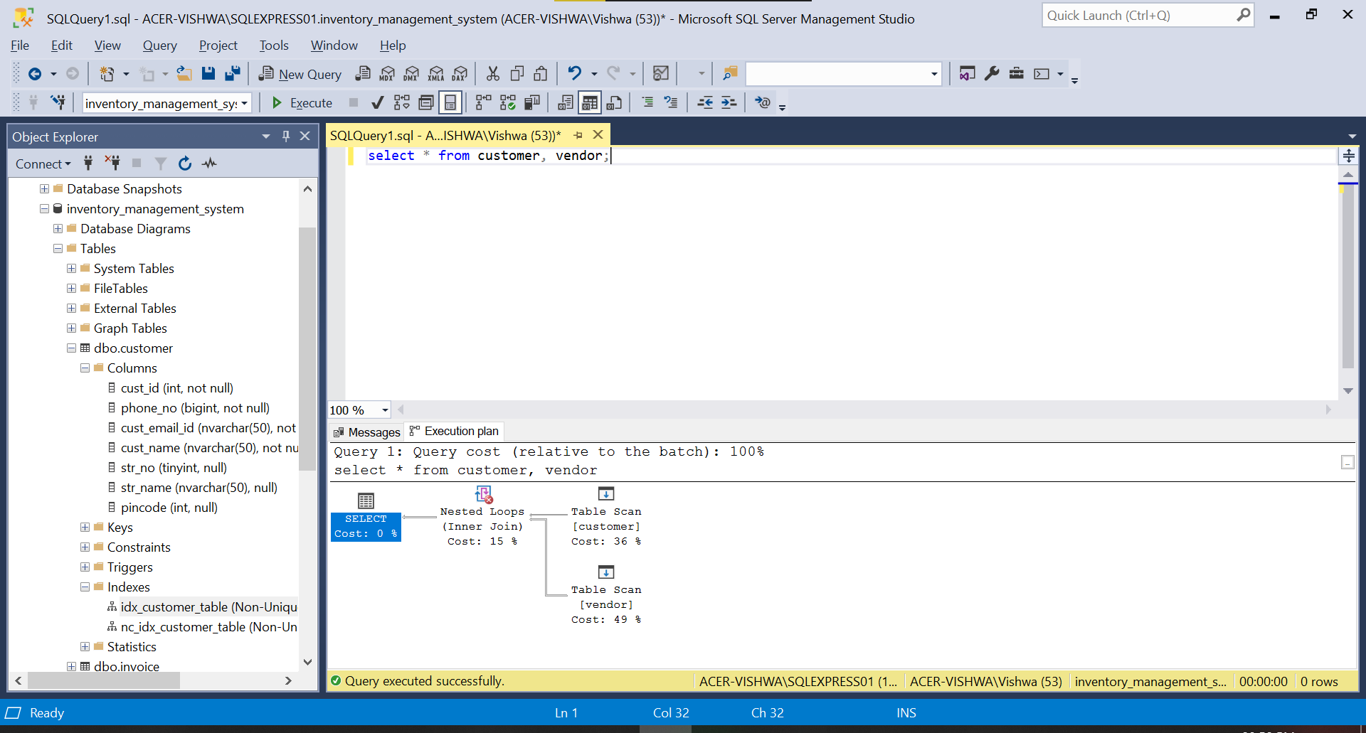

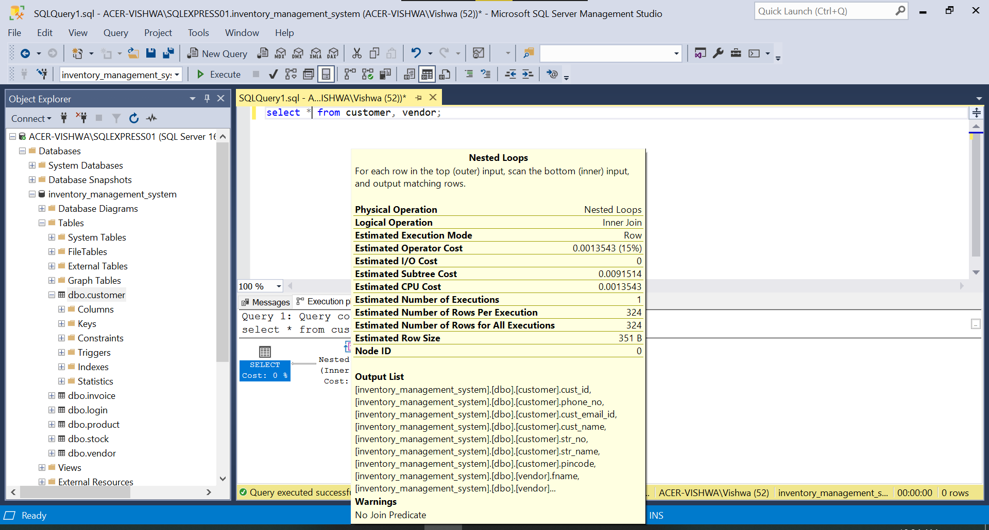

(b) Clustered index on customer and no index on vendor:

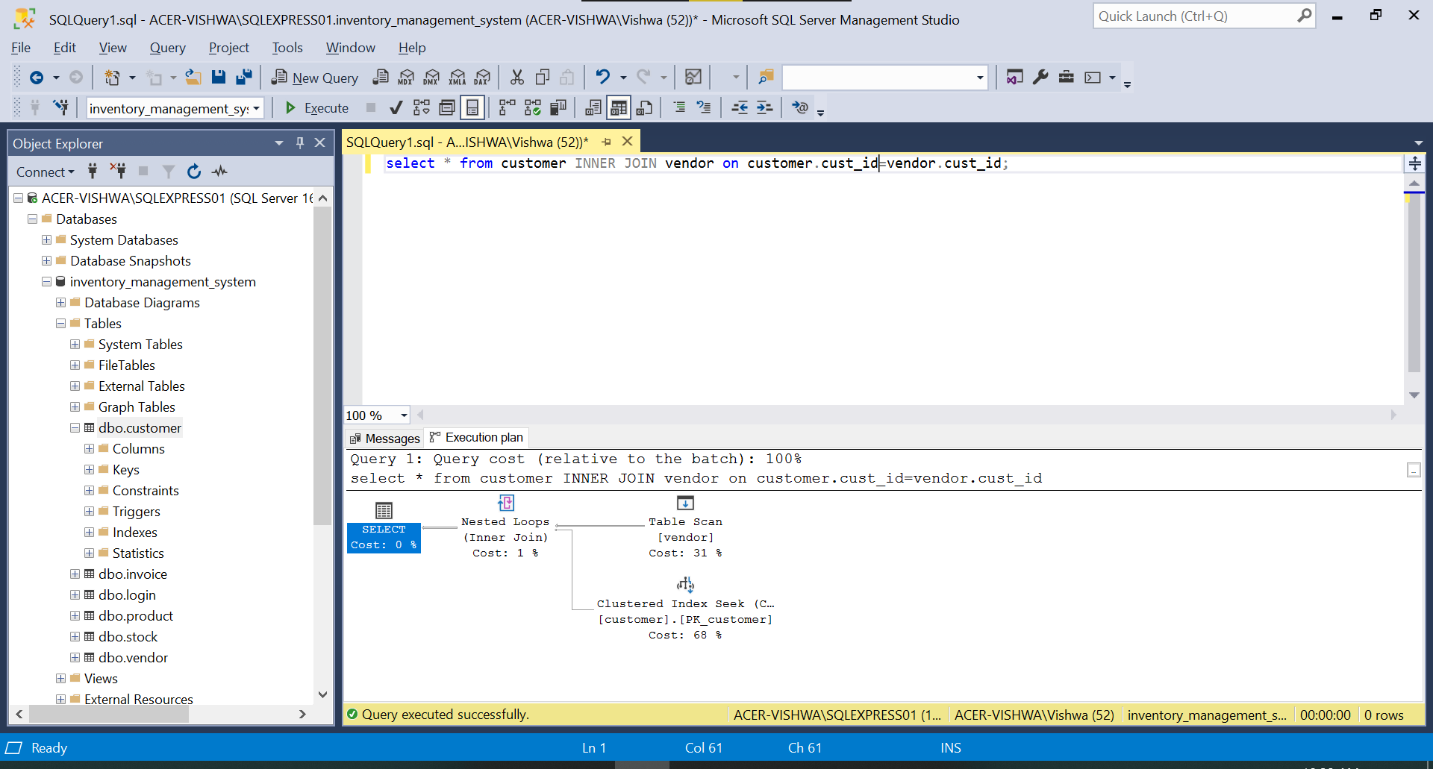

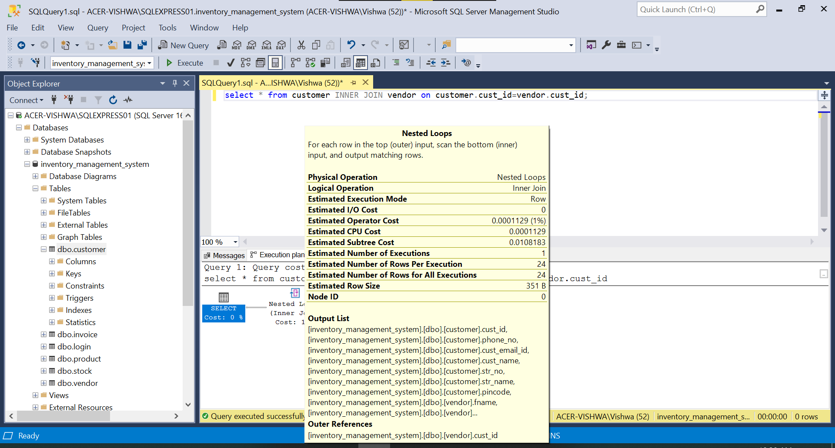

(c) Non clustered index on customer and no index on vendor:

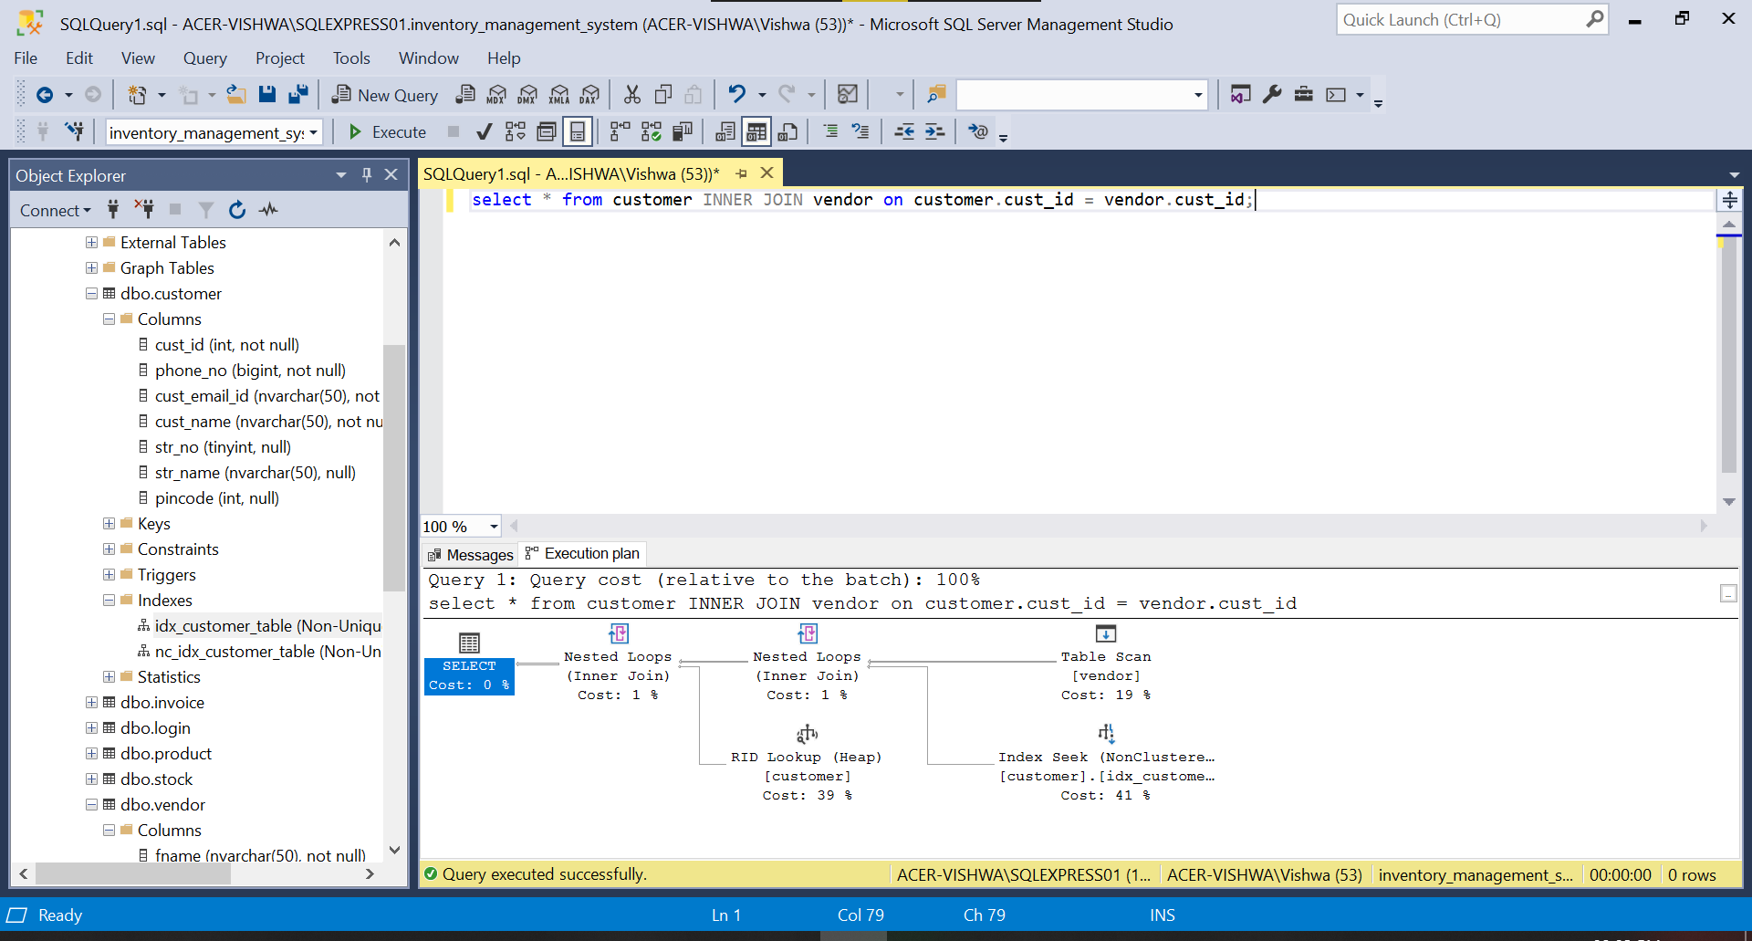

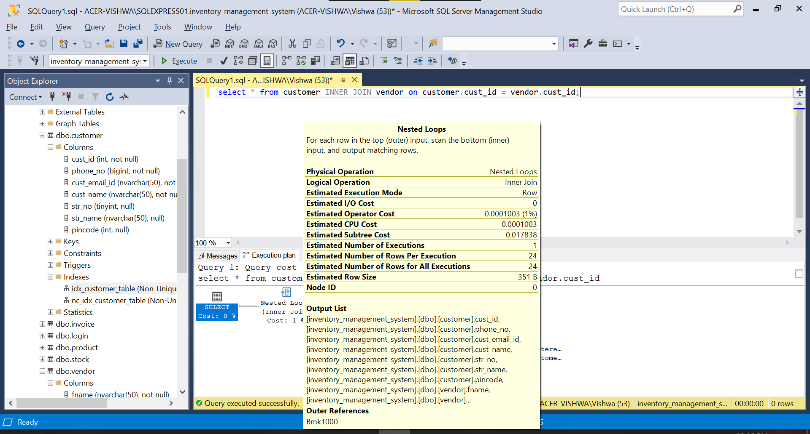

(d) No index on customer and no index on vendor using inner join:

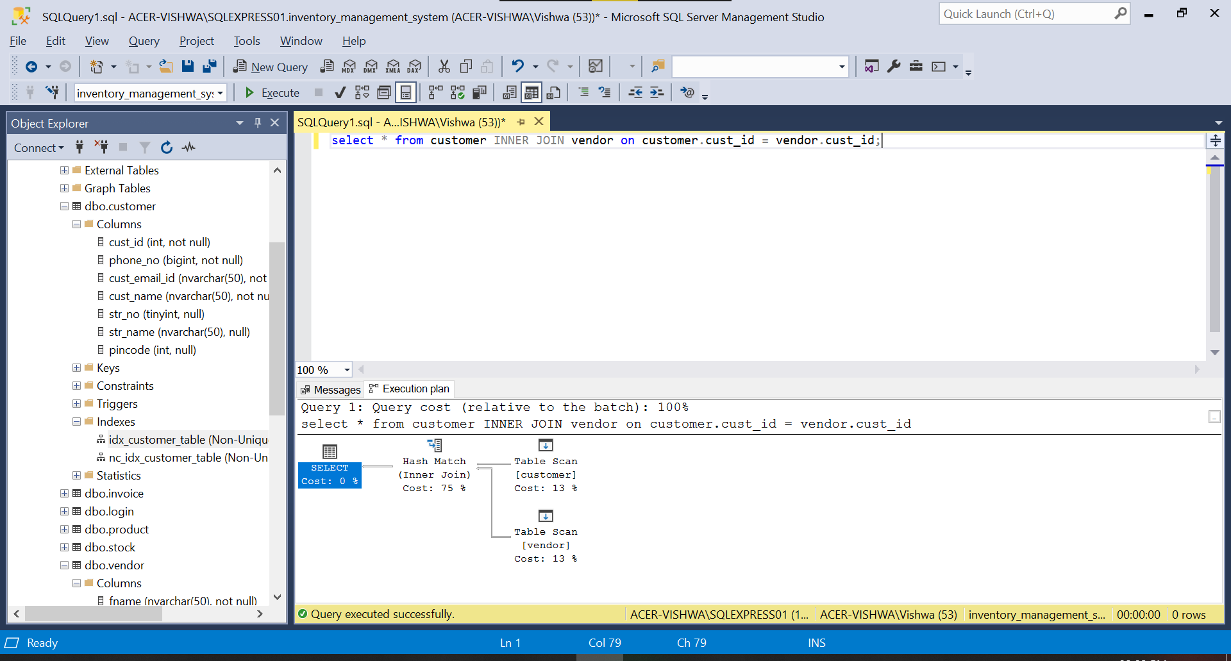

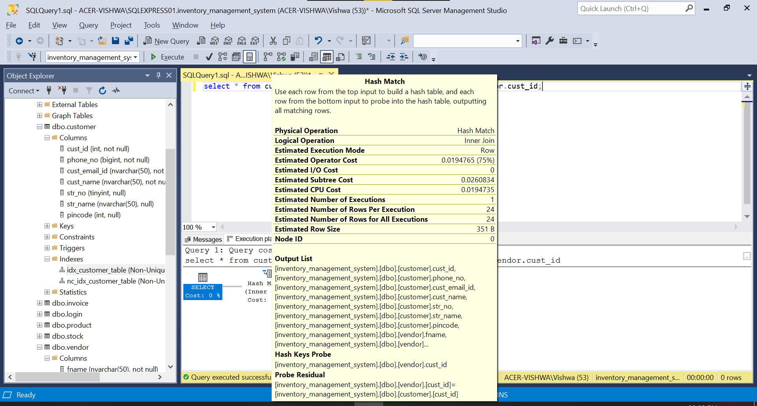

**Comparison of estimated subtree costs for different join operations and indexes:**

|  |  |
| --- | --- |
| **Operation** | **Estimated Subtree Cost** |
| 1. No index - cross join | 0.0091514 |
| 1. Clustered index – inner join | 0.0108183 |
| 1. Non clustered index – inner join | 0.0178380 |
| 1. No index – inner join | 0.0260834 |