**Microprocessor and Computer Architecture**

**UE20CS252**

**4th Semester, Academic Year 2021-22**

Date: 27/03/2022

|  |  |  |
| --- | --- | --- |
| Name:  Vishwa Mehul Mehta | SRN:  PES2UG20CS389 | Section:  F |

Week#____7_______ Program Number: ____1___

Title of the Program

**1. Write a program in ARM7TDMI-ISA to find the sum of all the digits in an 32bit number.**

1. **ARM Assembly Code(1)**

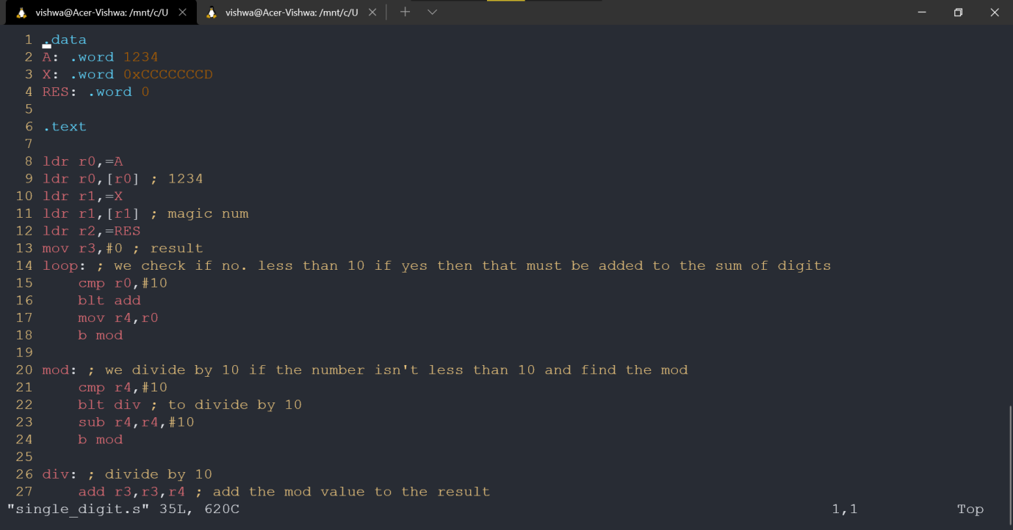

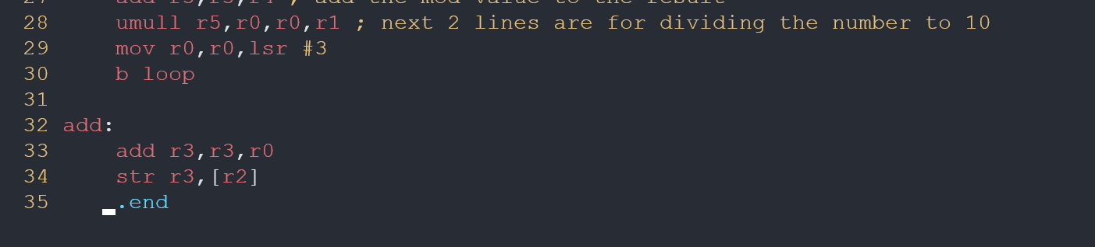

1. **Output Screen Shot (1)**

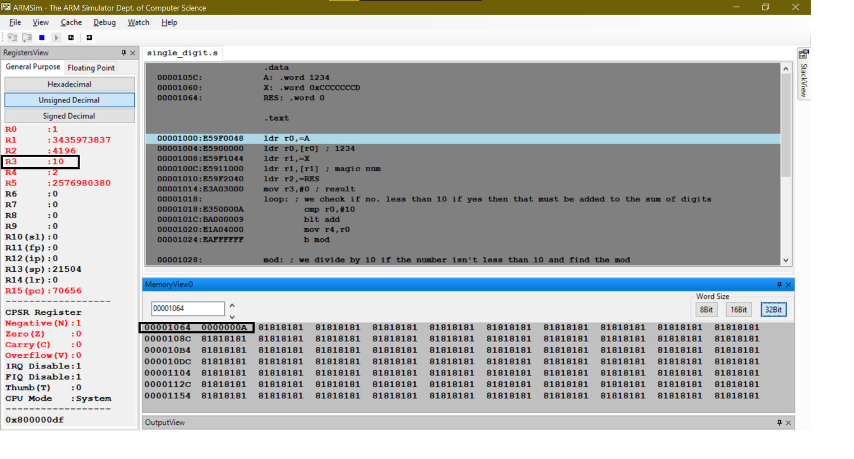

**Microprocessor and Computer Architecture**

**UE20CS252**

**4th Semester, Academic Year 2021-22**

Date: 27/03/2022

|  |  |  |
| --- | --- | --- |
| Name:  Vishwa Mehul Mehta | SRN:  PES2UG20CS389 | Section:  F |

Week#____7_______ Program Number: ____2___

Title of the Program

**2.** **Write a program in ARM7TDMI-ISA to find the number of occurrences of a given character in a string.**

**Example:**

**Given string: My name is Bond.**

**Character: ‘n’.**

**Expected output: Display 2 in a register.**

1. **ARM Assembly Code(1)**

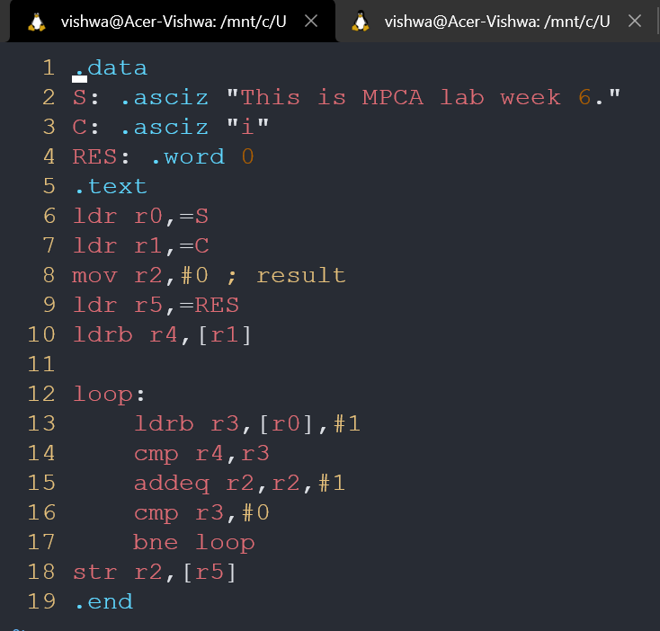

1. **Output Screen Shot (1)**

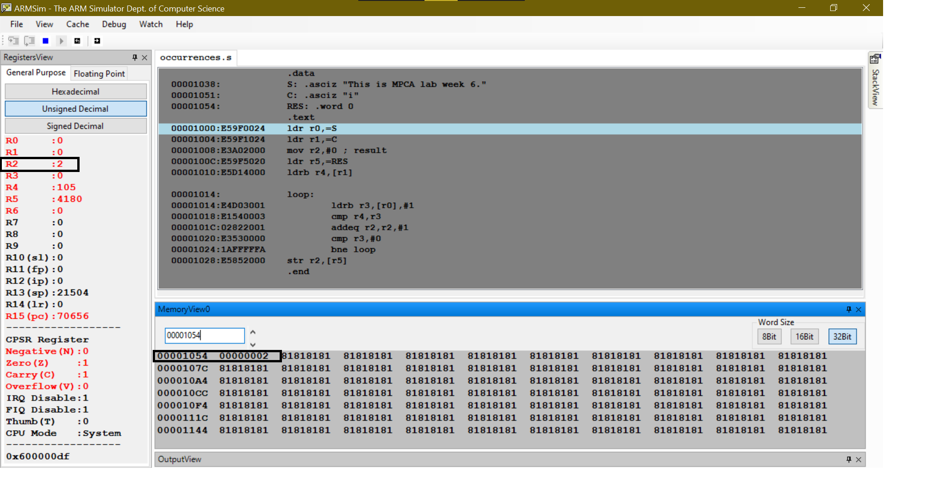

**Disclaimer:**

* The programs and output submitted is duly written, verified and executed by me.
* I have not copied from any of my peers nor from the external resource such as internet.
* If found plagiarized, I will abide with the disciplinary action of the University.

Signature: Vishwa Mehul Mehta

Name: Vishwa Mehul Mehta

SRN: PES2UG20CS389

Section: F

Date: 27/03/2022