OS Hands-on Session

WEEK-1

Name: Vishwa Mehul Mehta

SRN: PES2UG20CS389

SEC: F

Procedure to install a Linux Distribution (Ubuntu 20.04 LTS) on VirtualBox:

Step 1: Download the iso file from the official website. Virtual Box must be pre-installed.

Step 2: Click on “New”.

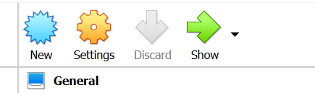

Step 3: Enter the type of OS to be installed. Click on Next.

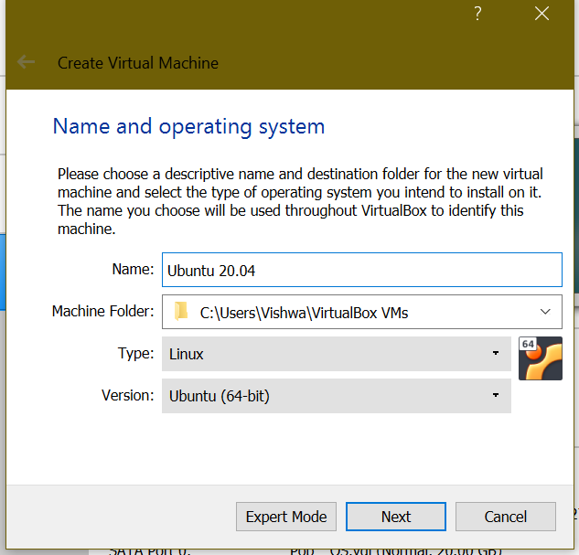

Step 4: Assign enough RAM for the OS. Click on Next.

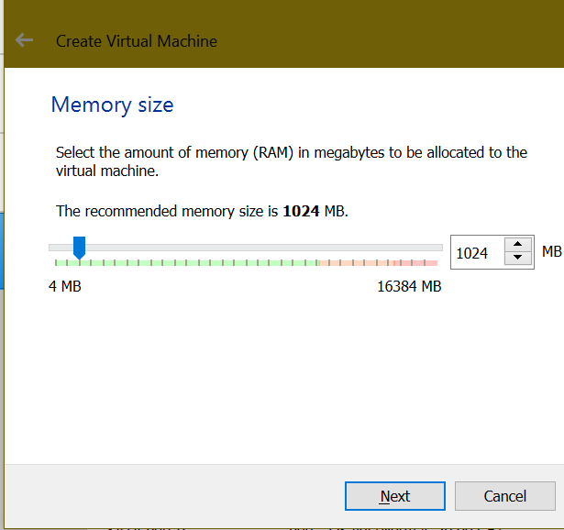

Step 5: Click on “Create” and then “Next”.

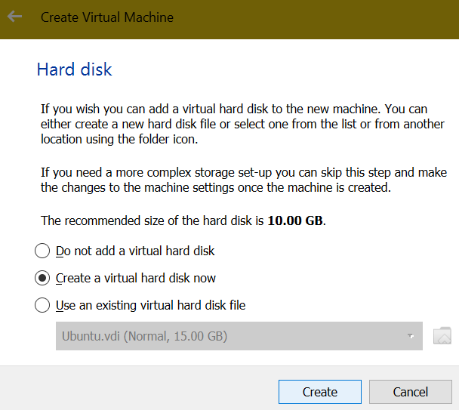 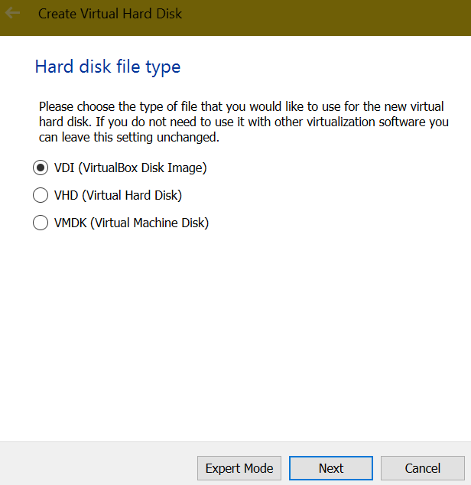 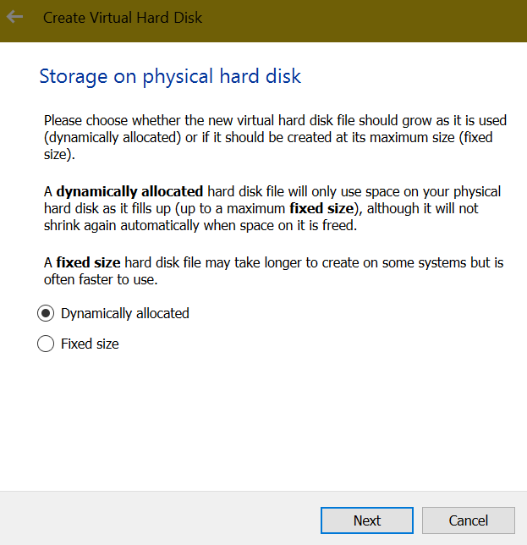

Step 6: Assign Storage Space for the OS and click on “Create”.

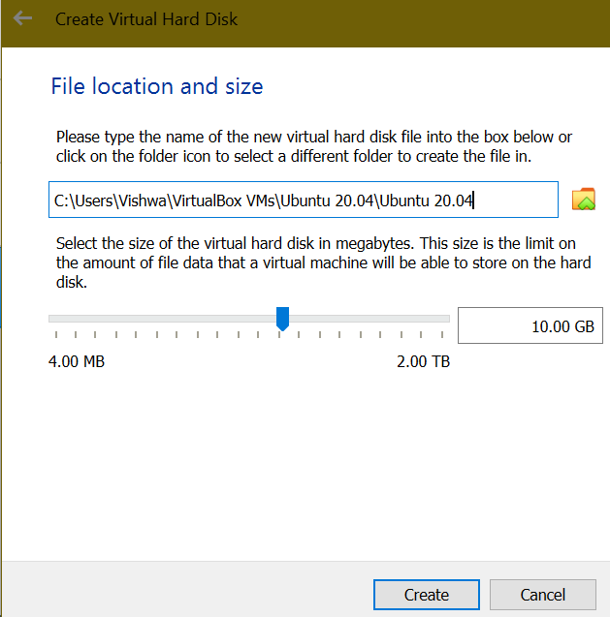

Step 7: Go to “Settings -> Storage -> Controller IDE” and click on the  icon and add the iso from downloads and click “Ok”.

Step 8: Click on “Start” and wait for the OS to load and follow the steps as directed by the OS setup wizard.

Linux Commands:

1. ls:

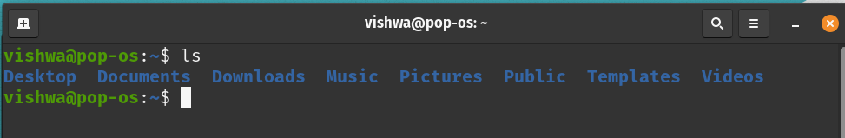

2. mkdir:

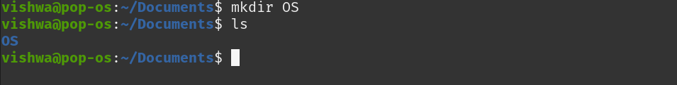

3. man:

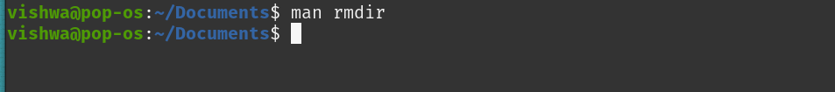

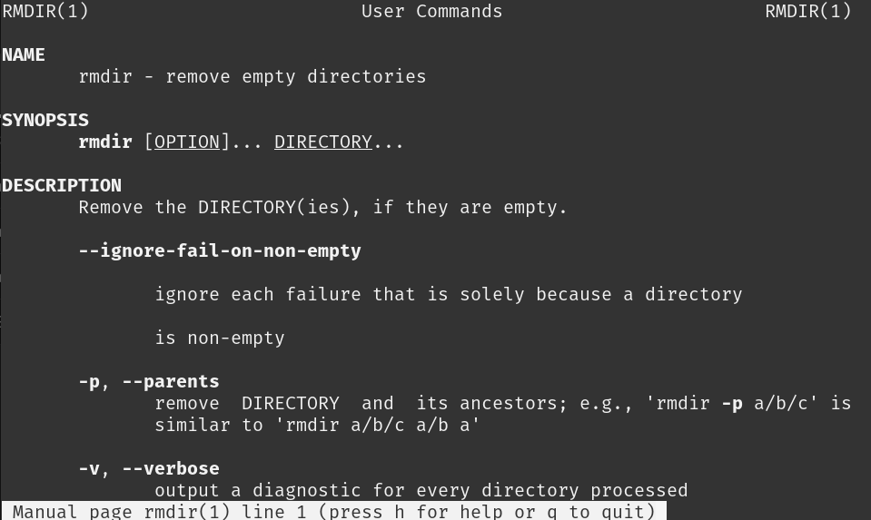

4. ping:

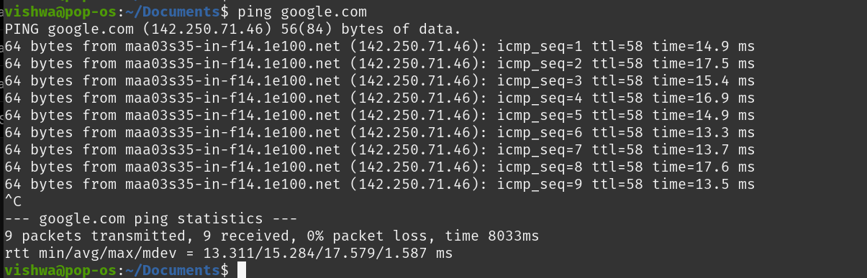

5. ifconfig:

