OS Hands-on Session

WEEK-2

Name: Vishwa Mehul Mehta

SRN: PES2UG20CS389

SEC: F

Program 1:

a) fork()

Fork system call is used for creating a new process (**child process)**, which runs concurrently with the process that makes the fork() call (parent process).

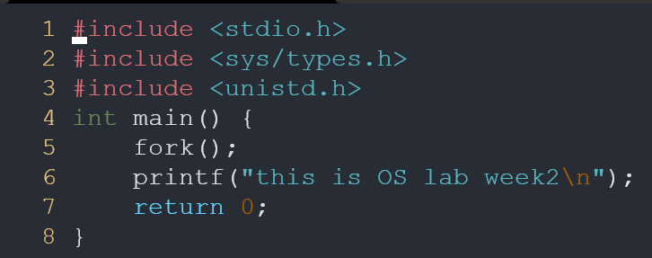



b) getpid() and getppid()

getpid(): When any process is created, it has a unique id which is called its process id. This function returns the process id of the calling function.

getppid(): This function returns the process id of the parent function.

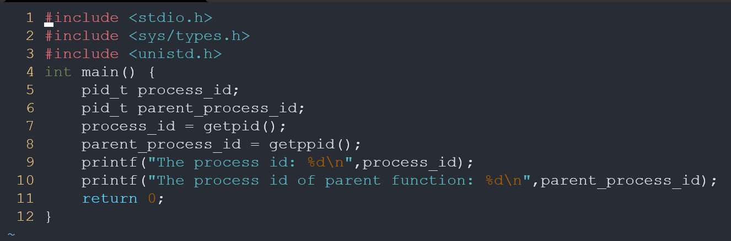



------------------------------------------------------------

Program 2:

wait()

A call to wait() blocks the calling process until one of its child processes exits or a signal is received. After child process terminates, parent ***continues*** its execution after wait system call instruction.

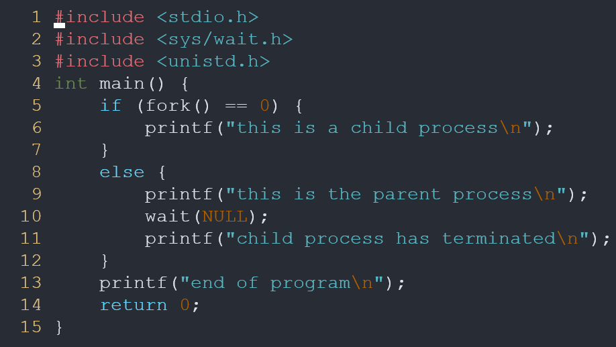

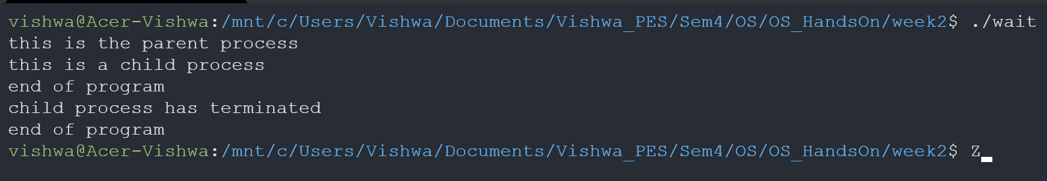

------------------------------------------------------------

Program 3:

a) execvp()

Using this command, the created child process does not have to run the same program as the parent process does.

execvp.c:

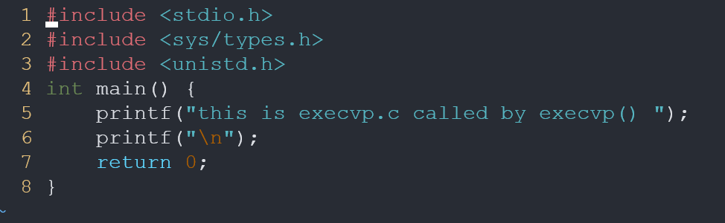

execvp_main.c:

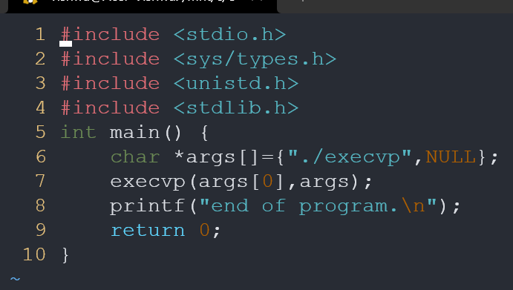



b) execv()

This is very similar to execvp() function in terms of syntax as well.

execv.c:

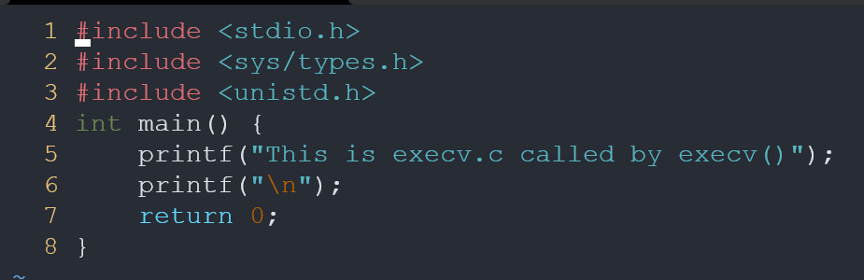

execv_main.c:

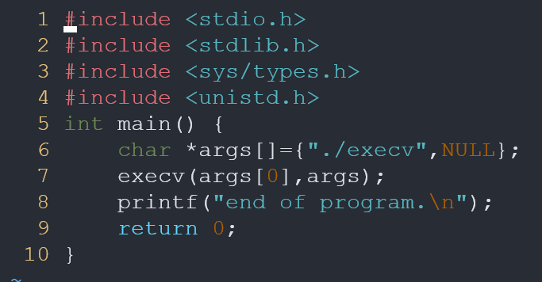



------------------------------------------------------------

Program 4:

cd, ps, du, w, kill

