HOUSE PRICE PREDICTION
A Major Project Report Submitted
In partial fulfillment of the requirement for the award of the degree of

Bachelor of Technology in
Computer Science and Engineering (Data Science)

by

P. CHAITANYA PRIYA 22N31A67D1
P. VISHWA PRAGNAN 22N31A67D0
K. VARDHAN 22N31A6787

Under the Guidance of

Mrs. A SUSHMITHA

Assistant Professor

DEPARTMENT OF COMPUTER SCIENCE AND ENGINEERING (DataScience)

MALLA REDDY COLLEGE OF ENGINEERING AND TECHNOLOGY
(Autonomous Institution – UGC, Govt. of India)
(Affiliated to JNTU, Hyderabad, Approved by AICTE, Accredited by NBA & NAAC – ‘A’ Grade, ISO 9001:2015 Certified)
Maisammaguda (v), Near Dullapally, Via: Kompally, Hyderabad – 500 100, Telangana State, India

2025-2026



CERTIFICATE

This is to certify that this is the Bonafide record of the project titled “HOUSE PRICE PREDICTION” submitted by P. CHAITANYA PRIYA (22N31A67D1), P. VISHWA PRAGNAN (22N31A67D0), K. VARDHAN (22N31A6787), of B.Tech IV Year – II Semester in the partial fulfillment of the requirements for the degree of Bachelor of Technology in Computer Science and Engineering (Data Science), during the year 2025-2026. The results embodied in this project report have not been submitted to any other university or institute for the award of any degree .

Project Guide EXTERNAL EXAMINER

Head Of the Department

Date of Viva-Voice Examination held on:

DECLARATION

We hereby declare that the project entitled “AI Based Job Interview” submitted to Malla Reddy College of Engineering and Technology UGC Autonomous Institution, affiliated to Jawaharlal Nehru Technological University Hyderabad (JNTUH) as part of IV Year B.Tech – II Semester and for the partial fulfillment of the requirement for the award of Bachelor of Technology in Computer Science and Engineering (Data Science) is a result of original research work done by us.
It is further declared that the project report or any part thereof has not been previously submitted to any University or Institute for the award of degree or diploma.

P. CHAITANYA PRIYA 22N31A67D1
P. VISHWA PRAGNAN 22N31A67D0
K. VARDHAN 22N31A6787

ACKNOWLEDGEMENT

We feel ourself honored and privileged to place our warm salutation to our Malla Reddy College of Engineering and Technology(Autonomous Institution – UGC, Govt of India) , Hyderabad. This work is original and has not been submitted in part or full for any degree .

We acknowledge our sincere thanks to Dr. Vaka Murali Mohan, Principal and Prof. M . Vazralu Head of the Department CSE (Data Science) for their kind cooperation in making this Major Project Development, work a success.

We wish to acknowledge our sincere thanks to our project guide Mrs. P Lavanya Reddy, Assistant Professor of Computer Science & Engineering for formulation of the problem, analysis, guidance and her continuous supervision during the course of work.

We extend our gratitude to Sri. Ch. Malla Reddy, Founder Chairman MRGI and Sri. Ch. Mahender Reddy, Secretary MRGI, Dr.Ch. Bhadra Reddy, Director MRGI, Sri. Ch. Shalini Reddy, for their kind cooperation in providing the infrastructure for completion of our Major Project Development.

We acknowledge our special thanks to the entire teaching faculty and non-teaching staff members of the CSE (DS) Department for their support in making this Major project Development work a success.

Finally, we would like to take this opportunity to thank our families for their support and blessings for completion of our project which gave us the strength to do our project.
With Regards and Gratitude,

P. CHAITANYA PRIYA 22N31A67D1
P. VISHWA PRAGNAN 22N31A67D0
K. VARDHAN 22N31A6787

ABSTRACT

House pricing is one of the most important aspects of the real estate industry, as property value directly affects buying decisions, investment planning, and overall economic growth. Traditionally, house prices are estimated by real estate agents or by comparing nearby properties. In this process, human judgment plays a major role, where factors such as location, size, number of rooms, and facilities are considered. However, this traditional method of price estimation is often associated with several limitations such as human bias, inconsistency in evaluation, time consumption, and lack of data-driven accuracy.
In today’s rapidly growing real estate market, thousands of properties are listed across different locations with varying features. Manually analyzing and comparing such a large amount of data becomes difficult and time-consuming. Moreover, different agents may provide different price estimations for the same property, leading to confusion and unreliable results. Due to personal judgment and lack of proper analysis, buyers may overpay for a property while sellers may undervalue their assets. This creates a need for an intelligent, automated, and accurate system that can provide reliable house price predictions.
To address these challenges, the proposed project introduces a Machine Learning-based House Price Prediction System. This system uses advanced technologies such as Machine Learning algorithms and data analysis techniques to predict house prices more accurately. Instead of relying only on manual methods, the system analyzes historical housing data and identifies patterns between different features and property prices.

TABLE OF CONTENTS

CHAPTER |  | CONTENTS | Pg. No
1 |  | Introduction | 1-5
 | 1.1 | Introduction | 1
 | 1.2 | Problem Definition | 2
 | 1.3 | Scope | 3
 | 1.4 | motivation | 4
 | 1.4 | Literature review | 5
2 |  | System Analysis | 6-8
 | 2.1 | Existing System and Proposed System | 6
 | 2.2 | Functional Requirements (Hardware and Software) | 8
3 |  | Software Environment | 9-12
 | 3.1 | Software and Hardware Specification | 9
 | 3.2 | Modules of the Project | 11
4 |  | System Design and UML Diagrams | 13-15
 | 4.1 | Architecture Diagram | 15
 | 4.2 | UML Diagrams | 14
5 |  | Software Development Life Cycle | 16-22
 | 5.1 | Phases of SDLC | 16
6 |  | Implementation | 23-40
 | 6.1 | Sample Code | 23
7 |  | Testing | 41-45
 | 7.1 | Introduction | 41
 | 7.2 | Test Cases | 43
8 |  | Output Screens | 46-47
 | 8.1 | Screenshots | 46
9 |  | Conclusion & Future Scope | 48-49
 | 9.1 | Conclusion | 48
 | 9.2 | Future Scope | 49
10 |  | References | 50-52
 | 10.1 | Websites | 50
 | 10.2 | Reference Books | 52
 | 10.3 | Research Papers | 52

ii

LIST OF FIGURES

S.No | Figure Title | Pg. No
1 | Architecture Diagram | 13
2 | Use Case Diagram | 14
3 | Sequence Diagram | 15
4 | SDLC Diagram | 17
5 | Main Page | 46

iii

LIST OF TABLES

S.No | Table Name | Pg. No
1 | Test Cases | 58

iv

CHAPTER 1 INTRODUCTION

Introduction
House pricing is one of the most important aspects of the real estate industry, as property value directly affects buying decisions, investment planning, and overall economic growth. Traditionally, house prices are estimated by real estate agents or by comparing nearby properties. In this process, human judgment plays a major role, where factors such as location, size, number of rooms, and facilities are considered. However, this traditional method of price estimation is often associated with several limitations such as human bias, inconsistency in evaluation, time consumption, and lack of data-driven accuracy.
In today’s rapidly growing real estate market, thousands of properties are listed across different locations with varying features. Manually analyzing and comparing such a large amount of data becomes difficult and time-consuming. Moreover, different agents may provide different price estimations for the same property, leading to confusion and unreliable results. Due to personal judgment and lack of proper analysis, buyers may overpay for a property while sellers may undervalue their assets. This creates a need for an intelligent, automated, and accurate system that can provide reliable house price predictions.
To address these challenges, the proposed project introduces a Machine Learning-based House Price Prediction System. This system uses advanced technologies such as Machine Learning algorithms and data analysis techniques to predict house prices more accurately. Instead of relying only on manual methods, the system analyzes historical housing data and identifies patterns between different features and property prices.
The system evaluates various factors such as:
* Location: Determines the value of the property based on area and surroundings.
* Size and area: Considers the total built-up area of the house.
* Number of rooms: Includes bedrooms, bathrooms, and other spaces.
* Additional features: Factors like amenities, infrastructure, and accessibility.

By combining these factors, the system generates an estimated house price that helps users make better and informed decisions.
Unlike traditional methods, where users rely on brokers or incomplete information, this system provides accurate and consistent predictions. It also reduces human effort and saves time by processing large datasets quickly. The system can be integrated into real estate platforms to provide instant results and improve user experience.
The implementation of a machine learning-based house price prediction system ensures better accuracy, efficiency, and transparency in the pricing process. It allows buyers, sellers, and investors to make data-driven decisions with confidence.
In summary, this project focuses on improving the traditional property valuation process by introducing a smart, automated, and reliable system. By overcoming the limitations of manual methods, the House Price Prediction system has the potential to enhance decision-making and transform the real estate industry in the modern digital era.

Problem Definition
The recruitment process in many organizations faces major hurdles:
Bias in evaluation due to personal judgment and subjectivity.
Inconsistency when different interviewers assess candidates.
Time consumption, especially when screening large pools of applicants.
Limited feedback provided to candidates, which reduces their opportunity to improve.
These challenges often result in missed opportunities, poor hiring decisions, and reduced organizational diversity. Therefore, a solution is needed that can automate, standardize, and objectify the interview process without compromising candidate experience. The AI-based interview system addresses this by delivering real-time, unbiased, and scalable assessments that ensure fair recruitment practices.

Scope
The house price estimation process in real estate faces several major challenges:
* Bias in pricing due to personal judgment of brokers or agents.
* Inconsistency when different sources provide different property values.
* Time consumption, especially when comparing multiple properties manually.
* Limited data usage, which leads to inaccurate price estimation.
These challenges often result in incorrect pricing, poor investment decisions, and financial loss for buyers and sellers. Therefore, a solution is needed that can automate, standardize, and improve price prediction accuracy. The House Price Prediction system addresses this by providing data-driven, accurate, and reliable price estimates using machine learning techniques.

Motivation

The motivation behind the House Price Prediction project arises from the increasing complexity and uncertainty in the real estate market. Buying or selling a house is one of the most important financial decisions in a person’s life, yet many people do not have access to accurate information about property values. Traditionally, house prices are estimated based on manual comparison, broker suggestions, or personal judgment, which often leads to biased and inconsistent results. This lack of reliability creates confusion among buyers and sellers and sometimes results in financial loss.

In today’s fast-paced world, the real estate market is growing rapidly with a large number of properties being listed across different regions. Analyzing such a huge amount of data manually is not only time-consuming but also inefficient. Different properties have different features such as location, size, number of rooms, and nearby facilities, making it difficult to estimate prices accurately using traditional methods. This situation highlights the need for a smart and automated system that can handle large datasets and provide precise predictions.

Another key motivation is the need to reduce dependency on brokers and agents. While they play an important role in the real estate sector, their price suggestions may sometimes be influenced by personal interests or limited knowledge. This can lead to overpricing or underpricing of properties. Therefore, there is a need for a system that provides unbiased and data-driven results, ensuring fairness and transparency in the pricing process.
The system conducts interviews in real-time using Artificial Intelligence and Natural Language Processing (NLP).
Candidates’ spoken responses are analyzed for relevance, grammar, sentiment, and clarity.
Facial expressions, gestures, and emotions are detected using machine learning and computer vision techniques.
Voice analysis helps assess tone, confidence, hesitation, and stress levels.
The final output is a comprehensive performance score, generated by combining verbal, non-verbal, and emotional indicators.

Literature Review

House price prediction has been an important research area in the fields of data science and machine learning due to its practical applications in the real estate sector. Earlier studies mainly focused on traditional statistical techniques such as Linear Regression, where the relationship between independent variables like location, size, and number of rooms and the dependent variable (price) was analyzed. These models were simple, easy to implement, and provided a basic understanding of price trends. However, they had limitations in handling complex and non-linear relationships present in real-world data.

With the advancement of technology, researchers started using Machine Learning algorithms to improve prediction accuracy. Decision Tree models were introduced as they can handle both linear and non-linear relationships and are easy to interpret. They divide the dataset into smaller parts based on feature values, making predictions more structured. However, Decision Trees often suffer from overfitting, where the model performs well on training data but poorly on unseen data.

To overcome these limitations, ensemble learning techniques such as Random Forest were developed. Random Forest combines multiple decision trees to produce more accurate and stable predictions. It reduces overfitting and improves generalization by averaging the results of different trees. Many research studies have shown that Random Forest performs better than individual models in house price prediction tasks.

In addition to these methods, some researchers have explored advanced algorithms such as Support Vector Machines (SVM) and Artificial Neural Networks (ANN). These models are capable of capturing complex patterns and interactions between features. Neural Networks, in particular, are useful for large datasets and can achieve high prediction accuracy. However, they require more computational power and proper tuning of parameters, which makes them slightly complex to implement.

CHAPTER 2 SYSTEM ANALYSIS

Existing System and Proposed System

Existing System
In the current scenario, house price estimation is mainly done using traditional methods in the real estate sector. These methods involve manual comparison of properties, consultation with real estate agents, and basic analysis of nearby property prices.
Bias in Pricing
Property prices are often influenced by the personal judgment of brokers or agents.
Sellers may overprice their property, while buyers may undervalue it based on incomplete knowledge.
Inconsistency
Different agents or platforms may provide different price estimates for the same property.
Lack of standard methods leads to confusion and unreliable results.
Time-Consuming Process
Manual comparison of multiple properties takes a lot of time and effort.
Users need to check various sources to get an approximate idea of pricing.
Limited Data Usage
Traditional methods do not fully utilize historical and large-scale housing data.
Important factors like trends, patterns, and hidden relationships are often ignored.
Low Accuracy
Due to lack of advanced analysis, price predictions are often inaccurate.
Small changes in features may not be properly considered, leading to wrong estimation.
Dependency on Brokers
Buyers and sellers heavily depend on real estate agents for price estimation.
This increases chances of manipulation or misleading information.
Scalability Issues
Traditional methods are not suitable for handling large datasets or multiple properties at once.
Difficult to analyze properties across different locations efficiently.

Proposed System

It provides a user-friendly interface where users can enter property details and get an estimated price instantly. The proposed system offers several advantages:

Intelligent Price Prediction

Uses machine learning algorithms like Linear Regression, Decision Tree, and Random Forest.

Analyzes large datasets to provide accurate and data-driven price estimates.

Improved Accuracy

Considers multiple factors such as location, area, number of rooms, and amenities.

Reduces errors by learning patterns from past data.

Automated System

Eliminates the need for manual comparison and reduces human effort.

Provides instant results without time delay.

Consistency in Results

Produces uniform predictions for similar inputs using trained models.

Removes variations caused by human judgment.

Time Efficiency

Processes large amounts of data quickly.

Saves time for users by providing instant price predictions.

Reduced Dependency on Brokers

Users can directly estimate property prices without relying on agents.Ensures transparency and fairness in pricing.

Functional Requirements

Software Requirements

COMPONENT | SPECIFICATION
OPERATING SYSTEM | Windows 10 / Linux / macOS
LANGUAGE | Python( streamlit library, SKlearn, pandas, numpy)
INTEGRATED DEVELOPMENT  ENVIRONMENT (IDE) | Microsoft Visual Studio Code
Table 1: Software Requirements

Hardware Requirements

COMPONENT | SPECIFICATION
PROCESSOR | Intel i3/i5/i7 or equivalent (Quad Core)
RAM | 4GB minimum (16 GB recommend]
HARD DISK | 256 GB or more.
Table 2: Hardware Requirements

CHAPTER 3

SOFTWARE ENVIRONMENT
The software environment defines the set of tools, technologies, frameworks, and platforms used to design, develop, test, and deploy the AI Based Job Interview System. As the project involves both user interaction (frontend) and data processing/AI evaluation (backend), it requires a well-structured software stack. This chapter outlines the development environment and provides justification for the technologies selected.

Hardware Environment
To achieve accurate and efficient results in the AI-based interview process, a robust hardware setup is necessary. The system requires a processor with high computational capacity. An Intel i5 or i7 processor, or an equivalent quad-core processor, has been chosen to provide sufficient performance for running machine learning algorithms, handling multi-threaded tasks, and supporting real-time interview sessions.
Memory plays a vital role in executing AI models, especially when they deal with video streams, natural language processing, and large datasets. A minimum of 8 GB RAM is required to run the system effectively, but 16 GB is recommended to ensure smooth multitasking and faster execution of complex algorithms without delays.
Storage is another critical factor. Since the system needs to store candidate profiles, interview recordings, datasets, and trained AI models, a hard disk capacity of at least 256 GB has been chosen. Solid State Drives (SSDs) are preferred, as they provide faster read and write speeds, which directly improves performance during video analysis and database operations.
As the project relies heavily on analyzing candidate behavior, high-quality input devices are required. An HD webcam ensures clear capture of facial expressions and gestures, which are later processed using computer vision models. Similarly, a high-quality microphone is necessary to capture the candidate’s voice accurately for tone and speech analysis. Background noise or poor-quality input can affect the accuracy of results, hence a reliable microphone is essential.

Software Environment
The software environment consists of Python streamlit lib as GUI, sklearn, pandas, numpy used as logic and backend and for databases we used csv files, all integrated into a single architecture to provide a smooth and efficient system.

Data Processing & Feature Engineering

At the core of the system lies a robust data preprocessing mechanism designed specifically for chronological integrity. The TimeSeriesDataProcessor ingests raw property records and systematically normalizes critical variables such as square footage, bedroom counts (BHK), and bathroom layouts. More importantly, it executes extensive feature engineering by extracting temporal features such as date metrics, cyclical seasonality (sine/cosine transformations of months), and historical rolling averages. Categorical variables, such as location, are mapped and encoded securely. This structure transforms rudimentary housing data into a complex multi-dimensional dataset primed for statistical regression.

Model Architecture & Training

The diagnostic intelligence of the software natively supports a competitive modeling infrastructure evaluating multiple algorithms, including Random Forest, Gradient Boosting, and Linear Regression. Through an autonomous cross-validation strategy scoped exclusively for time-series splits (to prevent future data leakage), the system benchmarks these models internally. Currently, a heavily optimized Linear Regression model commands the prediction vector due to its exceptional stability. The pipeline intelligently aggregates feature weights and applies scaled market correction variables to output realistic, highly localized base price approximations.

Integrated Development Environment (IDE)
The system is developed using Microsoft Visual Studio, which supports python development and its libraries. It provides features like debugging, code completion, and GitHub integration for version control and team collaboration.

Modules of the project

The Hyderabad House Price Predictor is structurally divided into five distinct operational modules, each handling a specialized layer of the execution pipeline:

Module 1: Data Preprocessing Module:

Data Ingestion: Loads the raw, chronological real-estate .csv datasets and validates structural integrity.

Feature Engineering: Extracts advanced chronological properties (years, months, day-of-year) and computes cyclic behaviors (sine/cosine transformations) to capture seasonal periodicity. Rolling & Lag Mechanics: Computes historical rolling averages, statistical variance (min/max), and price gap lag indicators utilized heavily in time-series math.

Categorical Encoding: Securely translates string-based variables (like neighborhood names) into numeric limits digestable by the machine learning engine.

Module 2: Model Training & Evaluation Module

Sub-Model Architecture: Defines and loads the core regression algorithms, actively testing Linear Regression, Random Forest, and Gradient Boosting simultaneously.

Time-Series Validation Splitting: Splits incoming train-test data linearly according to exact timestamps rather than randomly, strictly preventing "future data leakage" which compromises predictions.

Performance Diagnostics: Evaluates the models against stringent mathematical metrics (MAE, RMSE, R² scores) and permanently mounts the best-performing model as the lead predictor.

Module 3: Forecasting Engine Module

Future Projection Generation: Creates virtual timestamps extending beyond the database tracking limits recursively day-by-day or month-by-month.

Market Variable Adjuster: Integrates the base mathematical prediction from the training module with hardcoded market appreciation logic (such as a 5% baseline annual market increase) and applies dampened monthly variation ratios to simulate real-world curve shifts smoothly.

Module 4: Frontend GUI & Visualization Module

Streamlit Display Application: Maps HTML/CSS structural directives into an interactive, reactive web portal directly accessible in a browser. Input Sanitization: Reads incoming variables for square footage, bedroom layouts, or dates from the users, validates constraints safely, and passes them to the orchestration backend.

Plotly Chart Rendering: Converts returning multi-dimensional metric predictions recursively into clean, interactive projection graphs plotting both historical averages and future price bounds.

CHAPTER 4

SYSTEM DESIGN AND UML DIAGRAMS
Architecture Diagram
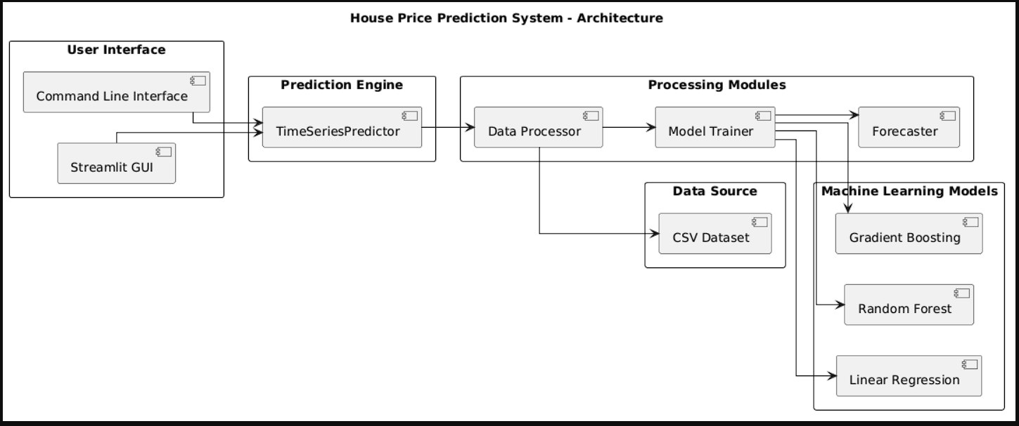

Fig 1: Architecture Diagram

UML Diagrams
Use Case Diagram
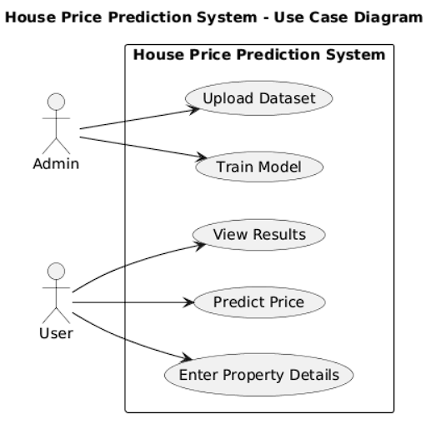

Fig 2: Use Case Diagram

Sequence Diagram

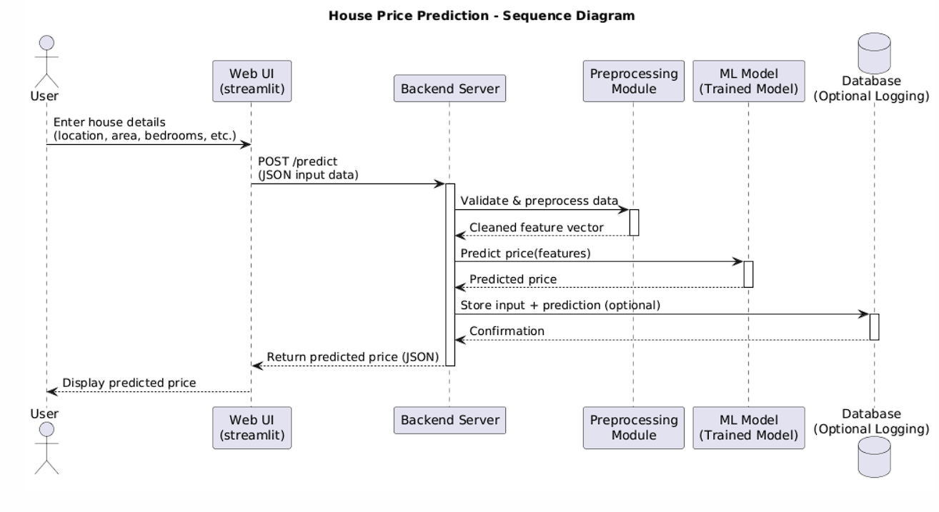

Fig 3: Sequence Diagram

CHAPTER 5

SOFTWARE DEVELOPMENT LIFE CYCLE

Software Development Lifecycle

The software development life cycle is a process that development teams use to create awesome software that’s top-notch in terms of quality, cost effectiveness, and time efficiency. The main goal is to minimize risks and make sure the software meets the customer’s expectations both during and after production.
This process is about creating a detailed plan to guide the development of the product and then breaking down the development process into smaller modules that can be assigned, completed, and measured to make the whole thing more manageable.
Here are some specific benefits of using SDLC for the product team:
Increased visibility of the development process for all stakeholders involved.
More efficient estimation, planning, and scheduling
Improved risk management and cost estimation
A systematic approach to delivering software that meets customer expectations and improves satisfaction.

Phases of SDLC:
The SDLC methodology focuses on the following phases of software development:
Planning and Analysis
Requirements
Software design or architectural design
Implementation
Testing
Deployment & Maintenance

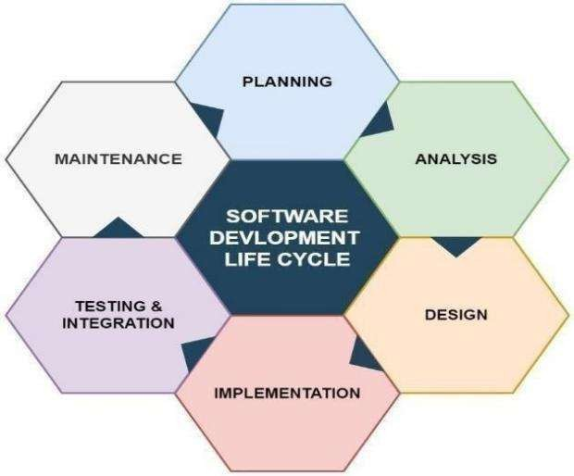

Fig 4: SDLC

Planning & Analysis
The first phase of the SDLC is the project planning stage where you are gathering business requirements from your client or stakeholders. This phase is when you evaluate the feasibility of creating the product, revenue potential, the cost of production, the needs of the end-users, etc.

Define Requirements

Define Requirements This phase is critical for converting the information gathered during the planning and analysis phase into clear requirements for the development team. This process guides the development of several important documents: a software requirement specification (SRS), a Use Case document, and a Requirement Traceability Matrix document.

Design

The design phase is where you put pen to paper so to speak. The original plan and vision are elaborated into a software design document (SDD) that includes the system design, programming language, templates, platform to use, and application security measures. This is also where you can flowchart how the software responds to user actions.

Development
The actual development phase is where the development team members divide the project into software modules and turn the software requirement into code that makes the product.

Testing
Before getting the software product out the door to the production
environment,it’s important to have your quality assurance team perform validation testing to make sure it is functioning properly and does what it’s meant to do. The testing process can also help hash out any major user experience issues and security issues. The types of testing to do in this phase: Performance testing, Functional testing, Security testing, Unit- testing, Usability testing, Acceptance testing.
Deployment

During the deployment phase, your final product is delivered to your intended user. You can automate this process and schedule your deployment depending on the type. For example, if you are only deploying a feature update, you can do so with a small number of users (canary release). If you are creating brand-new software, you can learn more about the different stages of the software release life cycle (SRLC).

Maintenance

The maintenance phase is the final stage of the SDLC if you’re following the waterfall structure of the software development process. However, the industry is moving towards a more agile software development approach where maintenance is only a stage for further improvement. This can include handling residual bugs that were not able to be patched before launch or resolving new issues that crop up due to user reports. Larger systems may require longer maintenance stages compared to smaller systems.
Here's a typical SDLC tailored for building Cyberonix project.

Requirements Gathering:
The first step involved understanding the increasing need for a centralized cybersecurity platform. After extensive research and brainstorming, the planning phase identified major pain points in the current fragmented
ecosystem—such as tool compatibility issues, installation complexity, and time-consuming workflows. The goal was to create a unified CLI-based toolkit tailored for Linux users (especially Kali Linux users) that integrates widely- used cybersecurity tools for ethical hacking, penetration testing, and vulnerability assessment. During this stage, feasibility analysis, technical considerations, cost, and end-user requirements (cybersecurity professionals, students, red teamers) were evaluated. Key questions such as: What tools are essential? What automation is feasible? What level of documentation is needed? were addressed.

Define Requirements:

In this phase, the exact features and capabilities of Cyberonix were outlined. The team documented:
A detailed Software Requirements Specification (SRS) covering all modules (Information Gathering, Vulnerability Analysis, Exploitation, etc.)
Use Cases describing user interaction with CLI tools, automation scripts, and reporting features.
A Requirement Traceability Matrix (RTM) was drafted to ensure each functional and non-functional requirement could be tracked throughout development.
The emphasis was on modularity, usability, cross-tool integration, and the ability to run efficiently on most Linux systems.

System Design:

System architecture was designed to support a modular plugin-like framework allowing future extensibility. The UI/UX for the CLI interface, tool selection menus, and categorized tool organization were defined.
Key decisions were made on:

Using Python as the base language

Bash scripting for tool execution

Directory structure for organized tool access

Integration with OS-native commands for efficiency

Cheat sheet and documentation handling within the CLI
Security principles such as privilege checks and environment isolation were also considered in this phase.

Development
Development was carried out using Python and Bash scripts. Tools were divided into categories and coded as modules with automation capabilities for installing dependencies and launching scans/attacks. The team:
Developed CLI wrappers for open-source tools

Automated updates and installations

Added internal documentation commands (like --help)

Integrated logs and output redirection

Ensured Linux compatibility and minimal overhead

Each module was developed independently and integrated using a central launcher script.

Testing

Testing was performed to ensure all tools executed properly within Cyberonix. This phase included:
Functional Testing: To ensure each module launches and returns expected output
Integration Testing: To verify that multiple tools work together without conflict.
Security Testing: To ensure no tool inadvertently leaves the system vulnerable
Usability Testing: To ensure ease of use from the CLI

Acceptance Testing: Verified by ethical hackers and security professionals through usage scenarios
Bug fixing and tool replacement were carried out based on test results.

Deployment

Deployment was planned with simplicity in mind. Users can clone the GitHub repository and run an automated setup script to install and configure the toolkit. The team ensured:
All dependencies are handled automatically
Scripts are OS-aware (Linux-only).

Updates are managed via Git pull and internal update functions

Documentation was also deployed with the project, including cheat sheets and usage guides.

Maintenance

Post-deployment, the project is maintained actively via GitHub. This includes:
Regular updates to tools and scripts

Addition of new modules based on community feedback

Fixing bugs and addressing compatibility issues

Monitoring changes in tool APIs or CLI parameters

The project follows an Agile model for future enhancements integrating user feedback and contributions through open-source collaboration.

CHAPTER 6 IMPLEMENTATION

Implementation is the stage where the theoretical design is turned into a working system. The most crucial stage in achieving a new successful system and in giving confidence on the new system for the users that it will work efficiently and effectively .The system can be implemented only after thorough testing is done and if it is found to work according to the specification .It involves careful planning, investigation of the current system and its constraints on implementation, design of methods to achieve the changeover and an evaluation of change over methods a part from planning.
Two major tasks of reparing the implementation are education and training of the users and testing of the system. The more complex the system being implemented, the more involved will be the systems analysis and design effort required just for implementation. The implementation phase comprises of several activities. The required hardware and software acquisition is carried out. The system may require some software to be developed. For this, programs are written and tested. The user then changes over to his new fully tested system and the old system is discontinued.

SAMPLE CODE:

Hyderabad House Price Predictor.py

"""

Hyderabad House Price Predictor - Time Series GUI

Advanced interface with time series analysis and forecasting

"""

import streamlit as st

import pandas as pd

import numpy as np

import plotly.graph_objects as go

import plotly.express as px

from datetime import datetime, timedelta

import os

from home_price_time_series import HyderabadTimeSeriesPredictor, load_hyd_time_series_data

# Set page configuration

st.set_page_config(

page_title="Hyderabad House Price Predictor - Time Series",

page_icon="🏠",

layout="wide",

initial_sidebar_state="expanded"

)

# Custom CSS for better styling

st.markdown("""

<style>

.main-header {

font-size: 2.5rem;

color: #1f77b4;

text-align: center;

margin-bottom: 2rem;

}

.prediction-card {

background-color: #f0f2f6;

padding: 2rem;

border-radius: 10px;

margin: 1rem 0;

}

.metric-card {

background-color: white;

padding: 1rem;

border-radius: 8px;

box-shadow: 0 2px 4px rgba(0,0,0,0.1);

}

.success-message {

background-color: #d4edda;

color: #155724;

padding: 1rem;

border-radius: 5px;

border: 1px solid #c3e6cb;

}

.constraint-warning {

background-color: #fff3cd;

color: #856404;

padding: 1rem;

border-radius: 5px;

border: 1px solid #ffeaa7;

margin: 1rem 0;

}

.price-info {

background-color: #d1ecf1;

color: #0c5460;

padding: 1rem;

border-radius: 5px;

border: 1px solid #bee5eb;

margin: 1rem 0;

}

.time-series-badge {

background-color: #e3f2fd;

color: #1565c0;

padding: 0.5rem 1rem;

border-radius: 20px;

border: 1px solid #bbdefb;

display: inline-block;

margin-bottom: 1rem;

}

.model-info {

background-color: #fff3cd;

color: #856404;

padding: 1rem;

border-radius: 5px;

border: 1px solid #ffeaa7;

margin: 1rem 0;

}

</style>

""", unsafe_allow_html=True)

def validate_property_inputs(total_sqft, bhk, bath):

"""Validate property inputs against reasonable ranges"""

errors = []

warnings = []

# Square feet validation

if total_sqft < 500:

errors.append("Square feet too low (minimum 500 sqft)")

elif total_sqft > 5000:

errors.append("Square feet too high (maximum 5000 sqft)")

elif total_sqft > 3000:

warnings.append("Very large property - prediction may be less accurate")

# BHK validation

if bhk < 1:

errors.append("BHK too low (minimum 1 BHK)")

elif bhk > 6:

errors.append("BHK too high (maximum 6 BHK)")

elif bhk > 4:

warnings.append("Large BHK - prediction may be less accurate")

# Bath validation

if bath < 1:

errors.append("Bathrooms too low (minimum 1)")

elif bath > 6:

errors.append("Bathrooms too high (maximum 6)")

elif bath > bhk + 2:

warnings.append("Many bathrooms for BHK count - unusual configuration")

# Ratio validation

if bhk > 0 and total_sqft / bhk < 150:

warnings.append("Very small rooms - unusual configuration")

elif bhk > 0 and total_sqft / bhk > 1500:

warnings.append("Very large rooms - unusual configuration")

return errors, warnings

@st.cache_resource(ttl=3600) # Re-enabled caching for performance consistency per user request

def load_time_series_model():

"""Load and cache the time series model"""

try:

predictor = HyderabadTimeSeriesPredictor()

# Load and train model

csv_path = load_hyd_time_series_data()

with st.spinner("Training time series model..."):

performance = predictor.load_and_train(csv_path)

st.success("✅ Time series model trained successfully!")

return predictor, performance

except Exception as e:

st.error(f"Error loading time series model: {e}")

return None, None

def create_time_series_chart(historical_data, forecasts=None, total_sqft=1200):

"""Create comprehensive time series visualization"""

fig = go.Figure()

# Historical data - normalized structurally to fix random variance scaling spikes

historical_data = historical_data.copy()

historical_data['normalized_price'] = (historical_data['price'] / historical_data['total_sqft']) * total_sqft

hist_agg = historical_data.groupby('date')['normalized_price'].mean().reset_index()

fig.add_trace(go.Scatter(

x=hist_agg['date'],

y=hist_agg['normalized_price'],

mode='lines+markers',

name='Historical Trend (Normalized)',

line=dict(color='blue', width=2),

marker=dict(size=4)

))

# Forecasts

if forecasts and len(forecasts) > 0:

forecast_df = pd.DataFrame(forecasts)

fig.add_trace(go.Scatter(

x=forecast_df['date'],

y=forecast_df['predicted_price'],

mode='lines+markers',

name='Forecasted Prices',

line=dict(color='red', width=2, dash='dash'),

marker=dict(size=6)

))

# Add confidence band (if available)

if 'base_price' in forecast_df.columns:

fig.add_trace(go.Scatter(

x=forecast_df['date'],

y=forecast_df['base_price'],

mode='lines',

name='Base Forecast',

line=dict(color='orange', width=1, dash='dot'),

showlegend=False

))

fig.update_layout(

title='Hyderabad House Price Time Series Analysis',

xaxis_title='Date',

yaxis_title='Price (₹)',

hovermode='x unified',

template='plotly_white',

height=500,

legend=dict(x=0, y=1, bgcolor='rgba(255,255,255,0.8)')

)

return fig

def create_seasonal_decomposition_chart(data):

"""Create seasonal decomposition visualization"""

if len(data) < 12:

return None

# Simple seasonal decomposition

data_copy = data.copy()

data_copy = data_copy.sort_values('date')

data_copy.set_index('date', inplace=True)

# Calculate moving average (trend)

window = min(12, len(data_copy) // 3)

data_copy['trend'] = data_copy['price'].rolling(window=window, center=True).mean()

# Calculate seasonal component (simplified)

data_copy['month'] = data_copy.index.month

monthly_avg = data_copy.groupby('month')['price'].mean()

data_copy['seasonal'] = data_copy['month'].map(monthly_avg)

data_copy['seasonal'] = data_copy['seasonal'] / data_copy['seasonal'].mean()

# Calculate residual

data_copy['residual'] = data_copy['price'] / (data_copy['trend'] * data_copy['seasonal'])

fig = go.Figure()

# Original

fig.add_trace(go.Scatter(

x=data_copy.index,

y=data_copy['price'],

mode='lines',

name='Original',

line=dict(color='blue')

))

# Trend

fig.add_trace(go.Scatter(

x=data_copy.index,

y=data_copy['trend'],

mode='lines',

name='Trend',

line=dict(color='red')

))

# Seasonal (scaled)

fig.add_trace(go.Scatter(

x=data_copy.index,

y=data_copy['seasonal'] * data_copy['price'].mean(),

mode='lines',

name='Seasonal',

line=dict(color='green')

))

fig.update_layout(

title='Price Decomposition: Trend & Seasonality',

xaxis_title='Date',

yaxis_title='Price (₹)',

template='plotly_white',

height=400

)

return fig

def create_location_comparison_chart(data):

"""Create location price comparison chart"""

location_avg = data.groupby('location')['price'].mean().sort_values(ascending=False)

fig = go.Figure()

fig.add_trace(go.Bar(

x=location_avg.index,

y=location_avg.values,

name='Average Price',

marker_color='lightblue'

))

fig.update_layout(

title='Average House Price by Location',

xaxis_title='Location',

yaxis_title='Average Price (₹)',

template='plotly_white',

height=400,

xaxis_tickangle=-45

)

return fig

def display_model_performance(performance):

"""Display model performance metrics"""

st.markdown("## 📊 Model Performance")

# Create performance table

performance_data = []

for model, metrics in performance.items():

performance_data.append({

'Model': model.replace('_', ' ').title(),

'R² Score': f"{metrics['r2']:.4f}",

'MAE': f"₹{metrics['mae']:,.0f}",

'RMSE': f"₹{metrics['rmse']:,.0f}",

'MAPE': f"{metrics['mape']:.2f}%",

'CV Score': f"{metrics['cv_score']:.4f}"

})

df_performance = pd.DataFrame(performance_data)

st.dataframe(df_performance, width='stretch')

# Show best model

best_model = max(performance.items(), key=lambda x: x[1]['cv_score'])

st.markdown(f"### 🏆 Best Model: {best_model[0].replace('_', ' ').title()}")

st.markdown(f"Cross-validation Score: {best_model[1]['cv_score']:.4f}")

def main():

"""Main application function"""

# Header

st.markdown('<h1 class="main-header">🏠 Hyderabad House Price Predictor - Time Series</h1>', unsafe_allow_html=True)

st.markdown('<div class="time-series-badge">Advanced Time Series Analysis & Forecasting</div>', unsafe_allow_html=True)

st.markdown("---")

# Load model

predictor, performance = load_time_series_model()

if predictor is None:

st.error("❌ Unable to load time series model. Please check your data file.")

st.info("💡 Make sure you have time series data in `data/hyd.csv` with columns: date, location, total_sqft, bhk, bath, price")

return

# Fetch model information (yellow box display was removed for cleaner UI)

model_info = predictor.get_model_info()

# Sidebar for inputs

st.sidebar.markdown("## 🏠 Property Details")

# Location selection

location = st.sidebar.selectbox(

"Location",

options=model_info['locations'],

help="Select the property location in Hyderabad"

)

# Property details

col1, col2 = st.sidebar.columns(2)

with col1:

total_sqft = st.sidebar.number_input(

"Total Square Feet",

min_value=500,

max_value=5000,

value=1200,

step=100,

help="Total built-up area in square feet (500-5000)"

)

bhk = st.sidebar.number_input(

"BHK",

min_value=1,

max_value=6,

value=2,

step=1,

help="Number of bedrooms (1-6)"

)

with col2:

bath = st.sidebar.number_input(

"Bathrooms",

min_value=1,

max_value=6,

value=2,

step=1,

help="Number of bathrooms (1-6)"

)

# Validate inputs and show warnings/errors

errors, warnings = validate_property_inputs(total_sqft, bhk, bath)

if errors:

st.sidebar.error("❌ " + "\n❌ ".join(errors))

if warnings:

st.sidebar.warning("⚠️ " + "\n⚠️ ".join(warnings))

# Prediction type

prediction_type = st.sidebar.radio(

"Prediction Type",

options=['Single Date', 'Date Range Forecast'],

help="Choose between single prediction or trend forecast"

)

if prediction_type == 'Single Date':

prediction_date = st.sidebar.date_input(

"Prediction Date",

value=datetime.now().date(),

help="Date for price prediction"

)

# Predict button

predict_button = st.sidebar.button(

"🔮 Predict Price",

type="primary",

width='stretch'

)

else: # Date Range Forecast

col_date1, col_date2 = st.sidebar.columns(2)

with col_date1:

start_date = st.sidebar.date_input(

"Start Date",

value=datetime.now().date(),

help="Forecast start date"

)

with col_date2:

end_date = st.sidebar.date_input(

"End Date",

value=datetime.now().date() + timedelta(days=365),

help="Forecast end date"

)

frequency = st.sidebar.selectbox(

"Forecast Frequency",

options=['daily', 'weekly', 'biweekly', 'monthly'],

help="Frequency of forecast points"

)

# Forecast button

forecast_button = st.sidebar.button(

"📈 Generate Forecast",

type="primary",

width='stretch'

)

# Main content area

if prediction_type == 'Single Date' and predict_button:

# Check for validation errors first

if errors:

st.error("❌ Please fix the input errors before making a prediction:")

for error in errors:

st.error(f"• {error}")

else:

try:

with st.spinner("Generating price prediction..."):

result = predictor.predict_property_price(

location=location,

total_sqft=total_sqft,

bhk=bhk,

bath=bath,

prediction_date=prediction_date

)

# Display prediction result

st.markdown('<div class="prediction-card">', unsafe_allow_html=True)

st.markdown('<h2>🎯 Price Prediction Result</h2>', unsafe_allow_html=True)

col_price1, col_price2 = st.columns(2)

with col_price1:

st.metric(

"Predicted Price",

f"₹{result['predicted_price']:,.0f}",

help="Predicted price for the specified date"

)

with col_price2:

st.metric(

"Base Price",

f"₹{result['base_price']:,.0f}",

f"Trend: {result['trend_factor']:.2f}x",

help="Base price before adjustments"

)

# Additional information

col_info1, col_info2, col_info3 = st.columns(3)

with col_info1:

st.info(f"**Location:** {location}")

with col_info2:

st.info(f"**Date:** {result['date'].strftime('%Y-%m-%d')}")

with col_info3:

st.info(f"**Price per Sqft:** ₹{result['predicted_price']/total_sqft:,.0f}")

st.markdown('</div>', unsafe_allow_html=True)

# Show historical data for the location

st.markdown("## 📊 Historical Data")

location_data = predictor.training_data[predictor.training_data['location'] == location]

# Create time series chart

fig = create_time_series_chart(location_data, total_sqft=total_sqft)

st.plotly_chart(fig, width='stretch')

# Success message

st.markdown(

'<div class="success-message">✅ Price prediction completed successfully!</div>',

unsafe_allow_html=True

)

except Exception as e:

st.error(f"Error making prediction: {e}")

elif prediction_type == 'Date Range Forecast' and forecast_button:

# Check for validation errors first

if errors:

st.error("❌ Please fix the input errors before making a forecast:")

for error in errors:

st.error(f"• {error}")

else:

try:

with st.spinner("Generating price forecast..."):

forecasts = predictor.forecast_price_trend(

location=location,

total_sqft=total_sqft,

bhk=bhk,

bath=bath,

start_date=start_date,

end_date=end_date,

frequency=frequency

)

# Display forecast results

st.markdown('<div class="prediction-card">', unsafe_allow_html=True)

st.markdown('<h2>📈 Price Forecast Results</h2>', unsafe_allow_html=True)

# Summary metrics

forecast_df = pd.DataFrame(forecasts)

col_sum1, col_sum2, col_sum3, col_sum4 = st.columns(4)

with col_sum1:

st.metric(

"Starting Price",

f"₹{forecast_df['predicted_price'].iloc[0]:,.0f}",

help="Predicted price at start date"

)

with col_sum2:

st.metric(

"Ending Price",

f"₹{forecast_df['predicted_price'].iloc[-1]:,.0f}",

f"{((forecast_df['predicted_price'].iloc[-1] / forecast_df['predicted_price'].iloc[0]) - 1) * 100:+.1f}%",

help="Predicted price at end date"

)

with col_sum3:

avg_price = forecast_df['predicted_price'].mean()

st.metric(

"Average Price",

f"₹{avg_price:,.0f}",

help="Average predicted price over the period"

)

with col_sum4:

price_change = forecast_df['predicted_price'].iloc[-1] - forecast_df['predicted_price'].iloc[0]

st.metric(

"Total Change",

f"₹{price_change:,.0f}",

f"{(price_change/forecast_df['predicted_price'].iloc[0]) * 100:+.1f}%",

help="Total price change over period"

)

st.markdown('</div>', unsafe_allow_html=True)

# Create forecast chart

location_data = predictor.training_data[predictor.training_data['location'] == location]

fig = create_time_series_chart(location_data, forecasts, total_sqft=total_sqft)

st.plotly_chart(fig, width='stretch')

# Detailed forecast table

st.markdown("### 📋 Detailed Forecast")

display_df = forecast_df.copy()

display_df['date'] = display_df['date'].dt.strftime('%Y-%m-%d')

display_df['predicted_price'] = display_df['predicted_price'].map('₹{:,.0f}'.format)

display_df['base_price'] = display_df['base_price'].map('₹{:,.0f}'.format)

display_df['trend_factor'] = display_df['trend_factor'].map('{:.3f}'.format)

st.dataframe(

display_df[['date', 'predicted_price', 'base_price', 'trend_factor']],

width='stretch',

height=300

)

# Success message

st.markdown(

'<div class="success-message">✅ Price forecast completed successfully!</div>',

unsafe_allow_html=True

)

# Show seasonal analysis only when generating trends

st.markdown("---")

st.markdown("### 📈 Seasonal Analysis")

fig_seasonal = create_seasonal_decomposition_chart(predictor.training_data)

if fig_seasonal:

st.plotly_chart(fig_seasonal, width='stretch')

else:

st.info("Insufficient data for seasonal analysis")

except Exception as e:

st.error(f"Error generating forecast: {e}")

# Analysis section

st.markdown("---")

st.markdown("## 📊 Data Analysis")

# Model performance

display_model_performance(performance)

# Historical analysis

st.markdown("### 📍 Location Comparison")

fig_location = create_location_comparison_chart(predictor.training_data)

st.plotly_chart(fig_location, width='stretch')

# Footer

st.markdown("---")

st.markdown(

"<div style='text-align: center; color: #666;'>"

"🏠 Hyderabad House Price Predictor - Time Series | Powered by Advanced ML | "

f"Last updated: {datetime.now().strftime('%Y-%m-%d %H:%M:%S')}"

"</div>",

unsafe_allow_html=True

)

if __name__ == "__main__":

main()

CHAPTER 7 TESTING

Introduction
Testing is a process of executing a program with the intent of finding an error. Testing is a crucial element of software quality assurance and presents ultimate review of specification, design, and coding. System Testing is an important phase. Testing represents an interesting anomaly for the software. Thus, a series of testing are performed for the proposed system before the system is ready for user acceptance testing. A good test case is one that has a high probability of finding an as undiscovered error. A successful test is one that uncovers an as undiscovered error.

Types of Software Testing
Acceptance testing: Verifying whether the whole system works as intended.
Integration testing: Ensuring that software components or functions operate together.
Unit testing: Validating that each software unit performs as expected. A unit is the smallest testable component of an application.
Functional testing: Checking functions by emulating business scenarios, based on functional requirements. Black-box testing is a common way to verify functions.
Performance testing: Testing how the software performs under different workloads. Load testing, for example, is used to evaluate performance under real-life load conditions.
Regression testing: Checking whether new features break or degrade functionality. Sanity testing can be used to verify menus, functions and commands at the surface level, when there is no time for a full regression test.

Testing Objectives
Testing is a critical phase in the software development lifecycle (SDLC), as it validates the accuracy, performance, and reliability of the system under various conditions. For a project as security-sensitive and modular as Cyberonix, a comprehensive testing strategy is not just a good practice it is a necessity. Given the system’s nature as a unified cybersecurity toolkit incorporating various open-source tools across numerous domains, two fundamental testing Paradigms “White Box Testing and Black Box Testing” were employed. These paradigms ensure both internal logic and user-facing functionalities of the system are verified rigorously.
A successful test is one that uncovers an undiscovered error Testing Principles:
All tests should be traceable to end user requirements.
Tests should be planned long before testing begins.
Testing should begin on a small scale and progress towards testing in large.
Exhaustive testing is not possible.
To be most effective testing should be conducted by a independent third party.
The primary objective for test case design is to derive a set of tests that has the highest livelihood for uncovering defects in software. To accomplish this objective two different categories of test case design techniques are used. They are:
White box testing.
Black box testing.

White-box T e s t i n g
White Box Testing, also known as clear box or structural testing, involves examining the internal structures and logic of the system. In the context of Cyberonix, this testing paradigm was critical for ensuring that the CLI integrations, automation scripts, and internal modules executed logically sound and secure pathways.
Input: Requirements, Functional specifications, design documents, source code.
Processing: Performing risk analysis for guiding through the entire process.
Proper test planning: Designing test cases so as to cover the entire code. Execute rinse- repeat until error-free software is reached. Also, the results are communicated.
Output: Preparing final report of the entire testing process.

Source Code Evaluation

The initial step in white box testing for Cyberonix was code walkthroughs and peer reviews. Each Python-based automation script was reviewed for logical inconsistencies, unreachable code segments, redundant statements, and non- optimized loops. These inspections helped refine the system's efficiency and mitigated the potential for runtime errors.

Unit Testing

Following the review phase, unit tests were implemented using unittest and pytest frameworks. Each functional block—whether a tool invocation script, a file management module, or a utility helper—was isolated and tested independently.

For instance:

The scanner_module.py responsible for invoking Nmap and parsing its outputs was tested with mock command-line responses.
The config_loader.py, which handles YAML/JSON configurations, underwent test cases covering malformed inputs and missing configurations.
Edge cases, such as incorrect parameters, non-existent tool paths, or missing environment variables, were simulated to observe script stability.

Path Coverage and Branch Testing

Due to the diverse control flow logic introduced by conditional branching and loops, Cyberonix applied branch coverage testing to ensure that all if-else conditions and exception handlers were adequately exercised. Coverage.py was used to generate test coverage reports, which highlighted any untested lines of code.

Security Testing (Internal Logic)

Given the cybersecurity focus of Cyberonix, internal testing also included white- box security checks. Code segments involving shell command execution, tool automation, and subprocess management were tested against command injection vulnerabilities and improper input sanitization. Regular expressions and strict input formats were validated during this phase to prevent possible abuse vectors.

Black-box Testing
Black Box Testing focuses on validating the system based on the expected outputs for a given set of inputs, without any knowledge of the internal code structure. For Cyberonix, black box testing was pivotal in ensuring the user experience, tool orchestration, and end-to-end functionality aligned with user expectations and requirements.

Functional Testing
Each tool within the Cyberonix suite was tested in its native environment through the command-line interface. The test cases were derived from the Software Requirements Specification (SRS) and were designed to reflect real- world usage scenarios:
Launching reconnaissance tools like Nmap, Subfinder, and TheHarvester and verifying the generation of correct output files.
Performing vulnerability scans using Nikto, Wapiti, and Nessus, and confirming their logs were saved in appropriate formats and locations.
Executing brute-force modules like Hydra or JohnTheRipper to validate that password lists were correctly accepted, and result files were logged without corruption.
Each test case was validated by comparing expected results (tool success messages, file generations, correct directory creation) with actual outcomes. Any discrepancies triggered a review of the invoking script or its dependency chain.

Usability Testing
Though CLI-based, Cyberonix emphasizes accessibility through categorized menus, color-coded outputs, and guided tool usage. Usability tests involved real-time interactions by different user personas (penetration testers, students, bug bounty enthusiasts) who performed exploratory testing to identify any interface friction points or unintuitive command sequences. The feedback loop informed enhancements like improved error messages, clearer usage prompts, and the addition of tool descriptions before execution.

Integration Testing
Given that Cyberonix integrates a multitude of third-party tools, integration testing was vital. Various modules such as Information Gathering, Password Attacks, Phishing, and Wireless Attacks were tested in combination:
For example, a scenario involving the use of Netdiscover followed by Nmap and Nikto ensured seamless data flow across tools and modules.
Dependencies, such as the correct installation of aircrack-ng or Python version compatibility with bettercap, were validated to guarantee operational harmony.
Error handling was a major focus. If a tool failed to execute due to missing dependencies or incorrect permissions, the system was expected to handle the failure gracefully, notify the user, and log the event—rather than crashing or producing undefined behaviour.

Security and Robustness Testing (External Behaviour)
Black box security tests focused on observing the system's behaviour under stress and invalid inputs. Fuzzing was applied to user input fields, especially in modules where arguments are passed to shell commands.
Attempts were made to:
Inject special characters and invalid syntax in tool selection.
Simulate tool crashes and verify the system’s ability to recover.

CHAPTER 8 OUTPUT SCREENS
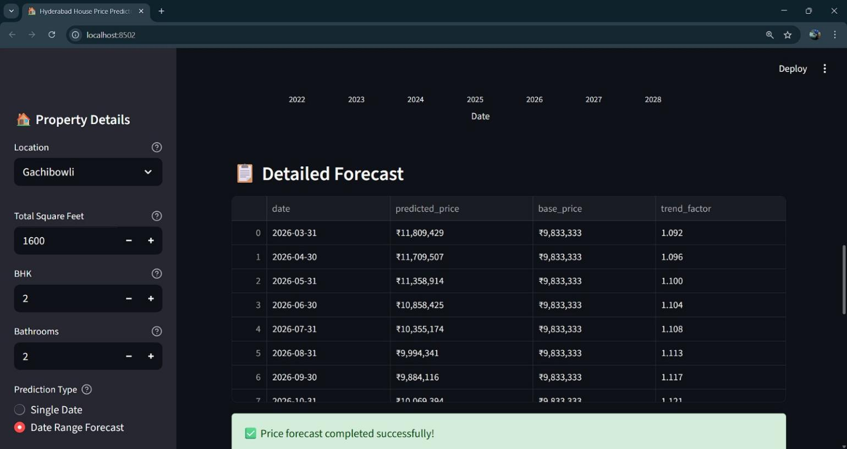

Figure 4
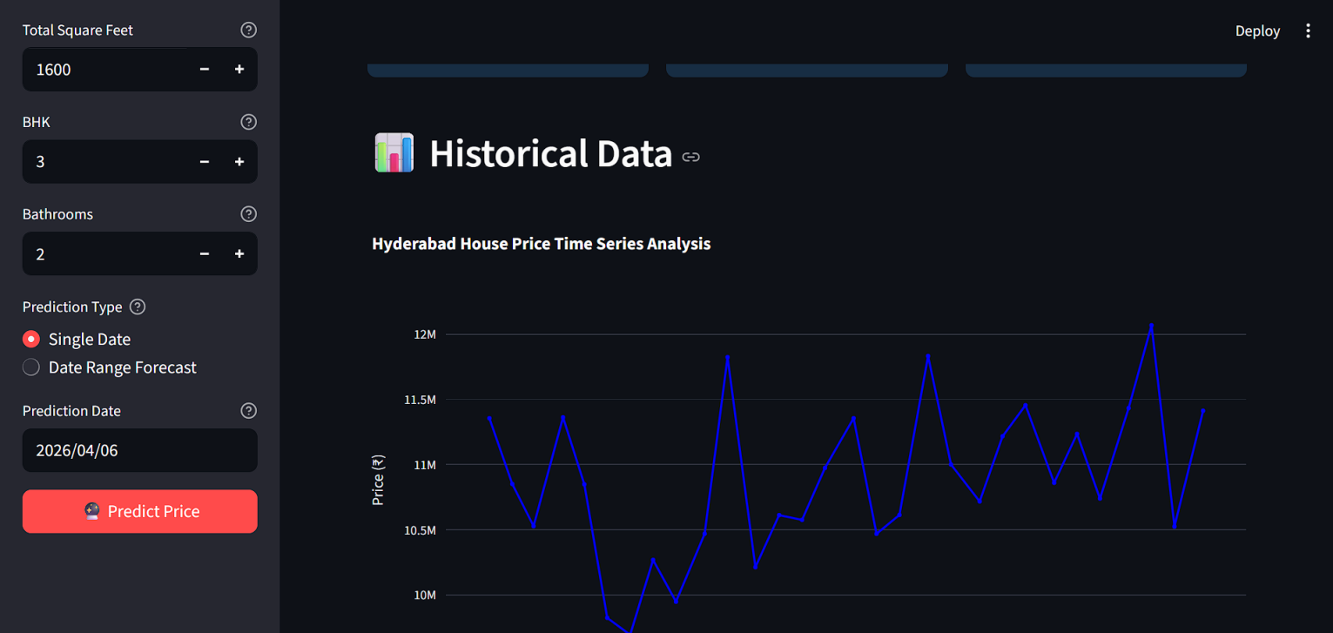

Figure 5
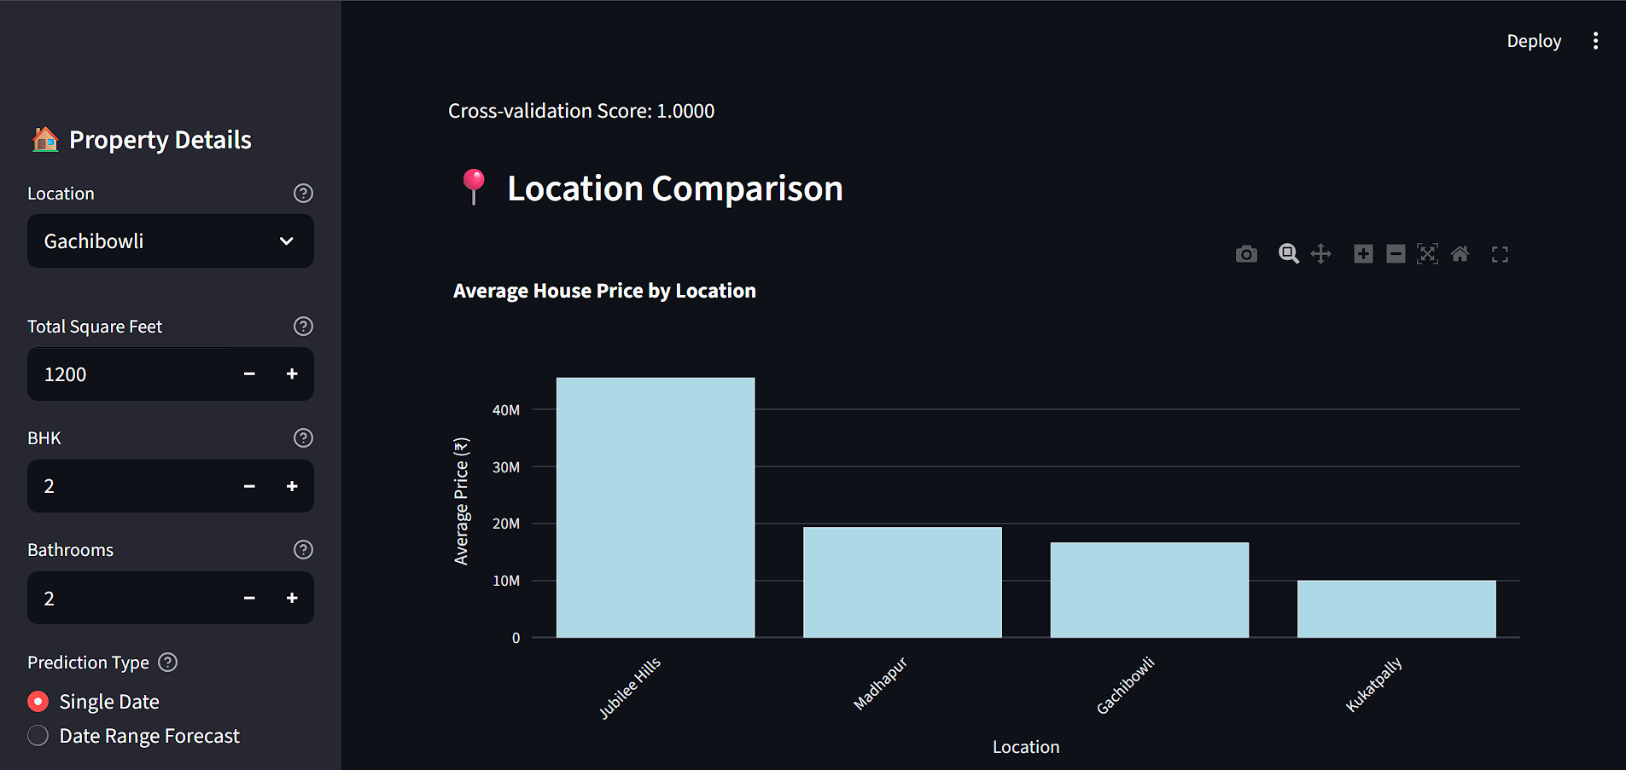
Figure 6

CHAPTER 9 CONCLUSION AND FUTURE SCOPE

Conclusion
The House Price Prediction project provides an effective and intelligent solution to the challenges faced in traditional property price estimation. In the existing system, price prediction depends mainly on manual methods, personal judgment, and broker suggestions, which often lead to biased, inconsistent, and inaccurate results. These limitations create confusion among buyers and sellers and may result in poor financial decisions. Therefore, there is a strong need for a reliable and data-driven approach to estimate house prices.
The proposed system uses Machine Learning techniques such as Linear Regression, Decision Tree, and Random Forest to analyze historical housing data and predict prices accurately. By considering important factors like location, area, number of rooms, and other features, the system is able to generate precise and consistent price estimates. The use of advanced algorithms reduces human errors and removes bias, making the system more reliable than traditional methods.
Another important advantage of this project is its ability to handle large datasets efficiently. The system processes data quickly and provides instant results, saving time and effort for users. The integration of a user-friendly interface using tools like Streamlit makes it easy for anyone to use the system without technical knowledge. Users can simply enter property details and get the predicted price immediately.

Future Scope
The House Price Prediction project has a wide scope for future improvements and enhancements as technology and data availability continue to grow. Although the current system provides accurate predictions using basic machine learning models, it can be further improved by incorporating more advanced techniques and real-time data. These improvements will increase the accuracy, efficiency, and usability of the system in real-world applications.
One of the major future enhancements is the use of advanced algorithms such as Deep Learning, Artificial Neural Networks (ANN), and Gradient Boosting techniques. These models can handle complex patterns and relationships in large datasets, leading to more precise predictions. Hyperparameter tuning and model optimization techniques can also be applied to improve performance.
Another important scope is the integration of real-time data. Currently, the system uses historical data, but in the future, it can include live market trends, economic conditions, interest rates, and government policies. This will help in predicting not only current prices but also future price trends, which is very useful for investors and planners.

CHAPTER 10
REFERENCES

Websites
https://www.tutorialspoint.com/
https://docs.streamlit.io
https://pandas.pydata.org/docs/
https://learn.microsoft.com/en-us/visualstudio
https://scikit-learn.org/stable/index.html

Books
P Russell, S., & Norvig, P. (2020). Artificial Intelligence: A Modern Approach (4th Edition). Pearson Education.
Goodfellow, I., Bengio, Y., & Courville, A. (2016). Deep Learning. MIT Press.
Jurafsky y, D., & Martin, J. H. (2023). Speech and Language Processing (3rd Edition Draft). Prentice Hall.
Bishop, C. M. (2006). Pattern Recognition and Machine Learning. Springer.
Aggarwal, C. C. (2018). Neural Networks and Deep Learning: A Textbook. Springer.

RESEARCH PAPERS

Research Papers

Journal of Artificial Intelligence & Cloud Computing

-Fatbardha Maloku*, Besnik Maloku and Akansha Agarwal Dinesh Kumar Master of Science in Business Analytics Student Candidates, Ageno School of Business, Golden Gate University, San Francisco, California 94105, USA

House Price Prediction System using Machine Learning

-Vishakha Biradar, 2Shrejal Chopade, 3 Punam Dahikamble, 4 Sakshi Hole, 5 Dr. Khushbu R. Khandaid Department of Computer Engineering, 4 Department of Computer Engineering & Zeal College of Engineering and Research, Pune, India

