NAME : VISHWA.R

Reg.no :192124161

Subject : SOFTWARE ENGINEERING

Subject code : CSA 1002

Experiment-1

Aim: USE-CASE diagram for Online Voting System using CASE tools.

OUTPUT:

USE CASE DIAGRAM FOR ONLINE VOTING SYSTEM

VISHWA

192124161

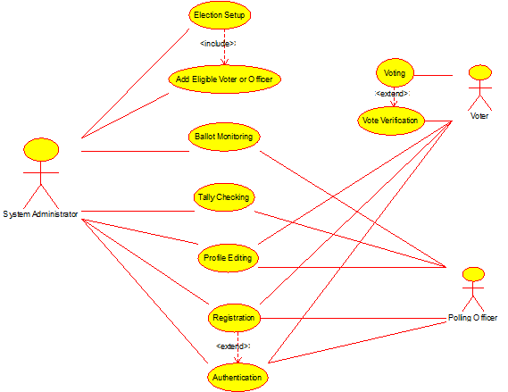

RESULT: Thus use case diagram for online voting system is implemented successfully.

EXPERIMENT-2

AIM: USE-CASE diagram for Library Management System using CASE tools.

Output:

USE CASE DIAGRAM FOR LIBRARY MANAGEMENT SYSTEM

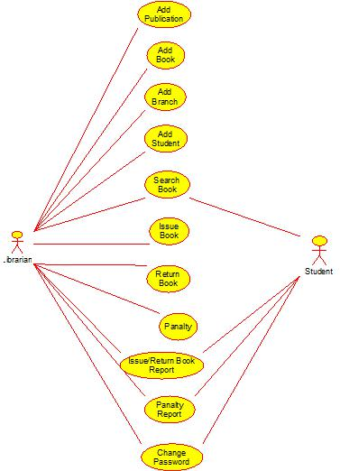

RESULT: Thus use case diagram for Library management system is implemented successfully.

EXPERIMENT-4

AIM: USE-CASE diagram for Online Shopping system using CASE tools.

OUTPUT:

USE CASE DIAGRAM FOR ONLINE SHOPPING SYSTEM

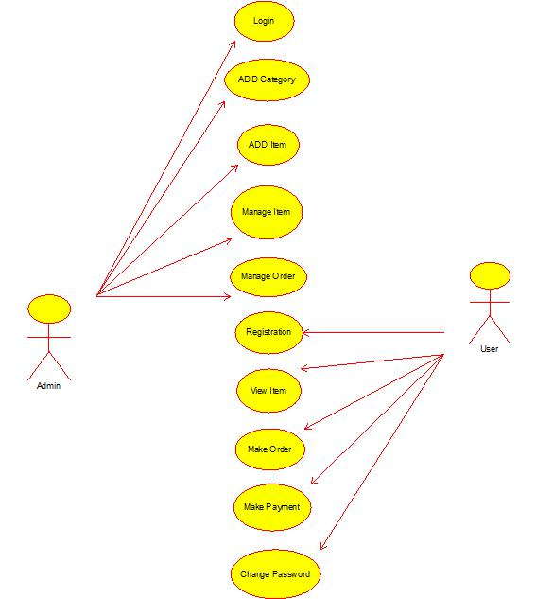

RESULT: Thus use case diagram for online shopping system is implemented successfully.

EXPERIMENT-5

AIM: USE-CASE diagram for Online Railway Reservation System using CASE tools.

Output:

USE CASE DIAGRAM FOR ONLINE RAILWAY RESERVATION SYSTEM

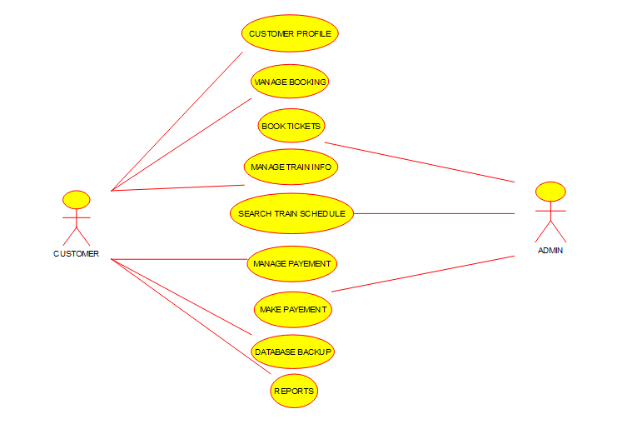

RESULT: Thus use case diagram for online Railway reservation system is implemented successfully.

Experiment-6

AIM: USE-CASE diagram for Hospital Management System using CASE tools.

OUTPUT:

USE CASE DIAGRAM FOR HOSPITAL MANAGEMENT SYSTEM

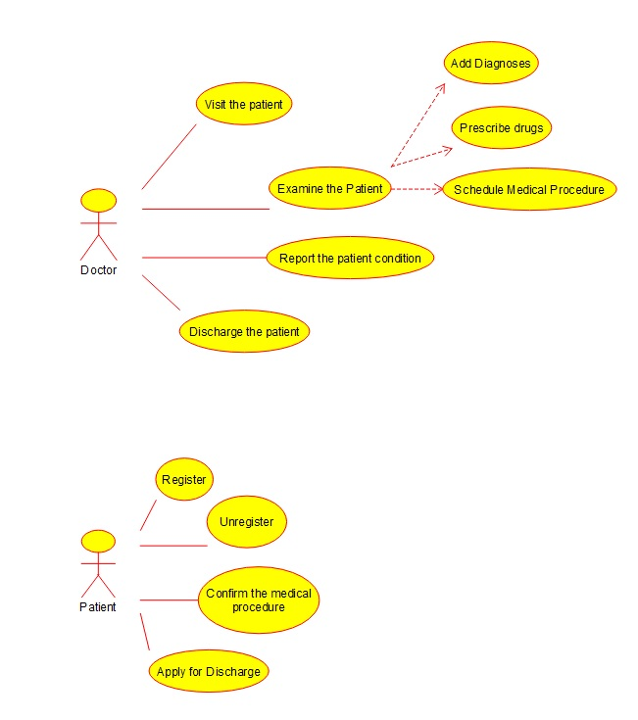

RESULT: Thus use case diagram for Hospital management system is implemented successfully.

EXPERIMENT-7

AIM: USE-CASE diagram for ATM system using CASE tools.

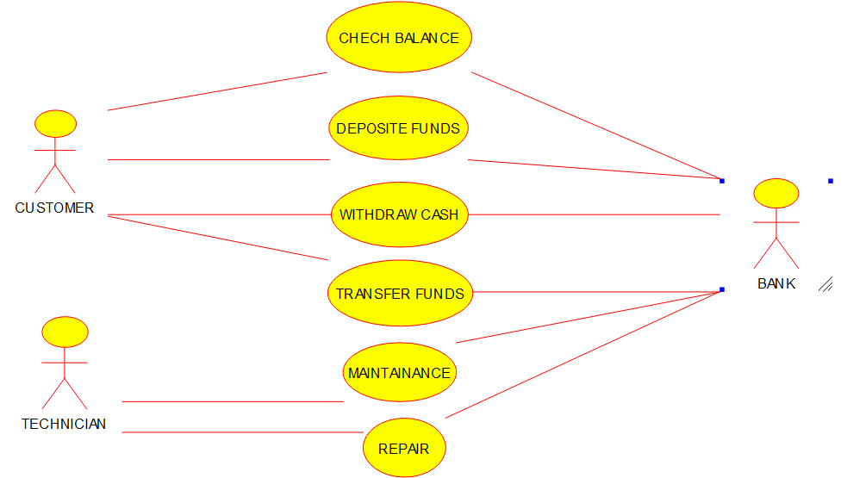

RESULT: Thus use case diagram for ATM system is implemented successfully.

EXPERIMENT-8

AIM: USE-CASE diagram for Online college management system using CASE tools.

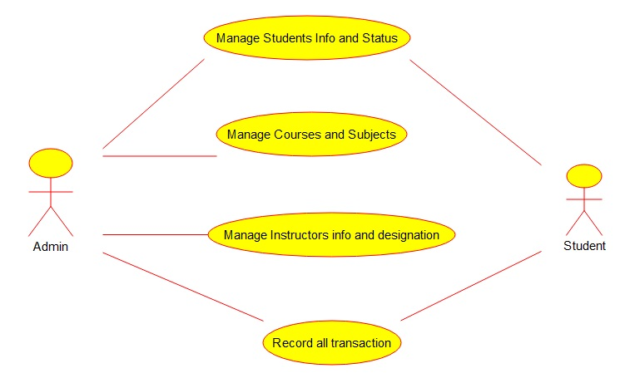

RESULT: Thus use case diagram for Online college management system is implemented successfully.

Experiment-9

AIM: USE-CASE diagram for Online Airline Reservation system using CASE tools.

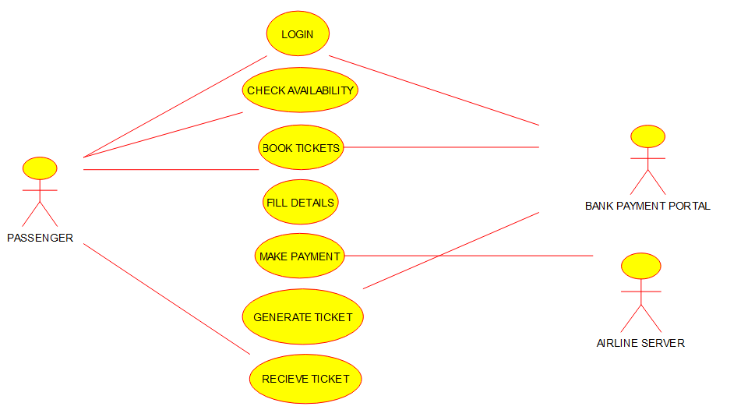

RESULT: Thus use case diagram for Online Airline reservation system is implemented successfully.

Experiment-10

AIM: Class diagram for online Airline Reservation system using CASE tools.

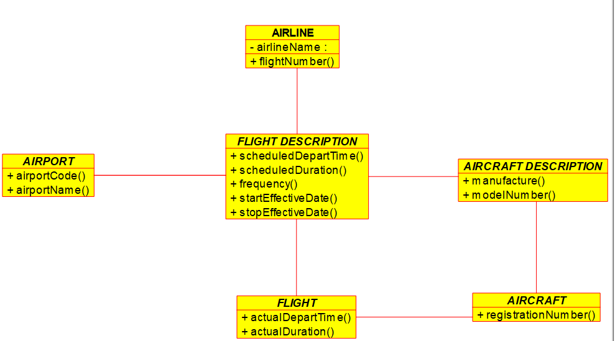

RESULT: Thus, class diagram for Online Airline reservation system is implemented successfully.

Experiment-11

AIM: Class diagram for Online Voting System using CASE tools.

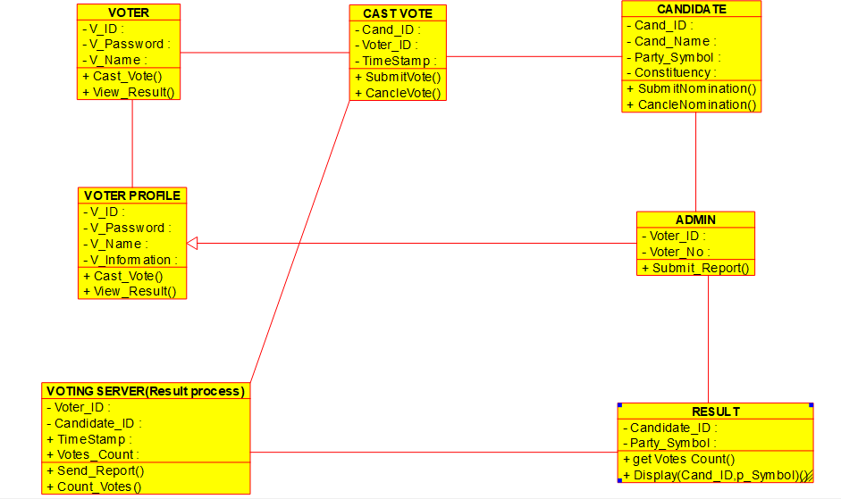

RESULT: Thus, class diagram for Online voting system is implemented successfully.