**A**

**Project Report**

**on**

**Look N Log**

**Developed By**

***Vishwa Alpeshbhai Thakkar [2305102120017]***

**developed at**

**CodTech - Hyderabad**

**as**

**Partial Fulfillment of IVth Semester of**

**Master of Computer Applications**

**for A.Y. 2024 - 2025**

**Under The Guidance of**

**Prof. Sweta Jethava**

**Submitted To**

**Department of MCA**

**Faculty of IT & Computer Science**

**PARUL University**





**CERTIFICATE**

This is to certify that **Ms. Vishwa Alpeshbhai Thakkar, Enrollment No. 2305102120017** student of Master of Computer Applications has satisfactorily completed the Major Project on **“Look N Log”** at **CodTech** as fulfillment of MCA Semester IV.

Seat No. _______________ Date of Submission: ____________

Sweta Jethava _______________ _______________

Internal Guide Project Coordinator Director - MCA

**Department of MCA**

**Faculty of IT & Computer Science**

**PARUL University, Vadodara**

**INDEX**

|  |  |  |
| --- | --- | --- |
| **No.** | **Description** | **Page No.** |
| **1.** | **About Department of MCA** |  |
| **2.** | **Company Profile** |  |
| **3.** | **Project Profile**  3.1 Project Definition  3.2 Project Description  3.3 Existing System / Work Environment  3.4 Problem Statements  3.5 Need for New System  3.6 Proposed System & Features  3.7 Scope  3.8 Outcomes  3.9 Tools & Technology used  3.10 Project Plan |  |
| **4.** | **Requirement Analysis**  4.1 Feasibility Study  4.2 Users of the System  4.3 Modules  4.4 Process Model  4.5 Hardware & Software Requirements  4.6 Use Cases  4.7 Use Case Diagram |  |
| **5.** | **Design**  5.1 Use Case Scenarios  5.2 Diagrams  5.2.1 UML / DFD  5.2.2 Entity Relationship Diagram  5.3 Data Dictionary |  |
| **6.** | **Implementation**  6.1 Form Layouts  6.2 Report Layouts  6.3 Coding Convention |  |
| **7.** | **Testing**  7.1 Test Strategy  7.2 Test Cases |  |
| **8.** | **Future Enhancement** |  |
| **9.** | **Bibliography** |  |

**About Department of MCA**

**PARUL University**

Parul University is a legitimate university established under Gujarat Private University Act 2009, after legislation passed by the Government of Gujarat on 26th March 2015 giving University status to Parul Group of Institutes functioning under the aegis of Parul Arogya Seva Mandal Trust.

**Faculty of IT & Computer Science**

Faculty of IT and Computer Science, Parul University has materialized as one of the prime IT education providers at global level. Various departments under Faculty of IT and Computer Science strive in preparing IT-industry ready professionals by means of various skill development courses, vocational courses, co-curricular & extra-curricular activities, industry visits and expert lectures.

**MCA Department**

The Department of Master of Computer Application at Parul University emphasizes on building professionals in the domain of computer applications by providing necessary environment by means of facilitating suitable blend of technical and non-technical learning experience. The department cultivates students in various curricular, co-curricular and extra-curricular activities in order to produce future system analysts, system designers, system programmers, application programmers, testing professionals, system managers, project managers, researchers and other leading positions in systems/IT department.

The department offers various subjects from diversified technical/non-technical areas such as – core IT domain, management, communication skills, mathematics & logic building and rich pool of elective subjects.

The department of MCA focuses on project-based learning, and hence students are motivated to work on tiny hands-on projects in practical oriented subjects to get better exposure. Moreover, throughout their MCA studies, students are required to work on around 3 mini/major projects in individual/team to get enough confidence on software-development and thereby become industry-ready.

**Company Profile**

**Empowering Businesses through Innovative IT Services and Consulting**

At CodTech IT Solutions, our mission is to empower businesses with innovative IT services and consulting. We deliver customized, reliable, and cost-effective technology solutions to help clients achieve their goals. Our commitment to excellence builds lasting partnerships and drives success in a digital landscape.

**Shaping the Future of Technology**

Our vision at CodTech IT Solutions is to be a global leader in IT services and consulting. We aim to shape the future of technology with innovation, quality, and a customer-centric approach. Through continuous learning and collaboration, we inspire and lead our clients towards a connected and sustainable future.

**Our Winning Approach**

We focus on understanding clients' unique needs, delivering innovative and tailored IT solutions. Through strong partnerships and a commitment to quality, we ensure reliable, high-performance results. Continuously improving, we stay ahead of industry trends to drive client success.

## 3. Project Profile

**3.1 Project Definition:**

* Project Title: "Face Recognition Attendance System"
* Project Name: "Look N Log"

**3.2 Project Description:**

The Face Recognition Attendance System represents a breakthrough in automating the attendance process, catering to environments such as workplaces, educational institutions, public events, and more. Unlike traditional attendance methods, this system utilizes **cutting-edge facial recognition technology to streamline and secure attendance tracking**. A high-definition camera captures each individual's unique facial features, which are then matched against a pre-registered database for swift and accurate identification. By doing so, it eliminates the errors and inefficiencies of manual systems and introduces a contactless, hygienic alternative to physical biometrics.

One of the standout features of this system is its **adaptability to dynamic environments**. It can recognize faces under varying lighting conditions, angles, and even partial occlusions, ensuring high reliability. The integration of real-time processing and robust algorithms further guarantees that attendance is marked almost instantaneously, enhancing user experience and operational efficiency. The system’s secure design also safeguards user data, addressing concerns about privacy and unauthorized access.

The Face Recognition Attendance System is especially relevant in **addressing the hygiene concerns** associated with biometric systems requiring physical touch, such as fingerprint scanners. Its contactless approach ensures user safety and mitigates health risks, making it a preferred choice during pandemics or in environments with stringent hygiene requirements. Additionally, the system’s ability to detect and prevent proxy attendance through unique facial verification significantly boosts its reliability over conventional methods.

Designed to be both scalable and user-friendly, the system accommodates organizations of all sizes, from small teams to large enterprises. Its integration capabilities enable seamless connectivity with existing HR management or student information systems, providing a holistic solution for attendance management. Whether it’s **monitoring employee punctuality in a corporate setting or ensuring accurate record-keeping** in educational institutions, this system sets a new standard for efficient, secure, and modern attendance practices.

**3.3 Existing System / Work Environment:**

Currently, attendance systems in many organizations or educational institutions are managed using either paper-based methods, RFID cards, or biometric scanners like fingerprint recognition. While these methods have been effective to some extent, they come with challenges such as:

* **Paper-based systems:** Prone to human error, delayed updates, and falsification.
* **RFID-based systems:** Requires students or employees to carry a physical card, which can be misplaced or shared.
* **Biometric systems:** While more accurate, fingerprint scanners may not work well for everyone and can be affected by hygiene or skin conditions.

The existing systems also suffer from inefficiencies in tracking, managing large databases, and often have a manual process for resolving discrepancies in attendance records. The proposed Face Recognition Attendance System addresses these shortcomings by offering a contactless, highly efficient, and fraud-resistant alternative. Unlike paper-based systems, it eliminates manual intervention, and compared to biometric systems, it provides a hygienic and durable solution that can adapt to dynamic environments. This modern approach ensures scalability, making it suitable for organizations of all sizes, while significantly enhancing reliability and user convenience.

**3.4 Problem Statements:**

* **Inaccuracy: Traditional attendance systems, such as paper logs or card-based systems, are prone to human error and fraud (e.g., buddy punching in biometric systems).**
* **Inconvenience: Physical attendance systems require employees or students to manually sign in or scan cards, which is time-consuming and error-prone.**
* **Security Issues: Paper and card-based systems are vulnerable to being misplaced or manipulated, leading to inaccurate attendance records.**
* **Lack of Automation: Existing systems often require manual intervention for correction, tracking, and reporting attendance data, leading to inefficiency.**

**3.5 Need for New System:**

The need for a Face Recognition Attendance System arises due to the following:

**Efficiency:** Reduces the time spent on marking attendance manually.

**Accuracy:** The system eliminates human errors and false attendance.

**Security:** Face recognition provides a higher level of security and is less prone to fraud or errors.

**Convenience:** It’s contactless, which reduces the need for handling materials or devices.

**Scalability:** The system can handle a large number of users without significant performance drops.

**3.6 Proposed System & Features:**

The proposed system will be based on advanced machine learning and computer vision technologies to automatically detect and recognize individuals based on their facial features. The following features will be included:

* **Real-time Facial Recognition:** The system will capture faces in real time and match them against a pre-registered database.
* **Attendance Marking:** Once a face is recognized, the system will automatically log the attendance.
* **Database Integration:** A centralized database will maintain records of all attendees, including time stamps of when they were marked present.
* **Reporting & Analytics:** The system will generate daily, weekly, or monthly reports, showing attendance patterns and any irregularities.
* **User Management:** Administrators will be able to add, update, or delete user data in the system.
* **Notification Alerts:** Users will receive notifications when their attendance is marked, or if there are discrepancies in the system.
* **Scalability:** The system will be designed to work for a small classroom or scale to large organizations.
* **Security:** Data will be encrypted and stored securely to ensure privacy and prevent unauthorized access.

**3.7 Scope:**

The scope of this project includes:

* **Attendance** **marking** in educational institutions, workplaces, or any other organization.
* **Integration with existing systems:** The system can be integrated with school or office management software to sync attendance data.
* **Multi-user support:** The system can manage attendance for a large number of users with minimal delays.
* **Data analytics and reporting:** Providing attendance reports based on daily, weekly, or monthly data.

This system will not involve features such as real-time surveillance or facial recognition across a wide area, as it is limited to the attendance function.

**3.8 Outcomes:**

The expected outcomes of implementing this system include:

* **Reduced Time and Effort:** Automated attendance eliminates the need for manual attendance taking.
* **Accurate and Reliable Data:** Face recognition ensures the accuracy of attendance records and minimizes errors.
* **Improved Security:** Only authorized individuals can mark their attendance, thus preventing fraud.
* **Better Insights:** The system provides analytical insights into attendance patterns and behaviours.
* **Cost-Effective:** Long-term savings by reducing the cost of paper, cards, and other manual tracking methods.

## 3.9 Tools & Technology Used:

## Programming Languages: Python, C++

## Libraries/Frameworks:

## OpenCV (for computer vision and image processing)

## dlib (for facial recognition)

## TensorFlow or Keras (for machine learning models, if needed)

## Database: MySQL or PostgreSQL and excel for storing attendance records and user data.

## Hardware:

## Camera or Webcam for capturing facial data.

## Computer/server to run the software and store the data.

## 3.10 Project Plan:

## Phase 1: Planning and Requirement Analysis

* Research existing systems and define system requirements.
* Identify project scope and stakeholders.

## Phase 2: Design

* Develop system architecture and data flow diagrams.
* Design UI/UX for the web and mobile applications.

## Phase 3: Development

* Implement facial recognition algorithms and backend services.
* Integrate the frontend with backend systems.

## Phase 4: Testing

* Conduct unit, integration, and user acceptance testing.
* Address bugs and optimize performance.

## Phase 5: Deployment and Training

* Deploy the system in a real-world environment.
* Train users and administrators on system operation.

## Phase 6: Maintenance and Support

* Monitor system performance and address any issues.
* Provide regular updates and feature enhancements.

## 4. Requirement Analysis

## A Face Recognition Attendance System automates the process of marking attendance using biometric technology, specifically facial recognition. This system aims to replace traditional methods, such as manual attendance marking or using RFID cards, by utilizing advanced machine learning algorithms to detect and authenticate students or employees based on their facial features.

**4.1 Feasibility Study:**

A feasibility study is essential to evaluate whether the project is viable in terms of technical, operational, and economic aspects. For a Face Recognition Attendance System, the feasibility study must assess:

**4.1.1 Technical Feasibility:**

**Face Recognition Algorithms:** There are various techniques such as Eigenfaces, Fisherfaces, and Convolutional Neural Networks (CNNs) for accurate recognition. The study will need to evaluate which algorithm best fits the required accuracy and speed.

**Integration with Existing Systems:** The system must work with databases and the educational institutions or company’s existing infrastructure, like Employee or Student Management Systems.

**Hardware Requirements:** The system will require high-quality cameras, servers for image processing, and possibly GPUs for faster computation.

**4.1.2 Operational Feasibility:**

**Ease of Use:** The system must be user-friendly for both administrators and users. It should require minimal effort to enrol faces and mark attendance.

**Privacy Concerns:** The system needs to ensure user data protection, following the best practices of data encryption and GDPR or relevant laws.

**4.1.3 Economic Feasibility:**

**Cost of Implementation:** The cost of setting up cameras, the software system, and servers for hosting the application will be evaluated. A Return on Investment (ROI) analysis will be done to determine if the system will save more time and money in the long term compared to traditional systems.

**4.2 Users of the System:**

The primary users of the Face Recognition Attendance System can be categorized into:

**Students/Employees:**

* They will interact with the system during attendance marking. Their facial data is captured and matched with the database to authenticate their identity.
* They can check their attendance status via a user-friendly interface.

**Administrators:**

* Administrators will manage the system by adding or removing users, monitoring attendance reports, and configuring system settings.
* They may also handle data storage and security measures.

**System:**

* The system itself works autonomously to process images, recognize faces, match them with existing data, and record attendance in real time.

**4.3 Modules:**

A face recognition attendance system typically consists of the following modules:

* **Face Enrolment Module:**

This module allows users to register their facial data in the system. It captures images or videos from the user’s face and stores them in a database for future recognition.

* **Face Recognition Module:**

The face recognition algorithm is responsible for identifying and authenticating users in real time. It uses facial features to match the user's image with the one stored in the database.

* **Attendance Management Module:**

This module records and manages attendance by associating recognized faces with specific times and dates.

* **Database Module:**

This module manages user data, including images, attendance logs, and metadata related to facial recognition results.

* **Reporting Module:**

This generates and displays reports of attendance statistics and patterns for administrators or managers. It can include graphs, summary reports, and individual attendance histories.

**4.4 Process Model:**

**1. Initialization & Enrolment:**

* **Step 1: User Registration:**

Users (students/employees) are enrolled in the system by capturing their face image.

A clear photograph of the face is taken using a camera, and facial features are extracted and stored in a database along with the user's ID.

The system processes and stores unique facial features in a face recognition model.

**2. Attendance Marking:**

* **Step 2: Face Capture:**

When an individual arrives, they approach a camera to have their face captured.

* **Step 3: Face Detection:**

The system detects the face in the captured image using algorithms like Haar Cascade or a deep learning model (e.g., CNN).

* **Step 4: Face Recognition:**

The detected face is compared with the stored face database.

A face recognition algorithm (e.g., Eigenfaces, Fisherfaces, or deep learning models like FaceNet or OpenFace) calculates the similarity between the captured image and the enrolled faces.

* **Step 5: Identity Verification:**

If a match is found above a threshold, the identity of the person is verified.

If no match is found or the match is below the threshold, a re-capture or a failure message is generated.

**3. Attendance Recording:**

* **Step 6: Log Attendance:**

Once verified, the system records the attendance by marking the individual as "present" in the system, associating the ID with the current timestamp.

* **Step 7: Notify User:**

The system provides feedback to the user (e.g., “Attendance marked successfully” or “Face not recognized”).

**4. Data Management:**

* **Step 8: Attendance Report Generation:**

The system generates real-time reports showing who is present, absent, or late, along with timestamps.

**5. Admin Review:**

* **Step 9: Admin Monitoring:**

Admins can review and manage attendance data for users, including resolving any discrepancies or manual intervention if needed.

**6. End of Day Processing:**

* **Step 10: Data Syncing:**

The system updates and syncs attendance data to the central server or cloud for storage and long-term reporting.

This process model outlines the steps involved in capturing facial images, matching them to stored data, and recording attendance in a secure and automated manner.

**4.5 Hardware & Software Requirements at Developers' End:**

**Hardware Requirements:**

* **Camera/Scanner:** High-quality camera(s) or webcam(s) are required for capturing clear facial images. The camera should be capable of capturing images in various lighting conditions.
* Server/Processing Unit: A dedicated server or cloud infrastructure is needed for processing face recognition algorithms. High processing power (with GPUs if necessary) will ensure real-time performance.
* **Storage:** A large-capacity database server to store the images, facial data, and attendance logs.
* **Network Infrastructure:** Adequate networking equipment to support communication between various system components (e.g., between client devices and servers).

**Software Requirements:**

* **Face Recognition Library:** Software libraries like OpenCV, Dlib, or TensorFlow can be used for implementing facial recognition algorithms.
* **Database Software:** A relational database system like MySQL or PostgreSQL to store user data and attendance logs.
* **Operating System:** The system can run on Windows, Linux, or cloud-based solutions depending on the chosen hardware.
* **Front-End and Back-End Development Tools:** Programming languages like Python, JavaScript, or Java for front-end and back-end development.

**4.6 Use Cases:**

Use cases define the interactions between the system and the users. In a Face Recognition Attendance System, key use cases include:

* **User Enrolment:**

Actors: Admin, User

Description: Users provide their facial data, which is captured and stored by the system.

* **Face Recognition:**

Actors: User

Description: During attendance, the user’s face is captured, processed, and compared with stored data to authenticate their identity.

* **Attendance Marking:**

Actors: Admin, User

Description: Attendance is marked when a successful match is made. The system updates the attendance log accordingly.

* **Generate Attendance Reports:**

Actors: Admin

Description: Admin generates reports for viewing and analysing attendance data.

* **Login/Logout:**

Actors: Admin, User

Description: Users log in to the system to check attendance or administrators to manage user details.

**4.7 Use Case Diagram:**

A use case diagram visualizes the interactions between users and the system. In the case of the Face Recognition Attendance System, the diagram will include actors such as "Admin" and "User," with use cases like "Enroll Face," "Capture Face for Recognition," "Mark Attendance," and "Generate Report" linked to the relevant actors.

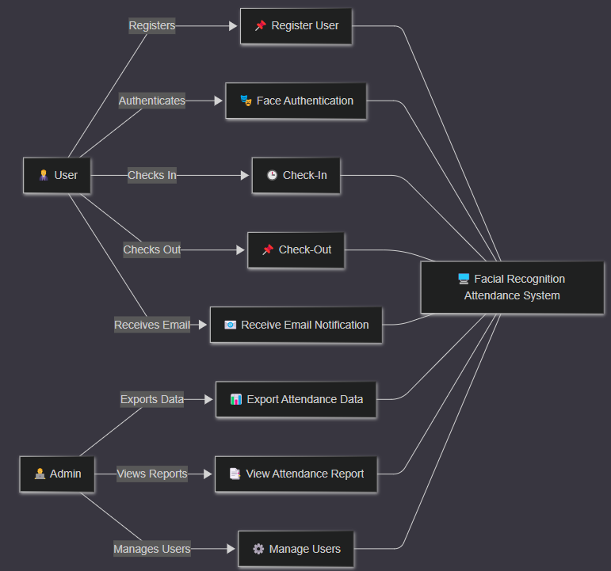

## 5. Design

**5.1 Use Case Scenarios:**

**User Registration:**

* A new user approaches the camera.
* The system captures multiple facial images.
* The user enters their personal information (name, email, etc.).
* The system stores the facial data and information in the database.
* An email is sent to the user confirming registration.

**Check-in:**

* A registered user approaches the camera.
* The system captures a facial image.
* The system compares the image with registered user data.
* If a match is found, the system records the check-in time.
* An email is sent to the user confirming check-in.

**Check-out:**

* A registered user approaches the camera.
* The system captures a facial image.
* The system compares the image with registered user data.
* If a match is found, the system records the check-out time.
* An email is sent to the user confirming check-out.

**Admin Reports:**

* An admin can generate attendance reports.
* An admin can view the registered users.

**5.2 Diagrams:**

**5.2.1 UML / DFD:**

**UML Diagram:**

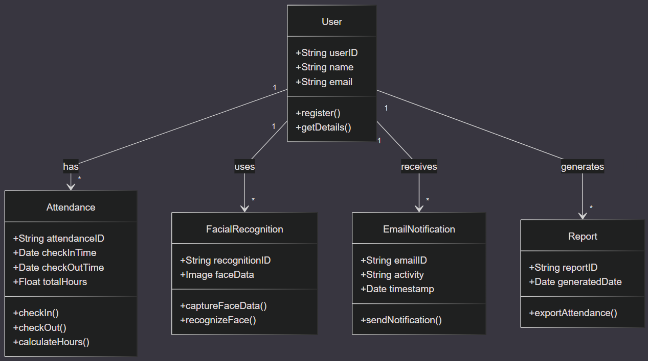

**Data Flow Diagram (DFD) Level I:**

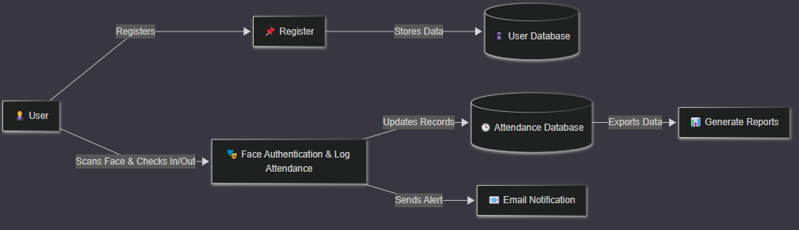

**Data Flow Diagram (DFD) Level II:**

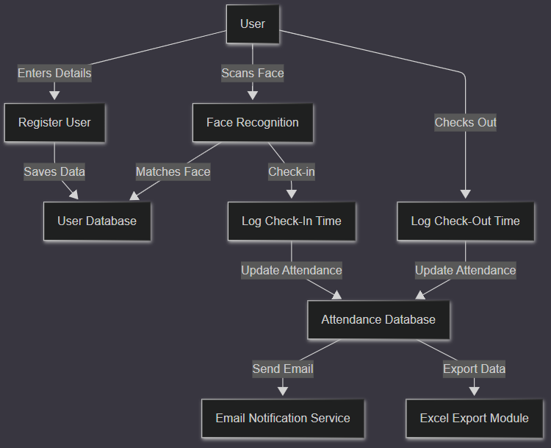

**5.2.2 Entity Relationship Diagram (ERD):**

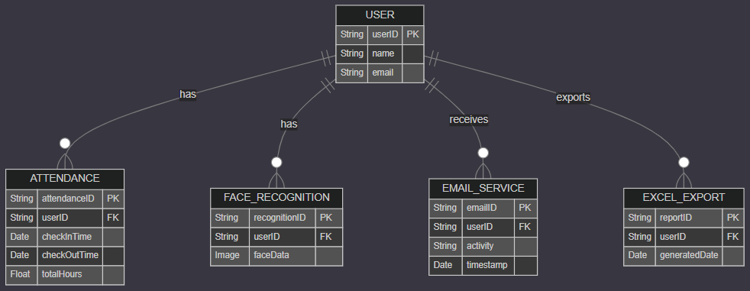

**5.2.3 Activity Diagram:**

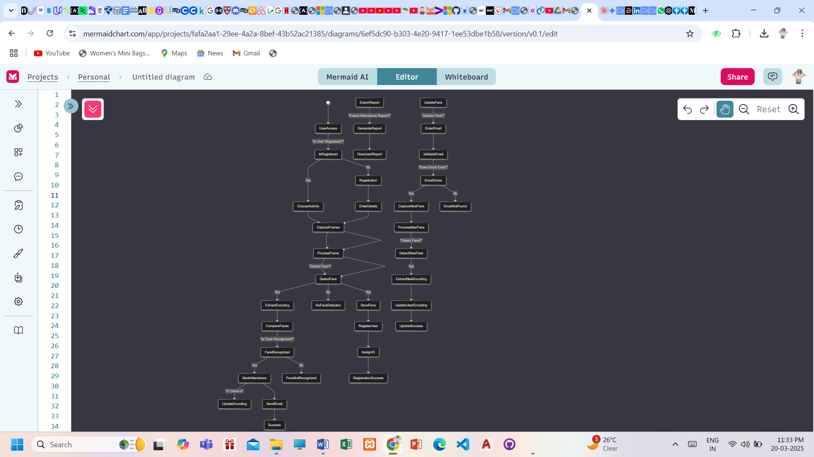

**5.3 Data Dictionary:**

`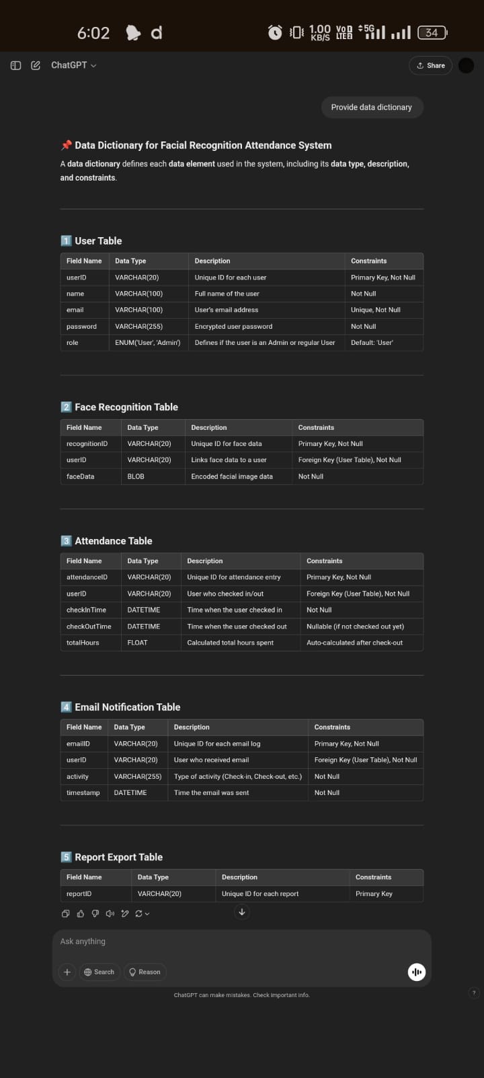

## 6. Implementation

**6.1 Form Layouts:**

* User Registration Form:
* Fields: Name, Email, Capture Facial Image button.
* Live camera feed display and capture button.
* Preview of captured images.
* Admin Report Form:
* Date range selection.
* Generate report button.
* Display report in table/graph format.

**6.2 Report Layouts:**

* Attendance Report:
* User Name, Check-in Time, Check-out Time, Total Hours.
* Date range filter.
* Export to CSV/Excel.
* Excel Report:
* Timestamp, Date, User Name, Activity.
* Automatically generated and updated.

**6.3 Coding Convention:**

* Descriptive variable names.
* Code comments.
* PEP 8 style guidelines.
* Error handling and logging.
* Modular Code design.
* Use of openpyxl library to generate and modify excel files.

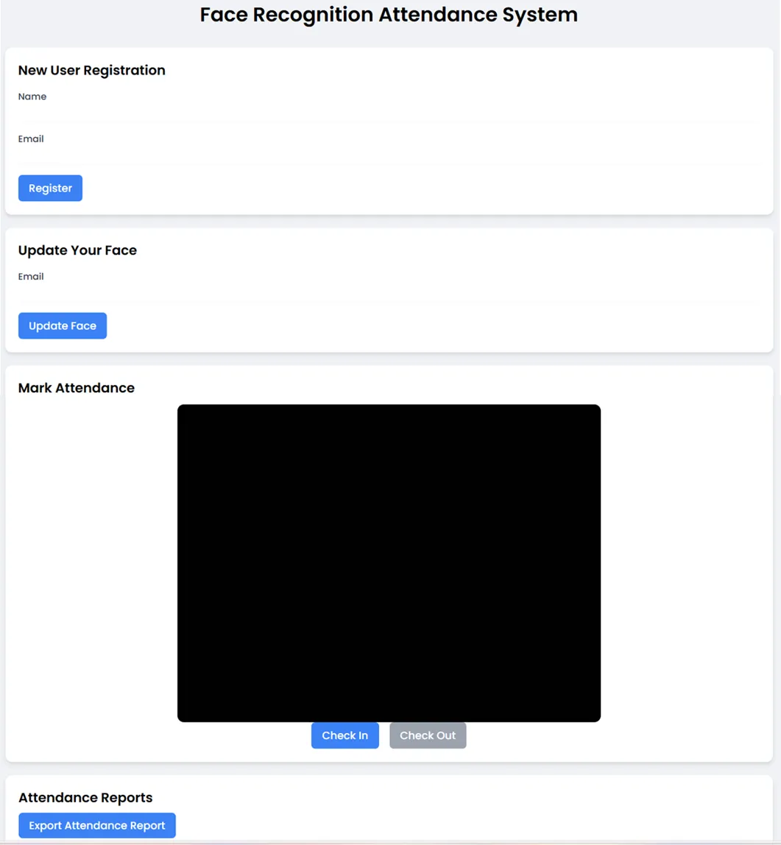

## 7. Testing

**7.1 Test Strategy:**

* Unit testing.
* Integration testing.
* System testing.
* User Acceptance Testing (UAT).
* Testing of excel report generation and accuracy.
* Testing of email sending functionality.

**7.2 Test Cases:**

* **User Registration:**
* Verify successful registration with valid data.
* Verify error handling for invalid data.
* Verify facial data storage.
* Verify email confirmation.
* **Check-in/Check-out:**
* Verify successful check-in/check-out for registered users.
* Verify error handling for unregistered users.
* Verify accurate time recording.
* Verify email notification.
* Verify excel sheet update.
* **Report Generation:**
* Verify accurate report generation for different date ranges.
* Verify data integrity.
* Verify excel report creation and data accuracy.

## 8. Future Enhancements

* **Behavioral Attendance Analysis:** Track subtle cues (gait, posture) alongside facial recognition to detect potential attendance fraud or disengagement.
* **Context-Aware Attendance:** Integrate environmental data (room occupancy, noise levels) to automatically adjust attendance recording sensitivity.
* **Predictive Attendance Forecasting:** Use machine learning to anticipate attendance patterns, aiding resource allocation and scheduling.
* **Biometric Fusion for Enhanced Security:** Combine facial recognition with other biometrics (voice, iris) for multi-layered authentication and spoofing prevention.
* **Distributed Edge Processing:** Perform facial recognition directly on camera devices, reducing latency and reliance on central servers.
* **Real-time Emotion Detection Integration:** Track user emotions during check-in/out to provide insights into workplace satisfaction.
* **Offline Attendance Synchronization:** Enable attendance recording in areas with limited connectivity, syncing data when online.
* **Haptic Feedback Integration:** Provide subtle tactile feedback to users during successful check-in/out.

## 9. Bibliography

[https://opencv.org/](https://www.google.com/url?sa=E&source=gmail&q=https://opencv.org/)

[https://docs.opencv.org/](https://www.google.com/search?q=https://docs.opencv.org/)

<https://docs.python.org/3/library/smtplib.html>

<https://openpyxl.readthedocs.io/en/stable/>

<https://flask.palletsprojects.com/>

<https://www.djangoproject.com/>

GitHub Repository: [[https://github.com/ageitgey/face](https://www.google.com/search?q=https://github.com/ageitgey/face)_recognition](<https://github.com/ageitgey/face>_recognition)

**General Facial Recognition Information:**

**NIST (National Institute of Standards and Technology) - Facial Recognition:**

* This is a good source for information on standards, testing, and research in facial recognition: [https://www.nist.gov/programs-offices/laboratory-programs/information-technology-laboratory/biometrics/facial-recognition](https://www.google.com/search?q=https://www.nist.gov/programs-offices/laboratory-programs/information-technology-laboratory/biometrics/facial-recognition)