SCHOOL OF COMPUTER SCIENCE AND ARTIFICIAL INTELLIGENCE |  |  |  |  | DEPARTMENT OF COMPUTER SCIENCE ENGINEERING
Program Name: B. Tech |  |  |  | Assignment Type: Lab |  |  | Academic Year:2025-2026
Course Coordinator Name |  |  |  | Venkataramana Veeramsetty
Instructor(s) Name |  |  |  | Dr. V. Venkataramana (Co-ordinator)  Dr. T. Sampath Kumar  Dr. Pramoda Patro  Dr. Brij Kishor Tiwari  Dr.J.Ravichander  Dr. Mohammand Ali Shaik  Dr. Anirodh Kumar  Mr. S.Naresh Kumar  Dr. RAJESH VELPULA  Mr. Kundhan Kumar  Ms. Ch.Rajitha  Mr. M Prakash  Mr. B.Raju  Intern 1 (Dharma teja)  Intern 2 (Sai Prasad)  Intern 3 (Sowmya)  NS_2 ( Mounika)
Course Code |  |  | 24CS002PC215 | Course Title |  | AI Assisted Coding
Year/Sem |  |  | II/I | Regulation |  | R24
Date and Day  of Assignment |  |  | Week9 - Tuesday | Time(s)
Duration |  |  | 2 Hours | Applicable to  Batches
AssignmentNumber:16.2(Present assignment number)/24(Total number of assignments)
 | Q.No. | Question |  |  |  |  |  | Expected Time  to complete
 | 1 | Creating a Table :  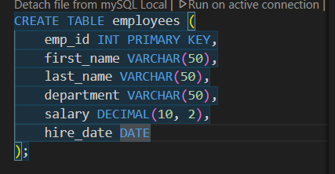  Inserting :  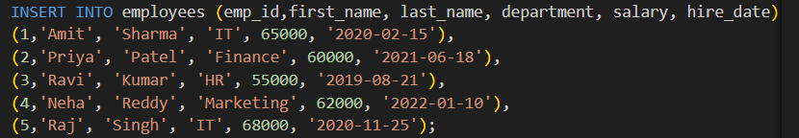  - Display all records from the employee’s table.  Prompt: Display all records from the employee’s table  Querry: 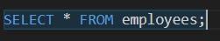  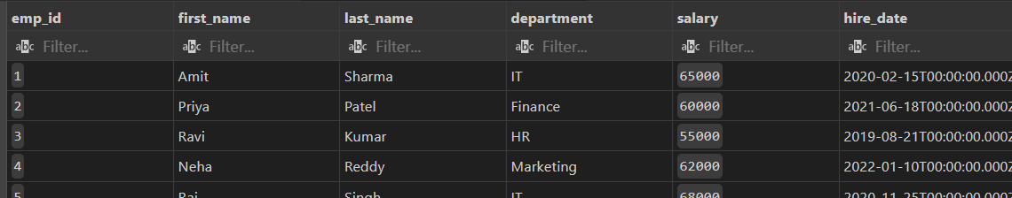  - 2. Display only employee names and their departments.  Prompt: Display only employee names and their departments.  Querry :  Out put :  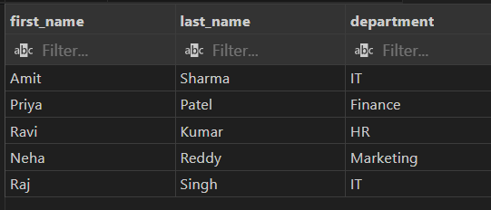  - 3. Show unique department names.  Prompt : . Show unique department names.  Querry :  Out put :  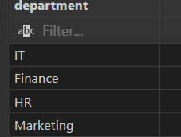  - 4. Find employees with salary greater than 50000.  Prompt : Find employees with salary greater than 50000.  Querry :  Out put :  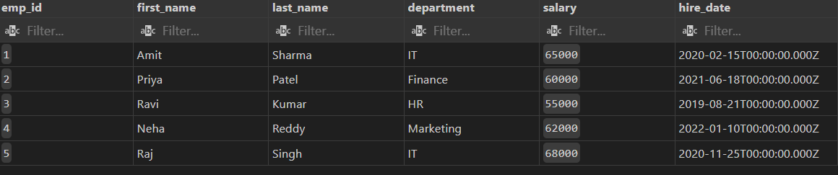  - 5. Find employees from the IT department.  Prompt : Find employees from the IT department.  Querry :  Out Put :  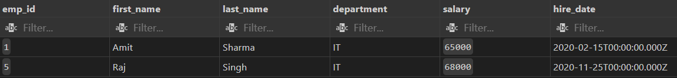6. 6. Display employees hired after 2020.  Prompt : Display employees hired after 2020.  Querry :  Out Put :  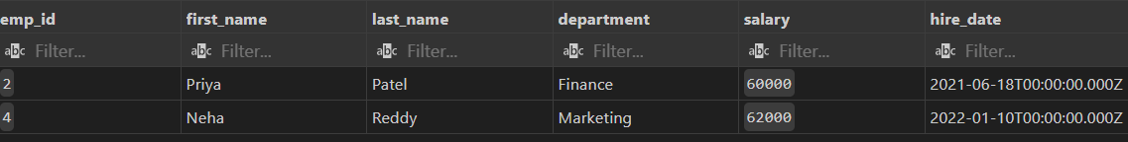  - 7. Show employees in ascending order of salary.  Prompt : Show employees in ascending order of salary.  Querry :  Out Put :  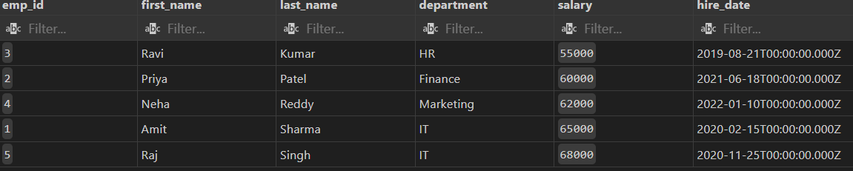  8. 8. Show top 3 highest-paid employees.  Prompt : Show top 3 highest-paid employees.  Querry :  Out Put :  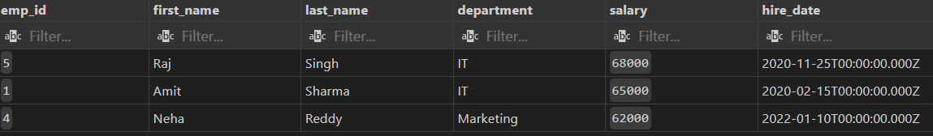  9. 9. Count total employees in the company.  Prompt : Count total employees in the company.  Querry :  SELECT COUNT(*) AS total_employees FROM employees;  Out Put :  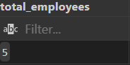  10. 10. Find the average salary of employees.  Prompt : Find the average salary of employees.  Querry :  Out Put :  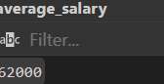  11. 11. Find the highest and lowest salary.  Prompt : Find the highest and lowest salary.  Querry :  Out Put :  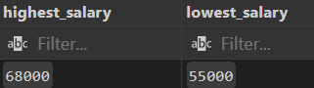  12. 12. Find total salary expenditure per department.  Prompt : . Find total salary expenditure per department.  Querry :  Out Put :  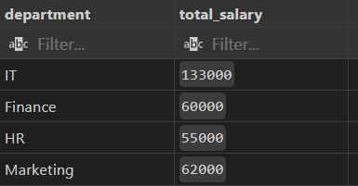  13. 13. Display departments having more than one employee.  Prompt : Display departments having more than one employee.  Querry :  Out Put :  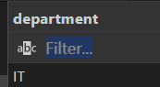  14. 14. Show average salary by department.;  Prompt : Show average salary by department.;  Querry :  Out Put :  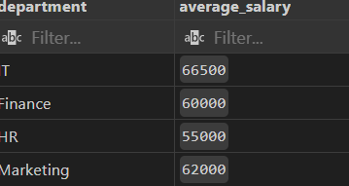  15. 15. Count employees hired each year.  Prompt : Count employees hired each year.  Querry :  Out Put :  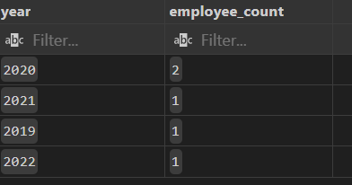  16. 16. List employees with their department locations.  Prompt : . List employees with their department locations.  Querry :  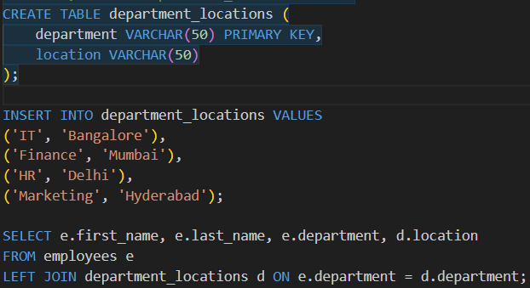  Out Put :  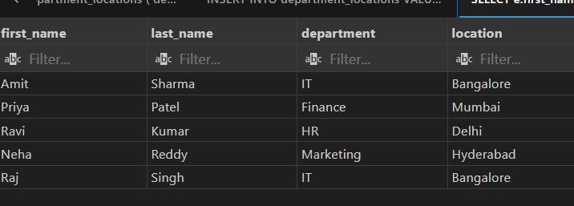  17. 17. Find employees working in Bangalore.  Prompt : Find employees working in Bangalore..  Querry :  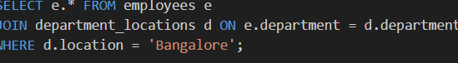  Out Put :  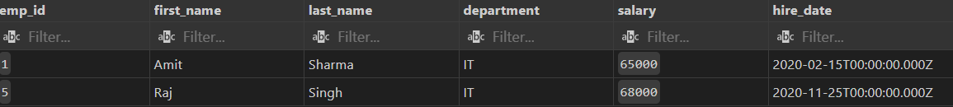  18. 18. Display all employees even if they don’t belong to a department.  Prompt : . Display all employees even if they don’t belong to a department.  Querry :  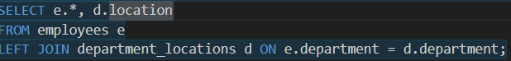  Out Put :  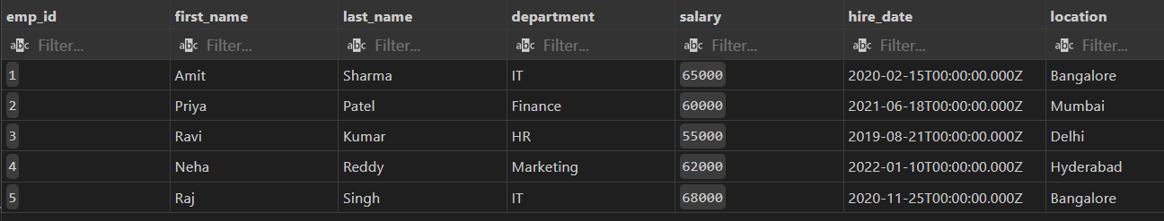  19. 19. Find departments with no employees.  Prompt : Find departments with no employees.  Querry :  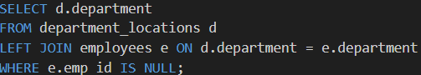  Out Put :  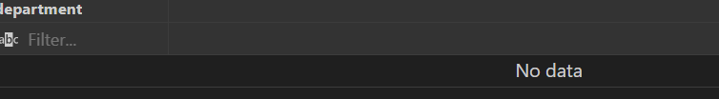  20. 20. Count employees in each department.  Prompt : Count employees in each department.  Querry :  Out Put :  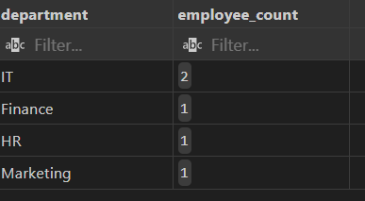  21. 21. Find employees earning above average salary.  Prompt : Find employees earning above average salary  Querry :  Out Put :  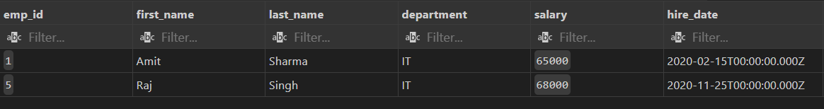  22. 22 . Find the department with the highest average salary.  Prompt : . . Find the department with the highest average salary.  Querry :  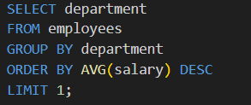  Out Put :  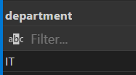  23. 23. Find employees hired most recently.  Prompt Find employees hired most recently.  Querry :  Out Put :  24. 24. Find employees earning the second highest salary.  Prompt : Find employees earning the second highest salary.  Querry :  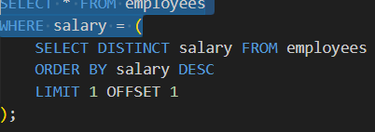  Out Put :  25. 25. Find all employees in the same department as 'Amit Sharma'.  Prompt : Find all employees in the same department as 'Amit Sharma'.  Querry :  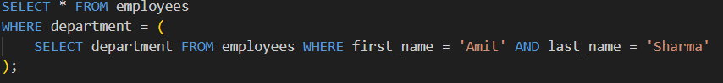  Out Put :  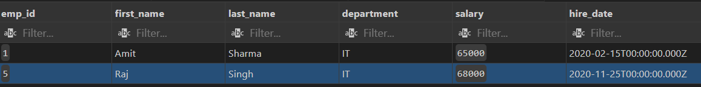  26. 26. Increase salary by 10% for IT employees.  Prompt : Increase salary by 10% for IT employees.  Querry :  Out Put :    27. 27. Change department of employee 'Ravi' to Marketing.  Prompt : Change department of employee 'Ravi' to Marketing.  Querry :  Out Put :    28. 28. Delete employees with salary below 40000.  Prompt : Delete employees with salary below 40000.  Querry :  Out Put :    29. 29. Add a new column 'email' to employees.  Prompt : Add a new column 'email' to employees.  Querry :  Out Put :    30. 30. Update email IDs for all employees.  Prompt : Update email IDs for all employees.  Querry :  Out Put :    31. 31. Find top 2 departments by average salary.  Prompt : Find top 2 departments by average salary  Querry :  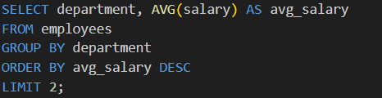  Out Put :  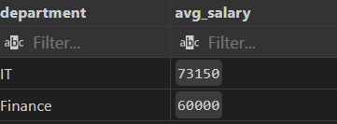  32. 32. Find how many employees work in each city.  Prompt : Find how many employees work in each city  Querry :  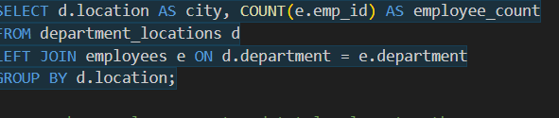  Out Put :  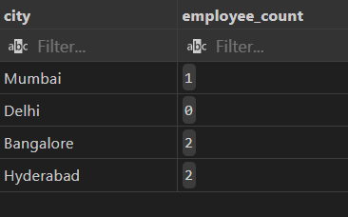  33. 33. Show employee count and total salary together.  Prompt : Show employee count and total salary together.  Querry :  Out Put :  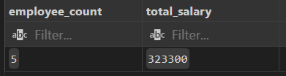  34. 34. Display employees with names starting with 'A'.  Prompt : . Display employees with names starting with 'A'.  Querry :  Out Put :  35. 35. Display employees whose last name ends with 'a'.  Prompt : . Display employees whose last name ends with 'a'.  Querry :  Out Put :  36. 36. Find employees hired in 2020.  Prompt : . Find employees hired in 2020.  Querry :  Out Put :  37. 37. Show number of days since each employee was hired.  Prompt : Show number of days since each employee was hired.  Querry :  Out Put :  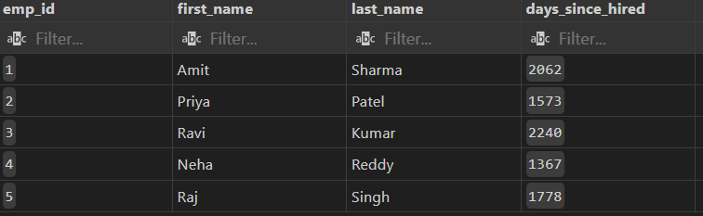  38. 38. Display employee names in uppercase.  Prompt : Display employee names in uppercase.  Querry :  Out Put :  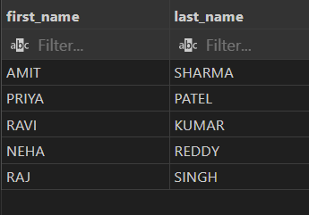  39. 39. Concatenate first and last names.  Prompt : Concatenate first and last names.  Querry :  Out Put :  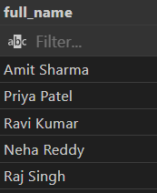  40. 40. Find employees whose salary is between 45000 and 60000.  Prompt : Find employees whose salary is between 45000 and 60000.  Querry :  Out Put :  41. 41. Create a view for high salary employees (>55000).  Prompt : Create a view for high salary employees (>55000).  Querry :  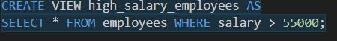  Out Put :  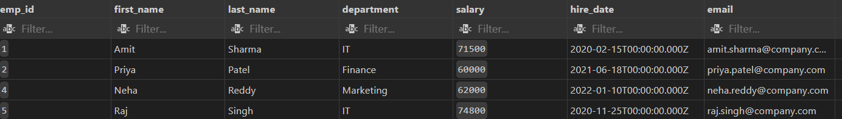  42. 42. Display all records from the view.  Prompt : Display all records from the view.  Querry :  Out Put :  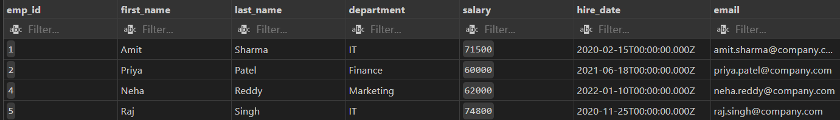  43. 43. Add NOT NULL constraint to department name.  Prompt : Add NOT NULL constraint to department name.  Querry :  Out Put :  44. 44. Drop the view.  Prompt : . Drop the view.  Querry :    Out Put :  45. 45. Rename the employees table to staff.  Prompt : Rename the employees table to staff.  Querry :  Out Put :  46. 46. Create a backup copy of the employees table.  Prompt : Create a backup copy of the employees table.  Querry :  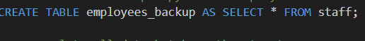  Out Put :  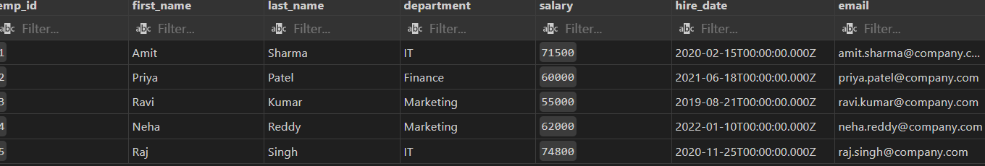  47. 47. Delete all data but keep the structure.  Prompt : Delete all data but keep the structure.  Querry :  Out Put :  48. 48. Drop the employees backup table.  Prompt : Drop the employees backup table.  Querry :    Out Put :  49. 49. Create an index on employee last name.  Prompt : . Create an index on employee last name.  Querry :  Out Put :  50. 50. Drop the index.  Prompt : Drop the index..  Querry :  Out Put : |  |  |  |  |  | Week9 - Monday

Employee Table
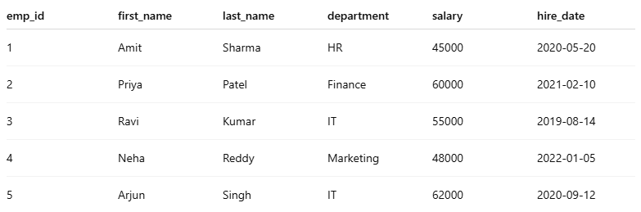

Department Table

