|  |  |
| --- | --- |
|  | SR UNIVERSITY  Campus Warangal |
| Program: II - B.Tech (CS& AI) |
| Professor(a): Dr. Venkataramana Veeramsetty, Professor |
| Department: Computer Science and AI Semester: I |
| AI Assisted Coding - Lab Test 1 - Set C |
| Instructions:   1. Use AI Tools like VScode+Github Copilot and Cursor AI for code generation 2. This Assignment will be evaluated for 15 Marks (10 Marks for Tasks and 5 Marks for viva based on regular lab activities) 3. Students need to submit assignment through canvas before due date 4. Students who are absent for lab will receive 0 Marks | |

1. (2 Marks) Write a Python program to extract all URLs (web links) from a block of text using regular expressions. Use the Cursor AI tool with zero-shot prompting to generate the solution

Prompt: Write a Python program to extract all URLs (web links) from a block of text using regular expressions.

Code:

Output:

1. (2 Marks) Given a list of books with their genres, write a Python function that recommends books based on a user’s preferred genre. Use the Cursor AI tool. Use few shot prompting.

Prompt: **write a Python function that recommends books based on a user’s preferred genre**.

Code :

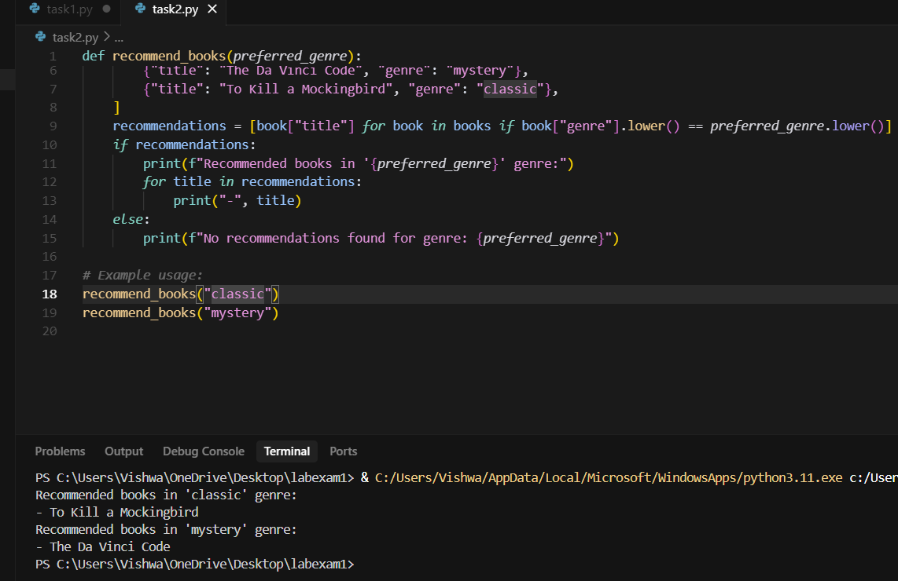

1. (2 Marks) Write a Python program that generates all prime numbers between start and end (both inclusive) entered by the user. Use GitHub Copilot along with VS Code. Use few shot prompting.

Prompt :

Write a Python program that generates all prime numbers between start and end (both inclusive) entered by the user.

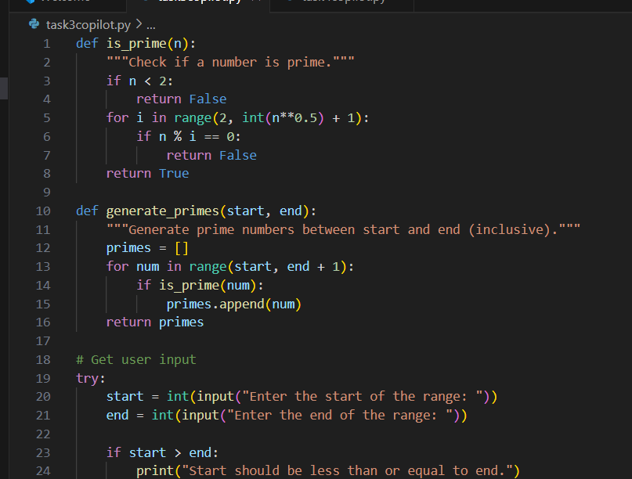

1. (2 Marks) Write Python code that takes a list of student names and generates institutional email IDs in the format: <firstletter><lastname>@sru.edu.in Example: "Anita Sharma"→ asharma@sru.edu.in. Use GitHub Copilot along with VS Code. Use few shot prompting.

Prompt : Write Python code that takes a list of student names and generates institutional email IDs in the format: <firstletter><lastname>@sru.edu.in Example: "Anita Sharma"→ asharma@sru.edu.in.A screen shot of a computer program

p

©Dr. Venkataramana Veeramsetty, Professor Pag. 1 de 1