1.Create a base class called Person with a virtual function work derive two classes Employee and manager from the base class implement the work function for each class

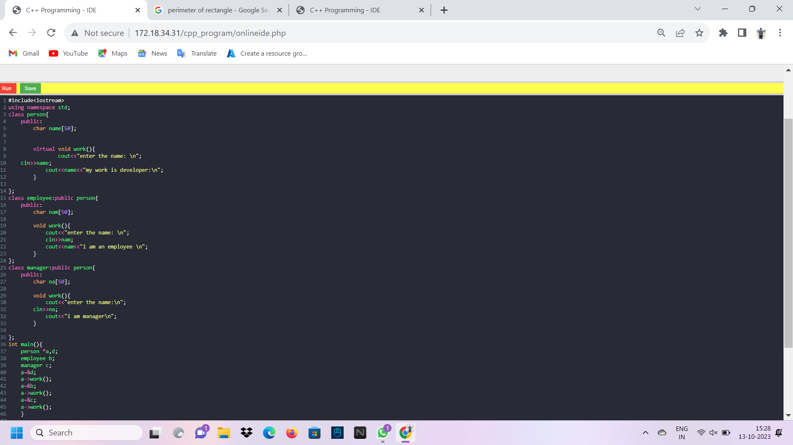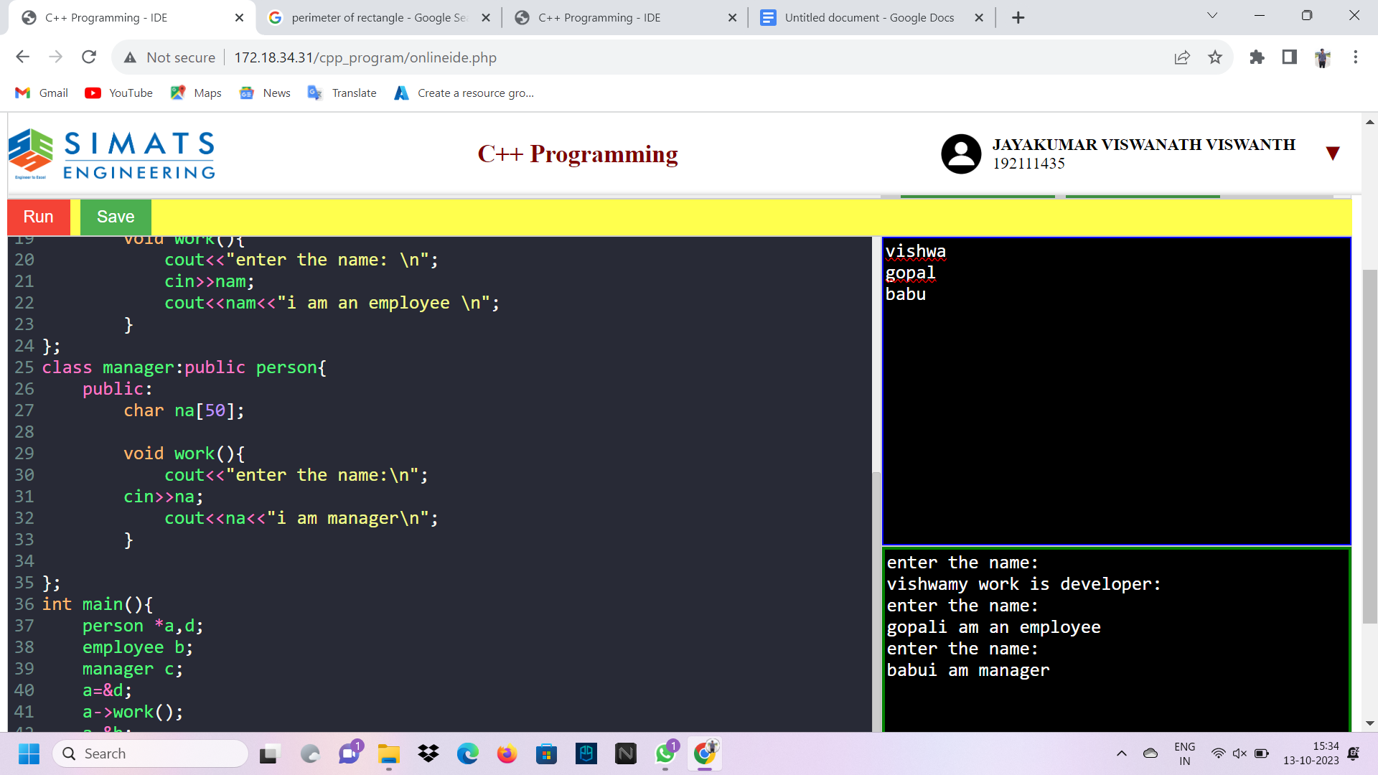2.Create a base class called Animal with a virtual function eat derive two classes Herbivore and Carnivore from the base class implement the eat function for each class.

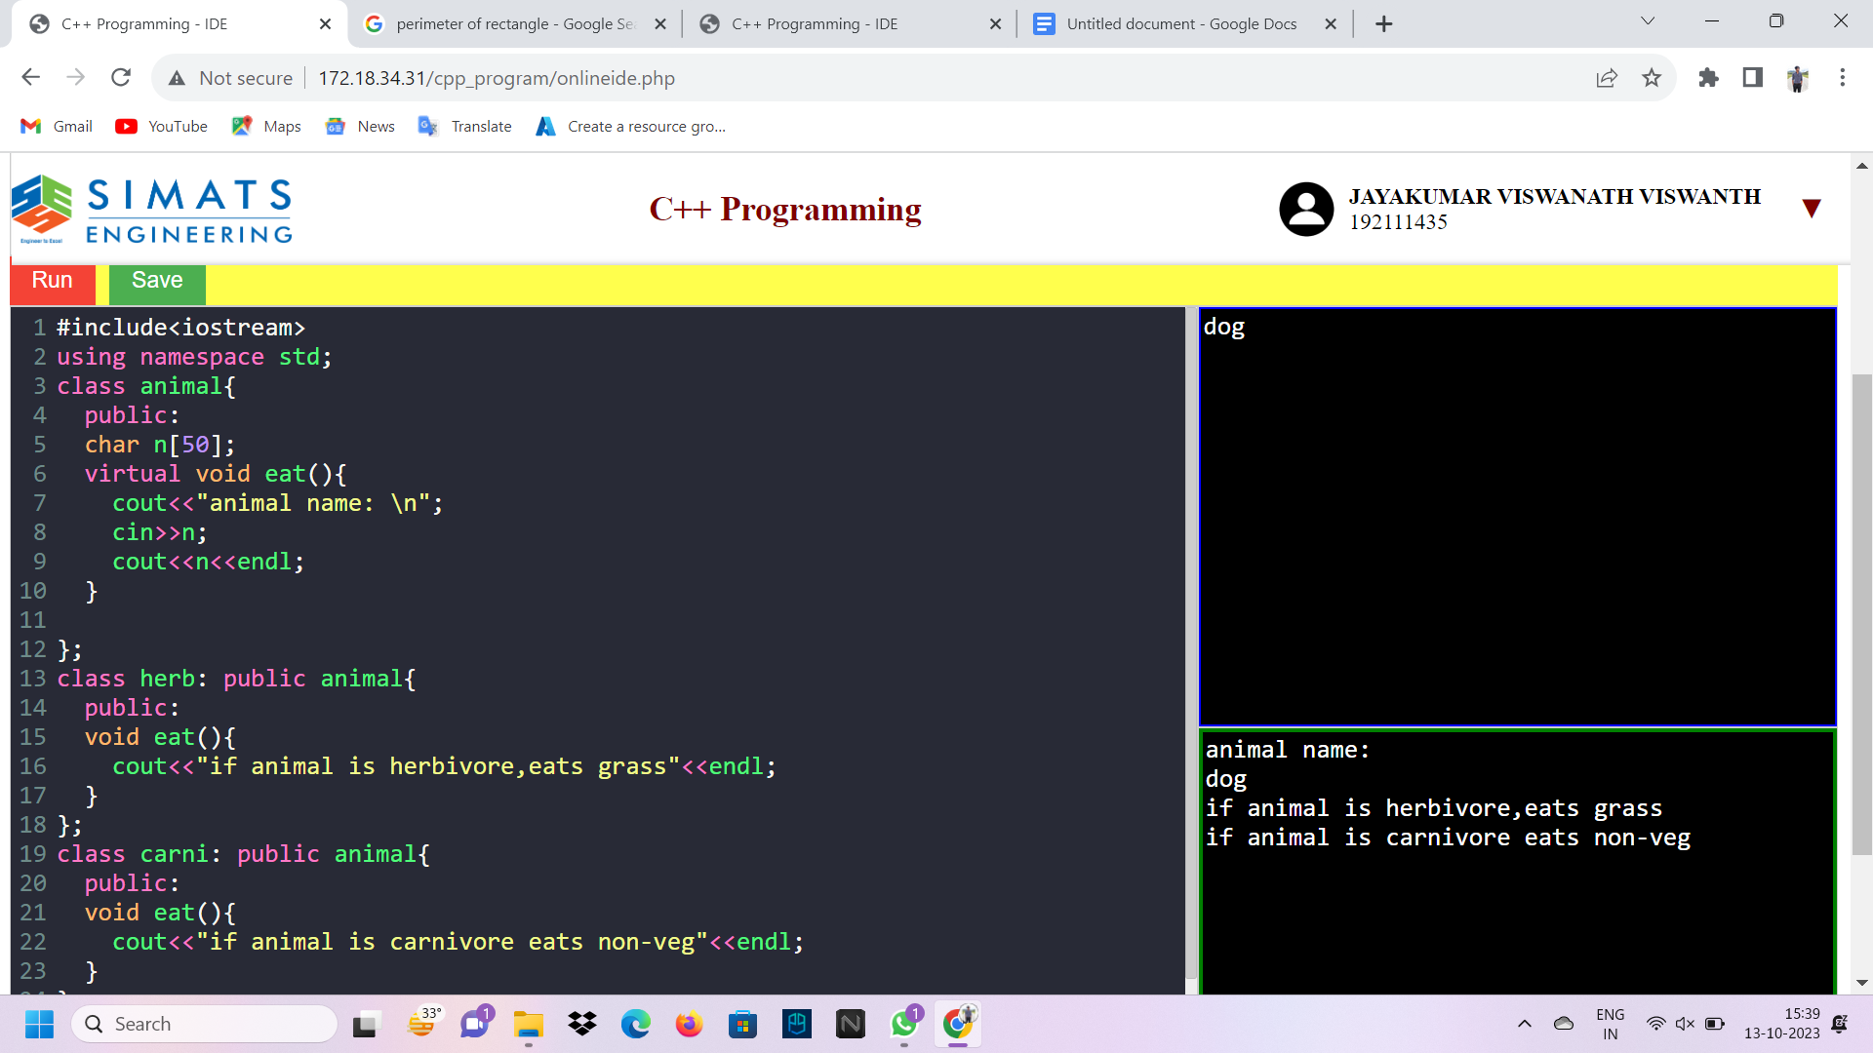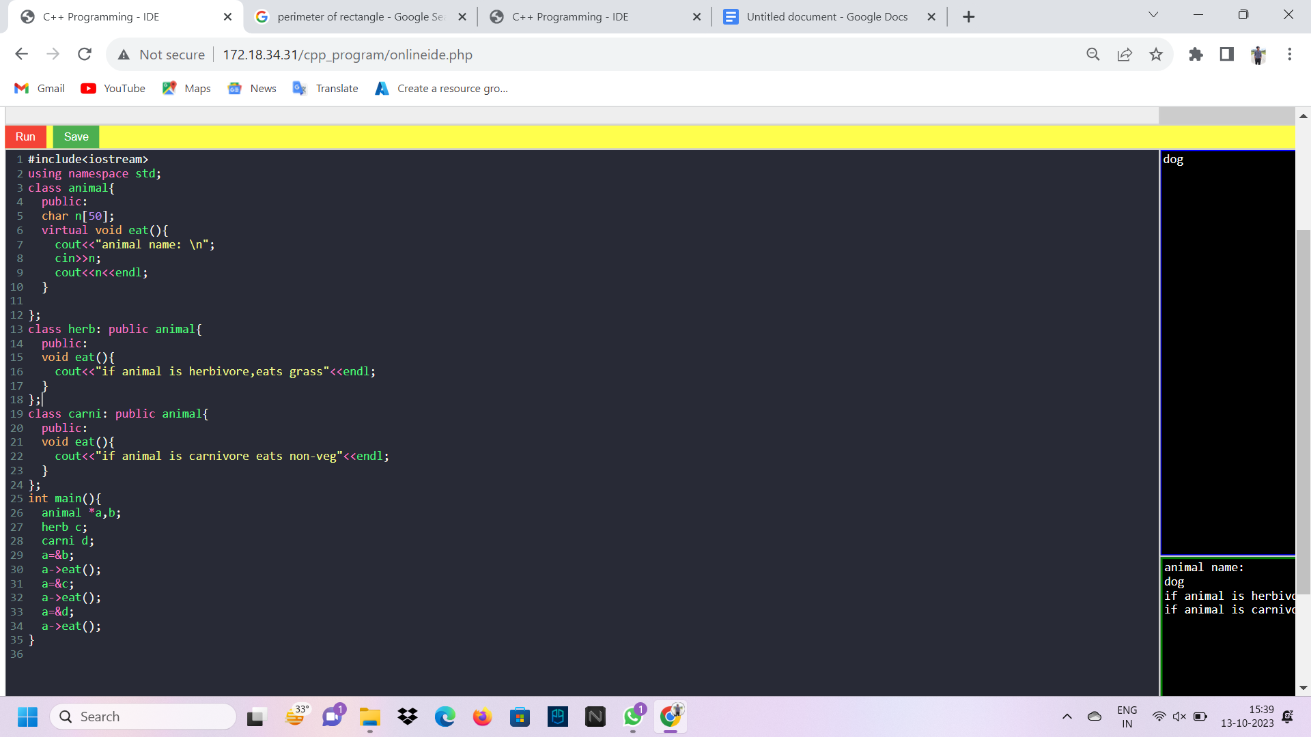

Create a base class called Shape with virtual functions area and volume derive two classes Sphere and Cylinder from the base class. Implement the area and volume functions for each class.

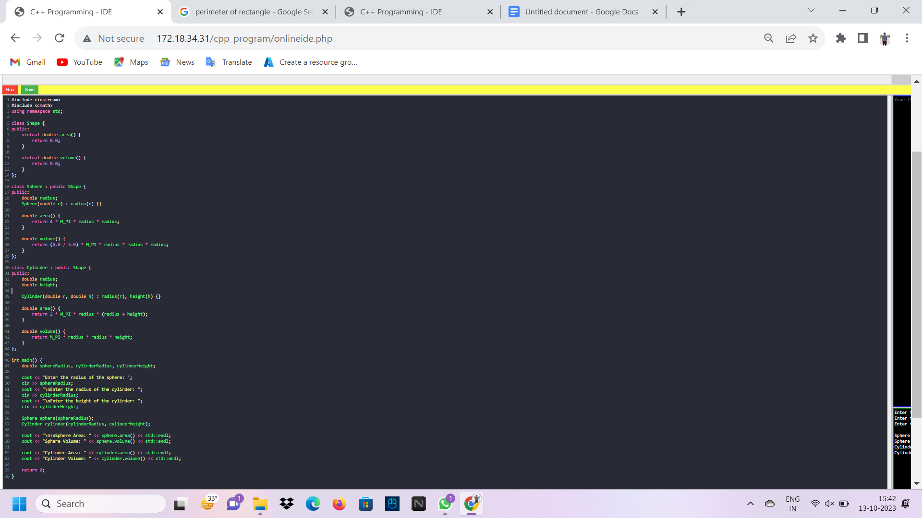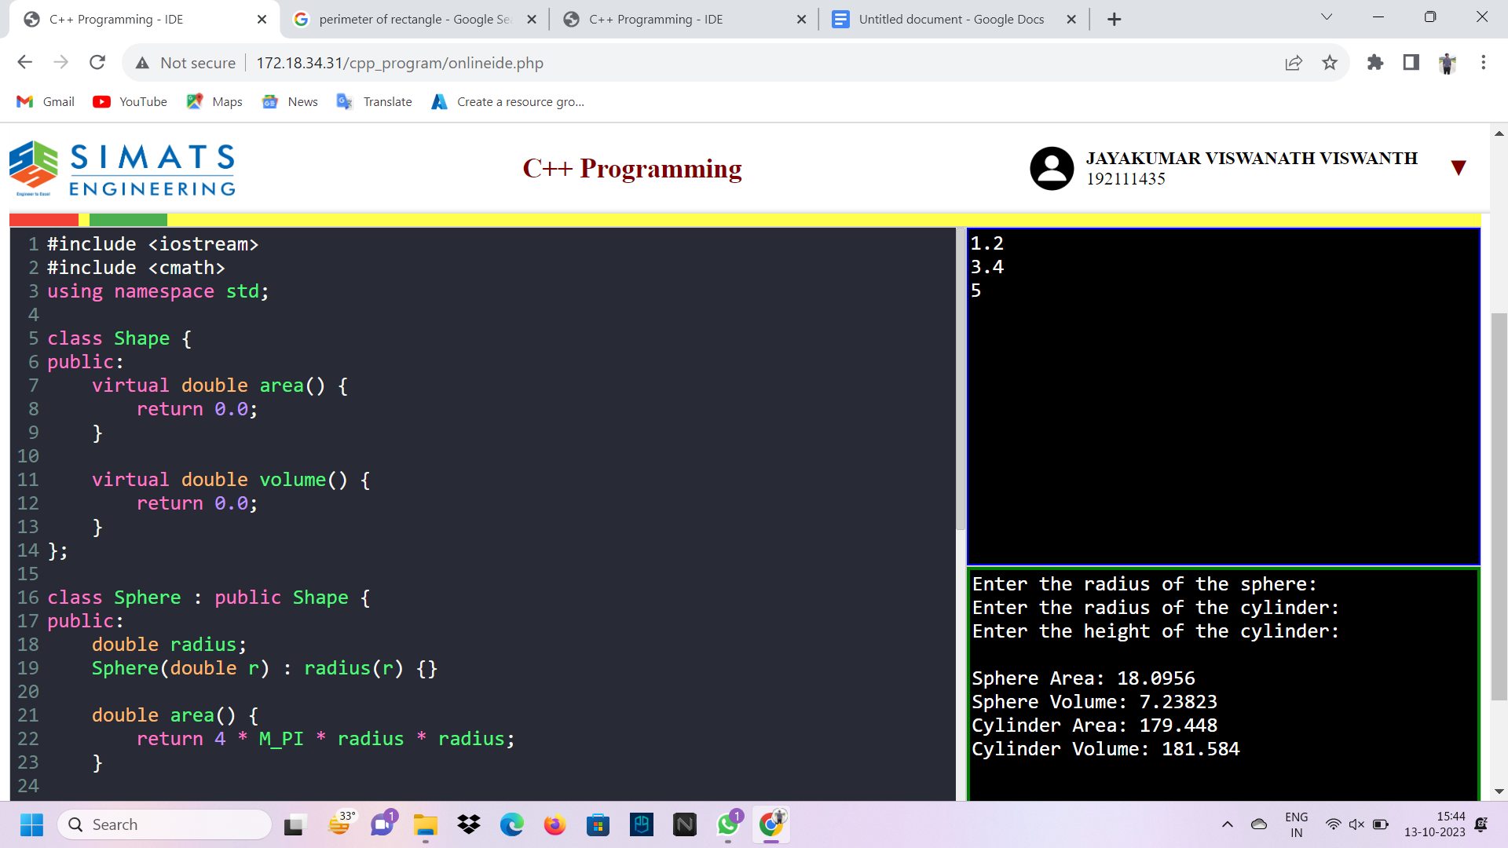4.Create a base class called Person with a virtual function greet derive two classes Student and Teacher from the base class. Implement the greet function for each class

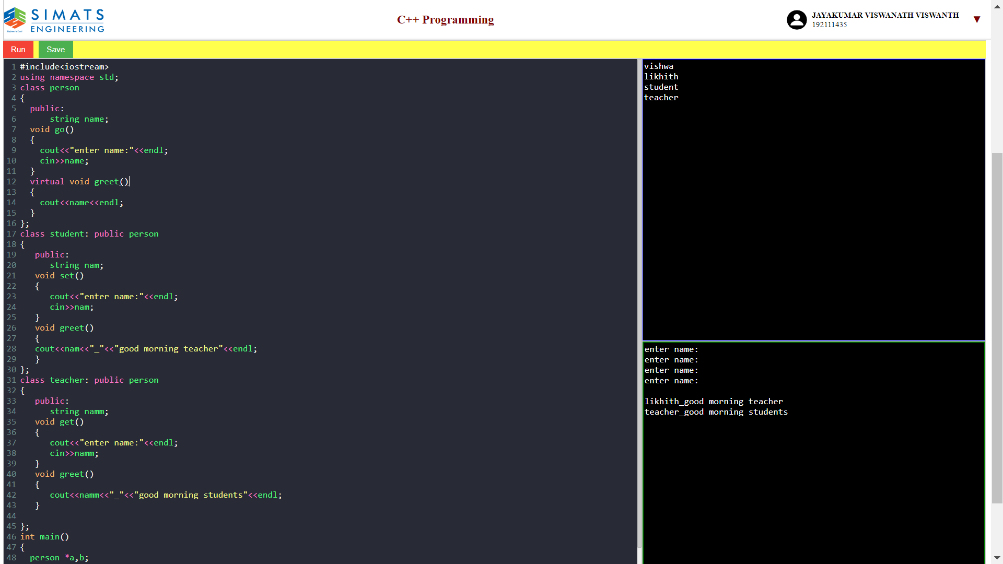5.Create a base class called Animal with a virtual function move derive two classes Bird and Fish from the base class. Implement the move function for each class.

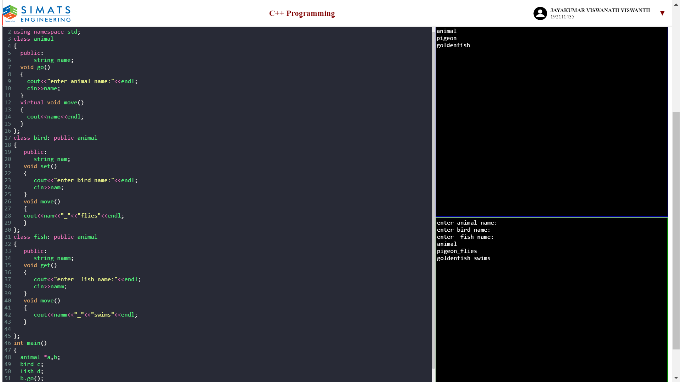6.Create a base class called Shape with virtual functions area and perimeter Derive two classes Rectangle and Triangle from the base class. Implement the area and perimeter functions for each class.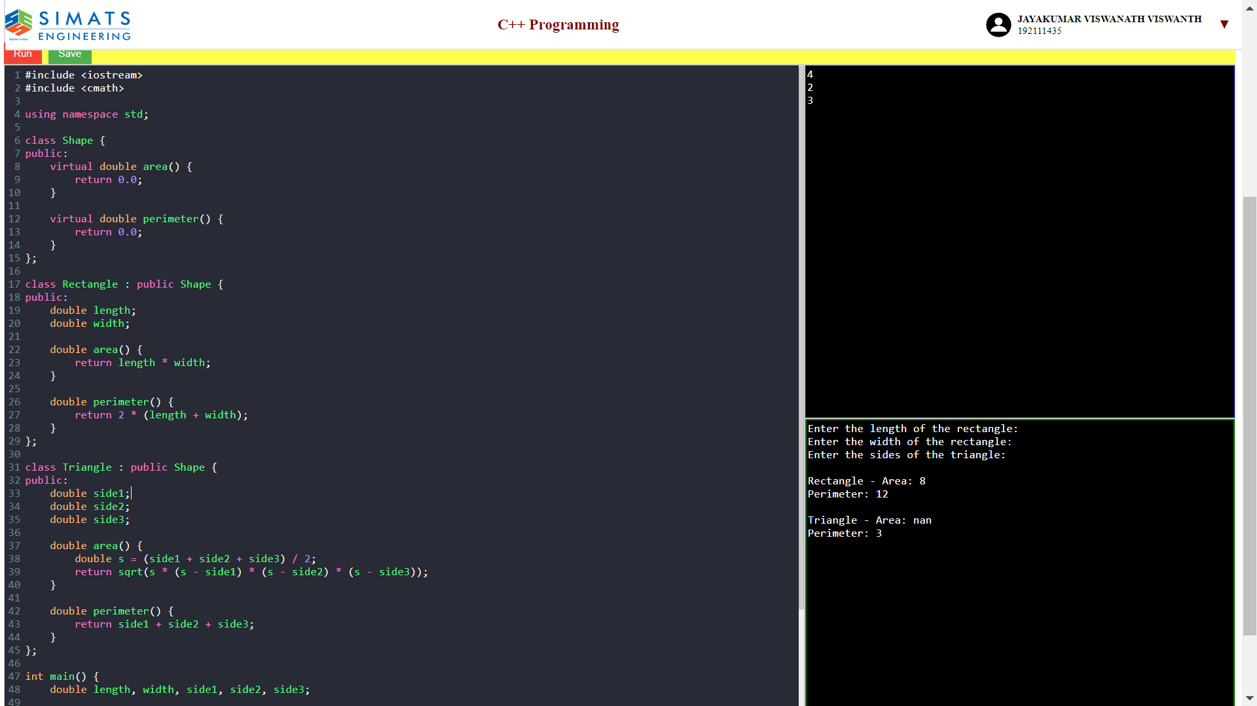7.Create a base class called Vehicle with a virtual function drive derive two classes Car and Truck from the base class. Implement the drive function for each class

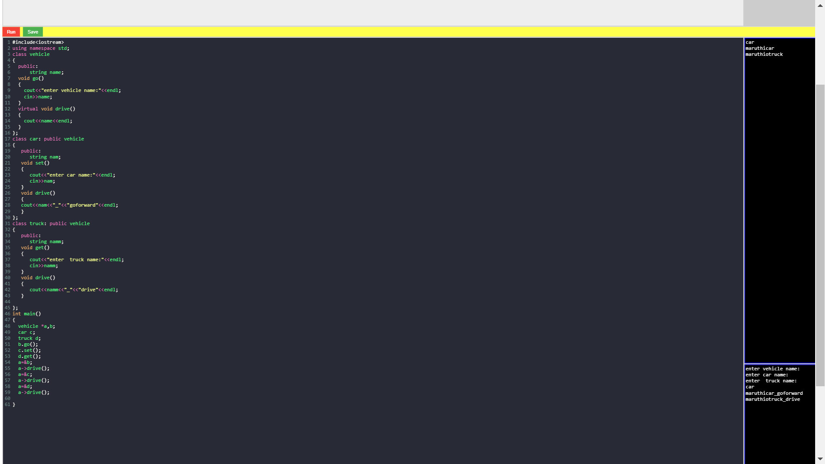

8.Create a base class called Employee with a virtual function calculatePay Derive two classes Manager and Engineer from the base class. Implement the calculatePay function for each class.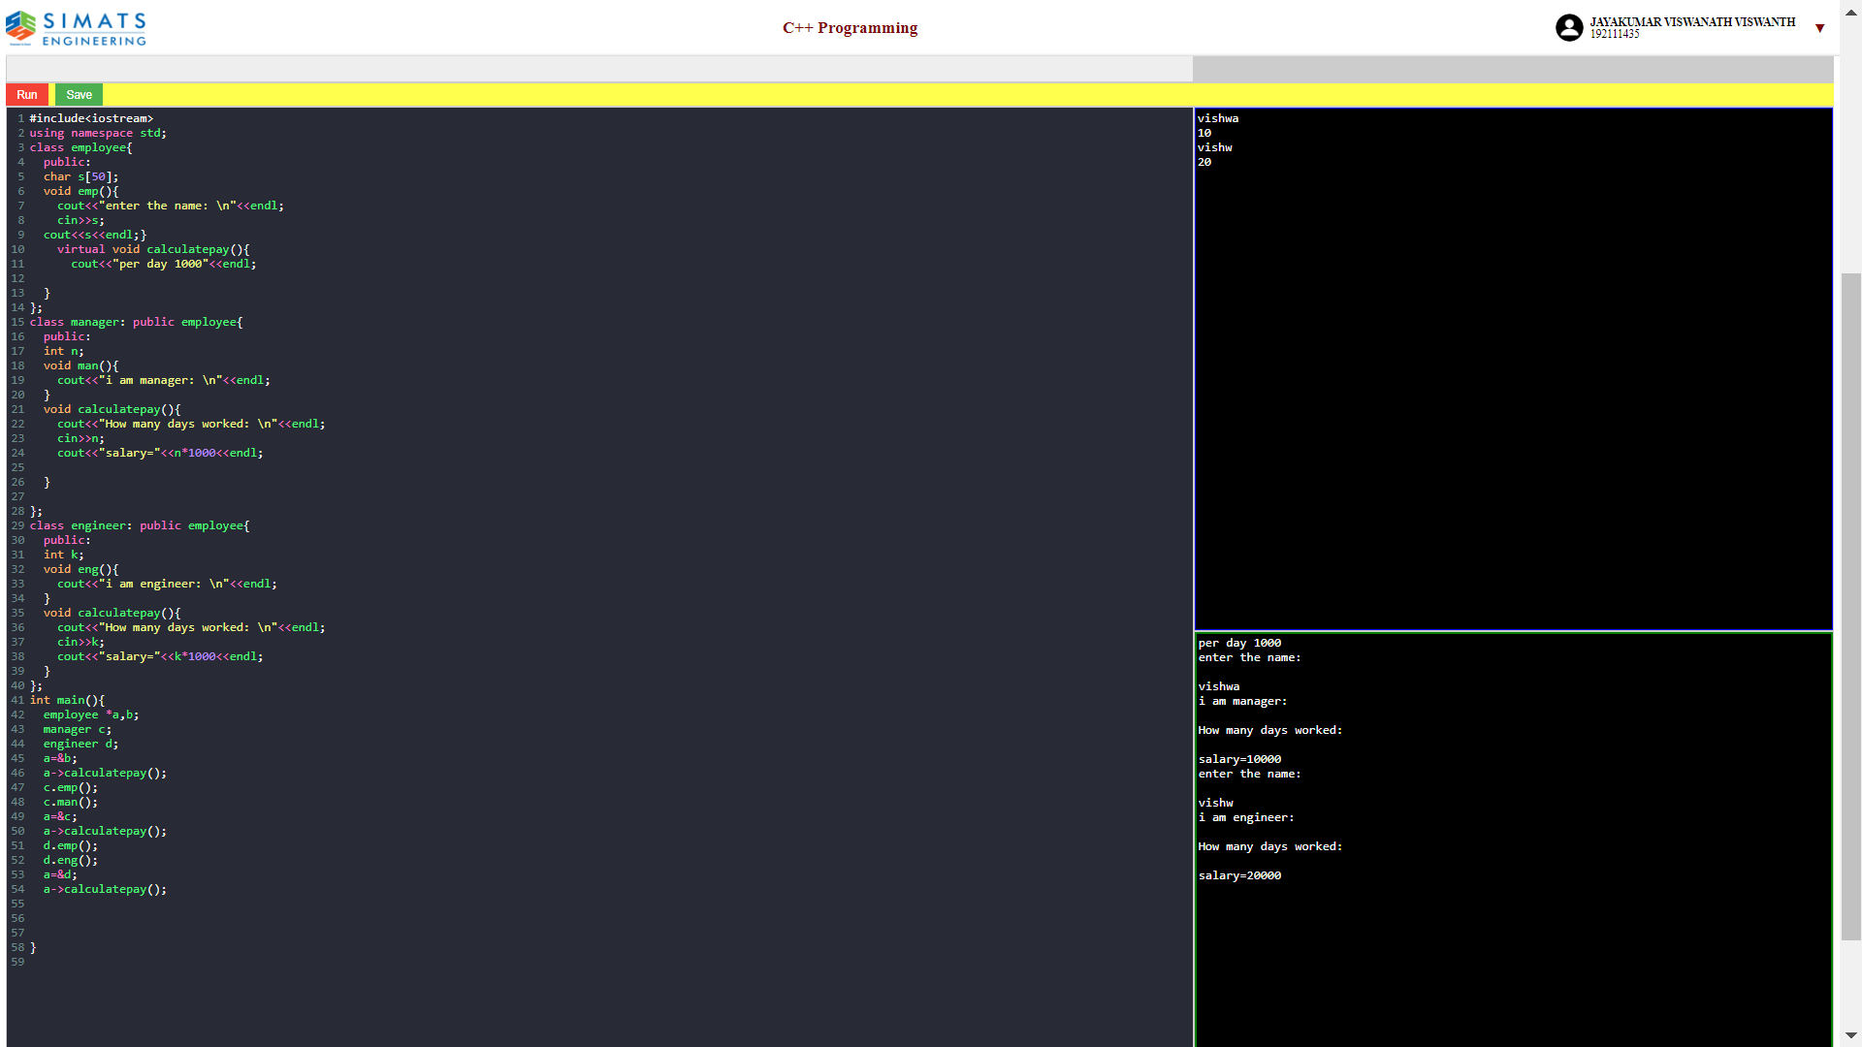9.Create a base class called Animal with a virtual function speak Derive two classes Cat and Dog from the base class. Implement the speak function for each class.

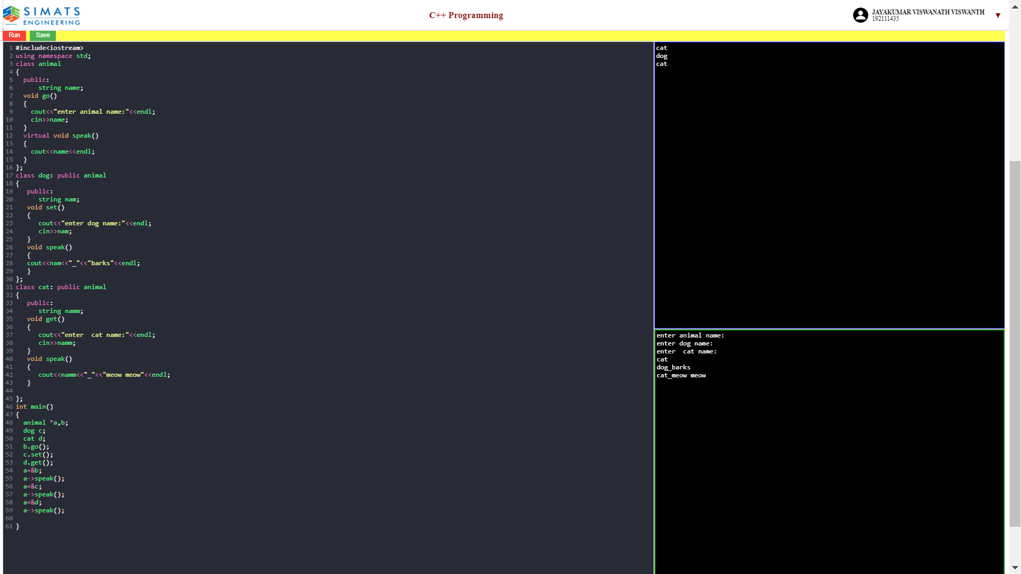

10.Create a base class called Shape with a virtual function area derive two classes Rectangle and Circle from the base class. Implement the area function for each class.