Name: J.Viswanath

Rg.no.: 192111435

Course: object oriented C++

Code: DSA0163

Topic: Inheritance

Sinlge inheritance:

#include<iostream>

#include<string>

using namespace std;

class student

{

public:

string name;

int age;

char gender;

void go()

{

cout<<"enter name:"<<endl;

cin>>name;

cout<<"enter age:"<<endl;

cin>>age;

cout<<"enter gender:"<<endl;

cin>>gender;

}

void display()

{

cout<<name<<endl;

cout<<age<<endl;

cout<<gender<<endl;

}

};

class teacher: public student

{

public:

string subject;

int section;

void get()

{

cout<<"enter name:"<<endl;

cin>>name;

cout<<"enter age:"<<endl;

cin>>age;

cout<<"enter gender:"<<endl;

cin>>gender;

cout<<"enter subject:"<<endl;

cin>>subject;

cout<<"enter section:"<<endl;

cin>>section;

}

void display1()

{

cout<<name<<endl;

cout<<age<<endl;

cout<<gender<<endl;

cout<<subject<<endl;

cout<<section<<endl;

}

};

int main()

{

student S1;

S1.go();

S1.display();

teacher T1;

T1.get();

T1.display1();

}

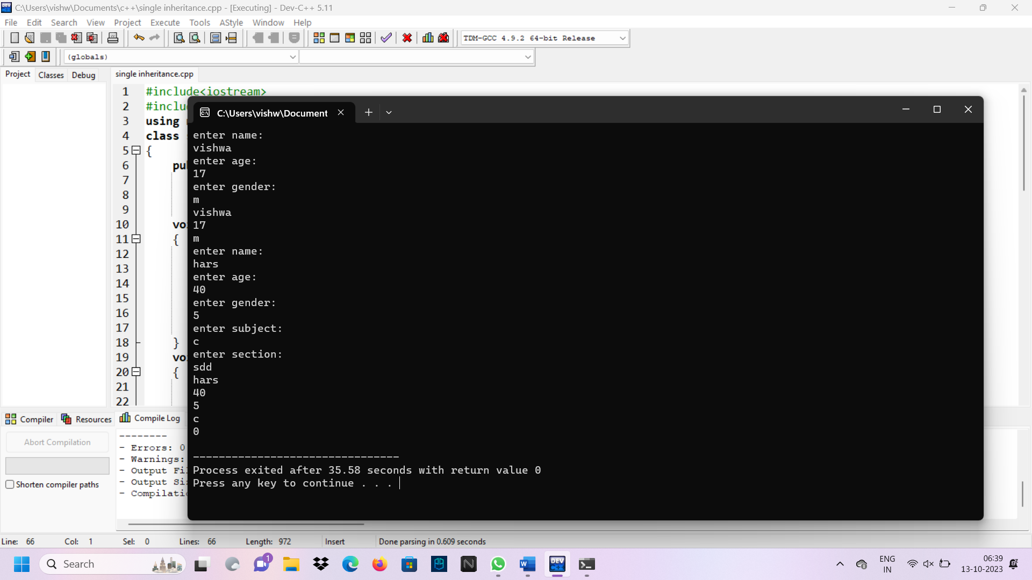

Multilevel inheritance:

#include<iostream>

#include<string>

using namespace std;

class student

{

public:

string name;

int age;

char gender;

void go()

{

cout<<"enter name:"<<endl;

cin>>name;

cout<<"enter age:"<<endl;

cin>>age;

cout<<"enter gender:"<<endl;

cin>>gender;

}

void display()

{

cout<<name<<endl;

cout<<age<<endl;

cout<<gender<<endl;

}

};

class teacher: public student

{

public:

string subject;

int section;

void get()

{

cout<<"enter name:"<<endl;

cin>>name;

cout<<"enter age:"<<endl;

cin>>age;

cout<<"enter gender:"<<endl;

cin>>gender;

cout<<"enter subject:"<<endl;

cin>>subject;

cout<<"enter section:"<<endl;

cin>>section;

}

void display1()

{

cout<<name<<endl;

cout<<age<<endl;

cout<<gender<<endl;

cout<<subject<<endl;

cout<<section<<endl;

}

};

class dean: public student,public teacher

{

public:

string examsschedule;

int classes;

void set()

{

cout<<"enter examsschedule"<<endl;

cin>>examsschedule;

cout<<"enter classes"<<endl;

cin>>classes;

}

void display2()

{

cout<<examsschedule<<endl;

cout<<classes<<endl;

}

};

int main()

{

student S1;

S1.go();

S1.display();

teacher T1;

T1.get();

T1.display1();

dean D1;

D1.set();

D1.display2();

}

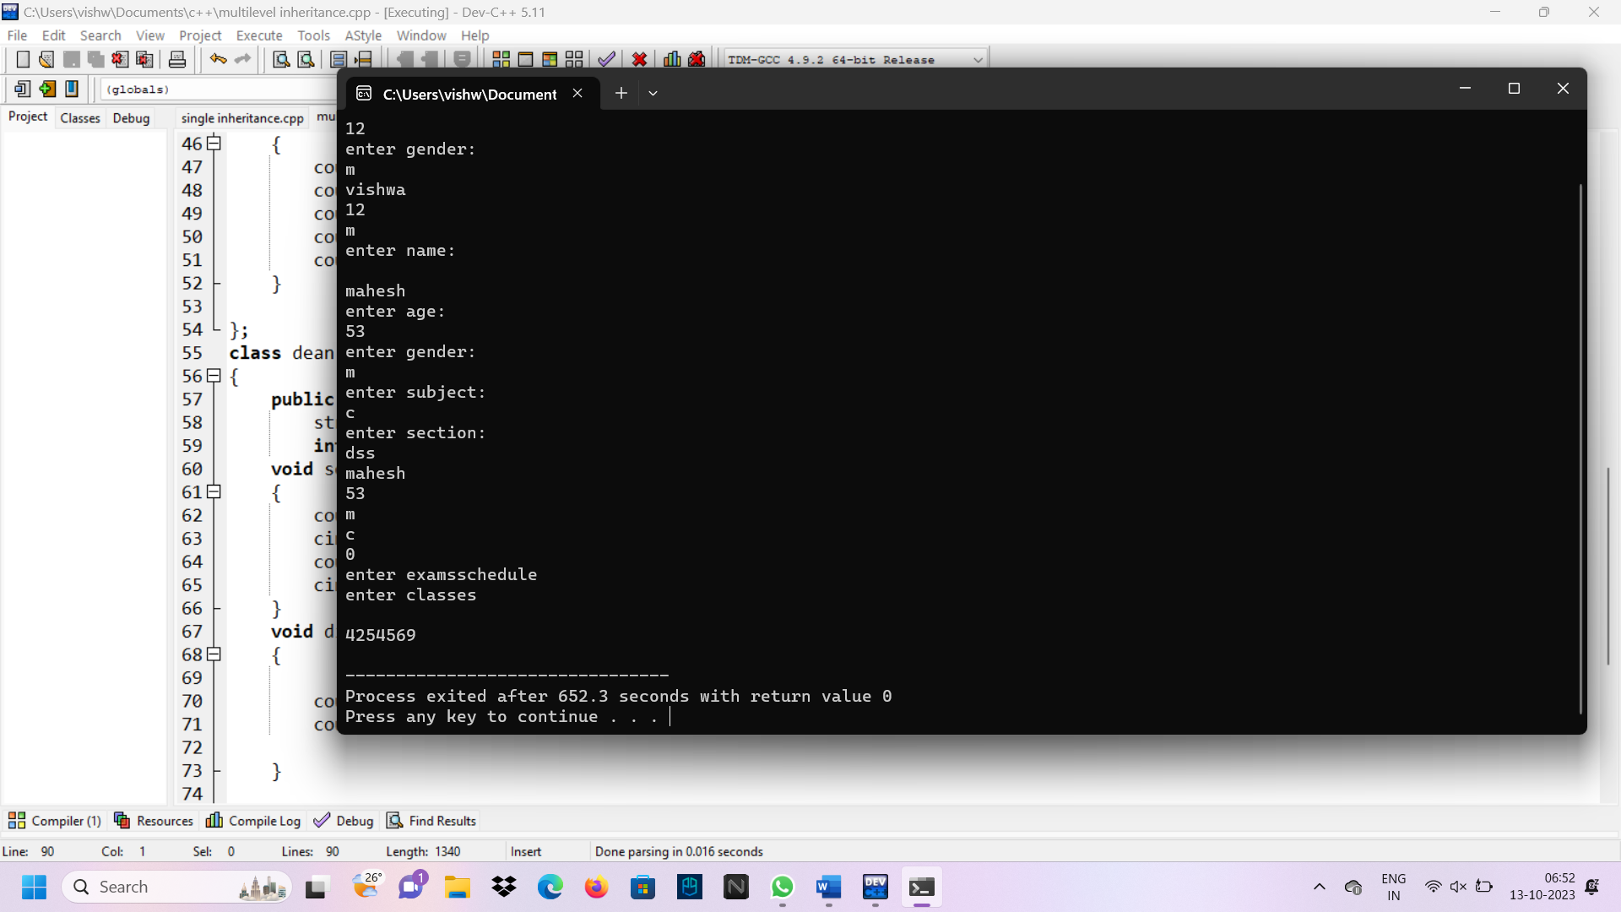

Multiple inheritance:

#include<iostream>

#include<string>

using namespace std;

class student

{

public:

string name;

int age;

char gender;

void go()

{

cout<<"enter name:"<<endl;

cin>>name;

cout<<"enter age:"<<endl;

cin>>age;

cout<<"enter gender:"<<endl;

cin>>gender;

}

void display()

{

cout<<name<<endl;

cout<<age<<endl;

cout<<gender<<endl;

}

};

class teacher

{

public:

string subject;

int section;

void get()

{

cout<<"enter subject:"<<endl;

cin>>subject;

cout<<"enter section:"<<endl;

cin>>section;

}

void display1()

{

cout<<subject<<endl;

cout<<section<<endl;

}

};

class dean: public student,public teacher

{

public:

string examsschedule;

int classes;

void set()

{

cout<<"enter name:"<<endl;

cin>>name;

cout<<"enter age:"<<endl;

cin>>age;

cout<<"enter gender:"<<endl;

cin>>gender;

cout<<"enter subject:"<<endl;

cin>>subject;

cout<<"enter section:"<<endl;

cin>>section;

cout<<"enter examsschedule"<<endl;

cin>>examsschedule;

cout<<"enter classes"<<endl;

cin>>classes;

}

void display2()

{

cout<<name<<endl;

cout<<age<<endl;

cout<<gender<<endl;

cout<<subject<<endl;

cout<<section<<endl;

cout<<examsschedule<<endl;

cout<<classes<<endl;

}

};

int main()

{

student S1;

S1.go();

S1.display();

teacher T1;

T1.get();

T1.display1();

dean D1;

D1.set();

D1.display2();

}

