# **Oil Spill Detection Using Image Processing and Video**

## Introduction

Oil spills are catastrophic environmental disasters with far-reaching consequences for aquatic ecosystems, wildlife, and coastal communities. The rapid detection and effective response to oil spills are crucial to minimize the environmental damage. This project aims to develop a system for oil spill detection using image processing and video analysis to enable quick and efficient response to such incidents.

**Problem Definition**

Oil spill detection is currently a challenging task, often relying on manual visual inspection or satellite imagery, which can be time-consuming and not always accurate. Our project addresses the following key problems:

1. **Timely Detection:** Oil spills must be detected quickly to minimize environmental impact. Delayed detection can lead to severe consequences.
2. **Accuracy:** Existing methods may produce false alarms, leading to unnecessary resource allocation.
3. **Automation:** Reducing the dependence on manual labor for oil spill detection can streamline response efforts.

## Proposed Solution

### **1. Data Acquisition**

To address the problem, the following steps will be taken:

* **Image and Video Data Collection:** A dataset containing images and videos of both clean and oil-contaminated water bodies will be created. This dataset will serve as the foundation for training and testing our detection system.
* **Satellite Imagery Integration:** Satellite imagery may be used to provide a broader perspective and monitor larger areas, which can help identify potential oil spills.

### **2. Preprocessing**

* **Image Enhancement:** To improve the quality of images and videos, preprocessing techniques such as noise reduction and contrast adjustment will be applied.
* **Frame Extraction:** Videos will be decomposed into frames, which will be analyzed individually to detect oil spills over time.

### **3. Image and Video Analysis**

* **Feature Extraction:** Key features like color, texture, and shape will be extracted from images and video frames. Oil spill characteristics will be compared to clean water body features.
* **Machine Learning Algorithms:** Supervised machine learning algorithms (e.g., convolutional neural networks) will be trained on the dataset to classify images and video frames as either oil-contaminated or clean.

### **4. Detection and Alerting**

* **Thresholding:** A threshold value will be determined to classify detected areas as oil spills. A confidence level for detection will also be calculated.
* **Alert System:** When an oil spill is detected, an alert system will trigger, notifying relevant authorities or response teams via email or other communication channels.

### **5. Evaluation**

* **Performance Metrics:** The system's performance will be evaluated using metrics like accuracy, precision, recall, and F1 score to ensure its effectiveness.
* **Real-world Testing:** The system will be tested in real-world scenarios to assess its practical utility.

**CODE:**

% Read the image containing the oil spill

image = imread('oilspill.jpg');

% Display the original image

subplot(3, 3, 1);

imshow(image);

title('Original Image');

% Convert the image to grayscale

gray_image = rgb2gray(image);

% Display the grayscale image

subplot(3, 3, 2);

imshow(gray_image);

title('Grayscale Image');

% Calculate and display the histogram of the grayscale image

subplot(3, 3, 3);

imhist(gray_image);

title('Grayscale Image Histogram');

% Apply median filtering to reduce noise

filtered_image = medfilt2(gray_image, [5, 5]);

% Display the filtered image

subplot(3, 3, 4);

imshow(filtered_image);

title('Filtered Image');

% Enhance the contrast using histogram equalization

enhanced_image = histeq(filtered_image);

% Display the enhanced image

subplot(3, 3, 5);

imshow(enhanced_image);

title('Enhanced Image');

% Calculate and display the histogram of the enhanced image

subplot(3, 3, 6);

imhist(enhanced_image);

title('Enhanced Image Histogram');

% Perform edge detection using the Canny edge detector

edge_image = edge(enhanced_image, 'Canny');

% Display the edge-detected image

subplot(3, 3, 7);

imshow(edge_image);

title('Edge-Detected Image');

% Apply morphological operations to clean up the edges

se = strel('disk', 5);

cleaned_edge_image = imdilate(edge_image, se);

% Display the cleaned edge image

subplot(3, 3, 8);

imshow(cleaned_edge_image);

title('Cleaned Edge Image');

% Fill holes in the cleaned edge image

filled_image = imfill(cleaned_edge_image, 'holes');

% Display the filled image

subplot(3, 3, 9);

imshow(filled_image);

title('Filled Image');

% You can now proceed with further oil spill detection methods using 'filled_image'.

% Example: Set a threshold for the minimum oil spill area

min_oil_spill_area = 1000;

% Perform connected component analysis

cc = bwconncomp(filled_image);

stats = regionprops(cc, 'Area', 'PixelList');

% Create a binary mask for detected oil spills

oil_spill_mask = false(size(filled_image));

for i = 1:cc.NumObjects

if stats(i).Area > min_oil_spill_area

oil_spill_mask(sub2ind(size(filled_image), stats(i).PixelList(:,2), stats(i).PixelList(:,1))) = true;

end

end

% Display the original image with detected oil spills outlined

figure;

imshow(image);

hold on;

% Outline detected spills on the original image

boundaries = bwboundaries(oil_spill_mask);

for k = 1:length(boundaries)

boundary = boundaries{k};

plot(boundary(:, 2), boundary(:, 1), 'r', 'LineWidth', 2);

end

hold off;

**OUTPUT:**

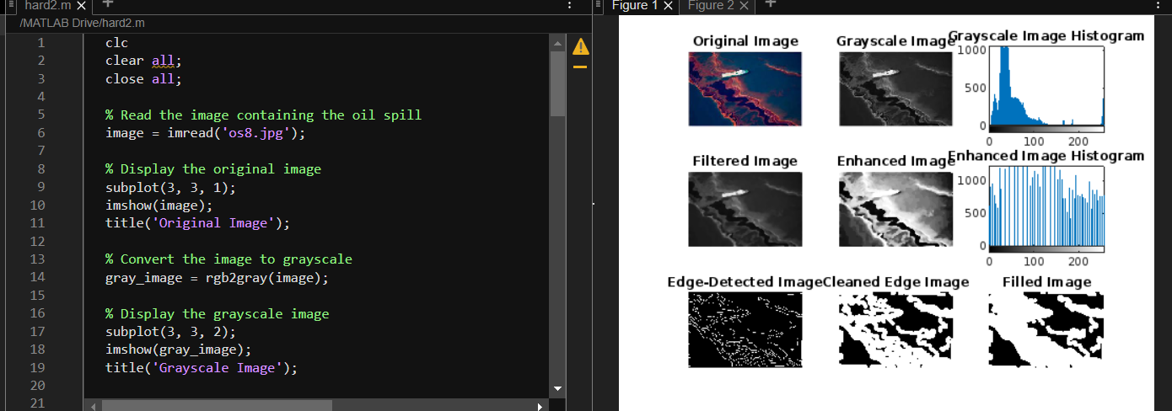

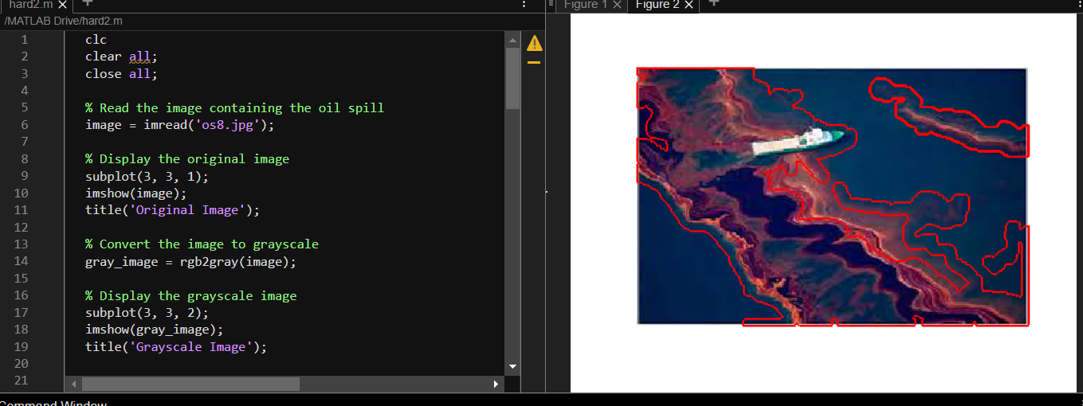

## Conclusion

In conclusion, the development of an automated oil spill detection system using image processing and video analysis has the potential to revolutionize the response to oil spill incidents. By addressing the challenges of timely detection, accuracy, and automation, this project aims to make a significant contribution to environmental protection and disaster management. The successful implementation of this system could lead to more efficient responses to oil spills, ultimately reducing their impact on the environment and communities.