Metro Railway Management System

By: Vishwa Bhalodia

**Metro Railway Database:**

Backend services of a Metro railway database

**INTRODUCTION**

The Railway Database management allows the passenger to check for a train from a source to a destination. Features like booking, cancellation, checking for the availability of tickets and also enquiring about the booking status are seen in this database. The aim of this project is to facilitate easy access to the train information along with their booking status and seat availability by the customer. If these records are written manually then it is prone to errors and maintenance and updating of these records become tiresome.

The entities present in this database are:

1. **Users​:** keeps track of all the users who logged into the railway database along with their details like name, age, gender, mobile, state, city and pin.
2. **Passengers​:** keeps track of all the passengers who have booked a ticket. Data like age, gender, seat_no, ticket_no and reservation status, booking_date are also stored along with it
3. **Station​:** The details about the name of the station, arrival and halting period for a particular train is stored in this table.
4. **Ticket​:** contains the details about booking status of that ticket.
5. **Train​:** This table stores the train details like train_no, train name, arrival & departure time, availability and date of running .
6. **Train_Status​:** tells us about the fare based on the options of an ac/non-ac seats.

**Entity Relation Diagram:**

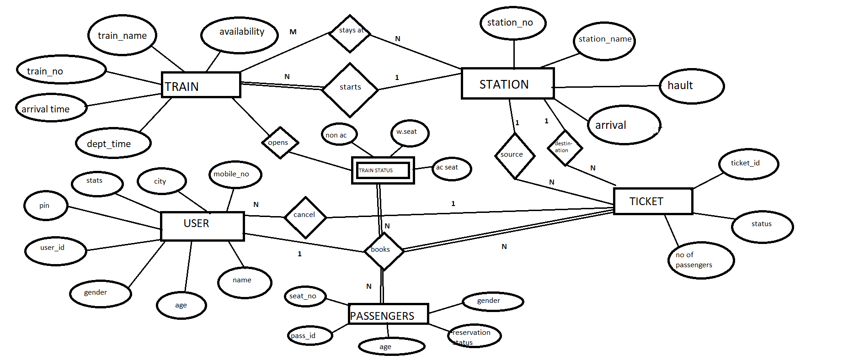

**After Normalisation:**

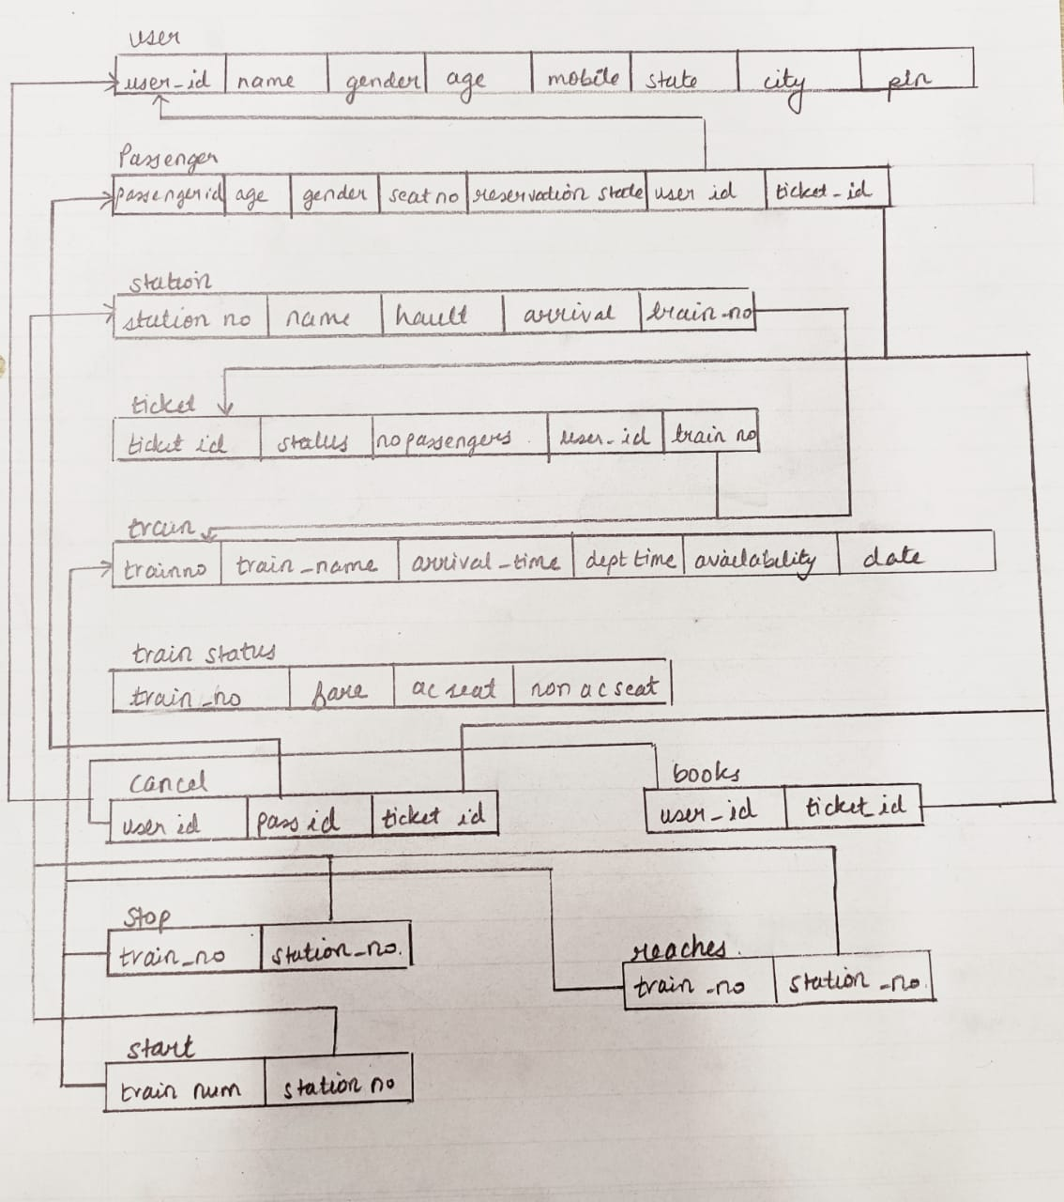

Reaches

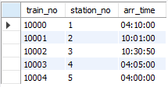

Start_at

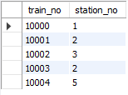

Station

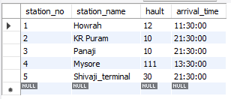

Stop_at

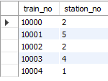

Ticket

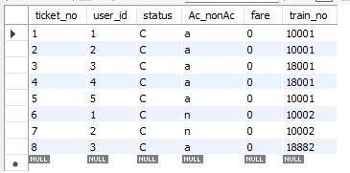

Train

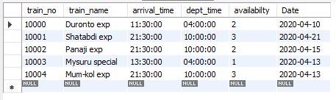

Train_stats

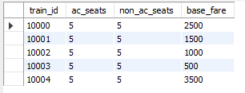

Users

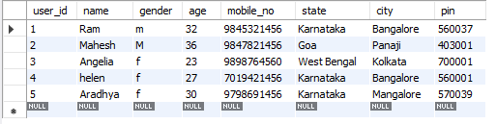

Creating Tables

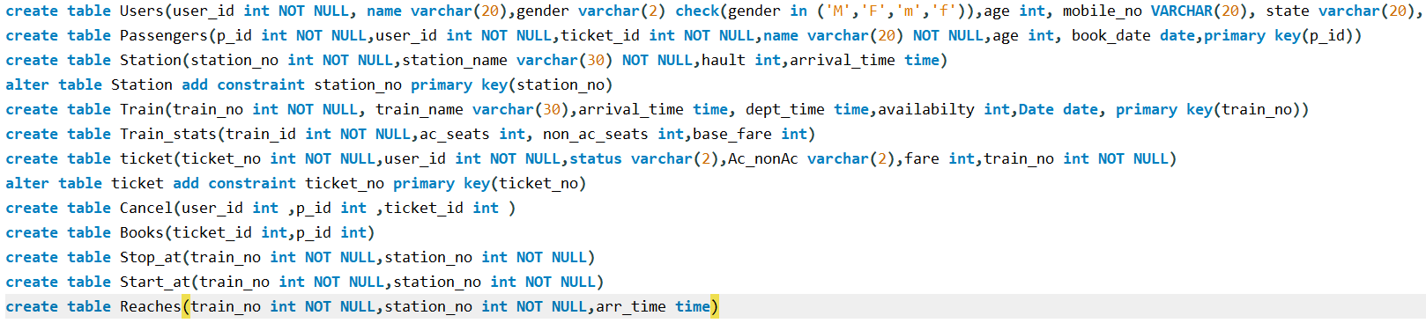

**Insertion:**

users

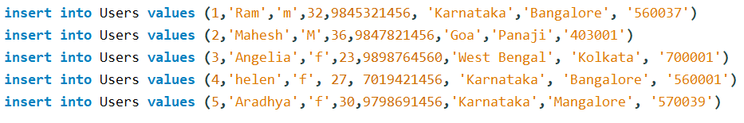

Train_value

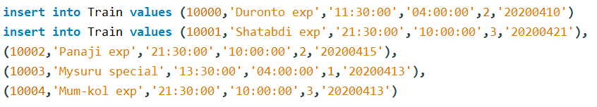

Station values

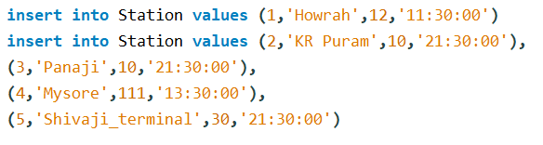

Train_stats



Reaches



Ticket

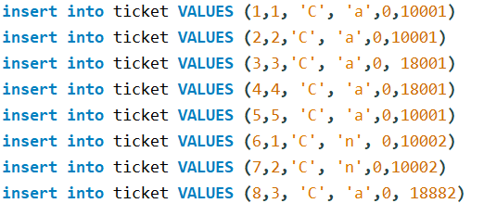

Constraint

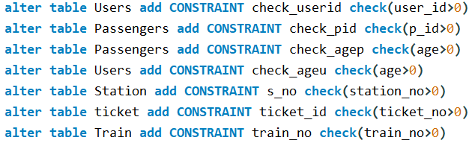

Queries:

1. Find the names of passengers who are less than age 25:

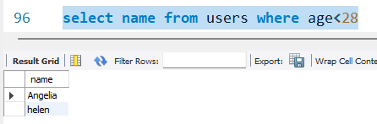

1. Find all the male passengers travelling from Bangalore

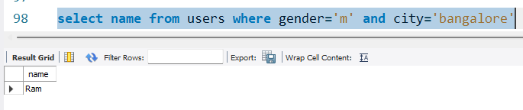

1. Find train no and names of trains which depart on 10.00

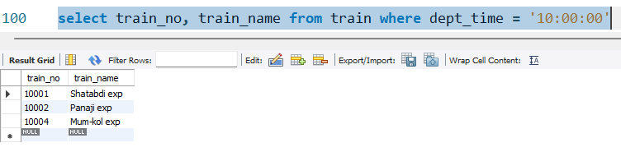

1. Find the train no and name which start from Station number 2

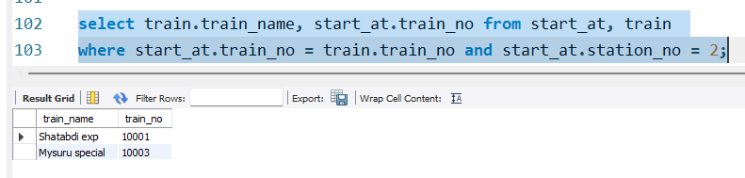

1. Find the station no, station name with halt more than 10

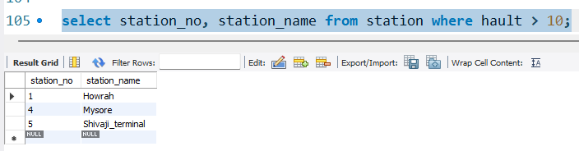

1. Find the train no and name with arrival time 21:30:00

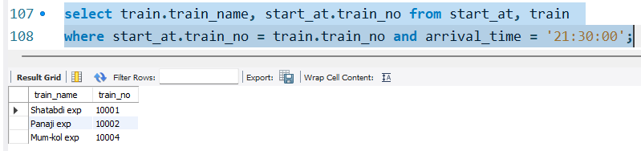

1. List the passengers name whose name start with A

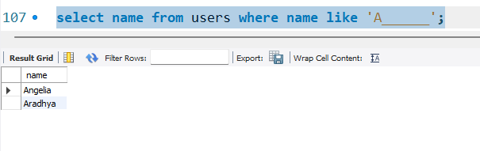

8.List the station name where number of hault is same as Panaji

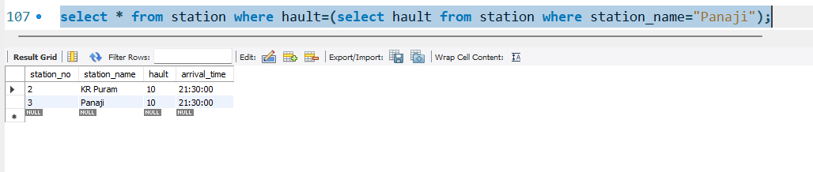

9.List the train number, train name and date whose availability is two or three.

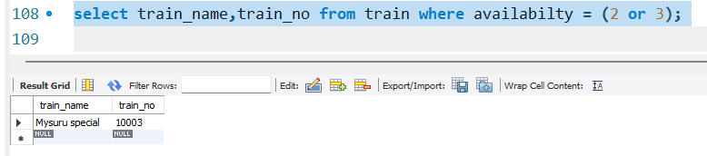

10. List the train no whose station no is not equal to 2

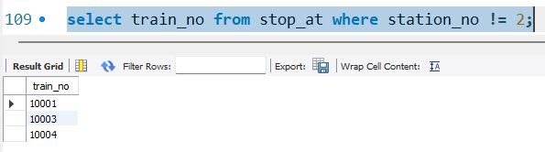

11. List the name of the trains that arrive after 04:00:00

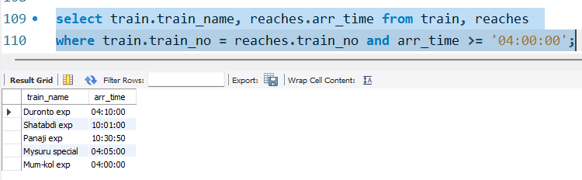

12. List the number and the price of AC seat for Shatabdi Express

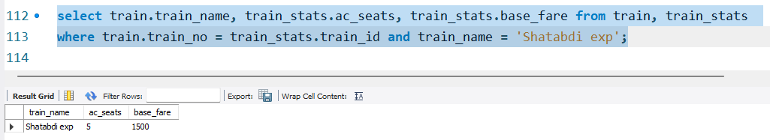

13. Find the name, age, mobile no of the oldest person travelling from Mysore

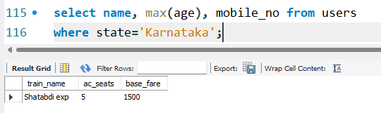

14. List the train name and number of non ac tickets available along with the price and sort that in ascending order of arrival time.

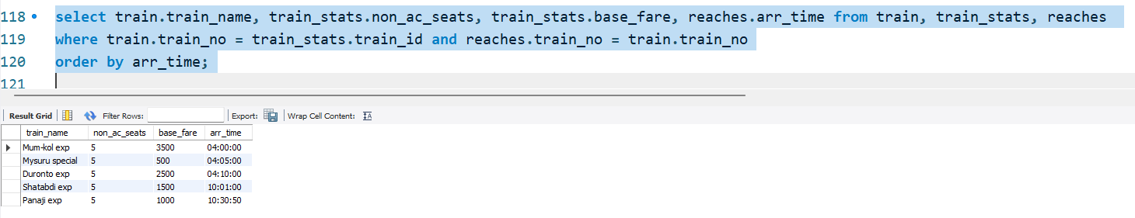

15. List the name, age, mobile no & pin of passengers travelling in AC ticket in the Mysuru Express.

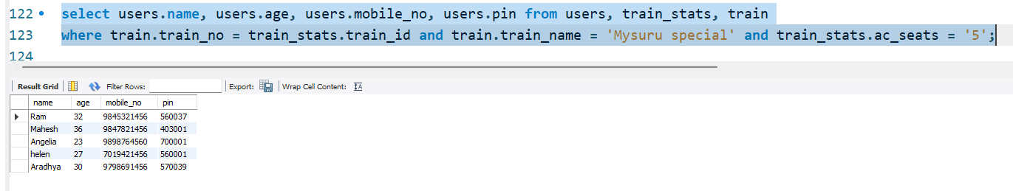

16. List the train no, train name and departure time of all the trains which reach station number 3 after the date 10th April 2020.

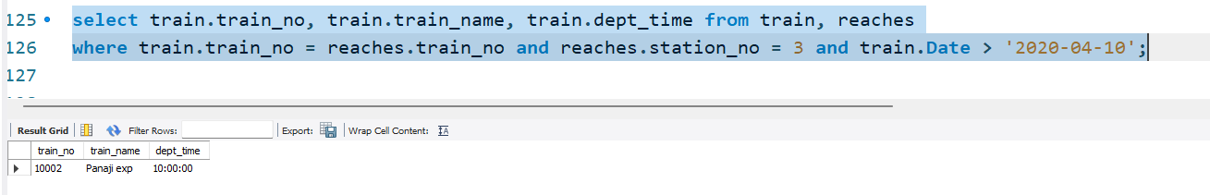

17. List all the details of the passengers and group them by their city

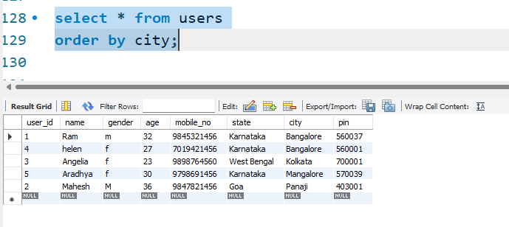

18. List the train no and names along with arrival and departure time for all the trains arriving on station 2.

