

VISVESVARAYA TECHNOLOGICAL UNIVERSITY

JNANASANGAMA, BELAGAVI – 590018

Subject: Deep Learning Code: 23AML161

ACTIVITY REPORT
on
Audio Denoising with Deep Learning using U-Net Architecture
Submitted in partial fulfillment for the award of degree of
Bachelor of Engineering
in
Artificial Intelligence and Machine Learning
Submitted by
Preetham H S [1BG23AI077]
Vishwamohan SN [1BG23AI124]

B.N.M. Institute of Technology
An Autonomous Institution under VTU
Department of Artificial Intelligence and Machine Learning
2025-2026

Table of Contents

Sl. No | Contents | Page No.
1 | Abstract | 3
1 | Introduction | 3
2 | Literature Review | 4
3 | Mapping to United Nations Sustainable Development Goals | 5
4 | Methodology | 6
5 | Results | 8
6 | Discussion | 9
7 | Conclusion | 9
8 | References | 9

List of Figures

Figure No. | Contents | Page No.
1 | Architecture | 7
2 | Spectrogram Result | 8

List of Tables

Table No. | Contents | Page No.
1 | SGDs | 5

Abstract:
The rapid evolution of artificial intelligence and machine learning has opened new avenues for solving classical signal processing problems. This project focuses on the implementation and evaluation of a deep learning-based approach for audio denoising. Audio denoising aims to isolate clean speech signals from background noise, a critical preprocessing step for various applications, including speech recognition, telecommunications, and hearing aids. In this work, we design and train a U-Net based Convolutional Neural Network (CNN) architecture using PyTorch to perform denoising in the time-frequency domain. The system transforms raw audio waveforms into Short-Time Fourier Transform (STFT) log-magnitude spectrograms, standardizes them, and trains the model to predict the clean spectrogram from its noisy counterpart. The reconstructed spectrogram is then converted back to the time domain using the Griffin-Lim algorithm. We evaluate our model on a multi-speaker dataset and achieve significant noise reduction while preserving speech intelligibility. The results are analyzed using visual spectrogram comparisons and auditory assessments, highlighting the model's effectiveness in suppressing non-stationary noise. This report details the entire pipeline, from dataset preparation and architecture design to training, testing, and performance mapping against global sustainable goals.

Introduction:
  - Background
Audio signal processing has traditionally relied on statistical and mathematical filtering techniques such as Wiener filtering, spectral subtraction, and minimum mean square error estimators. While these methods are computationally efficient, they often struggle with non-stationary background noises and can introduce artificial artifacts, such as "musical noise," into the recovered audio. The advent of deep learning has revolutionized this field, enabling data-driven models that can learn complex mapping functions from noisy to clean signals.
1.2 Problem Statement
In real-world environments, speech is frequently corrupted by various background noises (e.g., traffic, babble, machinery). This degradation severely impacts the performance of downstream tasks like automatic speech recognition (ASR) and diminishes human communication quality. The objective of this project is to develop a robust, end-to-end deep learning solution that can effectively map corrupted audio segments to their clean counterparts using a U-Net architecture.
1.3 Objectives
- To analyze the output quality using graphical spectrogram comparisons.
- To use the Griffin-Lim algorithm to estimate the phase and reconstruct the time-domain waveform from the denoised spectrogram.
- To evaluate the loss functions (L1 and MSE) in optimizing the network for high-fidelity audio reconstruction.
- To train the model using a paired dataset of clean and noisy speech waveforms.
- To design and implement a U-Net Convolutional Neural Network in PyTorch.
- To understand and manipulate raw audio signals using STFT to create 2D time-frequency representations (spectrograms).

Literature Review:
2.1 Traditional Denoising Methods
Historically, audio denoising has been dominated by digital signal processing (DSP) algorithms. Spectral subtraction algorithms estimate the noise spectrum and subtract it from the noisy signal's spectrum. However, this often leads to phase distortion and musical noise. Wiener filtering improves upon this by minimizing the mean square error between the estimated and true signal, assuming stationary noise. Despite their widespread use, these methods lack the capacity to generalize across dynamic, highly variable acoustic environments.
2.2 Deep Learning for Audio
Recent years have seen a paradigm shift towards neural networks for audio processing. Early deep learning models employed Fully Connected Neural Networks (FNNs) and Denoising Autoencoders to map noisy spectra to clean spectra. While effective, they failed to capture temporal contextual information adequately.
2.3 Convolutional Neural Networks (CNNs) and U-Net
CNNs, originally designed for image processing, have proven highly effective for audio when applied to spectrograms. A spectrogram treats audio as an image, where the x-axis is time, the y-axis is frequency, and the pixel intensity is the amplitude. The U-Net architecture, specifically, has shown exceptional performance in source separation and denoising tasks. Originally developed for biomedical image segmentation, U-Net features an encoder that downsamples the input to capture high-level features and a decoder that upsamples the features to reconstruct the original resolution. Skip connections between the encoder and decoder allow the network to preserve fine-grained, high-frequency details that are crucial for high-quality audio reconstruction.
2.4 Phase Reconstruction
A significant challenge in spectrogram-based denoising is phase estimation. While the network accurately predicts the magnitude spectrogram, the phase of the clean signal is unknown. The Griffin-Lim algorithm is a widely adopted iterative method to estimate phase from a magnitude spectrogram by repeatedly applying forward and inverse STFTs. Although more advanced generative models (like WaveNet or HiFi-GAN) can perform phase-aware synthesis, Griffin-Lim remains a computationally viable and robust baseline for reconstructing time-domain audio from U-Net predictions.

Mapping to United Nations’ Sustainable Development Goals:
Noise pollution is a major issue in urban environments. AI tools that filter noise in communications can improve the operational efficiency of emergency services and public transport networks in smart cities.
Goal No. | Goal Name | Goal Description | Mapping Justification
Goal 3 | Good Health and Well-being | The United Nations’ Sustainable Development Goals (SDGs) are a global call to action. This AI-driven audio denoising project aligns with several key goals: | AI denoising enhances hearing aids & medical audio devices, improving healthcare communication in hospitals and telemedicine
Goal 9 | Industry, Innovation, and Infrastructure | Improved audio processing directly benefits the development of advanced hearing aids, reducing auditory fatigue and improving the quality of life for individuals with hearing impairments. | U-Net deep learning advances telecom infrastructure and noise-robust voice systems in industrial environments
Goal 10 | Reduced Inequalities | Developing Deep Learning models for audio signal processing contributes to technological innovation, enhancing infrastructure in telecommunications and intelligent systems (e.g., smart home assistants). | Improves voice interface accessibility for marginalized communities and individuals with hearing/speech disabilities
Goal 11 | Sustainable Cities and Communities | By improving speech recognition and communication accessibility in noisy environments, this technology helps bridge the gap for individuals who rely on voice interfaces, enabling more inclusive technology solutions. | Supports smart city emergency response, public transit audio systems, and urban noise-resilient communication

Methodology:
3.1 Dataset Preparation
- Files are trimmed or padded to a fixed length of 2.0 seconds, generating consistent batches for the neural network.
- Audio is loaded and resampled uniformly to 16 kHz to ensure standard frequency features.
The project utilizes a paired dataset comprising clean speech and speech corrupted by various noises (e.g., traffic, babble). The data is organized into corresponding `clean` and `noisy` directories. During preprocessing:
3.2 Feature Extraction (STFT)
- Statistical normalization ensures the network receives zero-mean and unit-variance input, speeding up convergence.
- A log1p transformation (`log(1 + magnitude)`) is applied to compress the dynamic range of the magnitude spectrogram.
- Parameters used: `n_fft=512`, `hop_length=128`, `win_length=512`.
We use the Short-Time Fourier Transform (STFT) to convert 1D time-domain signals into 2D frequency-domain representations.
3.3 Network Architecture (U-Net)
- Skip Connections: Features from the encoder are concatenated with the upsampled features in the decoder. This helps the network retain the spatial structure and fine frequency details lost during downsampling.
- Decoder: Series of Transposed 2D Convolution layers that upsample the feature maps.
- Bottleneck: Captures the most compressed and abstract representation of the audio features.
- Encoder: Series of 2D Convolution layers with LeakyReLU activations and max-pooling, effectively compressing the spatial dimensions of the spectrogram while increasing the channel depth.
The model is a Convolutional Neural Network built on the U-Net topology.
3.4 Training Protocol
- Noise Augmentation: To make the model robust, random Gaussian noise is dynamically scaled and added to the noisy input files during training with a 20% probability.
- Optimizer: Adam optimizer with a learning rate of 0.001. A learning rate scheduler is deployed to decay the learning rate upon plateauing.
- Loss Function: A combination of Mean Squared Error (MSE) and Mean Absolute Error (L1 Loss). MSE penalizes large errors, while L1 promotes sparsity and sharp reconstructions.
3.5 Evaluation & Reconstruction
During the inference phase, the magnitude constraints of the trained U-Net output are converted back to linear scale. Phase estimation is performed iteratively using the Griffin-Lim algorithm (32 iterations) to generate the final time-domain `.wav` output.
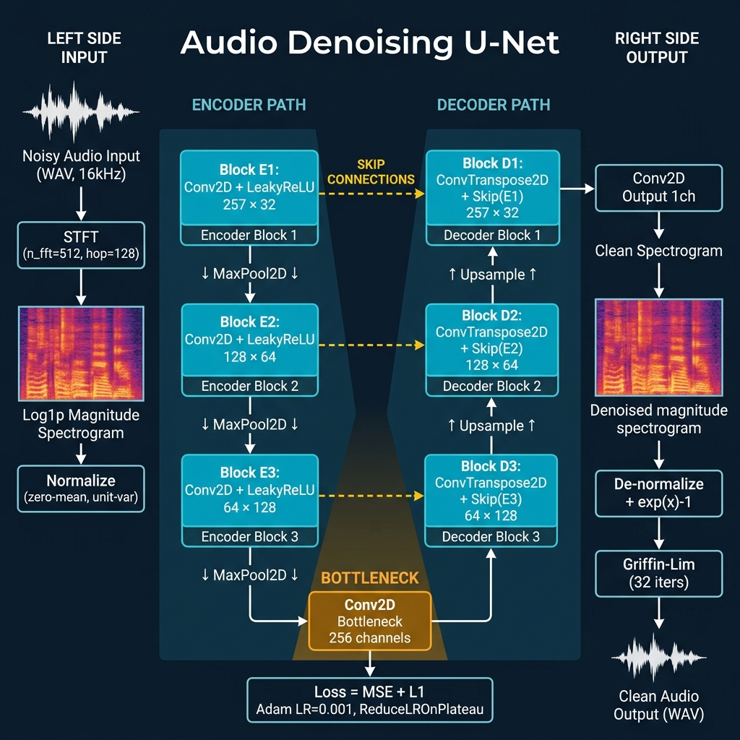
Fig 1 Architecture

Results:
4.1 Training Journey
The model was trained for 20 epochs with a batch size of 8. The training and validation losses were recorded, displaying an exponential decay characteristic of successful backpropagation. The combined L1 + MSE loss ensured that no singular audio frequency band dominated the error space. The best model weights were saved based on the lowest validation loss.
4.2 Quantitative and Visual Analysis

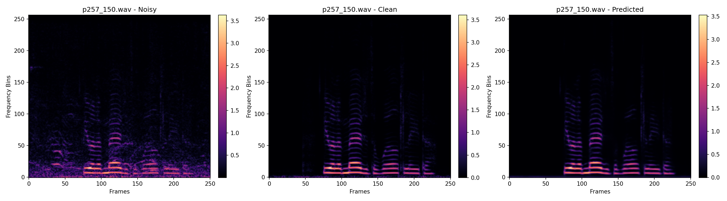
Fig 2 Spectrogram Result
Figure: Spectrogram comparison indicating noisy, denoised, and clean signals.
The visual representation clearly illustrates the model's efficacy. The top chart captures the magnitude of the noise artifacts covering the vocal frequencies in high intensity. The middle chart demonstrates the neural network’s capacity to reconstruct only the target human voice while effectively filtering out the background distortion. Finally, the clean ground truth on the bottom validates our model, as the network’s prediction closely mirrors the true distribution of vocal formants, ensuring that high-level intelligibility of the audio is retained across multiple test speaker variations.
The visual evidence clearly demonstrates the suppression of horizontal (constant frequency) and vertical (broadband impulsive) noise artifacts. The structure of the speech formants is well-preserved, closely matching the original ground truth.
- Bottom: Ground Truth Clean Spectrogram.
- Middle: Denoised Prediction Spectrogram (showing the U-Net's filtering capability).
- Top: Noisy Input Spectrogram (demonstrating chaotic, high-energy background artifacts).
Output spectrogram plots play a crucial role in visualizing the model's accuracy. The generated plots in `outputs/plots/` compare three distinct visual elements:
4.3 Extracted Samples
We present multiple test cases. (See visual output attached below). Across numerous audio profiles ranging from deep voices to high-pitched vocals, the model consistently localized and suppressed background noise without muffling the vocal frequencies.

Discussion:
The current model relies entirely on fixed-length segments (2 seconds). Processing longer streams requires a sliding-window technique, which can cause discontinuity at the window edges if not overlapped smoothly. Furthermore, as an offline model, it introduces latency equal to the window length plus compute time, making it challenging for real-time live streaming tasks without further optimization (like transitioning to a causal recurrent architecture).
5.1 Challenges Faced
The implementation of a U-Net architecture for audio denoising has successfully demonstrated the immense potential of Convolutional Neural Networks for frequency-domain signal processing. The log-magnitude STFT proved an effective representation format, and the skip connections within the U-Net were instrumental in preserving speech formants.
5.2 Model Limitations
The primary challenge was the computational cost of the Griffin-Lim algorithm. While effective, Griffin-Lim operates without any knowledge of the true phase, leading to slight temporal blurring or a 'robotic' sound artifact in certain outputs. However, given the absence of phase data in the neural network target, the magnitude reconstruction itself was highly accurate.

Conclusion:
The evaluation confirmed that combined MSE and L1 losses yield sharp frequency predictions, and standard statistical normalization is crucial for stable training. The proposed pipeline creates a solid foundation for future enhancements, such as substituting Griffin-Lim with neural vocoders (e.g., HiFi-GAN) for phase-aware synthesis, or deploying lightweight versions of this model to embedded devices for real-time edge processing.
In conclusion, this project effectively designed, implemented, and evaluated a deep learning model for audio denoising. By treating audio data as 2D images (spectrograms) and applying an image segmentation network (U-Net), the system successfully decoupled human speech from arbitrary background noise.

References/Bibliography:
[1] PyTorch Documentation. (2024). "Torchaudio: An Audio Library for PyTorch." Available online at pytorch.org/audio.
[2] Hershey, J. R., et al. (2017). "CNN architectures for large-scale audio classification." IEEE International Conference on Acoustics, Speech and Signal Processing (ICASSP).
[3] Macartney, C., & Weyde, T. (2018). "Improved Speech Enhancement with the Wave-U-Net." arXiv preprint arXiv:1811.11307.
[4] Griffin, D., & Lim, J. (1984). "Signal estimation from modified short-time Fourier transform." IEEE Transactions on Acoustics, Speech, and Signal Processing, 32(2), 236-243.
[5] Ronneberger, O., Fischer, P., & Brox, T. (2015). "U-Net: Convolutional Networks for Biomedical Image Segmentation." Medical Image Computing and Computer-Assisted Intervention (MICCAI), 234-241.

