Sentiment Analysis for Marketing: Understanding Customer Preferences through Data

*Phase 3: Development part 1 - loading and preprocessing the dataset*

# In Phase 3 of the "Sentiment Analysis for Marketing" project, we are focused on the initial stage of development, specifically "Loading and Preprocessing the Dataset." This phase involves the critical task of importing the "Twitter US Airline Sentiment" dataset, which serves as the foundational data source for our analysis. We are preparing the data for subsequent phases by cleaning, structuring, and organizing it, ensuring that it is in a suitable format for further analysis. This essential groundwork sets the stage for our project's success in uncovering insights from Twitter data related to airline sentiment, a valuable resource for marketing strategies.

**Table of contents**

* **Loading the dataset**
* **Text lower casing**
* **Outlier detection and treatment**
* **Handling noisy data**
* **Tokenization**
* **Stopword removal**
* **Count of airline’s, airline’s sentiment, user time zone**
* **Airline sentiment visualization**
* **Airline distribution visualization**
* **User time visualization**



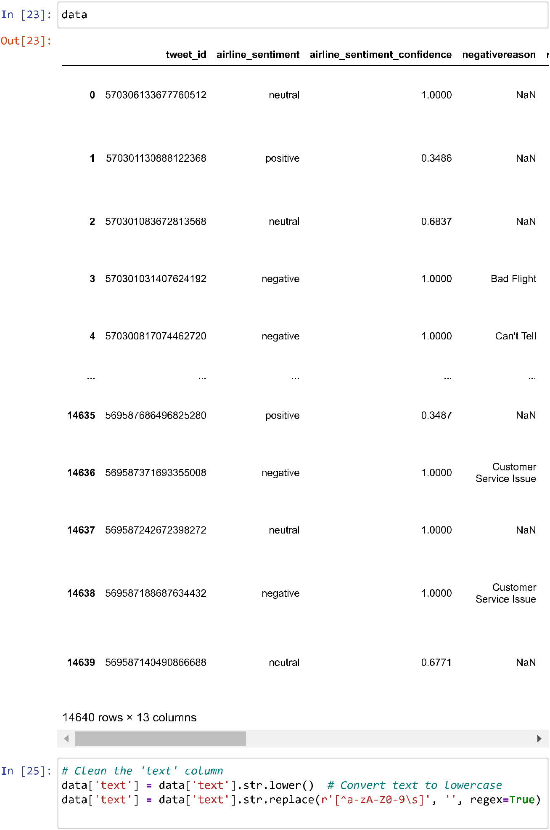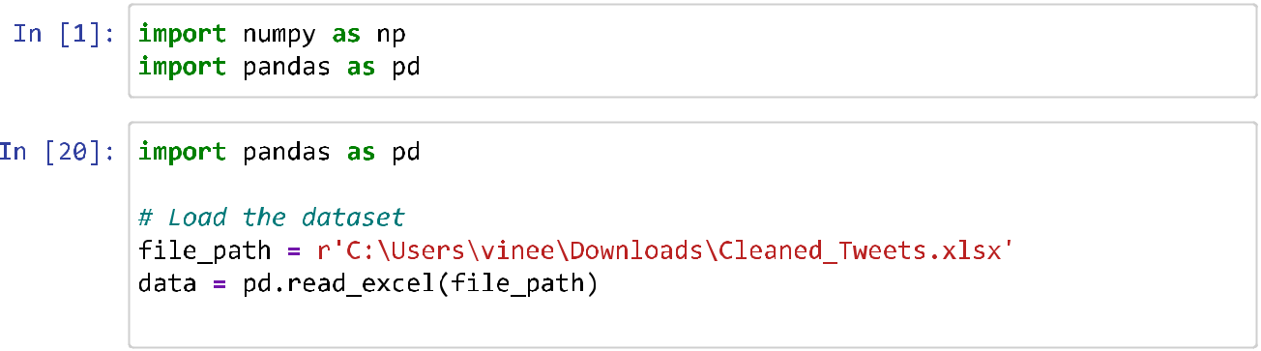

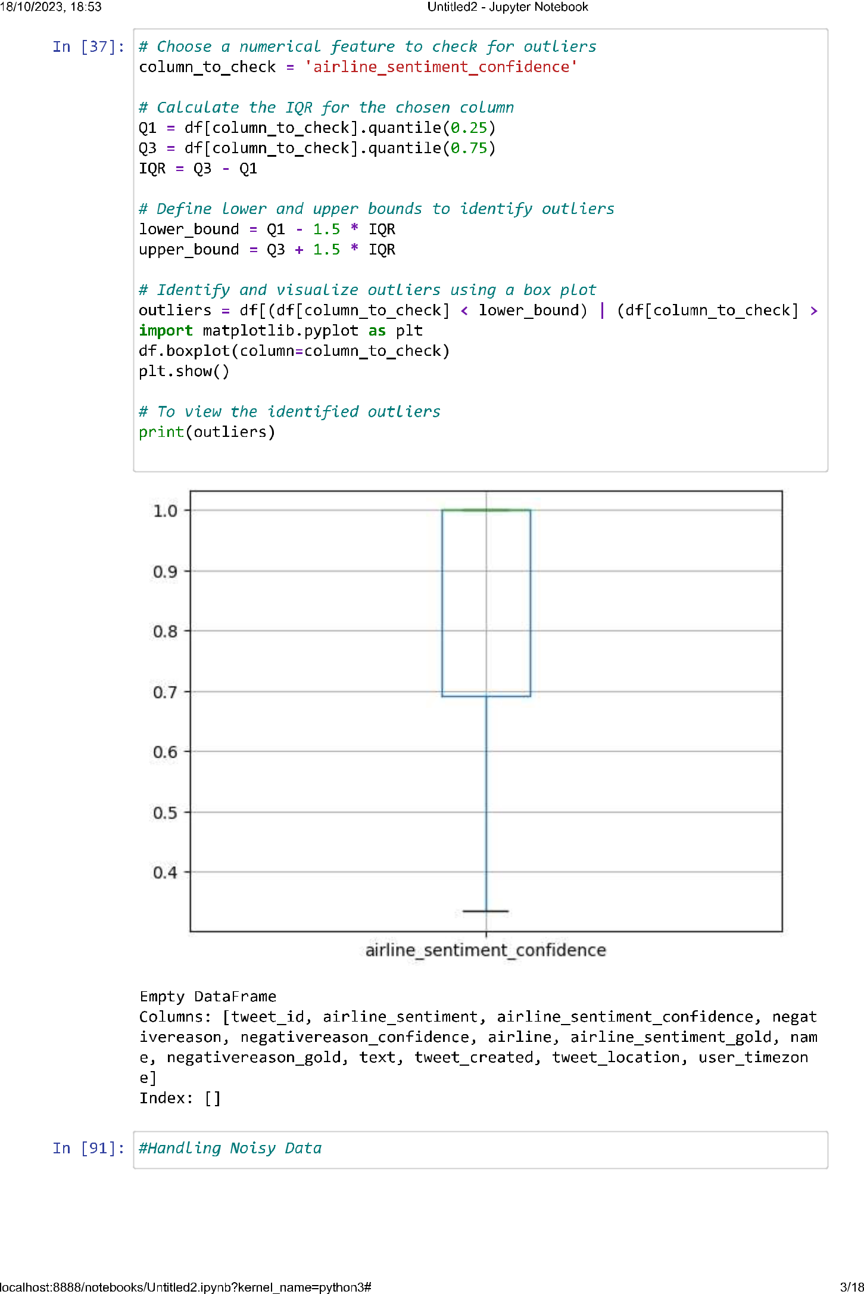

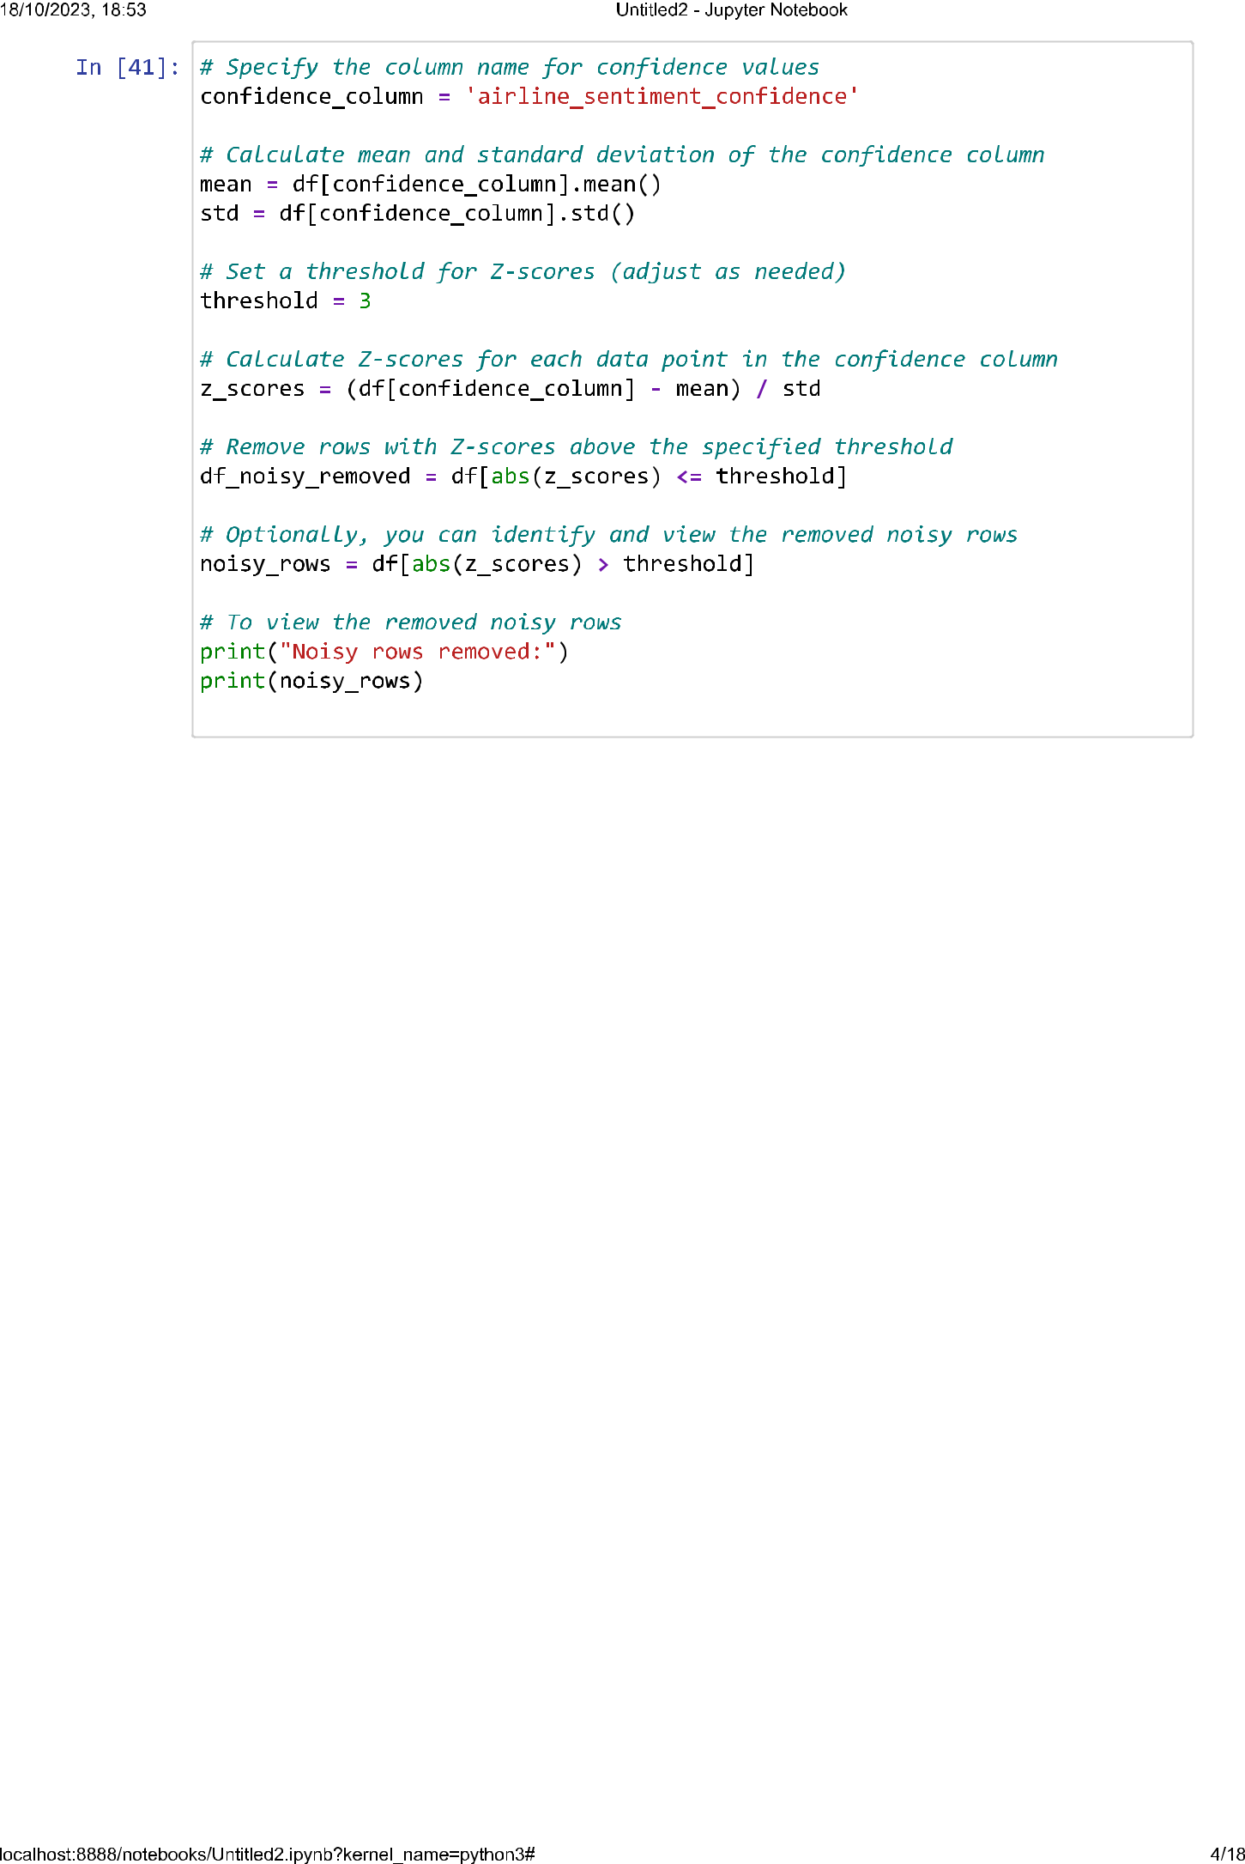

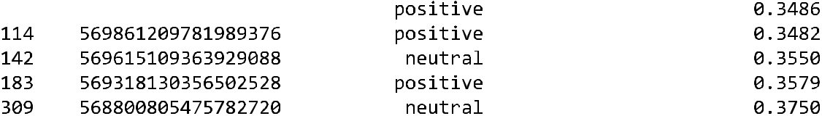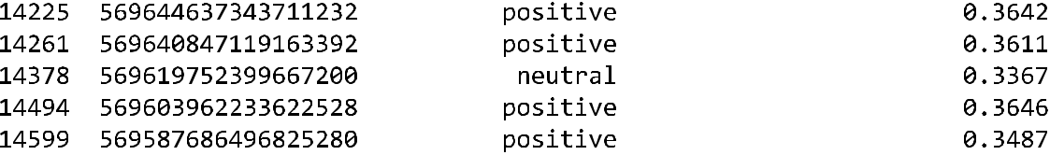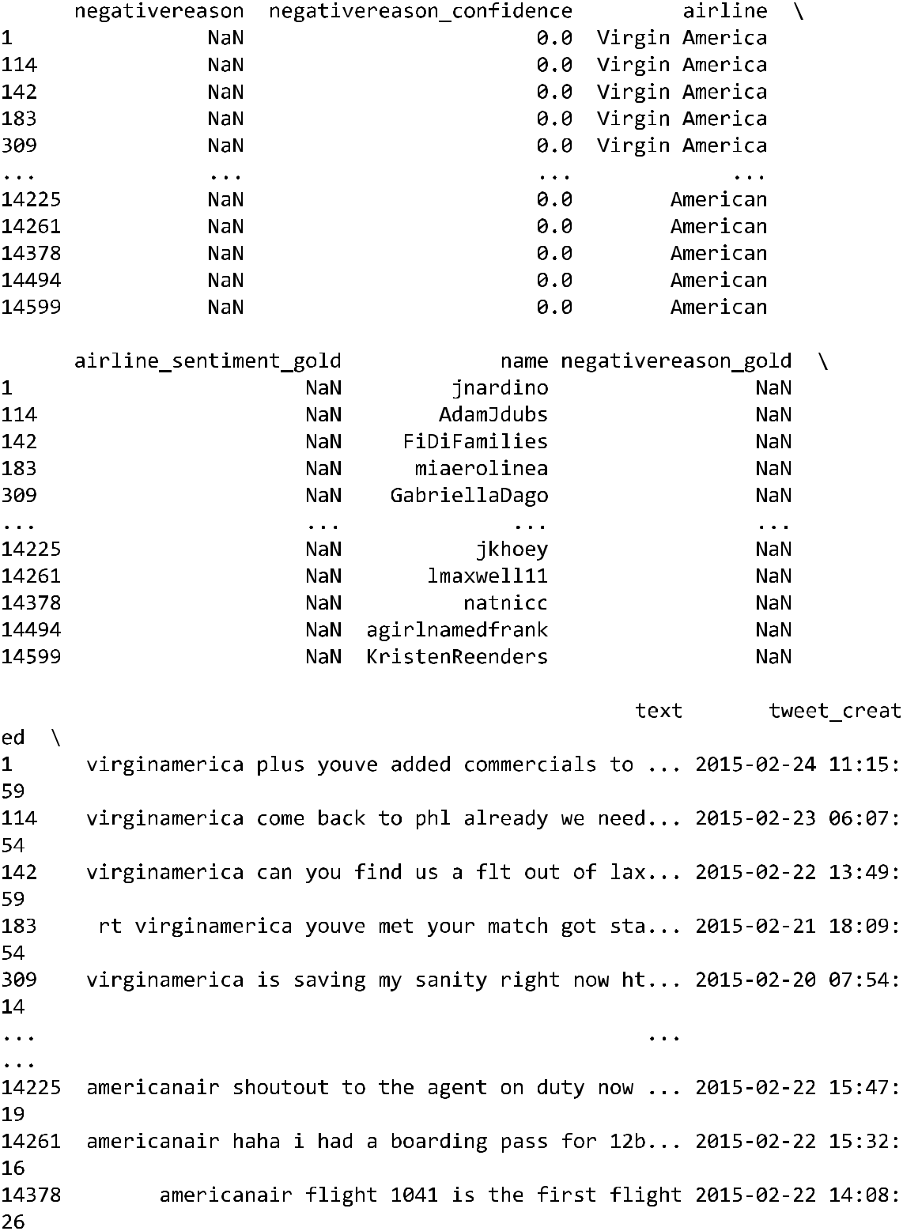

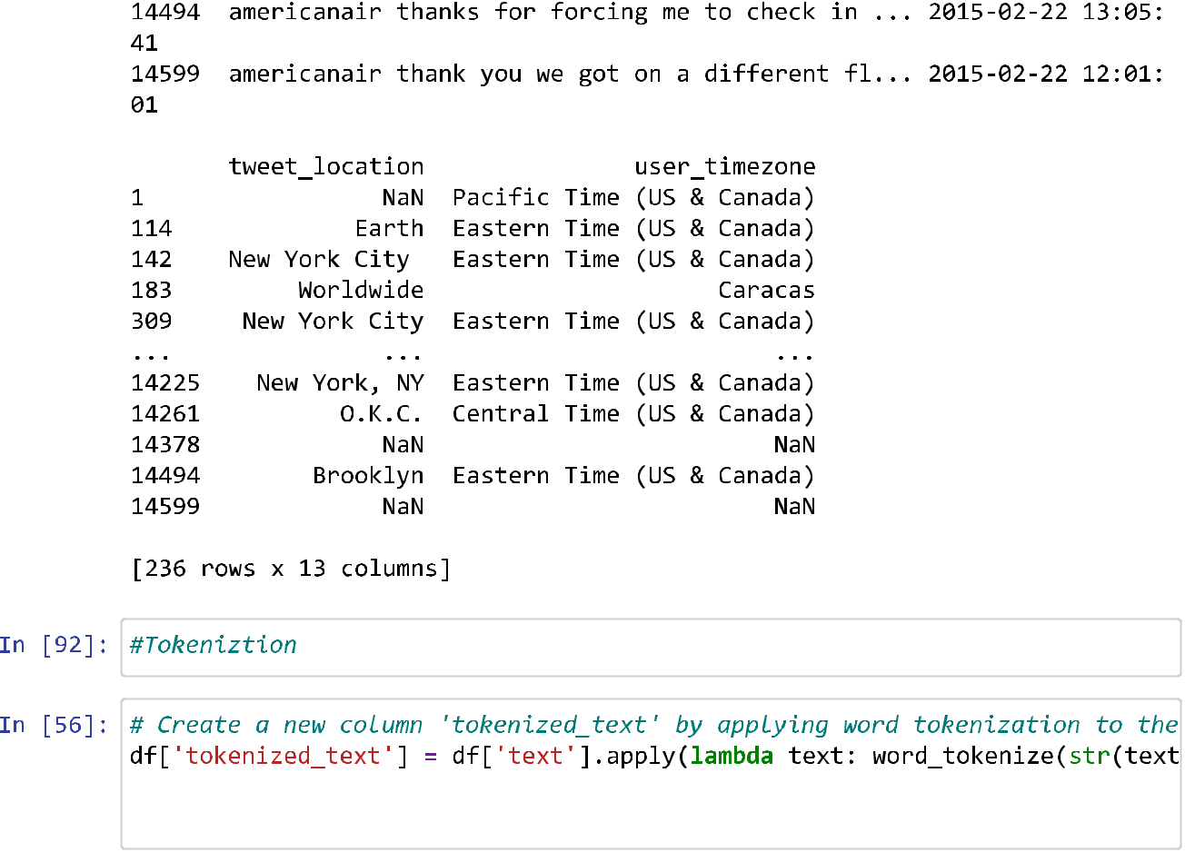

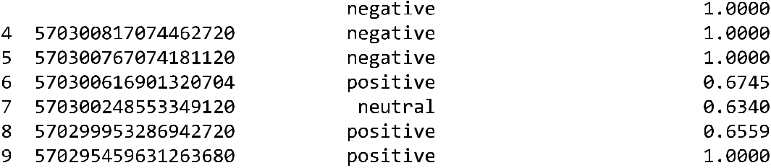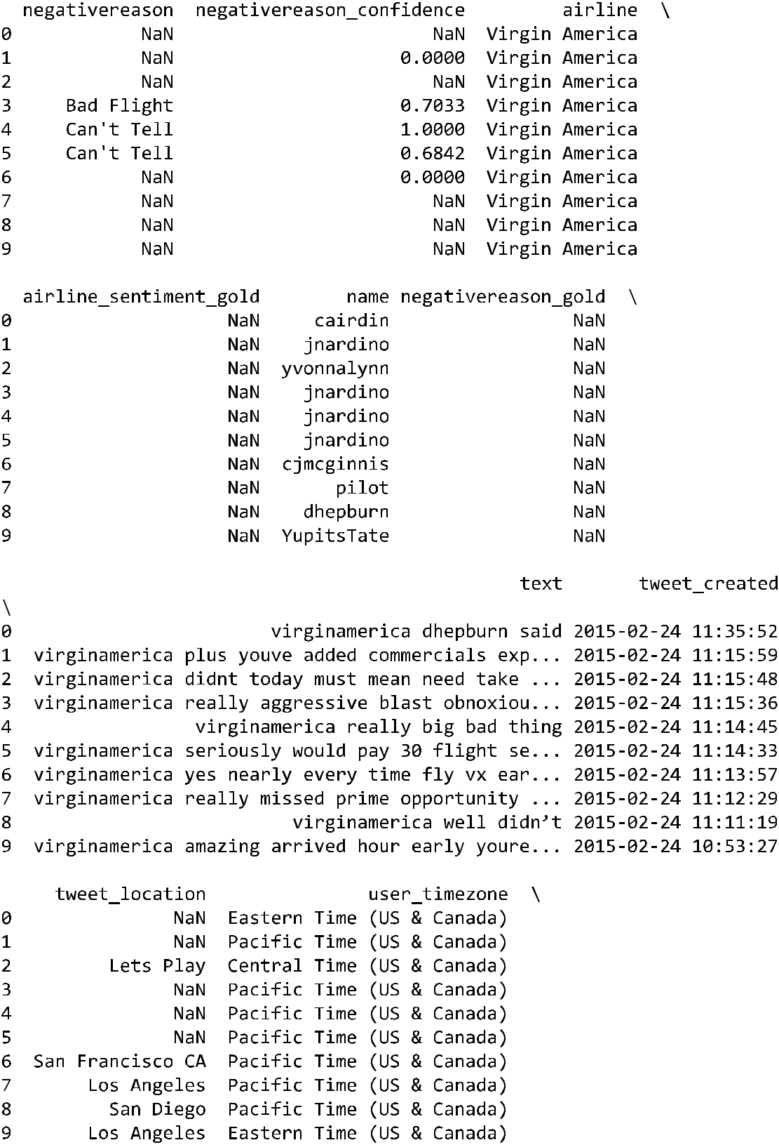

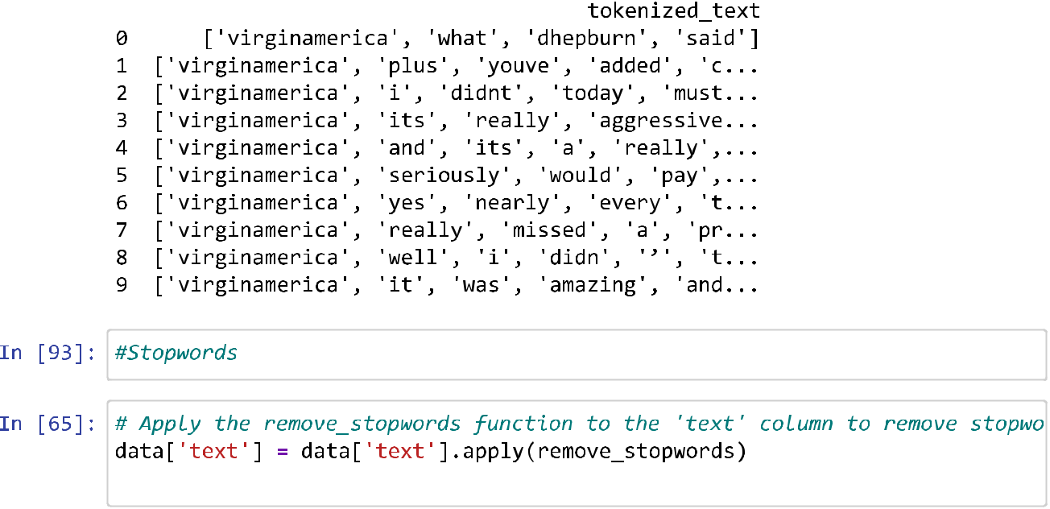

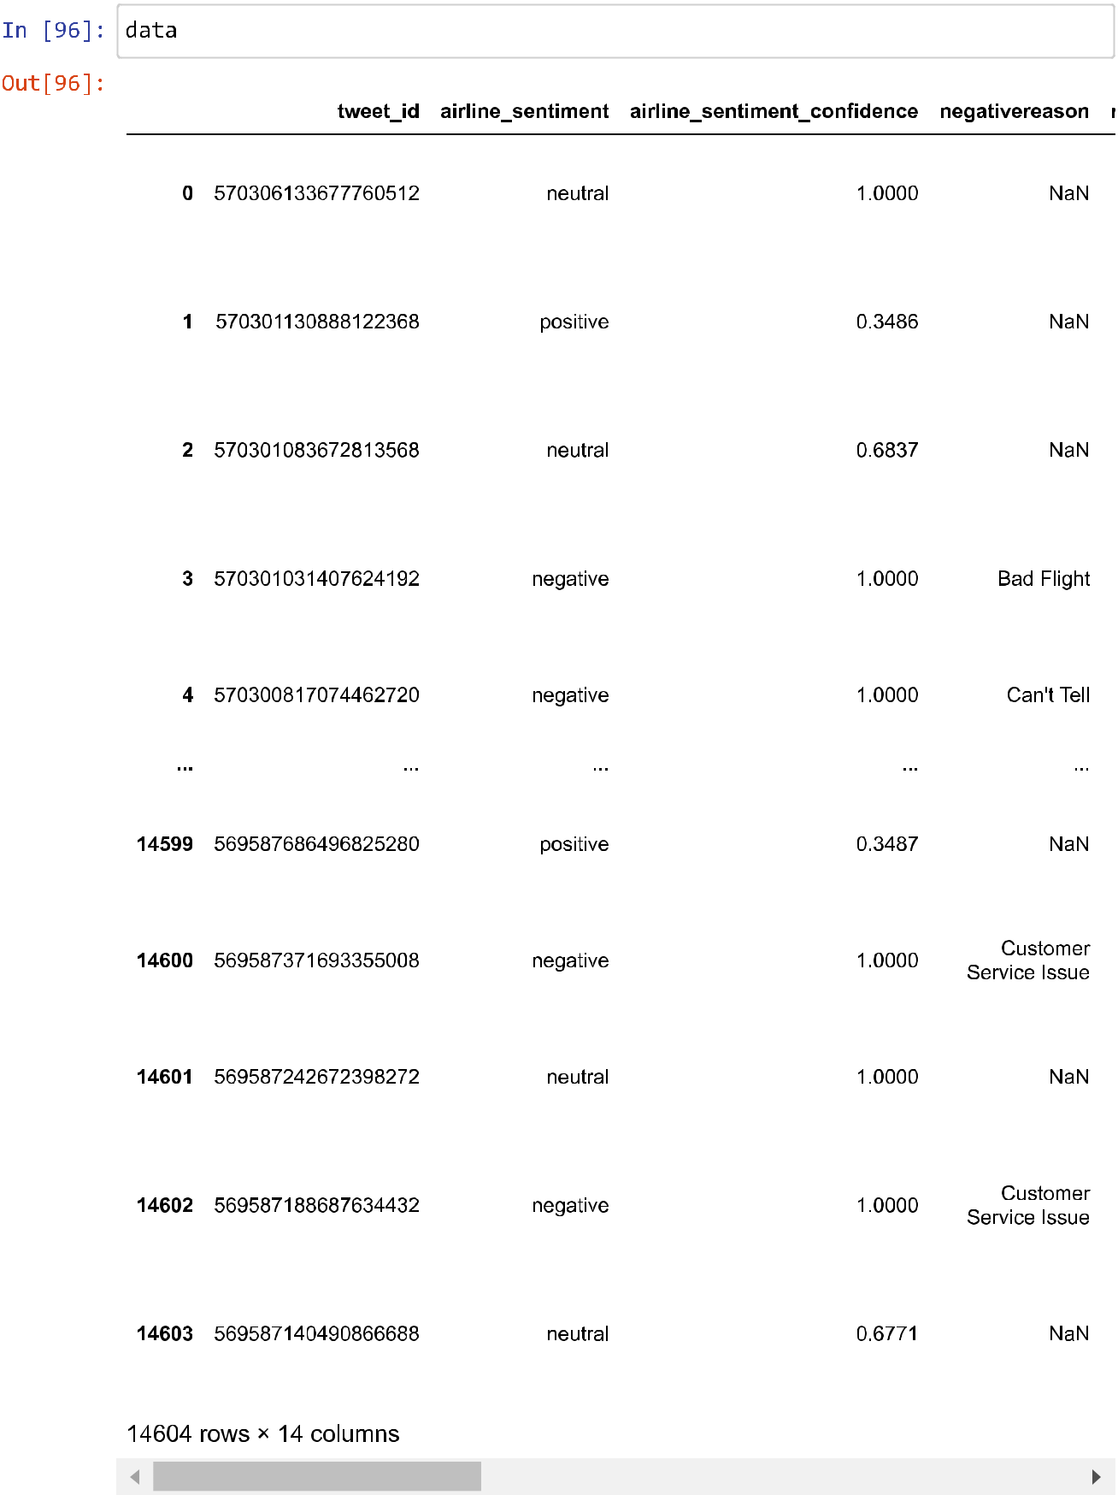

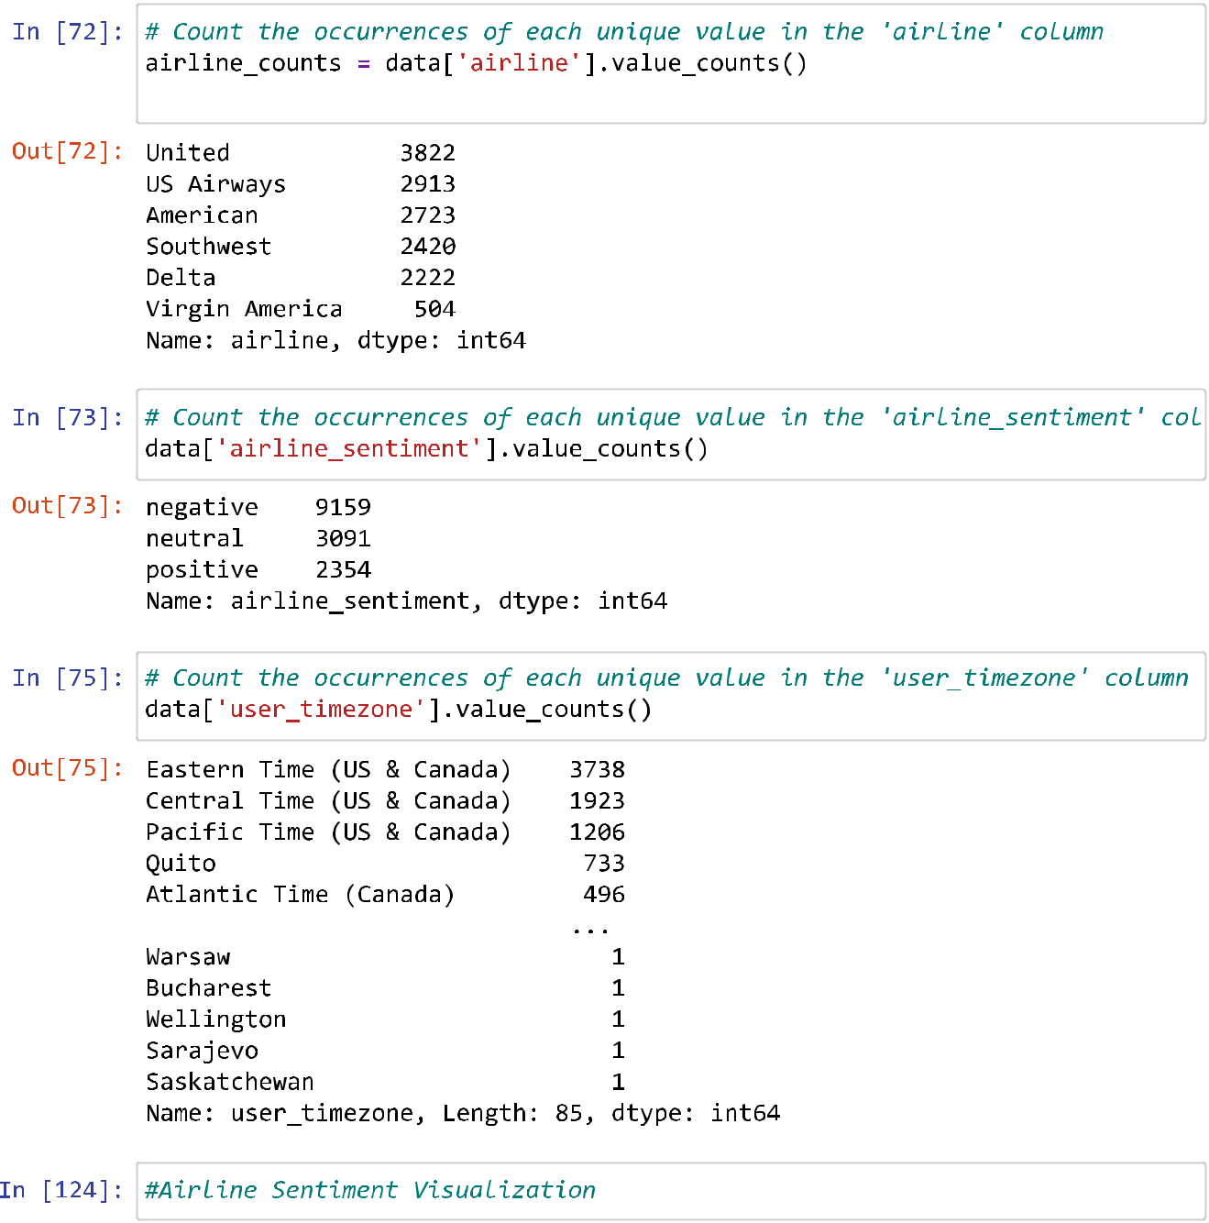

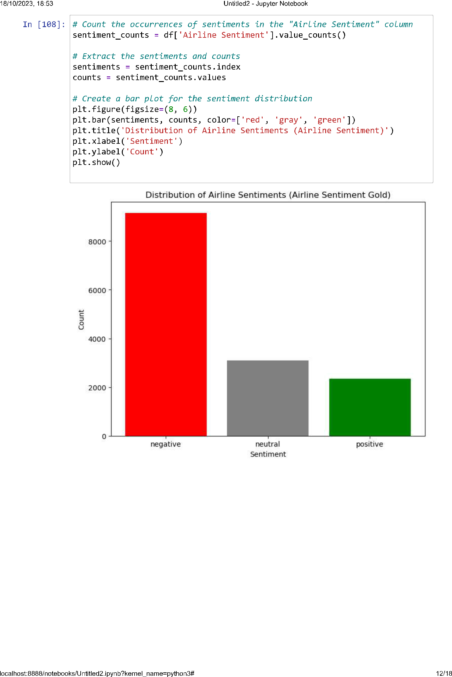

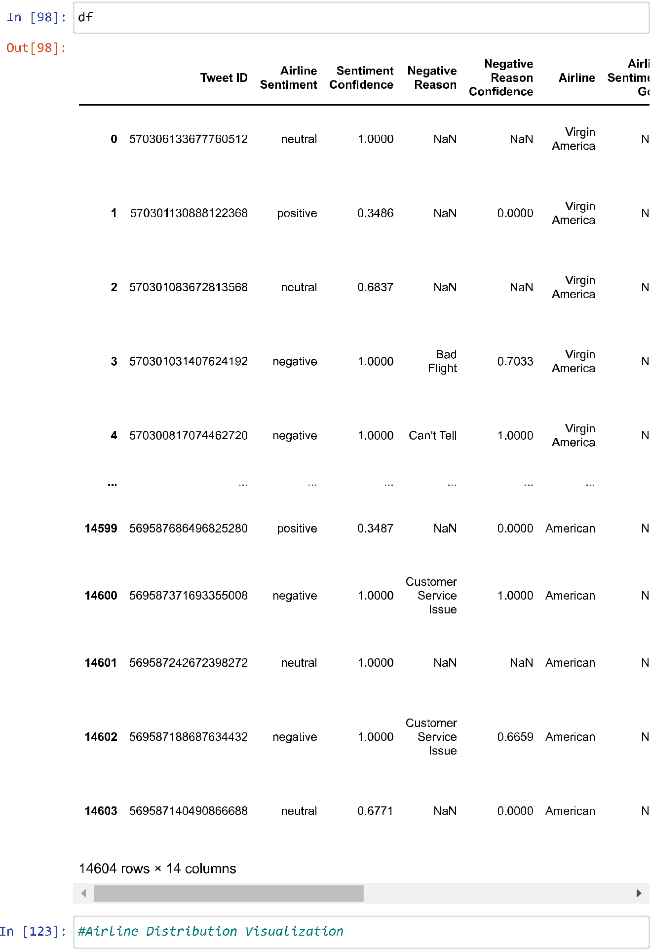

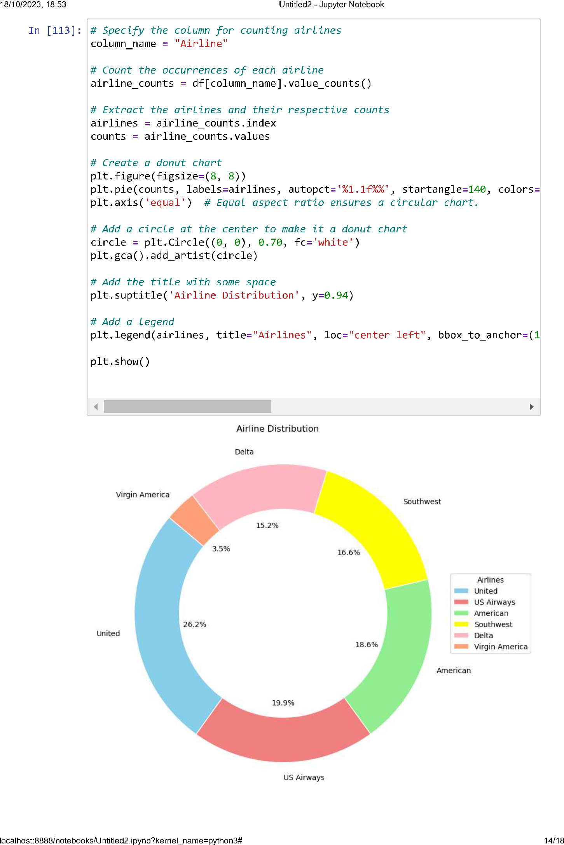

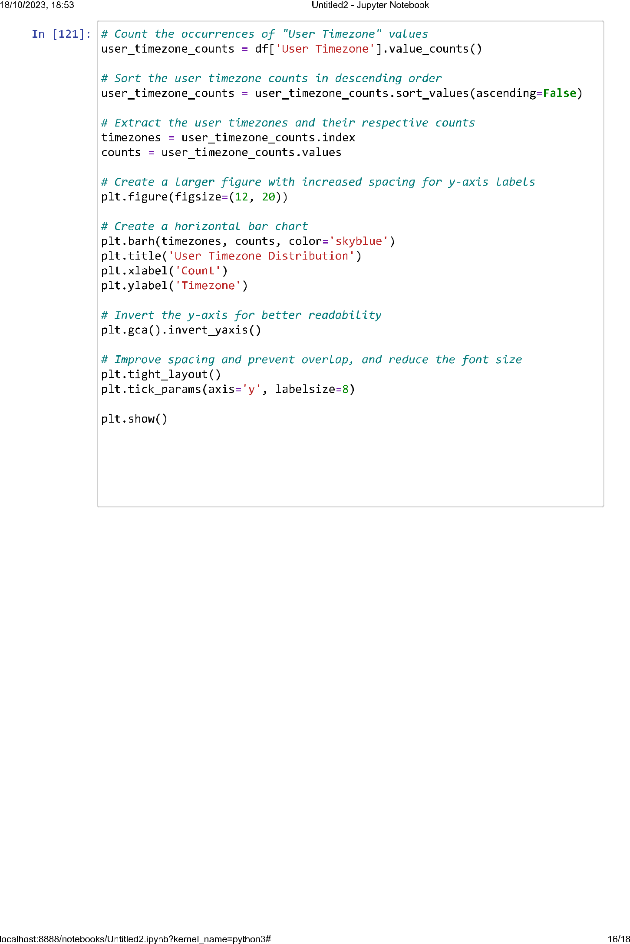

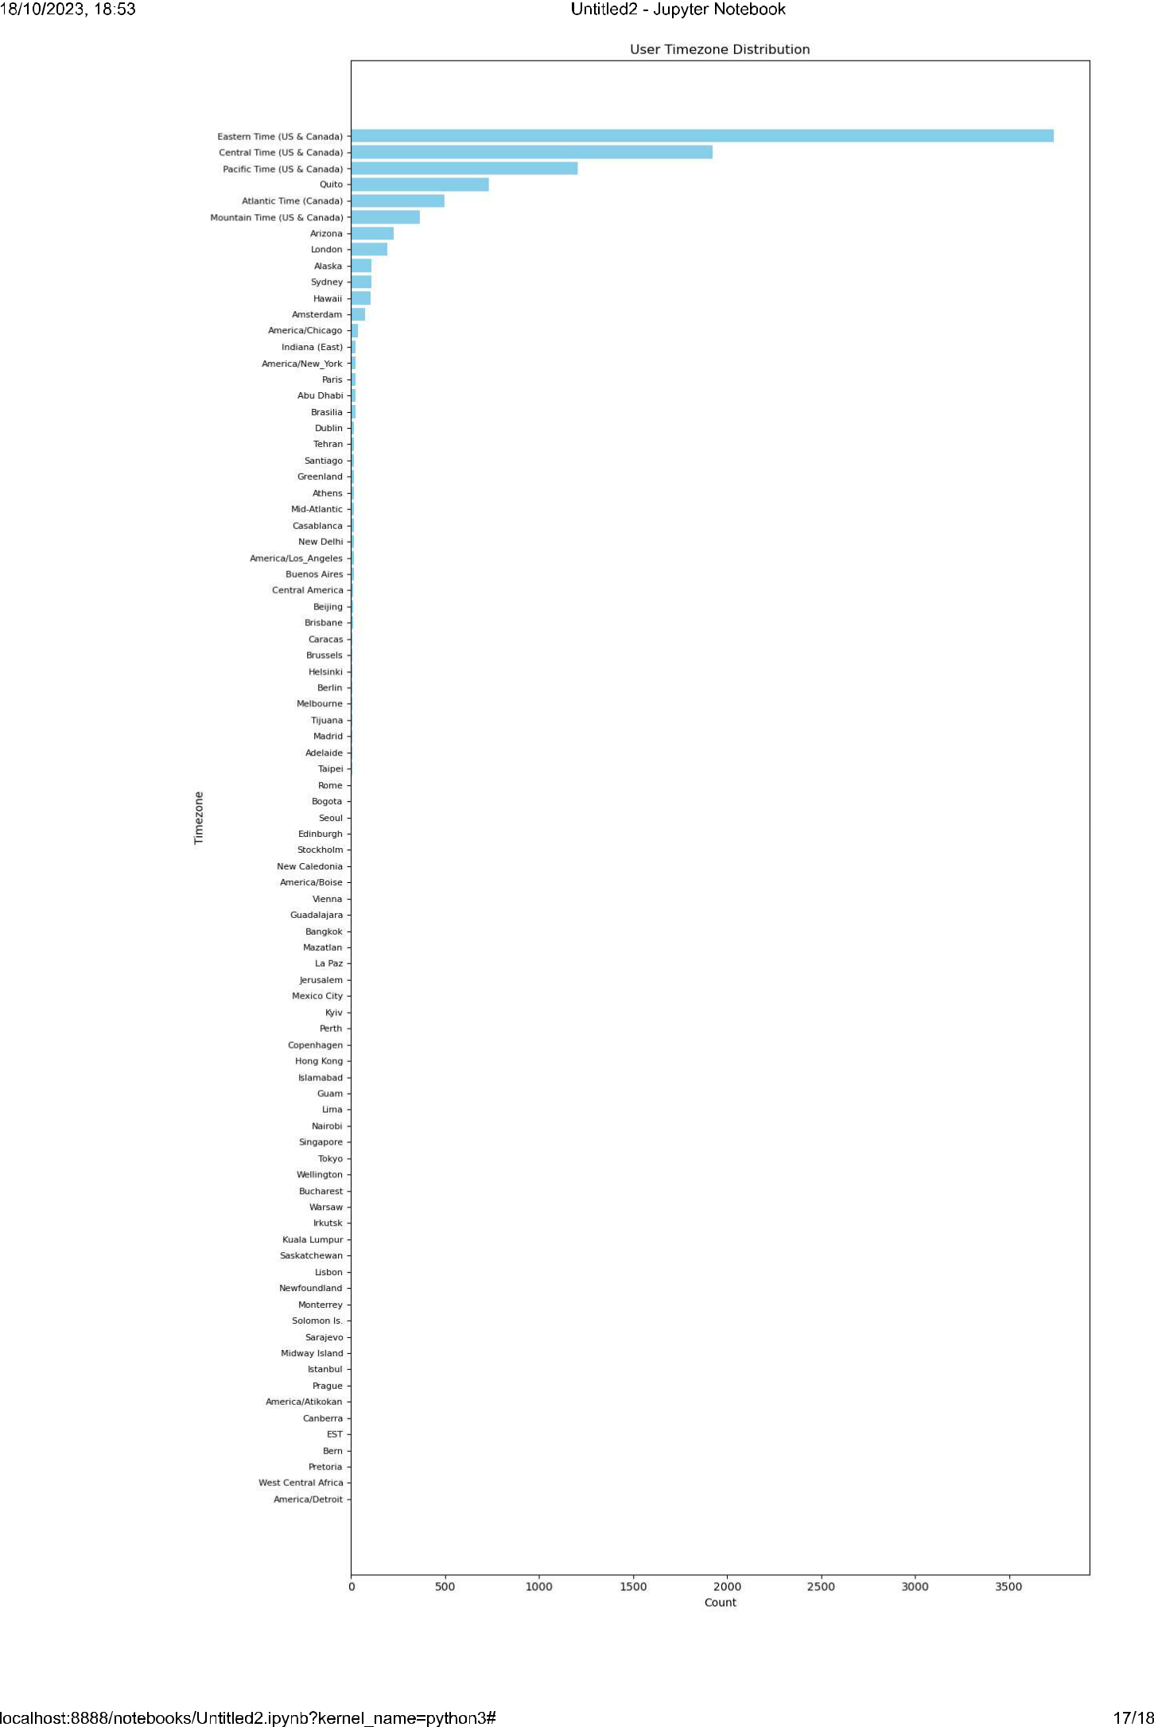

**conclusion:**

In conclusion, Phase 3 of the "Sentiment Analysis for Marketing" project has been instrumental in laying the foundation for our data analysis journey. By successfully loading and preprocessing the "Twitter US Airline Sentiment" dataset, we have prepared our data for more advanced phases. The comprehensive data cleaning and structuring performed in this phase ensure that our dataset is now in a suitable state for further analysis. As we move forward, we are well-equipped to delve deeper into sentiment analysis and extract valuable insights from the world of Twitter, a key step in informing and enhancing marketing

-S. Vishwa Moorthy

B.E CSE 3rd yr. 5th SEM

311421104306

Meenakshi College of Engineering - 3114

