# Exp No: 3

# Reg.No: 210701315 Date: 30.07.2024

VIRTUALIZATION

**INSTALLATION OF VIRTUAL MACHINE IN VIRTUAL BOX**

# AIM:

To configure a Virtual Machine using Virtual Box and Launch to execute a

simple program using PYTHON.

# PROCEDURE:

1. Launch a Virtual Box
2. Create new virtual machine
3. Customize the set-up
4. Set username and password
5. Browse for .iso file of an operating system
6. Configure the hardware capacity
7. Finish and power on the VM
8. Install C or PYTHON OR JAVA Compiler and execute a simple program

# INSTALLATION:

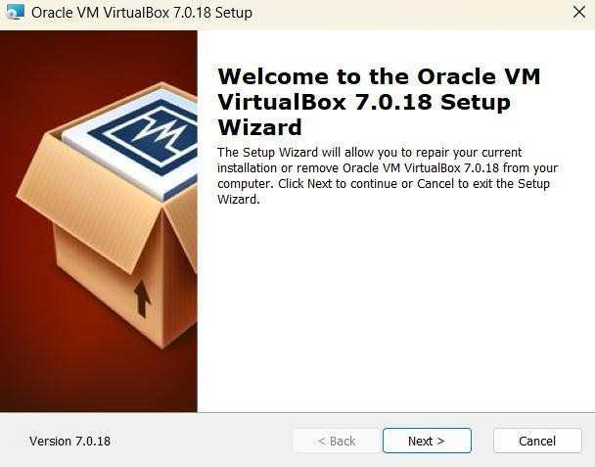

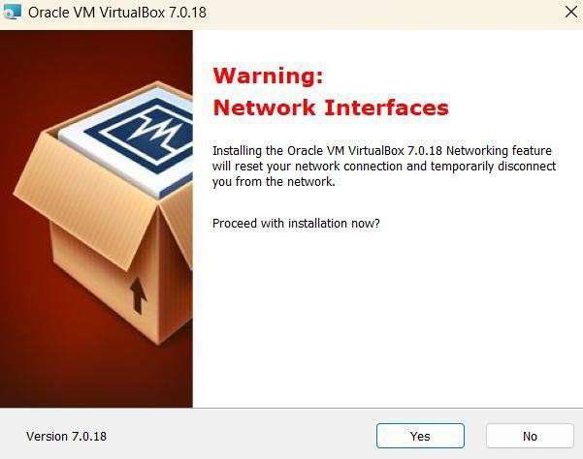

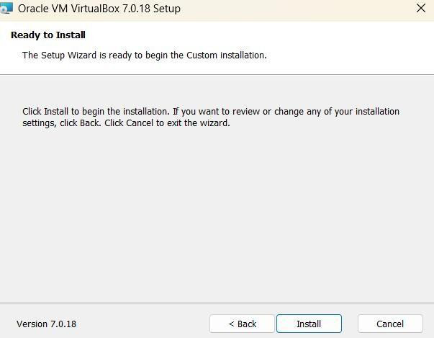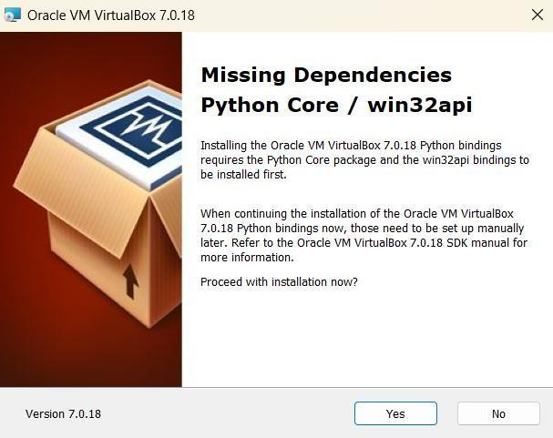

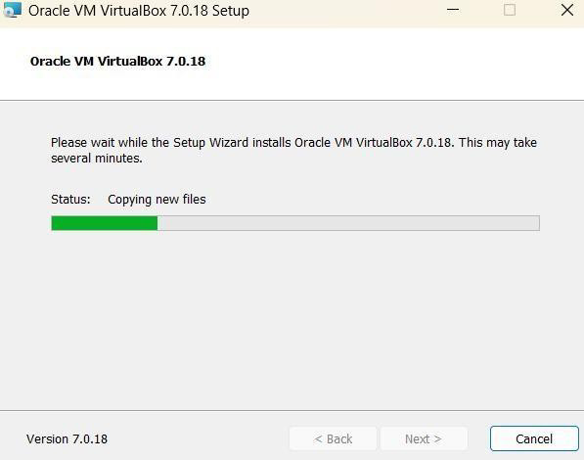

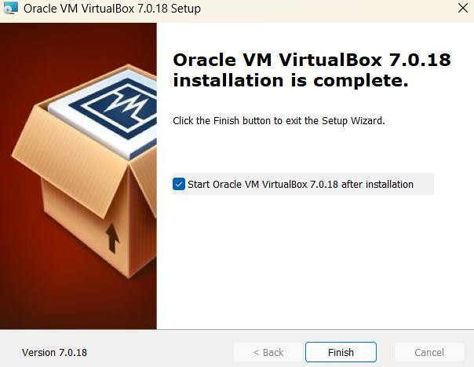

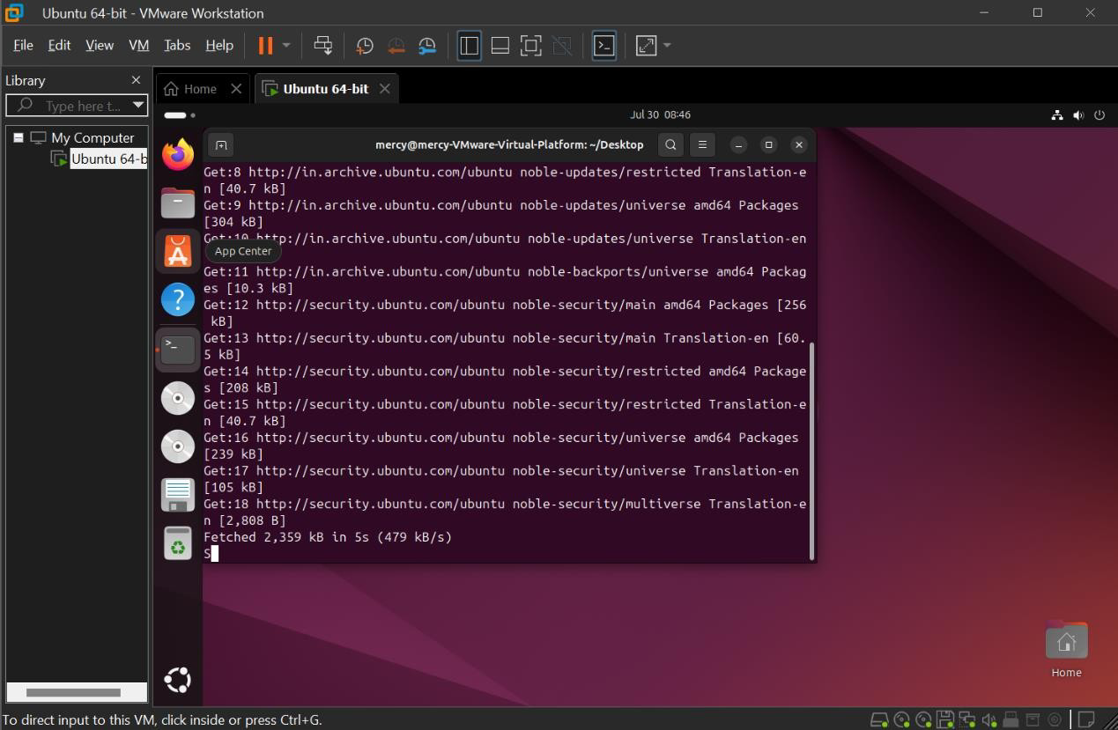

**PROGRAM:**

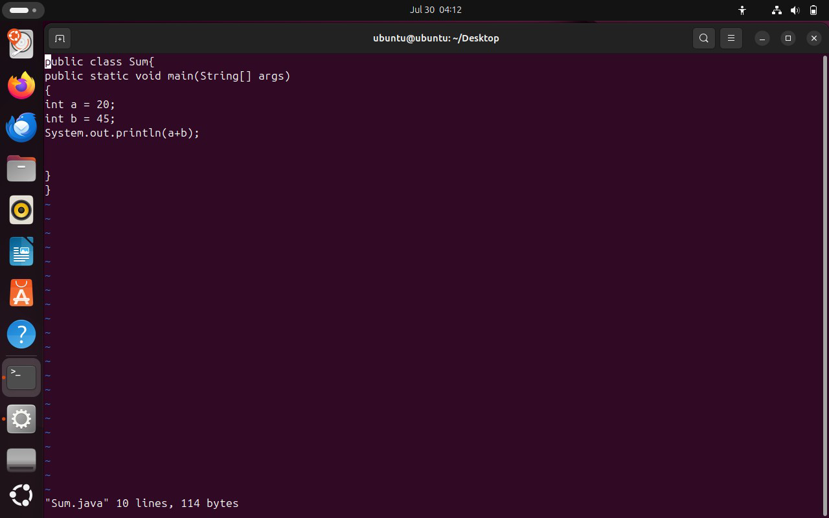

# OUTPUT:

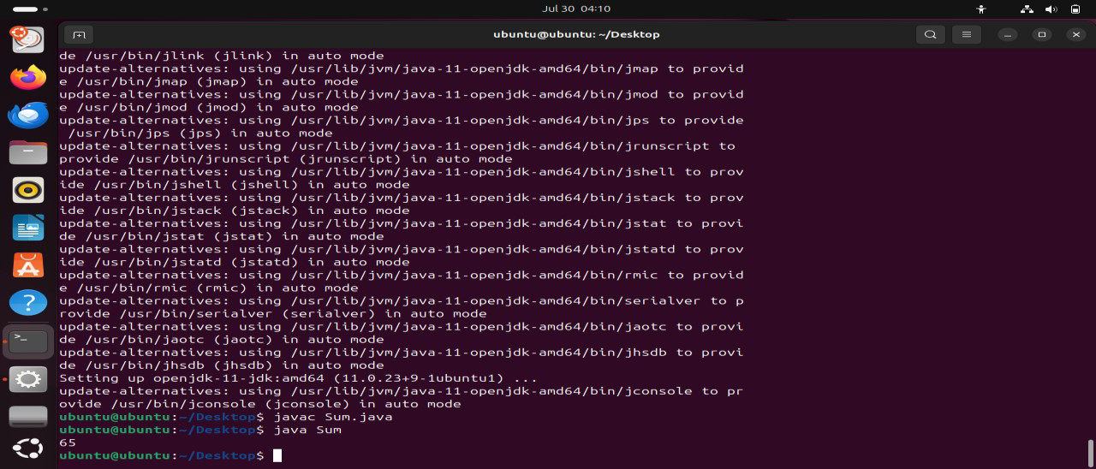

**RESULT:**

The virtual machine of Ubuntu OS was created using a virtual box. Ubuntu virtual machine running in Virtual Box.