EX.NO: 09 REG.NO:210701315

DATE:

**HADOOP SET UP A SINGLE HADOOP CLUSTER AND SHOW THE PROCESSUSING WEB UI**

**AIM:**

To set-up one node Hadoop cluster.

**PROCEDURE:**

1. System Update

2. Install Java

3. Add a dedicated Hadoop user

4. Install SSH and setup SSH certificates

5. Check if SSH works

6. Install Hadoop

7. Modify Hadoop config files

8. Format Hadoop filesystem

9. Start Hadoop

10. Check Hadoop through web UI

11. Stop Hadoop

**THEORY**

Hadoop is an Apache open source framework written in java that allows distributed processing of large datasets across clusters of computers using simple programming models. A Hadoop frame-worked application works in an environment that provides distributed storage and computation across clusters of computers. Hadoop is designed to scale up from a single server to thousands of machines, each offering local computation and storage.

**HADOOP ARCHITECTURE**

Hadoop framework includes following four modules:

Hadoop Common: These are Java libraries and utilities required by other Hadoop modules. These libraries provide filesystem and OS level abstractions and contain the necessary Java files and scripts required to start Hadoop.

Hadoop YARN: This is a framework for job scheduling and cluster resource management

Hadoop Distributed File System (HDFS): A distributed file system that provides highthroughput access to application data.

Hadoop MapReduce: This is a YARN-based system for parallel processing of large data sets.

We can use following diagram to depict these four components available in Hadoop

Framework.

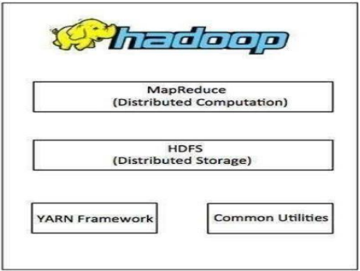

**PROCEDURE**

Step 1 – System Update

$ sudo apt-get update

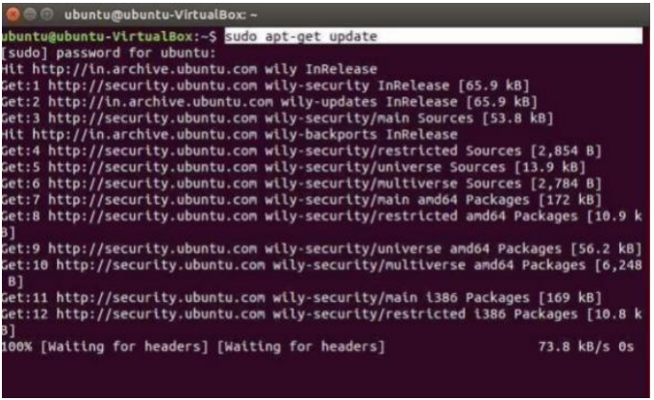

Step 2 – Install Java and Set JAVA_HOME

//This first thing to do is to setup the webupd8 ppa on your system. Run the following

command and proceed.

$ sudo apt-add-repository ppa:webupd8team/java

$ sudo apt-get update

//After setting up the ppa repository, update the package cache as well.

//Install the Java 8 installer

$ sudo apt-get install oracle-java8-installer

// After the installation is finished, Oracle Java is setup. Run the java command again to

check the version and vendor.

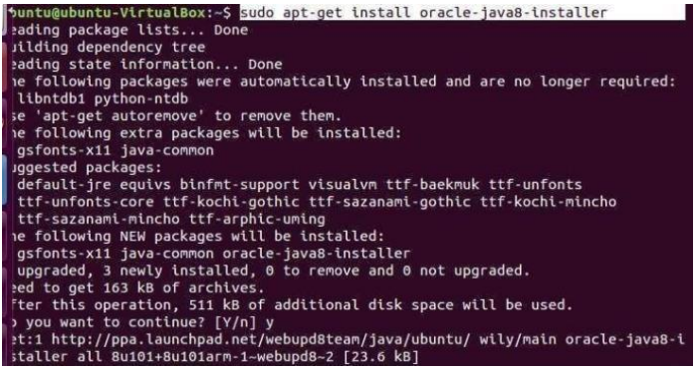

OR

$ sudo apt-get install default-jdk

$ java –version

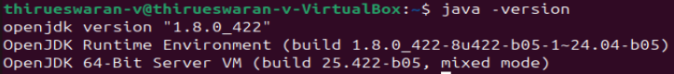

Step 3 – Add a dedicated Hadoop user

$ sudo addgroup hadoop



$ sudo adduser --ingroup hadoop hduse

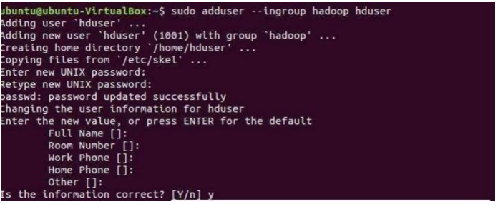

// Add hduser to sudo user group

$ sudo adduser hduser sudo

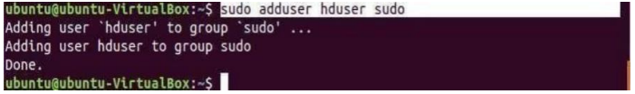

Step 4 – Install SSH and Create Certificates

$ sudo apt-get install ssh

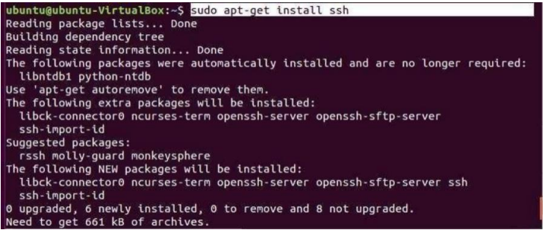

$ su hduser



$ ssh-keygen -t rsa -P ""

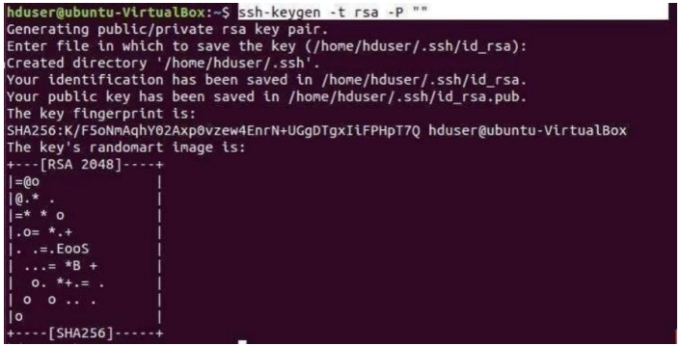

// Set Environmental variables

$ cat $HOME/.ssh/id_rsa.pub >> $HOME/.ssh/authorized_keys



Step 6 – Install Hadoop

$ wget https://archive.apache.org/dist/hadoop/core/hadoop-2.8.4/hadoop-2.8.4.tar.gz

// Extract Hadoop-2.8.4

$ sudo tar xvzf hadoop-2.8.4.tar.gz



// Create a folder ‘hadoop’ in /usr/local

$ sudo mkdir –p /usr/local/hadoop



// Move the Hadoop folder to /usr/local/hadoop

$ sudo mv hadoop-2.8.4 /usr/local/hadoop



// Assigning read and write access to Hadoop folder

$ sudo chown –R hduser:hadoop /usr/local/hadoop



Step 7 - Modify Hadoop config files

//Hadoop Environmental variable setting – The following files will be modified

1. ~/.bashrc

2. /usr/local/hadoop/hadoop-2.8.4/etc/hadoop/hadoop-env.sh

3. /usr/local/hadoop/hadoop-2.8.4/etc/hadoop/core-site.xml

4. /usr/local/hadoop/hadoop-2.8.4/etc/hadoop/hdfs-site.xml

5. /usr/local/hadoop/hadoop-2.8.4/etc/hadoop/yarn-site.xml

6. /usr/local/hadoop/hadoop-2.8.4/etc/hadoop/mapred-site.xml.template

$ sudo nano ~/.bashrc

// Add the following lines at the end of the file

export JAVA_HOME=/usr/lib/jvm/java-8-oracle

export HADOOP_HOME=/usr/local/hadoop/hadoop-2.8.4 export

PATH=$PATH:$HADOOP_HOME/bin

export PATH=$PATH:$HADOOP_HOME/sbin

export HADOOP_MAPRED_HOME=$HADOOP_HOME export

HADOOP_COMMON_HOME=$HADOOP_HOME export

HADOOP_HDFS_HOME=$HADOOP_HOME

export YARN_HOME=$HADOOP_HOME

HADOOP_COMMON_LIB_NATIVE_DIR=$HADOOP_HOME/lib/native export

HADOOP_OPTS="-D.java.library.path=$HADOOP_HOME/lib" export

PATH=$PATH:/usr/local/hadoop/hadoop-2.8.4/bin

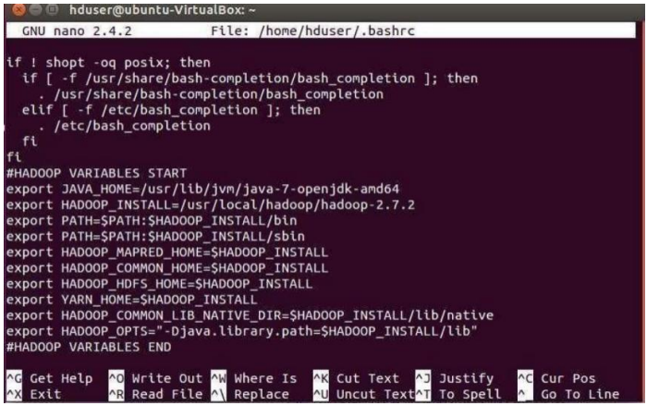

// Configure Hadoop Files

$ cd /usr/local/hadoop/hadoop-2.8.4/etc/hadoop/

$ sudo nano hadoop-env.sh

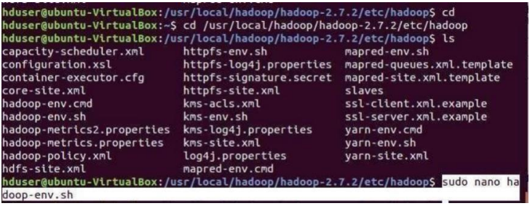

// Add following line in hadoop-env.sh – Set JAVA variable in Hadoop

# The java implementation to use.

export JAVA_HOME=/usr/lib/jvm/java-8-oracle

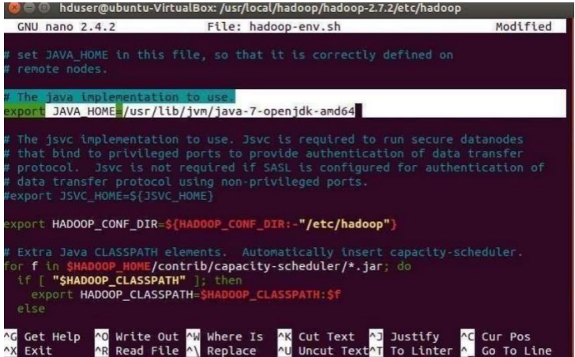

// Create datanode and namenode

$ sudo mkdir –p /usr/local/hadoop_tmp/hdfs/namenode

$ sudo mkdir –p /usr/local/hadoop_tmp/hdfs/datanode

// Changing ownership to hadoop_tmp

$ sudo chown –R hduser:hadoop /usr/local/hadoop_tmp



// Edit hdfs-site.xml

$ sudo nano hdfs-site.xml

// Add the following lines between <configuration> …… </configuration>

<configuration>

<property>

<name>dfs.replication</name>

<value>1</value>

</property>

<property>

<name>dfs.namenode.name.dir</name>

<value>file:/usr/local/hadoop_tmp/hdfs/namenode</value>

</property>

<property>

<name>dfs.datanode.data.dir</name>

<value>file:/usr/local/hadoop_tmp/hdfs/datanode</value>

</property>

</configuration>  
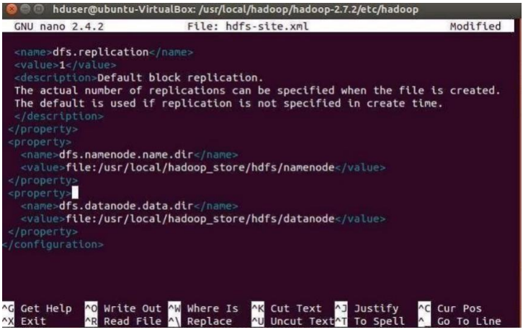

// Edit core-site.xml

$ sudo nano core-site.xml

// Add the following lines between <configuration> …… </configuration>

<configuration>

<property>

<name>fs.default.name</name>

<value>hdfs://localhost:9000</value>

</property>

</configuration>

// Edit yarn-site.xml

$ sudo nano yarn-site.xml

// Add the following lines between <configuration> …… </configuration>

<configuration>

<property>

<name>yarn.nodemanager.aux-services</name>

<value>mapreduce_shuffle</value>

</property>

<property>

<name>yarn.nodemanager.aux-services.mapreduce.shuffle.class</name>

<value>org.apache.hadoop.mapred.Shuffle-Handler</value>

</property>

</configuration>

// Edit mapred-site.xml

$ cp /usr/local/hadoop/hadoop-2.8.4/etc/hadoop/mapred-site.xml.template

/usr/local/hadoop/hadoop-2.8.4/etc/hadoop/mapred-site.xml



$ sudo nano mapred-site.xml

// Add the following lines between <configuration> …… </configuration>

<configuration>

<property>

<name>mapreduce.framework.name</name>

<value>yarn</value>

</property>

</configuration>

Step 8 – Format Hadoop File System

$ cd /usr/local/hadoop/hadoop-2.8.4/bin

$ hadoop namenode –format

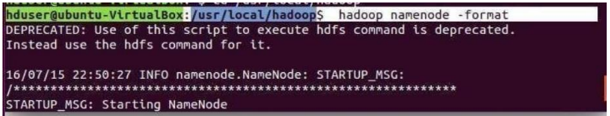

Step 9 - Start Hadoop

$ cd /usr/local/hadoop/hadoop-2.8.4/sbin

// Starting dfs services

$ start-dfs.sh

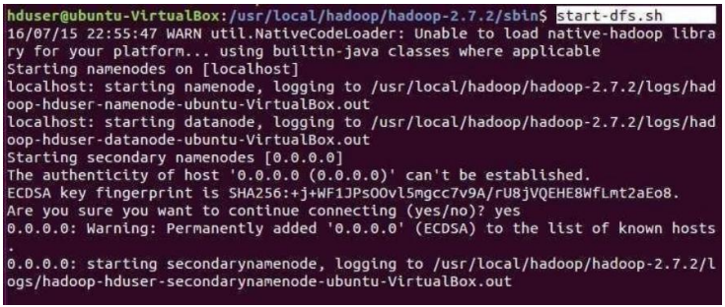

// Starting mapreduce services

$ start-yarn.sh

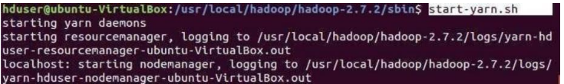

$ jps



Step 10 - Check Hadoop through web UI

Go to browser type http://localhost:8088 – All Applications Hadoop Cluster

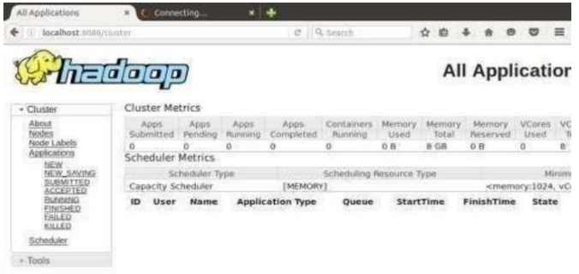

Go to browser type http://localhost:50070 – Hadoop Namenode

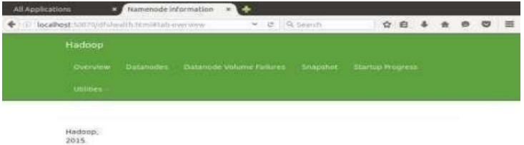

Step 11 - Stop Hadoop

$ stop-dfs.sh

$ stop-yarn.sh

**RESULT:**

Thus the procedure to install single-node Hadoop is executed successfully.