**ASSIGNMENT-5**

**CIFAR10 DATASET**

**(BLAZER ID : VCHALLA3)**

The Following Pictures of the Grid and Random Search Pictures will help in describing the plot between the training and validation data. Based On which we will be able to notice that there is any chance of overfitting for the data or not.

Loss Plot can also help in determining the Overfitting of the data.

**Grid Search Parameters.**

For the Grid Search Parameters, Hyper Parameters which I have chosen are number of neurons (32, 64 and 96) present in the dense layer and batch size (32, 64 and128) from the compiling params. Possible Cartesian Combinations are 9.

Number Of Neurons = 32, Batch Size = 32, loss: 0.6031 - accuracy: 0.7965

Number Of Neurons = 32, Batch Size = 64, loss: 0.5826 - accuracy: 0.7995

Number Of Neurons = 32, Batch Size = 128, loss: 0.5906 - accuracy: 0.7980

Number Of Neurons = 64, Batch Size = 32, loss: 0.5986 - accuracy: 0.7962

Number Of Neurons = 64, Batch Size = 64, loss: 0.5805 - accuracy: 0.7996

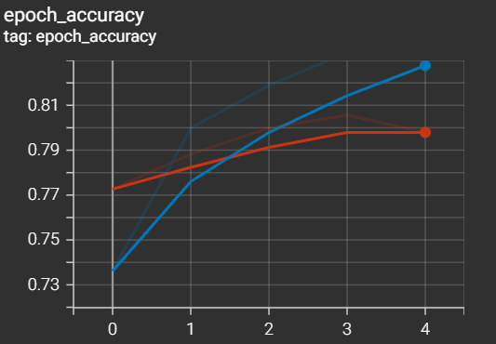

Number Of Neurons = 64, Batch Size = 128, loss: 0.5677 - accuracy: 0.8061

Number Of Neurons = 96, Batch Size = 32, loss: 0.6010 - accuracy: 0.8019

Number Of Neurons = 96, Batch Size = 64, loss: 0.5903 - accuracy: 0.8023

Number Of Neurons = 96, Batch Size = 128, loss: 0.5956 - accuracy: 0.7992

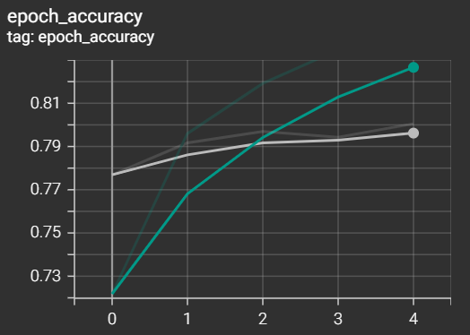

Complete Graph for the Grid Search.

**Random Search Parameters.**

I have considered the best outputs as the constant parameters(number of neurons:64,Batch Size:128) for the random search and made the Optimizer (Adam, RMSprop), Activation Function (relu, tanh) and Epochs (5, 10, 15). I have Given the iterations also as a random variable. For the Testing now it considered 6 iterations.

Epochs-5, Activation Function- ReLU, Optimizer- RMSprop, loss: 0.6252 - accuracy: 0.7879

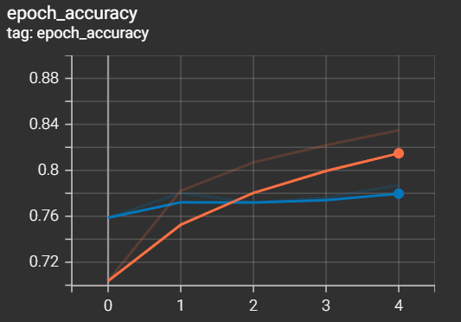

Epochs-10, Activation Function- tanh, Optimizer- RMSprop, loss: 0.6204 - accuracy: 0.7979

Epochs-15, Activation Function- relu, Optimizer- Adam, loss: 0.6603 - accuracy: 0.8031

Epochs-10, Activation Function- tanh, Optimizer- Adam, loss: 0.6044 - accuracy: 0.8049

Epochs-10, Activation Function- tanh, Optimizer- RMSprop, loss: 0.6276 - accuracy: 0.7976

Epochs-10, Activation Function- relu, Optimizer- RMSprop, loss: 0.6390 - accuracy: 0.7935

Overall Pictures For the Random Search

In the Grid Search We are going to validate each and every possible outcome whereas in the Random Search we are picking the Hyperparameters also in the randomized manner. In Random Search case we may miss the few cases of testing that might have the effect of losing the efficient data.

Grid search is suitable when the search space is relatively small and the relationships between hyperparameters are well understood. It's also a good choice when computational resources are not a major constraint.

Random search is more suitable for high-dimensional spaces or when computational resources are limited. It may be preferred when the interactions between hyperparameters are complex and not well-defined.