Name : Thakkar Vishwa Rajeshbhai
Enrollment no : 202326800109
Sem : 5 Stream : Fintech
Subject Name: VCS & Cloud Fundamentals
Subject code : DSC-C-FIN-355P

Que-1 screenshot of list of all the branch

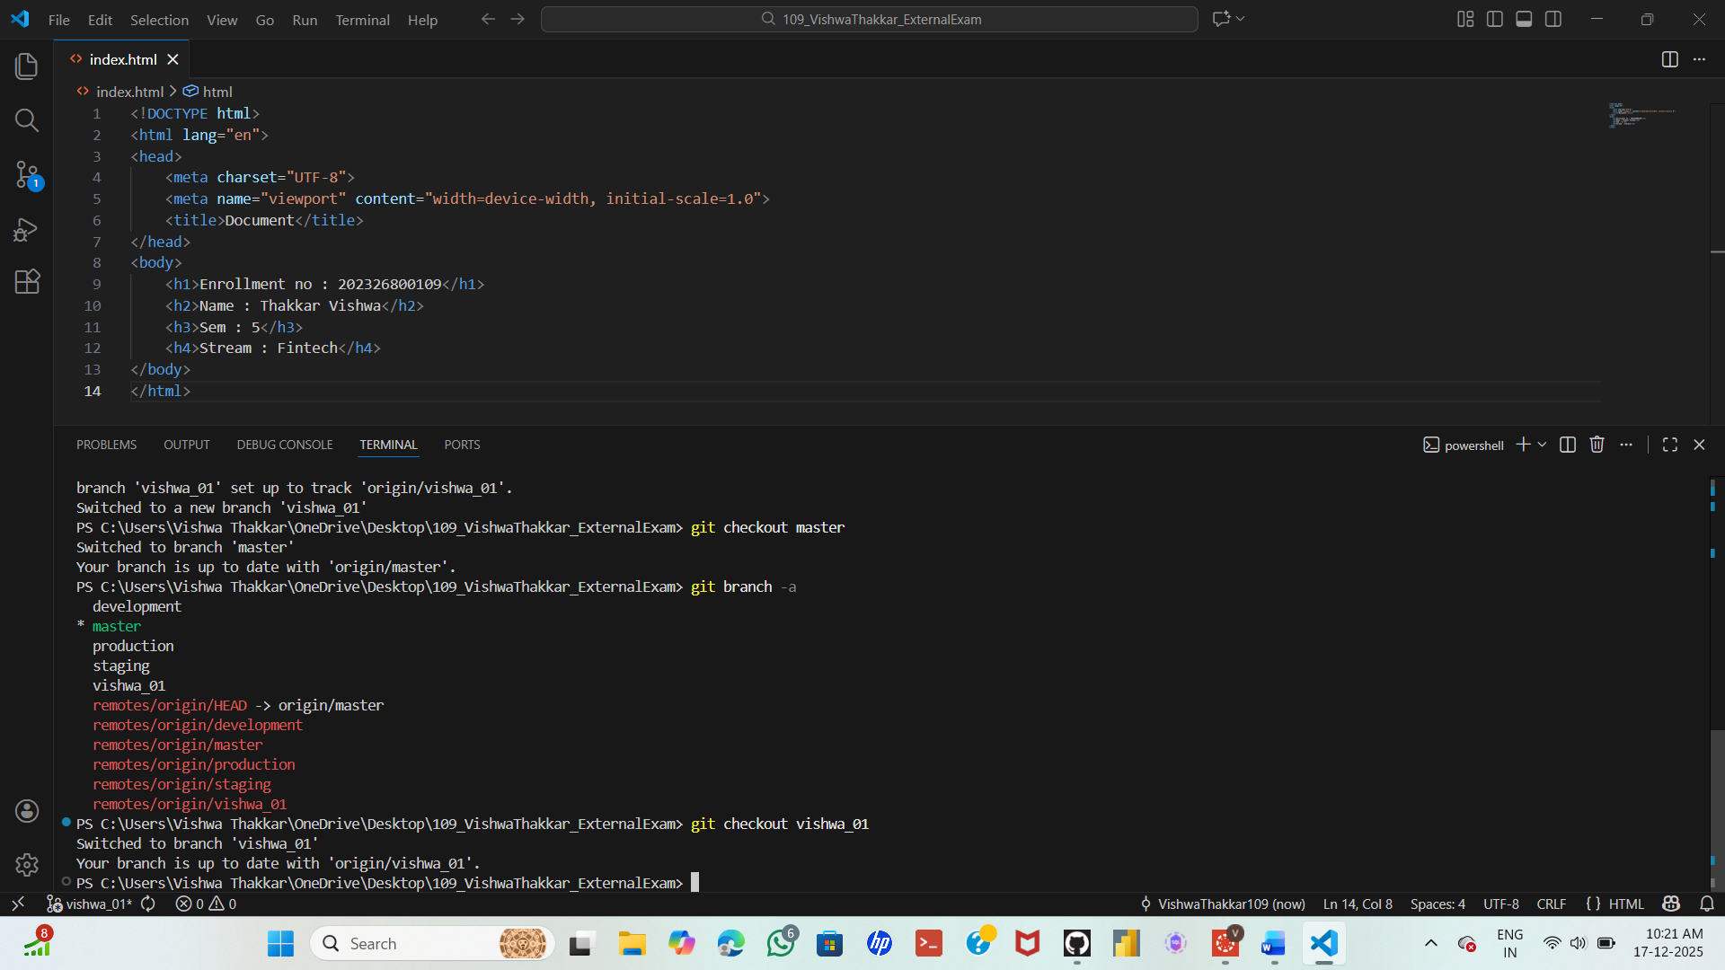

Que-2

