**Experiment -2.2**

**Student Name: Vishwachi Pandey UID: 22BDO10012**

**Branch: BE-CSE(DevOps) Section/Group: 22BCD-1/A**

**Semester: 4th Date of Performance:21/02/2024**

**Subject Name: GIT AND GITHUB Subject Code: 22CSH-293**

**1. Aim/Overview of the practical:** To merge pull request and update local repository on GitHub.

**2. Task to be done:** In this experiment we will be merging a file and will update it on our local repository.

**3. Apparatus(For applied/experimental sciences/materials based labs):** SOFTWARE(Git bash, github), HARDWARE( Computer system).

**4. Steps for experiment/practical:**

1. Firstly you have to create repository and named as‘Exper5.git’.
2. Then initiate it using ‘git init’.
3. Create a file named as ‘f1’ and commit a message file created.
4. Then push the file using ‘git push origin main’
5. Then change the branch to branch5 from main.
6. Now pull the file from branch origin using ‘git pull origin main’.

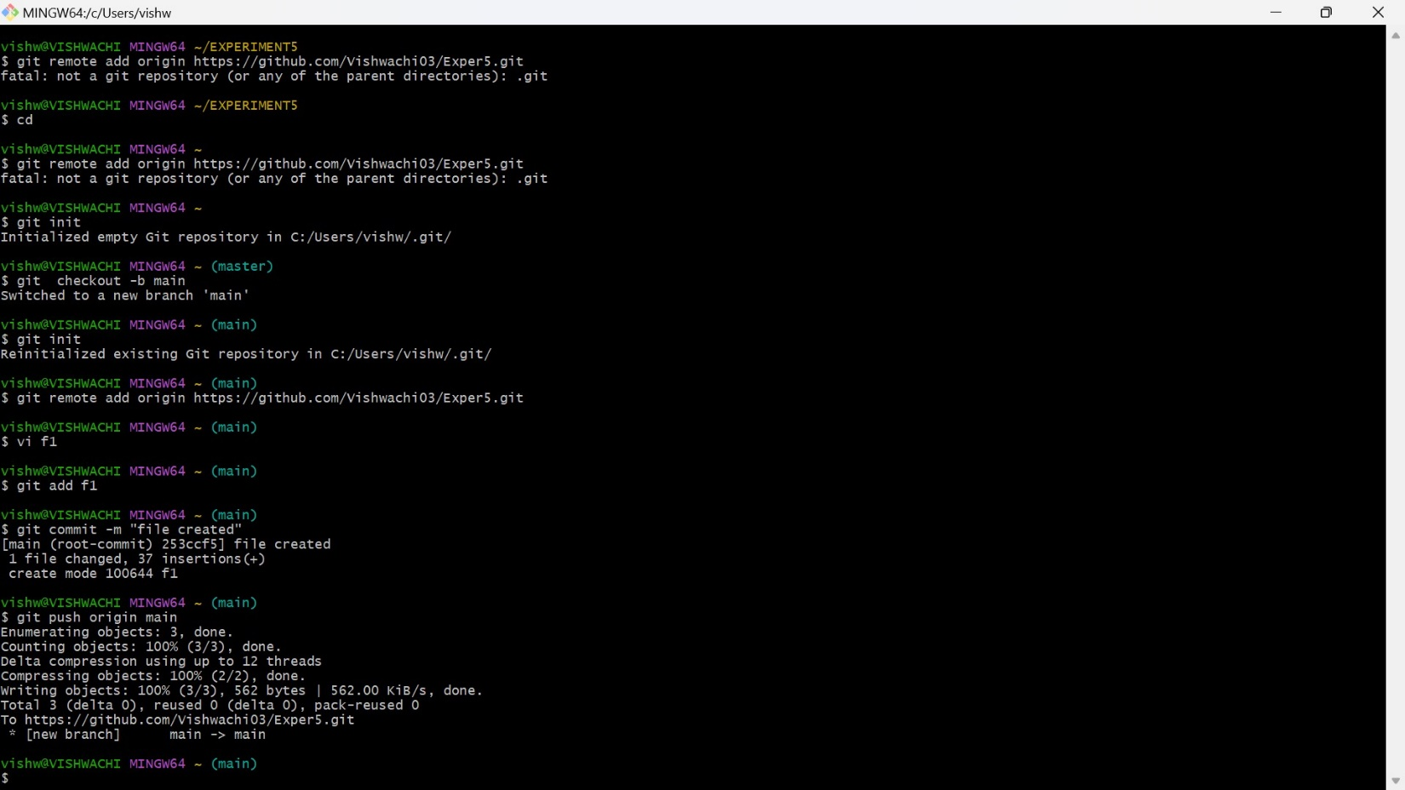

7.Now do the changes then commit updated.

8.Now merge main with branch5.

9.Then open f1 the change the branch to main.

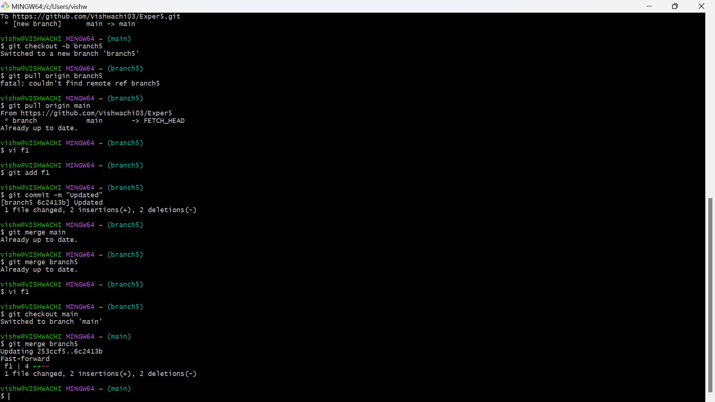

10. Now push the changes into the main then in branch5.

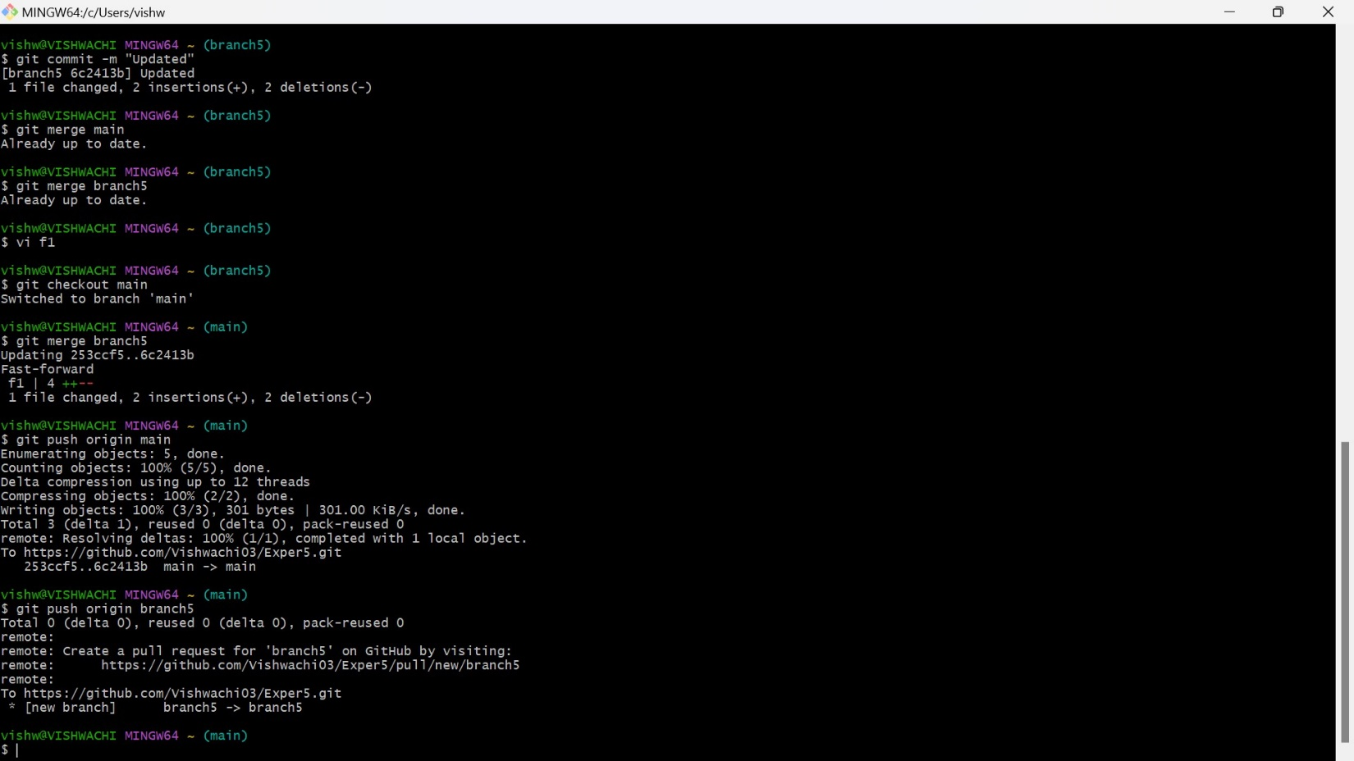

11. In branch5 n=file named as f1 is present below with the changes made.

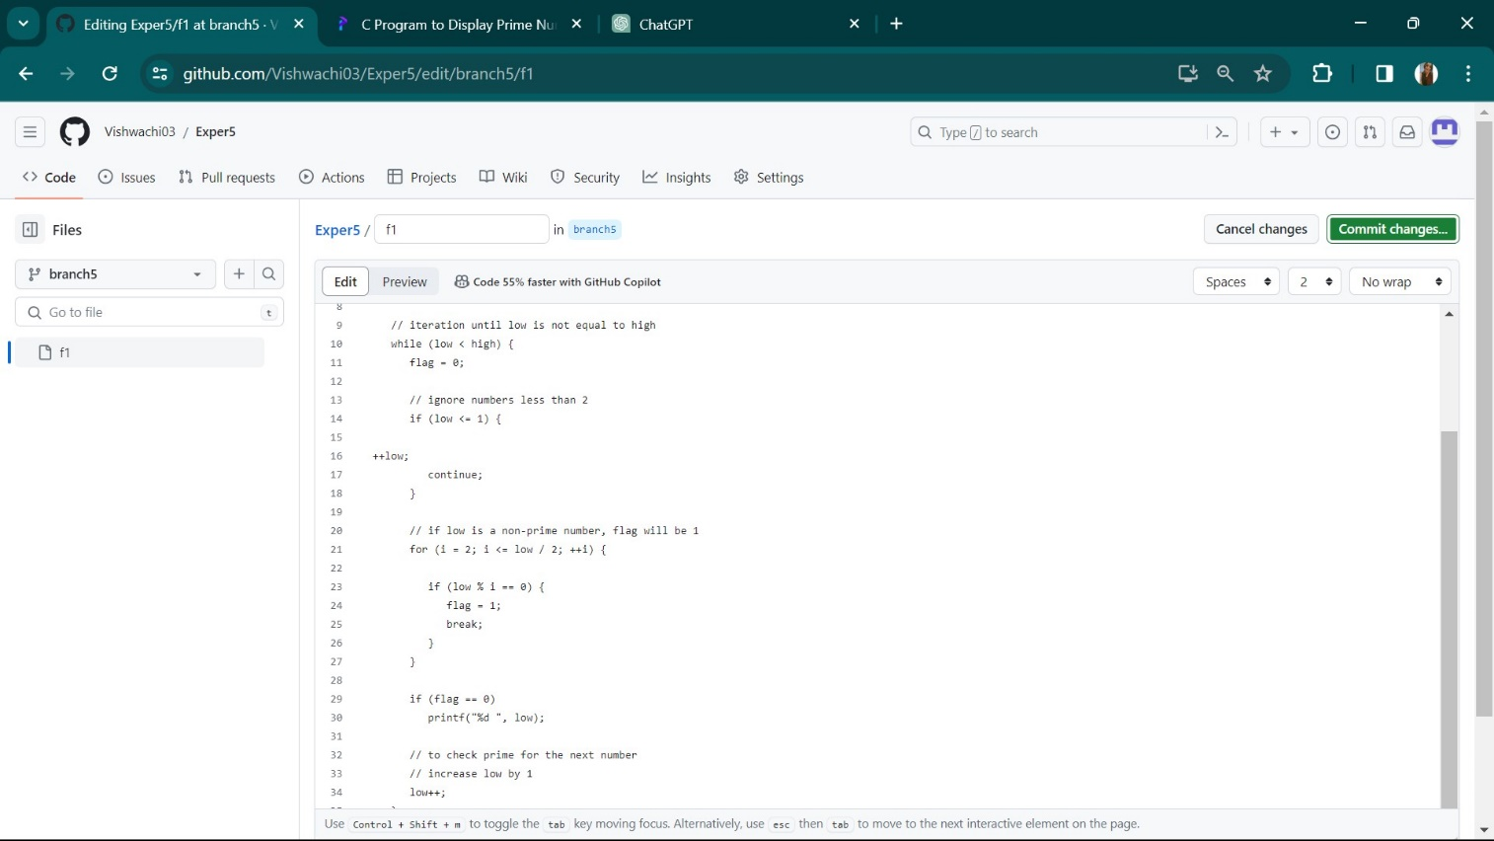

12. After all these steps we can see the option of comapre and pull request. 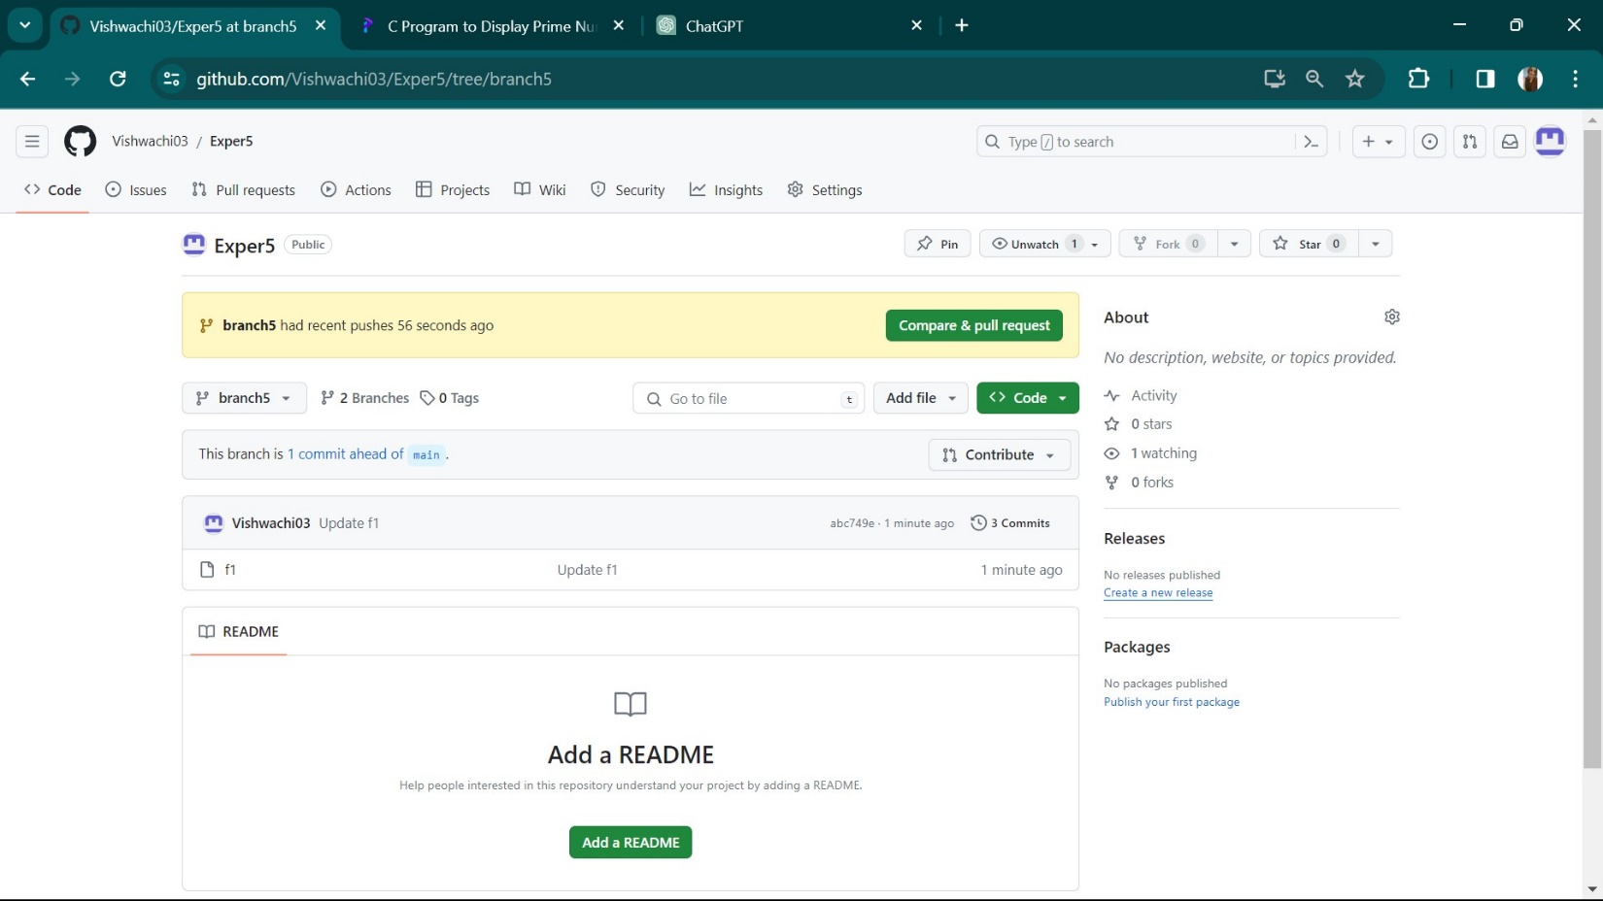

13. Create pull request.

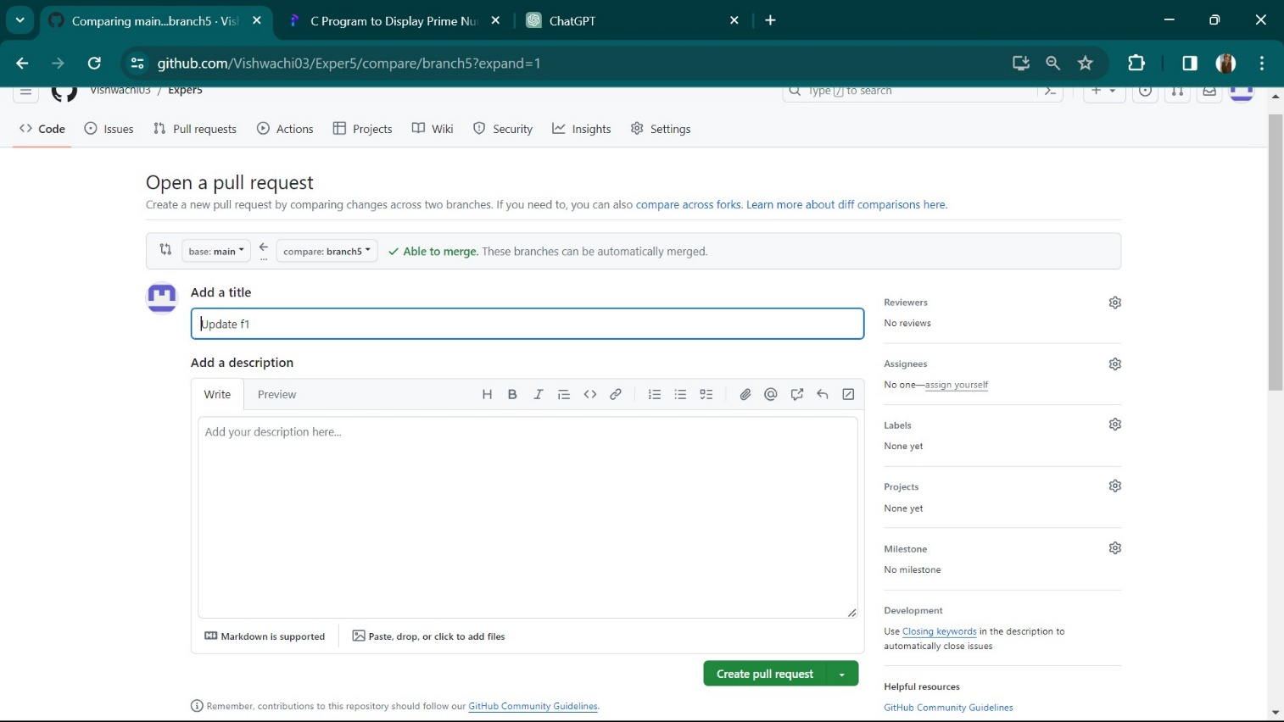

14. The merge the pull request.

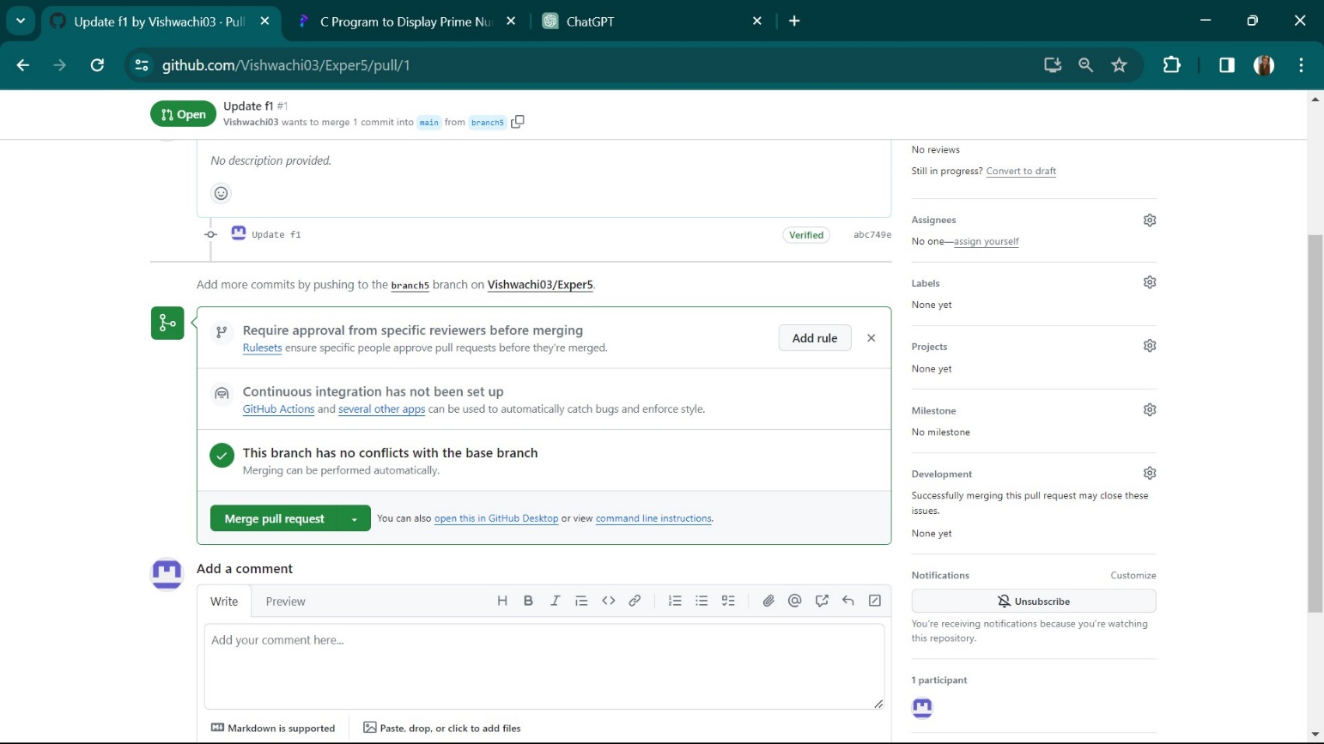

15. Now after the merges the below in the result.

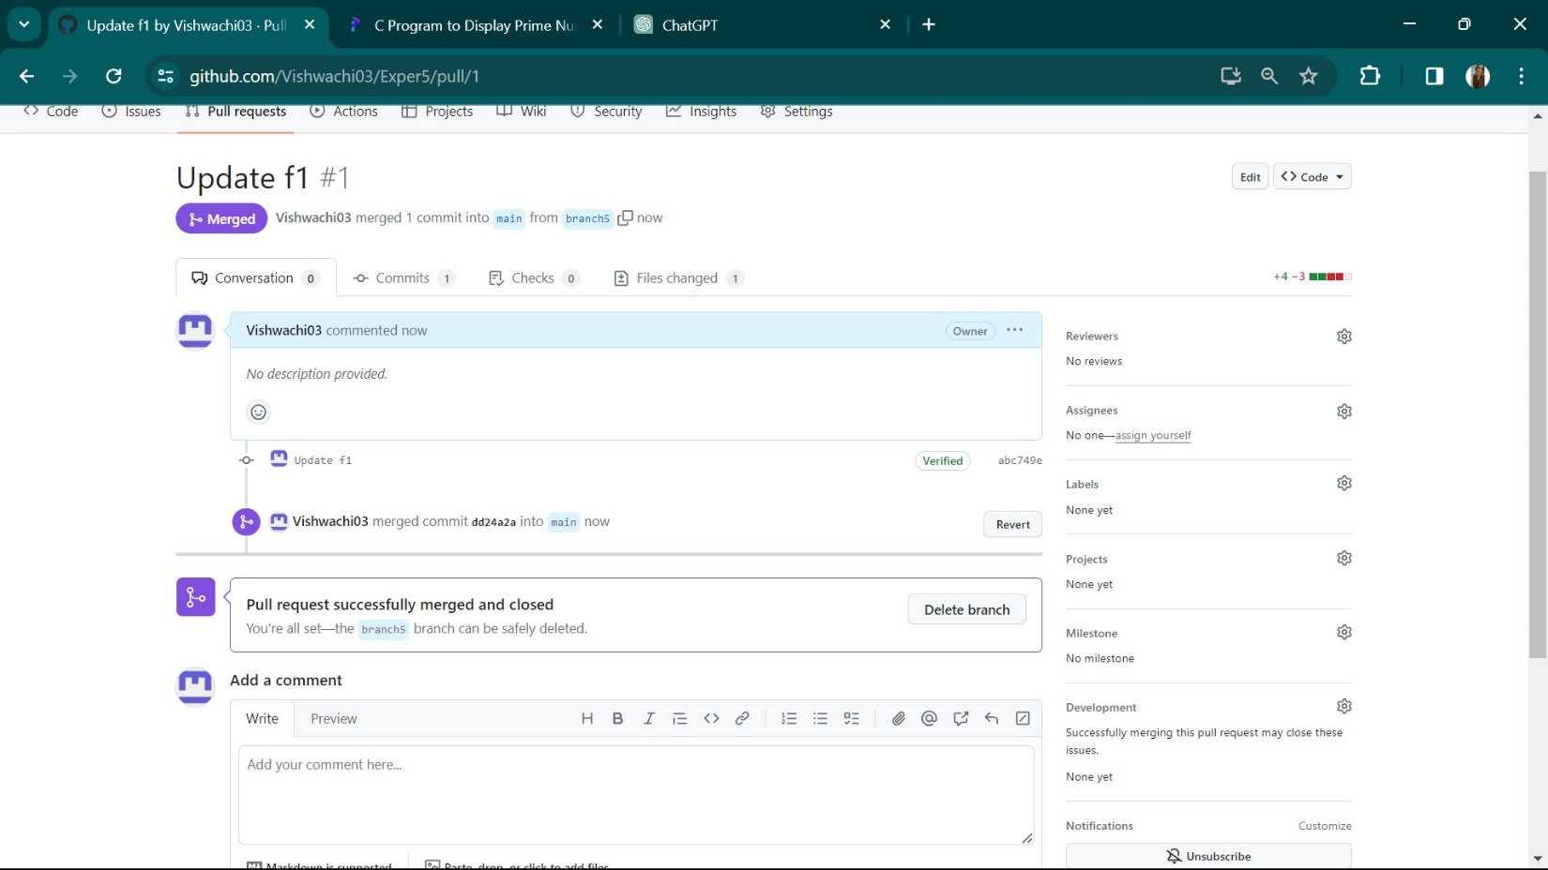

**10. Result/Output/Writing Summary:**

We have merged pull request and updated local repository on GitHub.

**Learning outcomes (What I have learnt):**

**1.** Learnt how to edited a file .

**2**. Learnt how to push from local to remote and vice versa.

**3.** Learnt how to match the branch in the local machine.

**4.** Learnt about merging.

**5**. Learnt how to update local repository on GitHub.

**Evaluation Grid (To be created as per the SOP and Assessment guidelines by the faculty):**

|  |  |  |  |
| --- | --- | --- | --- |
| Sr. No. | Parameters | Marks Obtained | Maximum Marks |
| 1. |  |  |  |
| 2. |  |  |  |
| 3. |  |  |  |
|  |  |  |  |