**Experiment -1.1**

Install Git and creating repository.

**Student Name: Vishwachi Pandey UID: 22BDO10012**

**Branch: BE-CSE(DevOps) Section/Group: 22BCD-1/A**

**Semester: 4th Date of Performance:17/01/2024**

**Subject Name: GIT AND GITHUB Subject Code: 22CSH-293**

## 1. Aim/Overview of the practical: Install Git and creating repository.

**2. Task to be done:** In this experiment we installed git and hub, and worked with git bash to create repository which made us understand creation and connection of the different directories. The main task of the experiment is to learn the installation of git and hub, creation of account and repository, basic linux commands, basic git operations like fork, connection and launching of git.

**3. Apparatus(For applied/experimental sciences/materials based labs):** SOFTWARE(Git bash, github), HARDWARE( Computer system).

**4. Theme/Interests definition( For creative domains):**

GIT: Git is a distributed version control system that tracks changes in source code during software development, facilitating collaboration and history.

GITHUB**:** GitHub is a web-based platform for version control and collaboration using Git. It hosts code repositories and fosters community development.

GIT BASH: Git Bash is a command-line interface for Git on Windows, providing a Unix-like environment with additional tools and utilities.

**5. Steps for experiment/practical:**

**For the installation of Git.**

1. Search for the link <https://git-scm.com/downloads> to download.

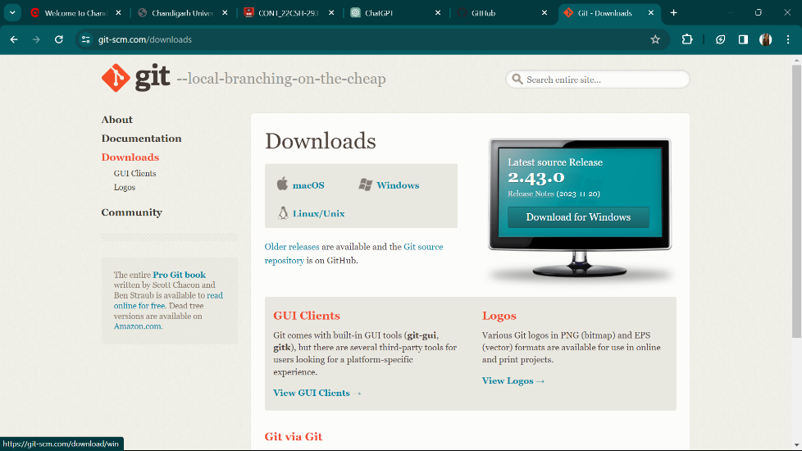

1. Then select windows, go for 64-bit Git Windows setup.

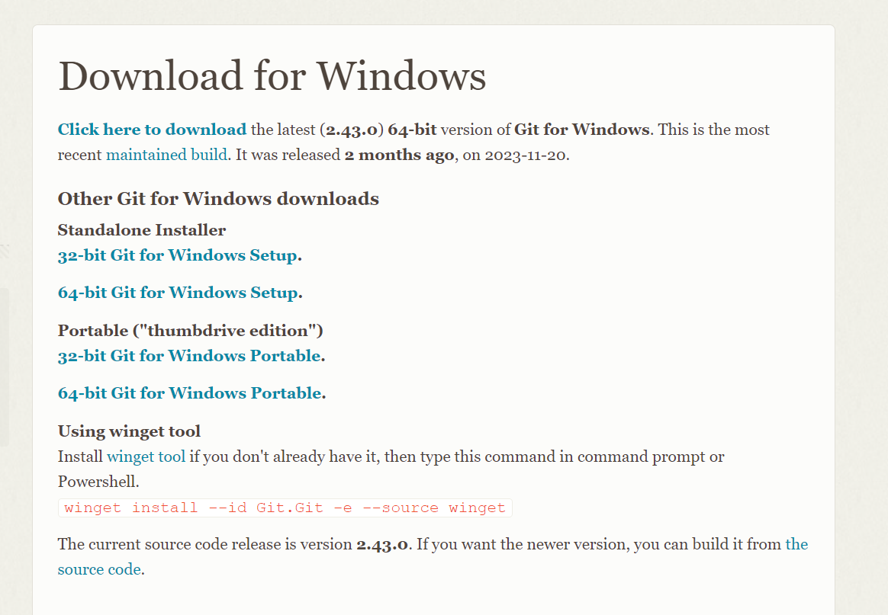

1. Now click on install

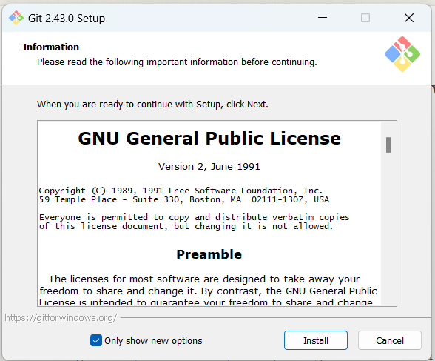

1. Select the location for installation for the git.

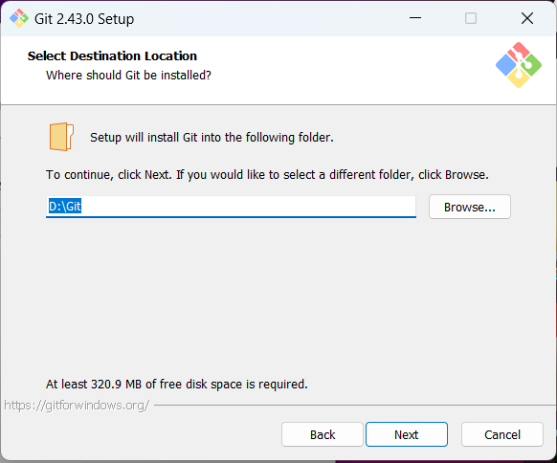

1. Now click next and follow the instruction given by faculty.

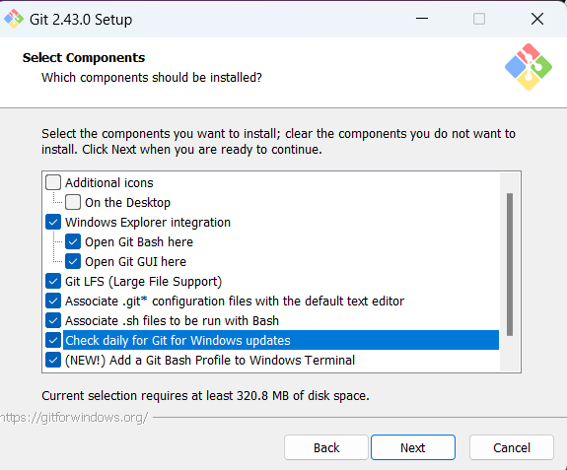 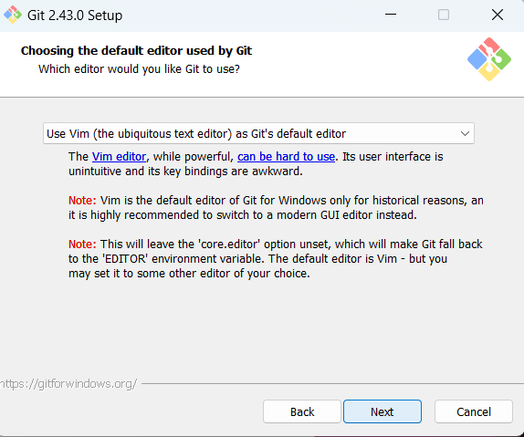

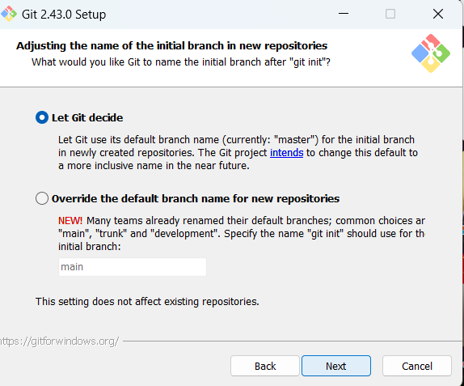 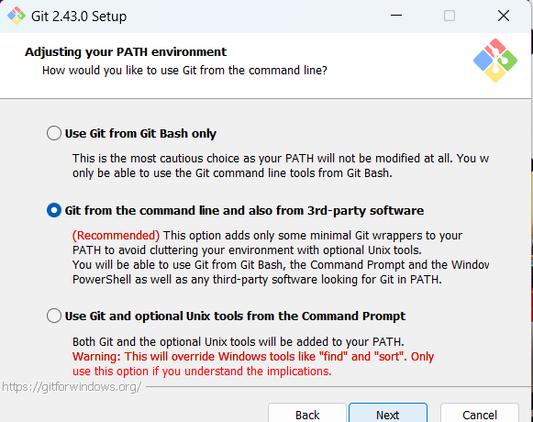

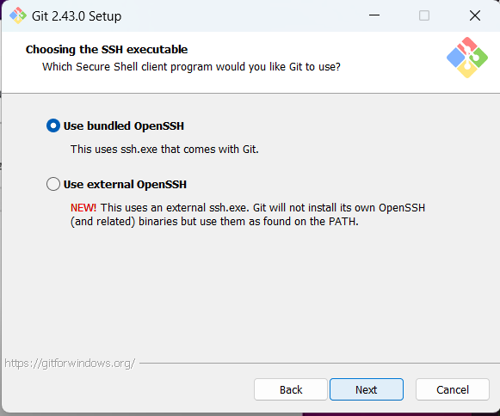 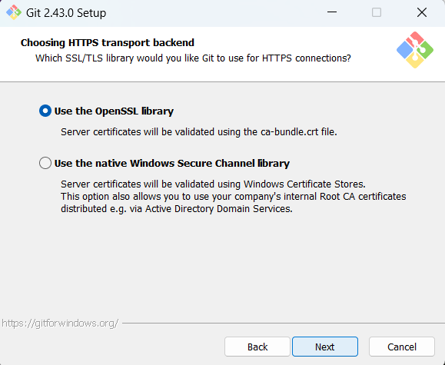

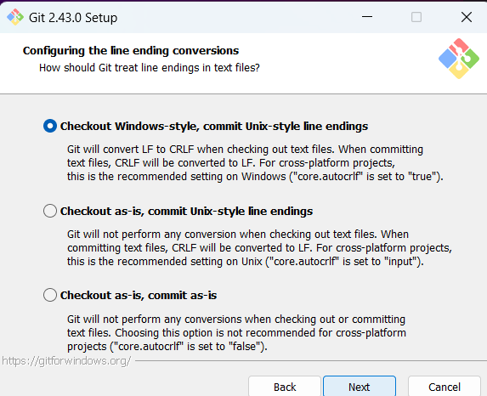 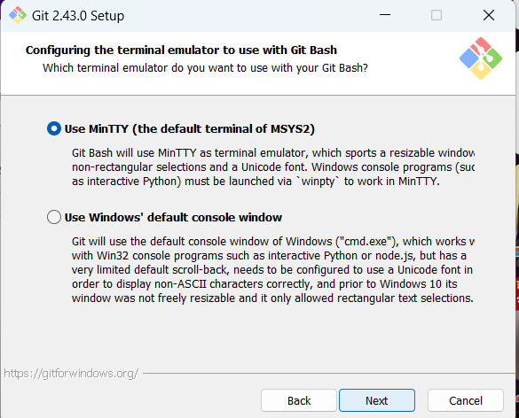

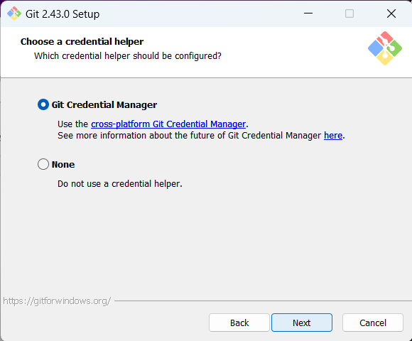 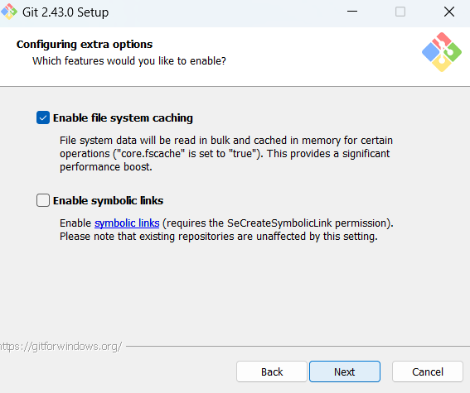

1. Now don’t select any option, click on finish.

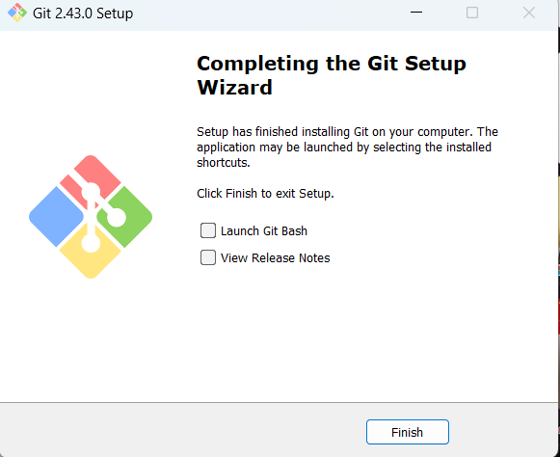

1. Next step is to verify whether the git is installed on system or not.

Go to CMD type *“git’* It will give version and description regarding Git.

**Creation of account on Githib:**

1. Search for Github on google.
2. Select signup.
3. Enter your email-id.
4. Enter the password.
5. Enter the further details which are required.
6. Your account will look like:

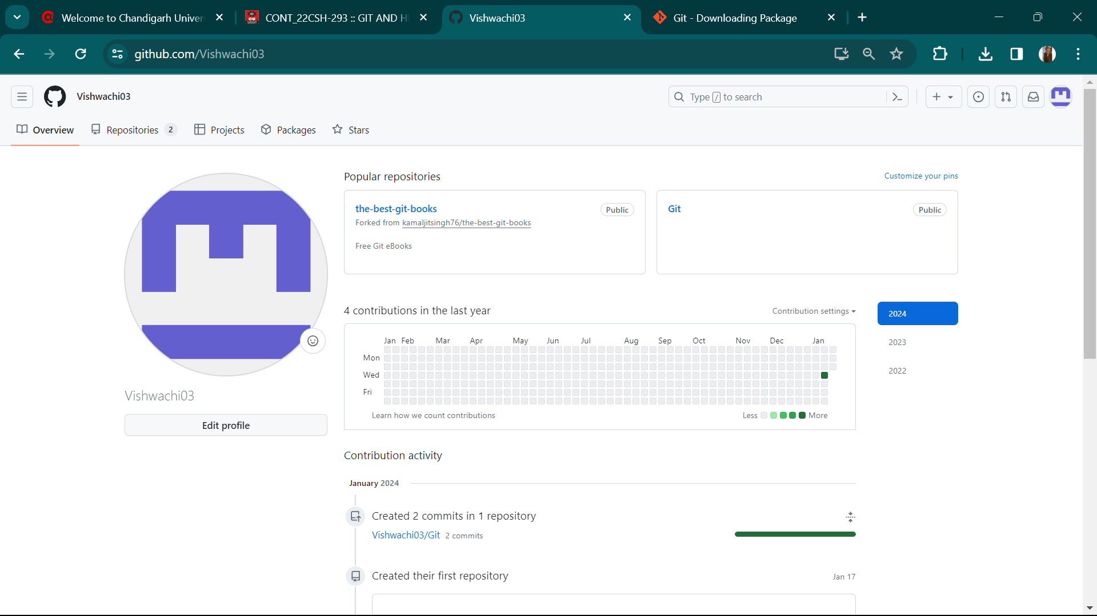

**Creation of Repository:**

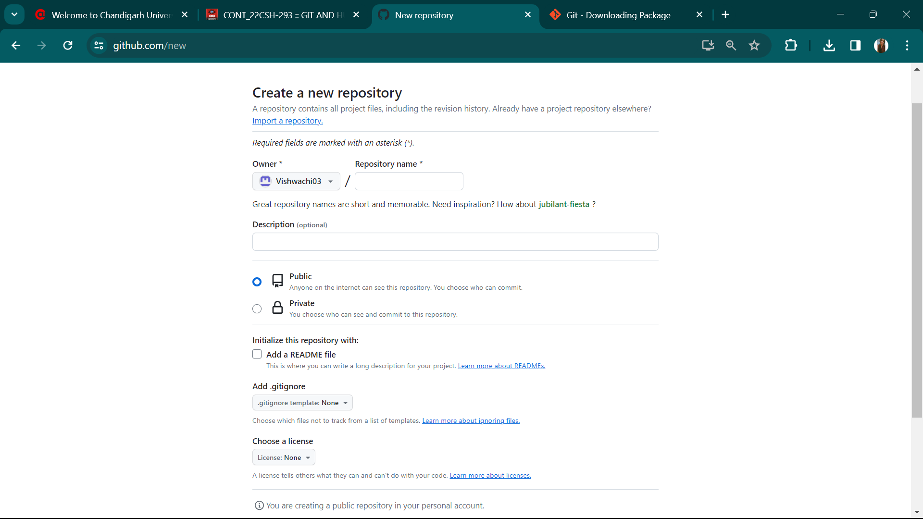

Go to new on dashboard, below screen will be displayed then fill the details like it should be public or private, do any license is required or not, describes it in description box, give a name to the repository.

**Configuration of Git And Github:**

For configuration we have basic commands which are listed below:

**For Username**

Command: *git config --global user.name “*vishwachi03 *”*

**For email**

Command: *git config --global user.emai lvishwachi03@gmail.com*

**To verify**

Command: *git config –list*

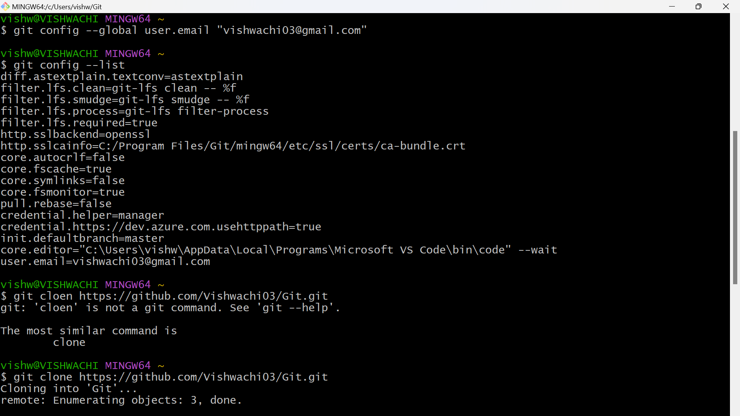

**For cloning the repository:**

Command

*git clone* [*https://github.com/Vishwachi03/Git.git*](https://github.com/Vishwachi03/Git.git)

This link is present under code section http link.

We have also used basic commands like cd, ls, touch, pwd .

Cd is used change the directory. Touch is used to create file.

Ls is used to print no of files in repository. Pwd is used to print the current working directory.

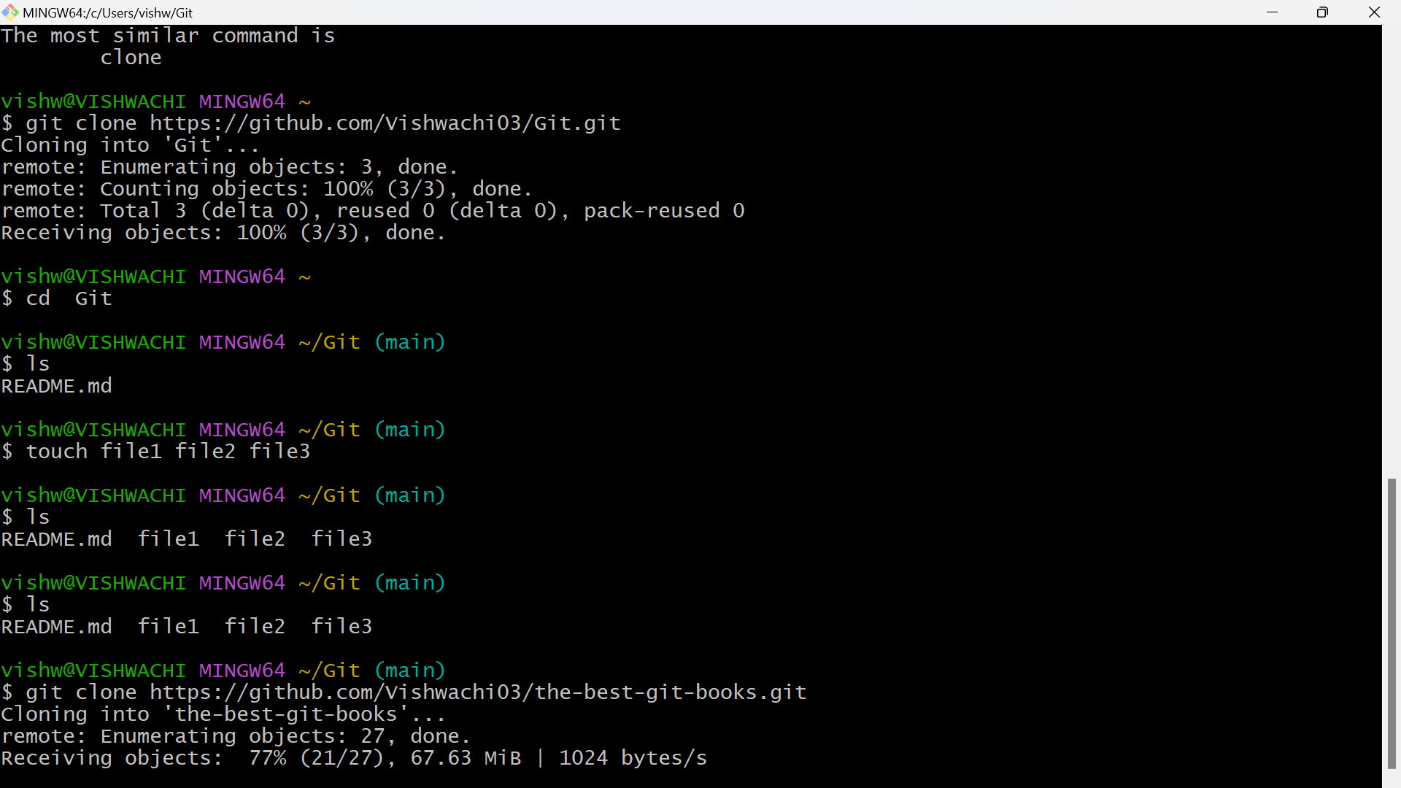

**6.Result/Output/Writing Summary:**

In this experiment we have successfully installed git and connected it to our system. We have created new repository. We have used basic commands like ls, cd, pwd.

**7.Learning outcomes (What I have learnt):**

1. Learnt how to install git on our system.

2. Learnt how to configure git with Github account.

3. Learnt about cloning.

4. Learnt how to add and do changes in our account

5. Learnt the implementation of basic commands like cd, pwd.

**Evaluation Grid (To be created as per the SOP and Assessment guidelines by the faculty):**

|  |  |  |  |
| --- | --- | --- | --- |
| Sr. No. | Parameters | Marks Obtained | Maximum Marks |
| 1. |  |  |  |
| 2. |  |  |  |
| 3. |  |  |  |
|  |  |  |  |