**Experiment -1.2**

Creating branches with GitHub.

**Student Name: Vishwachi Pandey UID: 22BDO10012**

**Branch: BE-CSE(DevOps) Section/Group: 22BCD-1/A**

**Semester: 4th Date of Performance:17/01/2024**

**Subject Name: GIT AND GITHUB Subject Code: 22CSH-293**

**1. Aim/Overview of the practical:** Creating branches with GitHub.

**2. Task to be done:** In this experiment we will be creating branches with the help of git bash in the master domain.

**3. Apparatus(For applied/experimental sciences/materials based labs):** SOFTWARE(Git bash, github), HARDWARE( Computer system).

**5. Theme/Interests definition( For creative domains):**

*GIT BASH:* Git Bash is a command-line interface for Git on Windows, providing a Unix-like environment with additional tools and utilities.

*BRANCHING:*

Isolation and Parallel Development: Branching in GitHub allows developers to work on features or bug fixes in isolated environments, preventing interference with the main codebase and enabling parallel development.

Collaboration and Merging: Different branches facilitate collaboration among team members, each focusing on specific tasks. Merging branches combines changes, ensuring a cohesive and updated main codebase.

**6. Steps for experiment/practical:**

**For Creating branch on GitHub :**

1. Firstly you have to login to your account on github.
2. Now click on the repository where you want to preform branching.
3. Select add file for the addition of new file and name it.

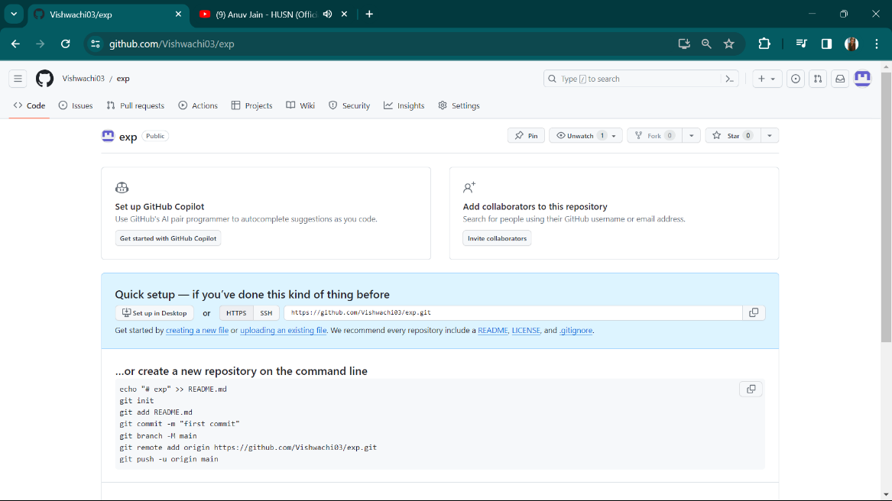 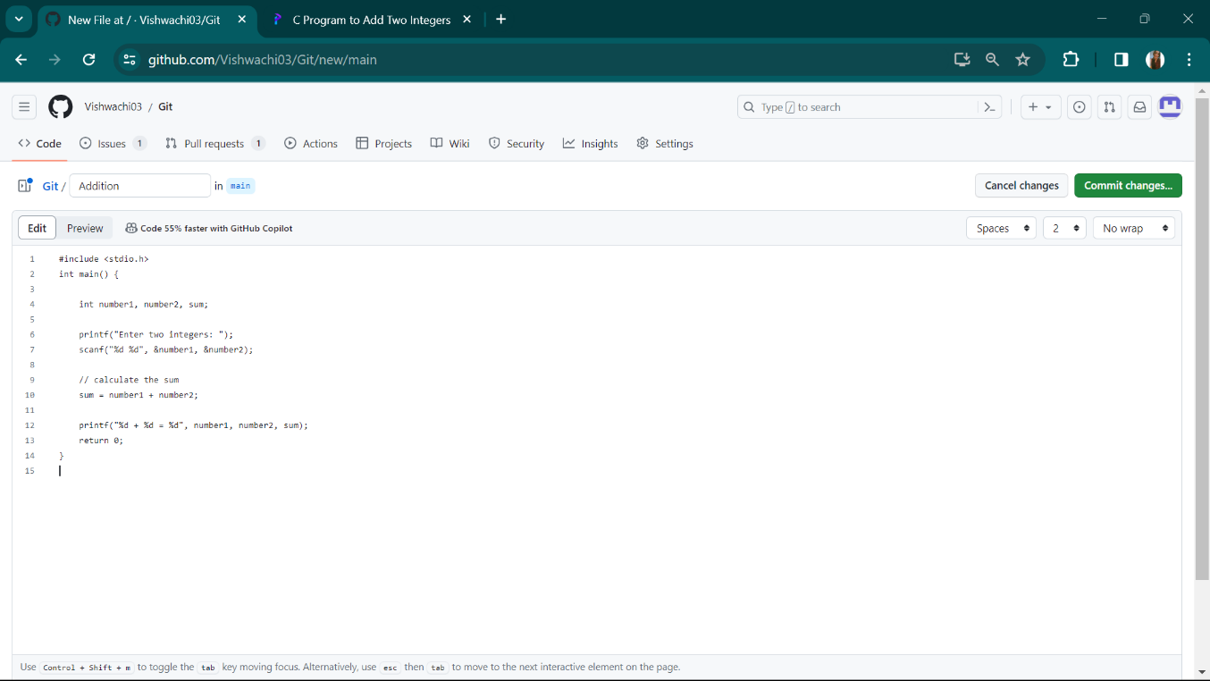

4.Click on commit changes for commiting the changes.

5.Provide commit messageand Extented description than click commit changes.

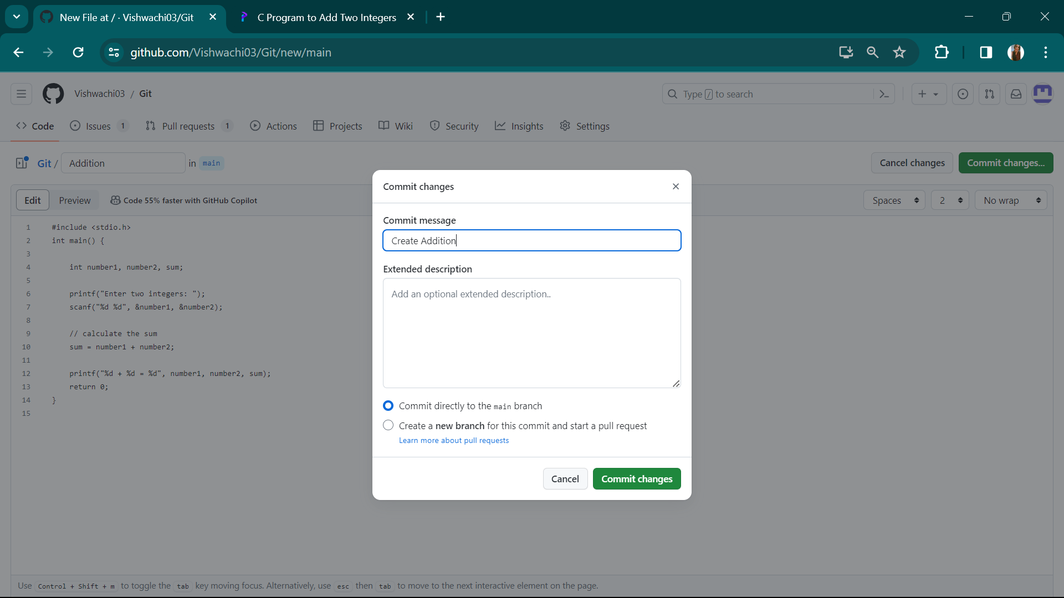

6.Select the main branch.

7.Give a new branch name and create branch from main.

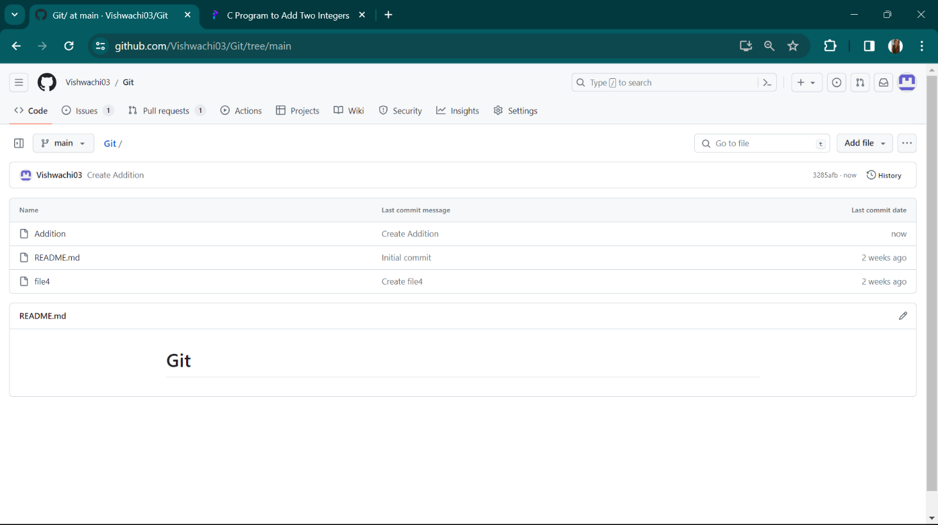

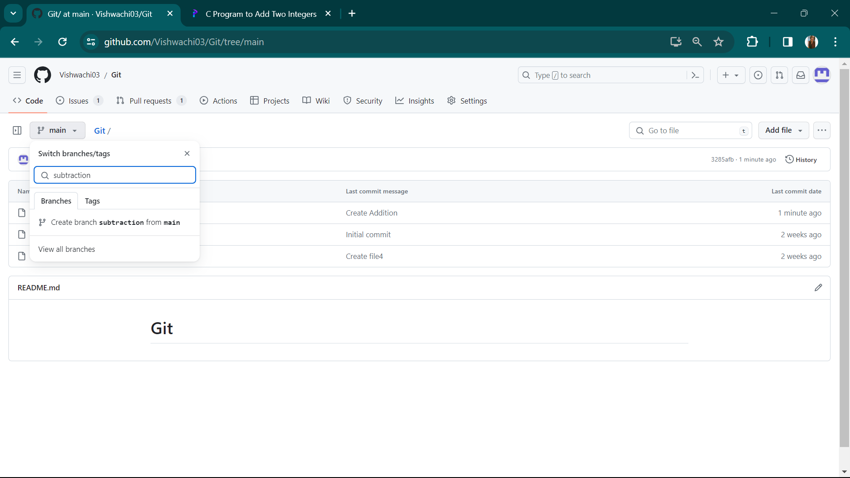

8.Select edit option then click on commit changes to commit the changes.

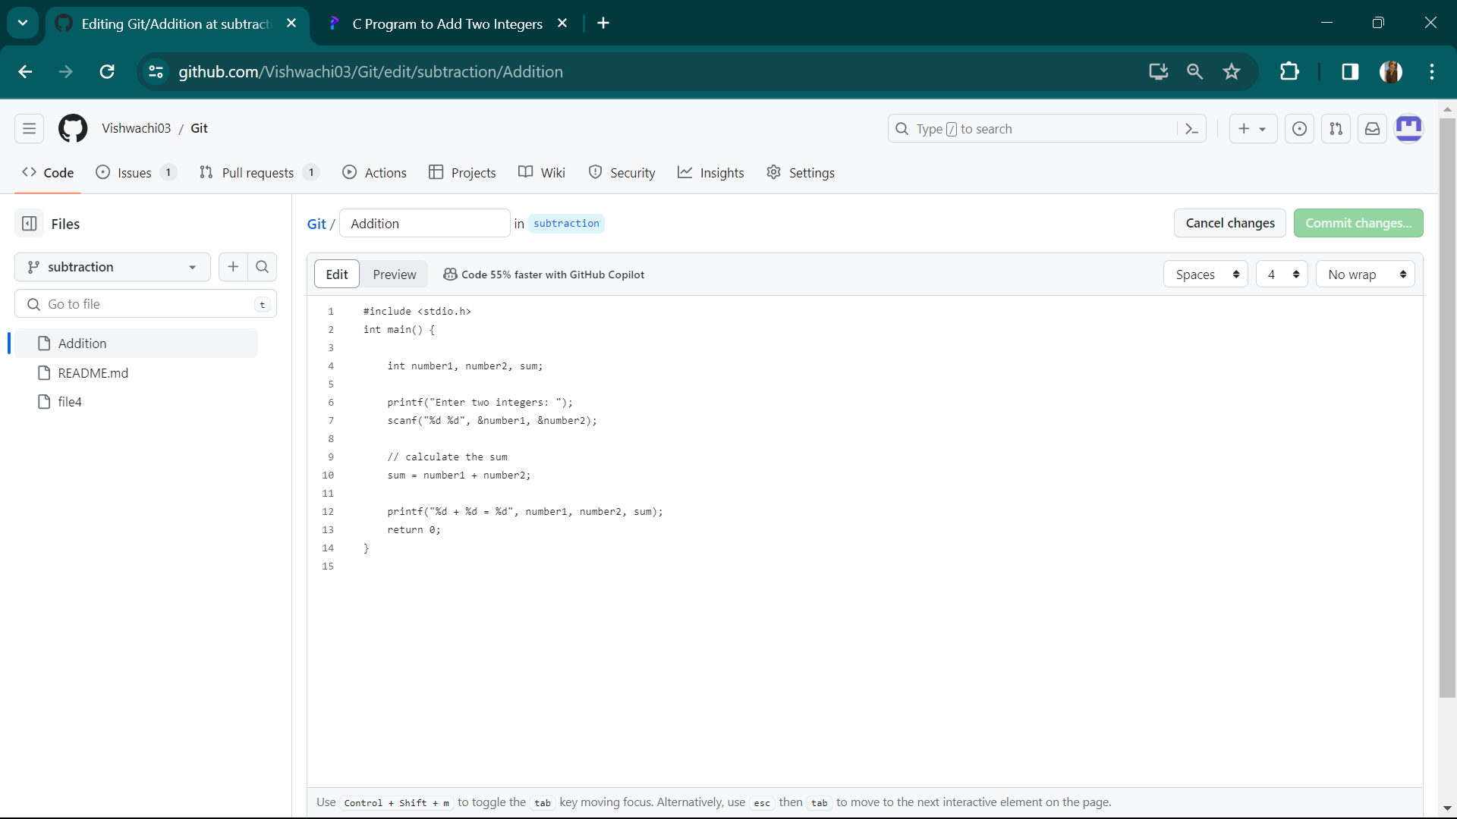

9.Now add commit message and extended description then commit changes.

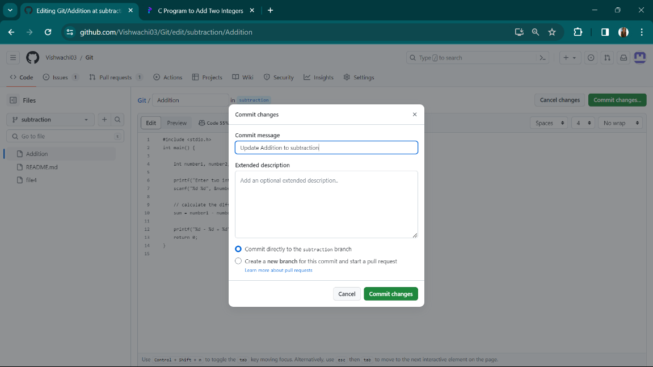

10.After this go to parent repository and click on compare and pull request.

11.Now compare the code in two nodes.

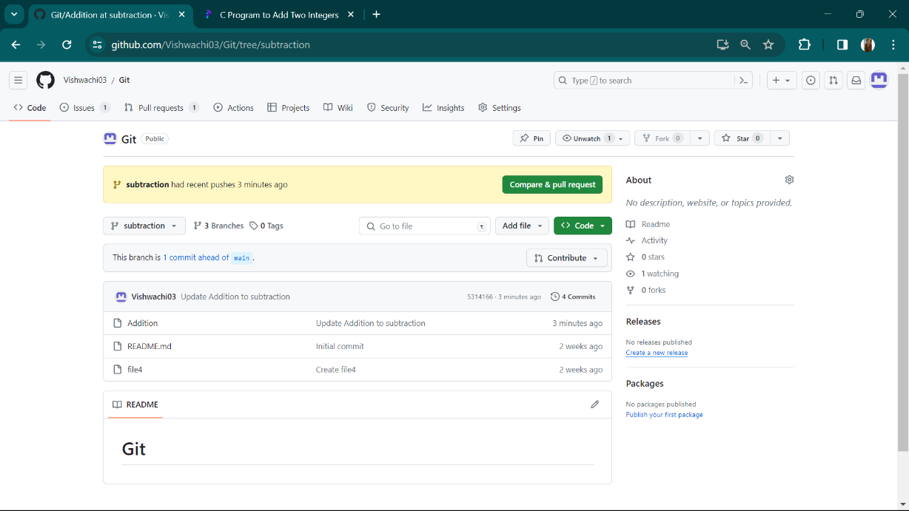

12.Click on create pull request and add title and code.

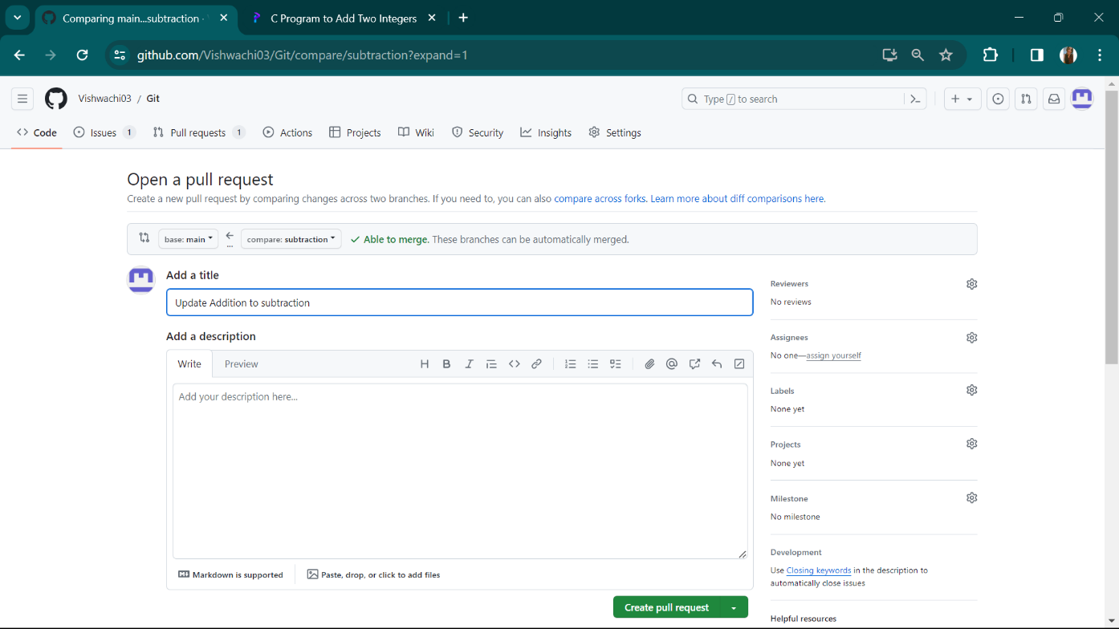

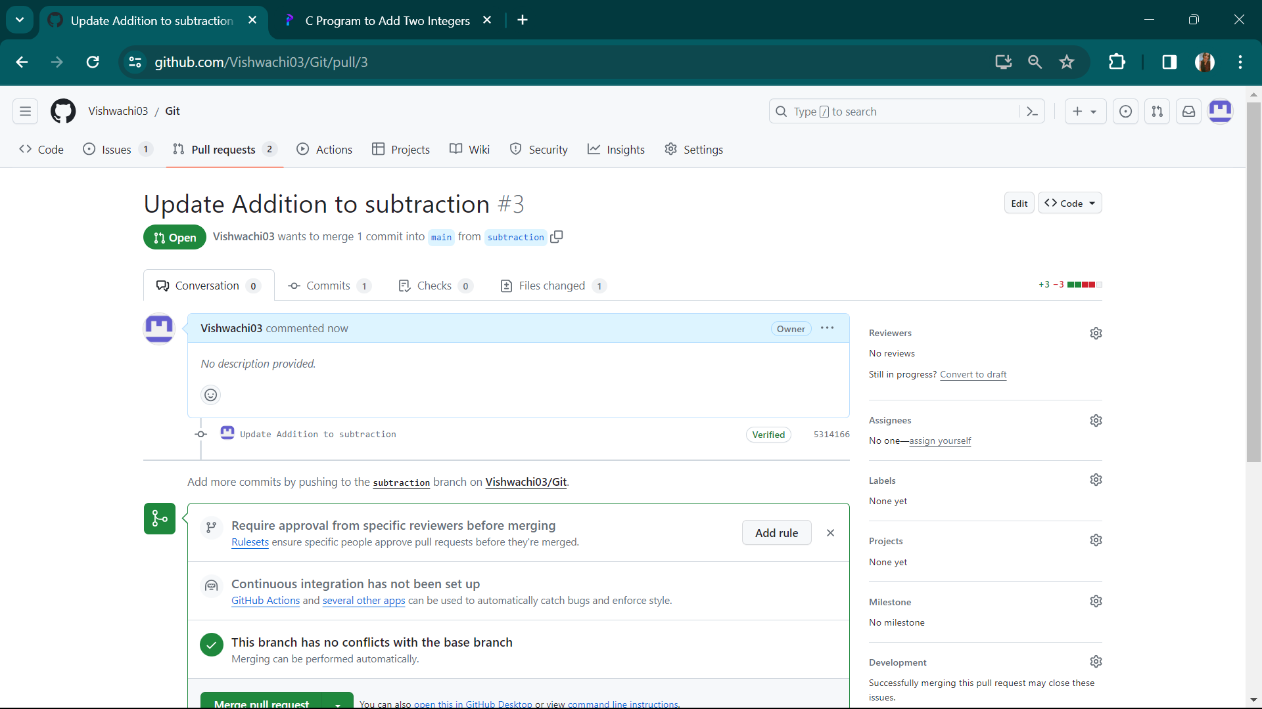

13.Now merge pull request.

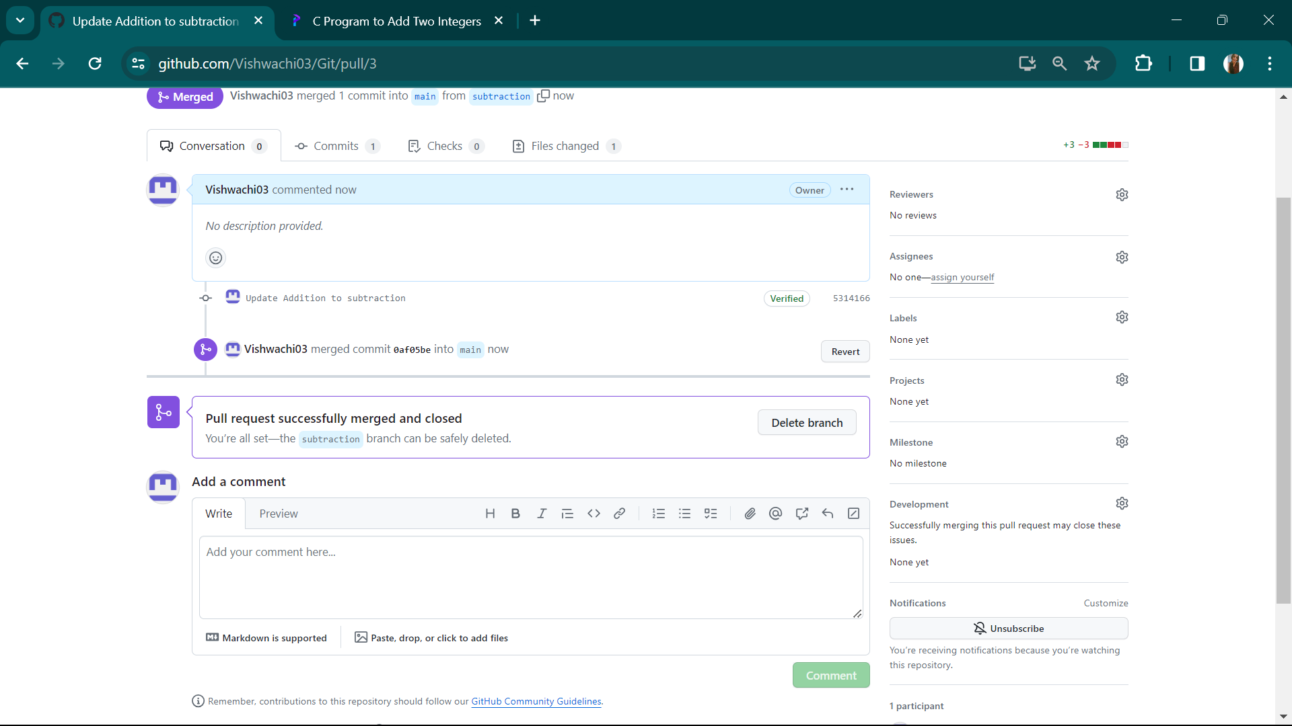

**For creating branch on Git bash.**

1.Firstly we create a new folder on desktop named as ‘exp2’.

2. then we initialize it using git init.

3. Now we create a file name as vish.

4. After this, we add the text.

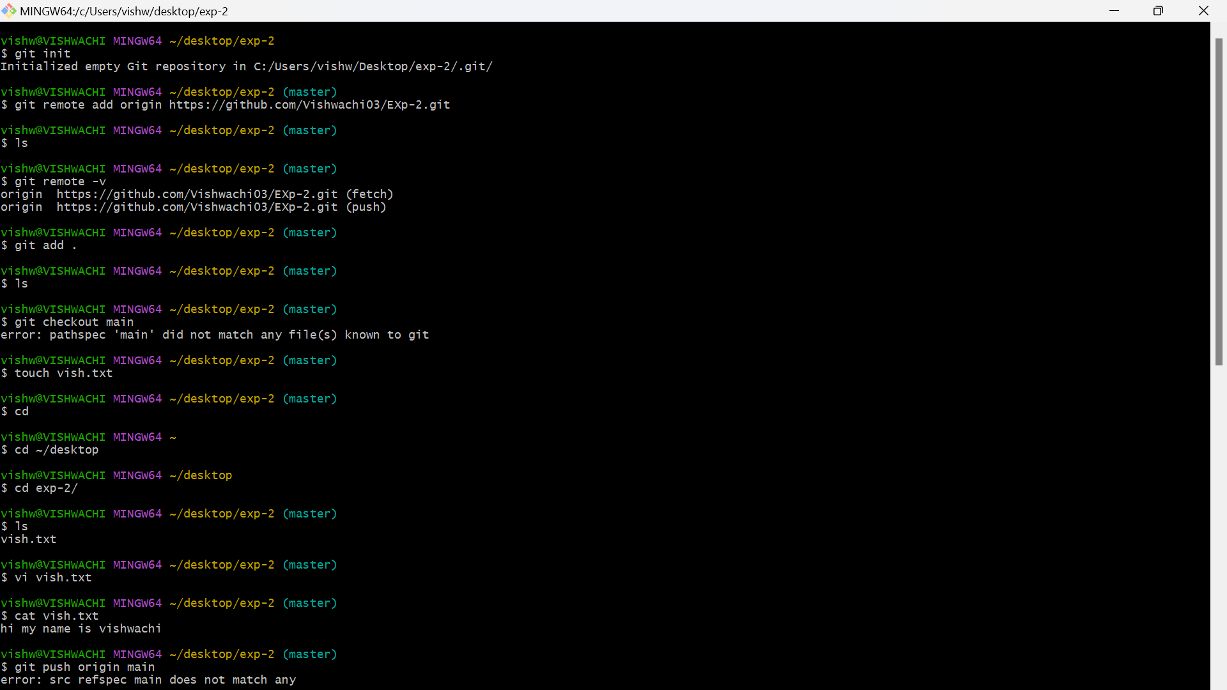

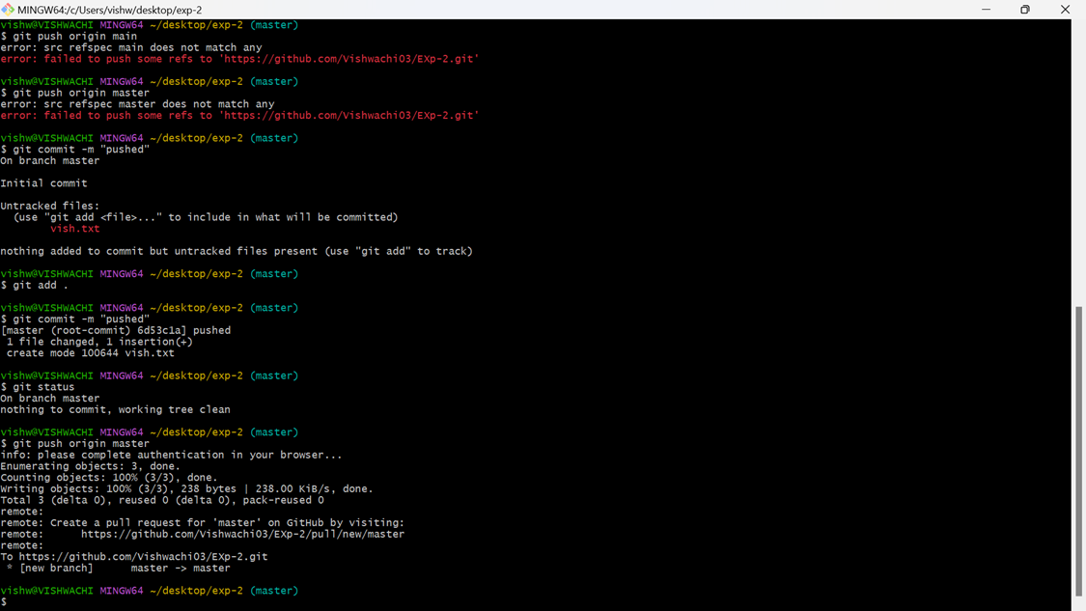

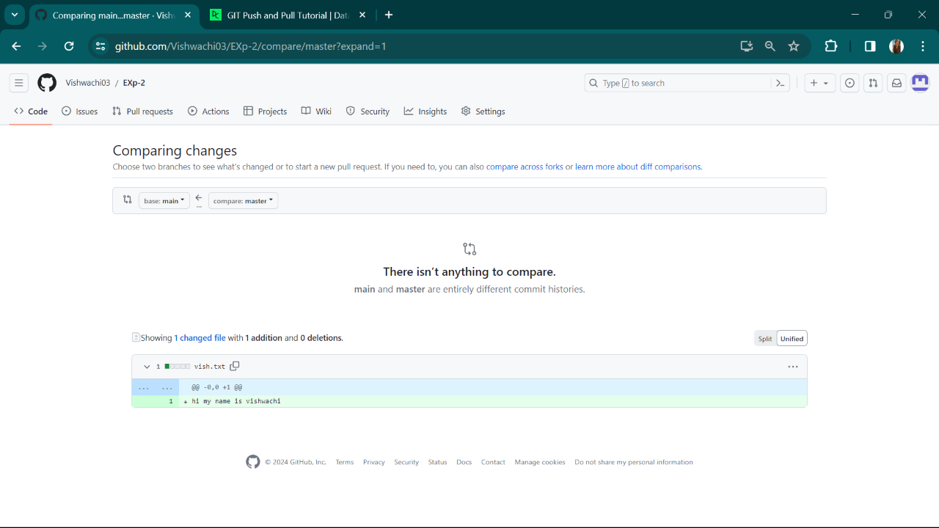

5.We have used different commands.

6.As you can see the result in last photo.

**10. Result/Output/Writing Summary:**

We have finally created the branching on github and also created with git bash.

**Learning outcomes (What I have learnt):**

**1.** Learnt the concept of branching**.**

**2**. Learnt how to create branch on github and git bash.

**3.** Learnt how to push and pull the request.

**4.** Learnt about merging.

**5**. Learnt about how to compare the codes.

**Evaluation Grid (To be created as per the SOP and Assessment guidelines by the faculty):**

|  |  |  |  |
| --- | --- | --- | --- |
| Sr. No. | Parameters | Marks Obtained | Maximum Marks |
| 1. |  |  |  |
| 2. |  |  |  |
| 3. |  |  |  |
|  |  |  |  |