**Experiment -1.3**

**Student Name: Vishwachi Pandey UID: 22BDO10012**

**Branch: BE-CSE(DevOps) Section/Group: 22BCD-1/A**

**Semester: 4th Date of Performance:17/01/2024**

**Subject Name: GIT AND GITHUB Subject Code: 22CSH-293**

**1. Aim/Overview of the practical:** To create and explore pull request in git bash.

**2. Task to be done:** In this experiment we will be creating branches of a repository and make changes and merge the file into main branch.

**3. Apparatus(For applied/experimental sciences/materials based labs):** SOFTWARE(Git bash, github), HARDWARE( Computer system).

**5. Theme/Interests definition( For creative domains):**

*GIT BASH:* Git Bash is a command-line interface for Git on Windows, providing a Unix-like environment with additional tools and utilities.

*BRANCHING:*

Isolation and Parallel Development: Branching in GitHub allows developers to work on features or bug fixes in isolated environments, preventing interference with the main codebase and enabling parallel development.

Collaboration and Merging: Different branches facilitate collaboration among team members, each focusing on specific tasks. Merging branches combines changes, ensuring a cohesive and updated main codebase.

**6. Steps for experiment/practical:**

1. Firstly you have to init the Git.
2. Git into your repository.

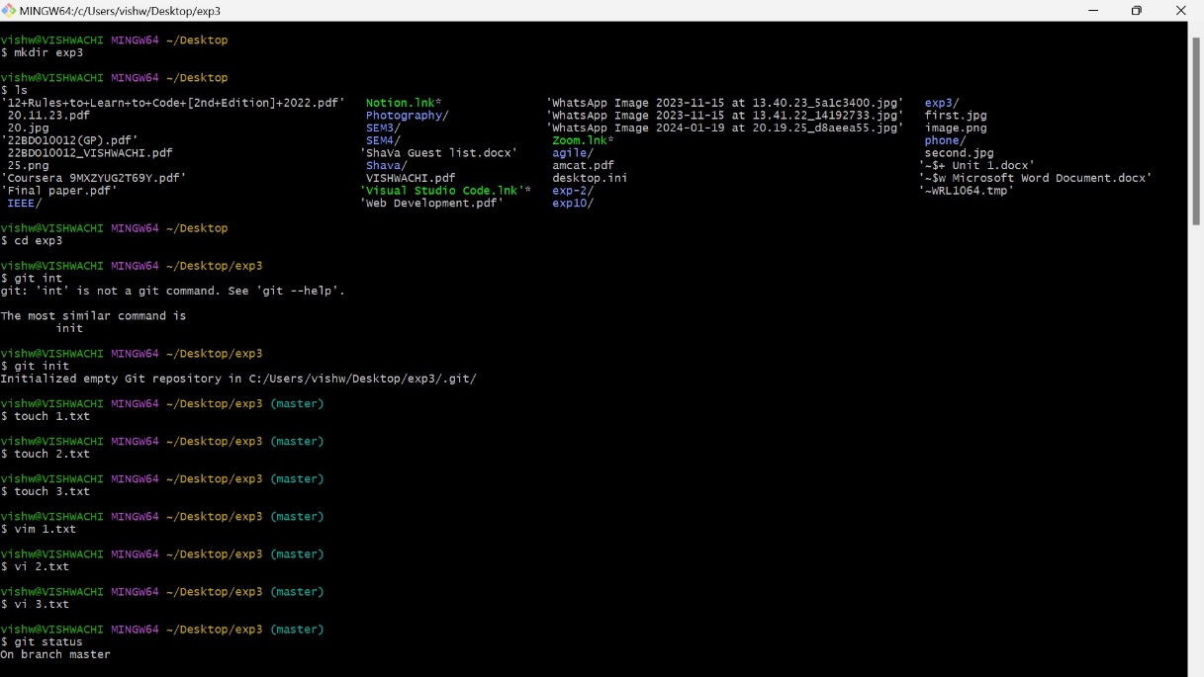

1. Create the branches.
2. Make the changes as you want.

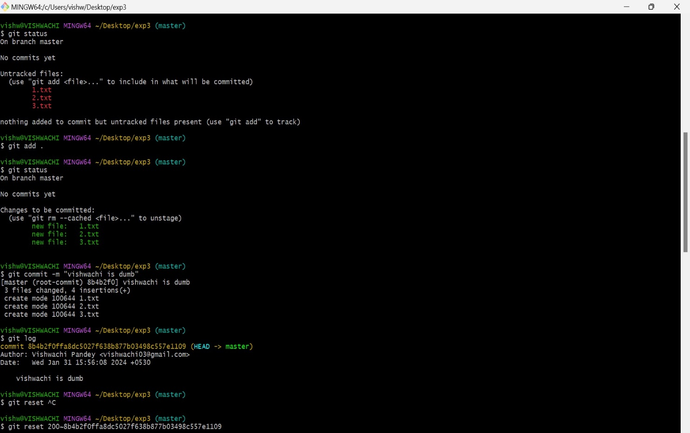

1. Push the changes to git hub.

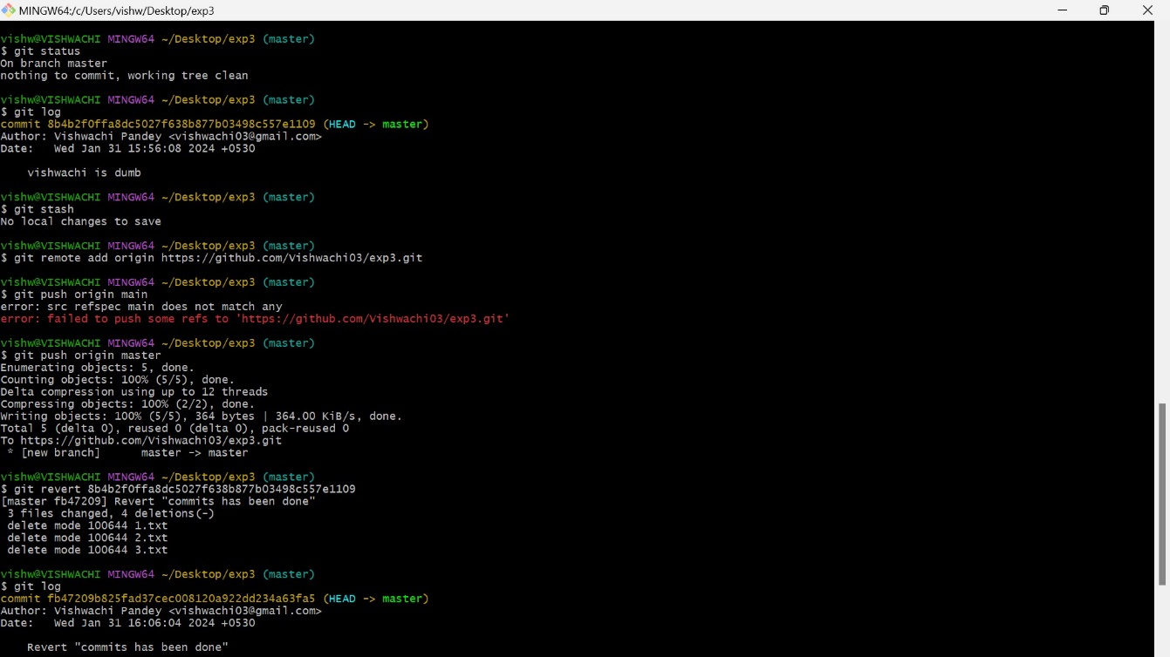

1. Go to the branch and make changes.
2. Compare and pull request.

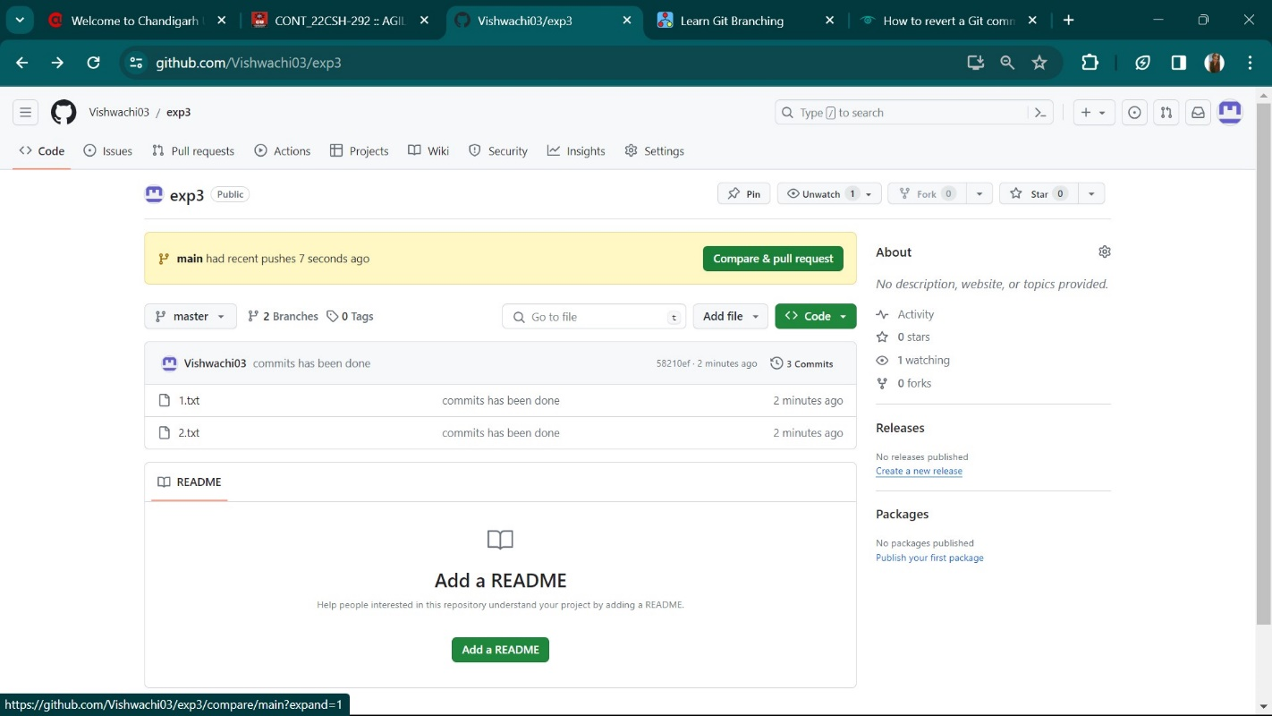

1. Create pull request.

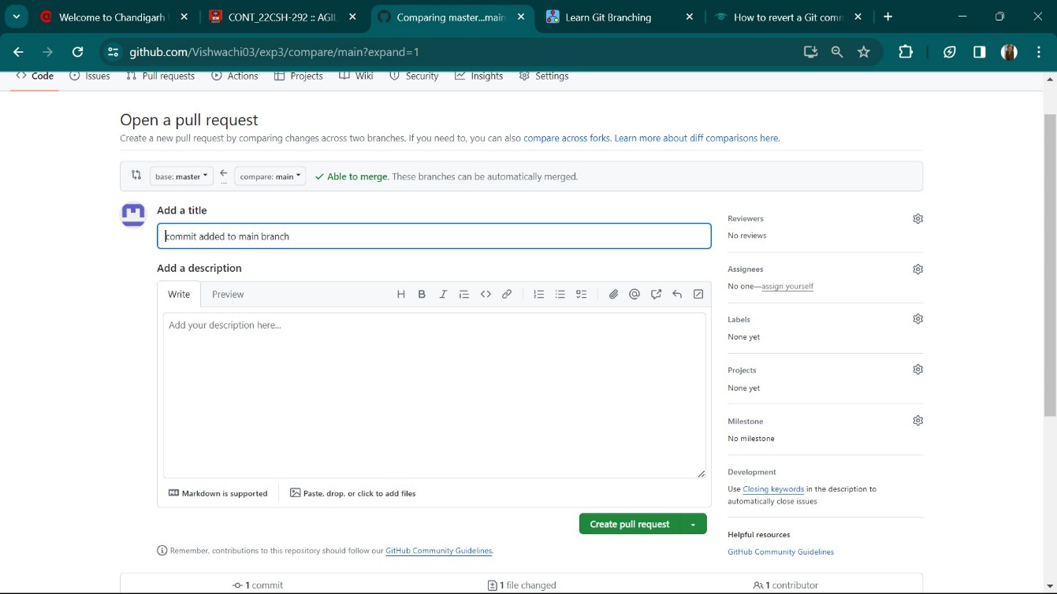

1. Now merge the pull request.

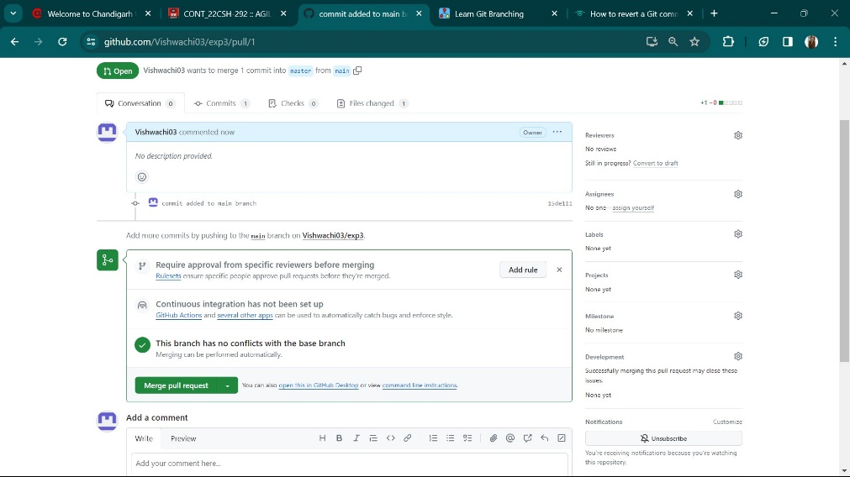

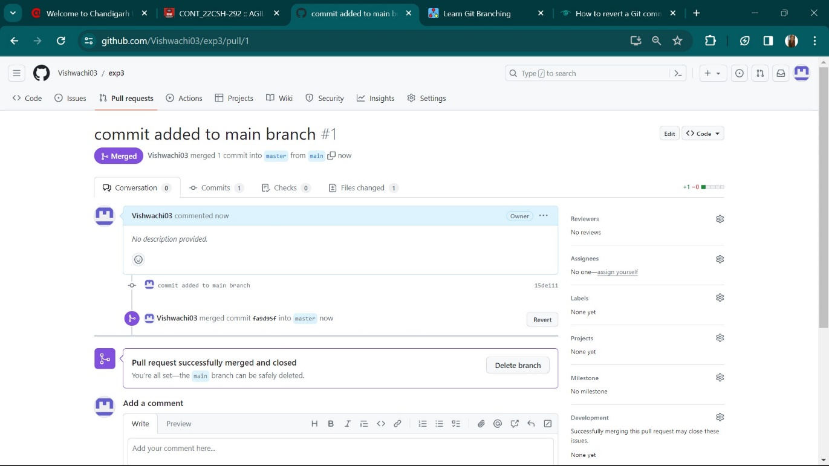

10.Review the changes you have made.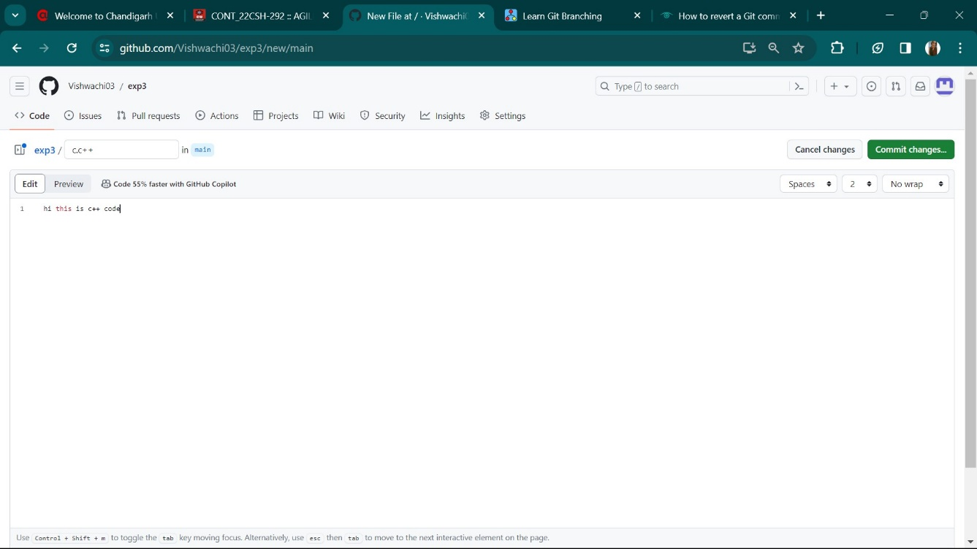

Commit the changes.

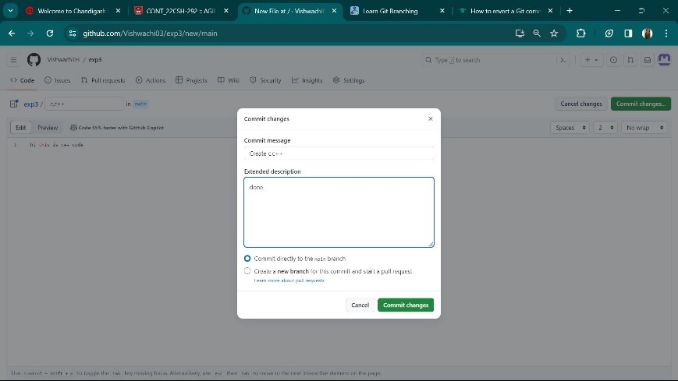

11.Commit all the changes.

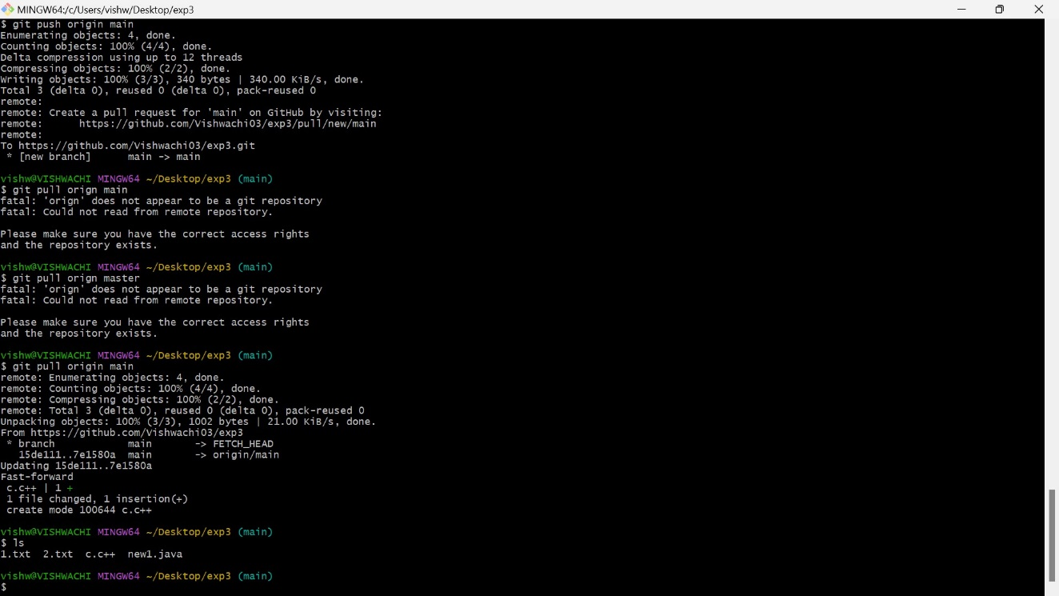

12.Review the files in main branch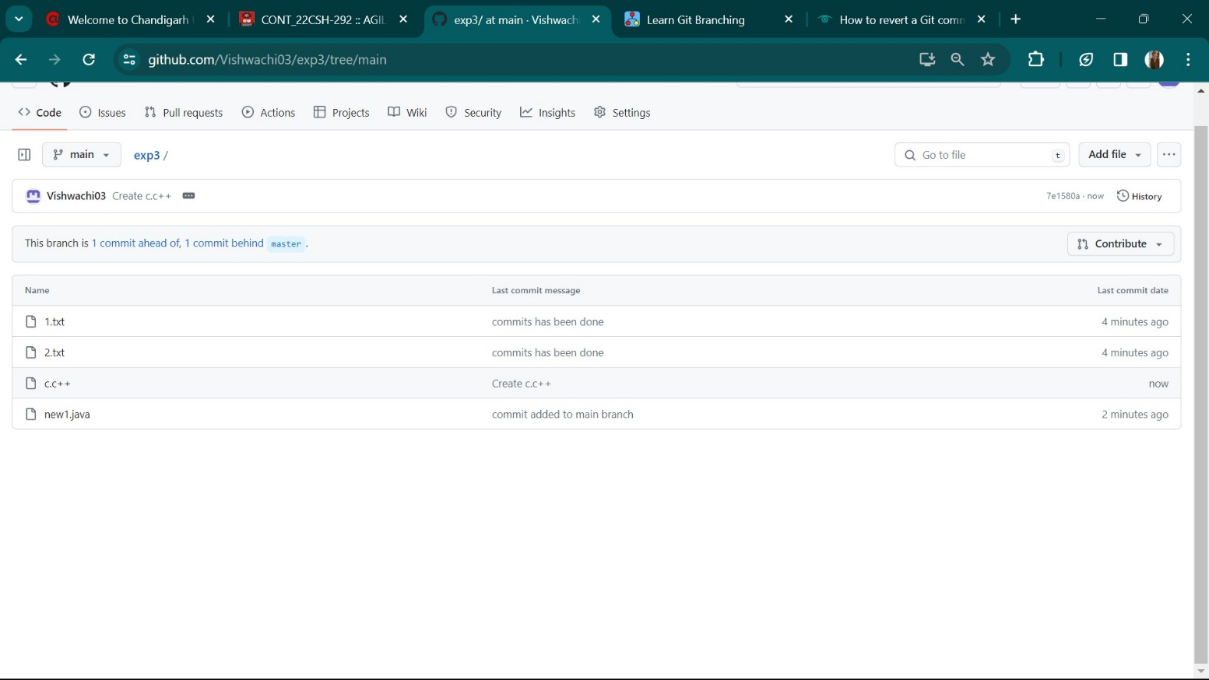

**10. Result/Output/Writing Summary:**

We have finally created explored pull request in git bash.

**Learning outcomes (What I have learnt):**

**1.** Learnt the concept of branching**.**

**2**. Learnt how to create branch on github and git bash.

**3.** Learnt how to push and pull the request.

**4.** Learnt about merging.

**5**. Learnt about how to compare the codes.

**Evaluation Grid (To be created as per the SOP and Assessment guidelines by the faculty):**

|  |  |  |  |
| --- | --- | --- | --- |
| Sr. No. | Parameters | Marks Obtained | Maximum Marks |
| 1. |  |  |  |
| 2. |  |  |  |
| 3. |  |  |  |
|  |  |  |  |