**Experiment -2.1**

**Student Name: Vishwachi Pandey UID: 22BDO10012**

**Branch: BE-CSE(DevOps) Section/Group: 22BCD-1/A**

**Semester: 4th Date of Performance:7/02/2024**

**Subject Name: GIT AND GITHUB Subject Code: 22CSH-293**

**1. Aim/Overview of the practical:** Editing a file and committing changes on GitHub.

**2. Task to be done:** In this experiment we will be editing a file and committing the changes.

**3. Apparatus(For applied/experimental sciences/materials based labs):** SOFTWARE(Git bash, github), HARDWARE( Computer system).

**4. Steps for experiment/practical:**

1. Firstly you have to create repository and named as‘editing’.

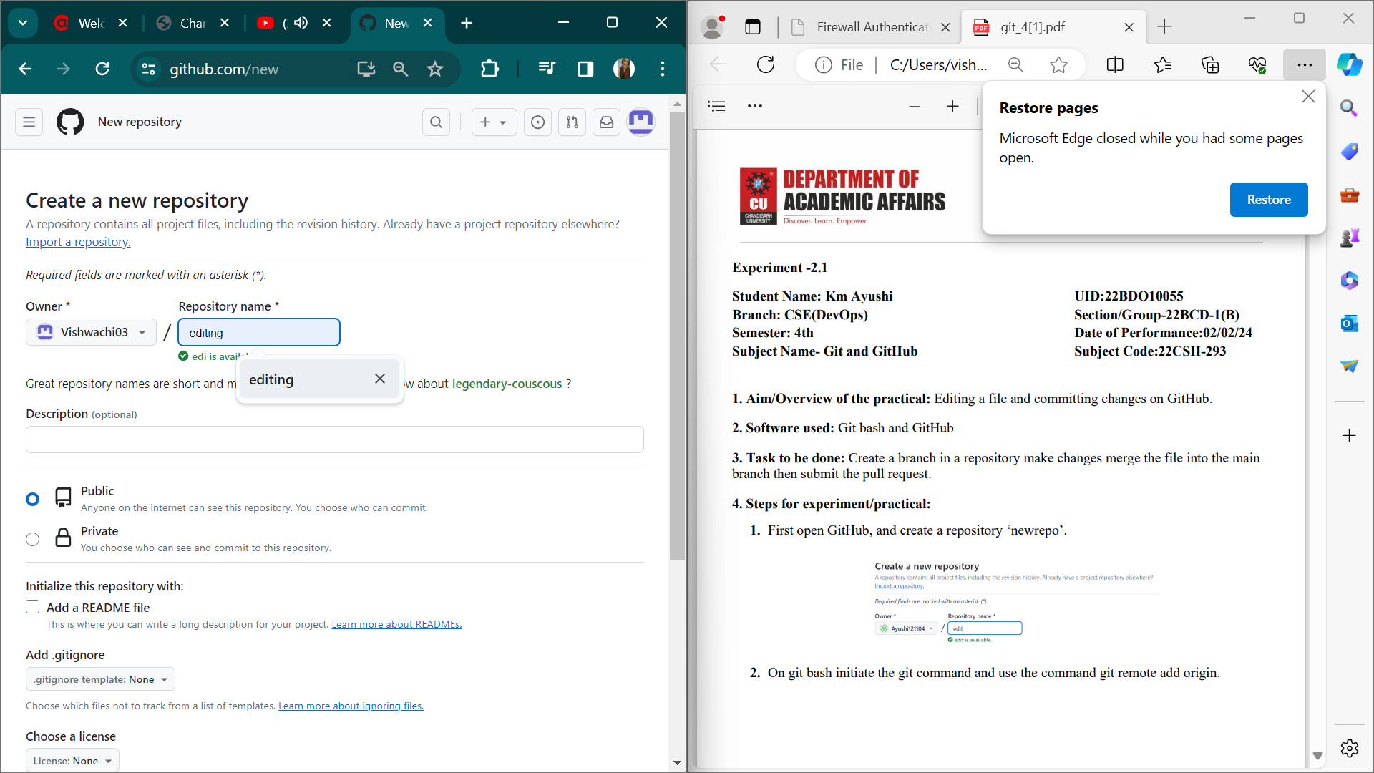

1. Now we have to go in git bash.
2. Then use git init to initiate and next use remote add origin and copy the link you copied from repo.
3. Next create a file named as ‘file1’

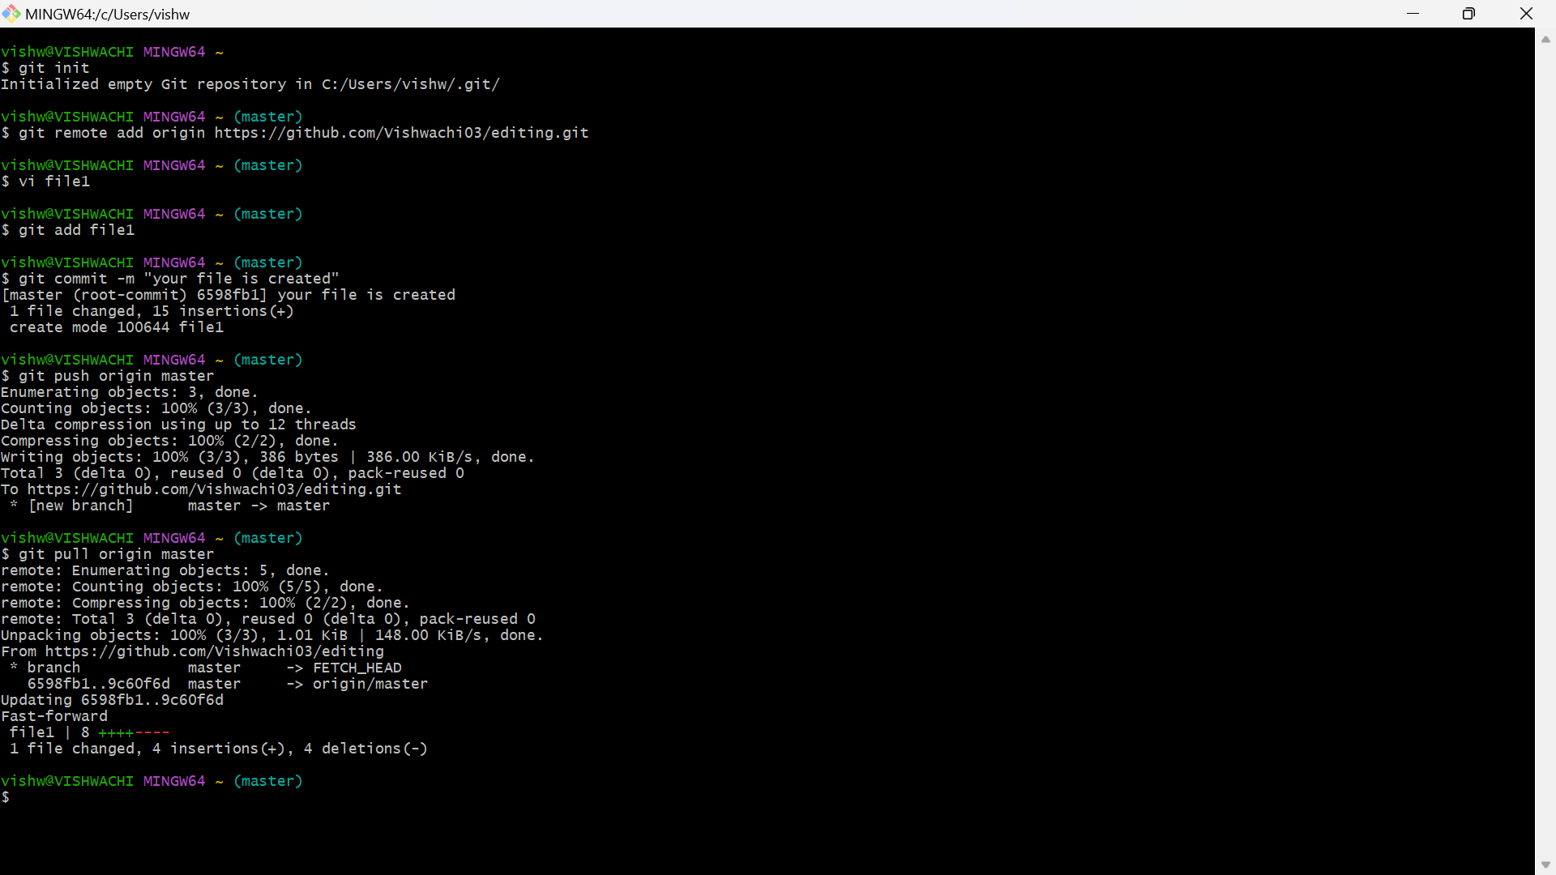

5.Now push the file to remote repository and do the changes and pull the file in the local repository.

 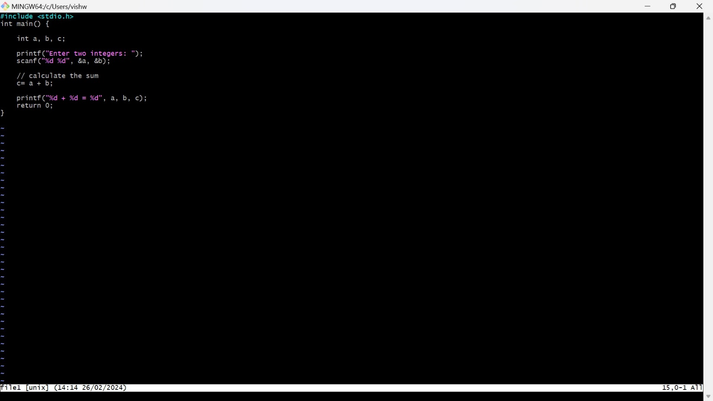

6.The below screenshot is for remote and then the changed one is add.

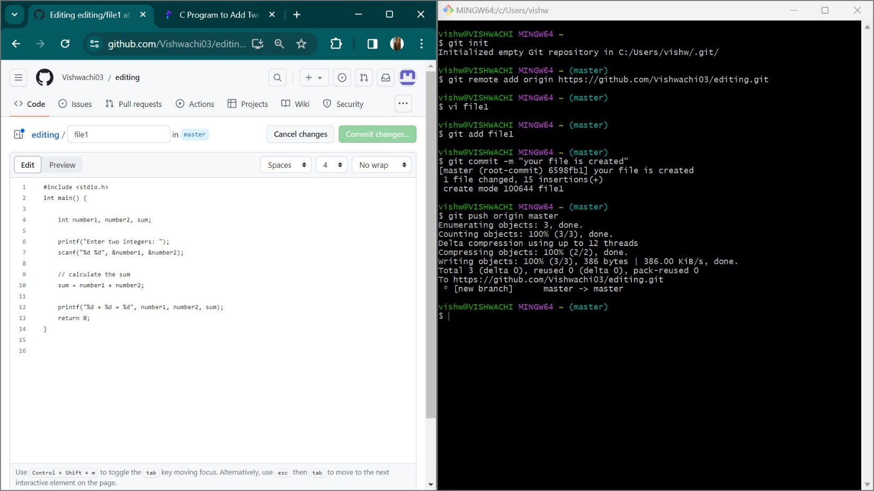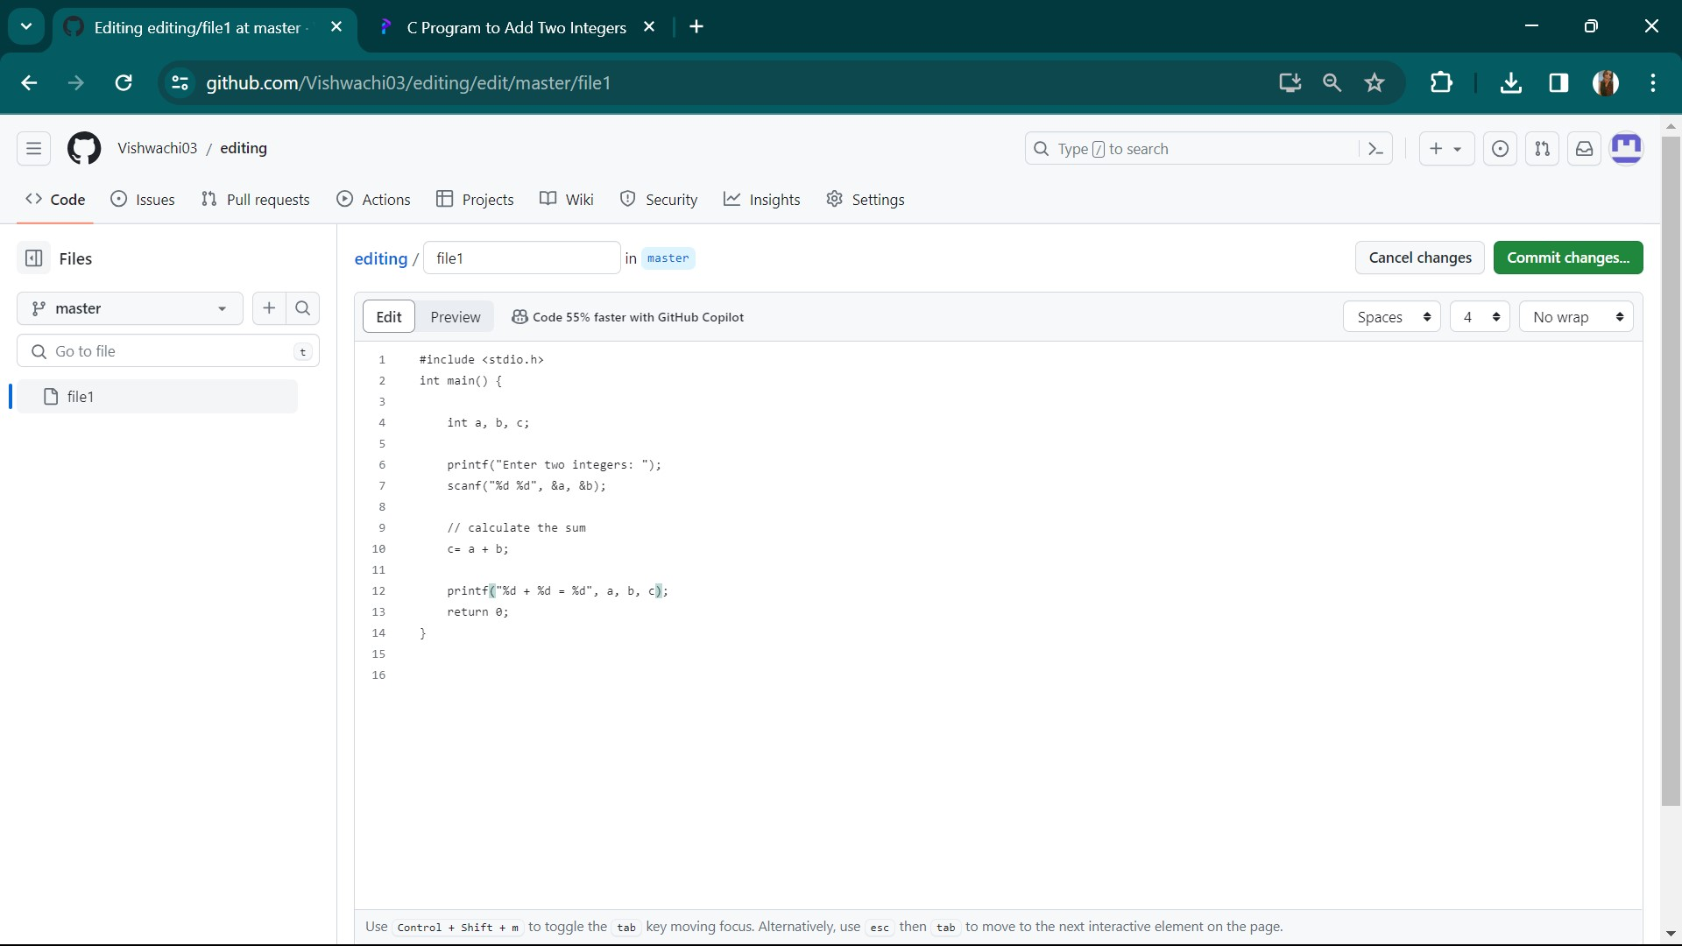

7. Now check whether the changes that you have done on the remote repository have pulled locally or not.

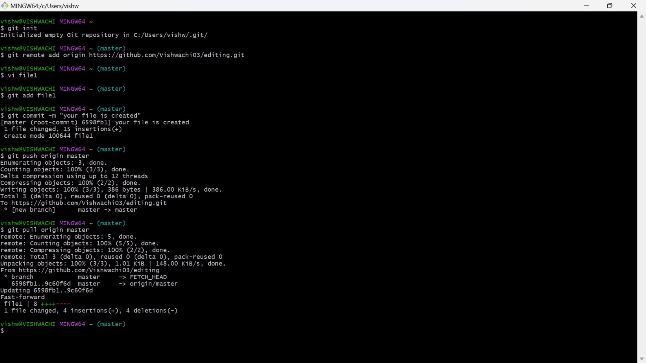

8. Next you have create a branch ‘First’ and then open the same file in the branch and edit it.

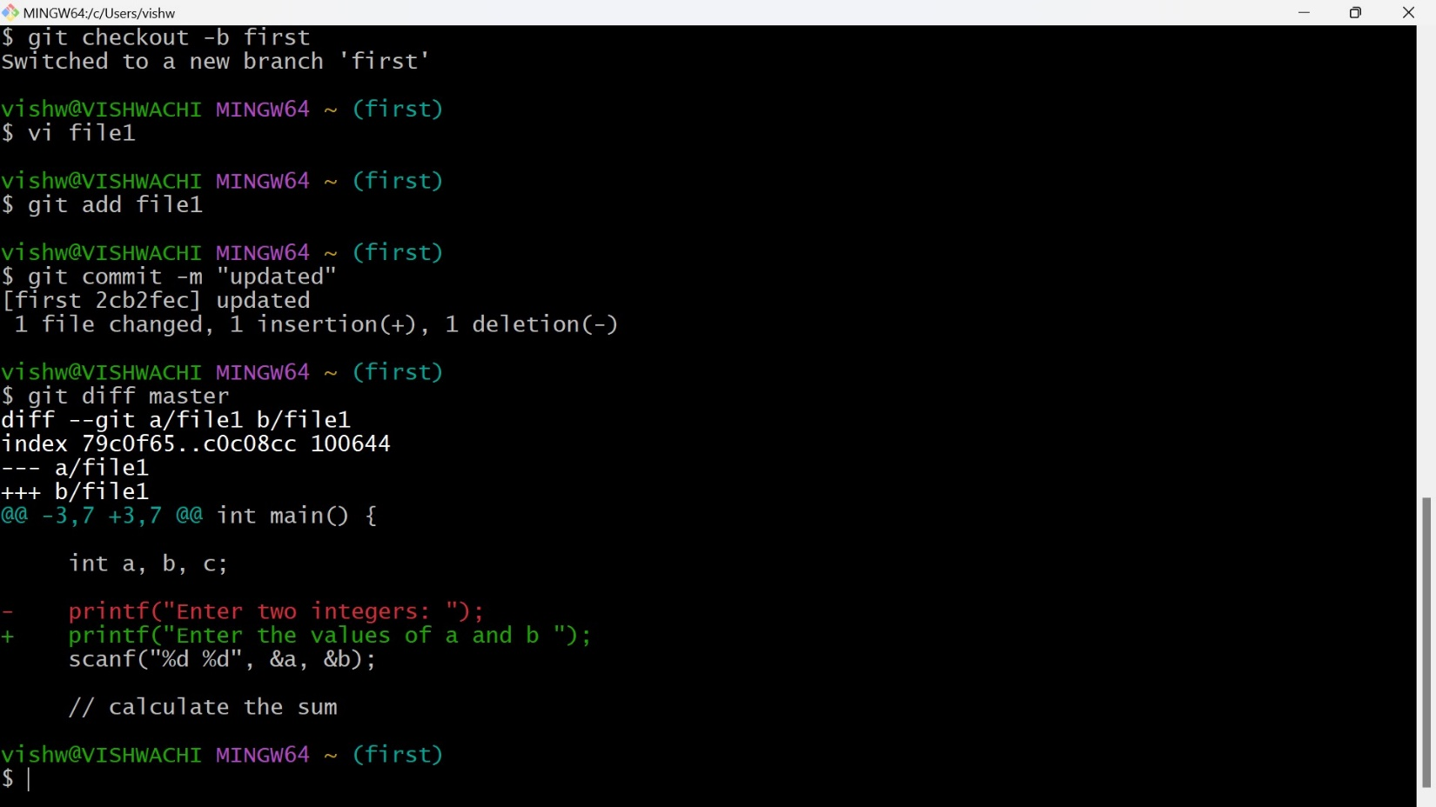

9. Now after adding and check the differences between the previous changes that we have done.



10. Now push the branch on the remote repository and merge the master branch with the branch that we have done

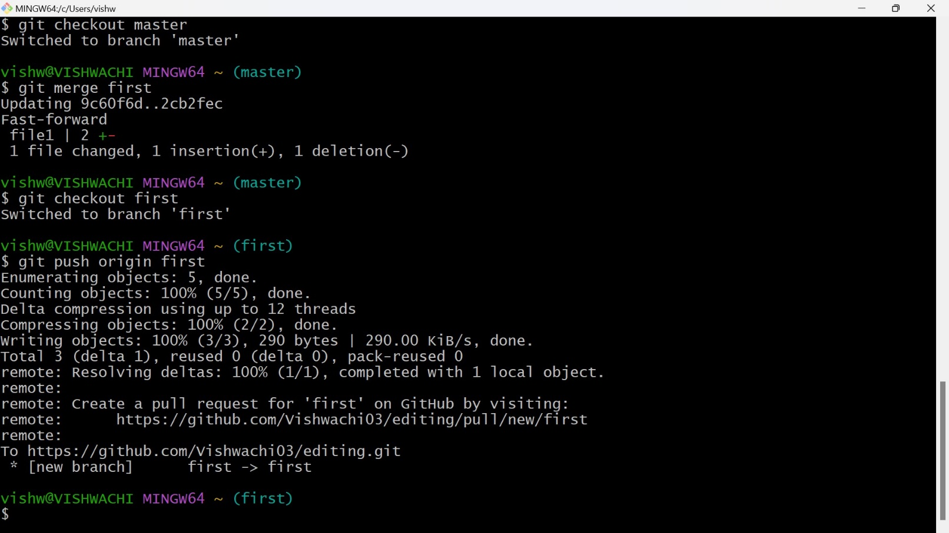

**10. Result/Output/Writing Summary:**

We have edited a file, commited the changes on Git Hub and compared the difference. In additional we pushed and pulled from the local to the remote repository.

**Learning outcomes (What I have learnt):**

**1.** Learnt how to edit a file locally.

**2**. Learnt how to push from local to remote and vice versa.

**3.** Learnt how to match the branch in the local machine.

**4.** Learnt about merging.

**5**. Learnt how to check the differences in the local machine.

**Evaluation Grid (To be created as per the SOP and Assessment guidelines by the faculty):**

|  |  |  |  |
| --- | --- | --- | --- |
| Sr. No. | Parameters | Marks Obtained | Maximum Marks |
| 1. |  |  |  |
| 2. |  |  |  |
| 3. |  |  |  |
|  |  |  |  |