## Website Traffic Analysis

PROJECT: Website traffic analysis( PHASE 3)

**Table of Contents**

|  |  |
| --- | --- |
| 1 | Introduction |
| 2 | Problem Statement |
| 3 | Design and Innovation Strategies |
| 3.1 | Data Collection and Feature Engineering |
| 3.2 | Data Preprocess |
| 3.3 | Model Selection and Training |
| 3.4 | Geographic Analysis |
| 3.5 | User Behavior Modeling |
| 3.6 | Predictive Analytics |
| 3.7 | Continuous Improvement |
| 4 | Conclusion |

**1. Introduction**

This document delves into the comprehensive strategies employed in the "Predicting Future Traffic Trends and User Behavior Patterns" project. Predicting future traffic trends and understanding user behavior are pivotal in optimizing traffic management and digital platform performance. Through innovative methodologies, this project seeks to provide actionable insights for stakeholders.

**2. Problem Statement**

Predicting future traffic trends and user behavior patterns is a multifaceted challenge influenced by various factors. This project's core objective is to develop a system that utilizes machine learning models to address this challenge effectively, providing predictive insights to inform decisionmaking

**3. Design and Innovation Strategies**

**3.1. Data Collection and Feature Engineering**

Innovation: Comprehensive Data Gathering

Implement advanced data collection techniques, including web scraping, API integration, and data enrichment, to gather diverse datasets encompassing traffic data and user interactions.

Apply innovative feature engineering techniques to extract meaningful insights from structured and unstructured data sources.

**3.2. Data Preprocess**

Innovation: Data Cleansing and Transformation

Implement data cleansing and transformation procedures to handle missing values, outliers, and data quality issues.

Utilize natural language processing (NLP) and text analytics for textual data preprocessing, enabling sentiment analysis and topic modeling.

**3.3. Model Selection and Training**

Innovation: Hybrid Models

Employ a combination of traditional machine learning models (e.g., regression, classification) and deep learning models (e.g., neural networks) to predict traffic trends and user behavior.

Develop hybrid models that leverage the strengths of both traditional and deep learning approaches for enhanced predictive accuracy.

**3.4. Geographic Analysis**

Innovation: Geospatial Insights

Integrate geospatial analysis to gain insights into the geographic patterns of traffic trends and user behavior.

Implement innovative spatial visualization techniques, such as heatmaps and geospatial clustering, to identify spatial trends.

**3.5** **User Behavior Modeling**

Innovation: Sequence Analysis

Utilize sequence modeling techniques, including recurrent neural networks (RNNs) and hidden Markov models (HMMs), to model and predict user behavior patterns.

Analyze user journeys, session durations, and entry/exit points for improved user experience.

**3.6. Predictive Analytics**

Innovation: Forecasting and Anomaly Detection

Develop predictive models for forecasting traffic trends and user behavior.

Implement anomaly detection techniques to identify unusual patterns that may require immediate attention..

**3.7. Continuous Improvement**

Innovation: Realtime Monitoring and Feedback Loop

Create realtime monitoring dashboards that provide instant updates on traffic trends and user behavior.

Establish a feedback loop to continuously improve models based on new data and changing user preferences.

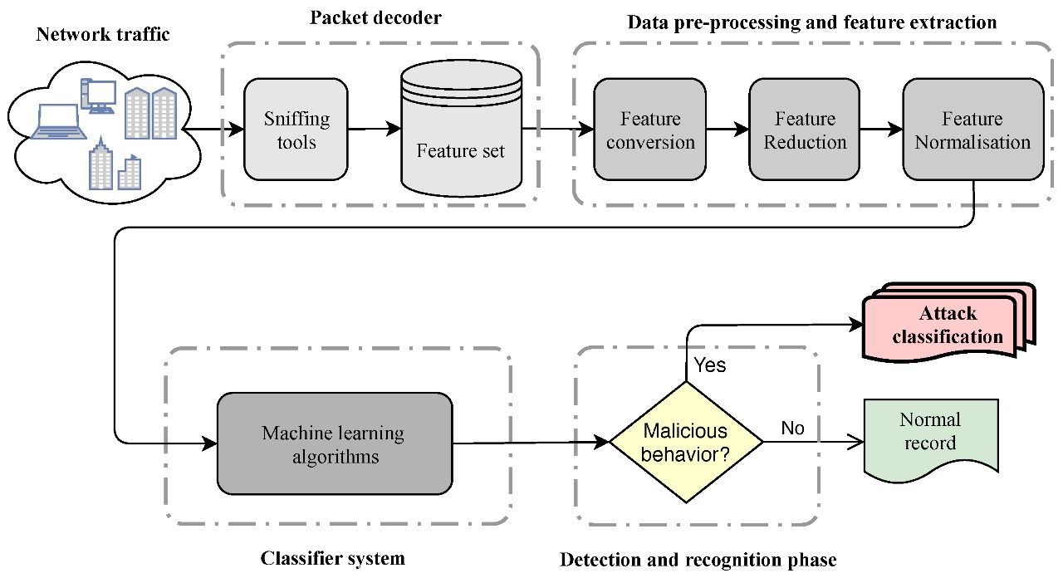

**4. Conclusion**

In conclusion, the integration of continuous learning into machine learning models for predicting future traffic trends and user behavior patterns is paramount in addressing the dynamic nature of these domains.In the realm of user behavior prediction, streamlined data collection, incremental model updates, real-time personalization, A/B testing, feedback loops, dynamic user clustering, privacy considerations, and regular model audits empower digital services to deliver tailored and relevant experiences to users, fostering engagement and satisfaction.