 | Sanjivani Rural Educational Society’s SANJIVANI COLLEGE OF ENGINEERING  (An Autonomous Institution)  Kopargaon – 423 603, Maharashtra. | ACAD-F-15 K
Academic Year: 2025-26 | CIA ACTIVITY REPORT | Revision: 00 Dated :
Department : | INFORMETION TECHNOLOGY | Date of  Preparation : 24-04-2026
Course Name: | SOFTWARE ENGINEERING MODELING DESIGN | Year/Sem:  SY Sem-II

Activity Title:

Student Mentoring Management System

Submitted by:

Roll  No. | PRN No. | Name of the Student | Signature
102 | 0124UITM1102 | Vishwajeet Pawde
103 | 0124UITM1103 | Samarth Sonawane
104 | 0124UITM1104 | Pavan Rothe
105 | 0124UITF105 | Ganesha Bhagwat

Course Incharge

DR. S.N.GUNJAL
INDEX

Sr.No. | Topic | Page no.
 | Abstract
 | Project Definition
 | Introduction
 | Scope of the Project
 | Objectives of the Project
 | Literature Review / Background Study
System Analysis
7.1 Existing System
7.2 Problems in Existing System
7.3 Proposed System
Software Requirements Specification (SRS)
8.1 Functional Requirements
8.2 Non-Functional Requirements
8.3 Use Case Diagram
8.4 Use Case Description
System Design
9.1 UML Diagrams
- Class Diagram
- Sequence Diagram
- Activity Diagram
- Sate chart Diagram
- Collaboration Diagram
- Component Diagram
- Deployment Diagram

 | Data Flow Diagram (DFD)
 | Control Flow Diagram(CFD)
 | Conclusion
 | References

- Abstract

In educational institutions, mentoring plays a crucial role in guiding students academically, personally, and professionally. However, in many colleges, mentoring activities such as tracking student progress, scheduling meetings, maintaining records, and communication between mentors and students are still handled manually. This traditional approach often leads to problems such as poor record management, lack of timely communication, difficulty in monitoring student performance, and inefficiency in mentor-student interactions.

To overcome these challenges, a Student Mentoring Management System is proposed. This system provides a centralized digital platform where mentors and students can interact efficiently. It allows student registration, mentor allocation, progress tracking, performance monitoring, meeting scheduling, and communication through notifications. The system helps institutions maintain organized records, improve student guidance, enhance communication, and reduce manual workload. Overall, it supports better academic performance and effective mentoring.

2.Project Defination

The Student Mentoring Management System is a web-based application designed to manage and streamline mentoring activities in educational institutions. It enables mentors, students, and administrators to interact through a centralized platform for tracking progress, communication, and performance evaluation.

3.Introduction

Mentoring plays an important role in the academic and personal development of students in educational institutions. It helps students receive proper guidance, improve their performance, and make better career decisions. However, in many colleges, mentoring activities are still managed manually using paper records or basic tools, which often leads to issues such as poor record management, lack of timely communication, and difficulty in tracking student progress.
With the increasing use of technology in education, there is a need for an efficient digital solution to overcome these limitations. A computerized system can provide centralized data management, improve communication between mentors and students, and allow easy monitoring of student performance. It also reduces manual effort and minimizes errors in maintaining records.
The proposed Student Mentoring Management System offers a structured and user-friendly platform to manage mentoring activities effectively. It enables features such as student registration, mentor allocation, progress tracking, and feedback management, thereby improving the overall efficiency and effectiveness of the mentoring process.

- Scope of Project

- The system supports student registration and mentor assignment.
- It allows mentors to track academic progress and record mentoring sessions.
- Students can communicate with mentors and view feedback.
- Administrators can monitor mentoring activities and generate reports.
- The system can be used by colleges, universities, and educational institutions.

- Objectives of the Project

- To develop an online platform for managing student mentoring activities.
- To maintain digital records of student academic performance and mentoring sessions.
- To improve communication between mentors and students.
- To enable easy monitoring of student progress by mentors and administrators.
- To reduce manual paperwork and improve efficiency in mentoring processes.

- Literature Review / Background Study

Existing systems in many institutions rely on manual record-keeping or basic digital tools like spreadsheets. Research shows that such systems lack real-time updates, automation, and efficient communication.
Modern mentoring systems use web-based platforms to:
- Maintain centralized data
- Provide real-time tracking
- Improve communication
However, many systems are either too complex or not customized for institutional needs. Hence, this project aims to provide a simple and efficient solution.

System Analysis

7.1 Existing System
- Manual record keeping (paper-based)
- Use of spreadsheets (Excel)
- No centralized system
- Limited communication channels

7.2 Problems in Existing System
- Data redundancy and loss
- Lack of real-time updates
- Poor communication between mentor and student
- Time-consuming processes
- Difficulty in tracking student progress

7.3 Proposed System
The proposed system introduces a digital platform that:
- Stores all student data securely
- Allows mentor-student interaction
- Tracks progress and performance
- Sends notifications
- Generates reports

Software Requirements Specification (SRS)

8.1 Functional Requirements
- FR: The system shall allow users to register and log in securely.
- FR: The system shall provide role-based access for students, mentors, and administrators.
- FR: The system shall assign mentors to students.
- FR: The system shall allow mentors to track student academic progress.
- FR: The system shall enable scheduling of mentoring sessions.
- FR: The system shall provide a feedback system between mentors and students.
- FR: The system shall allow students to view feedback and mentoring records.
- FR: The system shall generate reports for monitoring student performance.

8.2 Non-Functional Requirements
- NFR: The system shall be user-friendly and easy to use.
- NFR: The system shall ensure secure data storage and user authentication.
- NFR: The system shall provide fast response time.
- NFR: The system shall be reliable with minimal downtime.
- NFR: The system shall be scalable to handle increasing users and data.
- NFR: The system shall maintain data accuracy and consistency.

8.3 Use Case Diagram
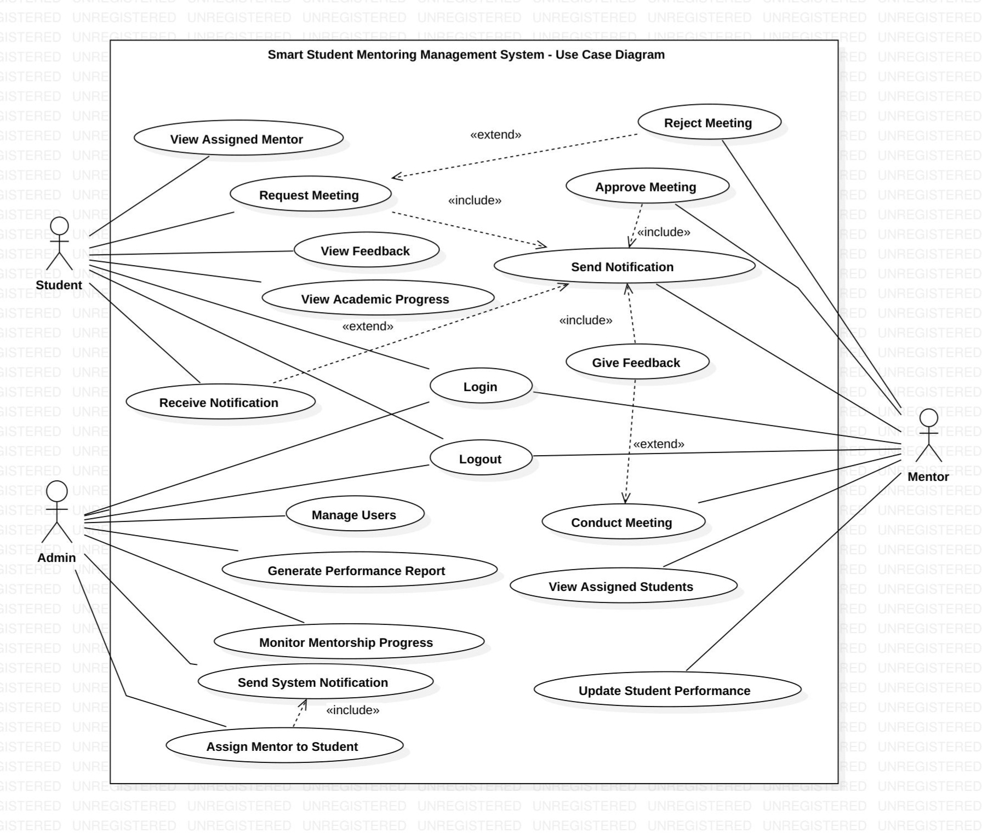

8.4 Use Case Description

The Student Mentoring Management System consists of multiple use cases that define the interaction between users (Student, Mentor, and Admin) and the system.

- User Registration & Login:
All users (students, mentors, and administrators) can register and log in securely using their credentials. The system validates user information and provides role-based access.

- Mentor Assignment:
The admin assigns mentors to students. This ensures that each student is guided properly and mentoring responsibilities are clearly defined.

- Track Student Progress:
Mentors can monitor and update the academic performance and overall progress of their assigned students. This helps in identifying weak areas and providing timely guidance.

- Schedule Mentoring Sessions:
Mentors can schedule meetings with students by selecting date and time. The system notifies students about upcoming sessions.

- Provide and View Feedback:
Mentors provide feedback after each session regarding student performance and behavior. Students can log in to view this feedback for improvement.

- Report Generation:
Admin can generate reports related to student performance, mentoring activities, and overall system usage. These reports help in analysis and decision-making.

- Communication (Notifications):
The system sends notifications to users regarding session schedules, feedback updates, and important announcements, ensuring smooth communication.

System Design
9.1 UML Diagrams

- Class Diagram
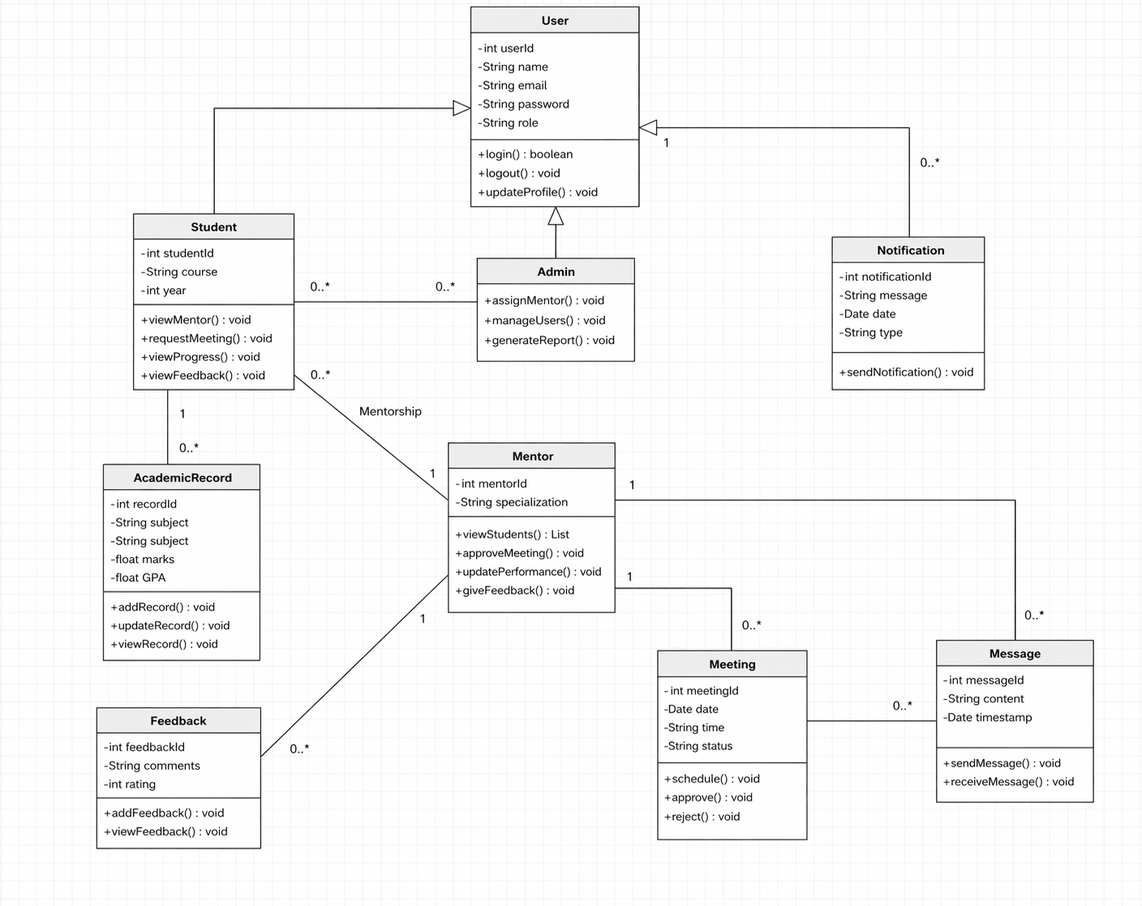

- Sequence Diagram
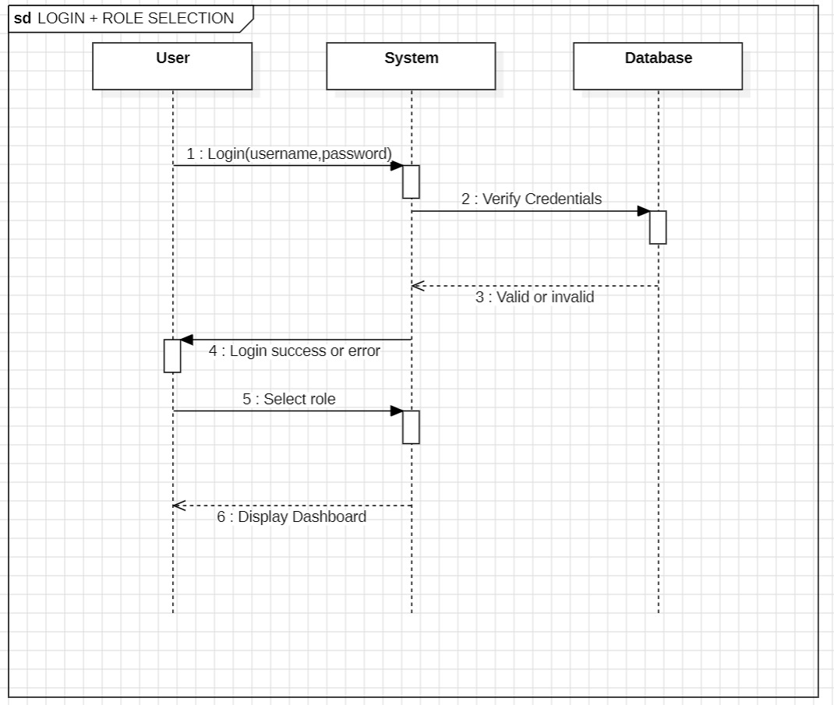
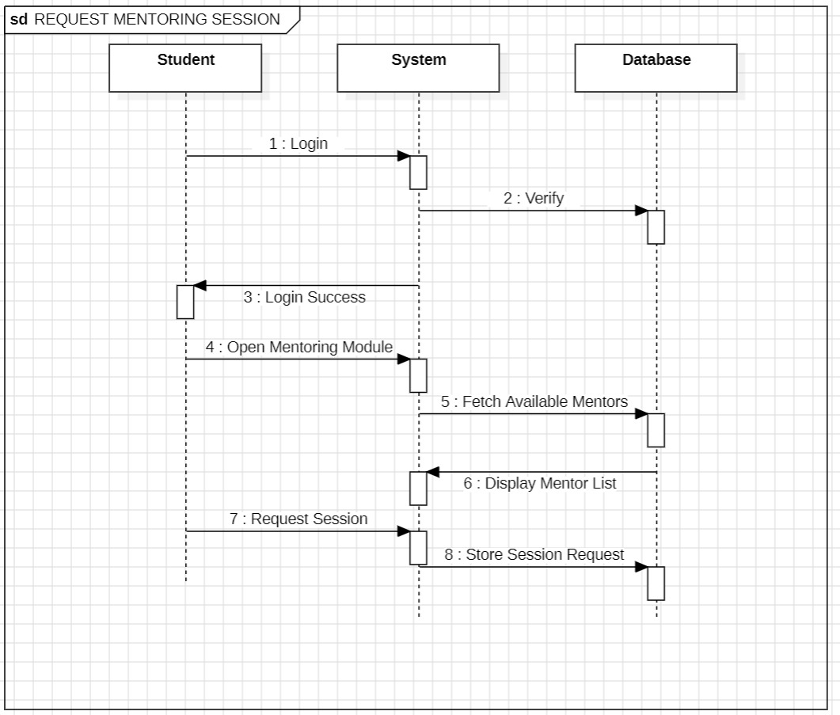
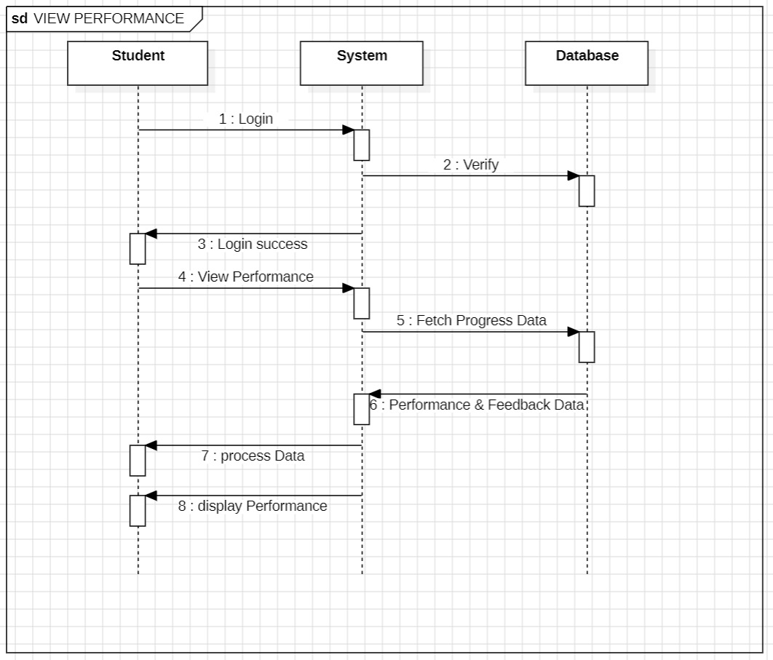
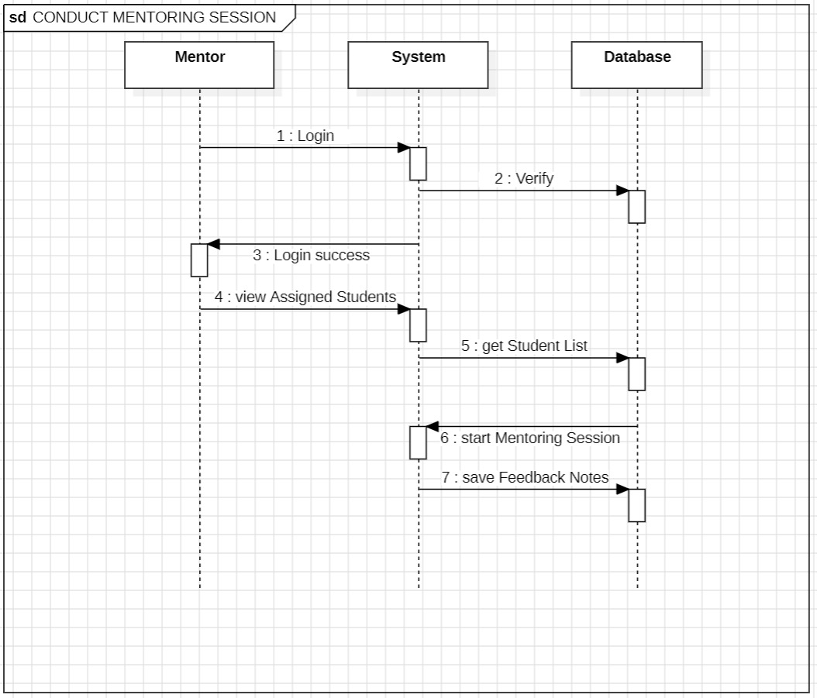

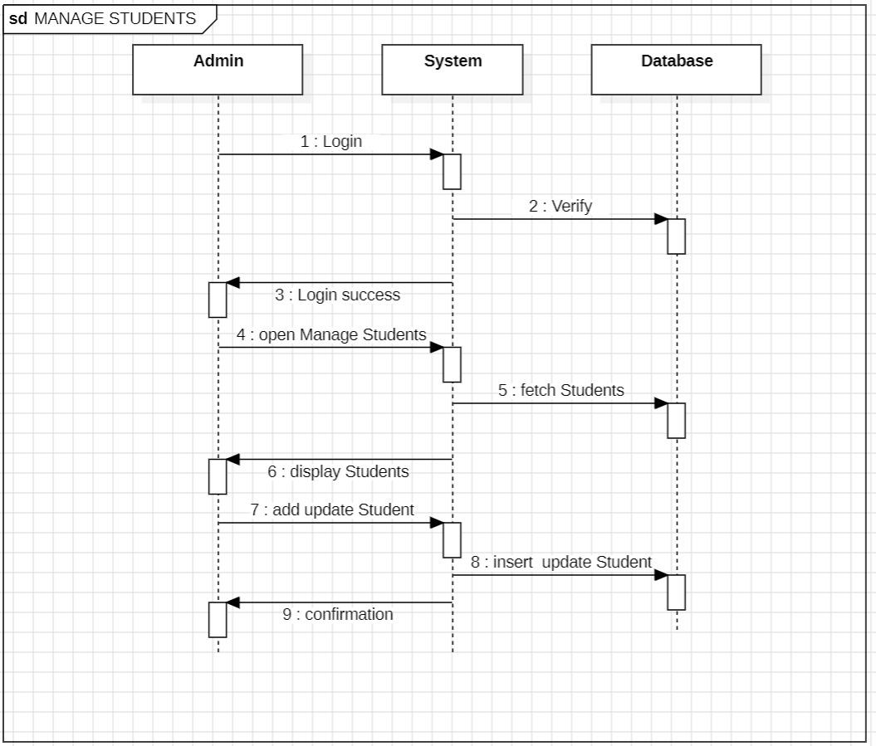

- Activity Diagram

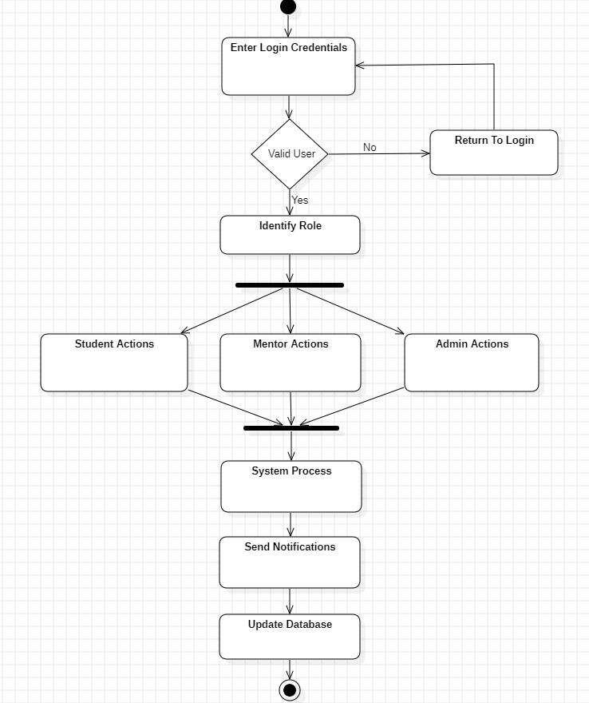

- State Chart Diagram

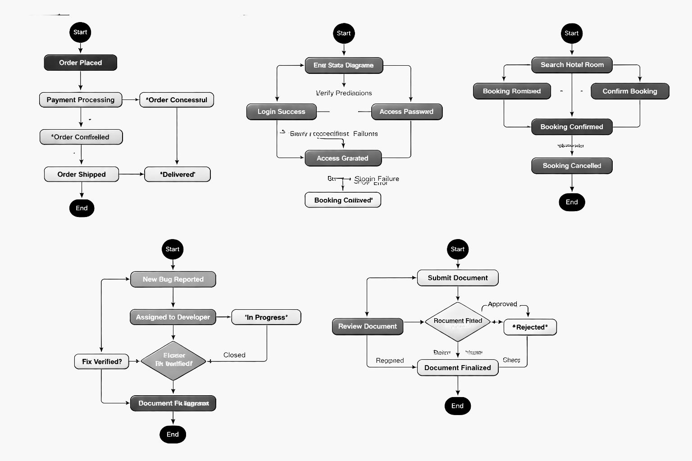

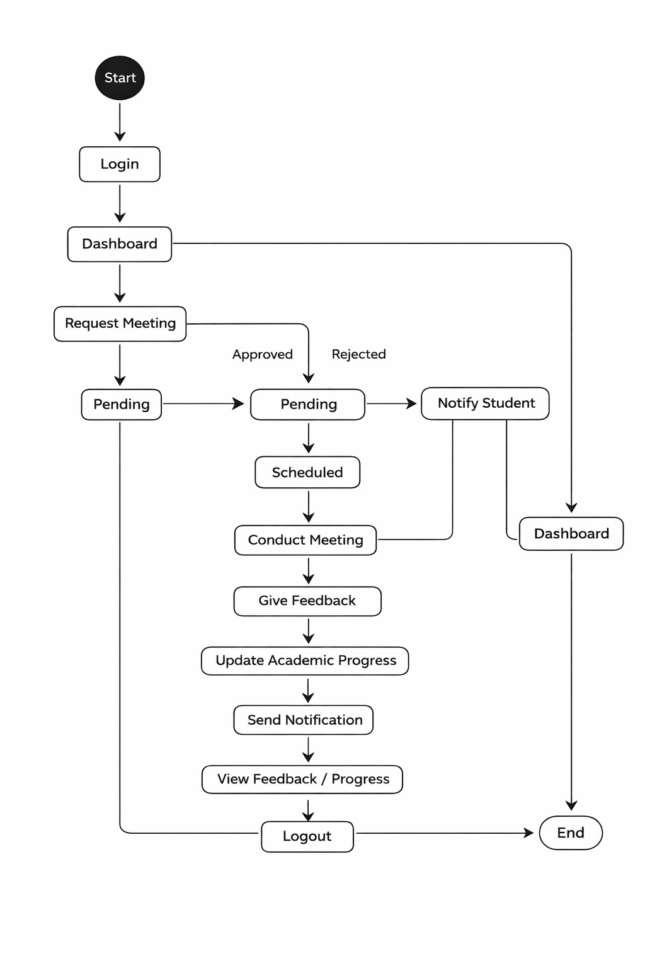

- Collaboration Diagram

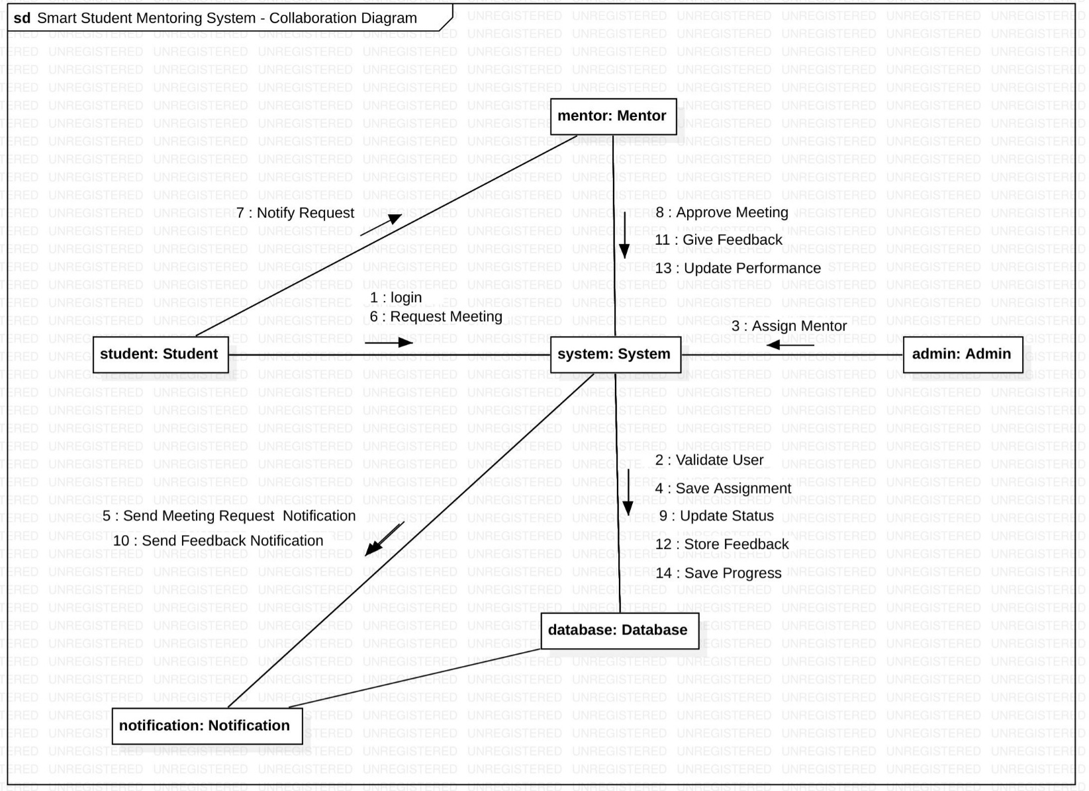

- Component Diagram

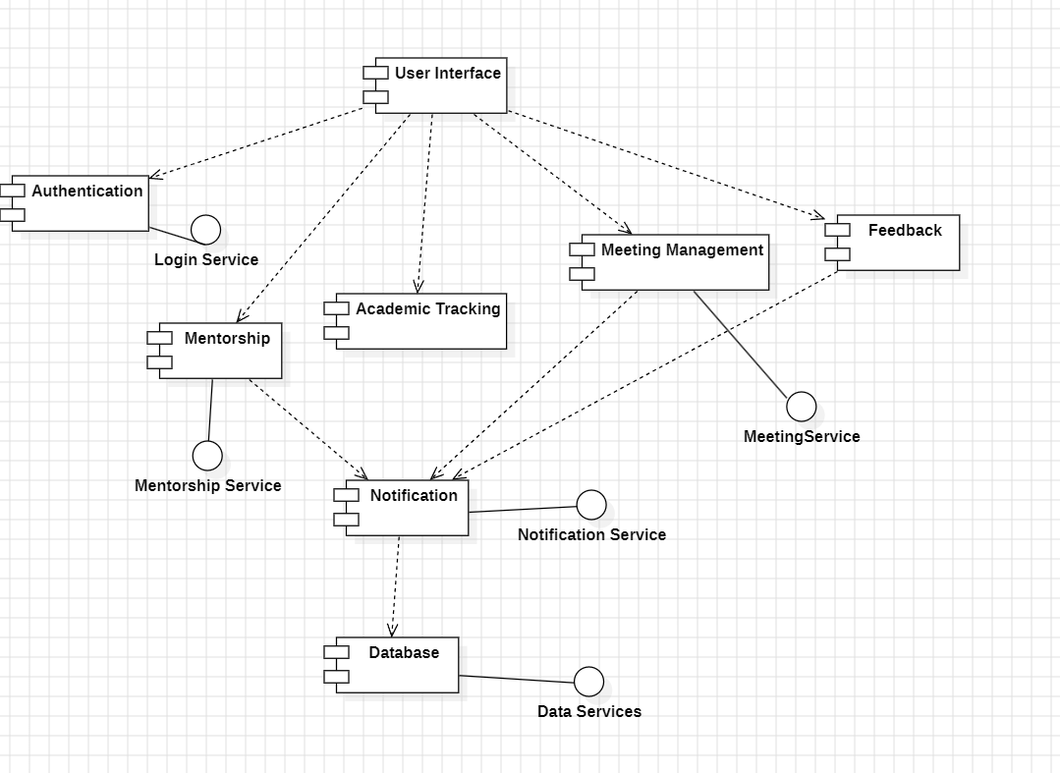

- Deployment Diagram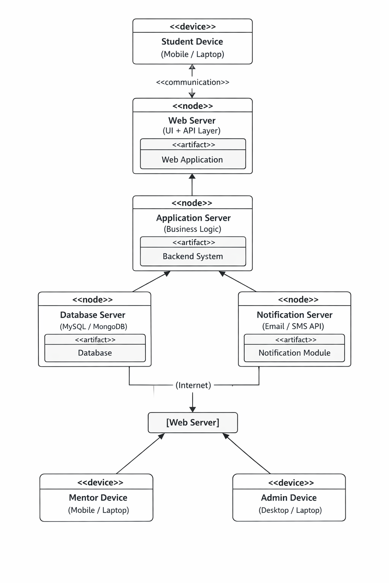

10.Data Flow Diagram(DFD)

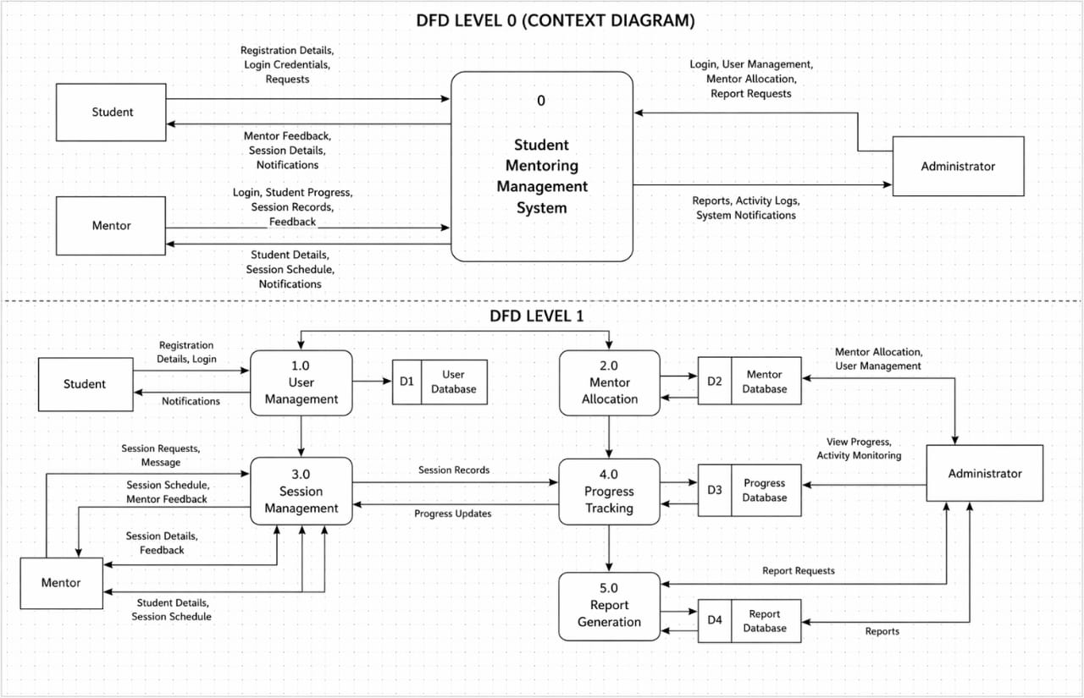

- Control Flow Diagram

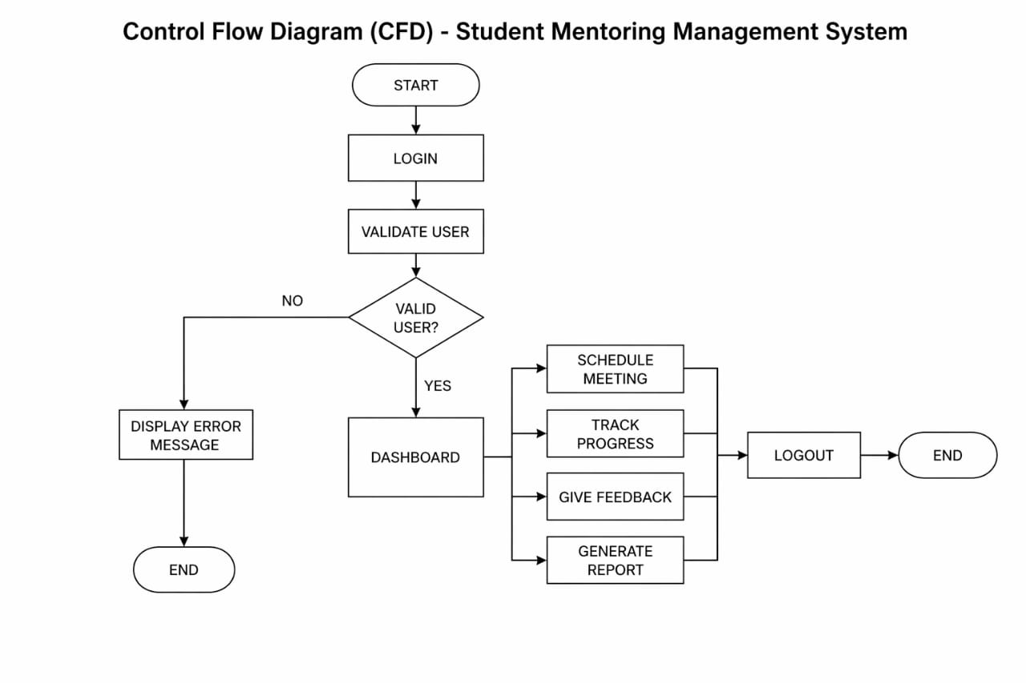

12. Conclusion
The Student Mentoring Management System provides an efficient and organized approach to managing mentoring activities within educational institutions. By digitizing processes such as student registration, mentor allocation, progress tracking, and communication, the system significantly reduces manual work and minimizes errors. It enhances interaction between mentors and students, ensuring timely guidance and better academic support.
Additionally, the system improves transparency and accessibility of information, allowing mentors and administrators to monitor student performance effectively. Its user-friendly design and scalability make it suitable for implementation in colleges, universities, and other educational institutions. Overall, the system contributes to improving the quality of mentoring and supports better academic and personal development of students.

13. References
- Books and research papers on Student Mentoring Systems and Educational Management Systems
- Articles from Google Scholar related to mentoring and student management
- Technical papers from IEEE on system design and software engineering
- Online tutorials and documentation related to system development (e.g., programming languages, databases, frameworks)
- Study materials and lecture notes on Software Engineering and System Analysis

