HEART DISEASE PREDICTION SYSTEM

Project Id: AIML-18

Name: INAKSHI BAHUKHANDI (Team Leader) Class Roll Number: 07
University Roll Number: 2028431
Section and Group: G(G1)

Name: VISHWAJEET SINGH
Class Roll Number:23 University Roll Number: 2028515
Section and Group: G(G1)

TABLE OF CONTENTS
- Problem Description 3
  - Dataset Description 3
  - Flow diagram 4
- Modules for Project Implementation 5
  - Modules Used
........................................................................................................................
5
  - Platform Used
........................................................................................................................
6
- Machine Learning model 7-8
- Evaluation metrics used 9
- Results and Visualizations 10-12
- Conclusion and Future Scope 14
- References 15

Problem Description
The Heart Disease Prediction System is a sophisticated machine learning-based application developed to address one of the most critical challenges in modern healthcare: the early detection of cardiovascular diseases. Cardiovascular diseases are a leading cause of mortality globally, and manual diagnosis can often be delayed due to the complexity of interpreting multiple clinical parameters simultaneously.
This system is designed to analyze diverse clinical patient data—including metabolic indicators like cholesterol and blood sugar, as well as physiological measures like blood pressure and heart rate—to predict the likelihood of heart disease risk. By leveraging computational intelligence and predictive modeling, the application automates the diagnostic workflow, transforming raw medical data into actionable insights. This not only assists medical practitioners in making data-driven decisions but also facilitates early intervention, which is vital for improving patient survival rates and optimizing hospital resource management.

Dataset Description
The foundation of this project is built upon a comprehensive medical dataset tailored for classification tasks.
    - Source and Volume: The primary data source is the heart.csv file, which comprises a robust collection of 918 unique patient observations. Each observation is mapped against 12 distinct clinical features, providing a multi-dimensional view of patient health.
    - Key Features (Input Variables):
      - Age: The age of the patient (years).
      - Sex: Biological sex of the patient.
      - Chest Pain Type (cp): Categorized into four types (Typical Angina, Atypical Angina, Non-Anginal Pain, Asymptomatic).
      - Resting Blood Pressure (RestingBP): Recorded in mm Hg upon admission.
      - Cholesterol (chol): Serum cholesterol measured in mg/dl.
      - Fasting Blood Sugar (fbs): Binary indicator (1 if > 120 mg/dl, 0 otherwise).
      - Resting ECG: Results of the electrocardiogram (Normal, ST, LVH).
      - Max Heart Rate (MaxHR): Maximum heart rate achieved during testing.
      - Exercise Angina (exang): Exercise-induced chest pain (Yes/No).
      - Oldpeak: ST depression induced by exercise relative to rest.
      - ST Slope: The slope of the peak exercise ST segment.
    - Target Variable (Output):
      - HeartDisease: This is a binary classification field. A value of 1 indicates the presence of heart disease, while 0 indicates a normal, healthy state.

Flow Diagram

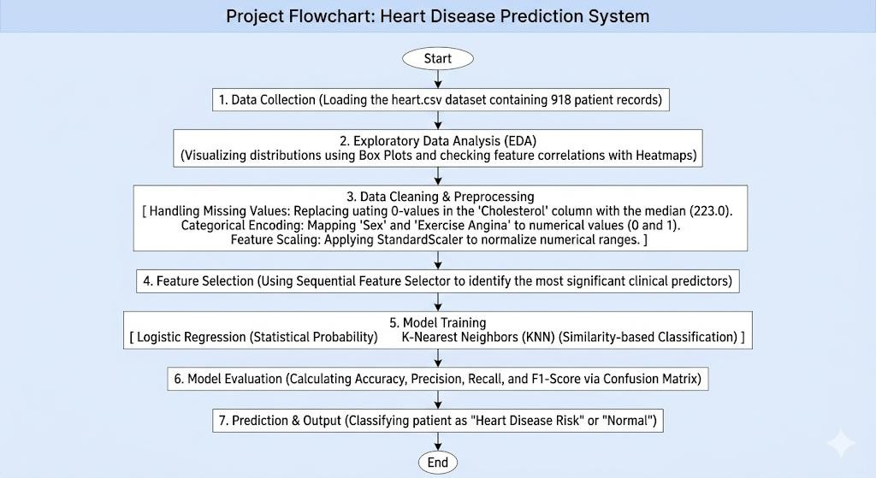

Modules for Project Implementation
The development of the Heart Disease Prediction System relied on several industry-standard Python libraries. These modules provided the necessary tools for data ingestion, statistical analysis, feature engineering, and the execution of machine learning algorithms.

Modules Used
- Pandas - Pandas served as the primary tool for data structuring and manipulation. In this project, the dataset was loaded into a DataFrame, which allowed for efficient row and column operations.
- Purpose: It was used to handle the heart.csv file, enabling the team to inspect the data structure and perform preliminary cleaning.
- Key Functions Used:
  - pd.read_csv(): To import the clinical data into the environment.
  - df.isnull().sum(): To identify missing values across the 12 features.
  - df.head() and df.describe(): To perform a statistical overview of patient age, cholesterol, and blood pressure.

- NumPy - NumPy provided the computational foundation for handling large, multi-dimensional arrays and matrices.
- Purpose: It was essential for mathematical consistency during the data cleaning phase.
- Key Functions Used:
  - np.where(): Utilized to identify and replace anomalous "0" values in the cholesterol and blood pressure columns.
  - np.median(): Calculated the central tendency for imputation, specifically the value 223.0 used for cholesterol correction.
- Matplotlib & Seaborn - These libraries were used to transform raw numbers into visual insights, which is critical for identifying medical trends and data outliers.
- Purpose: To conduct Exploratory Data Analysis (EDA) and visualize the relationship between different health indicators.
- Visuals Generated:
  - Box Plots: Used to detect extreme outliers in RestingBP and Cholesterol levels that could skew the model's accuracy.
  - Correlation Heatmaps: Used to determine which clinical features (like MaxHR or Oldpeak) had the strongest positive or negative correlation with heart disease.
- Scikit-Learn - Scikit-Learn was the core engine for all predictive modeling and preprocessing tasks.
- StandardScaler: This module was used to normalize the dataset.
- SequentialFeatureSelector (SFS): A wrapper-based feature selection method used to pick the top clinical attributes.
- Model Implementation: This library also provided the classes for LogisticRegression and KNeighborsClassifier, allowing for the construction and training of the actual

prediction engines.

Platform Used
The implementation of the Heart Disease Prediction System required a multi-faceted development environment. Different platforms were utilized at various stages of the project life cycle—from initial data exploration to final script optimization and debugging.

- Jupyter Notebook

Jupyter Notebook was selected as the primary environment for the Exploratory Data Analysis (EDA) and prototyping phases of the project.
  - Reason for Use: Its cell-based architecture allows for "literate programming," where code, output, and visualizations (like heatmaps and box plots) coexist in a single document.
  - Key Advantage: It enables simultaneous code execution and data visualization. This was crucial for immediately seeing the impact of data cleaning steps, such as replacing zero-values in the cholesterol column, without having to re-run the entire script.

- Spyder (Scientific Python Development Environment)

Spyder was integrated into the workflow to handle the heavy computational tasks and detailed variable inspection.
  - Reason for Use: As a powerful interactive development environment (IDE) specifically designed for scientists and engineers, Spyder provides an advanced Variable Explorer.
  - Key Advantage: This allowed the team to monitor the status of large NumPy arrays and Pandas DataFrames in real-time. During the feature selection process using the SequentialFeatureSelector, Spyder’s multi-pane layout made it easy to compare the shapes of scaled versus non-scaled data, ensuring that the StandardScaler was applied correctly across all clinical features.

Machine Learning Models Used

In this project, two distinct classification algorithms were implemented and compared to determine the most effective approach for predicting cardiac risk: Logistic Regression and K-Nearest Neighbors (KNN).

Logistic Regression
Logistic Regression is a fundamental statistical model used for binary classification. Unlike linear regression, which predicts continuous values, Logistic Regression predicts the probability of a categorical outcome—in this case, whether a patient has heart disease (1) or is normal (0).

- The Sigmoid Function
The core of Logistic Regression is the Sigmoid (Logistic) Function, which maps any real-valued number into a value between 0 and 1.
Where z is the linear combination of input features (Age, Cholesterol, BP, etc.) and their respective weights. If the resulting probability is 0.5, the patient is classified as "At Risk"; otherwise, they are classified as "Normal."

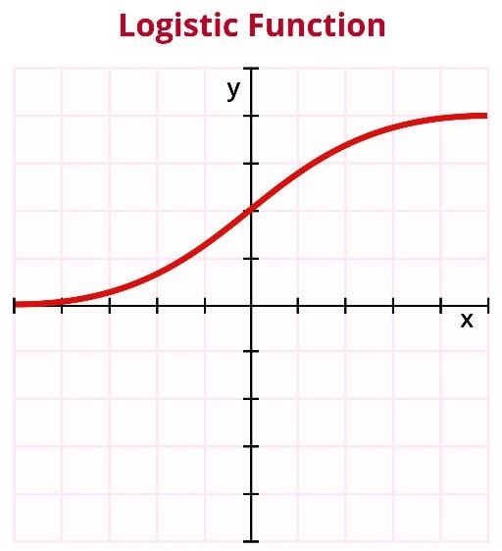

- How Training Works
  - Feature Weights: The model learns the optimal weights (coefficients) for each clinical feature. For instance, it might assign a higher weight to Oldpeak or MaxHR if they are stronger predictors of heart disease.
  - Cost Function: The system uses Log Loss (Cross-Entropy) to measure the error between the predicted probability and the actual patient outcome.
  - Gradient Descent: This optimization algorithm is used to iteratively update the

weights to minimize the loss function, ensuring the highest possible accuracy for the training set.
- Application in Heart Disease Prediction
Logistic Regression was chosen for its interpretability. It allows medical practitioners to understand how much each specific health factor contributes to the overall risk percentage.

K-Nearest Neighbors (KNN)
The K-Nearest Neighbors algorithm is a non-parametric, "lazy learning" method used for classification based on feature similarity. It operates on the principle that patients with similar clinical profiles will likely have the same health outcomes.

- The Mechanism of Similarity
KNN classifies a new patient record by identifying the "K" most similar records in the training dataset.
  - Distance Metric: The system typically uses Euclidean Distance to calculate the "closeness" between patients in a multi-dimensional space (where each health feature is a dimension).
  - Majority Voting: Once the K neighbors are identified, the model performs a majority vote. For example, if K=5 and three neighbors have heart disease while two do not, the new patient is classified as "At Risk."
- Why "No Training"?
Unlike Logistic Regression, KNN does not "learn" a set of weights during a training phase. Instead, it stores the entire dataset and performs all calculations at the time of prediction. This makes it highly flexible to new data but computationally intensive for very large datasets.
- Application in Heart Disease Prediction
In this project, KNN was implemented because it can capture non-linear relationships between clinical features that Logistic Regression might miss. The value of K was carefully selected (e.g., K=5) to balance the model between being too sensitive to noise and being too generalized.

Evaluation Metrics
In medical diagnostic systems, a single accuracy percentage is often insufficient. To ensure the reliability of the Heart Disease Prediction System, multiple statistical metrics are used to evaluate the classification performance.

- Accuracy Score
Accuracy represents the overall correctness of the model. It is the ratio of correctly predicted observations (both positive and negative) to the total number of observations in the dataset.
- Clinical Significance: While useful, accuracy can be misleading if the dataset is imbalanced. Therefore, we supplement it with precision and recall.
- Precision
Precision (also called Positive Predictive Value) measures the "exactness" of the model. It answers the question: Of all patients predicted to have heart disease, how many actually had it?
- Significance: High precision ensures that the model does not generate too many "False Alarms," which could lead to unnecessary medical anxiety or expenses for healthy patients.
- Recall (Sensitivity)
Recall measures the "completeness" of the model. It answers: Of all patients who actually have heart disease, how many did the model correctly identify?
- Clinical Significance: In this project, Recall is the most critical metric. A "False Negative" (failing to detect disease) is life-threatening. The system is optimized to ensure a high recall rate.
- F1-Score
The F1-Score is the harmonic mean of Precision and Recall. It provides a single score that balances the trade-off between the two.

Results and Visualizations
The following visualizations and data summaries provide a transparent look at the system's internal processing and the clinical patterns discovered in the heart.csv dataset.

Dataset Statistical Overview
    - df.info() Analysis: This output confirms that the dataset contains 918 non-null records. It also displays the data types (integers and floats) for our 12 features, ensuring no erroneous strings are present in the numerical columns.
    - df.describe() Analysis: This provides the mean, standard deviation, and quartiles for features like Age and Blood Pressure. It was through this statistical summary that we identified the need for data cleaning.

Outlier Analysis and Treatment
To prevent the models (especially KNN) from being skewed by extreme values, box plots were generated for the following primary features:
    - Age: Distribution was found to be relatively normal.
    - Resting Blood Pressure: Identified several cases of hypertension exceeding 180 mm Hg.
    - Cholesterol: Visualized a significant number of "0" values which were clinically impossible.

Data Cleaning and Integrity
A critical step in our implementation was handling the anomalous 0 values in the cholesterol column.
    - Method: Instead of deleting these records—which would have resulted in a significant loss of training data—we employed Median Imputation.
    - Value: The median cholesterol value of 223.0 mg/dl was used to replace the zeros. This ensured that the data distribution remained representative of the average patient while maintaining the integrity of the 918-record dataset.

Model Performance Visuals
Fig.1 - Heatmap showing correlation.
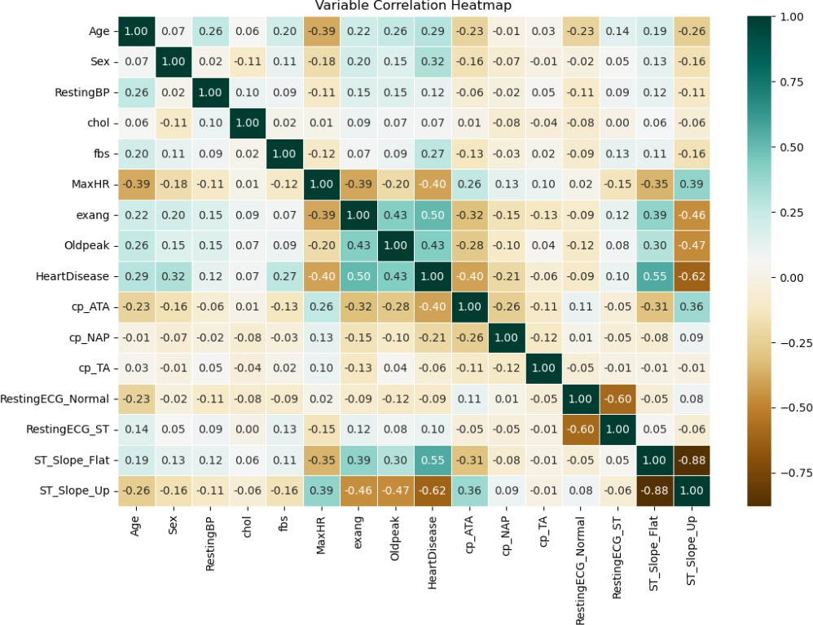

Fig.2 – confusion matrix of logistic regression
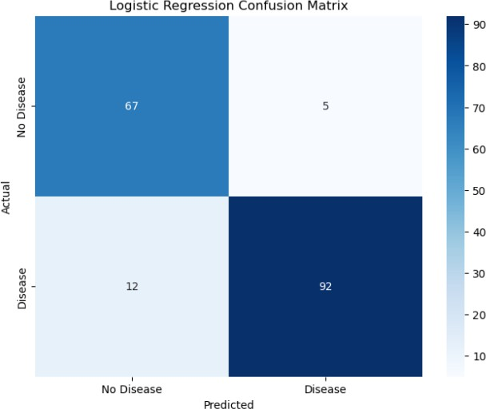

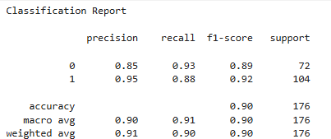
Fig.3 - classification report of logistic regression

Fig.4 – confusion matrix of KNN
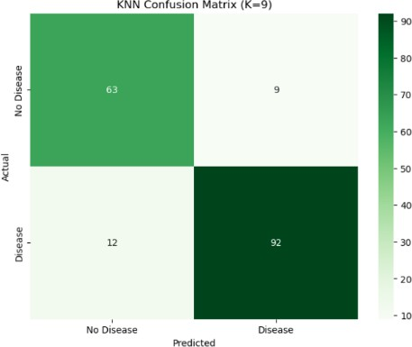

Fig.5 – classification report of KNN
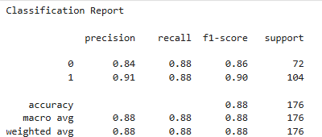

Fig.6 – ROC curve comparison
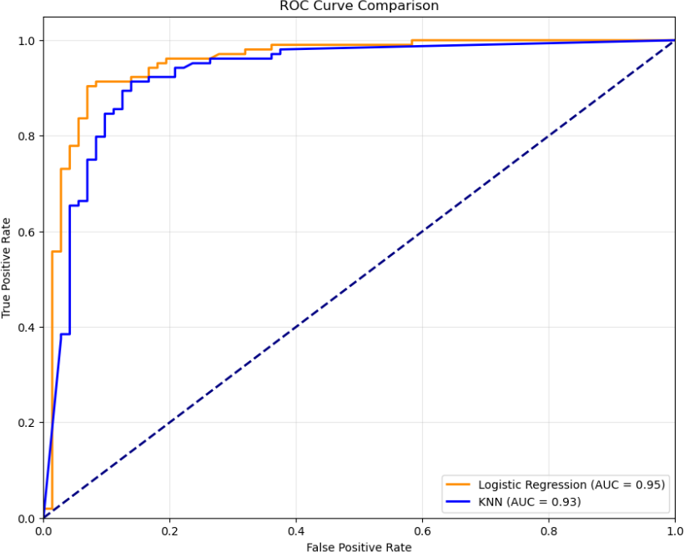

Conclusion and Future Scope

  - Conclusion
The development of the Heart Disease Prediction System successfully demonstrates the integration of machine learning into clinical diagnostics. Through rigorous data preprocessing, we addressed critical data integrity issues, such as the anomalous zero-values in cholesterol levels, using median imputation (223.0 mg/dl). By applying StandardScaler and Sequential Feature Selection, the system was optimized to focus on the most impactful clinical predictors, including Max Heart Rate and ST Slope.
The implementation of Logistic Regression and K-Nearest Neighbors (KNN) provided a robust framework for classification. A key takeaway from this project is the importance of Recall in medical modeling; while overall accuracy is vital, the ability of this system to minimize "False Negatives" ensures that high-risk patients are correctly identified for further clinical evaluation. Ultimately, this project serves as a proof-of-concept that automated data analysis can significantly reduce the diagnostic burden on healthcare professionals and improve patient outcomes through early detection.

Future Scope
While the current system provides a strong foundation, there are several avenues for future enhancement to transition it from a laboratory model to a real-world clinical application:
- Deployment as a Web Application: Future iterations will involve deploying the model using frameworks like Streamlit or Flask. This would allow doctors to input patient parameters (Age, BP, Cholesterol) via a user-friendly web interface and receive a
real-time risk assessment.
- Integration of Advanced Algorithms: While Logistic Regression and KNN are effective, future versions could explore Ensemble Methods such as Random Forests or XGBoost to further improve prediction accuracy and handle non-linear health data more effectively.
- Real-time Wearable Integration: The system could be expanded to ingest data directly from IoT-enabled wearable devices (like smartwatches). This would allow for continuous monitoring of heart rate and blood pressure, shifting the system from "snapshot" diagnosis to "continuous" heart health tracking.
- Expansion of Dataset Parameters: Incorporating additional physiological factors—such as BMI, genetic markers, smoking history, and dietary habits—would provide a more holistic view of patient health and likely increase the model's predictive power.
- Multi-Language Support & Mobile Compatibility: To ensure global accessibility, the tool can be developed into a mobile application supporting multiple regional languages, allowing users in remote areas to perform basic cardiac self-screenings.

References
Books:
- Let Us Python – Yashavant Kanetkar

Online Resources:
- Scikit-Learn Documentation: https://scikit-learn.org/ (For StandardScaler and SFS logic)
- GeeksforGeeks: https://www.geeksforgeeks.org/ (For algorithm implementation)
- Kaggle: https://www.kaggle.com/ (Source for the heart.csv dataset)
- Stack Overflow: https://stackoverflow.com/ (For debugging data cleaning scripts)

