HEART DISEASE PREDICTION SYSTEM

Project Id: AIML-18

Name: INAKSHI BAHUKHANDI (Team Leader) Class Roll Number: 07
University Roll Number: 2028431
Section and Group: G(G1)

Name: VISHWAJEET SINGH
Class Roll Number:23 University Roll Number: 2028515
Section and Group: G(G1)

- Problem Description 3
- Architecture 4
- Models model 5
- Evaluation metrics used 6
- Preliminary Results and Visualizations 7-8
- References 9

Problem Description
The Heart Disease Prediction System is a sophisticated machine learning-based application developed to address one of the most critical challenges in modern healthcare: the early detection of cardiovascular diseases. Cardiovascular diseases are a leading cause of mortality globally, and manual diagnosis can often be delayed due to the complexity of interpreting multiple clinical parameters simultaneously.
This system is designed to analyze diverse clinical patient data—including metabolic indicators like cholesterol and blood sugar, as well as physiological measures like blood pressure and heart rate—to predict the likelihood of heart disease risk. By leveraging computational intelligence and predictive modeling, the application automates the diagnostic workflow, transforming raw medical data into actionable insights. This not only assists medical practitioners in making data-driven decisions but also facilitates early intervention, which is vital for improving patient survival rates and optimizing hospital resource management.

Architecture

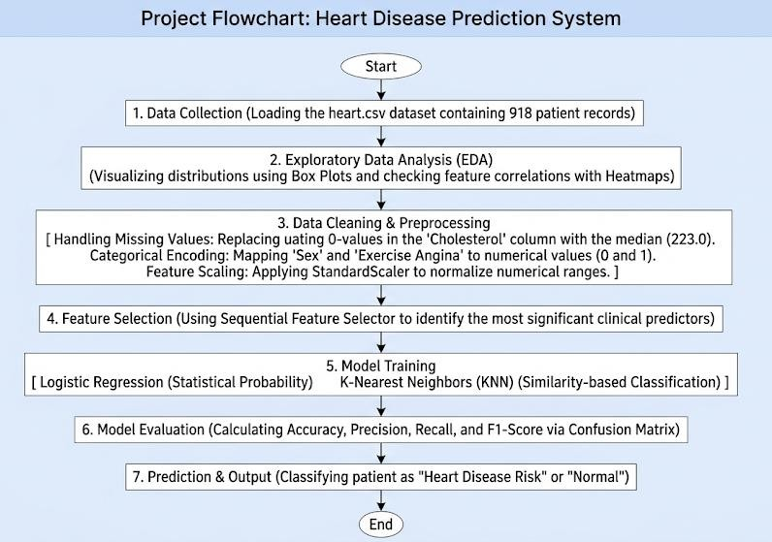

- Modules Used
- Pandas - Pandas served as the primary tool for data structuring and manipulation. In this project, the dataset was loaded into a DataFrame, which allowed for efficient row and column operations.
- Purpose: It was used to handle the heart.csv file, enabling the team to inspect the data structure and perform preliminary cleaning.
- Key Functions Used:
  - pd.read_csv(): To import the clinical data into the environment.
  - df.isnull().sum(): To identify missing values across the 12 features.
  - df.head() and df.describe(): To perform a statistical overview of patient age, cholesterol, and blood pressure.

- NumPy - NumPy provided the computational foundation for handling large, multi- dimensional arrays and matrices.
- Purpose: It was essential for mathematical consistency during the data cleaning phase.
- Key Functions Used:
  - np.where(): Utilized to identify and replace anomalous "0" values in the cholesterol and blood pressure columns.
  - np.median(): Calculated the central tendency for imputation, specifically the value 223.0 used for cholesterol correction.
- Matplotlib & Seaborn - These libraries were used to transform raw numbers into visual insights, which is critical for identifying medical trends and data outliers.
- Purpose: To conduct Exploratory Data Analysis (EDA) and visualize the relationship between different health indicators.
- Visuals Generated:
  - Box Plots: Used to detect extreme outliers in RestingBP and Cholesterol levels that could skew the model's accuracy.
  - Correlation Heatmaps: Used to determine which clinical features (like MaxHR or Oldpeak) had the strongest positive or negative correlation with heart disease.
- Scikit-Learn - Scikit-Learn was the core engine for all predictive modeling and preprocessing tasks.
- StandardScaler: This module was used to normalize the dataset.
- SequentialFeatureSelector (SFS): A wrapper-based feature selection method used to pick the top clinical attributes.
- Model Implementation: This library also provided the classes for LogisticRegression and KNeighborsClassifier, allowing for the construction and training of the actual prediction engines.

Evaluation metrics used
In medical diagnostic systems, a single accuracy percentage is often insufficient. To ensure the reliability of the Heart Disease Prediction System, multiple statistical metrics are used to evaluate the classification performance.

- Accuracy Score
Accuracy represents the overall correctness of the model. It is the ratio of correctly predicted observations (both positive and negative) to the total number of observations in the dataset.
  - Clinical Significance: While useful, accuracy can be misleading if the dataset is imbalanced. Therefore, we supplement it with precision and recall.
- Precision
Precision (also called Positive Predictive Value) measures the "exactness" of the model. It answers the question: Of all patients predicted to have heart disease, how many actually had it?
  - Significance: High precision ensures that the model does not generate too many "False Alarms," which could lead to unnecessary medical anxiety or expenses for healthy patients.
- Recall (Sensitivity)
Recall measures the "completeness" of the model. It answers: Of all patients who actually have heart disease, how many did the model correctly identify?
  - Clinical Significance: In this project, Recall is the most critical metric. A "False Negative" (failing to detect disease) is life-threatening. The system is optimized to ensure a high recall rate.
- F1-Score
The F1-Score is the harmonic mean of Precision and Recall. It provides a single score that balances the trade-off between the two.

Preliminary Results and Visualizations

Fig.1 - Heatmap showing correlation.
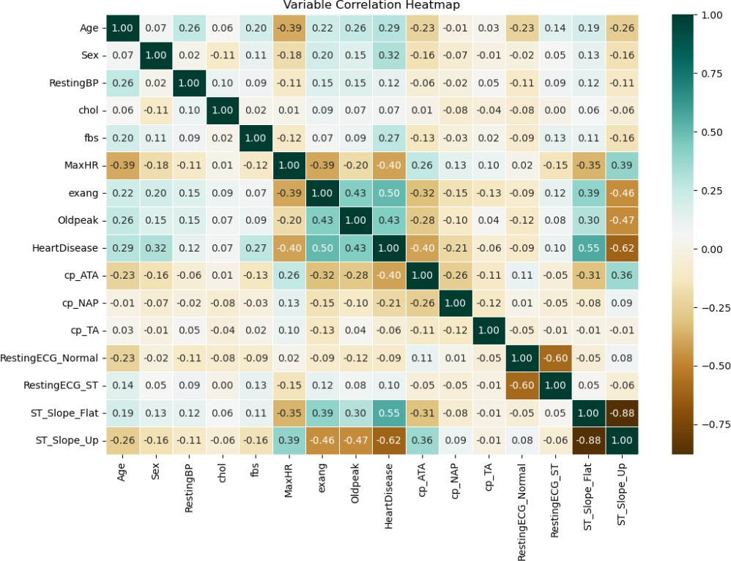

Fig.2 – confusion matrix of logistic regression
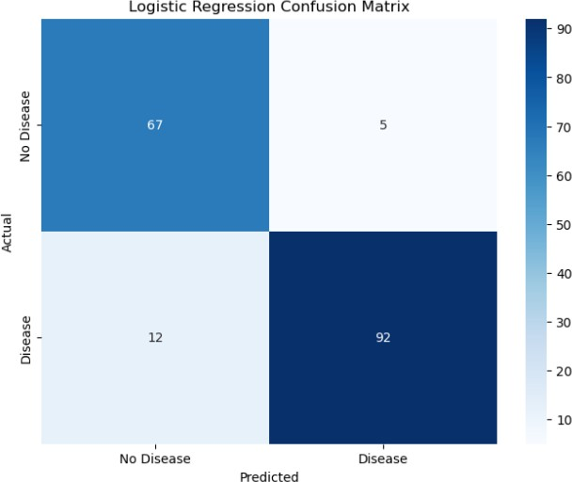

Fig.3 - classification report of logistic regression
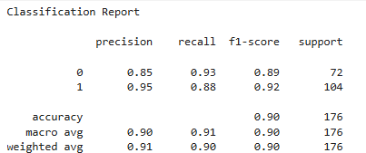

Fig.4 – confusion matrix of KNN
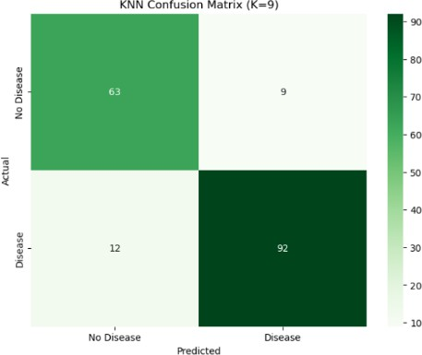

Fig.5 – classification report of KNN
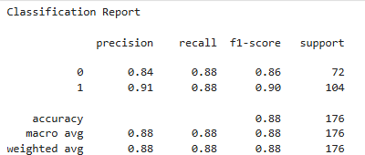

Fig.6 – ROC curve comparison
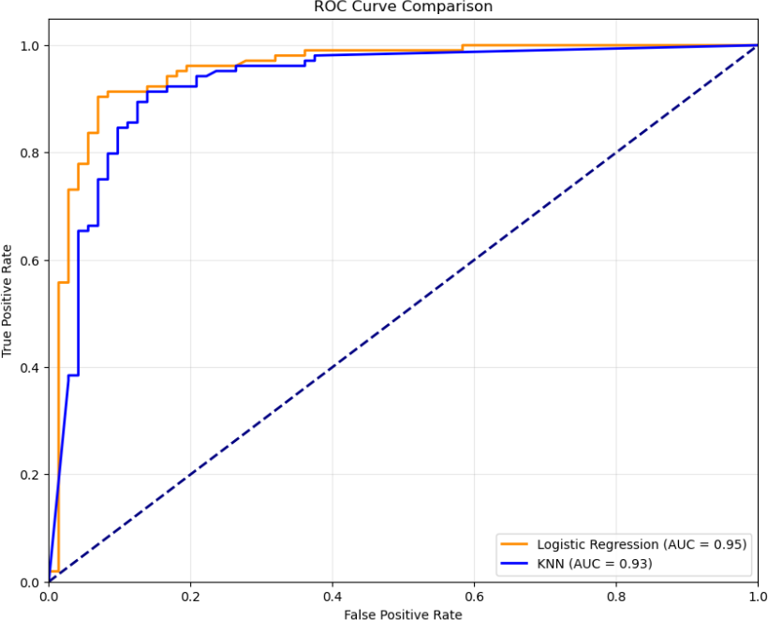

References:

Books:
  - Let Us Python – Yashavant Kanetkar

Online Resources:
  - Scikit-Learn Documentation: https://scikit-learn.org/ (For StandardScaler and SFS logic)
  - GeeksforGeeks: https://www.geeksforgeeks.org/ (For algorithm implementation)
  - Kaggle: https://www.kaggle.com/ (Source for the heart.csv dataset)
Stack Overflow: https://stackoverflow.com/ (For debugging data cleaning scripts)

