# TY B.Tech. (CSE) – II [ 2023-24]

**6CS371: Advanced Database System Lab**

Assignment No: 8

**Setting up InnoDB Cluster and MySQL Router**

**PRN:** 21510042  **Name:** Omkar Rajesh Auti

**Title:**

**Setting up InnoDB Cluster and MySQL Router: A Practical Guide**

**Objective/Aim:**

The objective of this guide is to provide a step-by-step walkthrough for setting up an InnoDB Cluster and MySQL Router using sandbox deployment with AdminAPI. The aim is to demonstrate how to deploy and configure these components locally for testing purposes before implementing them in a production environment.

**Introduction:**

InnoDB Cluster and MySQL Router are essential components for building a highly available and scalable MySQL infrastructure. InnoDB Cluster enables the creation of a fault-tolerant MySQL cluster, while MySQL Router facilitates dynamic routing of client requests to the appropriate cluster nodes. This guide aims to simplify the setup process by utilizing sandbox deployment, allowing users to experiment with the configuration in a controlled environment**.**

**Theory/Algorithms:**

InnoDB Cluster utilizes MySQL Group Replication to achieve high availability and fault tolerance. It ensures that data remains consistent across multiple nodes by synchronously replicating transactions to all members of the cluster. MySQL Router, on the other hand, acts as a lightweight proxy, directing client traffic to the appropriate MySQL server instances based on predefined routing rules.

**Procedure:**

Installation:

Install MySQL Server, MySQL Shell, and MySQL Router on the local machine.

Creating an InnoDB Cluster Sandbox Configuration:

Use MySQL Shell to deploy sandbox instances of MySQL Server.

Deploy at least three instances to ensure fault tolerance.

Creating InnoDB Cluster:

Connect to the primary instance using MySQL Shell.

Use AdminAPI to create an InnoDB Cluster and add instances to it.

Bootstrapping MySQL Router:

Configure MySQL Router to be aware of the InnoDB Cluster using the --bootstrap option.

Start MySQL Router with the generated configuration file.

Testing MySQL Router Configuration:

Connect to the InnoDB Cluster through MySQL Router.

Verify the status of the cluster and test failover by simulating the failure of a MySQL Server instance.

Restart the failed instance and ensure it rejoins the cluster as a secondary member.

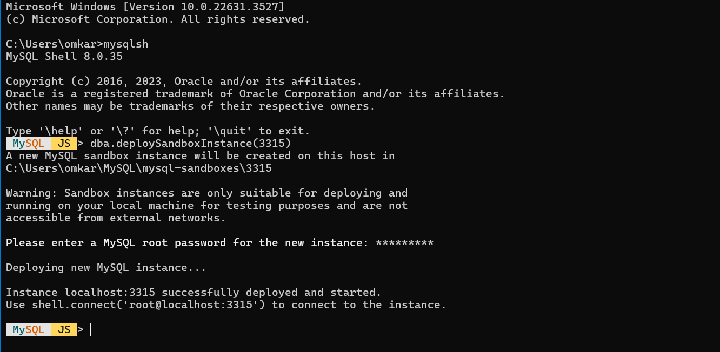

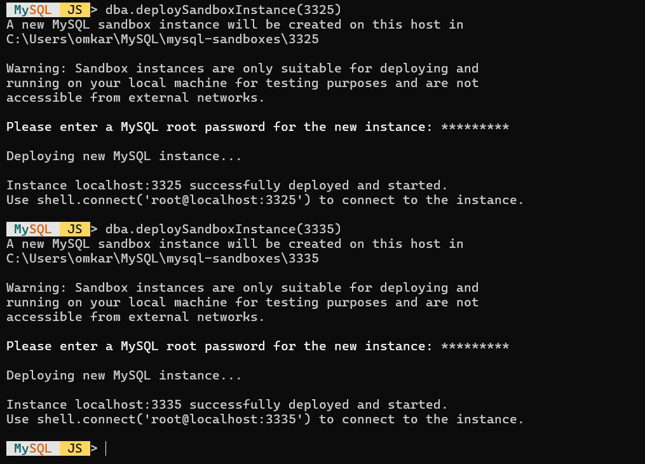

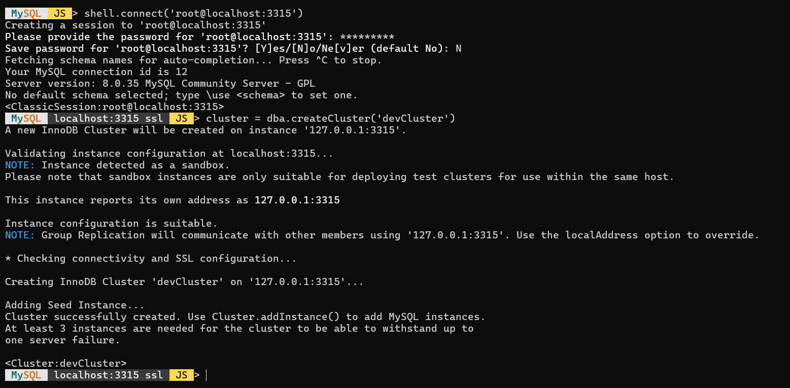

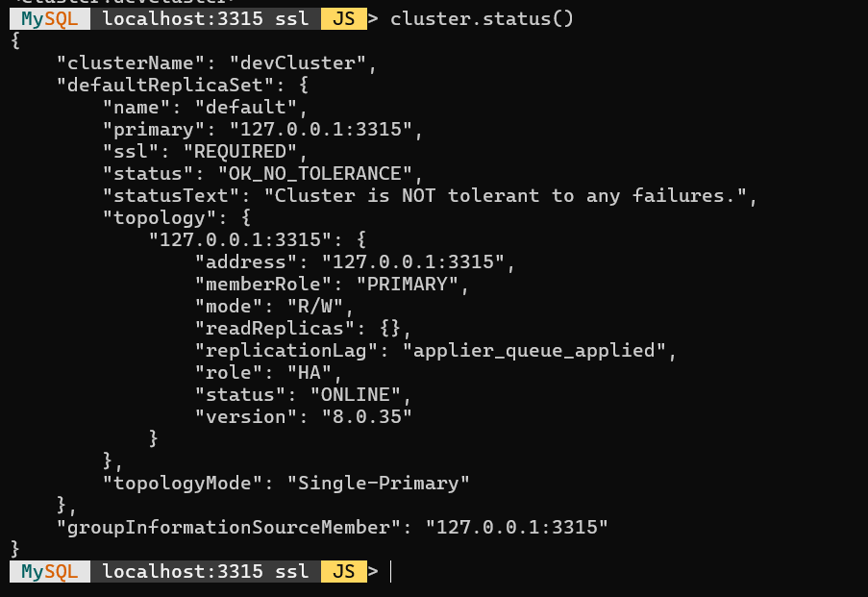

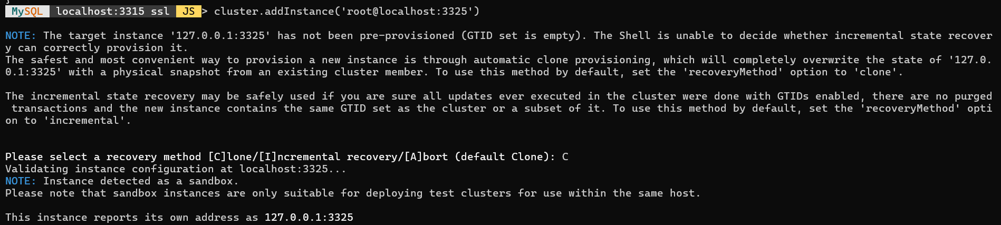

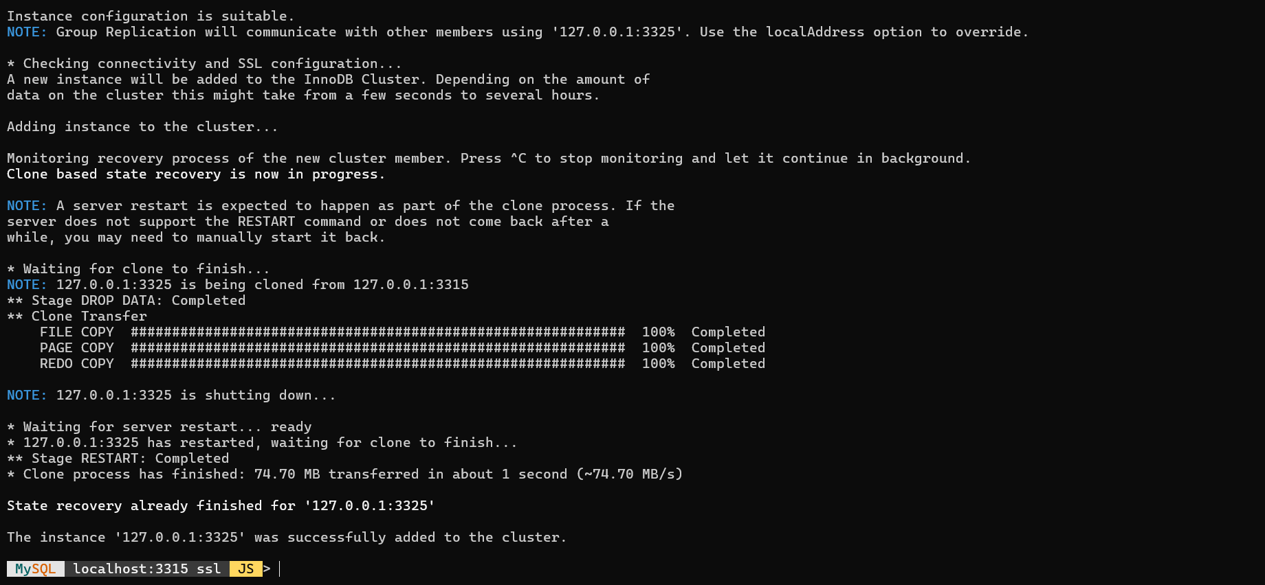

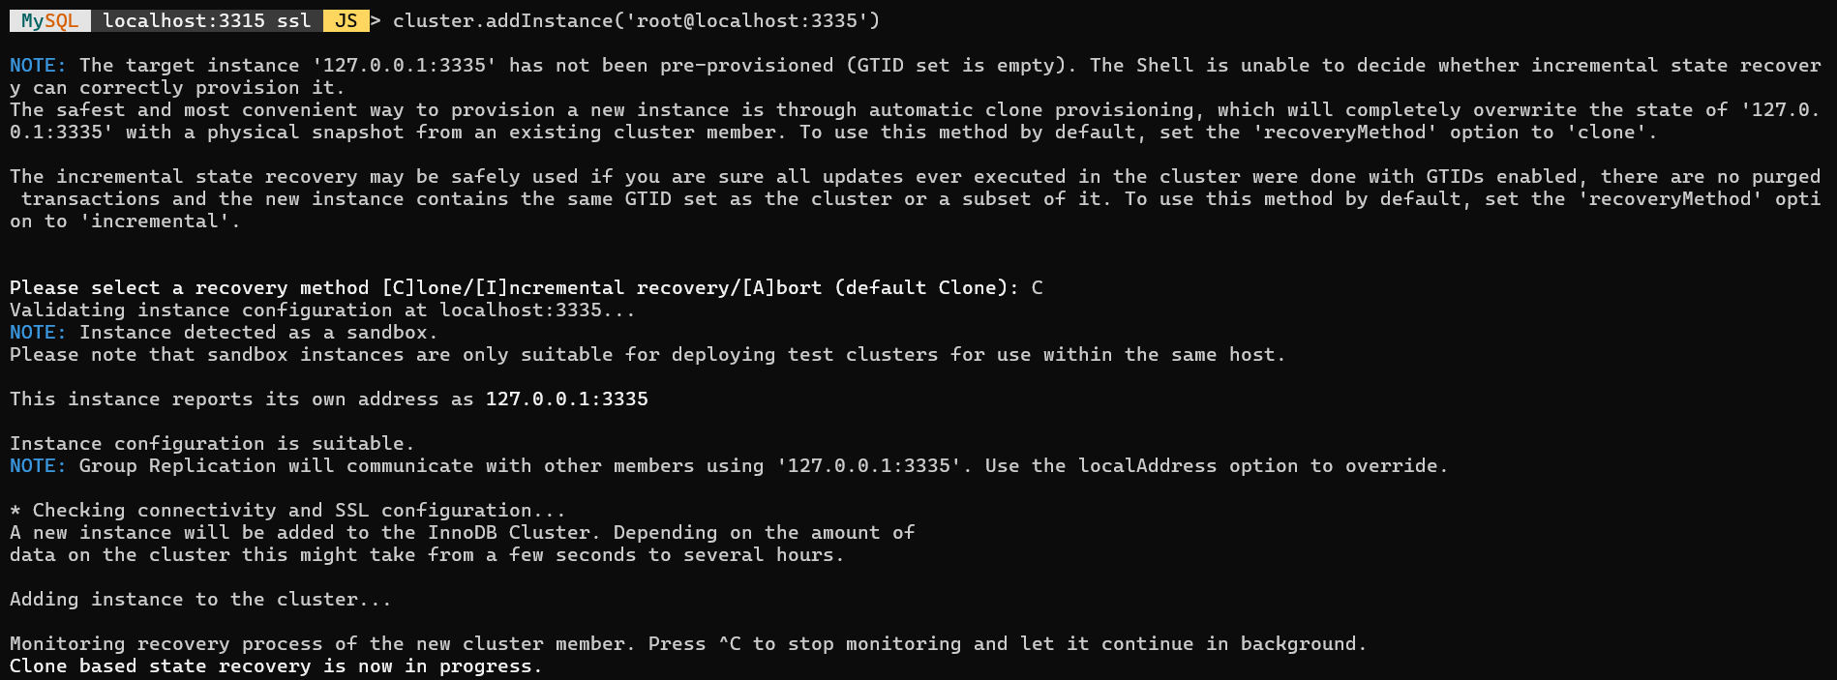

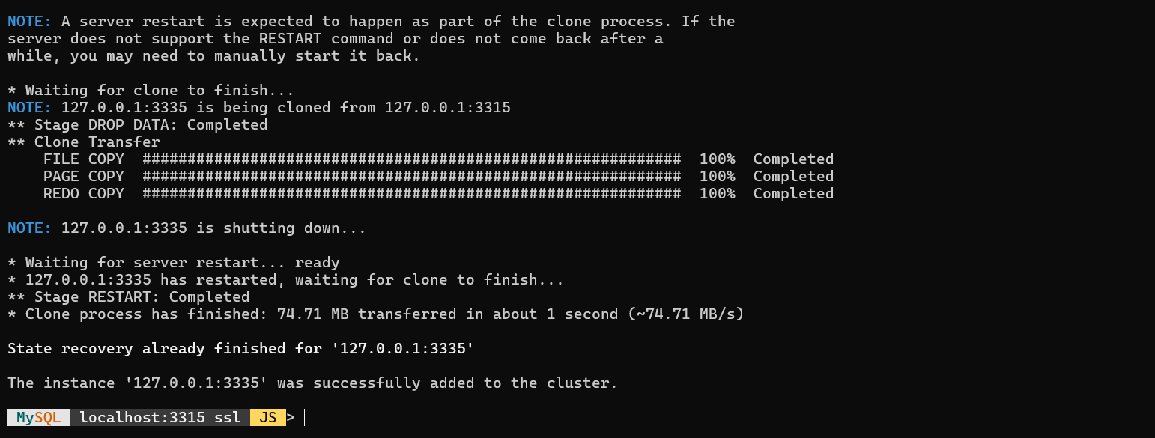

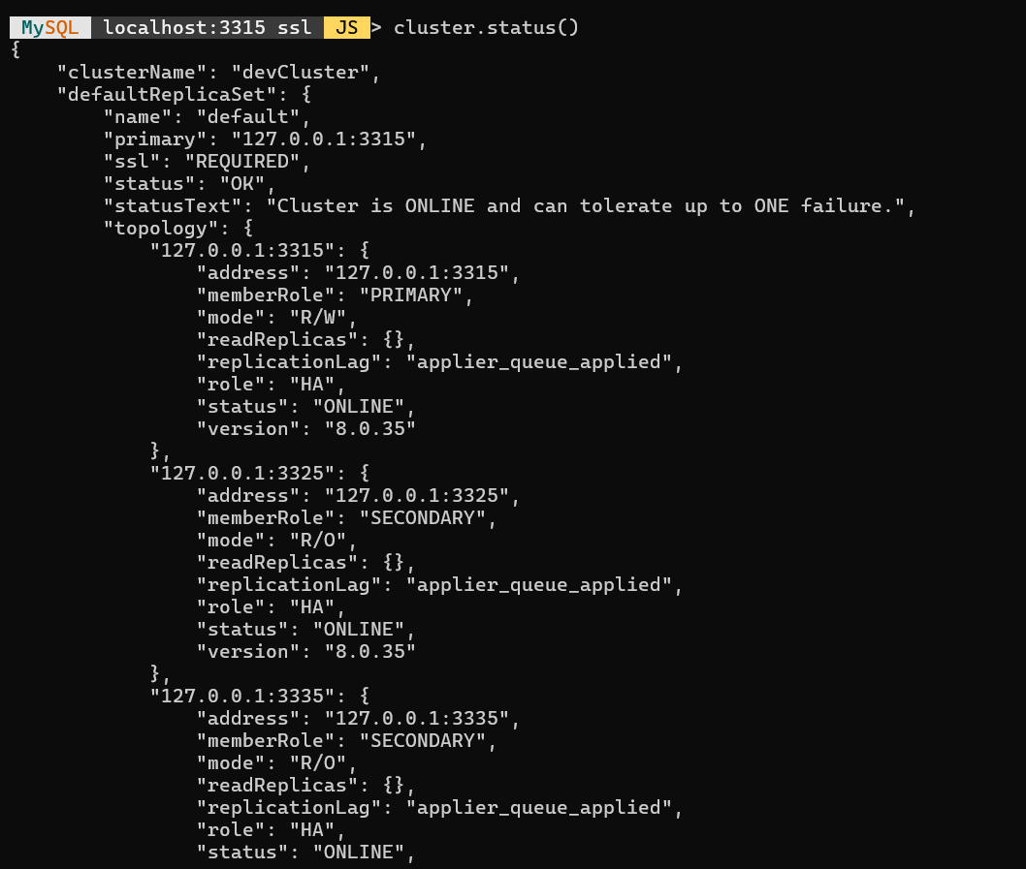



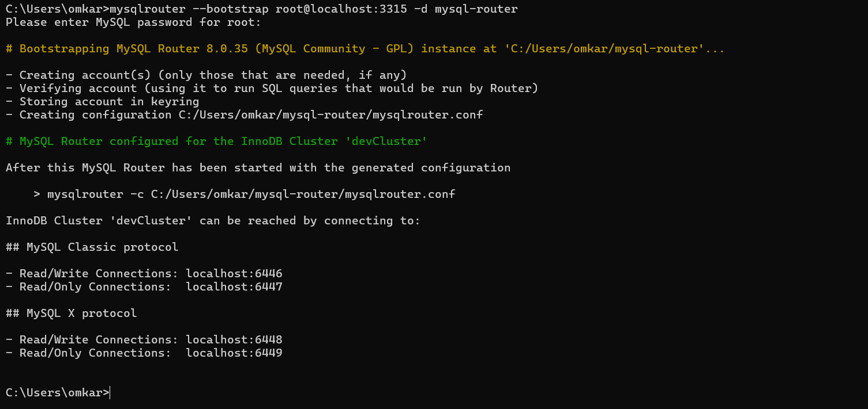

**Note: Do not close terminal**

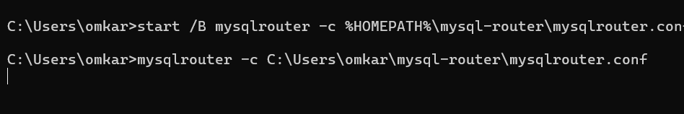

**Open new CMD**

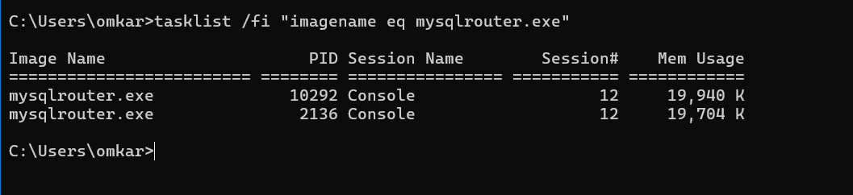

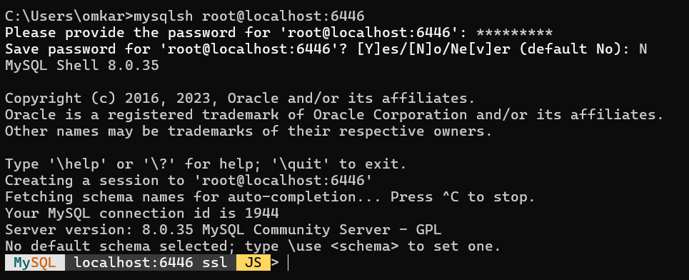

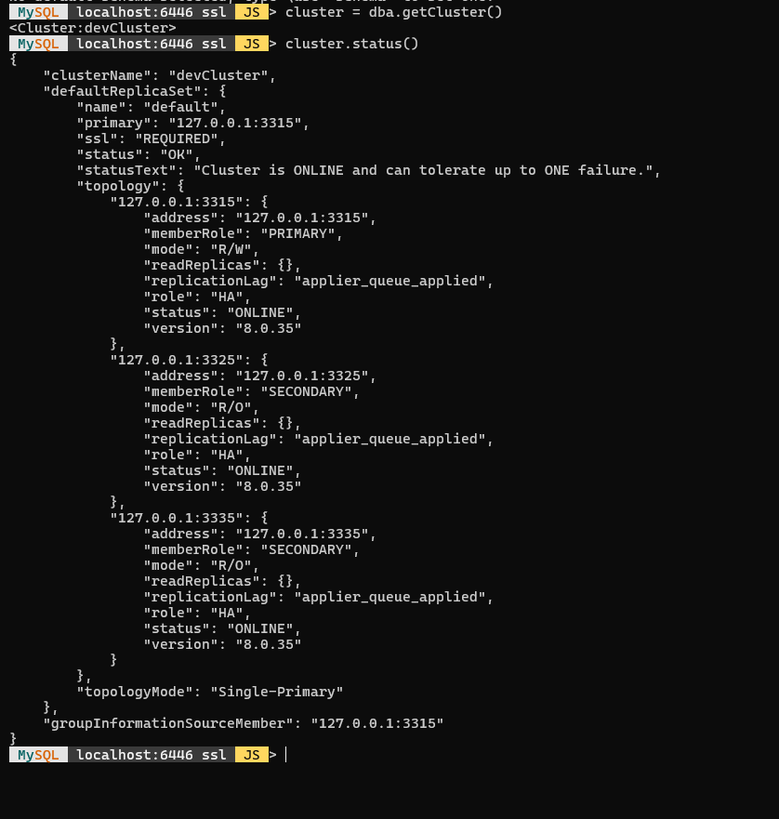



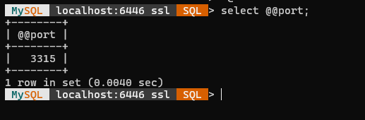

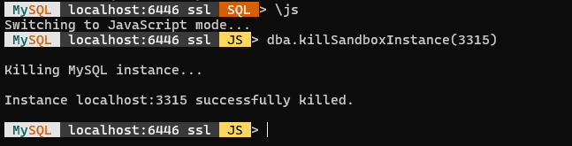

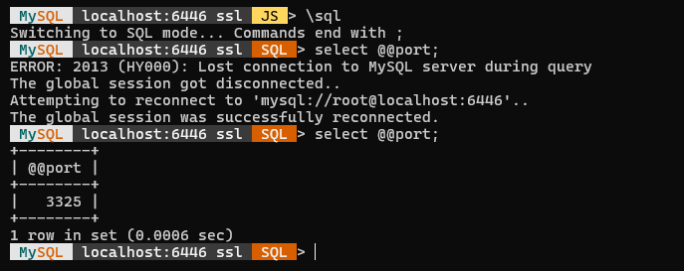

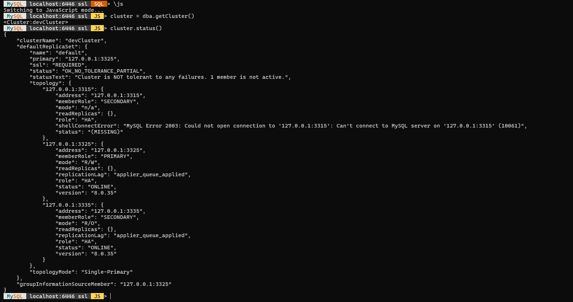

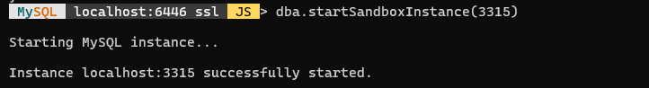

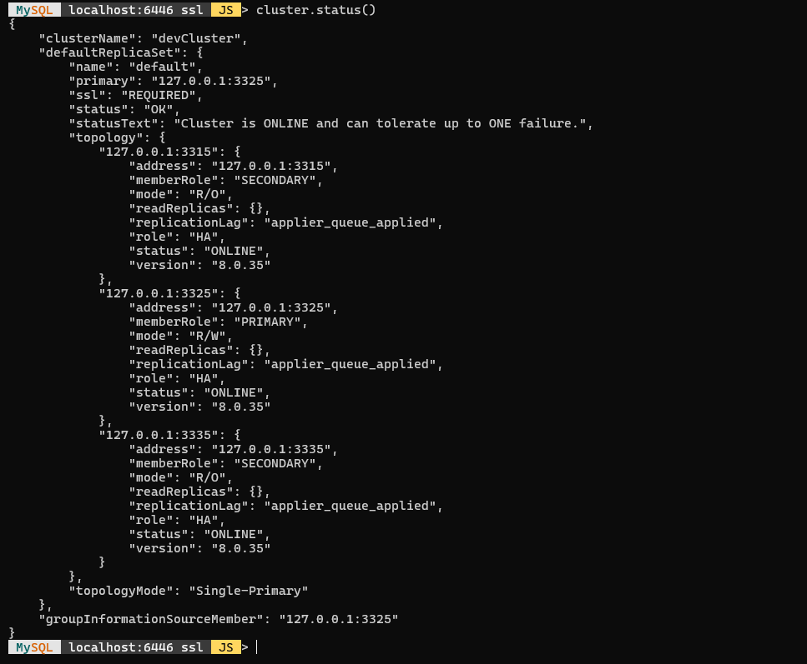

**Open New CMD**

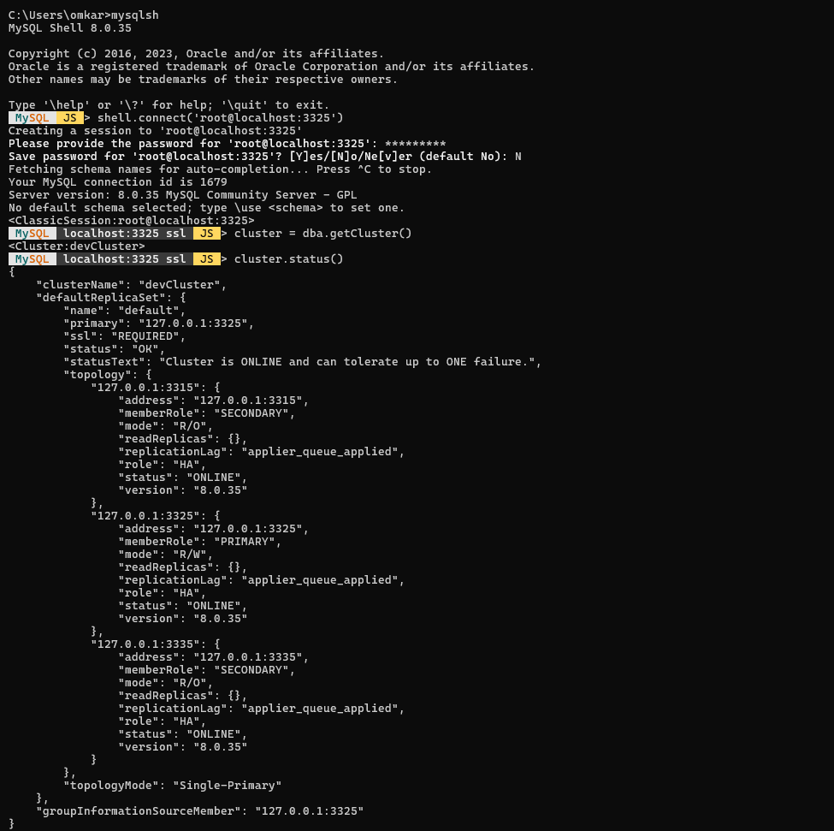

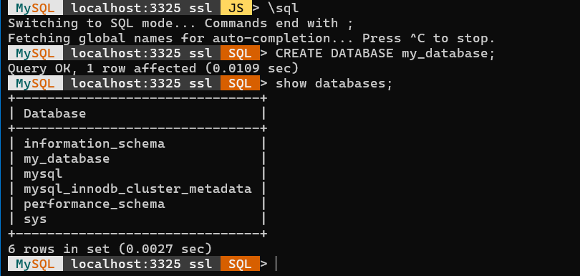

**Open CMD**

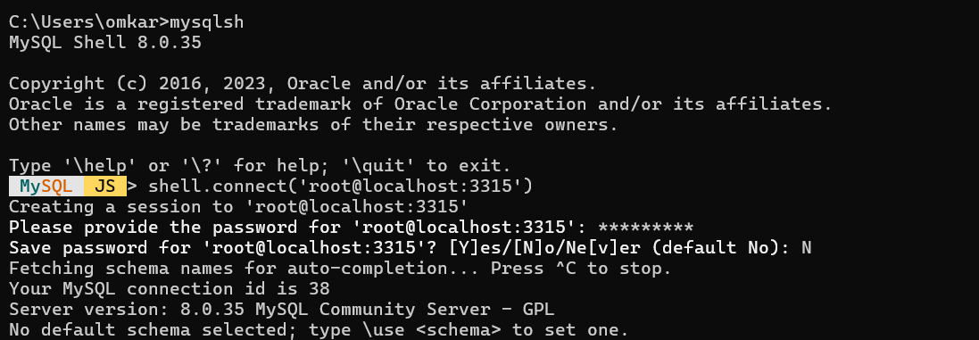

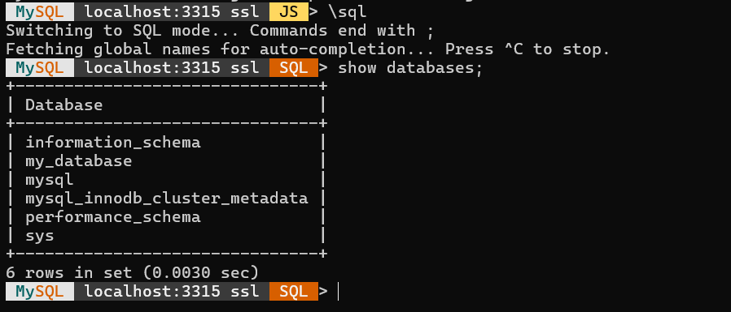

SQL> SET GLOBAL READ_ONLY OFF;  
**In case Read only**

**Conclusion:**

Setting up an InnoDB Cluster and MySQL Router using sandbox deployment provides a valuable opportunity to test the functionality of these components in a controlled environment before deploying them in production. This guide has demonstrated the step-by-step process of deploying a fault-tolerant MySQL cluster and configuring MySQL Router for dynamic routing of client requests.

By utilizing AdminAPI and MySQL Shell, users can easily deploy sandbox instances of MySQL Server and create an InnoDB Cluster with just a few commands. The integration of MySQL Router ensures that client traffic is efficiently directed to the appropriate cluster nodes, enhancing the overall availability and scalability of the MySQL infrastructure.

Through testing and simulating failover scenarios, users can gain confidence in the resilience of their MySQL cluster configuration. The ability to monitor and manage the cluster status using MySQL Shell further enhances the operational visibility of the deployment.

In conclusion, this guide empowers users to experiment with high availability configurations of MySQL databases in a risk-free environment, ultimately facilitating the implementation of robust and reliable MySQL infrastructures in production settings.

**References:**

1. Setting up InnoDB Cluster and MySQL Router:

<https://dev.mysql.com/doc/mysql-shell/8.0/en/setting-up-innodb-cluster-and-mysql-router.html>