Question 2:

What happened when you send message from client in Multicast UDP when server is not available?

Answer:

In Multicast UDP, there is no server/client differentiation at the protocol level. In this type of UDP, multicast datagrams are sent to a special multicast group addresses. To, receive any message, one must join the group. The messages are received by all the members who are in the group. **Hence, even when the server is off the clients in the group receive the messages.**

The server calls the joinGroup method to join the multicast group and sends a unicast message to reply the multicast message it receives from the client.

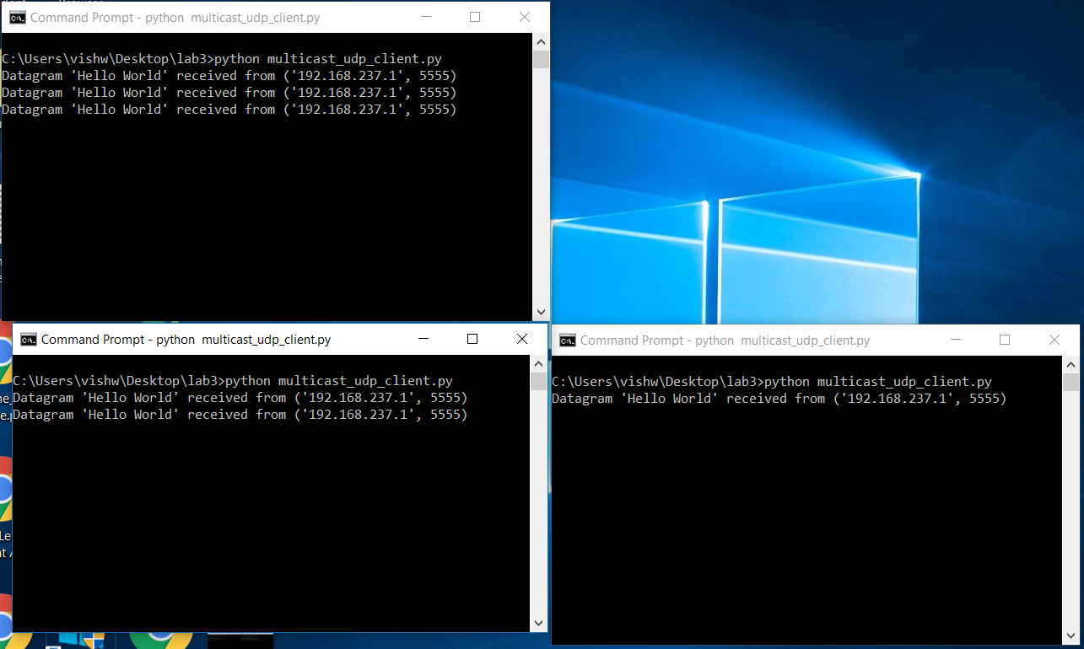

Figure: Multicast-UDP without server

Output of Connected UDP:

Screenshot-1: Exit after pressing n/N: User can continue to chat. Once he decides to end the communication he just has to press ’n’ or ‘N’.

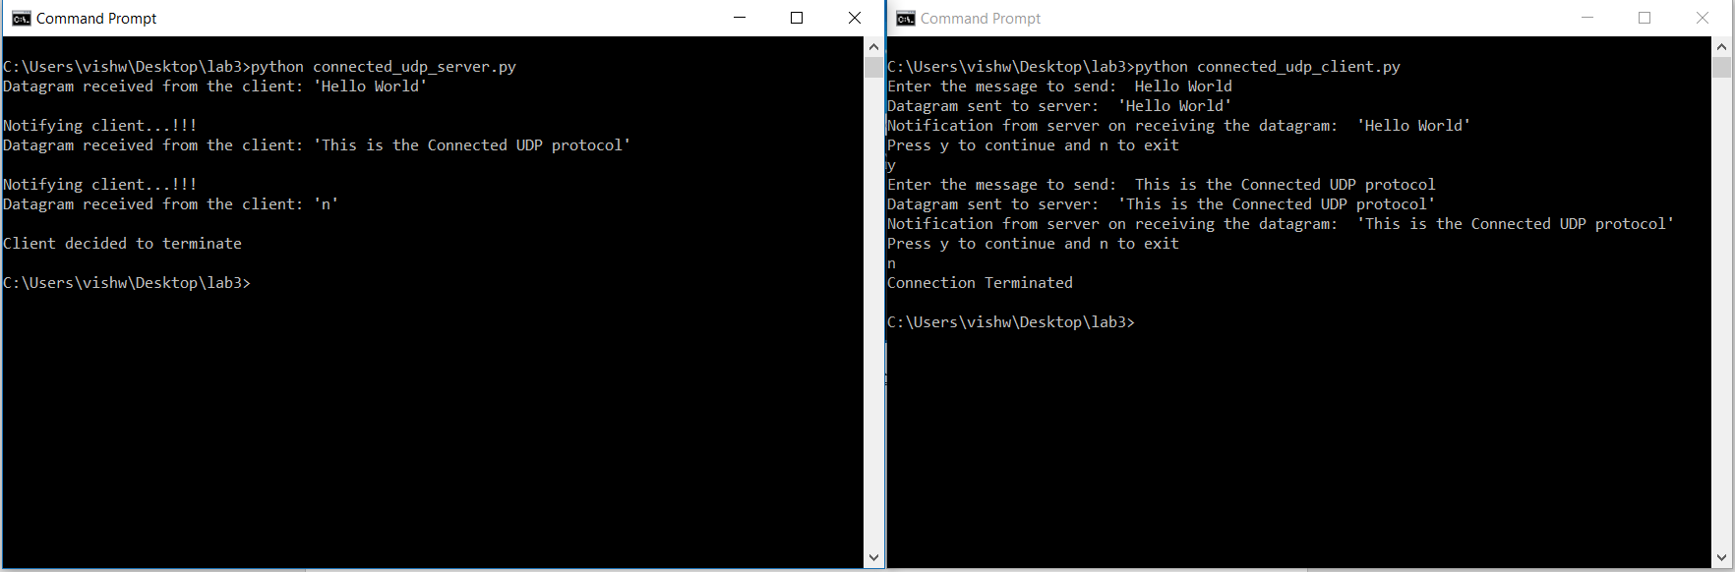

Screenshot-2: Exit on sending no data. User can continue to communicate. The connection can also be terminated if no data is sent from the client to the server.

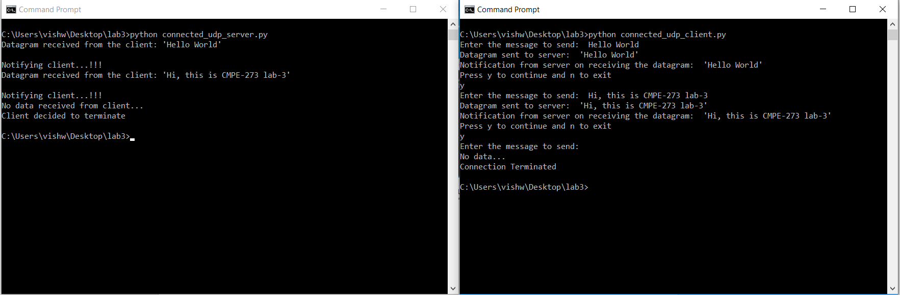

Output of Multicast UDP

Screenshot-1: When server is present

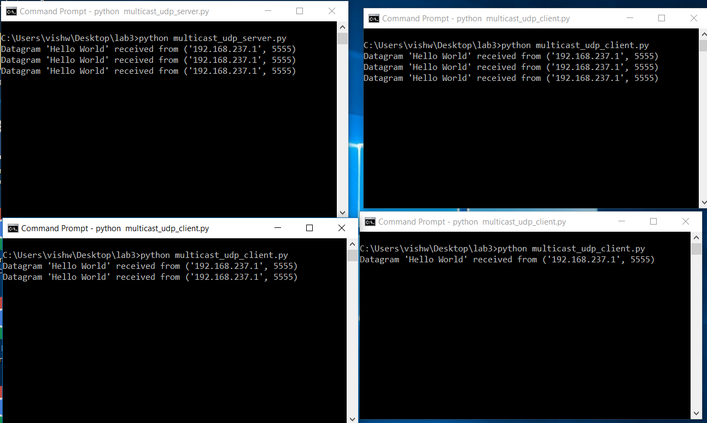

Screenshot-2: When server is off:

