**1 . MediaR-Notification** 1

**2 . Code Snippets** 3

**3. Send Data through Event** 7

# **1 . MediaR-Notification**

**Use Case**

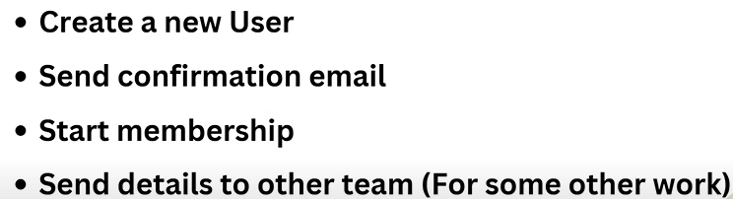

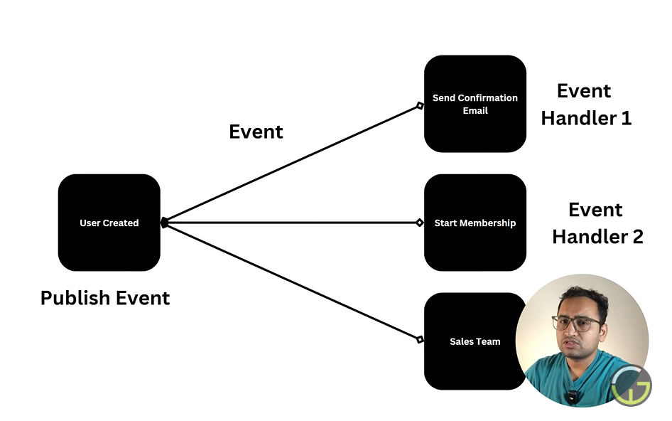

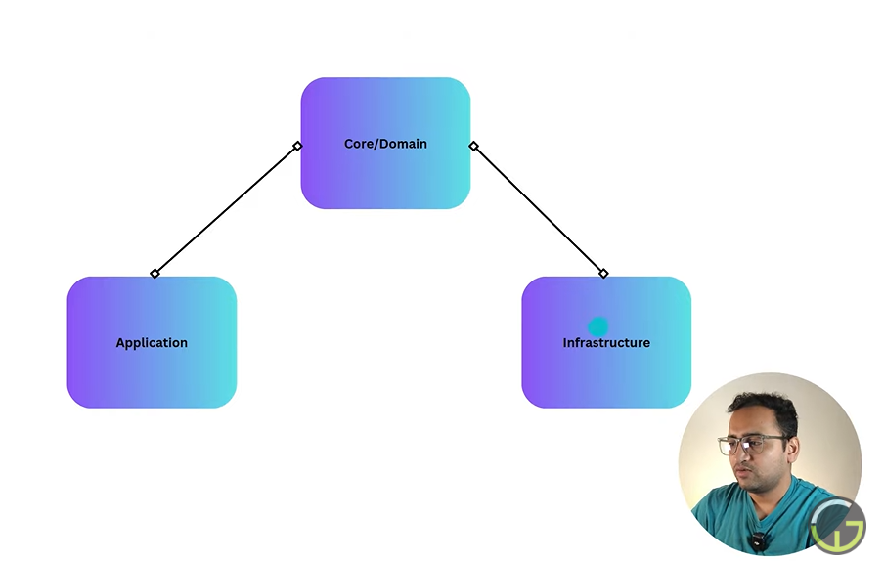

# **2 . Code Snippets**

Created Event folder under **MyApp.Application** project. Add **UserCreatedEvent.cs** and **SendEmailEventHandler.cs** file.

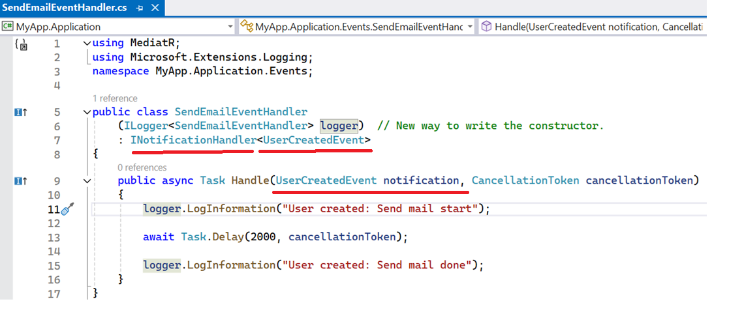

Add interface (MediaR.IPublisher) in **AddEmployeeCommand.cs** file (MyApp.Application > Commands)

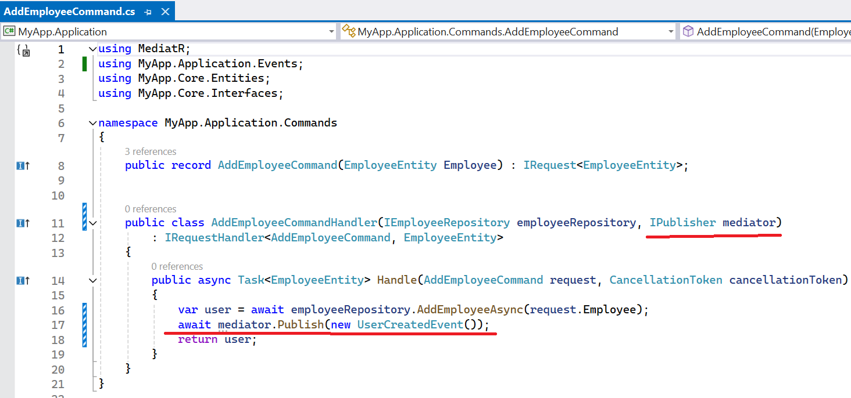

Similarly we can add one more handler like **StartMembershipEventHandler.cs**

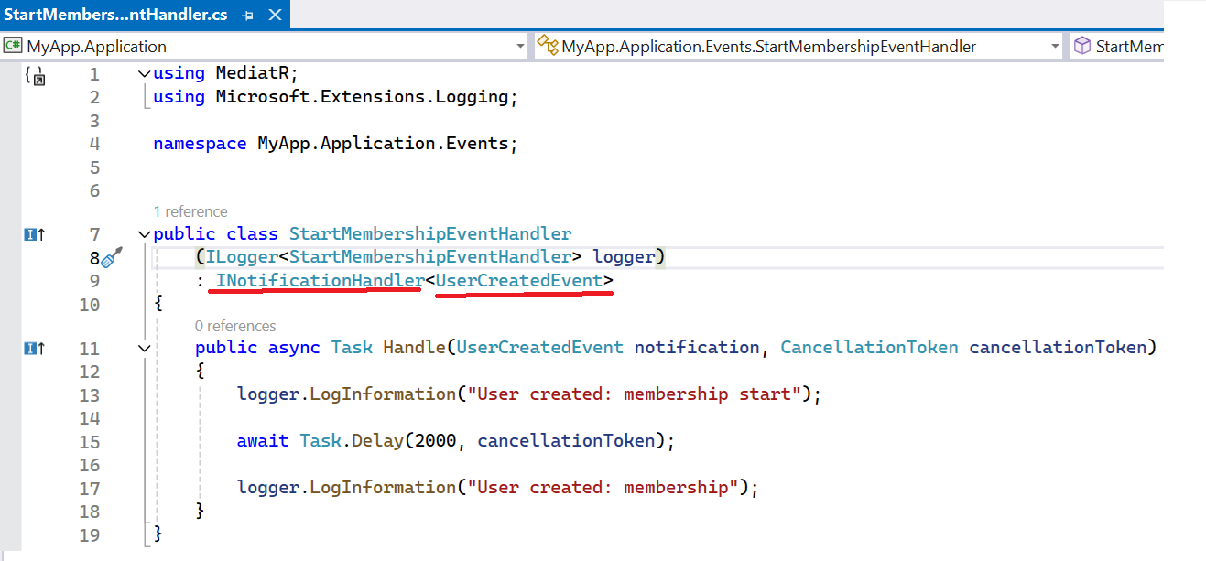

When we run the application and create the user using Swagger, then both the handler call one by one and this is the default implementation.

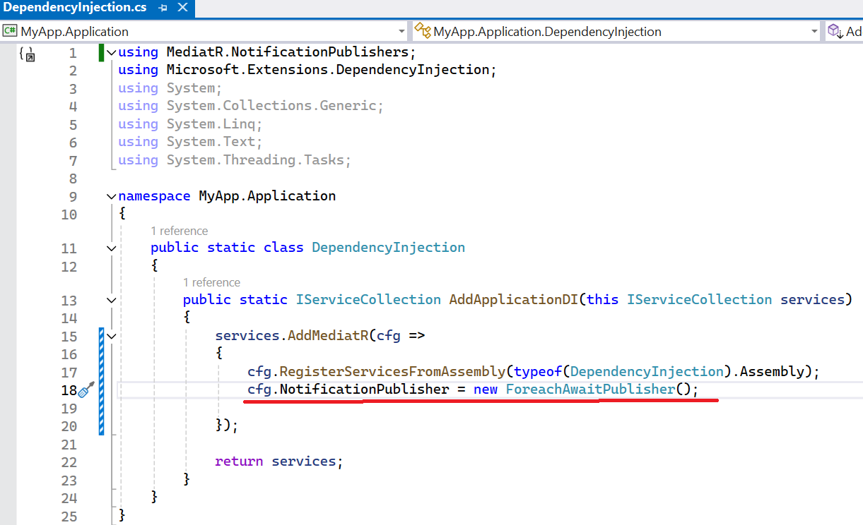

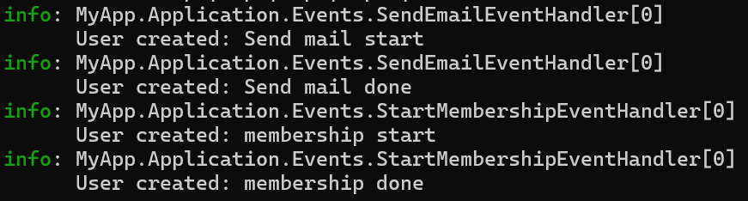

**Publish the event parallel for both the handler.**

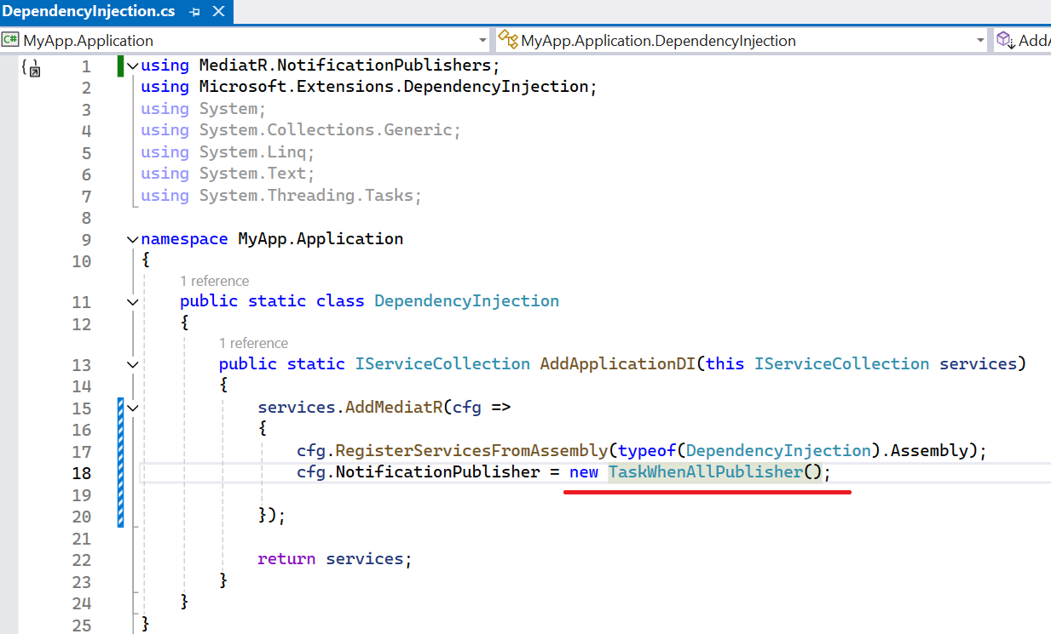

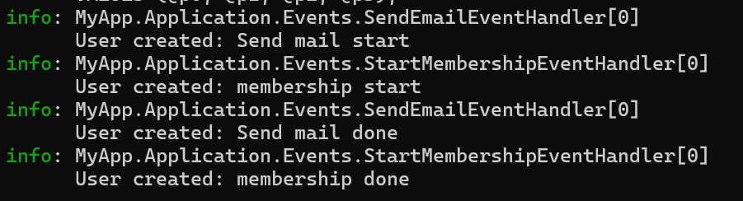

# **3. Send Data through Event**



