**1. SECTION – 1 : Auth-Service-Integration-Using-API-Gateway** 1

**2. SECTION – 2 : Authentication at Support UI** 13

# **1. SECTION – 1 : Auth-Service-Integration-Using-API-Gateway**

**Folder Structure Creation:**

1. Create New Project 🡪 select blank solution template 🡪 Give a name to empty solution as eShopFlix29Jun and select folder path.
2. Add BackendServices folder under empty solution 🡪 Right Click on folder 🡪 Add 🡪 New Project 🡪 Select ASP.NET Core Web API template 🡪 Next 🡪 Give Project name as AuthService and Location remains as it is by default selected 🡪 Next 🡪 Set the below checkbox as per screenshot 🡪 Create.
3. Same repeat the steps for CatalogService and OrderService under BackendServices folder.

1. Add FrontendServices folder under empty solution 🡪 Right Click on folder 🡪 Add 🡪 New Project 🡪 Select ASP.NET Core Web App (Model - View - Controller) template 🡪 Next 🡪 Name the project as WebApp and select FrontendServices folder 🡪 Next 🡪 Select the below screenshot setting 🡪 Create

1. Repeat the same step of 4 for the SupportApp
2. Add ApiGateways folder under empty solution 🡪 Right Click on folder 🡪 Add 🡪 New Project 🡪 Select ASP.NET Core Empty template 🡪 Next 🡪 Select path as ApiGateways folder inside empty solution 🡪 Next 🡪 Select the below checkboxes as per screen shot 🡪 Create.

Create the Database **AuthService29Jun** and Run the **Schema.sql** and SeedData.sql scripts under this DB in chronical order.

7 Install EF Core Power Tools (Visual Studio Extension)

8 Right click on AuthService project 🡪 EF Core Power Tools 🡪 Reverse Engineer.

Click on Add 🡪 Add Database Connection 🡪 Check the below screen shot

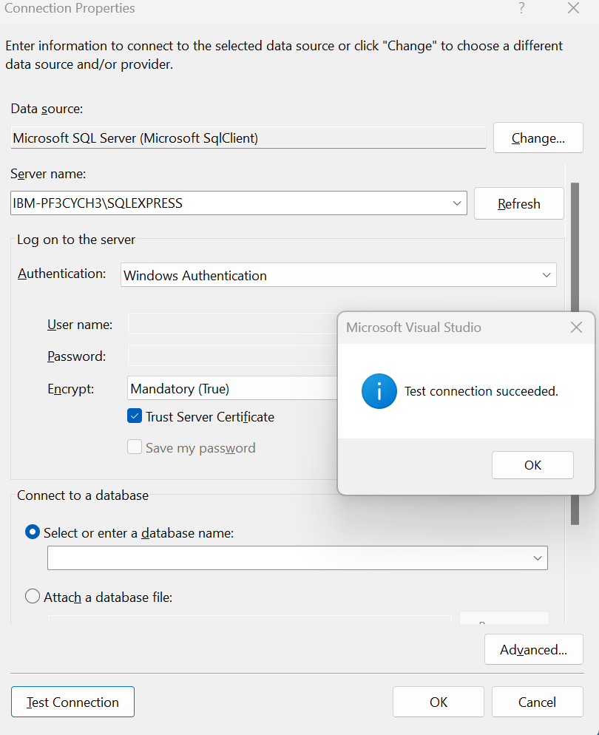

Select the Database.

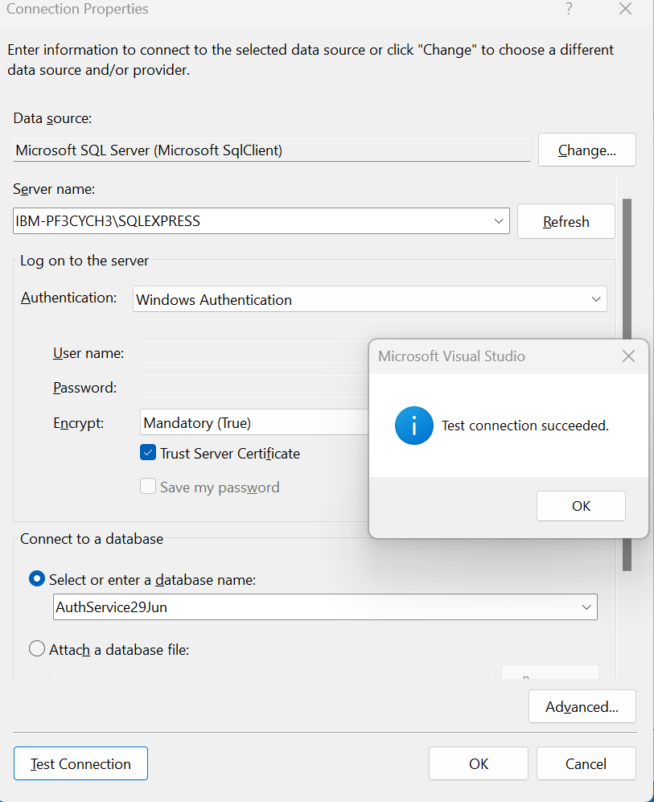

Click Ok 🡪 Click Ok ( Please check the below screen shot)

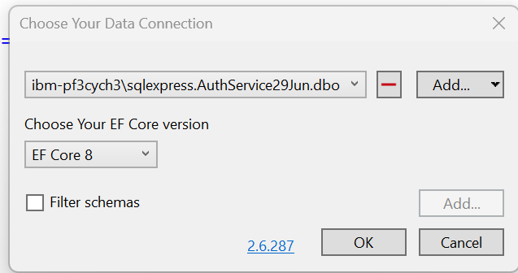

* Import all the tables from the below screenshot 🡪 Click Ok

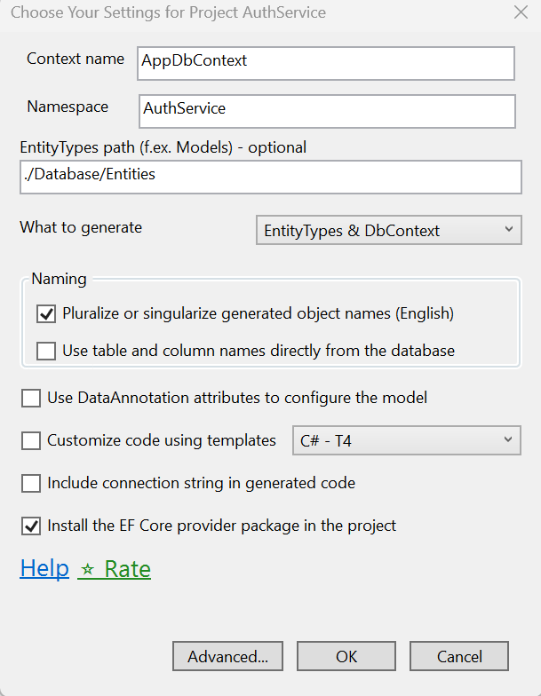

Click on Advanced 🡪 Make the below screenshot setting

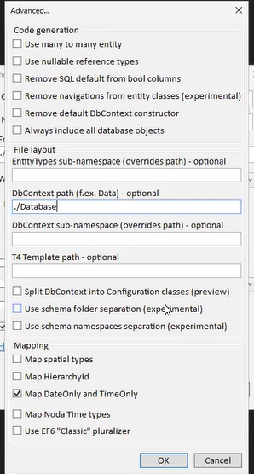

Click Ok 🡪 Click Ok of below window

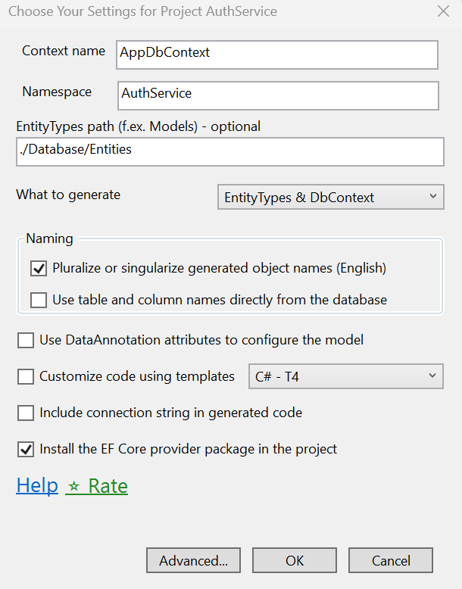

9. Specify the connection string in appsettings.json file of AppService project.

10. Add the Repository and Its implementation in AuthService project.

11. Install the below EF Core dependency.

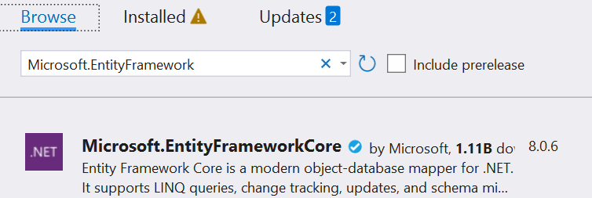

12. Create the Auth Controller and call repository method in Controller and add services to the container as below.

Test api using new feature of .Net Core 8.0 as below

After add on token logic in AuthRepository.cs file

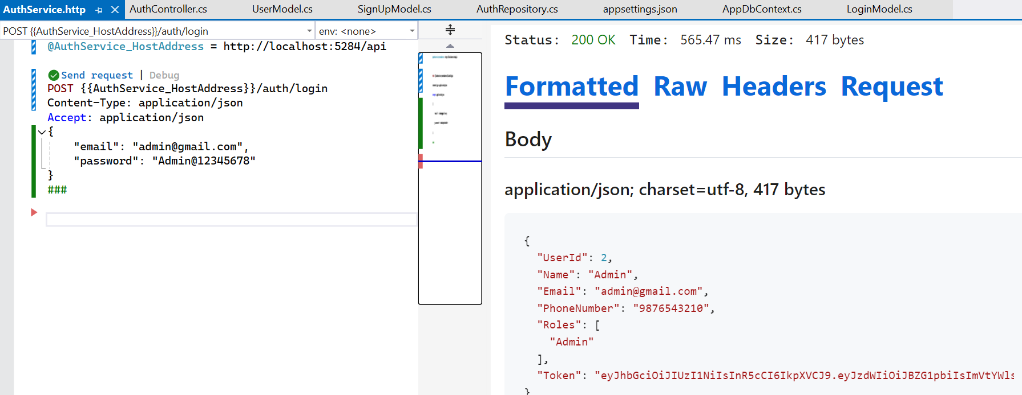

**Ocelot API Gateway**

13. Install Ocelot api gateway and JWT Token dependancy in ApiGateways 🡪 ApiGateway.Web

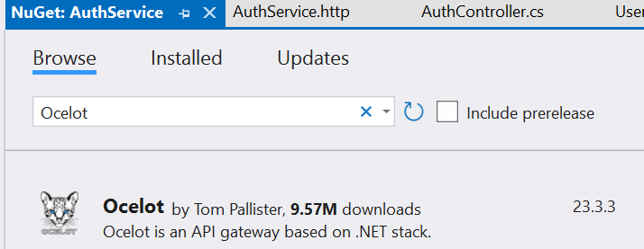

14. Add ocelot.json file in ApiGateways 🡪 ApiGateway.Web and mention launchSettings.json file https section of ApiGateway.web 7160 port with below ocelot.json file.

"GlobalConfiguration": {

"BaseUrl": "https://localhost:7160"

}

Refer the official site for API Gateway.

<https://ocelot.readthedocs.io/en/latest/introduction/gettingstarted.html>

15. Mention AuthRepository launchSettings.json file https section 7203 port in ApiGateways 🡪 ApiGateway.Web -- > ocelot.json in below section.

"DownstreamHostAndPorts": [

{

"Host": "localhost",

"Port": 7203

}

]

“DownstreamPathTemplate” => API endpoint path.

"UpstreamPathTemplate" => Frontend expose endpoint path.

In Program.cs file add the ocelot.json file for load ocelot configuration and service dependencies and ocelot middleware as below.

builder.Configuration.AddJsonFile("ocelot.json");

builder.Services.AddOcelot();

app.UseOcelot().Wait();

The final code of program.cs is as below.

using Ocelot.DependencyInjection;

using Ocelot.Middleware;

var builder = WebApplication.CreateBuilder(args);

builder.Configuration.AddJsonFile("ocelot.json");

builder.Services.AddOcelot();

var app = builder.Build();

app.UseOcelot().Wait();

app.Run();

Run both the project i.e ApiGateway.Web and AuthService

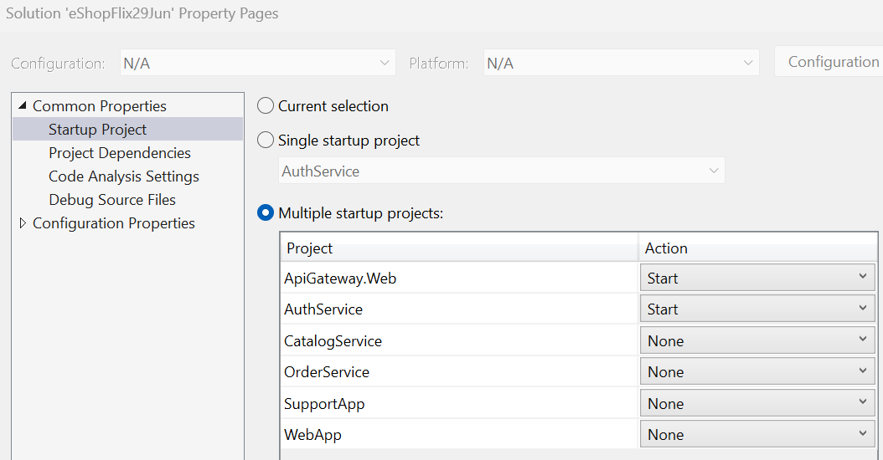

16. Download the Postman app from the below url and install it and login as google authentication.

<https://www.postman.com/downloads/?utm_source=postman-home>

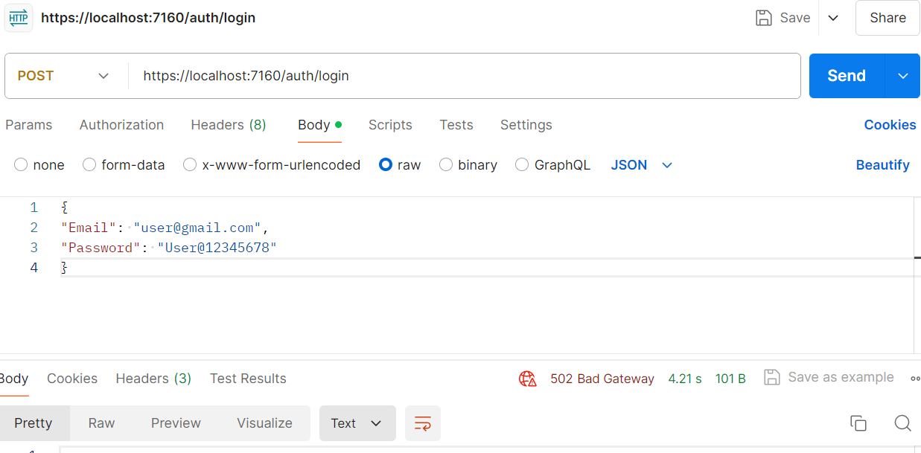

17. FrontendServices 🡪 WebApp 🡪 Add the AccountController.cs file and its respective Action method with view and modify the Views🡪 Shared 🡪 _Layout.cshtml file

18. Define the API Gateway address in appsettings.json file of WebApp project.

"ApiGatewayAddress": <https://localhost:7160/>

19. Used API Gateway inside program.cs file.

//Services

builder.Services.AddHttpClient<AuthService>(client =>

{

client.BaseAddress = new Uri(builder.Configuration["ApiGatewayAddress"]);

});

20. Adding the routing for area in program.cs file

app.MapControllerRoute(

name: "areas",

pattern: "{area:exists}/{controller=Home}/{action=Index}/{id?}"

);

21. Add the View in Area same as per the Root level view of WebApp.

22. Authenticating the user @ UI level by using Authentication cookie using GenerateTicket() method.

23. Add a CurrentUser property in BaseController.cs file (For controller level).

24. Same above logic we can add in UI level as a Helper and mention the

@inherits WebApp.Helpers.BaseViewPage<LoginModel> in _ViewImports.cshtml file of Areas.

25. Add Service for AddAuthentication before AddHttpClient and auth middleware app.UseAuthentication(); in program.cs file before app.UseAuthorization().

26. Set the ApiGateway.Web, AuthService and WebApp Project as start up project.

# **2. SECTION – 2 : Authentication at Support UI**

1. Create SupportApp project same as per the WebApp project.
2. Define LoginModel.cs file in Model folder and Create AccountController.cs file. Add UserModel.cs file under Model folder.
3. Define Login Action Method and based on that create login razor view.(Right click and add view)
4. A screenshot of a computer

   Description automatically generated
5. Program.cs file, set the default route to as below

app.MapControllerRoute(

name: "default",

pattern: "{controller=Account}/{action=Login}/{id?}");

1. Define Login Action Method of http POST verb.
2. Add HttpClients Folder and add AuthService.cs file inside it.
3. Add Helpers folder and add BaseViewPage.cs file inside it.
4. Add Admin Area

1. Define Admin Area route in Program.cs file

app.MapControllerRoute(

name: "areas",

pattern: "{area:exists}/{controller=Home}/{action=Index}/{id?}"

);

1. Define Home and Base controller under Admin Area. Decorate Base controller with Admin Area and Inherit Base controller from Home controller.
2. Add the view for the index method of the Home controller.
3. Copy the Shared folder and _viewImports.cshtml and _viewStart.cshtml from SupportApp parent folder into Admin Area View folder.
4. Import BaseViewPage under _viewImports.cshtml for both Admin Area and Parent view.

@inherits SupportApp.Helpers.BaseViewPage<TModel>

1. Add the API Gateway configuration in Program.cs file and Authentication Middleware.

builder.Services.AddAuthentication(CookieAuthenticationDefaults.AuthenticationScheme)

.AddCookie(options =>

{

options.Cookie.Name = "WebAppCookie";

options.LoginPath = "/Account/Login";

options.AccessDeniedPath = "/Account/UnAuthorize";

});

//Services

builder.Services.AddHttpClient<AuthService>(client =>

{

client.BaseAddress = new Uri(builder.Configuration["ApiGatewayAddress"]);

});

1. Add API Gateway address in the appsettings.json file is as below

"ApiGatewayAddress": <https://localhost:7160/>

**CatalogService.cs**

1. Create Product and Category API Controller, Its Interfaces (IProductService.cs and ICategoryService.cs) and its Implementation (ProductService.cs and CategoryService.cs)
2. Login on SQL Server (Windows Authentication) and create Database named as **CatalogService06Jul**
3. Run Schema.sql and SeedData.sql file in under created database.
4. Use DB first approach for **CatalogService06Jul** database using EF Core Power Tools same as we did in the WebApp Project.
5. Import the tables and click Ok

* Advnaced 🡪 Do the below setting and path
* A screenshot of a computer

  Description automatically generated
* Ok 🡪

1. Intall Nueget Packages (EFCore and EFCore.Sql) if tool is failed.
2. Add a connectionstring in appsettings.json file and add services dependancy for product and category and JsonSerializerOptions.

// Add services to the container.

builder.Services.AddDbContext<AppDbContext>(

options => options.UseSqlServer(builder.Configuration.GetConnectionString("DefaultConnection")));

builder.Services.AddScoped<ICategoryService, CategoryService>();

builder.Services.AddScoped<IProductService, ProductService>();

builder.Services.AddControllers().AddJsonOptions(options =>

{

options.JsonSerializerOptions.PropertyNamingPolicy = null;

});

1. Add a root folder (wwwroot) folder for product images. To serve a images we need to add a middleware.

app.UseStaticFiles();

1. Integrate CatalogService with API Gateway. Below is the public one (can access anyone)

{

"DownstreamPathTemplate": "/api/product/{everything}",

"DownstreamScheme": "https",

"DownstreamHostAndPorts": [

{

"Host": "localhost",

"Port": 7108

}

],

"UpstreamPathTemplate": "/catalog/{everything}",

"UpstreamHttpMethod": [ "GET" ]

},

1. Integrate CatalogService with API Gateway. Below is the private one. (For protect backend api). AuthenticationOptions is the, provide security for each service layer, because each service layer have separate security code. Here we added it for now CatalogService service.

{

"DownstreamPathTemplate": "/api/product/{everything}",

"DownstreamScheme": "https",

"DownstreamHostAndPorts": [

{

"Host": "localhost",

"Port": 7108

}

],

"AuthenticationOptions": {

"AuthenticationProviderKeys": "eShopFlixProduct@12345678"

},

"RouteClaimsRequirement": {

"Roles": "Admin"

},

"UpstreamPathTemplate": "/product/{everything}",

"UpstreamHttpMethod": [ "GET","POST","Put","Delete" ]

},

1. Add the authentication service and JWT key in ocelot.json (ApiGateway.Web) project.

"Jwt": {

"Key": "My$ecretKeyF0rAuth0123467890XYZKjkjkl8726826823",

"Issuer": "www.authapi.com",

"Audience": "www.apigateway.com"

},

"Keys": {

"CatalogService": "eShopFlixProduct@12345678"

}

1. Add the authentication for CatalogService in Program.cs file of ApiGateway.Web project.

var catalogAuthKey = builder.Configuration["Keys:CatalogService"];

builder.Services.AddAuthentication()

.AddJwtBearer(catalogAuthKey, options =>

{

options.TokenValidationParameters = new TokenValidationParameters

{

ValidateIssuer = true,

ValidateAudience = true,

ValidateLifetime = true,

ValidateIssuerSigningKey = true,

ValidIssuer = builder.Configuration["Jwt:Issuer"],

ValidAudience = builder.Configuration["Jwt:Audience"],

IssuerSigningKey = new SymmetricSecurityKey(Encoding.UTF8.GetBytes(builder.Configuration["Jwt:Key"]))

};

});

* Here service auth key (catalogAuthKey) i.e builder.Configuration["Keys:CatalogService"];

Its for **specific** service key. We can keep **one or different** auth key for all service layer.

* Recommended is use different auth key for each service layer but token is common every where.
* JWT part is common for all the service layer.

Public path for catalog (will open for anyone)

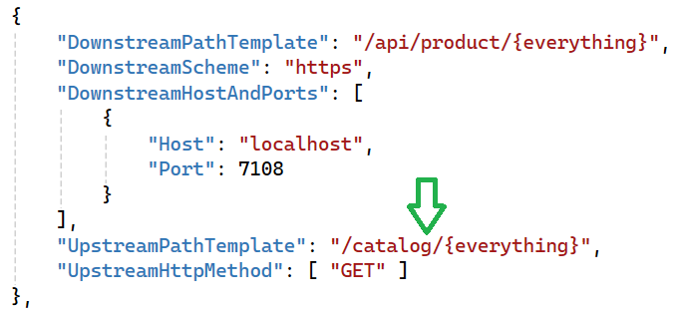

Protected path for Product ( Except Admin role , it protect the endpoint for all users)

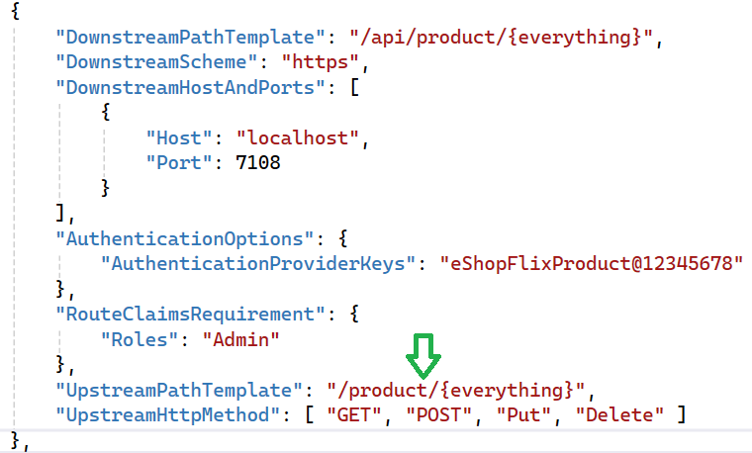

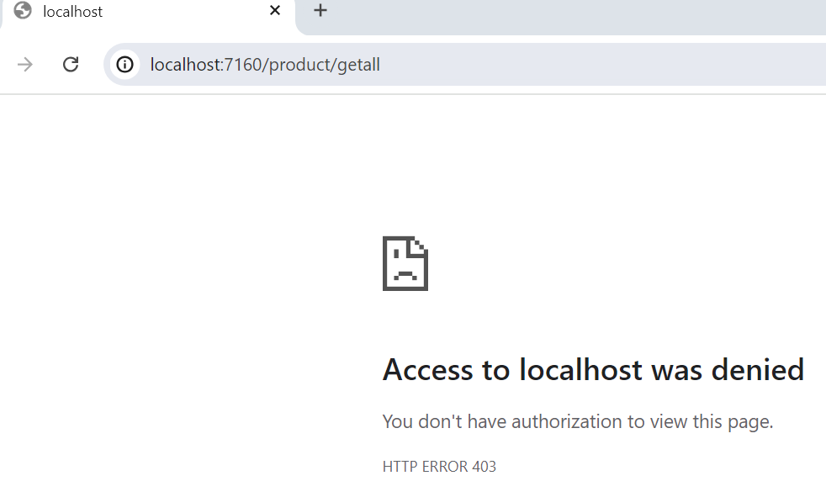

Check the flow through postman for User Role.

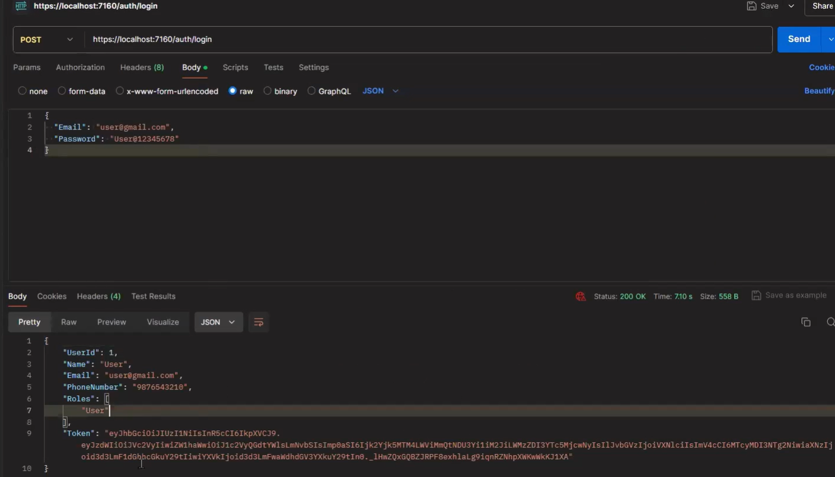

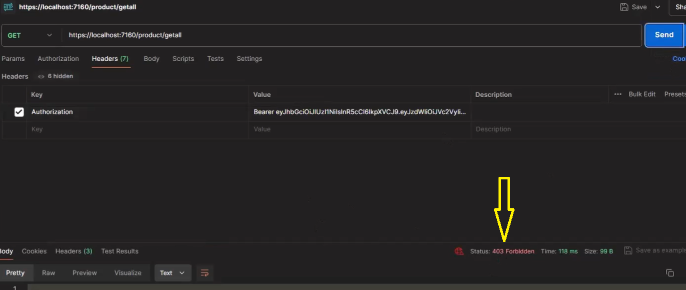

Check the flow through postman for Admin Role.

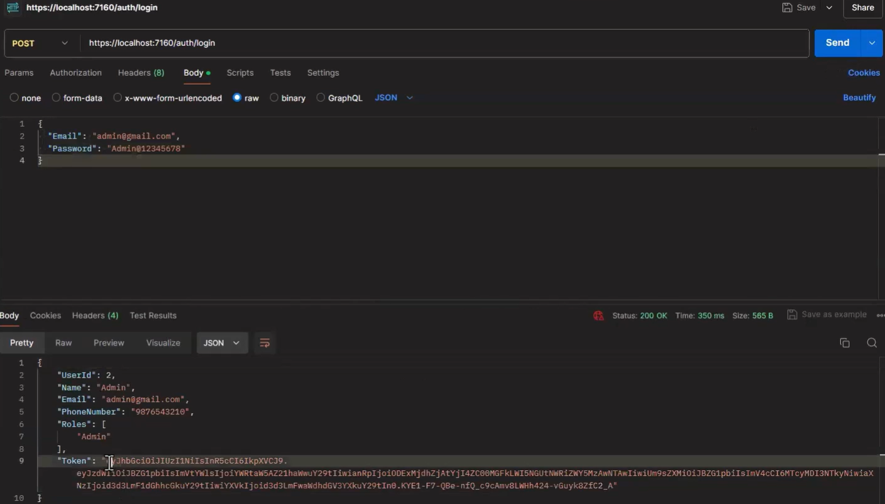

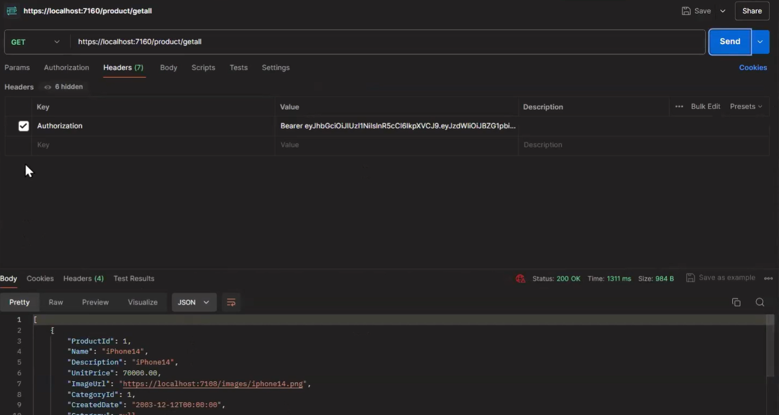

Suppose there are multiple Admin roles like Super Admin and Admin then the roles will be configure as below.

"RouteClaimsRequirement": {

"Roles": [ "Admin", "SuperAdmin" ]

},

1. Add the ProductModel.cs file in Model Folder and ProductService.cs file in HttpClients folder.
2. Register the ProductService in Program.cs file of SupportApp Project.

builder.Services.AddHttpClient<ProductService>(client =>

{

client.BaseAddress = new Uri(builder.Configuration["ApiGatewayAddress"]);

});

1. Create the Product controller and inject the ProductService