**1. SECTION – 1 : Azure Application Insights** 1

# **1. SECTION – 1 : Azure Application Insights**

1. We use the same solution i.e **Cart and Payment Service -Saga Pattern**.
2. Select the Resource group in Azure Portal.

1. Install the below Serilog NuGet Package in WebApp Project.

1. Define the Serilog configuration in appsettings.json file and appsettings.development.json file. Comment default logging from both the file.

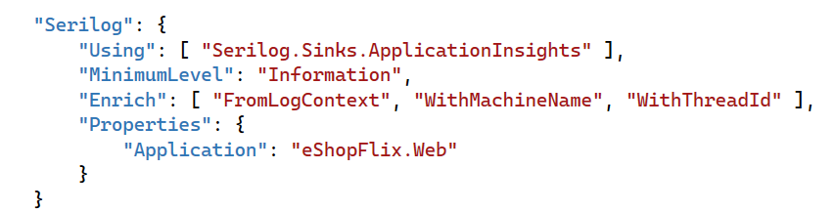

1. In Program.cs file of WebApp project, define the Application Insights settings.

1. Add a Helper class inside Helpers folder of WebApp for Logging the errors.
2. WebApp project > HomeController Index action method, we raise the divide by zero exception intentionally.
3. Create a section AppInsightConnection under WebApp appsettings.json file and add the below Azure Insight connection string in that section.

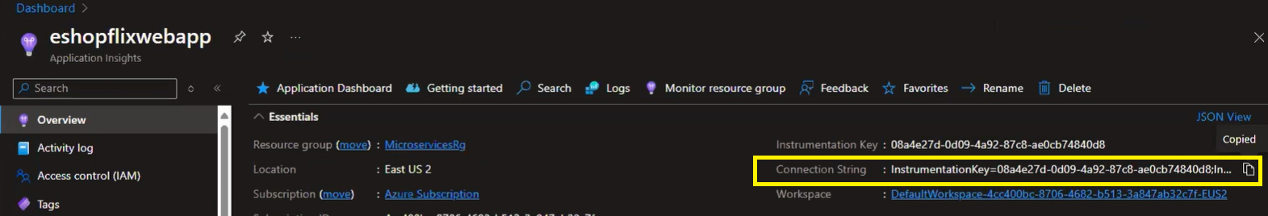

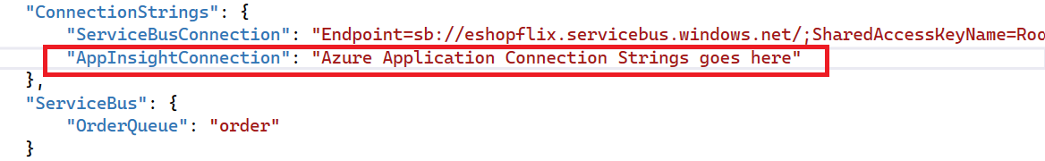

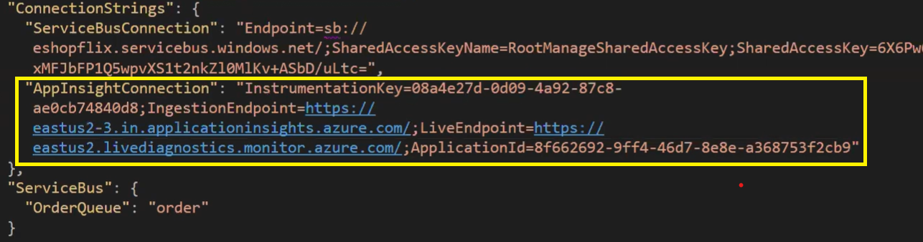

Run the application. Exception is getting

