**1. Redis Introduction** 1

**2. Caching** 3

**3. What is Redis** 4

**4. Setup Docker for Redis** 5

**5. Redis Command Line Tool (REDIS – CLI)** 7

**6. Redis Data Type** 7

**7. Project Setup** 8

# **1. Redis Introduction**



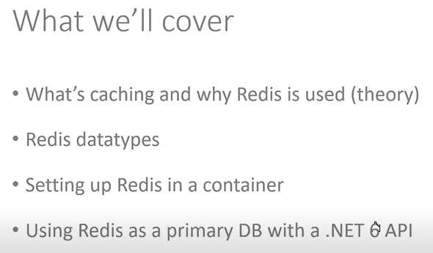

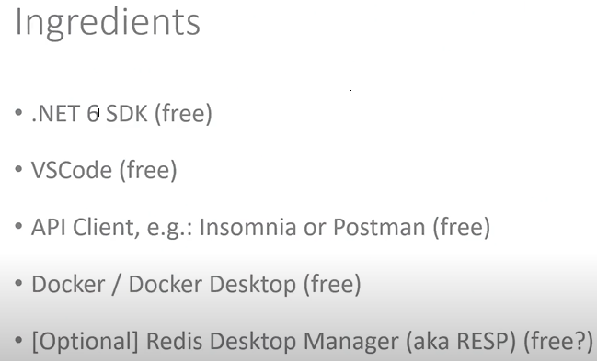

# **2. Caching**

Case 1.

Case 2.

Case 3.

# **3. What is Redis**

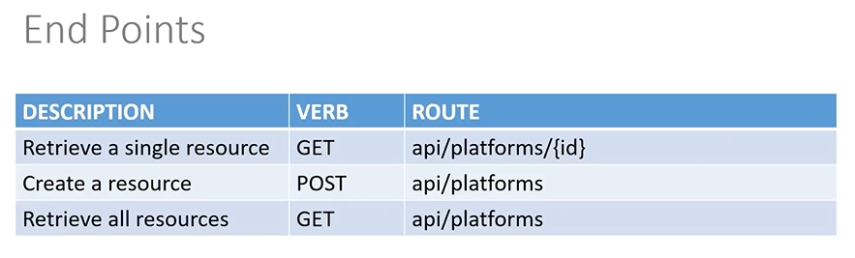

Create ASP.NET Core Web API in VS Code

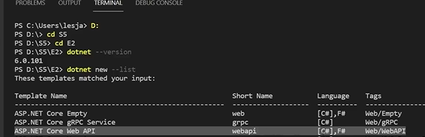

PS D:\ss\E2> code RedisAPI -r (It open the project)

# **4. Setup Docker for Redis**

1. Create docker compose file. Define the image and container name along with above ports.

Pull the redis image from the docker hub and run the below command in Visual Studio Developer Command Prompt.

1. Pulled redis image is showing in the docker desktop.

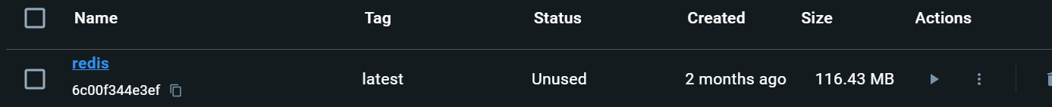

1. Run the container using below command in Visual Studio Developer command prompt to run the container. **(docker compose down)** to **remove** and **(docker compose stop)** to **stop** the container.

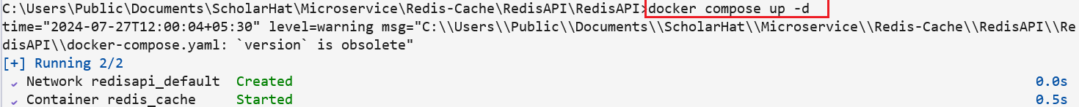

1. Run the below command, it shows running container name. ( As we can see in Docker Desktop also)



# **5. Redis Command Line Tool (REDIS – CLI)**

1. Run the below command in Visual Studio Developer Command Prompt.







Check weather it running or not by using the below command. (enter ping, and gives PONG as response)

# **6. Redis Data Type**

1. Run the below command

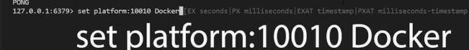

Please check the web site for reference (<https://redis.io/commands>)

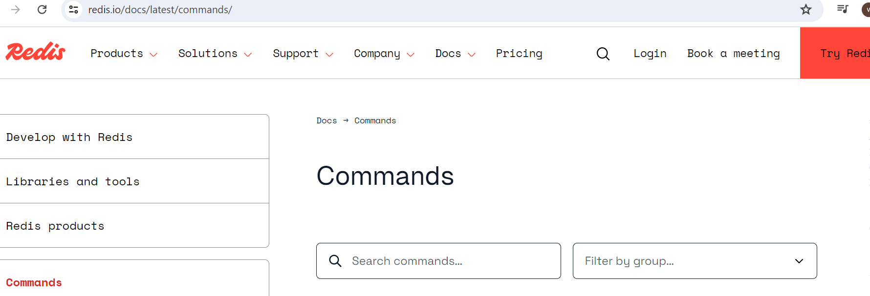

1. Exit from the Redis command prompt by using (**exit**) command.
2. First exit command represent exit connection from the redis database.
3. Second exit command exit from the interactive terminal command of redis container.

Once you exit and check for redis-cli command, it gives you below error.



# **7. Project Setup**

1. Intstall the below packages

1. We are going to use Package number 2 for IConnectionMultiplexer approach. Define the connection string in appsettings.Development.json and add its services to the container in Programm.cs file.

"ConnectionStrings": {

"RedisConnection": "127.0.0.1:6379"

}

Programm.cs



1. Add a Model
2. Create a Repository under Data folder (Interface and its implementation.)
3. Add a Services to the container for repository.
4. Add a PlatformsController.
5. Run the container using below command and redis command.

8. Install the Redis Insight (exe) and Test connection. Enter the details like credentials and Database name. Keep default Database name. Select the database and find the data using key type (here we use string type as key)

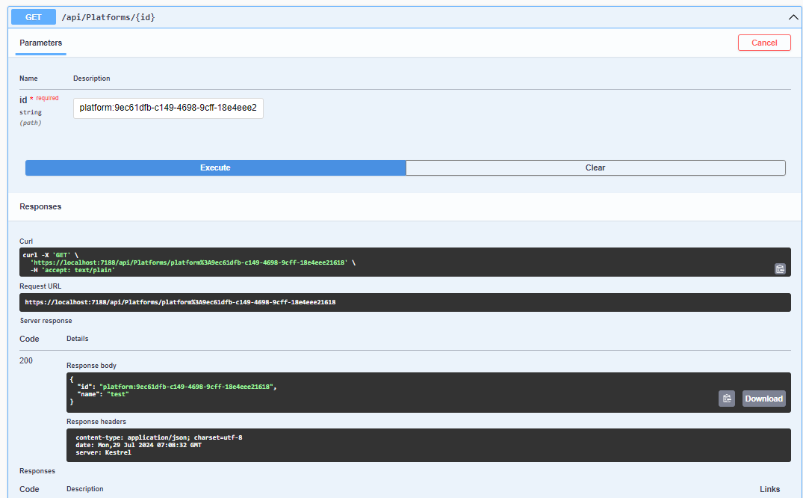

1. Add some platform like Docker, Kubernetes, Teraform using post method.

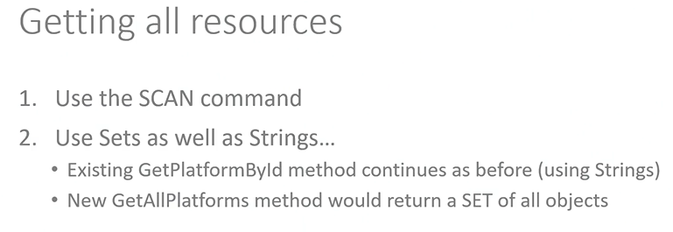

Add the below highlighted code in repository implementation.

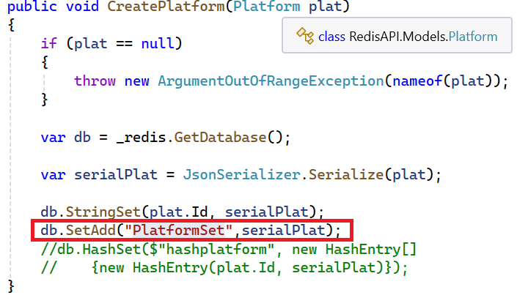

Then post the data as “name” : “Exchage” as we did earlier. The same can be see in Redis Insight.

Post the data as (Name: “XML”)

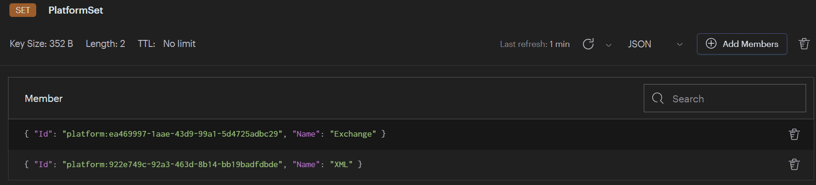

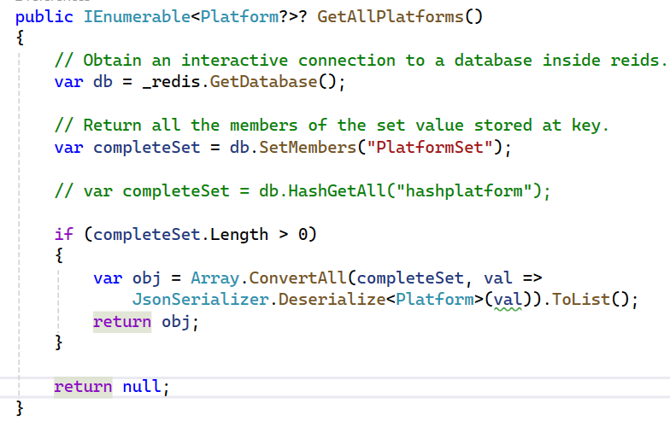

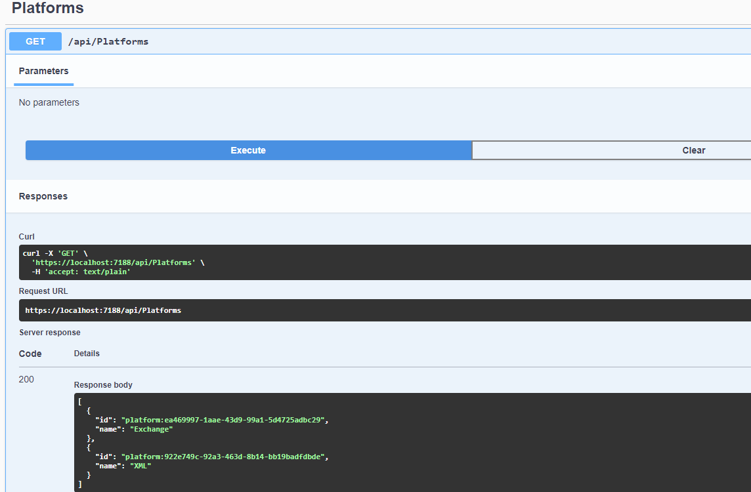

In Repository add the below code for hash

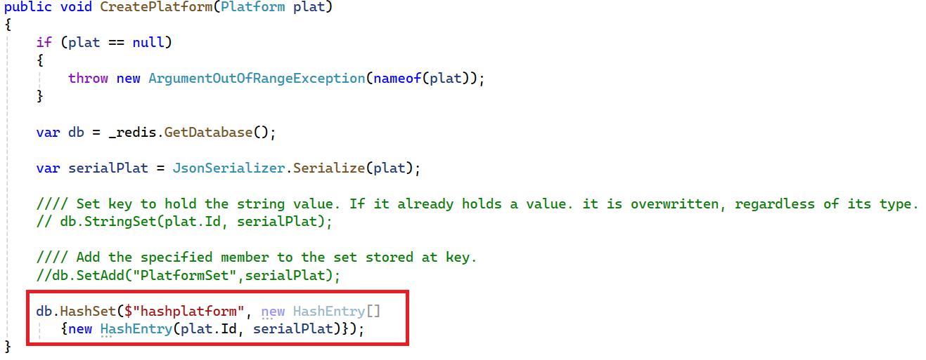

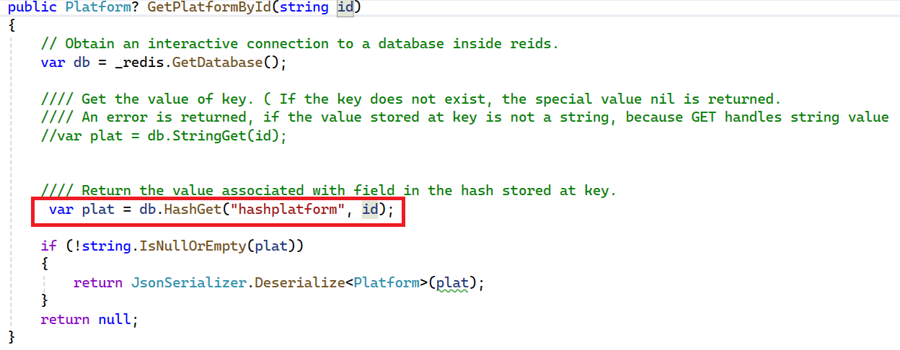

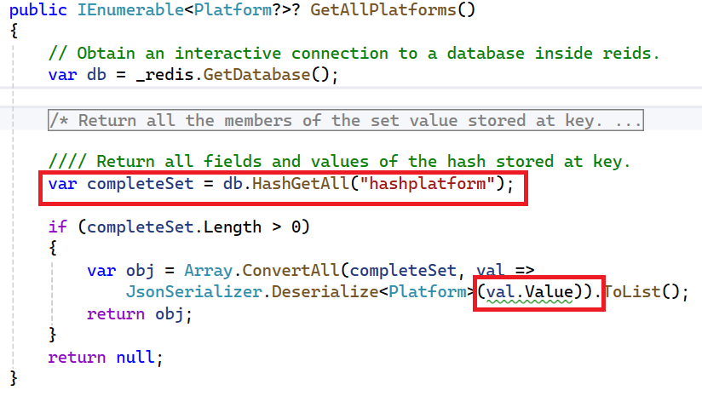

Post the data (“name” : “Redis”) and (“name”: “Python”)

We Scan the database 0 by using scan 0 command in Redis insight cli command or Visual Studio Developer Command Prompt.

Stop the docker container

**>docker ps** (Get list of running containers)

**>docker compose stop** ( Stop the docker containers)