# Project Name: A Restaurant Review Analysis

# College: Conestoga College (Doon)

# Subject: SQL and Data Analysis INFO8076

# Professor: Azar Khan

# Assignment: Individual Project

# Submitted By: Vishwajeet Ayyappa (8893410)

# Date: 21 June 2024

**Restaurant Review Analysis**

**Description:**

This project analyzes restaurant reviews and cuisines in Kitchener and Waterloo, Ontario. The goal is to gain insights into the restaurant industry, including the most popular cuisines, top-rated restaurants, and trends in customer reviews.

**Objectives:**

* To design a relational database schema to store restaurant, cuisine, and review data.
* To analyze the data to identify the most popular cuisines, top-rated restaurants, and trends in customer reviews.
* To provide insights into the restaurant industry in Kitchener and Waterloo.
* Target Audience: Restaurant owners, food critics, and customers interested in the restaurant industry in Kitchener and Waterloo.

**Specific Requirements or Constraints:**

* The database should be designed to store data for multiple restaurants, cuisines, and reviews.
* The database should be able to handle a large volume of data.
* The queries should be optimized for performance.

**Here is the relational schema for the project:**

**Tables:**

**1. Restaurants**

* **Primary Key (PK)**: restaurant_id
* **Foreign Key (FK)**: None

**Relationships**:

* **One-to-Many with Reviews**:
  + **Foreign Key**: restaurant_id in Reviews
  + **Description**: One restaurant can have multiple reviews.
* **Many-to-Many with Cuisines through Restaurant_Cuisines**:
  + **Foreign Keys**:
    - restaurant_id in Restaurant_Cuisines
    - cuisine_id in Restaurant_Cuisines
  + **Description**: One restaurant can offer multiple cuisines, and multiple restaurants can offer one cuisine.

**2. Cuisines**

* **Primary Key (PK)**: cuisine_id
* **Foreign Key (FK)**: None

**Relationships**:

* **Many-to-Many with Restaurants through Restaurant_Cuisines**:
  + **Foreign Keys**:
    - restaurant_id in Restaurant_Cuisines
    - cuisine_id in Restaurant_Cuisines
  + **Description**: Multiple restaurants can offer one cuisine, and one restaurant can offer multiple cuisines.

**3. Restaurant_Cuisines**

* **Composite Primary Key (PK)**: restaurant_id, cuisine_id
* **Foreign Keys (FKs)**:
  + restaurant_id references Restaurants(restaurant_id)
  + cuisine_id references Cuisines(cuisine_id)

**Relationships**:

* **Many-to-Many with Restaurants**:
  + **Foreign Key**: restaurant_id
  + **Description**: Links to Restaurants in a many-to-many relationship.
* **Many-to-Many with Cuisines**:
  + **Foreign Key**: cuisine_id
  + **Description**: Links to Cuisines in a many-to-many relationship.

**4. Reviews**

* **Primary Key (PK)**: review_id
* **Foreign Key (FK)**: restaurant_id references Restaurants(restaurant_id)

**Relationships**:

* **Many-to-One with Restaurants**:
  + **Foreign Key**: restaurant_id

**Description**: One review is associated with one restaurant, but one restaurant can have multiple reviews.

**Entity-Relationship Diagram (ERD):**

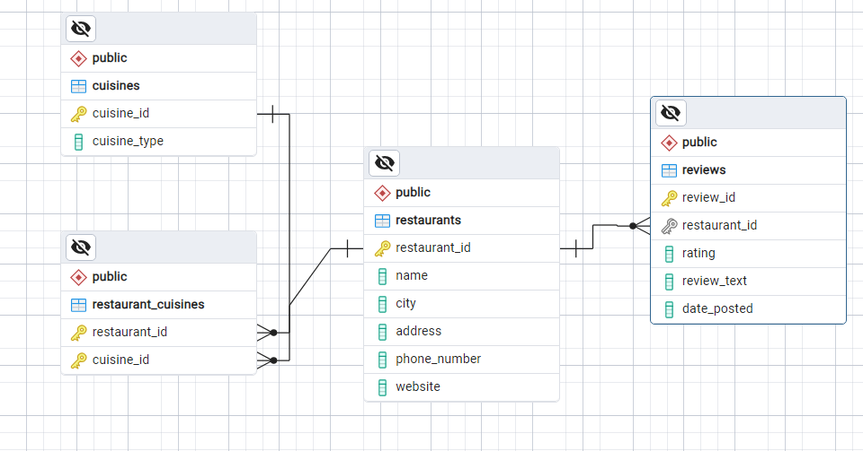

**Here are the queries used in the project:**

**Query 1: Filter - Get restaurants in Kitchener**



**Result:**

**Insight:** This query returns a list of restaurants located in Kitchener, which can be useful for customers looking for dining options in that city.

**Query 2: Join - Get restaurant names and their cuisines**

**Result:**

**Insight:** This query returns a list of restaurants with their corresponding cuisines, which can help customers find restaurants that serve their preferred type of cuisine.

**Query 3: Sub-query - Get restaurants with at least 2 cuisines**

**Result:**

**Insight:** This query returns a list of restaurants that offer at least two types of cuisine, which can be useful for customers who want to try different types of food at the same restaurant.

**Query 4: CTE - Get the top 3 restaurants with the most reviews**

**Result:**

**Insight:** This query returns the top 3 restaurants with the most reviews, which can help customers identify popular restaurants and make informed decisions about where to dine.

**Query 5: Aggregate function - Get the average rating for each restaurant**

**Result:**

**Insight:** This query returns the average rating for each restaurant, which can help customers evaluate the quality of a restaurant and make informed decisions about where to dine.

**Query 6: Filter with LIKE - Get reviews with the word "food" in the text**

**Result:**

**Insight:** This query returns reviews that mention the word "food", which can help customers understand the quality of food at a particular restaurant.

**Query 7: Join with multiple tables - Get restaurant names, reviews, and cuisines**

**Result:**

**Insight:** This query returns a comprehensive list of restaurants, their reviews, and cuisines, which can help customers make informed decisions about where to dine.

**Query 8: Top-rated Cuisine**

**Result:**

**Insight:** This query returns the top-rated cuisine for each restaurant, which can help customers identify the most popular cuisines and make informed decisions about where to dine.

**Query 9:** Most popular cuisine in each restaurant

**Result:**

**Insight:** This query returns the most popular cuisine in each restaurant, which can help customers understand the specialty of each restaurant and make informed decisions about where to dine.

**Query 10: Sub-query with EXISTS - Get restaurants with at least one 5-star review**

**Result:**

**Insight:** This query returns a list of restaurants that have at least one 5-star review, which can help customers identify high-quality restaurants.

**Query 11: Window function - Get the ranking of restaurants by average rating**

**Result:**

**Insight:** This query returns a list of restaurants ranked by their average rating, which can help customers identify the top-rated restaurants.

**Query 12: Filter with DATE functions - 1st Quarter (January to March) Reviews**

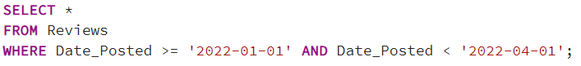**Result:**

**Insight**: This query returns a list of reviews posted during the 1st quarter of the year, which can help customers understand the quality of restaurants during that period.

**Query 13: Filter with DATE functions - 2nd Quarter (April to June)**

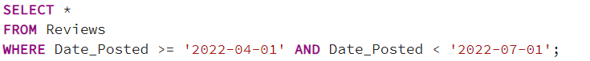**Result**:

**Insight**: This query returns a list of reviews posted during the 2nd quarter of the year, which can help customers understand the quality of restaurants during that period.

**Views:**

**1. Restaurants with Most Diverse Cuisines**

**Result:**

**Insight:** This view ranks restaurants by the number of cuisines they offer, providing a list of restaurants with the most diverse culinary options.

**2. Top Restaurants in both the location Waterloo-Kitchener**

**Result:**

**Insight:** This view identifies the top 10 restaurants in both Waterloo and Kitchener, comparing their average ratings and comparing the top-rated restaurants in each location.

**Conclusion:**

In this project, we analyzed a dataset of restaurant reviews to gain insights into customer opinions and preferences. We used SQL queries to extract and analyze the data and visualized the results to identify trends and patterns.

Example: Analysis output that helps Restaurant owners and managers

**Our findings suggest that:**

* Sushi Haven is the most popular restaurant, with the highest average rating and the most reviews.
* Tasty Tacos and Bistro Bliss are also well-liked, with high average ratings and many reviews.
* The Fancy Fork has a lower average rating, but still has a significant number of reviews.
* Customers are generally satisfied with the food at these restaurants, but some have concerns about service and price.
* Japanese cuisine has the highest average rating, followed by Mexican and Italian cuisine.
* Restaurants with more than 5 reviews tend to have higher average ratings.

**Restaurant owners and managers can use these insights to improve their businesses, such as:**

* Identifying areas for improvement, such as service or pricing.
* Developing targeted marketing campaigns to attract more customers.
* Enhancing the dining experience to increase customer satisfaction and loyalty.
* Overall, this project demonstrates the power of data analysis in understanding customer opinions and preferences and can be applied to a wide range of industries and businesses.

**Thank You**