**Chapter 1: INTRODUCTION**

Artificial Intelligence (AI) is progressing rapidly and has already caused many different effects. We see AI applications everywhere we look; from phones to autonomous vehicles to biotechnology, AI has become ubiquitous. AI is often considered the key component of the Fourth Industrial Revolution [1]. Like the revolutions that preceded it, the Fourth Industrial Revolution has the potential to raise global income levels and improve the quality of life for populations around the world. However, the revolution could yield greater inequality as well, particularly in its potential to disrupt labor markets as automation substitute’s labor across the entire economy [1]. Consider, for example, when entire work-forces were laid off when pinhead factories started incorporating machines in their fabrication process. A similar, though far larger threat looms due to new advances in AI development. Bill Gates had the idea to tax labor performed by AI-algorithms, to compensate for the loss of jobs in many sectors. This idea seemed science fiction at the time, but the concept can be realized on the Effect Network, a decentralized network for AI. Effect.AI brings AI-algorithms to an open and proven decentralized platform, powered by the blockchain and accessible to all.

The industry of artificial intelligence (machine learning, ML) and big data is at the very core of the 4th Industrial revolution. Today, there exist no decentralized or even centralized open markets for each of the components required for machine learning: big data, ML models and computing power. Our mission is to decentralize and disrupt the whole ML industry by creating open market inclusive for all key players, which will stimulate synergy and speed up development of artificial intelligence. In other words, Pandora aims to create world decentralized artificial intelligence the same way Bitcoin has created world decentralized payments and Ethereum — world decentralized computer.

According to [Forbes](https://www.forbes.com/sites/louiscolumbus/2016/08/20/roundup-of-analytics-big-data-bi-forecasts-and-market-estimates-2016/#fa5c44c6f218), big data market was estimated at $122 billions in 2015 and it will grow to more than $187 billions till 2019. Pandora can speed up its growth. Pandora targets to capture most of the market with its disruptive new way to compute ML models, which could bring total Pandora Network capitalization to tens of billions and more in term of 5–8 years. Our core strategy to capture the market is to give its players the ability to do things that they cannot do today: sell their computing power to AI tasks, sell their ML models to a broad community, monetize AI research, monetize datasets on an open market with fair price, easily find and acquire datasets required for training and computing ML models for business and research tasks.

Our team has already self-funded the development of technological description and economic model for the Pandora Network and Proof of Cognitive Work algorithm, as well as proof of concept in code written in Python, Ethereum smart contracts and Javascript that covers complete process cycle. This code is available on [GitHub](https://github.com/PandoraBoxchain).

We have completed closed funding round and token distribution for 5% of total supply for $500k over the course of July 2017. Raised funds will be used for launching the first testnet version, completion of technological yellow papers and preparation for a large open fundraising at the autumn-end of this year with target set in range of $25–45m.

**1.A Blockchain**

A blockchain is a decentralized data store that can contain arbitrary logic and processes, without the need for a trusted central party. Blockchain was first pro-posed in the Bitcoin whitepaper by Satoshi Nakamoto, 2009 [2]. Since then the technology has been applied in many areas, and has had a disruptive influence in the markets of banking, insurance, real-estate, to name a few. Decentralized applications have some unique properties like transparency and a fixed history. We propose a protocol that decentralizes the global market in AI; which lowers the barrier for entry, stimulates market growth and greatly reduces usage cost.

**NEO**

NEO [3] is (i) the use of blockchain technology and digital identity to digitize assets, and (ii) the use of smart contracts for digital assets to be self– managed. This establishes, what is called, a Smart Economy with a distributed network. Hence, it’s a smart contracts ecosystem, similar to Ethereum [4].

NEP5 tokens are tokens that are managed by smart contracts on the NEO blockchain. Most existing NEO projects use a NEP5 token (e.g. RedPulse, Qlink, and DeepBrain Chain ). NEP5 describes the protocol that these tokens conform to, as the Effect.AI

EFX token does as well.

**1.B Artificial Intelligence**

AI is intelligence displayed by machines, in contrast with the Natural Intelligence (NI) displayed by humans and other animals. In computer science AI is defined as the study of "intelligent agents": any device that perceives its environment and takes actions that maximize its chance of success at some goal. In the past five years there has been a rapid growth in the number of practical AI applications. Smart services like self-driving cars, face and voice recognition in mobile phones, and image translation are getting a central place in every-day life. The increase in AI applications can be explained by the advances in Machine Learning (ML), Computer Vision (CV), and Natural Language Processing (NLP) research, as well as the ready availability of cloud computing. This has resulted in large adoption by the industry and the birth of a billion-dollar-economy around smart applications. While academic achievements are available to the public most intelligent algorithms are developed behind the closed doors of large corporations. We propose a private, decentralized ecosystem called the Effect.AI Network ( Effect Network ). The network is designed to develop in the phases shown in fig. 1, and operates fully on smart contracts deployed on a Turing-complete blockchain.

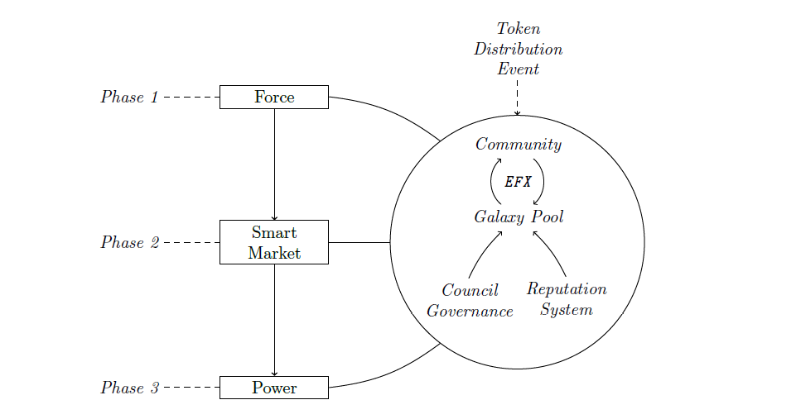

Figure 1.1: Development roadmap for the Effect Network

**1.C Problem Statement**

Despite the advantages AI brings there are a number of problems that have to be dealt with, especially regarding the research and development of AI technology. These problems can broadly be categorized into three areas that currently make AI research and development difficult to perform.

**Data processing:** The first problem is that of data processing . Intelligent applications perform tasks that traditionally require human feedback. Such tasks involve processing unstructured data and finding patterns that can provide useful output. These applications are trained on large data sets with annotations. Obtaining an annotated data set is non-trivial and requires a lot of time and resources.

**Diverging Tasks:** The second problem that currently makes AI hard to practice is that of diverging tasks. An obstacle when developing a complex algorithm is the need to interact with parts of the world outside the current domain. For example: a self-driving car learning to steer will also need to identify road signs around the world. This situation can best be treated as a knowledge system where the classification of the sign is done by an external application. This quickly increases the complexity of an application.

**Computational Costs:** The last main problem is the computational cost of AI algorithms. Developing and training AI systems is in most cases a computational intensive and thus expensive task. It requires a technical infrastructure capable of processing large amounts of data, doing batched processing on Graphics Processing Units (GPUs) and coordinating the results.

**1.D Solution Effect.AI**

A decentralized ledger like the blockchain provides a direct link between supply and demand which can greatly mitigate these problems. The transparency that blockchain offers will boost discoverability on the network, resulting in a high degree of collaboration and data sharing between agents. It also increases knowledge diversity and makes AI more affordable by sharing costs. Around this vision the Effect Network is designed. Like other decentralized applications, Effect.AI directly connects supply and demand without the need for an intermediary party. To be more specific, the Effect Network will establish the following:

**1. Accessibility.** By directly linking supply and demand through our micro tasking platform Effect.AI Force (EF) will make training AI algorithms easier, faster and cheaper. This will enable users who do not have access to a large dataset or a big network to train their AI algorithm.

**2. Accuracy.** The Effect.AI Smart Market (ESM) is an exchange with a rich ontology of specialist AI applications. Individual applications are able to find each other to buy or sell information. Through this exchange, users can use data sets with significantly higher complexities to train their AI algorithms.

**3. Performance.** Users can enrich their existing datasets by purchasing services from algorithms on the, or they can setup a new datasets by creating micro-tasks on the EF platform. By enabling users to build datasets quickly and accurately they can immediately use these datasets to train AI algorithms.

**4. Interoperability**. By putting the AI algorithms on the blockchain and creating a communication standard to which these AI algorithms have to comply to, we can truly decentralize AI and achieve interoperability between individual AIs.. The combination of multiple AI algorithms will result in powerful capabilities and emergent intelligence that

no single AI algorithm can achieve on its own.

The network will be deployed in consecutive phases, allowing adaptation and development of the network to grow together. The phases cover independent market sections but are interconnected in our network model and are all fueled by the same token; the EFX token.

**The main directions of development of multi-agent systems, distributed artificial intelligence:**

Synergistic content of MAS conception is based on the processes of interaction of individual and collective agents, leading to the formation of artificial groups and communities, i.e., **social computing systems with fundamentally new features**. Depending on the number of interacting agents and the inherent characteristics of their interactions, the various directions of development and types of MAS can be distinguished.

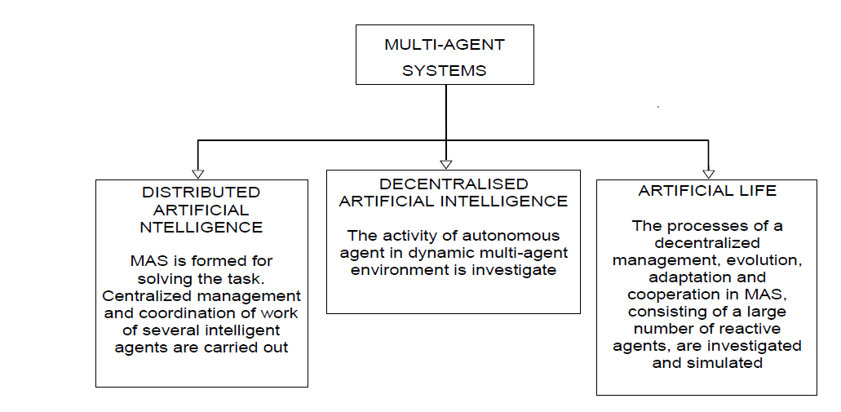

Figure 1.2: Classification of multi-agent systems.

A **distributed artificial intelligence and artificial life** (in the narrow sense of the term) and the main directions in the development of MAS (Fig. 1.2). The studies of interaction and cooperation of a small number of intelligent agents, for example, the classical intelligent systems, including knowledge bases and solvers, compose a kernel of Distributed Artificial Intelligence (**DAI**) [6−11]. The main problem in **DAI** lies in the development of intellectual groups and organizations, capable to solve tasks by reasoning, which is related to the treatment of symbols. In other words, group intellectual behavior in **DAI** is based on individual intellectual behaviors. This means a congruence of the objectives, interests and strategies of different agents, coordination of their actions, the resolution of conflicts through negotiations; theoretical base in this process consists of the results obtained in the psychology of small groups and the sociology of organizations.

DAI systems are defined by three main characteristics: 1) a method for the distribution of tasks between agents; 2) a method of distribution of powers; 3) method of communication of the agents.

Typical scheme of distributed solution of the tasks by several agents includes the following steps:

1) agent-subordinator (Head, the central body) decomposes the original problem into separate tasks;

2) these tasks are distributed between the agents-executants;

3) each agent-executant solves the task, sometimes also dividing it into sub-tasks;

4) in order to obtain the overall result a composition, integration of particular results corresponding to the selected task is produced. Agent-Integrator is responsible for the overall result (often, this is the same agent-subordinator).

**The disadvantages** of such systems consist of the inability of agents to the more complex organization, planning, and solution of the tasks, requiring sequential execution or data analysis, as well as the excess parallelism of tasks’ execution.