Ratio Data is defined as quantitative data, having the same properties as interval data, with an equal and definitive ratio between each data and absolute “zero” being treated as a point of origin. In other words, there can be no negative numerical value in ratio data.
For example:
Four people are randomly selected and asked how much money they have with them. Here are the results: $20, $40, $60, and $80.
- Is there an order to this data? Yes, $20 < $40 < $60 < $80.
- Are the differences between the data values meaningful? Sure, the person who has $40 has $20 more than the person with $20.
- Can we calculate ratios based on this data? Yes, because $0 is the absolute minimum amount of money a person could have with them.
- The person with $80 has four times as much as the person with $20.
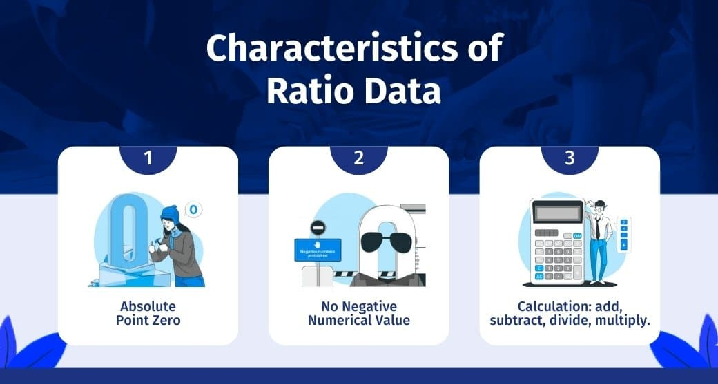
• Absolute Point Zero(Remainder Zero): It is measured on a ratio scale. One of the distinctive characteristics is the true absolute zero point, which makes the data relevant and meaningful in a manner where it is right to say, “one object is twice as long as the other,” or 4 has twice the value as 2.
• No Negative Numerical Value: It has no negative numerical value. For a value to be a ratio data researcher, one must first evaluate if it meets all the criteria of interval data and has an absolute zero point. For example, weight cannot be negative; -20 Kg doesn’t exist.
• Calculation: Data values can be added, subtracted, divided, and multiplied. A unique statistical analysis is possible for this data.

Interval Data Definition
The interval data definition is simply a way of measuring something using equal intervals of time.
In other words, it’s a way of dividing up time so that we can better understand how things change over certain periods. There are many different ways to collect and analyze interval data.

Interval Data Examples
- Time of day in a 12-hour clock.
- Temperature in degrees Fahrenheit or Celsius (not Kelvin).
- IQ test.
- SAT and ACT scores.
- Age.
- Income range.
- Year.
- Voltage.
- Grade levels in school.
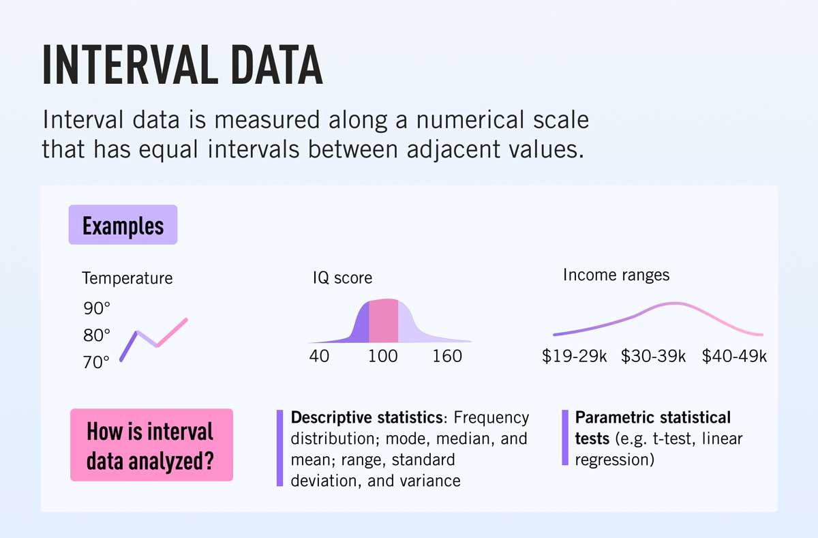

Problem Statements:
- Identify the data type (continuous/discrete) for the following:
Activity | Data Type(Discrete/Continuous)
Number of sheep counted while trying to sleep | Discrete
Results of rolling a dice | Discrete
Weight of a person | continuous
Weight of Gold | Continuous
Distance between two places | Continuous
Length of a leaf | Continuous
Dog's weight | continuous
Blue Color | Discrete
Number of kids | Discrete
Number of tickets in Indian railways | Discrete
Number of times married | Discrete
Gender (Male or Female) | discrete
Voltage | continuous
Speed of the car | Continuous
Distance between planets | Continuous
The size of a two a bedroom flat | Continuous
Wind speed | Continuous
Facebook likes | Discrete
Votes in election | Discrete
Make up kits purchased | Discrete
Death toll in flood disaster | Discrete
The waiting time of customers in bank | Continuous
Price of iPhone in the market | Discrete
Stolen Cars | discrete

- Identify the data types (Nominal, Ordinal, Interval, and Ratio)

Data | Data Type
Gender | Nominal(divide into fixed grup)
High School Class Ranking | Ordinal (specific range,more than two grps)
Celsius Temperature | Interval (interval)
Weight | Ratio ( No negative value)
Hair Color | nominal
Socioeconomic Status | Ordinal
Fahrenheit Temperature | Interval
Height | Ratio
Type of living accommodation | Nominal
Level of Agreement | Ordinal
IQ (Intelligence Scale) | interval
Sales Figures | Ratio
Blood Group | ordinal
Time of Day | Interval
Time on a Clock with Hands | Interval
Number of Children | Discrete
Religious Preference | nominal
Barometer Pressure | Ratioo
SAT Scores | Interval
Years of Education | Interval
Size of egg | Ratio
Monthly Income | ratio
Unemployment rate | Ratio
Military Rank | ordinal
Shoe size | nominal
Pulse rate | interval
Vital capacity | Ratio
Favorite candy bar | Nominal
Name of the Grains | nominal
Pesticides level | Ordinal
Tribe of origin | Nominal
Help Desk Service Satisfaction Score | Ordinal
Ethnicity | Nominal
Marital status | Nominal
Type of Residence | ordinal
Swimming level | nominal
Amount of Money | ratio
Colors of paint | Nominal
Weekly Food spending | Ratio

- Identify whether the data is qualitative or quantitative:
Data | Data Type (Qualitative/Quantitative)
I bought Strawberry lipstick today | Quallitative
Happiness rating | Quantitaative
Duration of red-light signal | Quantitative
I like butterscotch ice cream | Qualitative
Setosa belongs to Iris family of flowers | Qualitative
cold Coffee | Qualitative
The Tea smells good | Qualitative
Dress Size | Quantitative

- Identify whether the data is categorical or numerical for the following:
Data | Data Type (Categorical / Numerical)
Product type | Categorical
Native language | Categorical
Type of teaching approach | Categorical
Virus in a System | Categorical
Covid-19 Positive Cases | Numerical
Lockdown Days | Numerical

- Identify whether the data is structured or unstructured for the following:

Data | Data Type (Structured/Unstructured)
Credit card numbers | Structured
Transaction information | Structured
Text files | Unstructured
Images | Unstructured
Music files | Unstructured
Credit card numbers | Structured

