CASE STUDY REPORT
Understanding Guest Cancellation Behavior: A Data-Driven Case Study on Hotel Booking Cancellation Prediction and Analysis
An Integrated Machine Learning, Natural Language Processing and Time-Series Case Study on Reservation Cancellation Risk, based on the Hotel Booking Demand Data Set (119,390 Bookings) and a 515,738-Review Guest Feedback Corpus
VISHWAJEET SINGH  25MCAR0219  Dept. of Computer Science & IT | HARSH VISHWAKARMA  25MCAR0203  Dept. of Computer Science & IT
KHATRI BHAVYA  25MCAR0217  Dept. of Computer Science & IT | ASSUDANI SIDDHI SATYANKUMAR  25MCAR0199  Dept. of Computer Science & IT
SADANAND S
25MCAR0191
Dept. of Computer Science & IT

MCA Program, JAIN (Deemed-to-be University), Bengaluru
Course: Data Science — Case Study Activity 2 | Submitted to: Kavya Bijith P

Abstract — This report is the direct continuation of Activity 1, which profiled a 119,390-booking hotel reservation dataset covering City Hotel and Resort Hotel properties across 15 Indian cities and identified the construction of a trained cancellation classifier as future work. Activity 2 carries out that work and extends it with Natural Language Processing and Time-Series Analysis. The preprocessing recommended in Activity 1 was applied first, producing a 37-column file with no missing values; six columns were then removed before modelling, including reservation_status, which determines the target with no error across all 119,390 records. The remaining 31 predictors passed through a single scikit-learn pipeline expanding to 297 model inputs. Four classifiers were trained on a stratified 80/20 split (95,512 training and 23,878 test bookings). Random Forest performed best among the untuned models (F1 = 0.8100, accuracy = 85.90%, ROC-AUC = 0.9356), confirmed by three-fold cross-validation at F1 = 0.8106 ± 0.0012; randomised hyperparameter search then produced a tuned Random Forest reaching F1 = 0.8348, accuracy = 87.60% and ROC-AUC = 0.9497, reproduced to nine decimal places by re-scoring the saved model. Feature importance independently reproduces Activity 1's conclusions: deposit type (19.05%), country (13.93%) and lead time (9.42%) dominate, and market segment with customer type together carry 13.53% against 3.49% for hotel, city and month combined. In the NLP component, 19,994 reviews drawn from a 515,738-review corpus were analysed with the VADER lexicon, yielding 75.51% positive and 13.00% negative and agreeing with rating-derived labels on 72.21% of reviews; no supervised classifier was trained, so no classification accuracy is claimed. In the Time-Series component, a previous-seven-day rolling mean outperformed a Random Forest regressor over a 71-day chronological window (MAE 10.700 against 11.464; RMSE 18.000 against 18.541), and the model's R² of −0.036 places it below the test-period mean. Activity 1's Finding 3 — the extreme non-refundable-deposit signal — is confirmed and escalated. Verified limitations and a full gap list are reported.
Index Terms—machine learning, classification, random forest, hyperparameter tuning, hotel booking cancellation, data leakage, feature importance, VADER sentiment analysis, natural language processing, time-series forecasting, baseline comparison, model evaluation

I. INTRODUCTION
Activity 1 of this case study profiled a 119,390-booking hotel reservation dataset spanning City Hotel and Resort Hotel properties across 15 Indian cities over the 2024 calendar year. It established the shape of the problem through descriptive statistics, correlation analysis and twelve visualizations, and concluded with an explicit boundary: the scope was “limited to dataset profiling, exploratory analysis, and visualization; the construction and evaluation of a trained cancellation classifier is identified as future work.”
This report carries out that work and extends it in two further directions required by the assignment. It covers Steps 71–105 of the group's shared machine-learning pipeline, completing the sequence that Members 3 and 4 advanced through Steps 22–70 in Activity 1, together with a 33-step Natural Language Processing study of guest feedback and a 31-step Time-Series study of cancellation volume over time. The booking dataset, the target variable and the business question are unchanged; what changes is the method.
That shift matters for a practical reason. A correlation of +0.293 between lead time and cancellation, which Activity 1 reported as its strongest single linear relationship, tells a hotel that early bookings are riskier on average. It does not tell the front desk what to do about the specific reservation in front of them. A classifier does, provided its performance is honestly measured and the signals it relies on are genuine. Both of those qualifications are treated here as part of the result rather than as caveats appended to it, and Section V-H returns to each of Activity 1's eight findings to record whether the modelling stage confirmed, extended or failed to act on it.
Two further components broaden the study. The NLP component asks what guests actually write about and in what emotional register. The Time-Series component asks whether daily cancellation volume contains enough structure for a learned forecaster to improve on a simple statistical baseline. The three components are complementary but analytically separate, and a central contribution of this report is to state clearly what each does and does not establish.
II. PROBLEM STATEMENT
Activity 1 framed a data-quality problem and an analytical problem. With preprocessing now applied and the analytical groundwork laid, Activity 2 addresses four problems of its own:
- Predictive problem: given the attributes known at the time a reservation is made — lead time, deposit terms, market channel, guest history, room type, and rate — predict whether that reservation will be cancelled, with enough precision and recall to support an intervention decision rather than merely to score well on paper.
- Evaluation problem: the target is imbalanced at roughly 63:37. A model that predicts “not cancelled” for every booking achieves 62.96% accuracy while identifying zero cancellations. The evaluation design must therefore make such a model visibly worthless, which requires threshold-independent and positive-class-specific metrics rather than accuracy alone.
- Integrity problem: the dataset contains at least one attribute that determines the target exactly, and several others that duplicate information already present elsewhere. These must be identified and handled before training, because a model that scores well by reading the answer out of its own inputs is worse than useless — it is misleading.
- Extension problem: guest feedback and cancellation volume are different units of observation from the individual booking, and the review corpus is a different dataset entirely. Each must be analysed on its own terms, and no relationship may be claimed between them that the data cannot support.
The scope of this activity is model construction, tuning, evaluation and interpretation on the existing cleaned dataset, lexicon-based sentiment analysis and exploratory text mining of the review corpus, and trend analysis and short-horizon forecasting of daily cancellations. Deployment, live monitoring, supervised sentiment classification and any booking-level linkage of review sentiment are outside this scope and are carried forward as recommendations in Section X.
III. DATASET DESCRIPTION
A. Booking Dataset Source
The modelling input is hotel_bookings_cleaned.csv, the file exported at the end of Member 2's 21-step preprocessing stage. It follows the schema of the widely used Hotel Booking Demand dataset of Antonio, Almeida and Nunes [1], [2], which records reservations at a city hotel and a resort hotel, and has been adapted for this project with an Indian property and city layer: the hotel attribute carries 30 values of the form “City Hotel – Mumbai” or “Resort Hotel – Goa”, spanning two property types across fifteen cities. All arrival dates fall in a single calendar year (2024). Four derived columns — total_nights, total_guests, arrival_month_num and arrival_date — were added during preprocessing, taking the file from the 33-column source schema reported in Activity 1 to 37 columns.
TABLE I. BOOKING DATASET STRUCTURE AND CHARACTERISTICS
Characteristic | Value
Records (rows) | 119,390
Attributes (columns) | 37 (33 source + 4 derived)
Missing values remaining | 0
Exact duplicate rows | 0
Observation period | Calendar year 2024 (366 days)
Property types / cities | 2 / 15 (30 hotel values)
Distinct guest countries | 178
Target variable | is_canceled (0/1)

Two consequences of the preprocessing are material to Sections IV and IX. The agent column, missing for 16,340 bookings, and the company column, missing for 112,593, were filled with zero rather than flagged with an indicator variable, so zero now doubles as a marker for absence; and both fields remain typed as numeric although they hold categorical identifier codes.
B. Target Variable and Class Balance
The target is is_canceled, where 1 indicates that the reservation was cancelled or ended in a no-show and 0 indicates that the guest checked out. The balance is unchanged from Activity 1.
TABLE II. CLASS BALANCE OF THE TARGET
is_canceled | Record Count | Percentage
0 (not cancelled) | 75,166 | 62.96%
1 (cancelled) | 44,224 | 37.04%
Total | 119,390 | 100.00%

Activity 1 described this as “meaningfully skewed but far from the extreme rare-event case,” and concluded that standard classification metrics would remain informative without heavy resampling. The results in Section V bear that out: no synthetic resampling was applied, and the three learning models reached usable recall on the cancellation class through class weighting alone. The imbalance is nonetheless sufficient to make raw accuracy an unsafe single criterion, which is why a deliberately naive baseline was included in the comparison.

C. Feature Inventory
After removing the target and the leaking columns described in Section IV-A, 31 predictor columns remain and were partitioned automatically by data type.
TABLE III. FEATURE INVENTORY AFTER COLUMN REMOVAL
Type | Count | Examples
Numeric | 20 | lead_time, adr, booking_changes, previous_cancellations, total_of_special_requests, required_car_parking_spaces
Categorical | 11 | hotel, country, market_segment, deposit_type, customer_type, reserved_room_type, assigned_room_type, meal, city
Total predictors | 31 | —
Model inputs after one-hot encoding | 297 | —

The 11 categorical columns carry 282 distinct levels in the full dataset. One-hot encoding fitted on the training split produced 277 binary indicator columns, which together with the 20 numeric features give the 297 inputs the model actually sees. Five rare category levels present only in the test split were absent from the training fit and were silently mapped to all-zero vectors by the handle_unknown=“ignore” setting — the correct behaviour, and a design choice worth recording.
D. Guest Review Dataset
The NLP component uses a separate corpus, Hotel_Reviews.csv (238 MB), containing 515,738 guest reviews of European hotels with 17 columns, including separate Positive_Review and Negative_Review free-text fields and a numeric Reviewer_Score [3]. Because the file is large, a reproducible sample was drawn: the file was read in chunks of 50,000 rows, 2,000 rows were sampled from each chunk at seed 42, and the concatenated result was reduced to exactly 20,000 rows at the same seed. After removing rows with empty review text and missing scores, 19,994 reviews were analysed.
TABLE IV. GUEST REVIEW DATASET CHARACTERISTICS
Characteristic | Value
Reviews in source file | 515,738
Columns | 17
Free-text fields | Positive_Review, Negative_Review (stored separately)
Numeric rating field | Reviewer_Score
Sample drawn for analysis | 20,000 (chunk-stratified, seed 42)
Reviews analysed after cleaning | 19,994
Missing values | lat and lng only, 3,268 rows each (0.63%)
Duplicate rows in sample | 1

This corpus is not linked and cannot be linked to the booking dataset. The two describe different properties in different regions over different periods, and the review file carries no booking identifier, no cancellation field and no common key. No analysis in this report treats review sentiment as a predictor of an individual booking's cancellation, and no such claim is supported by the supplied files.

E. Daily Cancellation Series
The Time-Series component derives its data from the same cleaned booking file, aggregated by arrival date into a daily series of total bookings, cancellations, non-cancellations and cancellation rate.
TABLE V. DAILY CANCELLATION SERIES CHARACTERISTICS
Characteristic | Value
Daily observations | 366 (2024 was a leap year)
Date coverage | 1 January 2024 – 31 December 2024
Missing dates / invalid labels | 0 / 0
Mean daily cancellations | 120.83
Standard deviation [calculated] | 12.40
Minimum / maximum | 0 / 149
Usable rows after lag construction | 352

One data artefact is important. The final date, 31 December 2024, contains just 2 bookings and 0 cancellations, against a daily average of 326 bookings in the preceding days. The project identified this and excluded the date from the revised daily trend chart, leaving 365 of 366 dates plotted, and explicitly recorded that the underlying data was not modified. That date was therefore retained in the forecasting dataset and falls inside the test window, a point taken up in Section VII-G.
F. Fitness for the Case Study
With 119,390 labelled booking records, 31 predictors of mixed type, a well-defined binary outcome and a positive class comprising more than a third of the data, the booking dataset exceeds the assignment's minimum requirement of 500 records with multiple attributes by a wide margin and is well suited to supervised classification. The review corpus, at 515,738 documents, is more than adequate for text analysis. The daily series, at 366 observations, is adequate for trend description but short for forecasting — a limitation that Section VII shows to be decisive.
IV. MACHINE LEARNING METHODOLOGY
A. Leakage Control and Feature Selection
Before any model was defined, six columns were removed from the feature matrix. Their removal is the single most consequential methodological decision in this activity, and the reasoning is recorded in full.
TABLE VI. COLUMNS REMOVED BEFORE MODELLING
Column | Reason for Removal
is_canceled | The target variable itself.
reservation_status | Target leakage. Takes the values Check-Out, Canceled and No-Show, which map onto the target with no error whatsoever.
reservation_status_date | Leakage by proxy. Recorded at or after the moment of cancellation, so unavailable at prediction time.
arrival_date | Derived composite of date components that are retained separately.
arrival_month_num | Numeric duplicate of arrival_date_month.
total_guests | Exact sum of adults, children and babies, all retained.

The reservation_status removal deserves emphasis, and Activity 1 anticipated it: its Finding 3 warned that the pattern “should be validated against how reservation_status and deposit_type are jointly recorded before being used as a model feature.” A cross-tabulation confirms the leak exactly. All 75,166 Check-Out records carry is_canceled = 0, while all 43,017 Canceled and all 1,207 No-Show records carry is_canceled = 1. A model given this column would reach essentially 100% accuracy by restating its own input, and would be worthless at prediction time because the status is not known until the booking has already resolved. Identifying and removing it is the principal reason the results in Section V can be read as genuine predictive performance.
B. Train–Test Split
The data was divided once, before any fitting, using a stratified split that preserves the 37.04% cancellation rate in both partitions. A fixed random seed of 42 makes the split reproducible.
TABLE VII. TRAIN–TEST PARTITION
Partition | Rows | Not Cancelled | Cancelled | Rate
Training (80%) | 95,512 | 60,133 | 35,379 | 37.04%
Test (20%) | 23,878 | 15,033 | 8,845 | 37.04%
Total | 119,390 | 75,166 | 44,224 | 37.04%

A concern raised earlier in this project — that near-duplicate booking records might appear on both sides of the split and inflate test performance — was tested directly during the file audit and is not supported. On the 31-column feature matrix actually used for modelling, only 126 rows (0.11%) have a feature vector that is not unique, only 20 of the 23,878 test rows (0.08%) have an identical twin in the training set, and no duplicate group carries conflicting labels [calculated]. Duplicate leakage is therefore negligible, and the earlier concern is withdrawn.
C. Preprocessing Pipeline
All transformations were placed inside a scikit-learn ColumnTransformer wrapped in a Pipeline together with the estimator. This matters for correctness rather than convenience: because the imputer, the scaler and the encoder are fitted inside the pipeline, their parameters are learned from the training fold alone and applied unchanged to the test fold, so no test-set information reaches the training stage.
- Numeric branch (20 columns): remaining missing values filled with the column median, then standardized to zero mean and unit variance with StandardScaler.
- Categorical branch (11 columns): missing values filled with the most frequent category, then one-hot encoded with handle_unknown=“ignore” so that unseen levels at prediction time do not raise an error.
D. Models Evaluated
Four estimators were trained through the identical pipeline, so that any difference in measured performance is attributable to the estimator rather than to differences in data preparation. They form a deliberate ladder of complexity, and the first is not a serious candidate but an instrument.
TABLE VIII. MODELS AND CONFIGURATIONS
Model | Role | Key Settings
Dummy Baseline | Floor-always predicts the majority class | strategy = most_frequent
Logistic Regression | Linear reference model | max_iter = 1000, class_weight = balanced
Decision Tree | Single non-linear learner | max_depth = 12, min_samples_leaf = 2, class_weight = balanced
Random Forest | Ensemble of trees | n_estimators = 100, max_depth = 20, min_samples_leaf = 2, class_weight = balanced

The Dummy Baseline establishes the accuracy obtainable with no learning at all, so that the accuracy figures of the real models can be read against something meaningful. The three learning models all used class_weight = balanced, which reweights the loss in inverse proportion to class frequency and shifts the operating point towards recall on the cancellation class — the imbalance-aware approach Activity 1 recommended in its Section VIII-C, achieved without synthetic resampling.
E. Evaluation Metrics
- Accuracy: overall proportion of correct predictions. Reported, but not used for model selection, for the reason given in Section II.
- Precision: of the bookings flagged as likely cancellations, the share that genuinely cancelled. Governs the cost of acting on a false alarm.
- Recall: of the bookings that genuinely cancelled, the share the model caught. Governs the cost of a missed cancellation.
- F1 score: harmonic mean of precision and recall, and the criterion used to select the final model.
- ROC-AUC: threshold-independent ranking quality across all operating points.
- PR-AUC: average precision, more informative than ROC-AUC when the positive class is the minority, because its baseline is the positive-class rate rather than 0.5.
F. Cross-Validation and Hyperparameter Tuning
Two further stages were carried out beyond the initial comparison. Three-fold stratified cross-validation was run on the training data to establish that the model ranking is stable rather than an artefact of one partition, and a randomised search over eight parameter combinations was then run on the Random Forest, scoring on F1 with the same three-fold scheme.
TABLE IX. THREE-FOLD CROSS-VALIDATION ON THE TRAINING SET
Model | Accuracy (mean) | F1 (mean ± SD) | ROC-AUC (mean ± SD)
Random Forest | 0.8577 | 0.8106 ± 0.0012 | 0.9352 ± 0.0002
Decision Tree | 0.8345 | 0.7895 ± 0.0048 | 0.9247 ± 0.0001
Logistic Regression | 0.8081 | 0.7512 ± 0.0008 | 0.8955 ± 0.0007
Dummy Baseline | 0.6296 | 0.0000 ± 0.0000 | 0.5000 ± 0.0000

The cross-validated Random Forest F1 of 0.8106 ± 0.0012 agrees closely with the single-split test figure of 0.8100 reported in Section V-A, and the standard deviations are small enough that the gaps between the three learning models are comfortably larger than run-to-run variation. This materially strengthens the model comparison relative to Activity 1's single-split evidence.
TABLE X. RANDOMISED SEARCH RESULTS, RANKED BY CROSS-VALIDATED F1
Rank | max_depth | min_samples_leaf | max_features | CV F1 (test) | CV F1 (train)
1 | None | 2 | 0.5 | 0.8274 | 0.9759
2 | None | 4 | 0.5 | 0.8248 | 0.9331
3 | 20 | 1 | 0.5 | 0.8234 | 0.9118
4 | None | 2 | sqrt | 0.8183 | 0.9202
5 | None | 4 | sqrt | 0.8157 | 0.8841
8 | 10 | 2 | sqrt | 0.7779 | 0.7856

The train column is reported because it exposes a trade-off the search itself does not penalise. The winning configuration attains its 0.8274 cross-validated F1 alongside a training F1 of 0.9759 — a generalisation gap of 0.149 — whereas the third-ranked configuration, which limits depth to 20, reaches a cross-validated F1 only 0.004 lower with a gap of 0.064. The search bought a marginal validation gain at the cost of substantially more memorisation, a point taken up in Section IX.
V. MACHINE LEARNING RESULTS
A. Model Comparison
TABLE XI. MODEL PERFORMANCE ON THE 23,878-ROW TEST SET
Model | Accuracy | Precision | Recall | F1 | ROC-AUC | PR-AUC
Random Forest | 0.8590 | 0.8087 | 0.8112 | 0.8100 | 0.9356 | 0.9081
Decision Tree | 0.8437 | 0.7798 | 0.8058 | 0.7925 | 0.9259 | 0.8825
Logistic Regression | 0.8087 | 0.7263 | 0.7759 | 0.7503 | 0.8943 | 0.8522
Dummy Baseline | 0.6296 | 0.0000 | 0.0000 | 0.0000 | 0.5000 | 0.3704

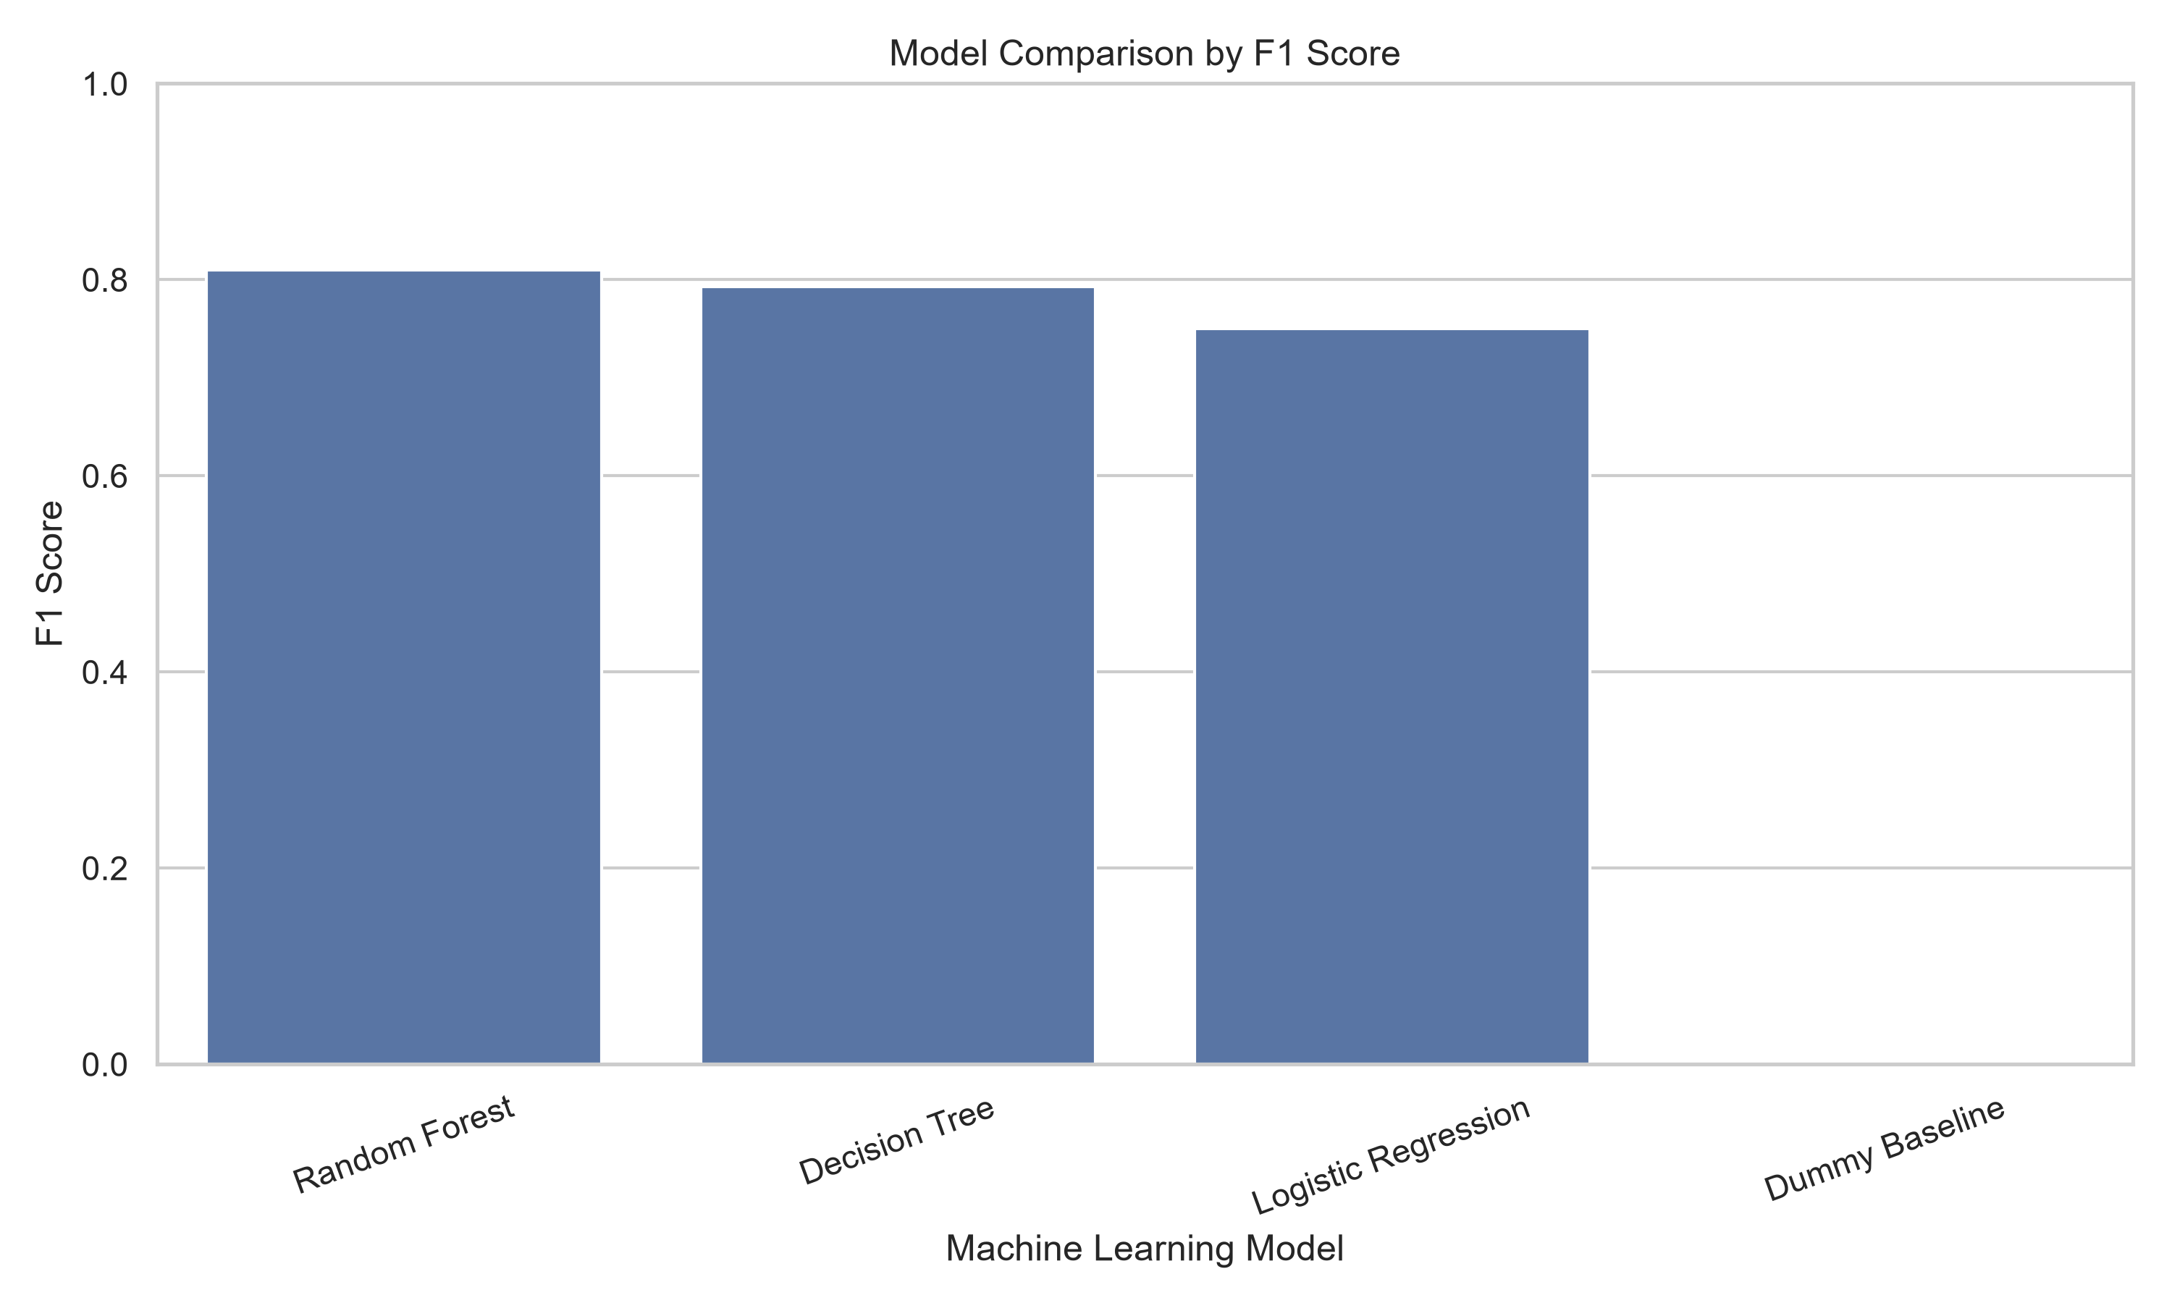
Fig. 1. F1 score by model on the held-out test set.
Interpretation: The ordering is monotonic in model capacity — Random Forest above Decision Tree above Logistic Regression — and the Dummy Baseline bar is absent entirely because its F1 is exactly zero. That empty fourth position is the most informative part of the chart: a model with 62.96% accuracy contributes nothing at all on the metric that matters.
Two internal consistency checks confirm the baseline behaved as intended. Its ROC-AUC is exactly 0.5000, the value expected from a classifier with no discriminative power. Its PR-AUC is 0.3704, which equals the positive-class rate in the test set (8,845 / 23,878 = 0.370425) — precisely the theoretical floor for average precision. Both figures match theory to four decimal places, which validates the evaluation harness itself before any claim is made about the real models.
Against that floor, Random Forest improves accuracy by 22.94 percentage points and lifts F1 from 0.0000 to 0.8100. Against the linear reference model it gains 5.97 F1 points, and against the single Decision Tree only 1.75 — a narrow margin, indicating that most of the available signal is already captured by one well-regularised tree and that the ensemble refines rather than transforms the result.
B. Best Model Selection
Random Forest was selected on F1 score. It also leads on every other metric reported in Table XI, so the selection is not an artefact of the criterion — no alternative choice among the metrics computed would have selected a different model. Sections V-C to V-E describe this untuned model; Sections V-F and V-G describe the tuned model that superseded it as the project's final candidate.
C. Confusion Matrix Analysis
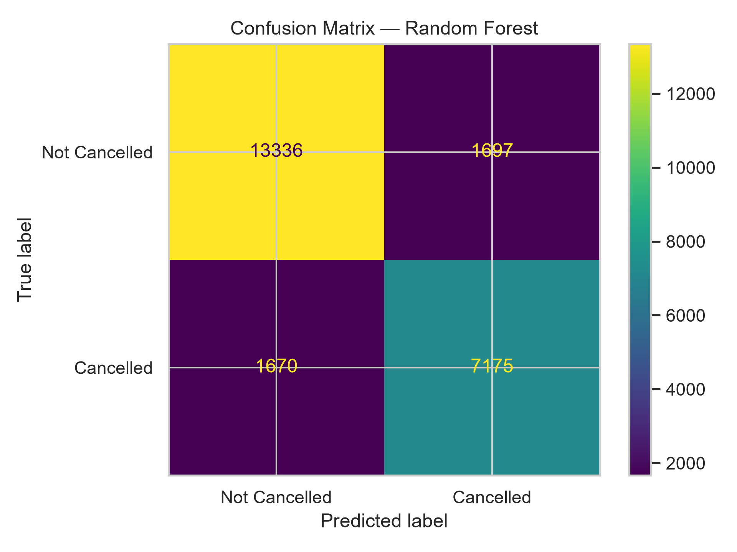
Fig. 2. Confusion matrix for the untuned Random Forest, test set (n = 23,878).
Interpretation: The two error cells are almost exactly balanced — 1,697 false alarms against 1,670 missed cancellations — which is the signature of a model operating near the point where precision and recall meet.
TABLE XII. CONFUSION MATRIX AND DERIVED METRICS, UNTUNED MODEL
Quantity | Value | Meaning
True Negatives | 13,336 | Correctly predicted to arrive
False Positives | 1,697 | Flagged as cancelling, but arrived
False Negatives | 1,670 | Predicted to arrive, but cancelled
True Positives | 7,175 | Correctly predicted cancellations
Precision | 80.87% | Reliability of a cancellation flag
Recall (Sensitivity) | 81.12% | Share of real cancellations caught
Specificity | 88.71% | Share of arrivals correctly left alone
Balanced Accuracy | 84.92% | Mean of recall and specificity
Matthews Correlation Coeff. | 0.6979 | Imbalance-robust agreement measure

The operational reading is direct. Of every 100 bookings the untuned model flags as likely cancellations, about 81 genuinely cancel; of every 100 bookings that genuinely cancel, it catches about 81. The Matthews correlation coefficient of 0.6979 is reported because, unlike accuracy, it accounts for all four cells and does not reward a model for exploiting the majority class; a value near 0.70 indicates substantial rather than near-perfect agreement, and is the more sober summary.
D. Threshold-Independent Performance
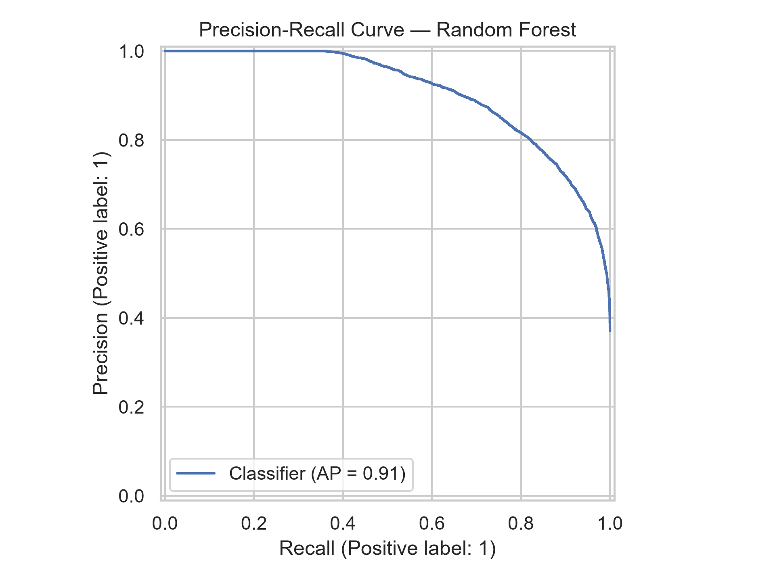
Fig. 3. ROC curve for the untuned Random Forest model (AUC = 0.94).
Interpretation: An AUC of 0.9356 means that for a randomly chosen cancelled booking and a randomly chosen non-cancelled booking, the model assigns the higher cancellation probability to the correct one about 94% of the time. The curve rises steeply, indicating that a large share of cancellations can be captured at a low false-positive cost.
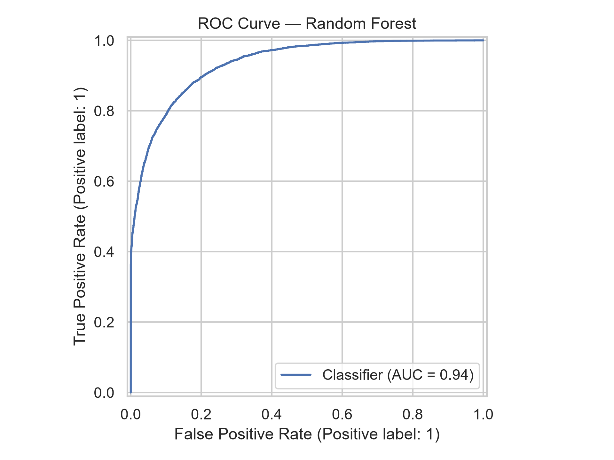

Fig. 4. Precision–recall curve for the untuned Random Forest model (AP = 0.91).
Interpretation: This is the more demanding of the two curves, because its no-skill baseline is the positive-class rate of 0.370, not 0.5. An average precision of 0.9081 therefore represents a substantial improvement over chance. Precision remains above 0.95 out to roughly 50% recall, so a hotel willing to act on only the highest-risk half of its cancellations could do so with very few false alarms.
E. Feature Importance
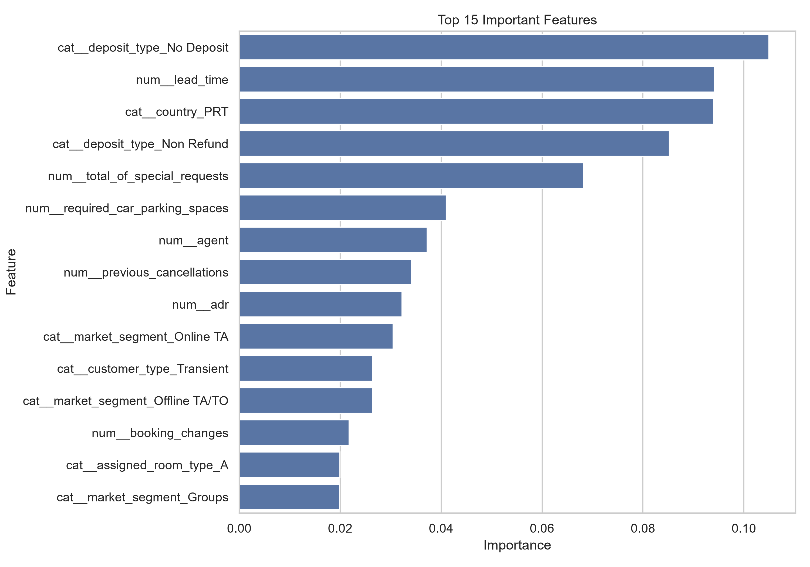
Fig. 5. Top 15 features by Gini importance in the Random Forest model.
Interpretation: The top 15 of 297 model inputs account for 73.63% of total importance, so the model's decisions rest on a comparatively small set of signals despite the wide encoded feature space. Sixty-eight inputs received an importance of exactly zero.
TABLE XIII. TOP TEN INDIVIDUAL MODEL INPUTS
Rank | Model Input | Importance
1 | deposit_type = No Deposit | 0.1050
2 | lead_time | 0.0942
3 | country = PRT | 0.0941
4 | deposit_type = Non Refund | 0.0852
5 | total_of_special_requests | 0.0682
6 | required_car_parking_spaces | 0.0410
7 | agent | 0.0372
8 | previous_cancellations | 0.0341
9 | adr (average daily rate) | 0.0323
10 | market_segment = Online TA | 0.0305

Because one-hot encoding splits a single variable across many columns, individual importances understate the influence of high-cardinality fields. Table XIV aggregates the 297 inputs back to their 31 source variables, which gives the more interpretable picture and allows direct comparison with Activity 1's correlation analysis.
TABLE XIV. IMPORTANCE AGGREGATED BY SOURCE VARIABLE
Source Variable | Encoded Columns | Total Importance
deposit_type | 3 | 19.05%
country | 173 | 13.93%
lead_time | 1 | 9.42%
market_segment | 8 | 8.61%
total_of_special_requests | 1 | 6.82%
customer_type | 4 | 4.92%
required_car_parking_spaces | 1 | 4.10%
agent | 1 | 3.72%
assigned_room_type | 12 | 3.49%
previous_cancellations | 1 | 3.41%
adr | 1 | 3.23%
distribution_channel | 5 | 2.76%
hotel | 30 | 1.46%
arrival_date_month | 12 | 1.02%
city | 15 | 1.01%
arrival_date_year | 1 | 0.00%

The aggregation changes the ranking materially. Country rises to second place overall, but its 13.93% is spread across 173 indicator columns of which PRT alone contributes 9.41 percentage points — so the apparent importance of geography is in practice almost entirely the importance of a single country, exactly the segment Activity 1 recommended modelling separately. Conversely, lead_time achieves 9.42% through one undivided column, making it the strongest genuinely behavioural predictor in the model. A verification check confirms the pipeline behaves correctly at the other end of the scale: arrival_date_year, constant at 2024 for every record, received an importance of exactly 0.0000, as a constant feature must. Gini importance is known to be biased towards high-cardinality features [9], which is precisely the bias inflating the country block, so these rankings are indicative rather than definitive.
F. Tuned Model Evaluation
The tuned Random Forest selected in Section IV-F was saved as final_tuned_hotel_cancellation_model.pkl and evaluated on the same held-out test split. During the file audit the saved model was loaded and the test set re-scored independently; every reported metric reproduced to nine decimal places, confirming that the figures below are genuine artefacts of the stated pipeline and not transcription.
TABLE XV. UNTUNED AND TUNED RANDOM FOREST ON THE SAME TEST SPLIT
Metric | Untuned Random Forest | Tuned Random Forest | Change
Accuracy | 0.8590 | 0.8760 | +0.0170
Precision | 0.8087 | 0.8239 | +0.0152
Recall | 0.8112 | 0.8460 | +0.0348
F1-score | 0.8100 | 0.8348 | +0.0249
ROC-AUC | 0.9356 | 0.9497 | +0.0141
PR-AUC | 0.9081 | 0.9270 | +0.0189

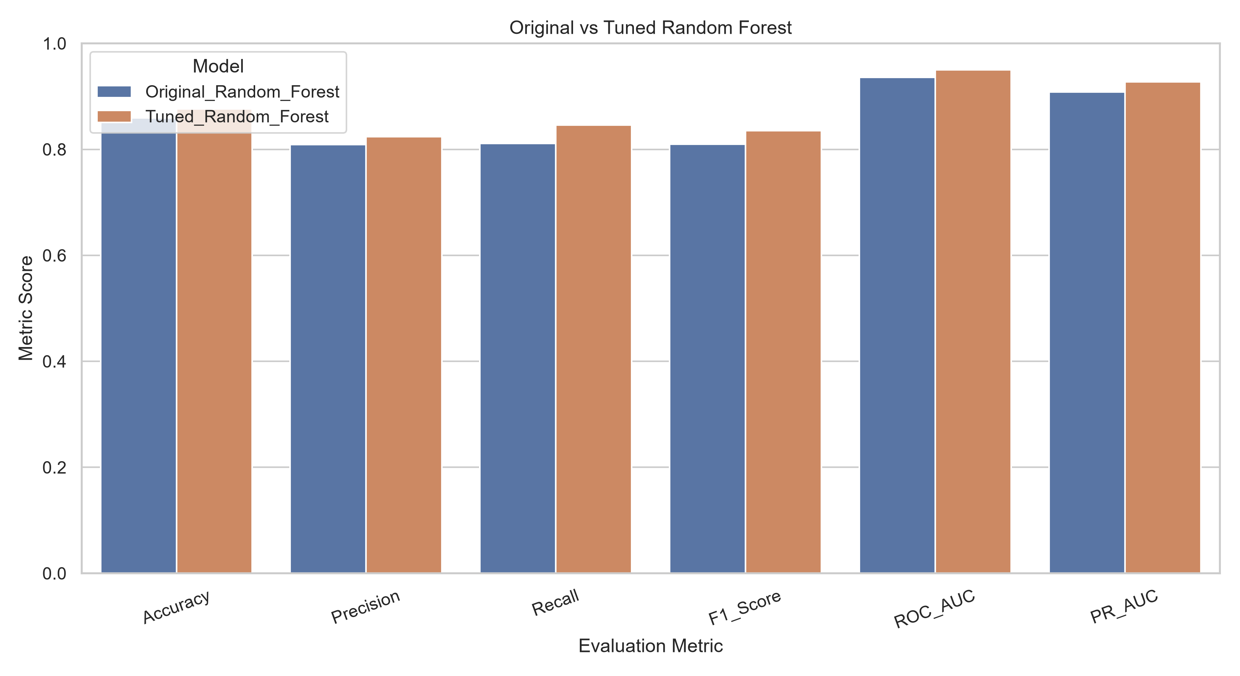
Fig. 6. Untuned versus tuned Random Forest across all six metrics.
Interpretation: The tuned model improves on every metric, with the largest single gain in recall (+0.0348). Since recall governs how many genuine cancellations the model catches, this is the most operationally valuable of the six improvements.
TABLE XVI. CONFUSION MATRIX AND DERIVED METRICS, TUNED MODEL
Quantity | Value | Meaning
True Negatives | 13,434 | Correctly predicted to arrive
False Positives | 1,599 | Flagged as cancelling, but arrived
False Negatives | 1,362 | Predicted to arrive, but cancelled
True Positives | 7,483 | Correctly predicted cancellations
Precision | 82.39% | Reliability of a cancellation flag
Recall (Sensitivity) | 84.60% | Share of real cancellations caught
Specificity | 89.36% | Share of arrivals correctly left alone
Balanced Accuracy | 86.98% | Mean of recall and specificity
Matthews Correlation Coeff. | 0.7358 | Imbalance-robust agreement measure

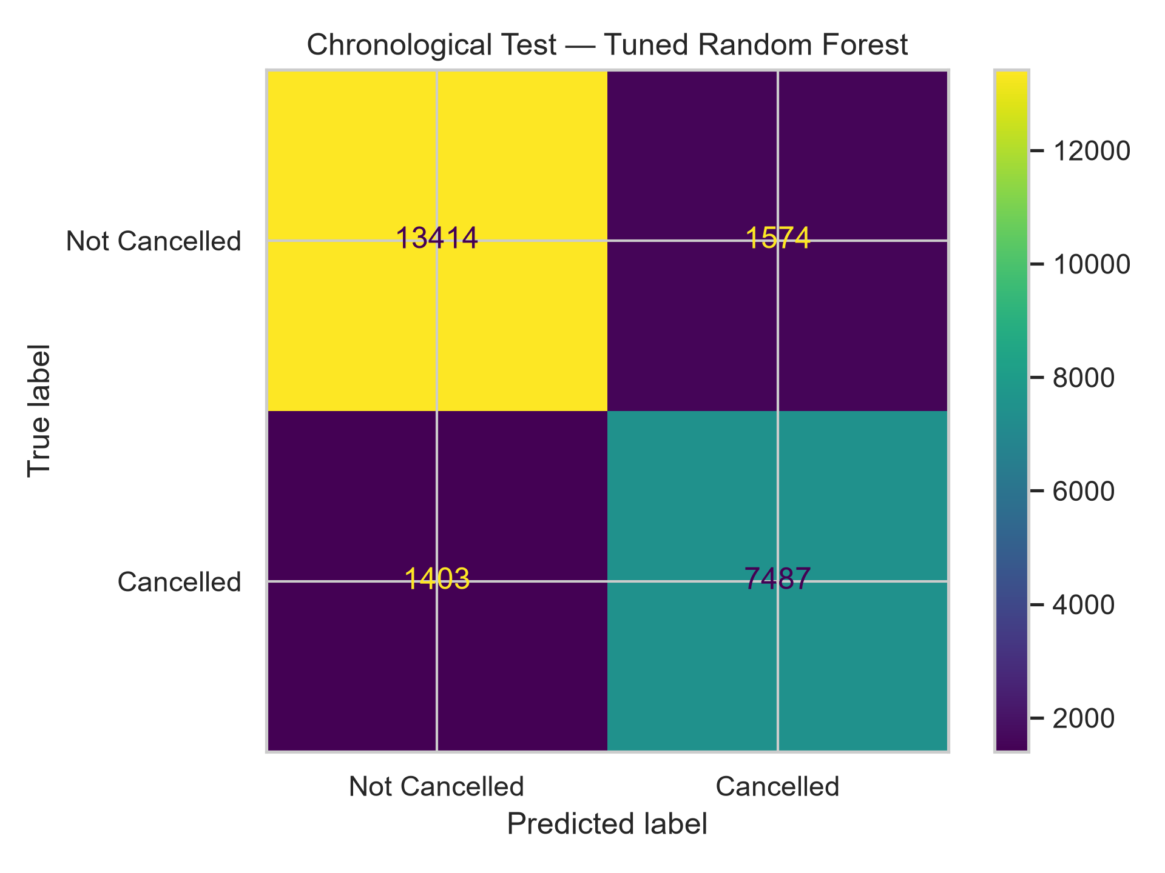
Fig. 7. Confusion matrix for the tuned Random Forest, random test split.
Interpretation: Both error cells fall relative to Fig. 2 — false alarms from 1,697 to 1,599 and missed cancellations from 1,670 to 1,362 — and the Matthews correlation coefficient rises from 0.6979 to 0.7358. The derived values in Table XVI were recomputed from this matrix during the audit [calculated].
Whether the balance between the two error types is correct is a business question rather than a statistical one. The model was evaluated at the default 0.5 decision threshold. If the cost of a missed cancellation — an unsold room on the night — exceeds the cost of an unnecessary follow-up contact, the threshold should be lowered to buy recall at the expense of precision. No cost-based tuning was performed, and that is listed as a recommendation in Section X-C.
G. Chronological Evaluation
A second evaluation was performed by ordering the records by arrival date, training on the earliest 80% and testing on the latest 20%, with the split falling at 18 October 2024. The resulting metrics are almost identical to the random-split figures.
TABLE XVII. RANDOM VERSUS CHRONOLOGICAL EVALUATION, TUNED MODEL
Metric | Random test | Chronological test | Difference
Accuracy | 0.8760 | 0.8753 | −0.0007
Precision | 0.8239 | 0.8263 | +0.0024
Recall | 0.8460 | 0.8422 | −0.0038
F1-score | 0.8348 | 0.8342 | −0.0007
ROC-AUC | 0.9497 | 0.9501 | +0.0004
PR-AUC | 0.9270 | 0.9277 | +0.0007

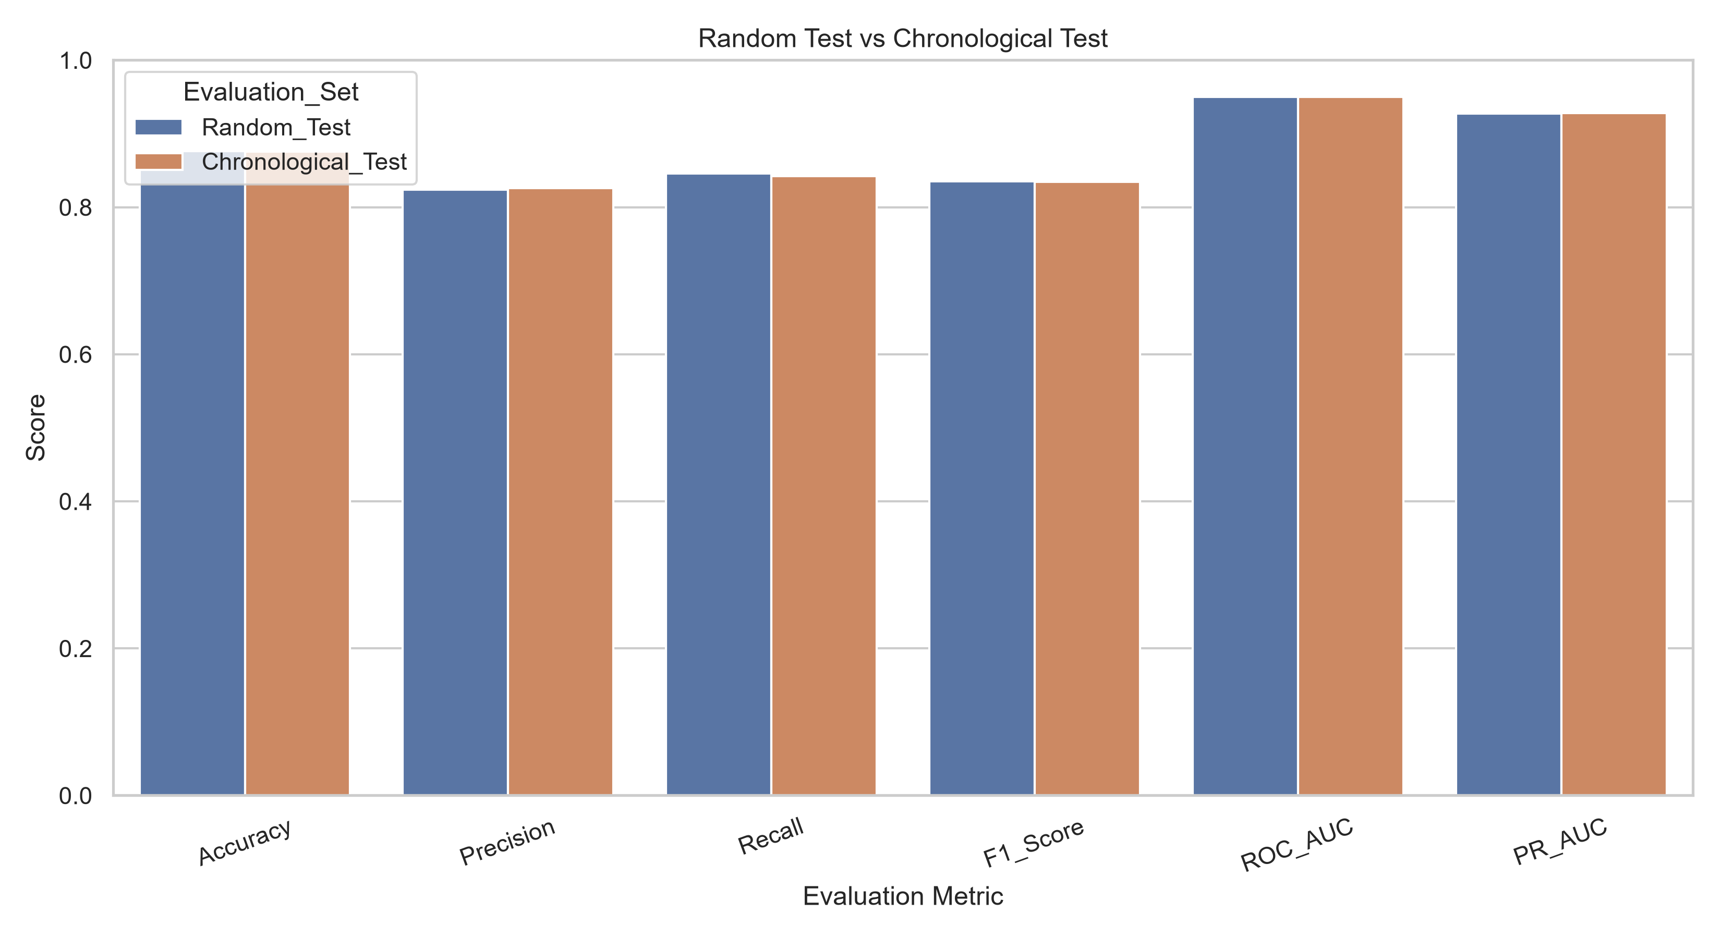
Fig. 8. Random versus chronological evaluation of the tuned model.
Interpretation: The two evaluations agree to within four thousandths on every metric. The agreement is genuine, but the paragraph below explains why it should not be read as evidence of forward-time robustness.
This result requires careful interpretation, and the audit established a limitation that the project files do not state. The split separates bookings by arrival date, not by the date the booking was made. Because lead time in this dataset extends to 737 days, the implied booking dates of the two partitions overlap heavily: training bookings were made between 25 January 2022 and 18 October 2024, test bookings between 1 February 2023 and 30 December 2024, and 94,520 of the 95,512 training bookings — 99.0% — were made after the earliest test booking was made [calculated]. The exercise is therefore a test of whether the model generalises to later arrivals, which it does, and not a test of whether it generalises to bookings taken in a later period, which remains unevaluated. The near-identical metrics in Table XVII are consistent with this reading, because the two partitions are drawn from substantially the same booking era.
H. Validation of Activity 1's Findings
Because Activity 2 analyses the same booking dataset by a different method, it provides an independent test of the conclusions Activity 1 reached from correlation and visualization alone. Table XVIII records the outcome for each of Activity 1's eight findings.
TABLE XVIII. ACTIVITY 1 FINDINGS TESTED AGAINST THE MODEL
Activity 1 Finding | Evidence from Activity 2 | Outcome
F1 — Lead time is the strongest behavioural predictor (r = +0.293) | Highest importance of any single undivided column, 9.42% | Confirmed
F2 — Guest engagement signals are protective | Special requests (6.82%) and parking (4.10%) total 10.92% of importance | Confirmed
F3 — The deposit-type signal is extreme and warrants scrutiny | Largest importance block at 19.05%; Non Refund alone is 32.77% of all cancellations | Confirmed and escalated
F4 — Prior cancellation history repeats | previous_cancellations carries 3.41% of importance | Confirmed, weaker than expected
F5 — Market segment and customer type matter more than city or season | Segment and customer type total 13.53%, against 3.49% for hotel, city and month combined | Confirmed
F6 — Missing-value treatment has not been applied | Applied before this stage; zero missing values remain | Acted on
F7 — The adr field contains implausible values | Not corrected; adr still ranges from −6.38 to 5,400 | Not acted on
F8 — Several count features are extremely right-skewed | No log or rank transformation applied; raw values standardized | Not acted on

Six of the eight findings were confirmed or acted upon, and none was contradicted. The two that were not — F7 and F8 — are both data-preparation items that Activity 1 explicitly assigned to the preprocessing stage, so their omission is a genuine gap in the pipeline rather than a disagreement about the data. Both reappear in Section X-B. Tree-based models are insensitive to monotone transformations, so F8 is unlikely to have affected the Random Forest result, but it would materially affect the Logistic Regression comparison in Tables IX and XI.
VI. NATURAL LANGUAGE PROCESSING — GUEST FEEDBACK ANALYSIS
A. Objective and Method
The objective of this component is to determine what guests write about and in what emotional register, using the 19,994-review working sample described in Section III-D. It is an exploratory text-mining and lexicon-sentiment study implemented in 33 steps. No supervised model is trained and no predictive claim is made; Section VI-G states the consequences of that choice explicitly.
B. Text Preprocessing
The Positive_Review and Negative_Review fields were concatenated into a single Review_Text field after replacing the dataset's “No Positive” and “No Negative” placeholders with empty strings. A cleaned variant was produced by lower-casing, removing URLs and non-alphabetic characters and normalising whitespace, and rows whose cleaned text was empty were removed. Two aspects shape the results. Concatenating praise and complaint means a review containing both is scored as one mixed document. Sentiment scoring was applied to the raw concatenated text rather than the cleaned variant, which for a lexicon method is the correct choice because capitalisation and punctuation are legitimate intensity cues; the cleaned field was used only for word and phrase frequency work.
No external tokenizer, stop-word list, stemmer or lemmatizer was used — word frequency operates on whitespace splitting of the cleaned text. This is a methodological simplification rather than an error, but it is a gap against the assignment's text-processing expectations.
C. Sentiment Labelling
Two independent labellings were produced, and the distinction between them is central to reading this section correctly. Neither is a human annotation.
TABLE XIX. THE TWO SENTIMENT LABELLING RULES
Labelling | Rule | Basis
Rating-derived | Reviewer_Score ≥ 7 → Positive; 5 ≤ score < 7 → Neutral; score < 5 → Negative | Numeric guest rating
VADER [4] | compound ≥ +0.05 → Positive; compound ≤ −0.05 → Negative; otherwise Neutral | Lexicon score of the review text

TABLE XX. SENTIMENT DISTRIBUTION UNDER EACH LABELLING
Sentiment | Rating-derived | Share | VADER | Share
Positive | 16,640 | 83.22% | 15,097 | 75.51%
Neutral | 2,498 | 12.49% | 2,298 | 11.49%
Negative | 856 | 4.28% | 2,599 | 13.00%
Total | 19,994 | 100.00% | 19,994 | 100.00%

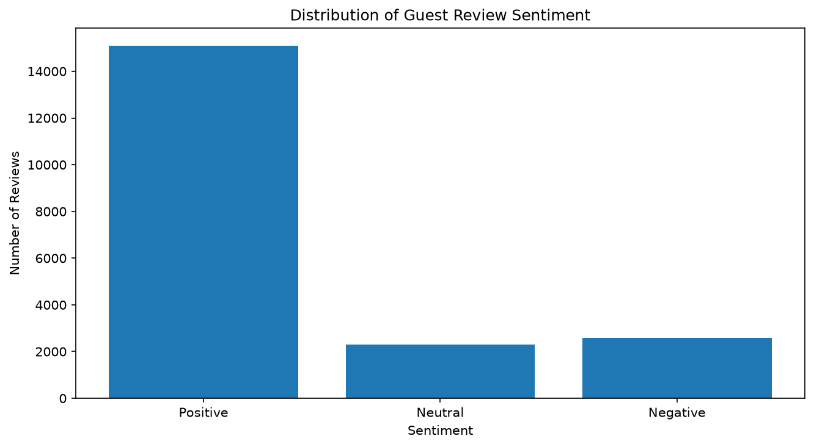
Fig. 9. VADER sentiment distribution across 19,994 reviews.
Interpretation: Guest feedback in this corpus is overwhelmingly favourable, with positive reviews outnumbering negative ones by roughly six to one under the lexicon labelling and by nearly twenty to one under the rating labelling.
The mean VADER compound score is +0.7263 for the positive group, +0.0002 for the neutral group and −0.4509 for the negative group, confirming that the three bands are cleanly separated on the underlying score. Mean guest rating also falls monotonically across the three VADER classes — 8.731, 8.121 and 6.665 respectively — which is independent evidence that the lexicon labels carry real signal.
D. Agreement Analysis
The two labellings agree on 72.21% of reviews, reproduced exactly during the audit. Because neither labelling is ground truth, this figure is an agreement rate and not a classification accuracy; the project files describe it correctly, and that description is preserved here.
TABLE XXI. AGREEMENT MATRIX: RATING LABEL (ROWS) AGAINST VADER LABEL (COLUMNS)
Rating label | VADER Negative | VADER Neutral | VADER Positive | Row total
Negative | 485 | 112 | 259 | 856
Neutral | 870 | 371 | 1,257 | 2,498
Positive | 1,244 | 1,815 | 13,581 | 16,640
Column total | 2,599 | 2,298 | 15,097 | 19,994

The matrix is more informative than the headline agreement rate. Of the 856 reviews that guests themselves rated below 5, VADER identifies only 485 as negative — a detection rate of 56.7%. Conversely, of the 2,599 reviews VADER labels negative, only 485 were rated below 5 by the guest, so 81.3% of the lexicon's negative flags correspond to reviews the guest did not rate as poor [calculated]. Both figures are explained by the concatenation described in Section VI-B: a review that praises the staff and complains about the bathroom contains both registers, and a lexicon applied to the merged text returns a mixed score that need not match a single overall rating. The practical implication is that this component should be read as a description of the language used in reviews, not as a measurement of guest satisfaction.
E. Word, Phrase and Theme Analysis
Frequency analysis of the cleaned text, two-word phrase (bigram) analysis and a keyword-based theme classification were produced. The theme classification matches each review against eight predefined keyword groups; a review may match several themes, so the counts in Table XXII are not mutually exclusive.
TABLE XXII. GUEST FEEDBACK THEMES BY VADER SENTIMENT
Theme | Positive | Neutral | Negative | Total matching
Staff | 7,850 | 359 | 849 | 9,058
Location | 6,900 | 717 | 951 | 8,568
Breakfast and Food | 4,923 | 403 | 731 | 6,057
Room Comfort | 3,869 | 209 | 511 | 4,589
Cleanliness | 2,940 | 86 | 337 | 3,363
Bathroom | 2,410 | 207 | 558 | 3,175
Price and Value | 1,802 | 170 | 333 | 2,305
Facilities | 1,598 | 148 | 341 | 2,087

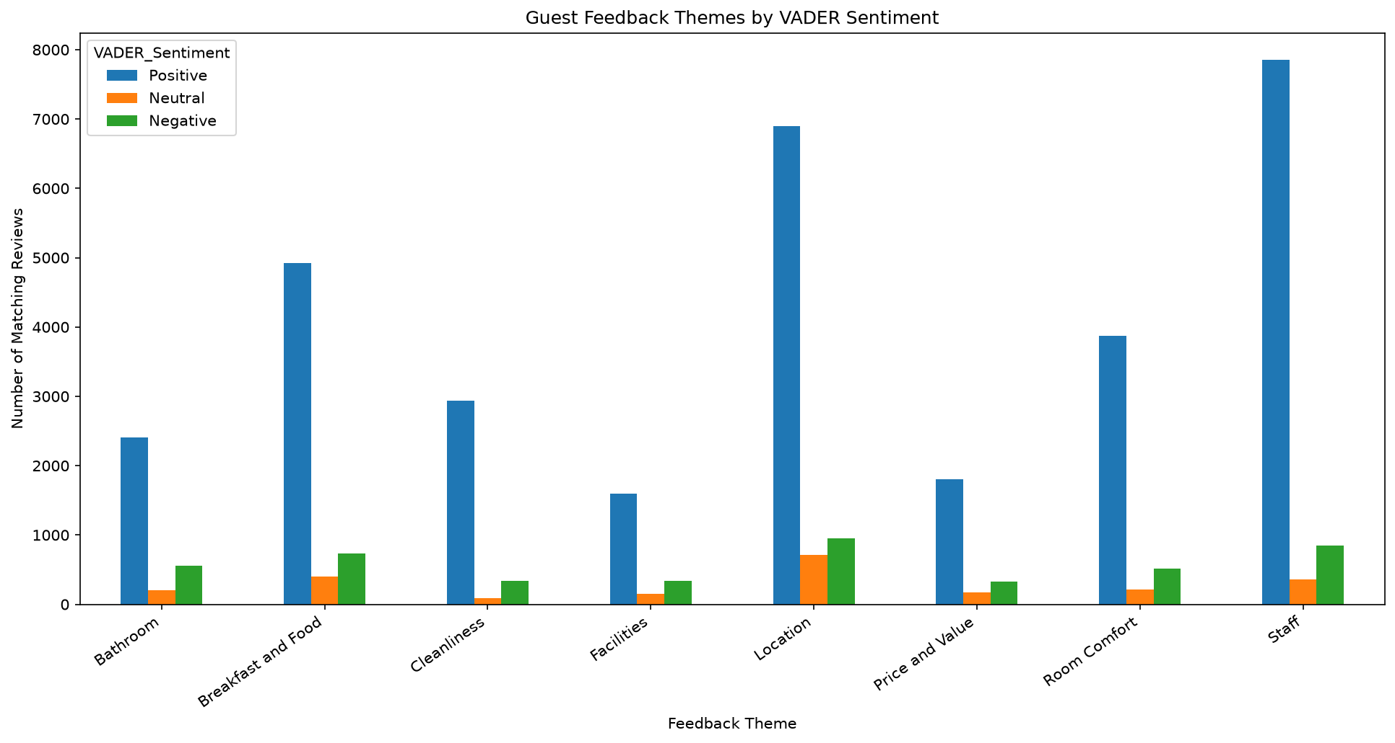
Fig. 10. Guest feedback themes by VADER sentiment.
Interpretation: Staff and Location dominate the corpus overall, together accounting for the two largest positive bars. The theme that stands out for the wrong reason is Bathroom: it ranks sixth by total mentions but has the highest share of negative mentions within the negative class at 21.47%, making it the most disproportionately complained-about attribute.
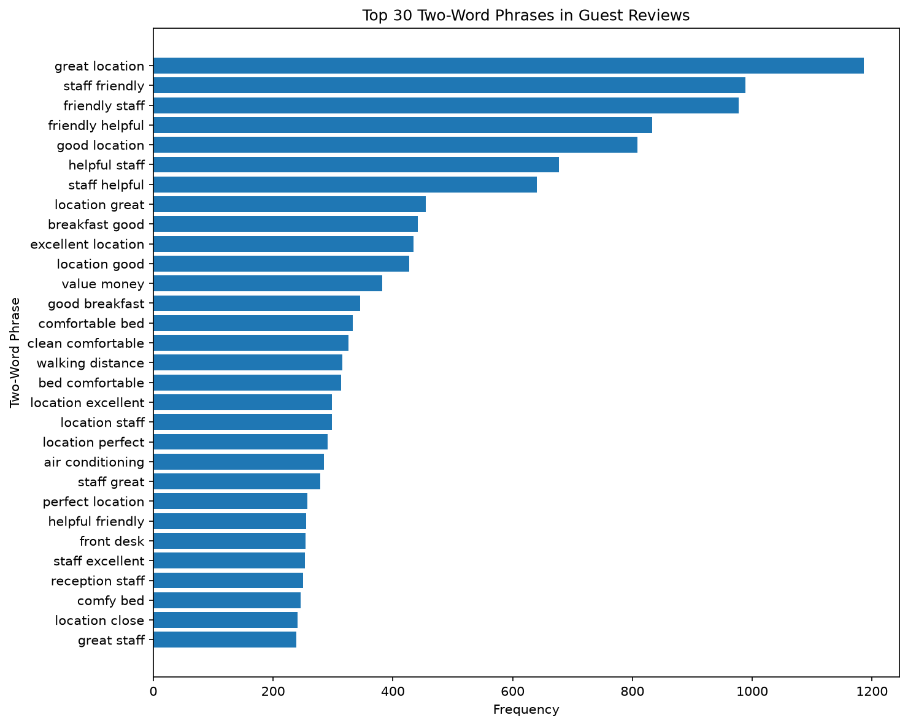
Fig. 11. Most frequent two-word phrases in the review corpus.
Interpretation: The ten most frequent bigrams are almost entirely complimentary — “great location” (1,186), “staff friendly” (989), “friendly staff” (977), “friendly helpful” (833) and “good location” (808) lead the list. Location and staff conduct are what guests choose to write about when satisfied.
One caveat applies to the frequency and bigram work. Because positive and negative comments were concatenated before analysis, phrase counts within the negative sentiment group are contaminated by praise drawn from the positive half of the same review. The separate-field analysis below was produced to address exactly this.
F. Separate-Field Analysis
The corpus stores praise and complaint in separate columns, so each was scored independently. This is the most methodologically informative result in the component.
TABLE XXIII. SENTIMENT DETECTED IN EACH COMMENT FIELD SEPARATELY
Field | Positive | Neutral | Negative | Empty
Positive_Review field | 15,316 (76.60%) | 2,945 (14.73%) | 301 (1.51%) | 1,432 (7.16%)
Negative_Review field | 3,947 (19.74%) | 5,484 (27.43%) | 5,647 (28.24%) | 4,916 (24.59%)

The positive field behaves as expected: 76.60% of entries score positive and only 1.51% negative. The negative field does not. Only 28.24% of entries in the complaint field score negative, while 19.74% score positive and 27.43% neutral. Two factors explain this. Guests frequently use the complaint box for mild or hedged remarks, which a lexicon reads as neutral or even positive; and a quarter of complaint fields are empty. This is strong evidence that lexicon sentiment applied to structured review fields of this kind requires validation against human labels before it can be relied upon, and it is the principal reason this section makes descriptive rather than evaluative claims.
G. Limitations and Gaps
- No supervised sentiment classifier. The assignment anticipates text representation such as TF-IDF and a trained classifier evaluated with accuracy, precision, recall, F1 and a confusion matrix. The notebook contains no vectoriser, no train/test split and no classifier; the audit confirmed this by searching the notebook source. Consequently no classification metrics exist for this component, and the 72.21% figure must not be presented as model accuracy.
- No linguistic normalisation. Tokenization is whitespace-based, and no stop-word list, stemmer or lemmatizer was applied.
- Automated labels only. Both labellings are automated. No human-annotated subset exists against which either could be validated.
- Mixed-document scoring. Concatenating praise and complaint before scoring suppresses the negative class, as Sections VI-D and VI-F demonstrate.
- Sample and domain. Results describe a chunk-stratified 19,994-review sample of European hotel reviews. They do not describe the Indian properties in the booking dataset and cannot be generalised to them.
- No linkage to bookings. The corpus has no booking identifier or cancellation field, so no relationship between sentiment and cancellation is measured or claimed.
VII. TIME-SERIES ANALYSIS AND FORECASTING
A. Aggregation and Data Quality
The booking records were aggregated by arrival date to produce the daily series described in Section III-E, covering 366 consecutive days with no missing dates, no missing cancellation labels and no invalid label values. The component was implemented in 31 steps.
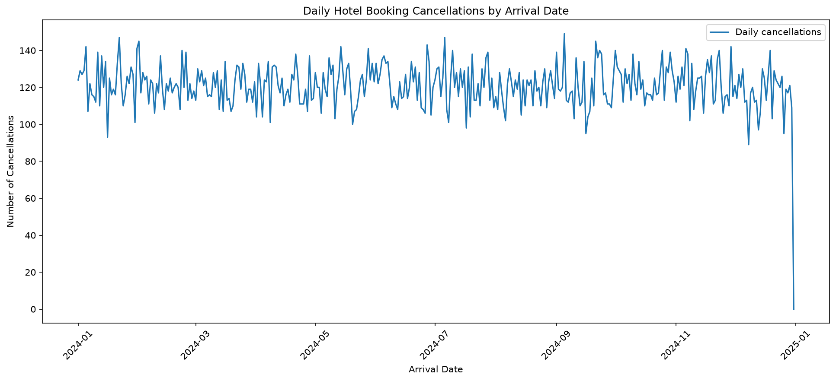
Fig. 12. Daily cancellations across 2024, final partial date excluded.
Interpretation: The series fluctuates around a stable level with no visible trend and no obvious annual seasonality, which is consistent with the flat monthly and quarterly rates reported below and foreshadows the forecasting result in Section VII-E.
B. Trend Analysis
Cancellation behaviour was examined at four frequencies. The consistent finding is an absence of temporal structure.
TABLE XXIV. CANCELLATION RATE BY AGGREGATION LEVEL
Aggregation | Range of cancellation rate | Spread
Monthly (12 points) | 36.53% (March) – 37.95% (November) | 1.42 pp
Quarterly (4 points) | 36.83% (Q3) – 37.26% (Q4) | 0.43 pp
Day of week (7 points) | 36.76% (Saturday) – 37.61% (Sunday) | 0.85 pp
Property type (2 groups) | 27.76% (Resort) – 41.73% (City) | 13.97 pp

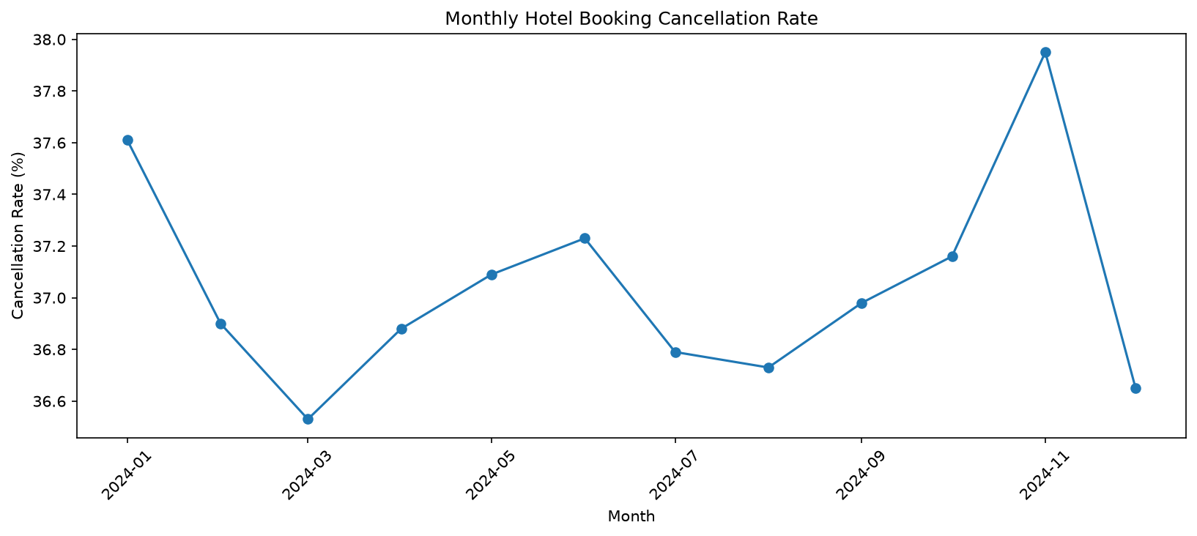
Fig. 13. Monthly cancellation rate across 2024.
Interpretation: The vertical axis spans less than one and a half percentage points. What looks like month-to-month movement is a very narrow band, and the chart is best read as evidence that month of arrival carries almost no information about cancellation.
The contrast in the final row of Table XXIV is the substantive result. Across every temporal cut the rate moves by at most 1.42 percentage points, whereas a single structural attribute — property type — moves it by almost fourteen. This independently corroborates the machine-learning finding in Table XIV, where month of arrival and city together carry only 2.03% of total importance: cancellation in this dataset is a function of what is booked and through which channel, not of when the stay occurs.
C. Stationarity
An Augmented Dickey-Fuller test [8] on the daily cancellation series returned a statistic of −16.147 with a p-value of 4.61 × 10⁻²⁹ over 365 observations, far below the 1% critical value of −3.448. The null hypothesis of a unit root is decisively rejected, so the series is stationary and no differencing is required before modelling. This is consistent with the visual absence of trend in Fig. 12.
D. Feature Engineering and Forecast Design
Five predictors were engineered from the series itself: the cancellation count lagged by one, seven and fourteen days; a seven-day rolling mean of cancellations; and the day of week. The rolling mean was computed as a shift of one day followed by a seven-day window, so it uses only information available before the day being predicted. The audit confirmed that every predictor is correctly lagged and that no look-ahead leakage is present. Removing the rows with undefined lags left 352 usable observations, which were split chronologically without shuffling into the earliest 281 (15 January to 21 October 2024) for training and the latest 71 (22 October to 31 December 2024) for testing. Unlike the classification split discussed in Section V-G, this is a genuine forward-time separation, because the unit of observation is the day itself.
E. Baseline versus Model
A Random Forest regressor with 300 trees, a maximum depth of five and a minimum of five samples per leaf was compared against a baseline that simply predicts each day's cancellations as the mean of the previous seven days. Both were evaluated on the same 71-day test window.
TABLE XXV. FORECAST EVALUATION OVER THE 71-DAY TEST WINDOW
Predictor | MAE | RMSE | R²
Previous 7-day rolling mean (baseline) | 10.700 | 18.000 | +0.023 [calculated]
Random Forest regressor | 11.464 | 18.541 | −0.036
Predicting the test-period mean [calculated] | 10.834 | 18.211 | 0.000

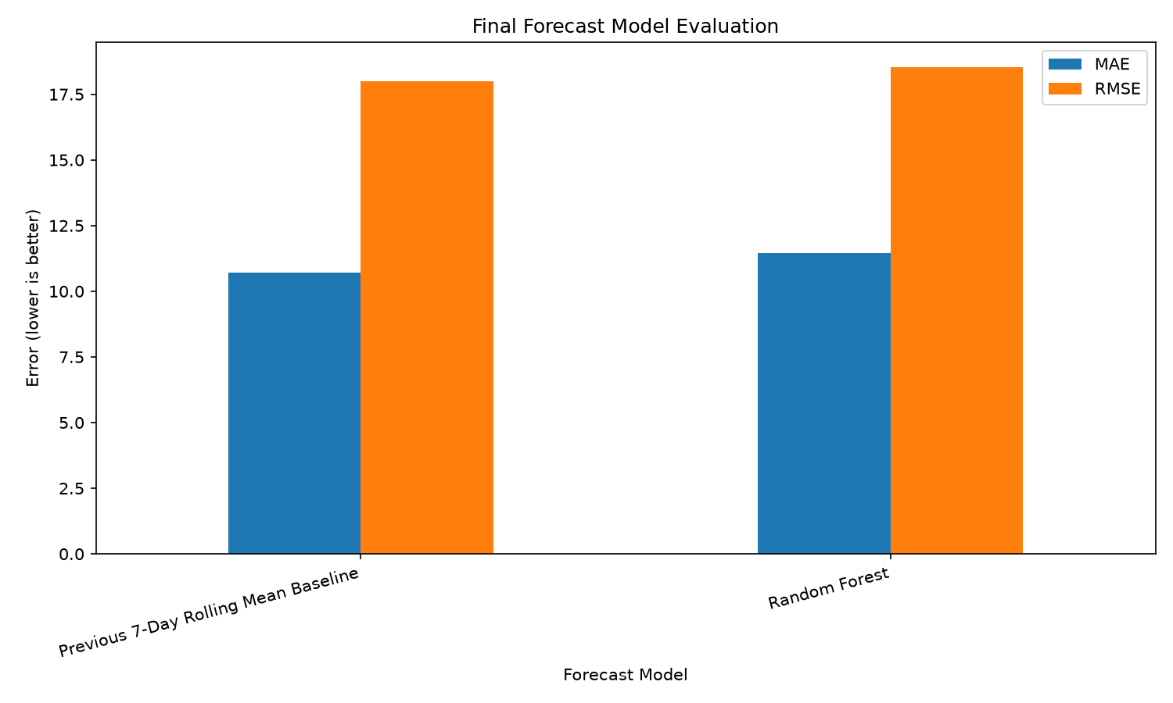
Fig. 14. Baseline versus Random Forest on MAE and RMSE.
Interpretation: The baseline is lower on both error metrics. The Random Forest's MAE is 0.764 higher (7.14% worse) and its RMSE 0.541 higher (3.01% worse).
Two conclusions follow, and the second is stronger than the project files state. First, the baseline outperformed the Random Forest on both error metrics, so the Random Forest is not the better forecasting model and is not described as such in this report. Second, the third row of Table XXV was added during the audit as a reference point: predicting the test-period mean for every day yields an MAE of 10.834 and an RMSE of 18.211. The baseline beats that constant by only 0.134 MAE and the Random Forest loses to it by 0.630. Neither predictor demonstrates meaningful forecasting skill, and the honest summary is that daily cancellation volume in this dataset is close to unforecastable from its own history.
This is also what the negative R² means. The coefficient of determination compares a model's squared error against that of the test-period mean, so R² = −0.036 states precisely that the Random Forest is about 3.6% worse than predicting a flat average. A negative R² is not a computational error; it is the expected outcome when a flexible model is fitted to a series that is stationary, weakly autocorrelated and short. The ADF result in Section VII-C and the flat profile in Table XXIV together explain why: there is little systematic structure for the model to learn, so it fits noise in the 281 training days that does not recur in the 71 test days.
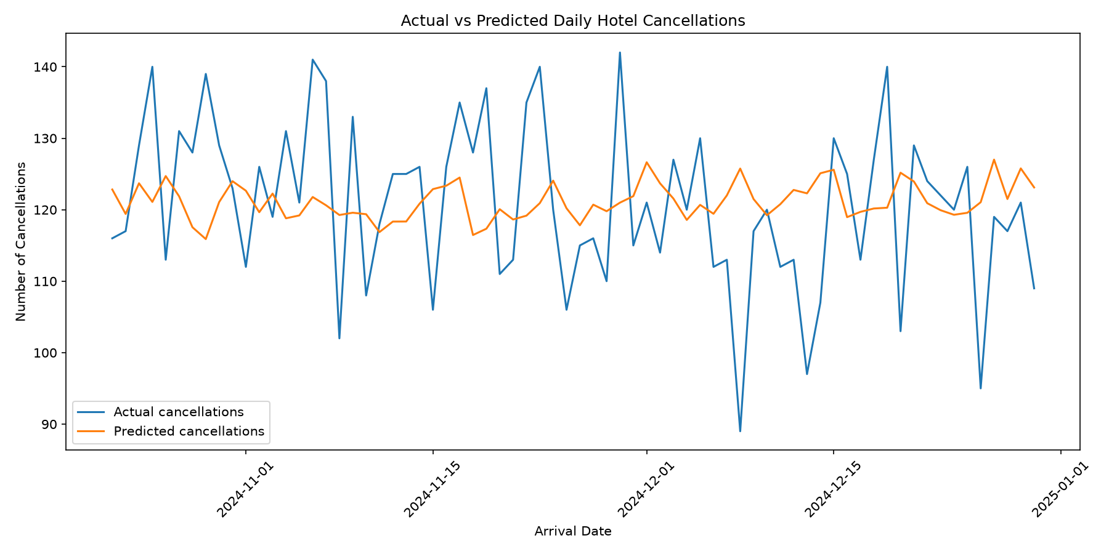
Fig. 15. Actual versus predicted daily cancellations over the test window.
Interpretation: The predicted series is visibly smoother than the actual series and tracks its general level without reproducing its day-to-day movement. The sharp terminal drop in the actual series is the 31 December partial date discussed in Section III-E.
In absolute terms both predictors are accurate to roughly 9% of mean daily volume — an MAE of 10.700 against a test-window mean of 119.11 cancellations per day for the baseline, and 11.464 for the Random Forest [calculated]. For coarse capacity planning that may be serviceable; for day-level decision-making it is not, and in either case the simpler method should be preferred because it is cheaper, transparent and more accurate.
F. Exploratory 30-Day Forecast
A 30-day forward forecast was generated for 1 to 30 January 2025, with a mean of 120.79 predicted daily cancellations and a range of 117.19 to 123.70.
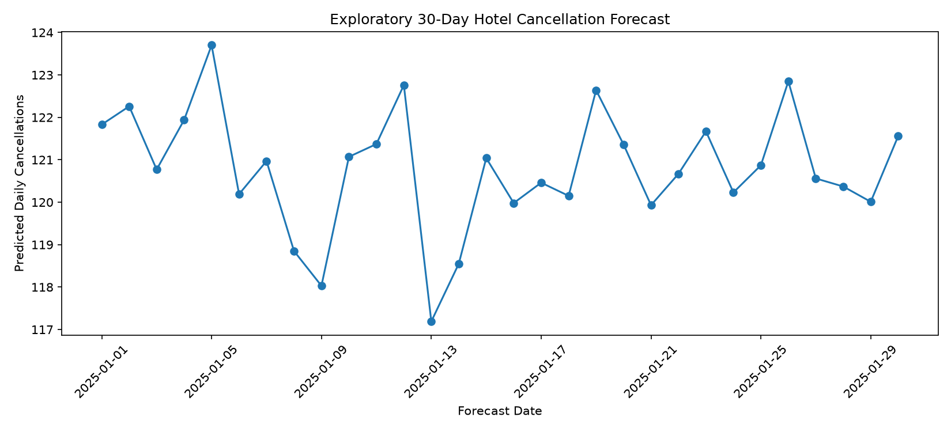
Fig. 16. Exploratory 30-day forecast for January 2025.
Interpretation: The vertical axis spans less than seven cancellations. Although the line appears to oscillate, the forecast is close to flat: its standard deviation is 1.43 against an observed daily standard deviation of 12.40 in the historical series, so it reproduces under 12% of the real variability [calculated].
This behaviour is intrinsic to recursive forecasting with lagged features. Each predicted day feeds the lags of the next, so errors average out and the sequence converges towards the series mean. The forecast should therefore be read as an estimate of the expected level of January 2025 cancellations, not as a day-by-day prediction. It also extrapolates beyond the observed data entirely: the dataset ends on 31 December 2024 and contains no 2025 observations, so the forecast cannot be validated against anything. The project labels it exploratory, which is correct, and this report preserves that label.
G. Limitations
- One year of observations. 366 daily points, of which 352 are usable after lag construction and only 71 form the test window. This is too short to identify annual seasonality, and a 30-day horizon on this basis is speculative [13].
- No skill demonstrated. As Table XXV shows, neither predictor clearly beats a constant. No forecasting claim in this report rests on the Random Forest.
- Partial final date retained. 31 December 2024 has 2 bookings and 0 cancellations. It was excluded from the trend chart but retained in the modelling data, where it sits in the test window and inflates the error of both predictors.
- Unvalidated horizon. The January 2025 forecast cannot be evaluated, as no 2025 data exists in the project.
- Aggregation by arrival date. The series counts cancellations by the arrival date of the cancelled booking, not by the date the cancellation was made. It therefore describes which arrival dates lose bookings, not when cancellation activity occurs.
VIII. BUSINESS INSIGHTS
A. Deposit Policy
TABLE XXVI. CANCELLATION RATE BY DEPOSIT TYPE
Deposit Type | Bookings | Cancelled | Rate
No Deposit | 104,641 | 29,694 | 28.38%
Non Refund | 14,587 | 14,494 | 99.36%
Refundable | 162 | 36 | 22.22%
All bookings | 119,390 | 44,224 | 37.04%

Activity 1 flagged this pattern in its Finding 3 and declined to take it at face value. The modelling stage supports that caution and sharpens it. A 99.36% cancellation rate — 14,494 of 14,587 bookings — is not how a population of guests behaves; it is how a recording convention looks. The most probable explanation is that non-refundable bookings whose guests failed to appear were systematically coded as cancellations because no refund transaction was required to close them. These 14,494 records account for 32.77% of every cancellation in the dataset, and deposit_type is the model's largest single importance block at 19.05%, so a material part of the headline F1 of 0.8348 rests on the model learning a labelling rule rather than guest behaviour.
B. Customer Type and Booking Channel
TABLE XXVII. CANCELLATION RATE BY CUSTOMER TYPE AND MARKET SEGMENT
Category | Bookings | Rate
Customer type — Transient | 89,613 | 40.75%
Customer type — Contract | 4,076 | 30.96%
Customer type — Transient-Party | 25,124 | 25.43%
Customer type — Group | 577 | 10.23%
Segment — Groups | 19,811 | 61.06%
Segment — Online TA | 56,477 | 36.72%
Segment — Offline TA/TO | 24,219 | 34.32%
Segment — Corporate | 5,295 | 18.73%
Segment — Direct | 12,606 | 15.34%

Two patterns are operationally usable. Intermediated demand is markedly less reliable than direct demand: bookings arriving through a travel agent or tour operator cancel at 41.03%, while bookings made directly with the hotel cancel at 17.46% — a gap of more than twenty-three percentage points. And the Groups market segment is the single riskiest channel at 61.06%, roughly four times the Direct rate, across 19,811 bookings. Repeat guests cancel at 14.49% against 37.79% for first-time guests, which makes guest history one of the cheapest available risk signals.

C. Property Type and Location
TABLE XXVIII. CANCELLATION RATE BY PROPERTY TYPE
Property Type | Bookings | Rate
City Hotel | 79,330 | 41.73%
Resort Hotel | 40,060 | 27.76%

City properties cancel at nearly fourteen percentage points above resort properties. The city layer within each property type carries very little signal: across the fifteen cities, City Hotel rates fall in a narrow 40.64%–43.24% band and Resort Hotel rates in a 26.27%–29.90% band. This reproduces Activity 1's conclusion that cancellation behaviour is driven far more by booking characteristics than by city of stay, and the model agrees: hotel and city together carry 2.47% of total importance.
D. Behavioural Separation
TABLE XXIX. MEAN FEATURE VALUES BY OUTCOME
Feature | Not Cancelled | Cancelled | Reading
Lead time (days, mean) | 79.98 | 144.85 | Cancellations booked far earlier
Lead time (days, median) | 45.0 | 113.0 | The gap holds at the median
Total special requests | 0.714 | 0.329 | Requests signal commitment
Required car parking spaces | 0.099 | 0.000 | No cancelled booking reserved parking
Previous cancellations | 0.016 | 0.208 | Past behaviour repeats
Booking changes | 0.293 | 0.098 | Engagement is protective
Average daily rate | 99.99 | 104.96 | Weak effect
Total nights | 3.39 | 3.49 | Negligible effect

Lead time gives the clearest behavioural separation in the dataset: cancelled bookings were made on average 145 days ahead against 80 days for bookings that were honoured, and the gap survives at the median (113 against 45 days), so it is not an artefact of a few extreme values. The parking row is the most striking: the mean number of parking spaces requested among cancelled bookings is 0.000, meaning that in this dataset a booking that reserved parking essentially never cancelled. Parking, special requests and self-initiated booking changes all act as commitment signals — a guest who has arranged the details of a stay is a guest who intends to take it. Rate and length of stay, by contrast, separate the two groups hardly at all.
E. Integrated View Across the Three Components
TABLE XXX. CONTRIBUTION AND VERIFIED STATUS OF EACH COMPONENT
Component | Principal verified result | What it supports
Machine Learning | Tuned Random Forest: F1 = 0.8348, accuracy = 87.60%, ROC-AUC = 0.9497 on 23,878 held-out bookings | Booking-level risk scoring at reservation
NLP | 19,994 reviews; 75.51% positive, 13.00% negative by VADER; Staff and Location dominant; Bathroom most disproportionately negative | Service-attribute prioritisation, descriptively
Time-Series | Baseline MAE 10.700 beats Random Forest 11.464; neither beats a constant | A negative result on short-horizon forecastability

The three results are of different kinds, and presenting them as equally successful would misrepresent the project. The Machine Learning component produced a strong, reproducible and independently verified model. The NLP component produced a credible description of review language but no measured classifier. The Time-Series component produced a well-executed negative result, which is a legitimate and useful scientific outcome but not a working forecaster. The Machine Learning and Time-Series components share the same booking dataset and agree with each other on the unimportance of timing; the NLP component is independent, and no relationship between review sentiment and booking cancellation is measured or claimed anywhere in this report.
IX. KEY INSIGHTS AND FINDINGS
Twelve findings emerge from the three components. They are stated with the substantive results first and the methodological qualifications second, following the practice Activity 1 adopted.
- Finding 1 — Random Forest is the best of the four classifiers, and the margin over a naive baseline is genuine. F1 rises from 0.0000 to 0.8100 untuned and 0.8348 tuned, and accuracy from 62.96% to 87.60%. Because the leaking columns were removed before training, this reflects predictive skill rather than the model reading the outcome out of its own inputs.
- Finding 2 — Accuracy alone would have been a misleading criterion, and the baseline proves it. The Dummy model reaches 62.96% accuracy while identifying not a single cancellation. Its ROC-AUC of exactly 0.5000 and PR-AUC of exactly 0.3704 — the test-set positive rate — match theory to four decimal places and validate the evaluation harness.
- Finding 3 — Tuning produced a real improvement, verified independently. Randomised search raised test F1 from 0.8100 to 0.8348 and recall from 81.12% to 84.60%. Loading the saved model and re-scoring the test split during the audit reproduced every metric to nine decimal places.
- Finding 4 — The tuned model is close to memorising its training data. With no depth limit its 100 trees reach depths of 45 to 65 and contain 616,175 leaves, and its training F1 of 0.9761 against a test F1 of 0.8348 is a generalisation gap of 0.141 [calculated]. A depth-20 alternative scored only 0.004 lower in cross-validation with less than half the gap.
- Finding 5 — The dominant feature is a data artefact rather than a behavioural signal. Activity 1's Finding 3 was right to withhold judgement. Deposit type carries 19.05% of total importance, but the Non Refund category cancels at 99.36% and alone accounts for 32.77% of all cancellations. A near-deterministic relationship of this kind reflects a recording convention, and a material part of the model's headline performance rests on it.
- Finding 6 — Lead time is the strongest genuinely behavioural predictor. It carries 9.42% of importance in a single undivided column, and the underlying effect is large and robust: 144.85 days mean lead time for cancelled bookings against 79.98 for honoured ones, with the gap preserved at the median. This confirms Activity 1's Finding 1 by an independent method.
- Finding 7 — Commitment signals predict non-cancellation strongly. Special requests (0.714 against 0.329), car parking (0.099 against 0.000) and booking changes (0.293 against 0.098) are all protective, and the first two contribute 10.92% of importance. These are recorded at booking time and cost nothing to collect.
- Finding 8 — The chronological evaluation does not establish forward-time performance. The split separates bookings by arrival date, not by the date the booking was made, and 99.0% of training bookings were made after the earliest test booking [calculated]. It shows the model generalises to later arrivals, not to a later booking period.
- Finding 9 — Duplicate leakage is negligible, contrary to an earlier concern. On the 31-column modelling feature matrix only 126 rows (0.11%) are non-unique and only 20 test rows have an identical twin in training, with no conflicting labels [calculated]. The earlier claim of roughly 32,723 near-duplicates applied to a reduced column set and is withdrawn.
- Finding 10 — Guest feedback is overwhelmingly positive, but the lexicon under-detects complaints. Across 19,994 reviews VADER returns 75.51% positive and 13.00% negative, agreeing with rating-derived labels on 72.21%. Of the 856 reviews guests rated below 5, VADER identifies only 485 (56.7%), and scoring the complaint field alone returns just 28.24% negative. Praise and complaint were concatenated before scoring, which suppresses the negative class.
- Finding 11 — Staff and Location dominate guest commentary; Bathroom is the disproportionate complaint. Staff appears in 9,058 reviews and Location in 8,568, and the ten most frequent bigrams are almost entirely complimentary. Bathroom ranks only sixth by total mentions but accounts for 21.47% of the negative class, the highest share of any theme.
- Finding 12 — Daily cancellation volume is close to unforecastable from one year of history. A seven-day rolling mean achieved MAE 10.700 and RMSE 18.000 against the Random Forest's 11.464 and 18.541, and the model's R² of −0.036 places it below a constant predictor. Predicting the test-period mean yields MAE 10.834 [calculated], so the baseline barely improves on a constant and the model is worse than one. The series is stationary (ADF p = 4.61 × 10⁻²⁹) with little structure to learn.
X. RECOMMENDATIONS
A. Operational Recommendations
- Score bookings at the point of reservation and route the high-risk tail into an active follow-up workflow — confirmation contact, deposit request, or release to resale. The tuned model supports this at 84.60% recall and 82.39% precision.
- Use lead time as the primary scheduling trigger: bookings made more than roughly 113 days ahead sit above the median lead time of the cancelled group and warrant re-confirmation closer to the arrival date.
- Apply tighter terms or earlier re-confirmation to Groups-segment bookings, which cancel at 61.06% across 19,811 reservations.
- Price and promote the direct channel more aggressively: direct bookings cancel at 17.46% against 41.03% through travel agents and tour operators.
- Treat special requests, parking reservations and self-initiated booking changes as positive commitment indicators and deprioritise those bookings for intervention, freeing capacity for genuinely uncertain reservations.
- Use the seven-day rolling mean, not a learned model, for day-level cancellation volume planning, and treat either figure as accurate only to roughly 9% of daily volume.
- Prioritise bathroom condition in service improvement planning, noting that this evidence comes from a different property set and region and is therefore indicative only.
B. Data and Pipeline Recommendations
- Audit the Non Refund recording convention with the reservations team, as Activity 1 recommended, and until it is resolved report model performance both with and without that category so the headline figure is not quietly carried by a labelling rule.
- Complete Activity 1's Finding 7: cap or correct the negative adr value and the extreme high-rate outliers before the next modelling pass.
- Complete Activity 1's Finding 8: apply log or rank transformation to previous_cancellations, days_in_waiting_list and babies, which matters for any linear or distance-based model.
- Replace the zero-fill of agent and company with an explicit missing-value indicator, and re-type both as categorical rather than numeric.
- Drop the city column, which is fully determined by hotel, and drop one of total_nights or its two components, to remove exact redundancy from the feature matrix.
- Remove arrival_date_year while the dataset covers a single year, and re-introduce it only when multiple years are present.
- Group the 173 country indicators into a top-N plus Other scheme, or replace them with target encoding, to recover the importance currently fragmented across 68 zero-importance columns.
- Re-aggregate the time series by cancellation date rather than arrival date, and extend the booking data beyond one year before attempting forecasting again.
C. Modelling Recommendations
- Re-run the tuned pipeline with the Non Refund category excluded, to measure how much of the 0.8348 F1 survives without it. This is the single most informative experiment the project has not performed.
- Construct a true forward-time split on the implied booking date (arrival date minus lead time) and re-evaluate, to obtain the forward-time estimate Section V-G shows is currently missing.
- Constrain tree depth or apply gradient boosting with early stopping, and compare generalisation gaps rather than validation scores alone.
- Replace Gini importance with permutation importance or SHAP values, which are not biased towards high-cardinality features.
- Calibrate the predicted probabilities and select the decision threshold from an explicit cost matrix for empty rooms against follow-up contacts, so that a score of 0.8 corresponds to an 80% observed cancellation rate.
D. NLP and Forecasting Recommendations
- Add a TF-IDF or embedding representation and train a supervised sentiment classifier, evaluated with accuracy, precision, recall, F1 and a confusion matrix on a human-annotated subset. This is the project's largest outstanding assessment requirement.
- Score the Positive_Review and Negative_Review fields separately rather than concatenated, since Section VI-F shows concatenation suppresses the negative class.
- Apply standard linguistic normalisation — a stop-word list, and stemming or lemmatisation — before frequency and n-gram analysis.
- Obtain a review corpus for the same properties as the booking data if any relationship between sentiment and cancellation is to be investigated; no such analysis is possible with the current unlinked datasets.
XI. CONCLUSION
This activity completed the modelling stage that Activity 1 identified as future work. Four classifiers were trained through an identical, leakage-controlled pipeline on 95,512 bookings and evaluated on a held-out 23,878. The untuned Random Forest reached an F1 of 0.8100, confirmed by cross-validation at 0.8106 ± 0.0012, and hyperparameter search raised this to 0.8348 with accuracy 87.60% and ROC-AUC 0.9497, reproduced exactly by reloading the saved model. The decisive step came before any model was defined: removing reservation_status, which maps onto the target without error and would have produced a near-perfect but worthless classifier.
The classification result is valuable because it reached Activity 1’s conclusions by a different route. Lead time ranks first under Gini importance as it did under linear correlation; engagement signals remain protective, with special requests and parking carrying 10.92% of total importance; and segment and customer type outweigh city and season by 13.53% to 3.49%. Six of Activity 1’s eight findings are confirmed, and none is contradicted.
The two extension components gave results of different kinds. Across 19,994 reviews, 75.51% read as positive and 13.00% as negative under VADER, with Staff and Location dominant and Bathroom most disproportionately negative; no supervised classifier was trained, so no classification accuracy is claimed. The time-series work produced a clear negative result: over a 71-day test window a seven-day rolling mean achieved MAE 10.700 against the Random Forest’s 11.464, and an R² of −0.036 places the model below a constant predictor.
Four qualifications bound the result: the largest single signal is a deposit category that cancels 99.36% of the time and resembles a recording convention; the tuned model carries a generalisation gap of 0.141; no evaluation separates bookings by booking date, so forward-time performance is unmeasured; and the review corpus is unlinked to the booking records. The tuned Random Forest is therefore a verified analytical result and a strong final candidate, not a production-ready system. Its principal contribution is not any single metric but the discipline of checking each one — leakage removed before training, a baseline that exposed accuracy as misleading, and a reference predictor that revealed a forecasting model to be no better than an average.
XII. REFERENCES
[1] N. Antonio, A. de Almeida, and L. Nunes, “Predicting hotel booking cancellations to decrease uncertainty and increase revenue,” Tourism & Management Studies, vol. 13, no. 2, pp. 25–39, 2017.
[2] N. Antonio, A. de Almeida, and L. Nunes, “Hotel booking demand datasets,” Data in Brief, vol. 22, pp. 41–49, 2019.
[3] J. Liu, “515K Hotel Reviews Data in Europe,” Kaggle dataset. [Online]. Available: https://www.kaggle.com/datasets/jiashenliu/515k-hotel-reviews-data-in-europe
[4] C. J. Hutto and E. Gilbert, “VADER: A Parsimonious Rule-Based Model for Sentiment Analysis of Social Media Text,” in Proc. 8th Int. AAAI Conf. on Weblogs and Social Media, 2014.
[5] F. Pedregosa et al., “Scikit-learn: Machine Learning in Python,” Journal of Machine Learning Research, vol. 12, pp. 2825–2830, 2011.
[6] L. Breiman, “Random Forests,” Machine Learning, vol. 45, no. 1, pp. 5–32, 2001.
[7] J. Bergstra and Y. Bengio, “Random Search for Hyper-Parameter Optimization,” Journal of Machine Learning Research, vol. 13, pp. 281–305, 2012.
[8] D. A. Dickey and W. A. Fuller, “Distribution of the Estimators for Autoregressive Time Series with a Unit Root,” Journal of the American Statistical Association, vol. 74, no. 366, pp. 427–431, 1979.
[9] C. Strobl, A.-L. Boulesteix, A. Zeileis, and T. Hothorn, “Bias in random forest variable importance measures,” BMC Bioinformatics, vol. 8, no. 25, 2007.
[10] D. Chicco and G. Jurman, “The advantages of the Matthews correlation coefficient (MCC) over F1 score and accuracy in binary classification evaluation,” BMC Genomics, vol. 21, no. 6, 2020.
[11] T. Saito and M. Rehmsmeier, “The Precision-Recall Plot Is More Informative than the ROC Plot When Evaluating Binary Classifiers on Imbalanced Datasets,” PLoS ONE, vol. 10, no. 3, e0118432, 2015.
[12] S. Kaufman, S. Rosset, and C. Perlich, “Leakage in Data Mining: Formulation, Detection, and Avoidance,” ACM TKDD, vol. 6, no. 4, pp. 1–21, 2012.
[13] R. J. Hyndman and G. Athanasopoulos, Forecasting: Principles and Practice, 3rd ed. Melbourne, Australia: OTexts, 2021.
[14] Pandas Development Team, pandas documentation. [Online]. Available: https://pandas.pydata.org/docs/
[15] J. D. Hunter, “Matplotlib: A 2D graphics environment,” Computing in Science & Engineering, vol. 9, no. 3, pp. 90–95, 2007.

