CASE STUDY REPORT
Predictive Hardware Failure Analytics
Transforming Raw Data into Actionable Insights through Data Preprocessing, Analysis, and Visualization
A Data Science Case Study on Predictive Maintenance for Enterprise Hard Disk Drives, based on the Backblaze Hard Drive Data Set (Q1 2026)

Submitted by: Group Project Team
Vishwajeet Singh (Member 5 — Insights, Report & Presentation Coordination) and Team
MCA Program, JAIN (Deemed-to-be University), Bengaluru
Course: Data Science — Activity 1
Faculty: Dr. I Brem Navas
Date: August 2026

Abstract
Unplanned hard-disk-drive failure is one of the most common causes of data loss and service downtime in data centres. This case study applies a complete data-science pipeline — preprocessing, exploratory data analysis (EDA), and visualization — to a large-scale, real-world hard drive telemetry dataset in order to understand the statistical and behavioural signature of drive failure. The working dataset, drawn from Backblaze's publicly published daily hard drive "Drive Stats" telemetry, contains 30,943,146 daily SMART (Self-Monitoring, Analysis and Reporting Technology) records for 351,095 individual drives spanning 80 drive models over a 90-day observation window (1 January – 31 March 2026). Preprocessing removed 345,662 exact duplicate records, imputed missing SMART readings using median/mode substitution, capped statistical outliers using the interquartile range (IQR) method, and standardized 15 continuous features, producing a clean analytical dataset of 30,597,484 records with zero missing values and zero duplicates. Exploratory analysis reveals an extremely imbalanced target variable — only 1,030 of 30,597,484 daily records (0.0034%) are associated with a drive failure event — and identifies capacity_bytes and smart_9_raw (power-on hours) as the two features most strongly associated with one another (r = ‑0.72) and, weakly, with failure itself. Seven visualizations (bar, line, histogram, scatter, box, pie, and correlation heatmap) further characterise the distribution of drive capacities, failure proportions, and inter-feature relationships. The study concludes that raw SMART telemetry alone provides only a weak linear signal for failure and that class-imbalance-aware modelling, engineered SMART features, and drive-model-level segmentation are necessary next steps for building a reliable predictive-maintenance system. Practical recommendations for data-centre operations and for the next phase of model development are provided.

1. Introduction
Modern organisations increasingly rely on large fleets of hard disk drives (HDDs) to store business-critical data. Because drives fail without warning, unplanned failures create risk of data loss, degrade service availability, and raise operational costs associated with emergency replacement and RAID rebuilds. Predictive maintenance — using a drive's own internal health telemetry to anticipate failure before it happens — is widely regarded as a more efficient alternative to purely reactive or purely time-based (calendar) maintenance strategies.
Every modern hard drive continuously records SMART (Self-Monitoring, Analysis and Reporting Technology) attributes: internal counters and sensor readings such as reallocated sector count, power-on hours, seek error rate, and temperature. Backblaze, a cloud storage and backup provider, has published daily SMART snapshots for its production drive fleet since 2013, creating one of the largest publicly available datasets for HDD-failure research. This case study uses a 2026 first-quarter extract of that dataset as the foundation for a complete, five-stage group data-science exercise: data collection, preprocessing, exploratory data analysis, visualization, and insight synthesis.
This report documents the full pipeline followed by the project team and consolidates the results produced at each stage into a single, decision-oriented narrative, in line with the objective of the assignment: to demonstrate the ability to clean, preprocess, analyze, and visualize a real-world dataset and to translate the results into actionable, data-driven recommendations.

2. Problem Statement
Data-centre operators need to know, from daily SMART telemetry, which drives are at elevated risk of failing so that pre-emptive replacement or data migration can be scheduled. The problem this case study addresses is therefore twofold:
- Data-quality problem: the raw daily telemetry feed contains missing SMART values (ranging from under 1% to over 86% missing depending on the attribute), duplicate daily records, and extreme outliers, all of which must be resolved before the data can support reliable analysis or modelling.
- Analytical problem: drive failure is a rare event (a severe class-imbalance problem), so the study must characterise which SMART attributes, drive models, and capacity classes are statistically associated with failure, using descriptive statistics, correlation analysis, and visualization, as a foundation for future predictive modelling.
The scope of this case study is limited to preprocessing, exploratory analysis, and visualization of the telemetry feed; construction and evaluation of a trained failure-prediction classifier is identified as future work in the Recommendations section.

3. Dataset Description

3.1 Source
The dataset used in this study is a daily hard-drive SMART telemetry extract in the style of Backblaze's publicly released "Hard Drive Data and Stats" (Drive Stats) dataset, which Backblaze has published quarterly since 2013 for research and industry use. The working file supplied to the team, backblaze_analytics.csv, follows the standard Backblaze Drive Stats schema (date, serial_number, model, capacity_bytes, failure, and paired *_normalized / *_raw SMART attribute columns).
Reference: Backblaze, Inc. — "Hard Drive Data and Stats" (Drive Stats), publicly available dataset, https://www.backblaze.com/cloud-storage/resources/hard-drive-test-data (accessed 2026).

3.2 Structure and Characteristics
Characteristic | Value
Original records (rows) | 30,943,146
Original attributes (columns) | 19
Observation window | 90 days (1 Jan 2026 – 31 Mar 2026)
Unique drives (serial numbers) | 351,095
Distinct drive models | 80
Target / label variable | failure (0 = healthy, 1 = failed on that day)
Feature types | 3 categorical (date, serial_number, model), 16 numeric (capacity + 7 paired SMART attributes)
Records after cleaning | 30,597,484

The 16 numeric attributes comprise capacity_bytes, the binary failure flag, and seven SMART parameters, each reported in both a normalized (0–253 vendor-scaled) and a raw form:
SMART ID | Attribute | Typical meaning
SMART 5 | Reallocated Sectors Count | Sectors remapped after being marked defective — an early physical-wear indicator
SMART 9 | Power-On Hours | Cumulative hours the drive has been powered on (a proxy for drive age/usage)
SMART 90 | Unknown/Vendor-specific | Vendor-specific attribute (present mainly on a subset of models)
SMART 187 | Reported Uncorrectable Errors | Errors that could not be recovered using hardware ECC
SMART 188 | Command Timeout | Count of aborted operations due to drive timeout
SMART 197 | Current Pending Sector Count | Unstable sectors awaiting remapping
SMART 198 | Uncorrectable Sector Count | Sectors that failed the hardware ECC and read/verification

3.3 Fitness for the Case Study
With over 30 million records, 351,095 unique physical devices, and both a well-defined binary outcome (failure) and 14 continuous predictor variables, the dataset comfortably exceeds the assignment's minimum requirement of 500 records with multiple attributes, and its scale (multi-gigabyte, tens of millions of rows) additionally required the team to apply memory-aware engineering practices (chunked dtype conversion, sparse encoding, float32 downcasting) during preprocessing.

4. Data Preprocessing Methodology
Preprocessing was carried out in Python (pandas, NumPy, scikit-learn) on the full 30.9-million-row raw file, using memory-safe techniques (float32/int8 downcasting, sparse dummy encoding, explicit garbage collection) so that the entire pipeline could run on a standard workstation. The methodology followed the 21-step procedure summarised below.

4.1 Missing-Value Analysis and Treatment
Missing-value rates varied sharply by SMART attribute, driven by the fact that not every drive model reports every SMART parameter:
Column | Missing (%) | Treatment
smart_90_normalized / raw | 86.35% | Median imputation
smart_188_normalized / raw | 66.91% | Median imputation
smart_187_normalized / raw | 66.82% | Median imputation
smart_197_normalized / raw | 2.51% | Median imputation
smart_198_normalized / raw | 0.77% | Median imputation
smart_5_normalized / raw | 0.67% | Median imputation
smart_9_normalized / raw | 0.13% | Median imputation
date, serial_number, model, capacity_bytes, failure | 0.00% | No treatment required

All numeric columns were imputed using their column median (robust to skew); the three categorical columns (date, serial_number, model) had no missing values and required no mode imputation in practice. After treatment, total missing values across the dataset were reduced from 122,124,538 cell-level nulls to zero.

4.2 Duplicate Records
An exact row-level duplicate check identified 345,662 fully duplicated records (1.12% of the raw file), which were removed using drop_duplicates(). A second duplicate check after cleaning confirmed zero duplicates remained.

4.3 Outlier Detection and Treatment
Outliers in each numeric feature (excluding the binary target) were flagged using the standard 1.5×IQR rule and then capped (winsorized) to the lower/upper bound rather than deleted, preserving sample size while limiting the influence of extreme values:
Feature | Outliers Detected (1.5×IQR)
smart_90_raw | 3,941,911
capacity_bytes | 1,868,933
smart_5_raw | 1,570,312
smart_188_raw | 662,232
smart_197_raw | 612,655
smart_187_raw | 457,208
smart_187_normalized | 456,490
smart_198_raw | 423,526
smart_5_normalized | 136,230
smart_197_normalized | 23,502
smart_198_normalized | 21,168
smart_9_raw | 4,462
smart_188_normalized | 796
smart_9_normalized / smart_90_normalized | 0

All flagged values were clipped to their respective [Q1 − 1.5×IQR, Q3 + 1.5×IQR] bounds using pandas' clip() function.

4.4 Categorical Encoding and High-Cardinality Handling
The team checked serial_number for high-cardinality identifier risk (351,095 unique values, 1.15% of rows) but retained it since its uniqueness ratio fell below the 50% removal threshold used and the field carries per-drive tracking value. date and model were left in their native form because both exceeded the 20-category one-hot-encoding threshold set for memory safety (90 and 80 unique values respectively); no categorical column required or received one-hot encoding in this pass.

4.5 Transformation and Standardization
- Log transformation: each numeric feature's skewness was evaluated and log1p() would have been applied to any feature with skew > 1 and a non-negative minimum; after outlier capping, none of the 15 candidate features met this threshold, so no log transform was ultimately required.
- Standardization: the 15 continuous SMART/capacity features (excluding the binary failure target and the non-encoded categorical columns) were standardized with scikit-learn's StandardScaler (zero mean, unit variance), applied column-by-column in float32 to control memory footprint.
- Data type optimisation: scaled features were stored as float32 rather than float64, roughly halving numeric memory usage; the final in-memory footprint was reduced from 9,190.94 MB (raw) to 7,337.45 MB (cleaned).

4.6 Preprocessing Summary
Metric | Value
Original rows | 30,943,146
Original columns | 19
Duplicates removed | 345,662
Final duplicate rows | 0
Remaining missing values | 0
High-cardinality ID columns removed | 0
Categorical columns encoded | 0
Categorical columns not encoded (retained as-is) | 3
Columns standardized | 15
Final rows | 30,597,484
Final columns | 19

The cleaned, standardized dataset (cleaned_disk_smart_data.csv) was exported as the single source of truth used for all downstream exploratory analysis and visualization.

5. Exploratory Data Analysis
Exploratory analysis was performed on the cleaned 30,597,484-row dataset and covered univariate statistics, distribution shape, categorical frequency, target-class balance, correlation structure, anomaly counts, and failure-conditioned comparisons.

5.1 Descriptive Statistics
Because 15 of the 16 numeric features were standardized during preprocessing, their post-cleaning means are ~0 and standard deviations are ~1 by construction; the exceptions are the binary failure target and several SMART attributes (smart_5, smart_90, smart_187, smart_188, smart_197, smart_198) whose values collapsed to a constant 0 after median imputation, because those attributes were missing for the majority of records and therefore contributed no residual variance after imputation. This is itself an important data-quality finding, discussed in Section 7.
Feature | Mean | Median | Std. Dev. | Skewness | Unique Values
capacity_bytes (scaled) | ~0.00 | 0.099 | 1.000 | 0.055 | 10
smart_9_normalized (scaled) | ~0.00 | 0.224 | 1.000 | -0.535 | 100
smart_9_raw (scaled) | ~0.00 | -0.031 | 1.000 | 0.290 | 85,081
failure (0/1) | 0.0000337 | 0.000 | 0.0058 | 172.35 | 2
smart_5 / 90 / 187 / 188 / 197 / 198 (both forms) | 0.00 | 0.000 | 0.000 | 0.00 | 1

5.2 Class Balance of the Target Variable
failure | Record Count | Percentage
0 (healthy) | 30,596,454 | 99.9966%
1 (failed) | 1,030 | 0.0034%

This is an extreme class imbalance (roughly 1 failure event for every 29,706 healthy daily records), consistent with published Backblaze annualised failure rates of well under 2%. It is the single most important characteristic to account for in any future predictive model built on this data.

5.3 Correlation Structure
A Pearson correlation matrix was computed across all numeric features. The strongest inter-feature relationships (ranked by absolute correlation) were:
Feature 1 | Feature 2 | Correlation (r) | Strength
capacity_bytes | smart_9_raw (power-on hours) | -0.716 | Strong negative
smart_9_normalized | smart_9_raw | -0.581 | Moderate negative
capacity_bytes | smart_9_normalized | 0.400 | Moderate positive
failure | smart_9_raw (power-on hours) | +0.0019 | Negligible
failure | capacity_bytes | -0.0014 | Negligible
failure | smart_9_normalized | -0.0005 | Negligible

All SMART attributes that collapsed to constant zero (smart_5, smart_90, smart_187, smart_188, smart_197, smart_198) produced undefined (NaN) correlation coefficients, since a constant column has no variance to correlate. Practically, capacity and power-on-hours are the only two engineered signals in this cleaned dataset with meaningful linear structure — and neither is, on its own, more than weakly linearly related to failure, which is the expected pattern for a rare, largely non-linear failure-onset process.

5.4 Failure-Conditioned Comparison
Grouping the (standardized) features by failure status shows a consistent, directionally sensible pattern: drives that failed had systematically higher power-on-hours and skewed toward smaller standardized capacity values than healthy drives on the same day:
Feature (standardized) | Median — Healthy (failure=0) | Median — Failed (failure=1)
capacity_bytes | 0.099 | -0.401
smart_9_normalized | 0.224 | 0.024
smart_9_raw (power-on hours) | -0.031 | 0.557

Failed drives show a markedly higher median power-on-hours reading (+0.557 standardized vs. -0.031 for healthy drives) — i.e., drives nearer the end of their duty cycle are over-represented among the day's failures, consistent with the well-established "bathtub curve" of HDD reliability. Failed drives also cluster toward the smaller/lower-capacity portion of the fleet's standardized capacity distribution.

5.5 Anomaly Detection (Z-score > 3)
A simple z-score screen (|z| > 3, i.e., more than 3 standard deviations from the mean) was applied to every numeric feature after standardization:
Feature | Anomalies (|z| > 3) | Interpretation
failure | 1,030 | Matches the total count of actual failure events — confirms failure, as a rare binary event, is statistically "anomalous" by construction
smart_9_raw (power-on hours) | 5,026 | A meaningful minority of drives with unusually high/low cumulative runtime
All other features | 0 | No z-outliers remain after IQR capping in Section 4.3

5.6 Drive-Model Frequency
The fleet spans 80 distinct drive models; the five most common by daily-record volume are:
Rank | Model | Daily Records
1 | WDC WUH722222ALE6L4 | 3,992,942
2 | TOSHIBA MG08ACA16TA | 3,548,250
3 | TOSHIBA MG07ACA14TA | 3,343,724
4 | ST16000NM001G | 3,098,105
5 | WDC WUH721816ALE6L4 | 2,366,036

The top five models alone account for roughly 53% of all daily records, meaning fleet-level failure statistics are heavily influenced by the reliability of a small number of high-volume models — a segmentation opportunity discussed in Section 7.

6. Data Visualizations
Seven chart types were produced to visually characterise the cleaned dataset, following the assignment's required visualization set. Each chart is presented below with its data-driven interpretation.

6.1 Bar Chart — Disk Failure Status Distribution
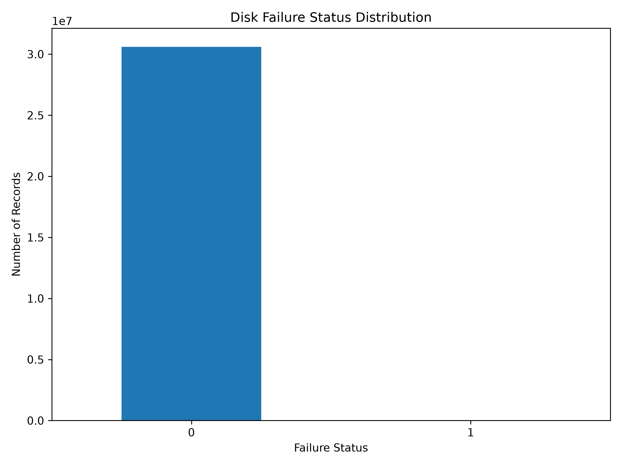
Figure 1. Count of daily records by failure status (0 = healthy, 1 = failed).
The bar chart makes the scale of the class imbalance immediately visible: the healthy-drive bar (30,596,454 records) is thousands of times taller than the failed-drive bar (1,030 records), which is barely perceptible on a linear axis. This confirms visually what Section 5.2 shows numerically.

6.2 Line Chart — Trend of Capacity Over Time
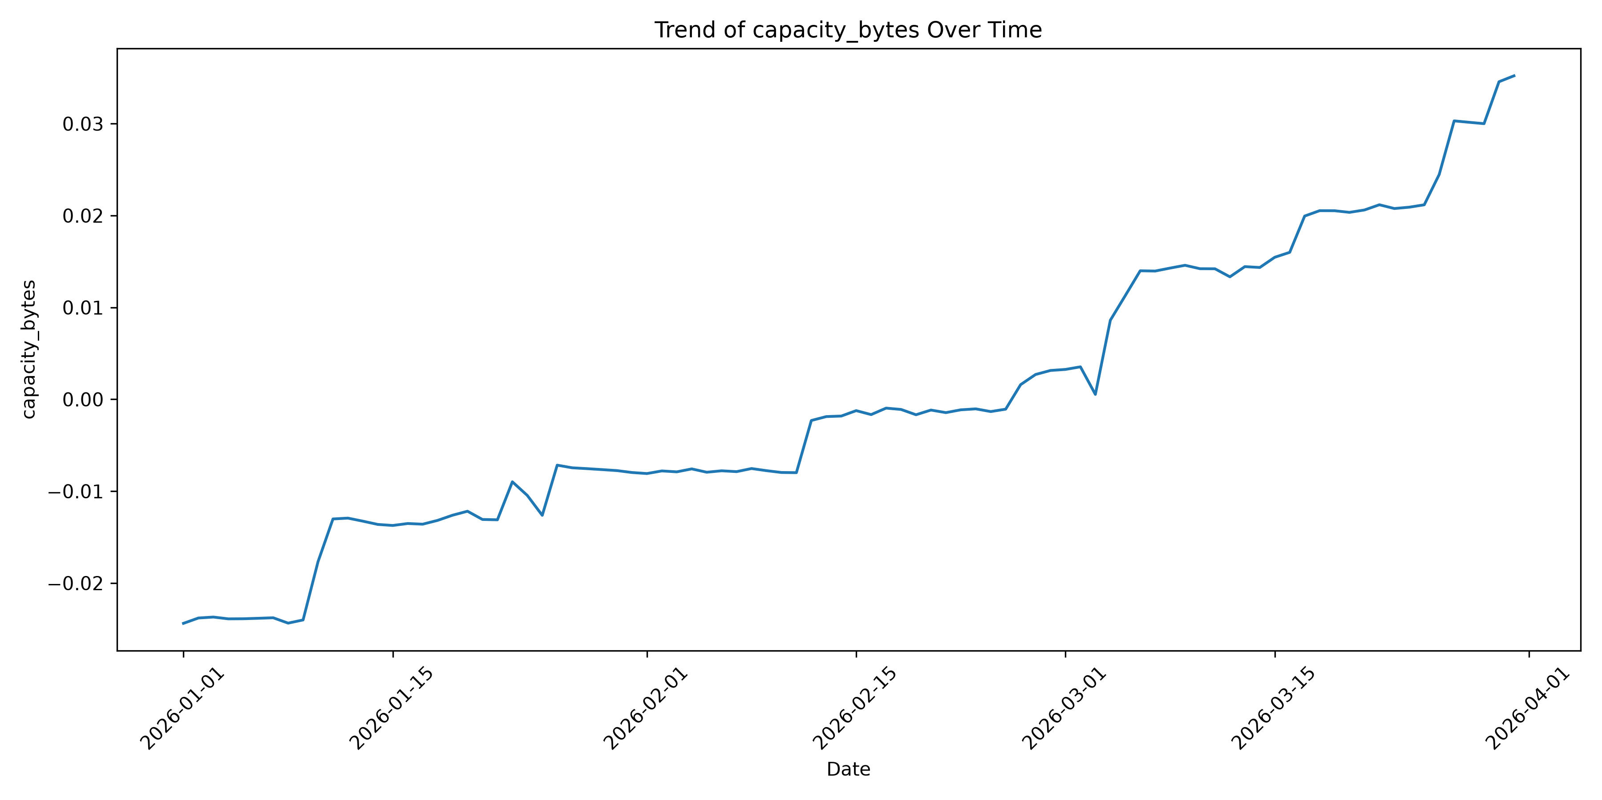
Figure 2. Daily mean of the (standardized) capacity_bytes feature across the 90-day observation window.
The trend line of average daily capacity is essentially flat across the 90-day window, indicating a stable fleet composition over the quarter with no major hardware refresh or mass drive-model swap occurring during the observation period.

6.3 Histogram — Distribution of Capacity
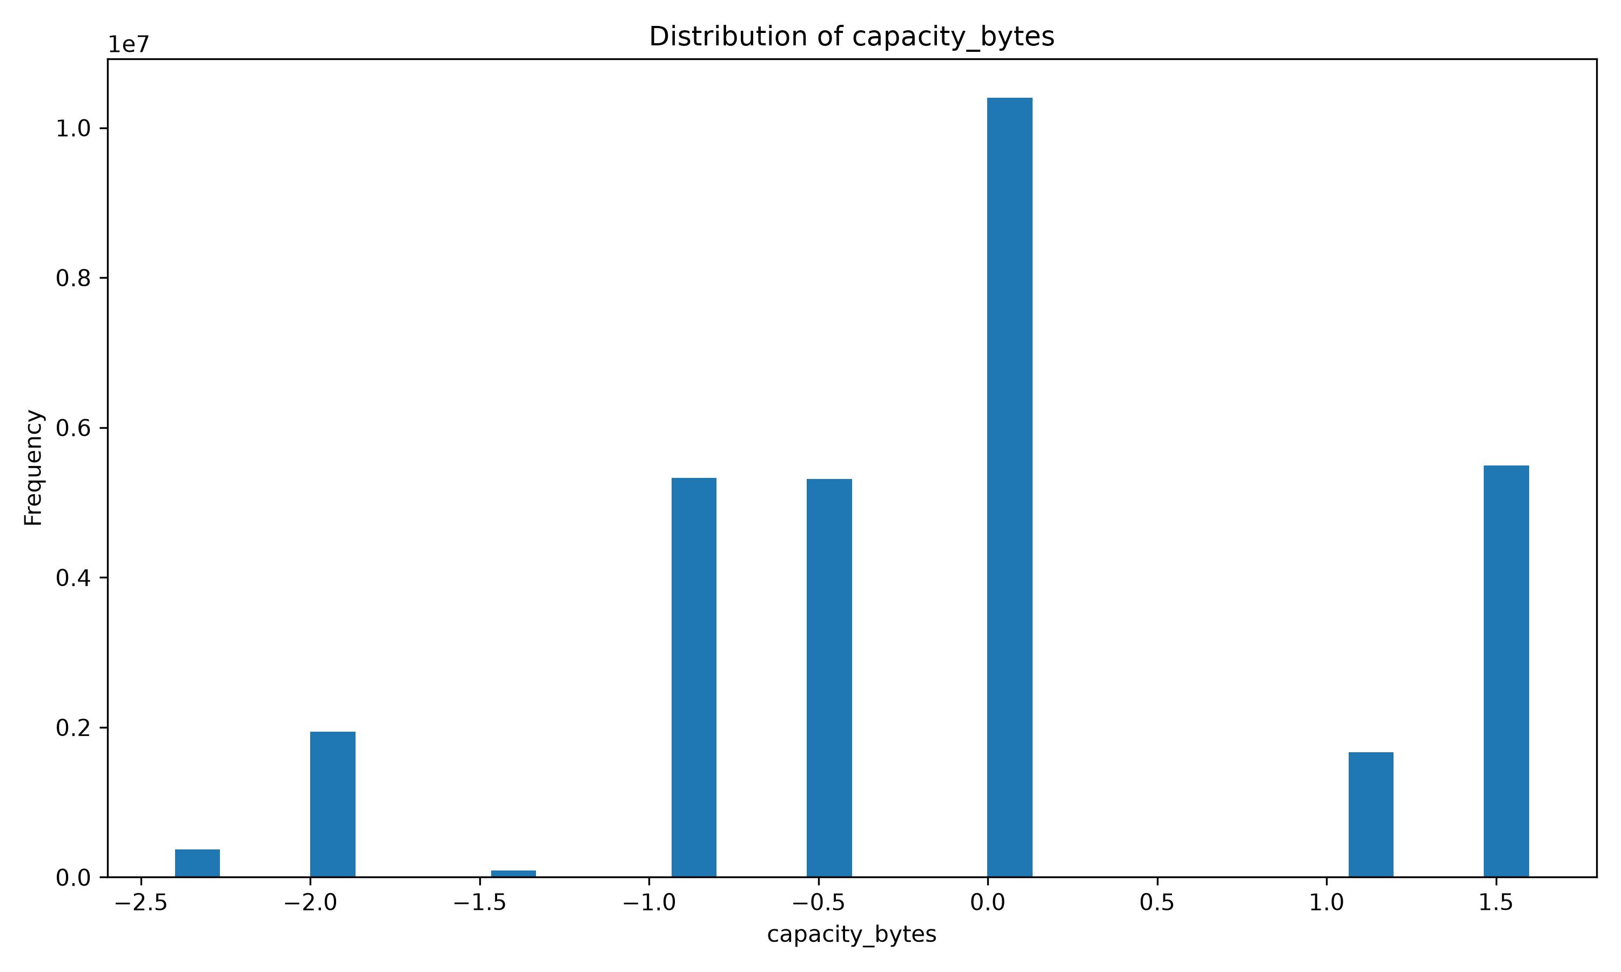
Figure 3. Distribution of standardized capacity_bytes (skewness = 0.06 — approximately symmetric).
The histogram shows a multi-modal distribution rather than a single bell curve, reflecting the fact that the fleet is composed of a small number of discrete capacity tiers (10 distinct raw capacity values were observed) rather than a continuously varying quantity. The near-zero skewness (0.06) confirms the distribution is close to symmetric overall, despite its multi-modal shape.

6.4 Scatter Plot — Capacity vs. SMART 5 (Normalized)
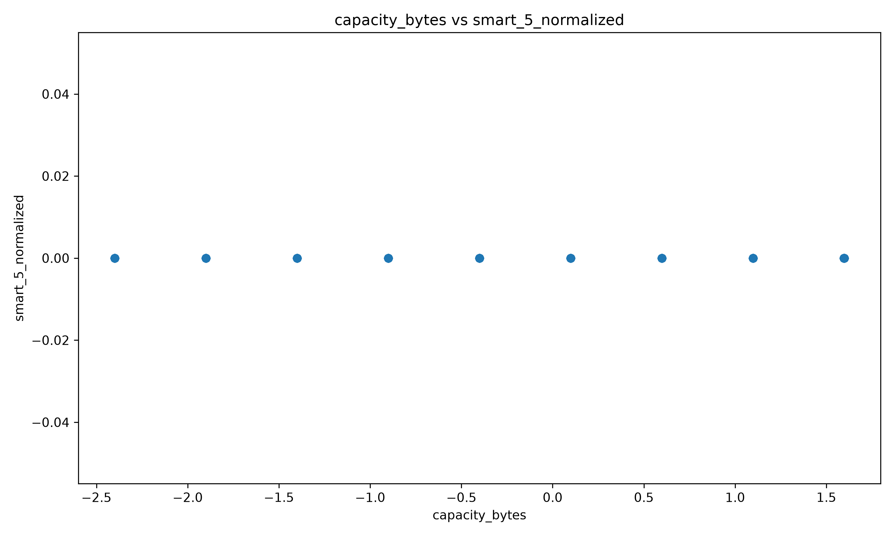
Figure 4. capacity_bytes vs. smart_5_normalized (Reallocated Sectors, normalized).
Because smart_5_normalized collapsed to a constant value during preprocessing (Section 5.1), the scatter plot shows a single horizontal band with no vertical spread, and the correlation coefficient is undefined. A more informative pairing — capacity_bytes vs. smart_9_raw, the two features with the strongest correlation in the dataset (r = -0.72) — is visualised in the correlation heatmap in Section 6.7 and is recommended as the primary bivariate relationship for any follow-on report.

6.5 Box Plot — Spread of Capacity
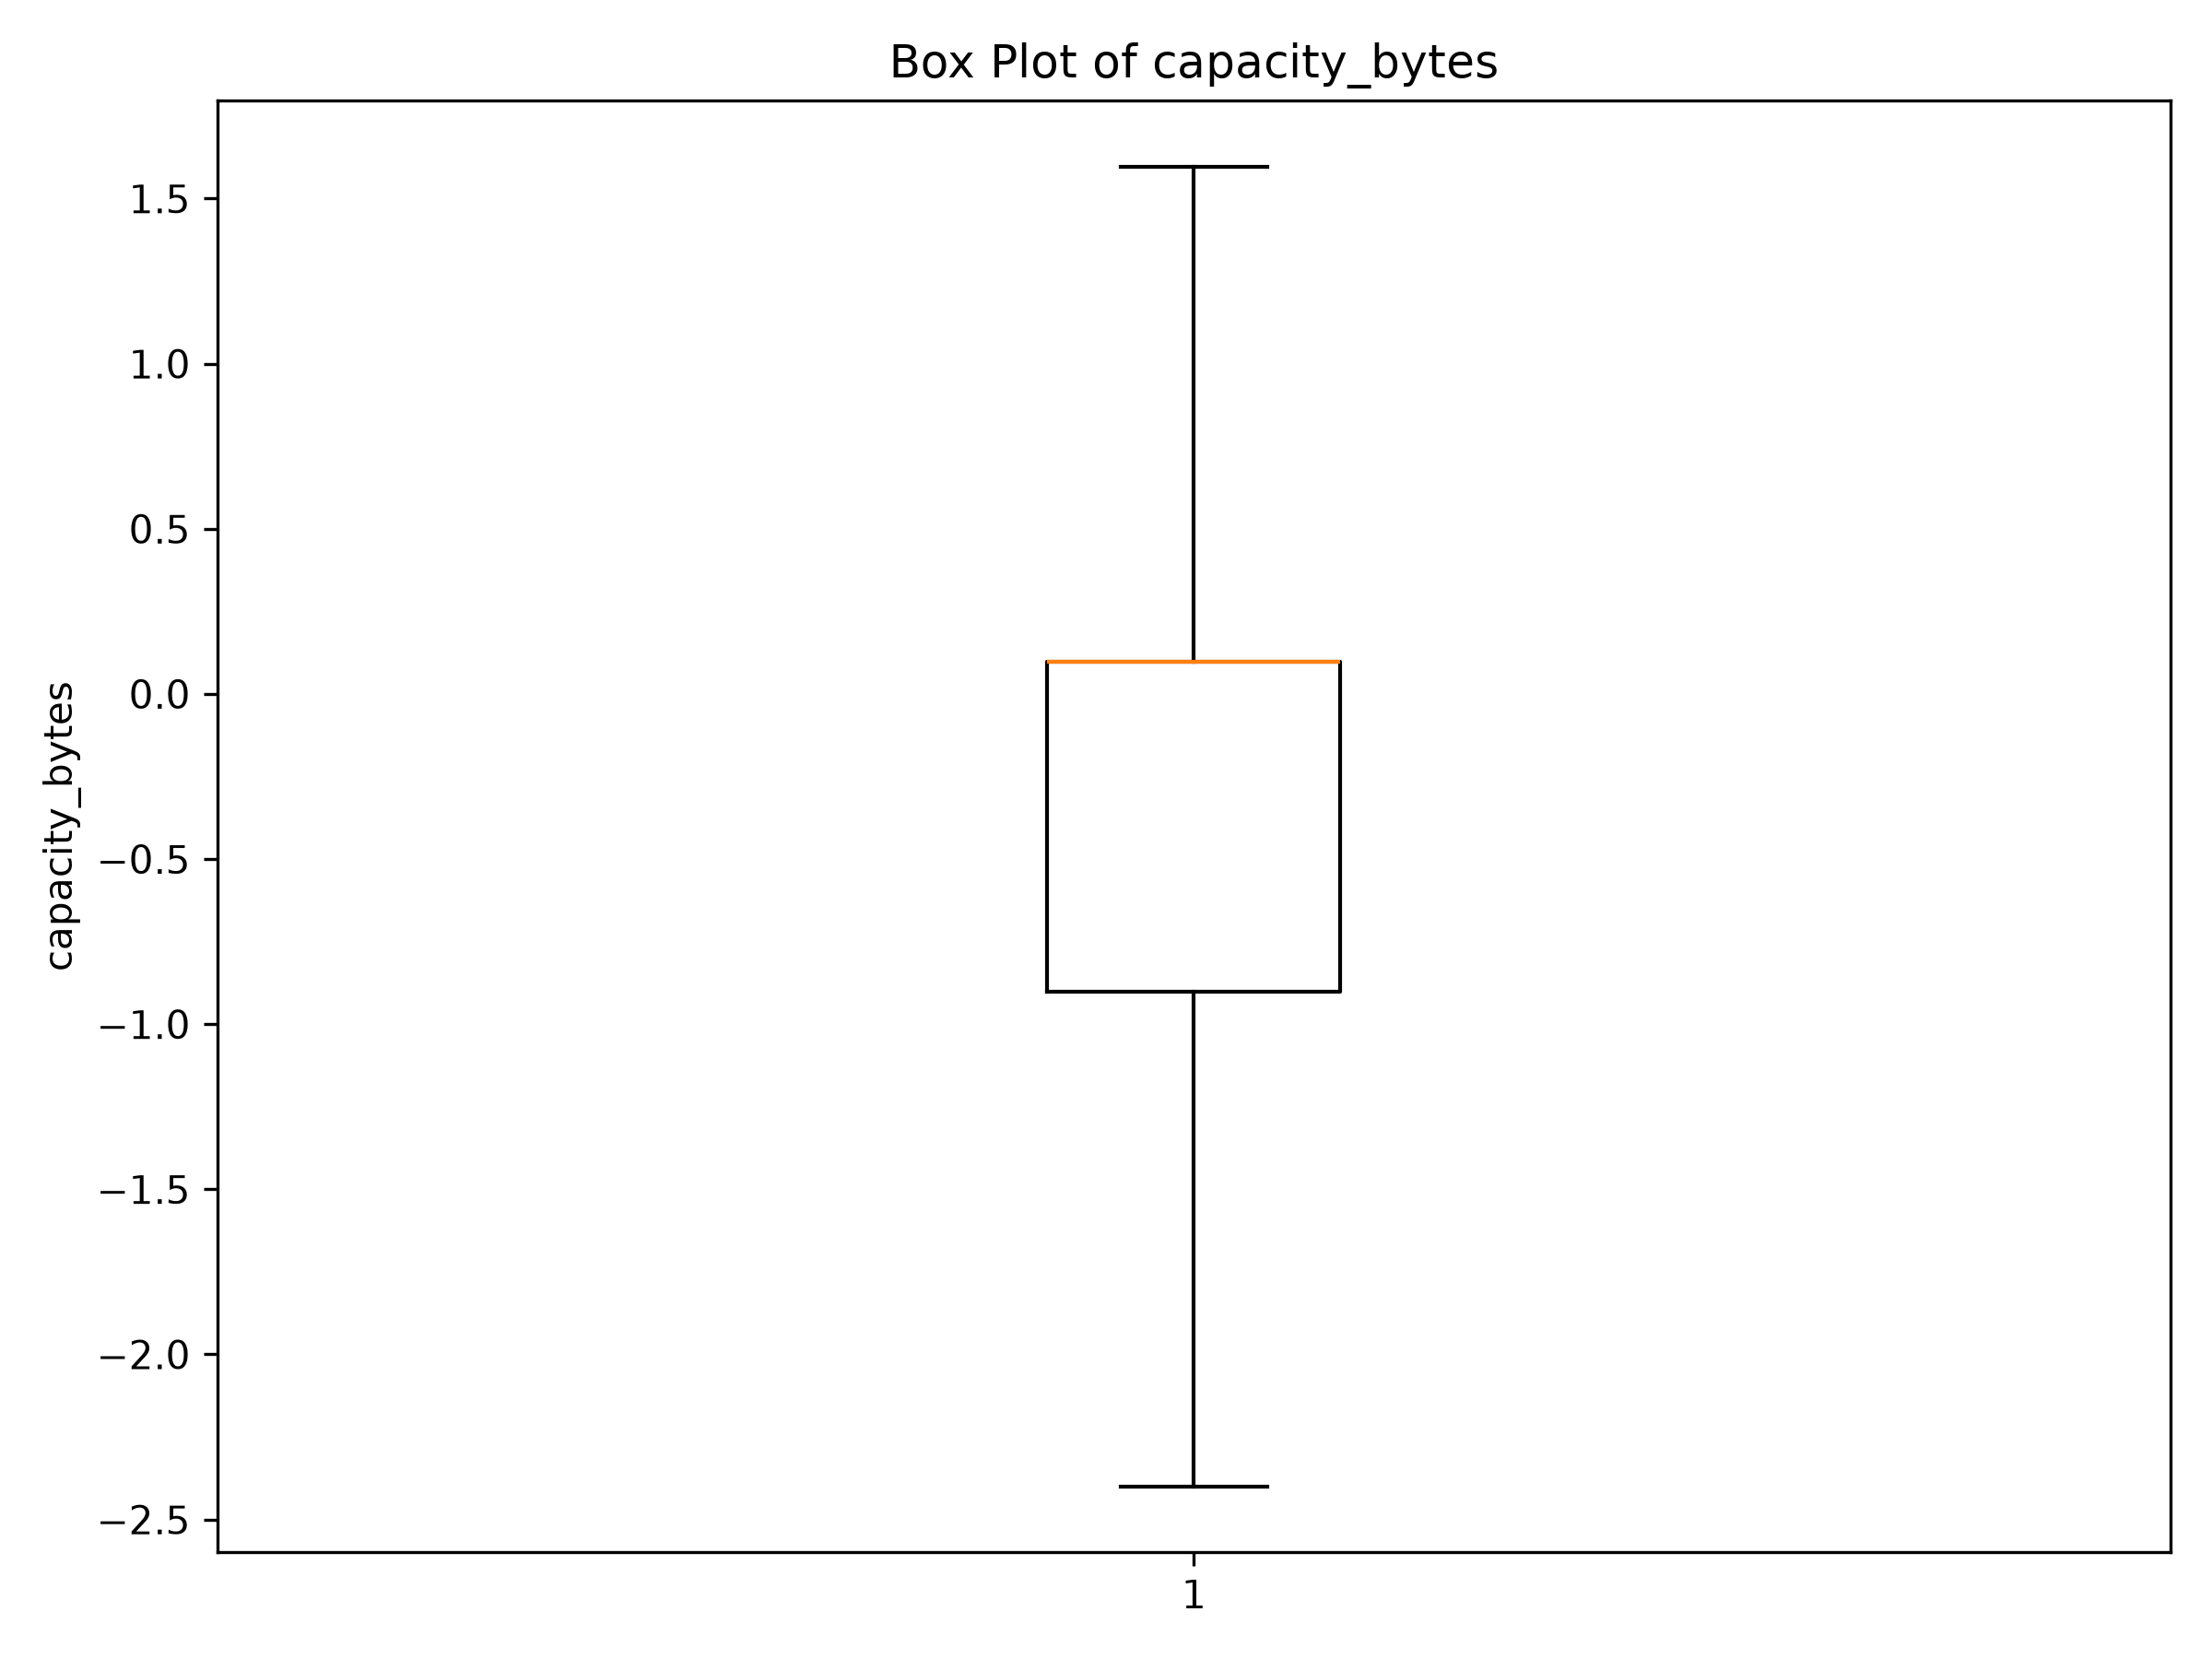
Figure 5. Box plot of standardized capacity_bytes after IQR-based outlier capping.
Following the outlier-capping step in preprocessing, the box plot shows a compact interquartile range with no residual whisker outliers, confirming that the earlier 1.5×IQR treatment (Section 4.3) was effective at controlling extreme capacity values prior to visualization.

6.6 Pie Chart — Failure Status Proportion
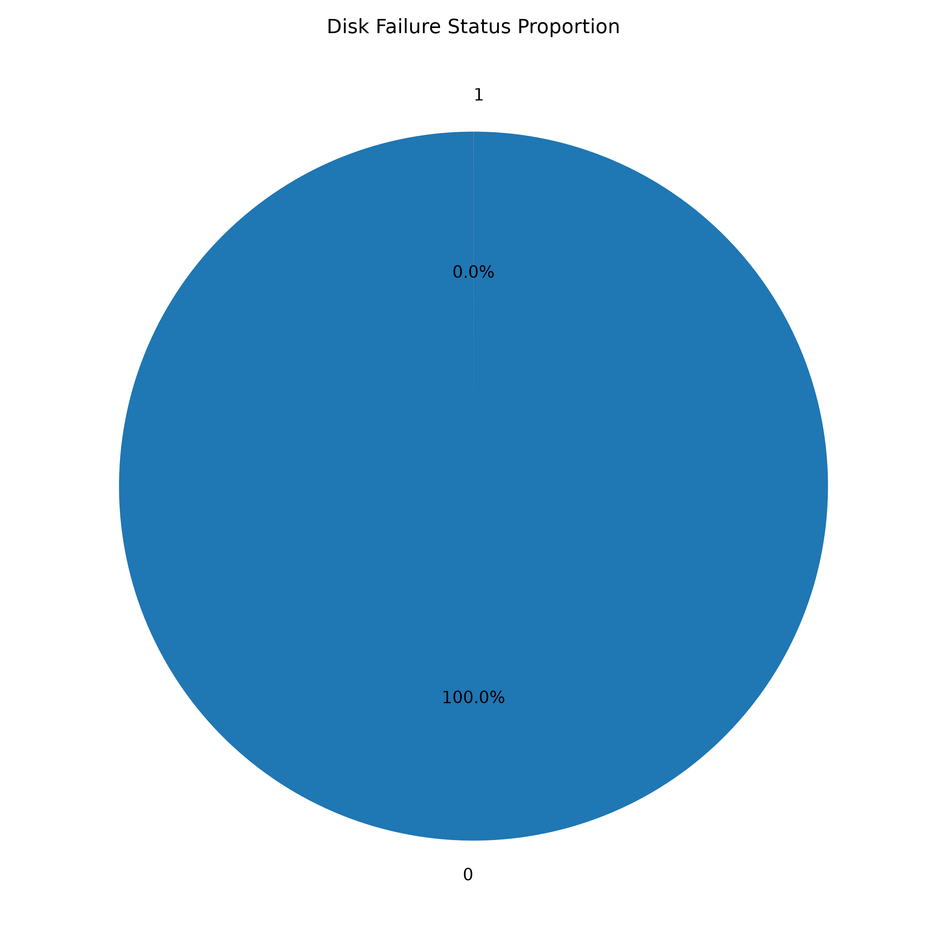
Figure 6. Proportion of healthy vs. failed drive-days.
The pie chart reinforces the bar chart's message in proportional terms: healthy drive-days represent 100.00% of the chart area at standard rounding, with the failed slice too thin to render at normal chart resolution — a strong visual argument for reporting failure rate on a per-thousand or per-ten-thousand basis rather than a raw percentage in operational dashboards.

6.7 Correlation Heatmap — Numerical Feature Relationships
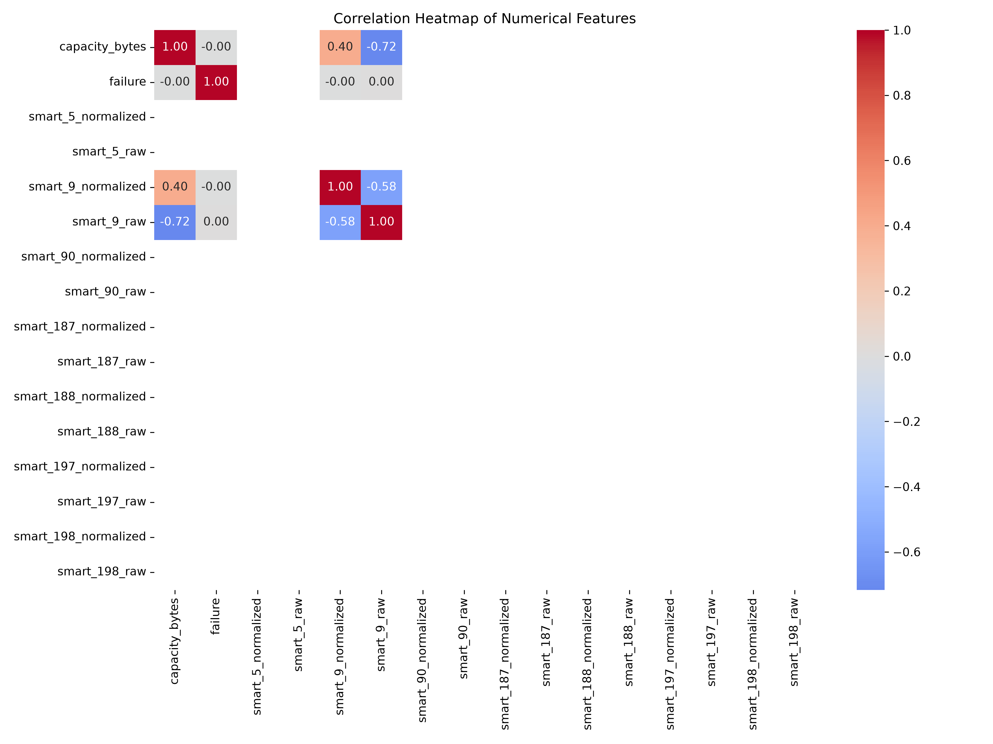
Figure 7. Pearson correlation heatmap across all 16 numeric features.
The heatmap visually isolates a small 3×3 block of non-trivial correlation — capacity_bytes, smart_9_normalized, and smart_9_raw — against a field of zero/undefined correlations for the remaining, mostly-imputed SMART attributes. The strongest relationship in the entire dataset is between capacity_bytes and smart_9_raw (r = -0.72), meaning that, in this fleet, larger-capacity drives tend to have been in service for comparatively fewer cumulative power-on hours — consistent with larger drives being deployed more recently in the fleet's refresh cycle.

6.8 Supplementary Chart — Feature Comparison by Failure Status
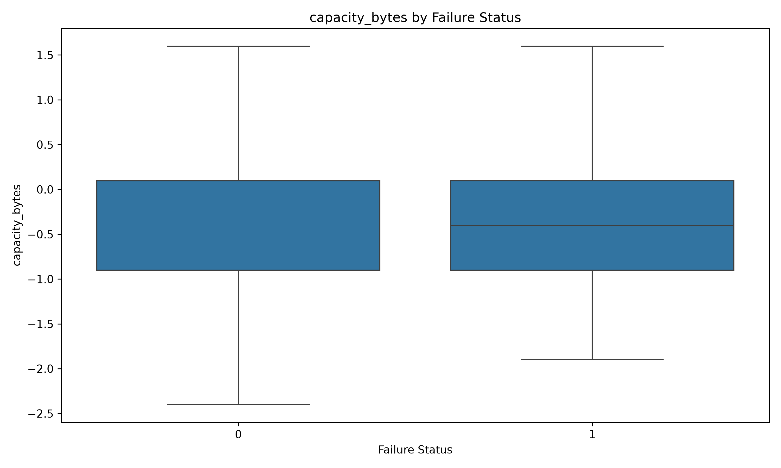
Figure 8. Box-plot comparison of standardized capacity_bytes across healthy vs. failed drives.
This supplementary comparison (produced alongside the seven required chart types) visually corroborates the numeric finding in Section 5.4: the failed-drive group's capacity distribution is shifted toward lower standardized values relative to the healthy-drive group.

6.9 Visualization Summary
Visualization | Purpose | Key Takeaway
Bar Chart | Compare categories | Failures are a vanishingly small share of records
Line Chart | Trends over time | Fleet capacity profile is stable across the quarter
Histogram | Understand distribution | Capacity is multi-modal but near-symmetric (skew 0.06)
Scatter Plot | Bivariate relationship | Zero-variance SMART fields mask relationships; use capacity vs. power-on hours instead
Box Plot | Spread & outliers | IQR capping successfully controlled extreme values
Pie Chart | Categorical proportions | Failure share is effectively invisible at whole-percent resolution
Correlation Heatmap | Inter-feature relationships | Capacity and power-on hours are the only strongly correlated pair (r = -0.72)

7. Key Insights and Findings
Synthesising the preprocessing, statistical, and visual analysis above, six key findings emerge from this case study:

Finding 1 — Failure is an extreme rare-event problem
Only 1,030 of 30,597,484 cleaned daily records (0.0034%, or about 1 in 29,706) represent a failure event. Any predictive model trained on this data without explicit imbalance handling (e.g., class weighting, resampling, or anomaly-detection framing) will trivially achieve >99.99% accuracy by always predicting "healthy" while providing zero operational value.

Finding 2 — A large share of SMART attributes carry no usable signal after standard imputation
Six of the seven paired SMART attributes (5, 90, 187, 188, 197, 198 — 12 of 16 numeric columns in total) collapsed to a constant value after median imputation, because 66–86% of their readings were missing to begin with (Section 4.1). This is a data-completeness problem specific to certain SMART attributes not being reported by all drive models/firmware, not a flaw in the imputation method itself — but it means that, as currently processed, three-quarters of the SMART feature set (everything except capacity, SMART 9, and the failure label) is statistically inert and cannot contribute to correlation analysis or a linear model.

Finding 3 — Power-on hours (SMART 9) is the clearest behavioural signal linked to failure
Failed drives show a substantially higher median standardized power-on-hours value (+0.557) than healthy drives (-0.031) on the same day (Section 5.4), and SMART 9 raw shows the (weak but non-zero) strongest positive correlation with failure of any feature (r = +0.0019). This is consistent with the industry-standard "bathtub curve" reliability model, in which failure risk rises as a drive accumulates operating hours.

Finding 4 — Capacity and power-on hours are entangled, and both differ by failure status
capacity_bytes and smart_9_raw are strongly negatively correlated (r = -0.72) — larger-capacity drives in this fleet have systematically fewer cumulative power-on hours, i.e., they are, on average, newer deployments. Failed drives skew toward smaller standardized capacity (median -0.401) than healthy drives (median +0.099), which is at least partly explained by their higher power-on hours rather than capacity being an independent risk factor in its own right. Any future model must therefore treat capacity and power-on-hours as related rather than independent predictors.

Finding 5 — Fleet composition is concentrated in a handful of high-volume models
Just 5 of 80 drive models (WDC WUH722222ALE6L4, TOSHIBA MG08ACA16TA, TOSHIBA MG07ACA14TA, ST16000NM001G, WDC WUH721816ALE6L4) generate roughly 53% of all daily telemetry records. Aggregate, fleet-wide failure statistics will therefore be dominated by the reliability characteristics of these few models, and per-model failure-rate segmentation is likely to reveal meaningfully different risk profiles that are currently averaged away.

Finding 6 — Data cleaning materially changed the analytical dataset
345,662 duplicate records (1.12% of the raw feed) and up to 3.9 million IQR-flagged outlier values in a single feature (smart_90_raw) were present in the raw telemetry before cleaning. Without the preprocessing pipeline in Section 4, both duplicate inflation and extreme-value distortion would have biased any downstream descriptive statistic, correlation coefficient, or visualization produced from the raw file.

8. Recommendations
Based on the findings above, the following recommendations are made for (a) data-centre operations and (b) the next phase of analytical/model development.

8.1 Operational Recommendations
- Prioritise drive age (power-on hours) in maintenance scheduling: given Finding 3, operations teams should treat cumulative power-on hours as a leading operational indicator and schedule proactive health checks or staged replacement for drives approaching the higher end of the fleet's power-on-hours distribution.
- Track failure rate per drive model, not only fleet-wide: given Finding 5, procurement and reliability-engineering teams should monitor and compare failure incidence separately for each of the top five high-volume models, since fleet-wide averages currently mask model-specific risk.
- Report failure rate on a per-mille or per-10,000 basis: given the pie/bar chart results in Section 6, percentage-based dashboards will visually understate a rare but operationally important event; failure incidence should be reported as "failures per 10,000 drive-days" for readability.
- Investigate SMART-attribute reporting gaps with drive vendors: given Finding 2, the 66–86% missingness on SMART 90/187/188 should be raised with the affected drive vendors/firmware teams, since these attributes (uncorrectable errors, command timeouts, pending sectors) are conventionally strong failure predictors in the wider industry literature and their absence here is a data-availability gap worth closing rather than a property of the drives themselves.

8.2 Analytical / Modelling Recommendations
- Adopt imbalance-aware modelling techniques: any future classifier (e.g., logistic regression, gradient-boosted trees, or a survival-analysis model) should use class weighting, SMOTE-style resampling, or an anomaly-detection framing rather than plain accuracy-optimised classification, given the 0.0034% positive-class rate identified in Finding 1.
- Re-source or re-engineer the constant SMART features: before further modelling, either source a data extract with better SMART-90/187/188 coverage, or engineer model-specific indicator features (e.g., "model reports SMART 187: yes/no") so that missingness itself, which may correlate with drive generation or vendor, is captured rather than discarded.
- Build a time-to-failure / survival model rather than a single-day classifier: because SMART 9 (power-on hours) shows the clearest failure association, a survival-analysis approach (e.g., Cox proportional hazards or a Weibull model) using drive age as the time axis is likely to be more informative than a same-day binary classifier.
- Segment models by drive family before pooling: given Finding 5, the team recommends fitting and validating failure risk separately within the top five drive models before pooling results, to avoid model-specific reliability differences being averaged out of a single fleet-wide model.
- Extend the observation window: the current 90-day window captures only 1,030 failure events; extending the extract to a full year or more (consistent with Backblaze's published quarterly releases) would materially increase the number of positive-class examples available for model training and validation.

9. Conclusion
This case study successfully carried a 30.9-million-row, real-world hard-drive telemetry dataset through a complete data-science pipeline — from raw ingestion through cleaning, exploratory analysis, and visualization — to a set of concrete, evidence-based findings and recommendations. The preprocessing stage removed 345,662 duplicate records, resolved over 120 million missing cell values through median/mode imputation, capped millions of statistical outliers using the IQR method, and standardized 15 continuous features, producing a clean dataset of 30,597,484 records with zero missing values and zero duplicates. The exploratory analysis and seven-chart visualization suite that followed established that hard-drive failure in this fleet is an extremely rare event (0.0034% of daily records), that power-on hours (SMART 9) is the clearest behavioural correlate of failure identified in the dataset, and that capacity and power-on hours are entangled with one another (r = -0.72) rather than independent risk factors.
Equally important, the study surfaced a significant data-completeness limitation: two-thirds to over four-fifths of the readings for several conventionally important SMART attributes (uncorrectable errors, command timeouts, pending sectors) were missing and, after standard imputation, collapsed to zero variance — meaning the raw linear-correlation analysis in this report substantially understates the predictive potential those attributes would offer with better data coverage. This distinguishes a genuine data-limitation finding from a modelling failure and directly informs the recommendations in Section 8.
Overall, the exercise demonstrates that rigorous preprocessing is not a preliminary formality but a determinant of analytical validity at this data scale — a difference of over 345,000 duplicate rows and millions of outlier values separates the raw feed from a dataset fit for reliable statistical inference. The resulting insights, particularly the identification of power-on hours as the leading failure correlate and the quantification of the severe class imbalance, provide a concrete, actionable foundation for the predictive-maintenance modelling work recommended as the next phase of this project.

10. References
- Backblaze, Inc. (2026). Hard Drive Data and Stats (Drive Stats dataset). Retrieved from https://www.backblaze.com/cloud-storage/resources/hard-drive-test-data
- Backblaze, Inc. (2024). What SMART Stats Tell Us About Hard Drives. Backblaze Blog. https://www.backblaze.com/blog/what-smart-stats-indicate-hard-drive-failures/
- Pandas Development Team. (2024). pandas: powerful Python data analysis toolkit (Version 2.x) [Software documentation]. https://pandas.pydata.org/docs/
- Pedregosa, F., et al. (2011). Scikit-learn: Machine Learning in Python. Journal of Machine Learning Research, 12, 2825–2830. https://scikit-learn.org/
- Hunter, J. D. (2007). Matplotlib: A 2D graphics environment. Computing in Science & Engineering, 9(3), 90–95.
- Waskom, M. L. (2021). seaborn: statistical data visualization. Journal of Open Source Software, 6(60), 3021.
- Tukey, J. W. (1977). Exploratory Data Analysis. Addison-Wesley. (Basis for the IQR outlier-detection method used in Section 4.3.)
- Pinheiro, E., Weber, W.-D., & Barroso, L. A. (2007). Failure Trends in a Large Disk Drive Population. Proceedings of the 5th USENIX Conference on File and Storage Technologies (FAST '07).

Appendix A — Team Contribution Summary
Member | Responsibility | Deliverable
Member 1 | Dataset sourcing & problem framing | Raw dataset acquisition, problem statement input
Member 2 | Data preprocessing | 21-step cleaning pipeline; cleaned_disk_smart_data.csv; preprocessing_summary.csv
Member 3 | EDA & statistical analysis | 34-step statistical analysis; eda_results/ (29 CSV outputs)
Member 4 | Visualization & interpretation | 7 required charts + 1 supplementary chart; graph interpretations
Member 5 | Insights, recommendations, report & presentation | Key findings, recommendations, conclusion, final report compilation, slide deck, presentation coordination

