Identify the dimensions, and fact measurements based on the following description:

Question 1. One of the online retail company’s features is an e-wallet service, that holds credit that can be used to pay for products purchased on the platform.

Users can receive credit in three different ways:

(1). When a product purchase that is paid for is canceled, the money is refunded as cancellation credit.

(2). Users can receive gift card credit as a gift.

(3). If a user has a poor service experience, sorry credit may be provided.

Requirement

The Finance department of the company would like to build reporting and analytics on the e-wallet service so they can understand the extent of the wallet liabilities the company has.

Some of the questions they would want to answer from this are like below:

(1). What is the daily balance of credit in the e-wallet service?

(2). How much credit will expire in the next month?

(3). What is the outcome (i.e. % used, % expired, % left) of credit given in a particular month?

Step 1: What is the business process:

The usage /spending of e-wallet from the customer;

Step 2: Define the grain:

The product purchased in one transaction by one customer at a certain time using e-wallet credits;

Step 3: Identify the Dimensions:

Date, Product, Customer, E-wallet, Employee (optional), Payment Method, Promotion (optional)

Date Dim

|  |  |  |
| --- | --- | --- |
| Column Name | Description | Key |
| DateKey | YYYYMMDD | Primary Key |
| Holiday |  |  |
| Month |  |  |
| Day of Week |  |  |

ProductDim

|  |  |  |
| --- | --- | --- |
| Column Name | Description | Key |
| ProductKey | Surrogate Key | Primary Key |
| SKUcode | Natural Key |  |
| ProductName |  |  |

CustomerDim

|  |  |  |
| --- | --- | --- |
| Column Name | Description | Key |
| CustomerKey | Surrogate Key | Primary Key |
| CustomerID | Natural Key |  |
| CustomerName |  |  |
| CustomerEmail |  |  |

E-WalletDim

|  |  |  |
| --- | --- | --- |
| Column Name | Description | Key |
| WalletKey | Surrogate Key | Primary Key |
| WalletID | Natural Key |  |
| StartDate |  |  |
| ExprrationDate |  |  |
| InitialCredits | Sorry credits, cancellation, giftcard |  |

PaymentDim

|  |  |  |
| --- | --- | --- |
| Column Name | Description | Key |
| PaymentKey |  |  |
| PaymentID |  | Primary Key |
| PaymentName |  |  |
| PaymentDescription |  |  |
| PaymentStatus |  |  |

Step 4: Identify the Fact Tables

Quantity of the product

Unit Price

Total payment amount: Quantity of the product*Unit price

Total credit payment amount using e-wallet

Total payment amount by other payment methods

|  |  |  |
| --- | --- | --- |
| Column Name | Description | Key |
| DateKey |  | Part of composite key , foreign key |
| ProductKey |  | Part of composite key , foreign key |
| PaymentKey |  | Part of composite key , foreign key |
| WalletKey |  | Part of composite key , foreign key |
| CustomerKey |  | Part of composite key , foreign key |
| Quantity of the product |  |  |
| Unit Price |  |  |
| Total payment amount: Quantity of the product*Unit price |  |  |
| Total credit payment amount using e-wallet |  |  |
| Total payment amount by other payment methods |  |  |

Step 5: Star Schema

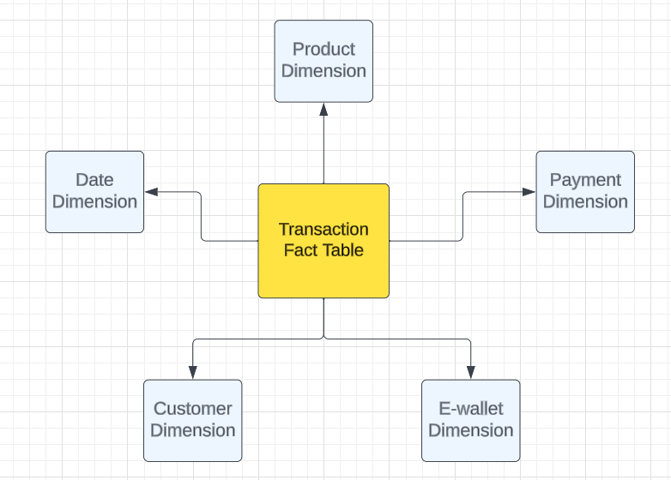

Question 2. The fictional Global Computing Company was established in 1990. Global Computing distributes computer hardware and software components to customers on a worldwide basis. The Sales and Marketing department has not been meeting its budgeted numbers. As a result, this department has been challenged to develop a successful sales and marketing strategy.

Various factors in Global Computing's current business point to a decline in sales and profits:

(1). Traditionally, Global Computing experiences low third-quarter sales (July through September). However, recent sales in other quarters have also been lower than expected. The company has experienced bursts of growth but, for no apparent reason, has had lower first-quarter sales during the last two years as compared with prior years.

(2). Global has been successful with its newest sales channel, the Internet. Although sales within this channel are growing, overall profits are declining.

Perhaps the most significant factor is that margins on personal computers - previously the source of most of Global Computing's profits - are declining rapidly.

Interviews with the VP of Sales and Marketing, salespeople, and market analysts at Global Computing reveal the following business analysis questions:

1. What products are profitable?

2. Who are our customers, and what and how are they buying?

3. What is the performance of each distribution channel?

Step 1: What is the business process:

Global computing company sells products via different distribution channels to customers;

Step 2: Define the grain:

One product sold to one customer using one distribution channel at one point of time in one transaction.

One transaction allows one payment method.

Step 3: Identify the Dimensions:

Date, Product, Payment Method, distribution channel

Date Dim

|  |  |  |
| --- | --- | --- |
| Column Name | Description | Key |
| DateKey | YYYYMMDD | Primary Key |
| Holiday |  |  |
| Month |  |  |
| Day of Week |  |  |

PaymentDim

|  |  |  |
| --- | --- | --- |
| Column Name | Description | Key |
| PaymentKey |  |  |
| PaymentID |  | Primary Key |
| PaymentName |  |  |
| PaymentDescription |  |  |
| PaymentStatus |  |  |

ProductDim

|  |  |  |
| --- | --- | --- |
| Column Name | Description | Key |
| ProductKey | Surrogate Key | Primary Key |
| SKUcode | Natural Key |  |
| ProductName |  |  |

Distribution channel Dim

|  |  |  |
| --- | --- | --- |
| Column Name | Description | Key |
| DisttibutionKey |  | Primary Key |
| Type |  |  |
| Description |  |  |

Step 4: Identify the Fact Tables

Quantity

Unit Price

Unit Cost

Total Amount Paid: Quantity*Unit price

Total Cost: Quantity*Unit Cost

Gross Profit: Total Amount Paid- Total Cost

Step 5: Star Schema

