**E1.** UsedCarInc is a used car dealer. When a customer arrive with a car to sell, a dealer agent inspects the car and makes an offer to purchase the car. After purchasing, the car is cleaned and is made available for sale to other customers who come to buy used cars. Any dealer agent can be involved in either the purchase or sale process. Develop a dimensional model to support their main car purchase and sale process. A car purchase by dealer transaction includes information on the seller, dealer agent (employee), car, purchase price, and date. A car sale by dealer includes information on buyer, car, dealer agent (employee), sale price, and date. The company wants to increase profit (sale price minus purchase price) and have higher profit margins, and lower the number of days between car purchase by dealer and car sold by dealer (increase inventory turnover).

1. What is the business process of interest here?
2. Car purchasing process;
3. Car selling process
4. What are the different levels of granularity present?

Transaction fact tables;

a. one car purchase by the dealership

b. one car sold by the dealership.

1. What are the dimensions for each grain identified in #2?
   1. Seller, car, employee, date
   2. Buyer, car, employee, date
2. What are the facts for each grain in #2?
   1. Purchase price, inspection cost, maintenance cost
   2. Selling price, purchase price, inspection cost, maintenance cost, extended profit = selling price -purchase price – inspection cost-maintenance cost;
3. Specify if VIN Number and Mileage are included in the model and the most appropriate table where they can be included

Car dimension table

1. Would an accumulating fact table apply in this case?

Yes.

* Grain: one car from being purchased to being sold.
* Fact table attributes: purchase date, inspection date, maintenance date selling date, lag between purchase date and selling date.
* Minimize the lag for each car;

**E2.** SunDucks coffee has coffee shops in multiple states. They sell coffee, snacks and related products. You have been provided the following dimensional model for Sales process of SunDucks Coffee, built for the granularity of 1 row per transaction. Identify (1) errors or issues with the model, (2) potential problems due to the errors and (3) propose revisions to correct the errors.

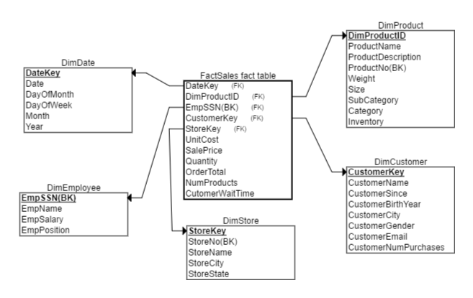

|  |  |
| --- | --- |
| DimProduct | |
| DimProductID | Primary key, sequentially generated |
| ProductName  ProductDescription | Name of product  Description of Product |
| ProductNo | Business Key |
| Weight | Product Weight |
| Size | Product size |
| SubCategory | Product Sub-cateogry |
| Category | Product category |
| Inventory | Number of product in company inventory |
|  |  |
| DimCustomer | |
| CustomerKey | Primary key, sequentially generated |
| CustomerName | Name of Customer |
| CustomerSince | Date of first purchase |
| CustomerBirthYear | Year of Birth of customer |
| CustomerCity | Customer City of residence |
| CustomerGender | Customer gender |
| CustomerEmail | Customer email |
| CustomerNumPurchases | Number of purchases made by customer to date |
|  |  |
| DimStore | |
| StoreKey | Primary key, sequentially generated |
| StoreNo | Business key |
| StoreName | Name of store |
| StoreCity | City in which store is located |
| StoreState | State in which store is located |
|  |  |
| DimEmployee | |
|  | |
| EmpSSN | Employee SSN, Primary Key, Business Key |
| EmpName | Name of Employee |
| EmpSalary | Salary of Employee |
| EmpPosition | Position of Employee |
|  |  |
| FactSales | |
| UnitCost | Unit cost of product sold |
| SalePrice | Price at which product was sold |
| Quantity | Quantity of a product sold ( for e.g. two regular coffees) |
| OrderTotal | Total price of all products sold |
| NumProducts | Total number of products sold in order (for e.g. 3 products coffee, cookies and bottled water) |
| CustomerWaitTime | Total time waited by customer to receive all products in order |

1. Product dimension should not have “inventory” measurement;

Solution: create a periodical snapshot fact table to connect to the product dimension. In this fact table, we will have one product’s ending inventory per day.

1. CustomerNumPurchases is not correct attribute, we should include in the customer dimension table.
   1. Aggregate using queries to sum up the total number of transactions made by one customer.
   2. We can create another periodical snapshot fact table with the total number of transactions per customer per day as the grain.
2. Ssn should not be used as primary key in the dimension table, also it’s not the natural key;

Solution: create surrogate key for employee dimension table.

1. Sales Fact table has mixed grain: both transaction and product.
2. convert the existing sales fact table to product level (grain : one product per transaction per customer)
3. transaction level grain (one transaction per customer) remove the first three measurement and also remove product key (because one transaction doesn’t have one product key.)