1. Identify the business process:

The business process is related to managing patients and their payment accounts, generating bills for them.

1. Grain:

Individual generated bill per patient.

1. Dimensions:

PatientDim, HosptialDim, DepartmentDim, DateDim, DoctorDim, AccountDim, BillDim, InsuranceDim.

PatientDim

|  |  |  |
| --- | --- | --- |
| Column name | Nullable | Description |
| PatientID | No | Primary Key |
| PatientName | No |  |
| PateintDOB | Yes | Date of birth |
| PatientCellNumber | Yes | Phone number |
| PateintGender | Yes |  |

HospitalDim:

|  |  |  |
| --- | --- | --- |
| Column name | Nullable | Description |
| HospitalID | No | Primary Key |
| HospitalName | No |  |
| DepartmentNames | No |  |
| Address | Yes |  |

DepartmentDim:

|  |  |  |
| --- | --- | --- |
| Column name | Nullable | Description |
| DepartmentID | No | Primary Key |
| DepartmentName | No |  |

DateDim:

|  |  |  |
| --- | --- | --- |
| Column Name | Nullable | Description |
| DateKey | No | Primary Key (YYYYMMDD) |
| Month | Yes |  |
| Quarter | Yes |  |
| Year | Yes |  |

DoctorDim:

|  |  |  |
| --- | --- | --- |
| Column Name | Nullable | Description |
| DoctorID | No | Primary Key |
| DoctorName | No |  |
| PhnNumber | Yes | Phone Number |
| Specialization | Yes |  |

AccountDim:

|  |  |  |
| --- | --- | --- |
| Column Name | Nullable | Description |
| AccountID | No | Surrogate Key |
| InitialAmount | No |  |
| Date | No | date |

BillDim:

|  |  |  |
| --- | --- | --- |
| Column Name | Nullable | Description |
| BillID | No | Foreign Key |
| Date | No |  |
| BillingBy | No |  |
| Insurance | No | Amount paid through Insurance |
| PatientAccount | No | Amount paid through Patient Account |
| Cash | No | Amount paid through Cash |
| CreditCard | No | Amount paid through Cash |
| other | No |  |

InsuranceDim:

|  |  |  |
| --- | --- | --- |
| Column Name | Nullable | Description |
| ClaimID | No | Primary Key |
| Date | No |  |
| CompanyID | No |  |
| CompanyName | Yes | Insurance Company Name |

1. Identify Facts:

PatientAccountFact:

|  |  |  |
| --- | --- | --- |
| Column Name | Nullable | Description |
| AccountID | No | Foreign Key |
| PatientID | No | Foreign Key |
| DateKey | No | Foreign Key |
| CreditsAvailable | No | Available amount or credits |
| CreditsUsed | No | Amount used |

BillFact:

|  |  |  |
| --- | --- | --- |
| Column Name | Nullable | Description |
| BillID | No | Foreign Key |
| PatientID | No | Foreign Key |
| DoctorID | No | Foreign Key |
| DateKey | No | Foreign Key |
| HospitalID | No | Foreign Key |
| DepartmentID | No | Foreign Key |
| BillAmount | No |  |

InsuranceFact:

|  |  |  |
| --- | --- | --- |
| Column Name | Nullable | Description |
| ClaimID | No | Foreign Key |
| PatientID | No | Foreign Key |
| DateKey | No | Foreign Key |
| ClaimedAmount | No | Requested amount |
| GrantedAmount | No | Received Amount |

1. Star Schema:

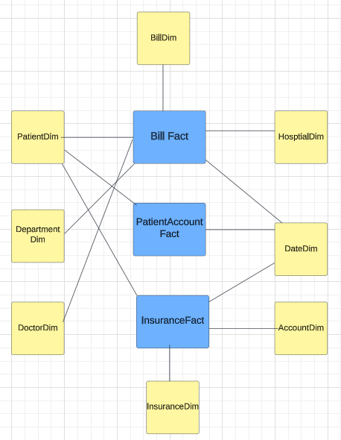

(1). Which local central hospitals, what departments and what doctors are generating most of the bills?

Answer: For this question we can get the most bills from the fact table using bill amount. Then we can get detailed information about hospitals, department and doctors by joining billfact with individual dim tables.

(2). Who are our patients, and how are they paying for their bills?

Answer: Again, we have to use billfact table, you can get patient information through the patientID and for method of paying bills, using the billID you can see various options like Insurance, patient account, cash, creditcard, other.

(3). What is the daily balance of credit in a medical account?

Answer: Using AccountDim we can get credit in medical account, and if you want for particular day then you can use date column.

(4). What is the % used and % left of credits in the medical accounts given in a particular month?

Answer: For this we can use the AcccountDim and PatientAccountFact. Using this we can calculate %left= 100*((InitialAmount -CreditsUsed)/ InitialAmount) and %used = 100*(CreditsUsed/ InitialAmount).

(5). When filling claims to patients’ insurance companies, what is the average duration between the claim filling date and the payment receipt date?

Answer:

For average duration between the claim date and payment receipt date, we can use DateDiff(DateKey, GrantDate)/Count of all claims.