Question: Shoreline Stadium Case

The G&E Company is preparing a bid to build the new 47,000-seat Shoreline baseball stadium. The construction must start on July 3, 2017, and be completed in time for the start of the 2020 season. A penalty clause of $250,000 per day of delay beyond April 3 is written into the contract. Percival Young, the president of the company, expressed optimism at obtaining the contract and revealed that the company could net as much as $3 million on the project. He also said if they were successful, the prospects of future projects are bright since there is a projected renaissance in building classic ball parks with modern luxury boxes. ASSIGNMENT Given the information provided in Table 6.3, construct a network schedule for the stadium project and answer the following questions: 1. Will the project be able to be completed by the April 3 deadline? How long will it take? 2. What is the critical path for the project? 3. Based on the schedule would you recommend that G&E pursue this contact? Why? Include a one-page Gantt chart for the stadium schedule.

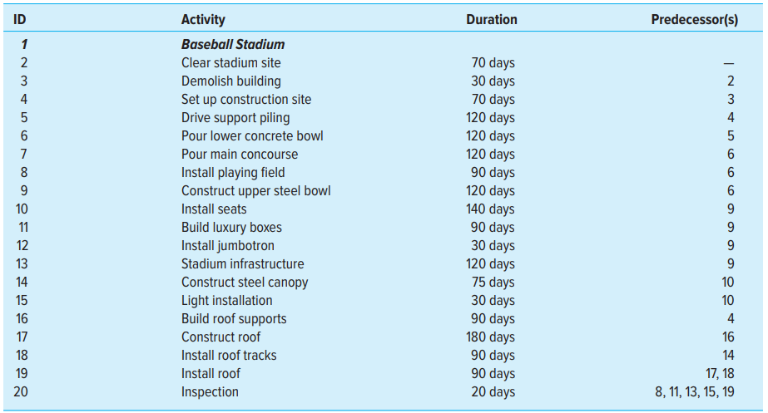

Answer:

WBS structure for Shoreline Baseball Stadium is as follows:

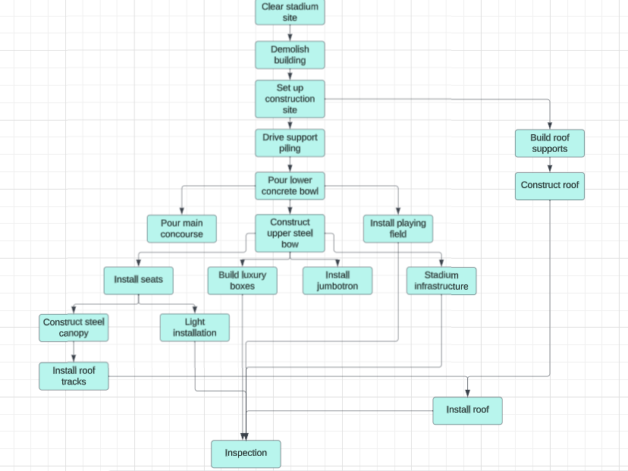

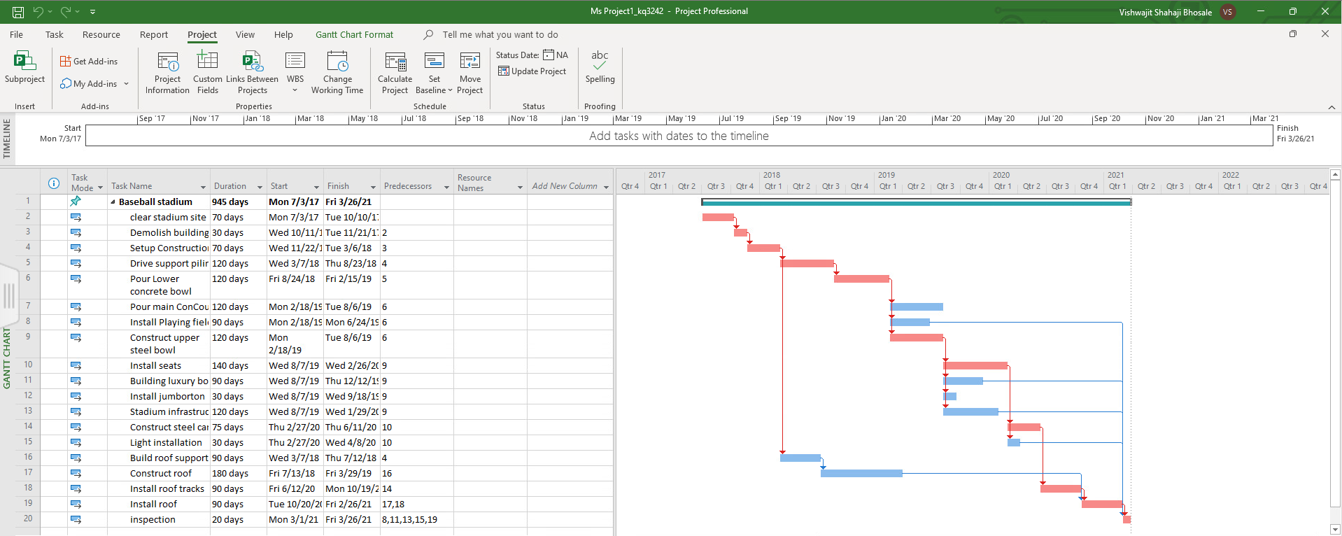

Will the project be able to be completed by the April 3 deadline? How long will it take?

The Shoreline stadium project will not be completed under the April 3 2020 deadline. As you can see in the grant chart provided above the project will extend beyond the 2020 and estimated completion time is around first quarter of 2021. The total time taken is 945 days which you can see in the above grant chart. Estimated time of finish is 3/26/2021.

What is the critical path for the project?

The Critical path for the project is 2-3-4-5-6-9-10-14-18-19-20. Also this path is shown in the red color arrows in below chart.

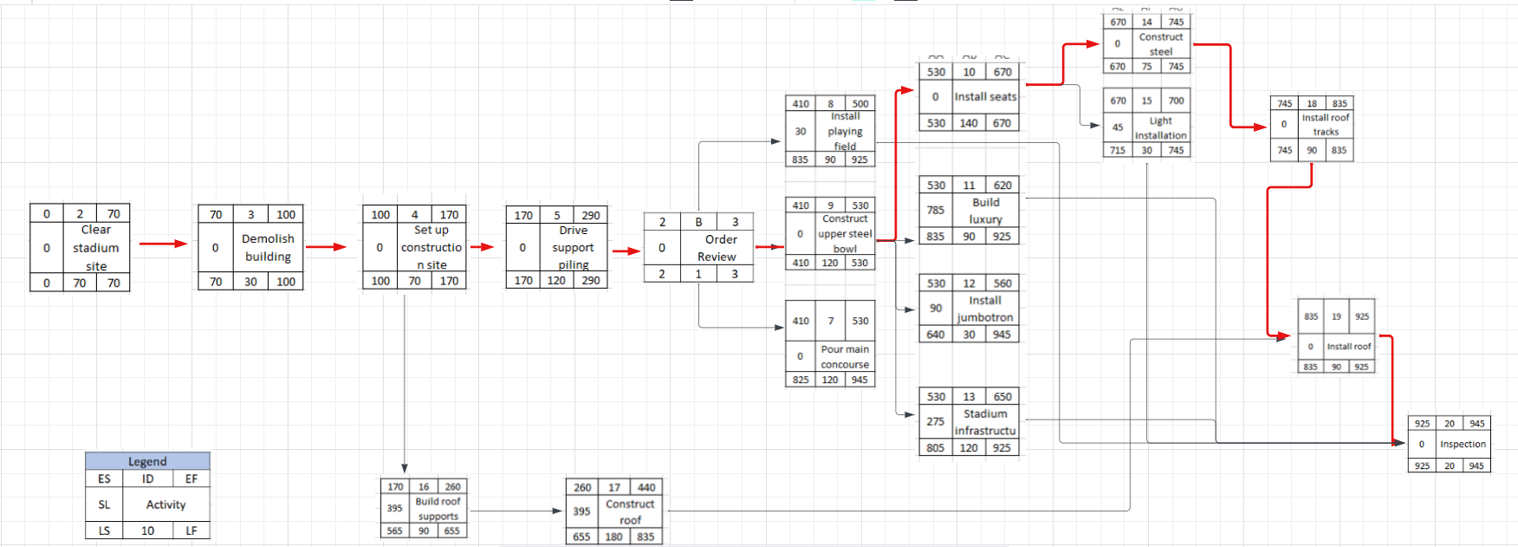

Based on the schedule would you recommend that G&E pursue this contact? Why? Include a one-page Gantt chart for the stadium schedule.

Based on the schedule, I would advise against G&E pursuing this contract. The project was originally expected to be completed by April 3, 2020, but it is currently overdue by 357 days. The contract includes a penalty clause, imposing a fee of $250,000 for each day of delay beyond April 3.

To calculate the penalty: For 1 day of delay, the penalty is $250,000.

For 357 days of delay, the penalty amounts to $250,000 multiplied by 357, which equals $89,250,000.

Considering that the project is now complete, G&E will receive approximately $3 million for its completion. However, the net loss incurred due to the delay would be: $89,250,000 (penalty) - $3,000,000 (project completion revenue) = $86,250,000.

Therefore, the net loss associated with this contract would be $86,250,000.