**Part1:**

Nightingale Project—A You are the assistant project manager to Rassy Brown, who is in charge of the Nightingale project. Nightingale was the code name given to the development of a handheld electronic medical reference guide. Nightingale would be designed for emergency medical technicians and paramedics who need a quick reference guide to use in emergency situations. Rassy and her project team were developing a project plan aimed at producing 30 working models in time for MedCON, the biggest medical equipment trade show each year. Meeting the MedCON October 25 deadline was critical to success. All the major medical equipment manufacturers demonstrated and took orders for new products at MedCON. Rassy had also heard rumors that competitors were considering developing a similar product, and she knew that being first to market would have a significant sales advantage. Besides, top management made funding contingent upon developing a workable plan for meeting the MedCON deadline. The project team spent the morning working on the schedule for Nightingale. They started with the WBS and developed the information for a network, adding activities when needed. Then the team added the time estimates they had collected for each activity. Following is the preliminary information for activities with duration time and predecessors:

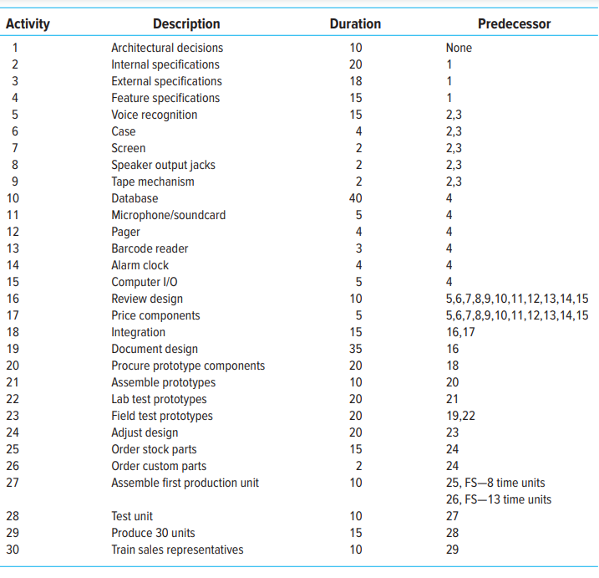

Answer:

Early start, early Finish, Late start, late finish and slack are not present in the above chart. But all of them are there in the provided gantt chart file.

(This Schedule is including holidays)

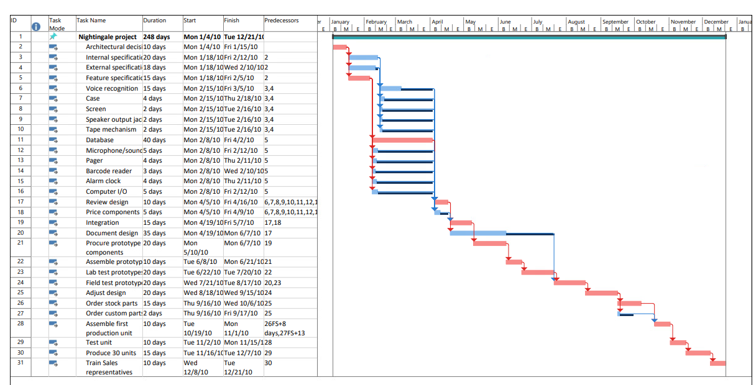

1.Will the project as planned meet the October 25th deadline?

Ans: The project is expected to be completed on December 21, 2010, which is approximately 2 months beyond the initially planned completion date of October 25. This delay accounts for weekends, treating Saturdays and Sundays as non-working days and holidays. The total project duration is estimated to be around 248 days.

2. What activities lie on the critical path?

Ans: In Gantt chart the critical paths is shown in red color, which is 2,5,11,17,19,21,22,23,24,25,26,28,29,30,31.

3. How sensitive is this network?

Ans: The length of the critical path is quite long which is directly proportional to the sensitivity of the network. Also, there are various activities on the critical path. Thus, we can say that this network is highly sensitive.

**Part2:**

Rassy and the team were concerned with the results of your analysis. They spent the afternoon brainstorming alternative ways for shortening the project duration. They rejected outsourcing activities because most of the work was developmental in nature and could only be done in-house. They considered altering the scope of the project by eliminating some of the proposed product features. After much debate, they felt they could not compromise any of the core features and be successful in the marketplace. They then turned their attention to accelerating the completion of activities through overtime and adding additional technical manpower. Rassy had built into her proposal a discretionary fund of $200,000. She was willing to invest up to half of this fund to accelerate the project, but wanted to hold onto at least $100,000 to deal with unexpected problems. After a lengthy discussion, her team concluded that the following activities could be reduced at the specified cost: ∙ Development of voice recognition system could be reduced from 15 days to 10 days at a cost of $15,000. ∙ Creation of database could be reduced from 40 days to 35 days at a cost of $35,000. ∙ Document design could be reduced from 35 days to 30 days at a cost of $25,000. ∙ External specifications could be reduced from 18 days to 12 days at a cost of $20,000. ∙ Procure prototype components could be reduced from 20 days to 15 days at a cost of $30,000. ∙ Order stock parts could be reduced from 15 days to 10 days at a cost of $20,000. Ken Clark, a development engineer, pointed out that the network contained only finish-to-start relationships and that it might be possible to reduce project duration by creating start-to-start lags. For example, he said that his people would not have to wait for all of the field tests to be completed to begin making final adjustments in the design. They could start making adjustments after the first 15 days of testing. The project team spent the remainder of the day analyzing how they could introduce lags into the network to hopefully shorten the project. They concluded that the following finish-to-start relationships could be converted into lags: ∙ Document design could begin 5 days after the start of the review design. ∙ Adjust design could begin 15 days after the start of field test prototypes. ∙ Order stock parts could begin 5 days after the start of adjust design. ∙ Order custom parts could begin 5 days after the start of adjust design. 334 Chapter 9 Reducing Project Duration ∙ Training sales representatives could begin 5 days after the start of test unit and completed 5 days after the production of 30 units. As the meeting adjourns, Rassy turns to you and tells you to assess the options presented and try to develop a schedule that will meet the October 25th deadline. You are to prepare a report to be presented to the project team that answers the following questions: 1. Is it possible to meet the deadline? 2. If so, how would you recommend changing the original schedule (Part A) and why? Assess the relative impact of crashing activities versus introducing lags to shorten project duration. 3. What would the new schedule look like? 4. What other factors should be considered before finalizing the schedule?

Answer:

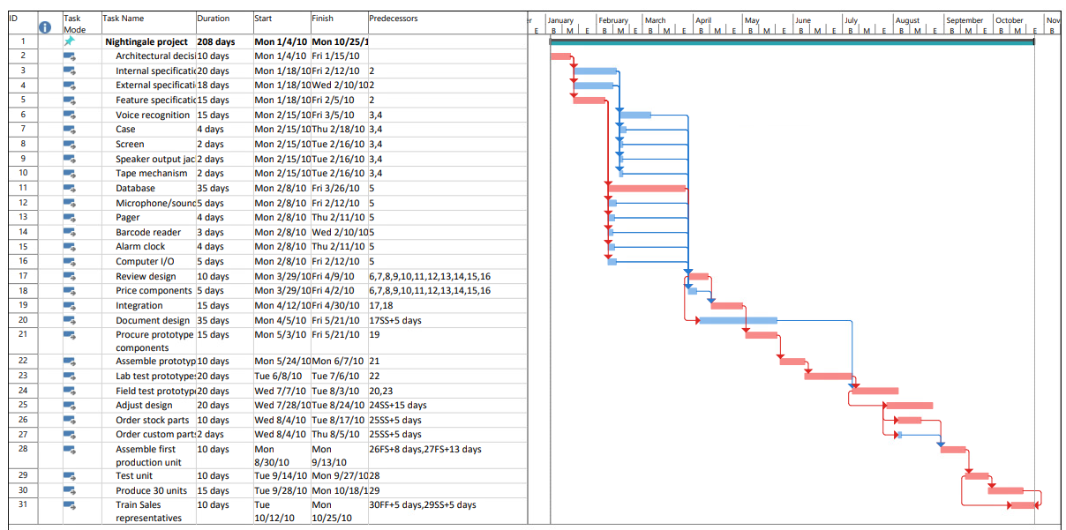

1. Is it possible to meet the deadline?

Yes, With the new changes like adjusting the duration of 11th , 21st and 26th activities on the critical path, we will able to finish the project within the deadline of 25 oct 2010. But the cost of the project will increase by 85000$.

1. If so, how would you recommend changing the original schedule (Part A) and why? Assess the relative impact of crashing activities versus introducing lags to shorten project duration.

By allocating additional resources and incurring extra costs, we have the opportunity to expedite the critical path activities, reducing the overall project duration to some extent. However, it should be noted that even with these adjustments, it may not be possible to achieve an on-time project completion. Here are details on selected activities:

* + Accelerating the 11th activity by 5 days involves an expenditure of $35,000.
  + Advancing the 21st activity by 5 days requires a budget of $30,000.
  + Speeding up the 26th activity by 5 days incurs an additional cost of $20,000.

In addition to these measures, the strategic use of lags has also played a significant role in shortening the project duration. It is through the combination of these strategies, crashing and lag management, that we aim to bring the project back on schedule.

1. What would the new schedule look like?

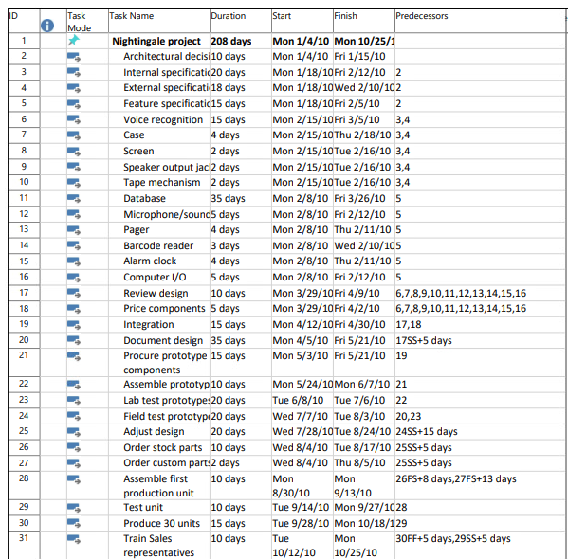

Start date will be Jan 4, 2010, and will be October 25, 2010, with the duration of 208 days Including holidays.

1. What other factors should be considered before finalizing the schedule?

The other factors should be considered before finalizing the schedule are:

1. Risk Management: Introducing start-to-start lags and shortening the project duration can potentially elevate the risk profile of the project. Therefore, it's essential to plan for risk mitigation strategies to minimize any adverse impacts.

2. Quality: The alterations made to reduce project duration may carry a risk of compromising quality. Therefore, it's imperative to rigorously monitor and safeguard the project's quality standards amidst these changes.

3.Budget: Always maintain a vigilant eye on the project's financial health to ensure that it remains within the originally allocated budget. Avoid any unplanned budget extensions.