1)

Two new software projects are proposed to a young, start-up company. The Alpha project will cost $150,000 to develop and is expected to have annual net cash flow of $40,000. The Beta project will cost $200,000 to develop and is expected to have annual net cash flow of $50,000. The company is very concerned about their cash flow. Using the payback period, which project is better from a cash flow standpoint? Why?

Answer:

Alpha Project: Initial Cost: $150,000, Annual Net Cash Flow: $40,000

Formula for Payback Period = Initial Cost / Annual Cash Flow

Payback Period = $150,000 / $40,000 = 3.75 years which is 3 years and 9 months

Beta Project: Initial Cost: $200,000, Annual Net Cash Flow: $50,000

Formula for Payback Period = Initial Cost / Annual Cash Flow

Payback Period = $200,000 / $50,000 = 4 years

Thus, based on payback period we can say that will able to repay the initial investment early if we go with the alpha project.

2) A five-year project has a projected net cash flow of $15,000, $25,000, $30,000, $20,000, and $15,000 in the next five years. It will cost $50,000 to implement the project. If the required rate of return is 20 percent, conduct a discounted cash flow calculation to determine the NPV.

Answer:

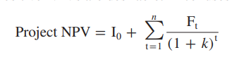

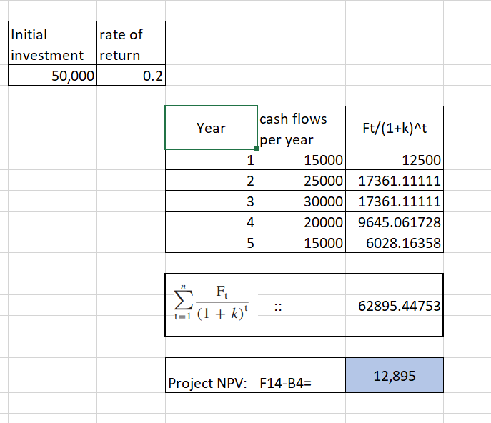

The positive Net Present Value (NPV) is $12895 (a positive number) indicates that the project is likely to yield a favorable return, making it a potentially attractive investment at the 20% required rate of return.

3)

* You are the head of the project selection team at SIMSOX. Your team is considering three different projects. Based on past history, SIMSOX expects at least a rate of return of 20 percent. Given the following information for each project, which one should be SIMSOX’s first priority? Should SIMSOX fund any of the other projects? If so, what should be the order of priority based on return on investment?

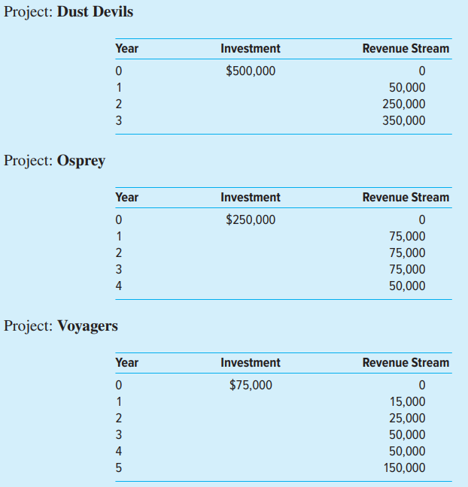

Answer:

Detailed calculation for calculating the NPV for 3 projects is provided below:

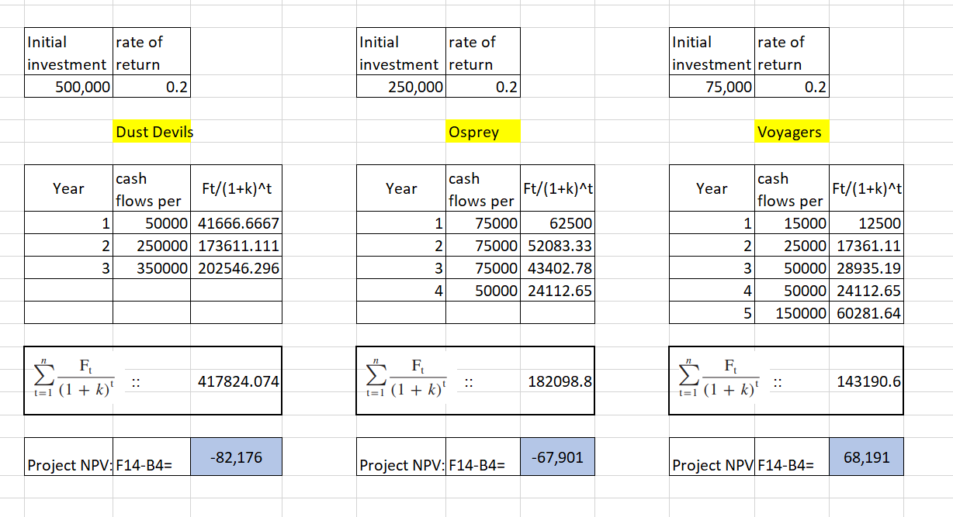

Based on the value of NPV we can tell that for project Voyagers the NPV is positive. Thus priority should be given to the Voyage project.

And the NPV of other two project is negative those should not be considered.

4) The Custom Bike Company has set up a weighted scoring matrix for evaluation of potential projects. Below are five projects under consideration. a. Using the scoring matrix in the following chart, which project would you rate highest? Lowest? b. If the weight for “Strong Sponsor” is changed from 2.0 to 5.0, will the project selection change? What are the three highest weighted project scores with this new weight? c. Why is it important that the weights mirror critical strategic factors?

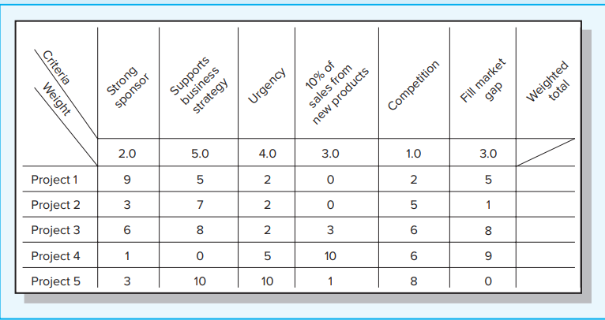

Answer:

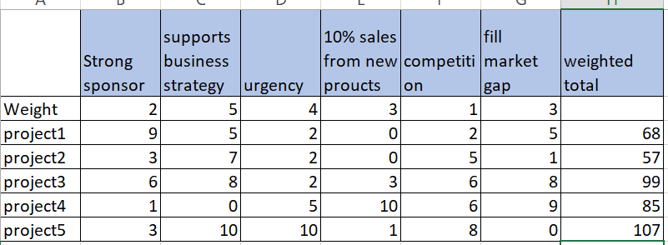

Based on the above calculation for weighted total we can say project 5 has the highest weighted total (107) and project 3 has lowest weighted total (99)



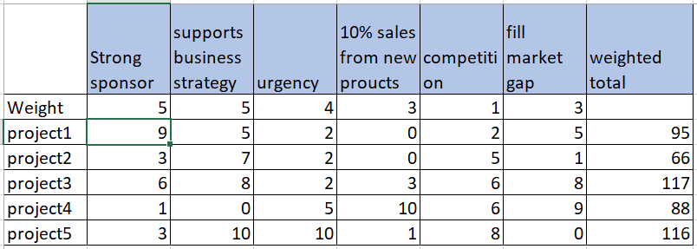

After changing the strong sponsor weight, we can see that weighted total for projects is changed. Highest is project3 (117) then project 4 (116) and third is project 1 with 95 weighted total.

1. Assigning weights that mirror critical strategic factors is important because they help prioritize projects based on their alignment with the company's strategic goals and objectives.

5) Mrs. Tolstoy and her husband, Serge, are planning their dream house. The lot for the house sits high on a hill with a beautiful view of the Appalachian Mountains. The plans show the size of the house to be 2,900 square feet. The average price for a lot and house similar to this one has been $120 per square foot. Fortunately, Serge is a retired plumber and feels he can save money by installing the plumbing himself. Mrs. Tolstoy feels she can take care of the interior decorating. Exercises The following average cost information is available from a local bank that makes loans to local contractors and dispenses progress payments to contractors when specific tasks are verified as complete. 24% Excavation and framing complete 8% Roof and fireplace complete 3% Wiring roughed in 6% Plumbing roughed in 5% Siding on 17% Windows, insulation, walks, plaster, and garage complete 9% Furnace installed 4% Plumbing fixtures installed 10% Exterior paint, light fixtures installed, finish hardware installed 6% Carpet and trim installed 4% Interior decorating 4% Floors laid and finished a. What is the estimated cost for the Tolstoys’ house if they use contractors to complete all of the house? b. Estimate what the cost of the house would be if the Tolstoys use their talents to do some of the work themselves.

Answer:

1. Total Square Footage: 2,900 square feet , Average Price per Square Foot: $120

1: Calculate the Total Cost of the House (before any savings from plumbing and decorating)

Total Cost without savings = Total Square Footage x Average Price per Square Foot

Total Cost without savings = 2,900 sq. ft. x $120/sq. ft.

Total Cost without savings = $348,000

2:

|  |  |  |  |
| --- | --- | --- | --- |
| Plumbing roughed in | 6% x $348,000 | = | $20,880 |
| Plumbing fixtures installed | 4% x $348,000 | = | $13,920 |
| Interior decorating | 4% x $348,000 | = | $13,920 |
| **Total saving** | | **=** | **$48,720** |
| **Thus, Total Cost with savings 348000-48720 =** | |  | **$299280** |

6) If the total project cost is estimated to be $600,000, what are the estimated costs for the following deliverables? a. Design b. Programming c. In-house testing What weaknesses are inherent in this estimating approach?

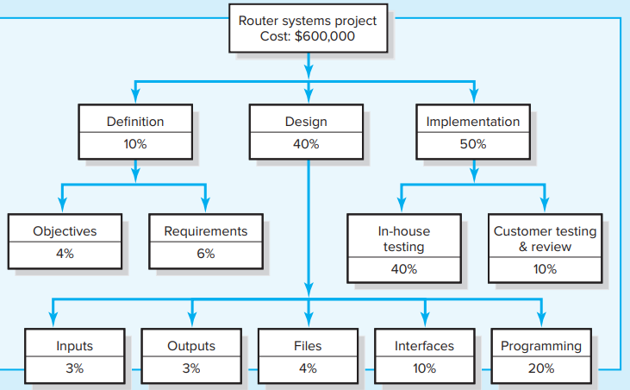

Answer:

a. So, for design the we have to calculate the 40% of 600000 which is 240000.

b. For programming we should calculate 20% of which is 120000.

c. For in house testing, we have to calculate 40% of 600000 which is 240000.

Weakness in the estimating approach are as follows:

Having accurate historical data is crucial. If the estimate is wrong, it can affect the whole project. Also, the project should be similar to past ones for sub-deliverable estimates to work well.

7) Firewall Project XT. Using the “complexity weighting” scheme shown in fig. and the function point complexity weight table shown below, estimate the total function point count. Assume historical data suggest five function points equal one person a month and six people can work on the project.

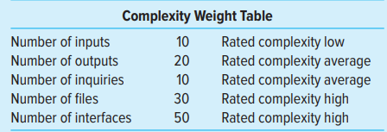

a. What is the estimated project duration? b. If 20 people are available for the project, what is the estimated project duration? c. If the project must be completed in six months, how many people will be needed for the project?

Answer:

Complexity weighting is shown below as per the provided details:

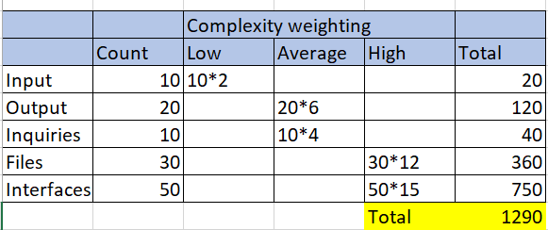

1. 1290/ 5 function points = 258 person months. Assuming six people available, the project duration will be approximately 43 months (258/ 6 =43).
2. If 20 people are available then project duration will be 258/20=12.9 thus approximately 12.9 Months.
3. If project need to be finished in six months, then 258/6=43 thus approximately 43 people will require to do so.