1)

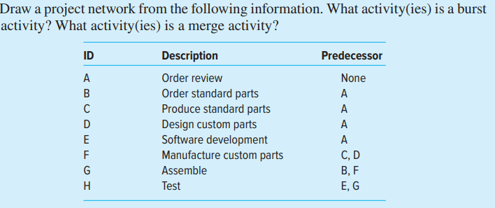

Answer:

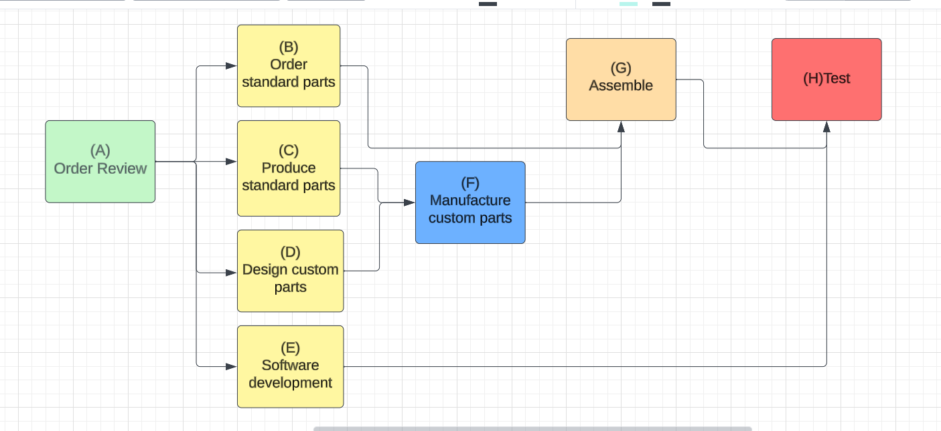

Based on the project network we can say that A is the burst activity (4 activity arrows are coming out of A). Whereas F, G and H are the merge activity as two arrows are merging from previous activity.

2)

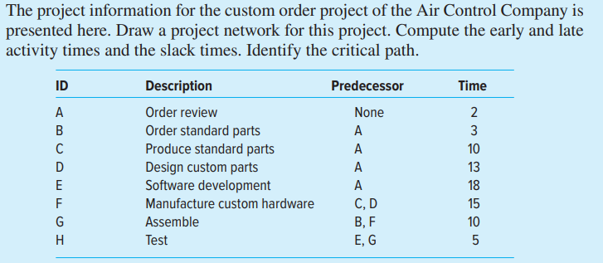

Answer:

Solution for second question is provided below: Also, legend is provided with SL= slack, ES = early start, EF= early finish, LS = late start, LF = late finish.

Critical path is shown in the figure with red marks A-D-F-G-H with 45 days.

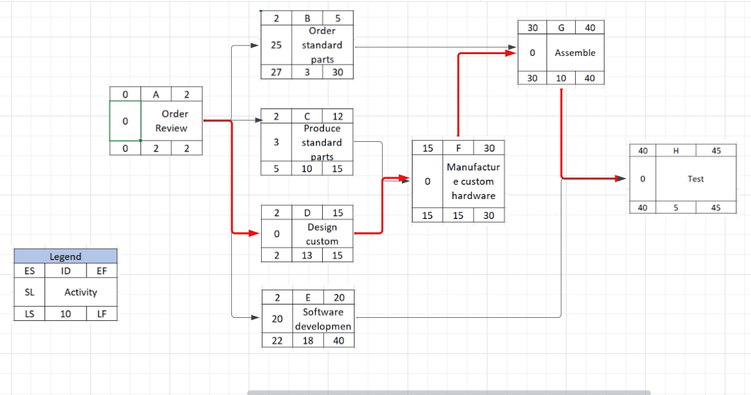

3) You are creating a customer database for the Hillsboro Hops minor league baseball team. Draw a project network given the information in the table that follows. Complete the forward and backward pass, compute activity slack, and identify the critical path. How long will this project take? How sensitive is the network schedule? Calculate the free slack and total slack for all noncritical activities.

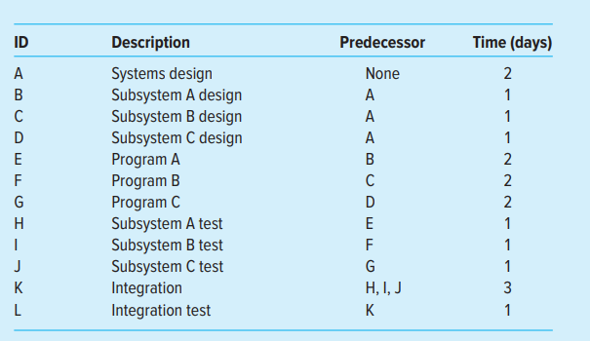

Answer:

All the three paths are critical paths as the duration for all of them is 10 days.

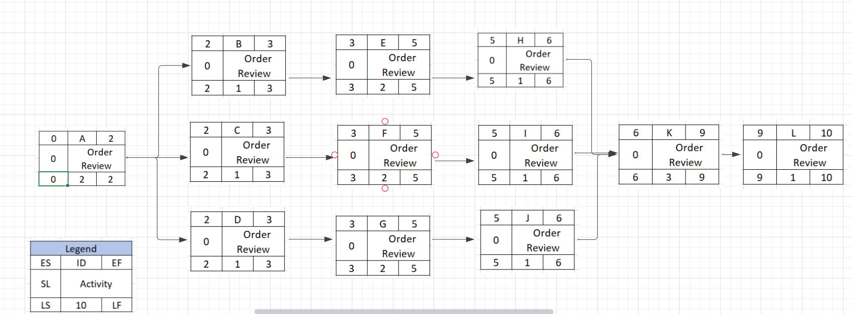

All paths are critical path with 0 slack, thus any delay on any of the path can lead to the project delay. Also all the paths are critical thus schedule is highly sensitive.

4) You are managing a product upgrade project for Bangkokagogo. Given the project network that follows, complete the forward and backward pass, compute activity slack, and identify the critical path. Use this information to create a Gantt chart for the project. Be sure to show slack for noncritical activities.

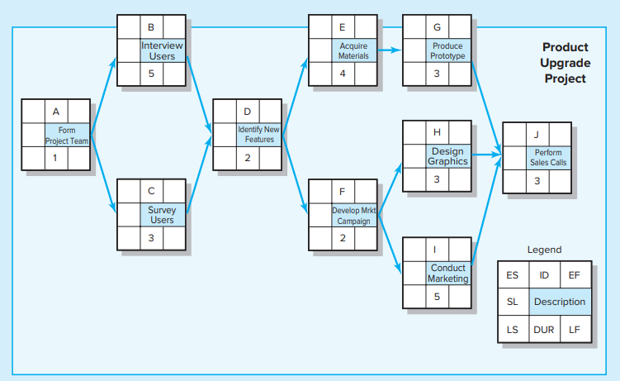

Answer:

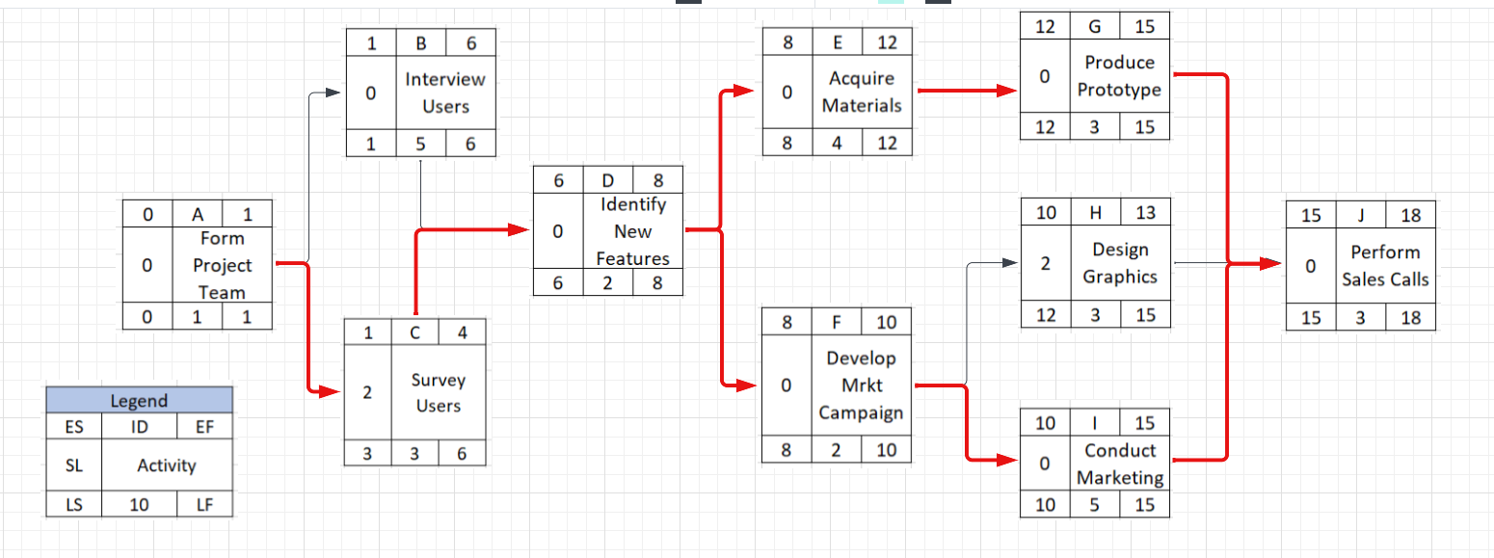

As you can see there are two critical paths (

1. A-C-D-E-G-J

2. A-C-D-F-I-J

) Shown in the figure. With the maximum duration 18. Slack for nor critical path is 2 which you can see in the design graphics activity.

Gantt chart is provided below:

