1. Connect tableau to the data:

(1). to the excel file;

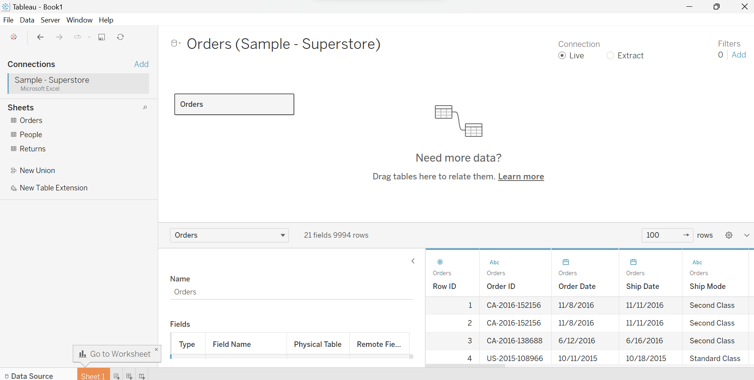

(2). to the database/data warehouse: correlate multiple tables;

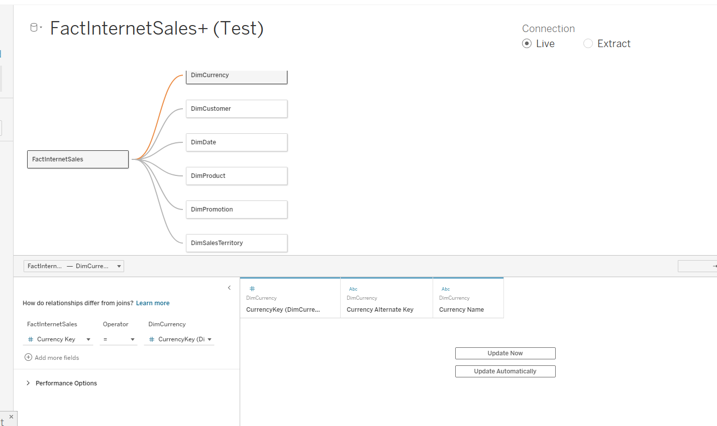

2. Analyze data in the View:

(1). create bar/column charts;

a. Use Category and Sum of the Sales to create a column chart:

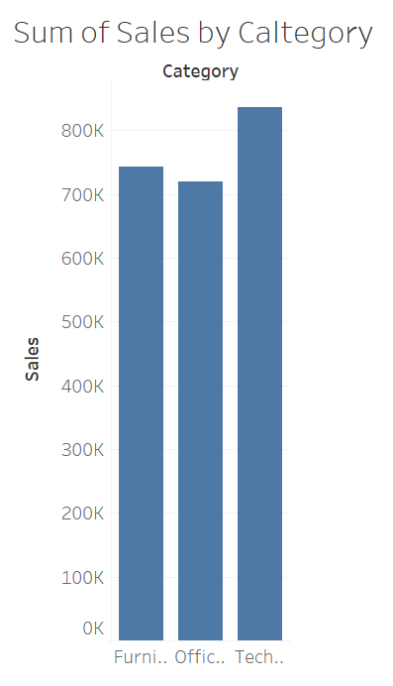

b. Use Category, sub-category and Sum of the Sales to create a bar chart:

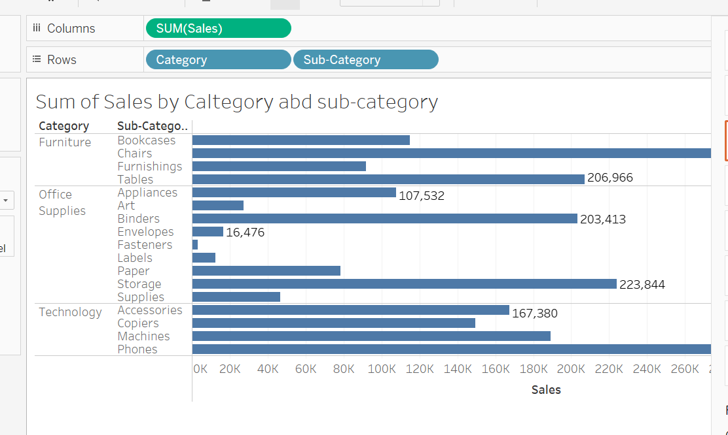

(2). Use additional Measurements (Sum of the Profit) for color comparison:

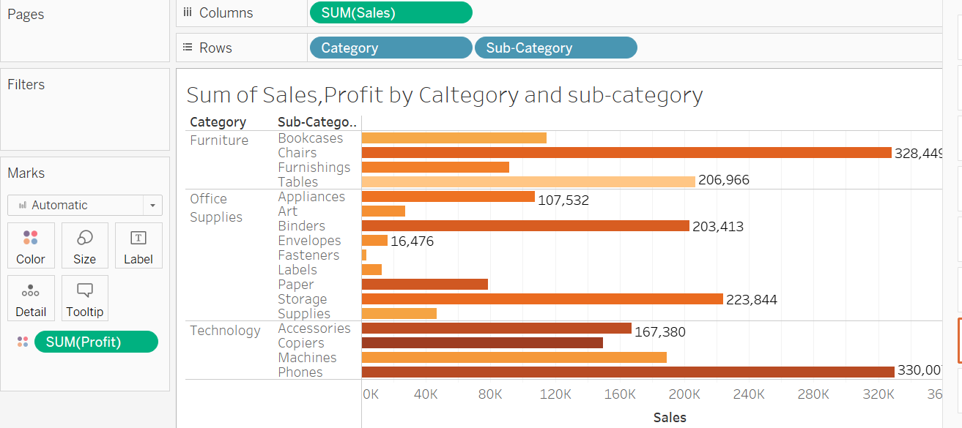

(3). Create cross tables:

a. Use Category, Sub-Category, Sum of the profit, Sum of the sales to create a cross table;

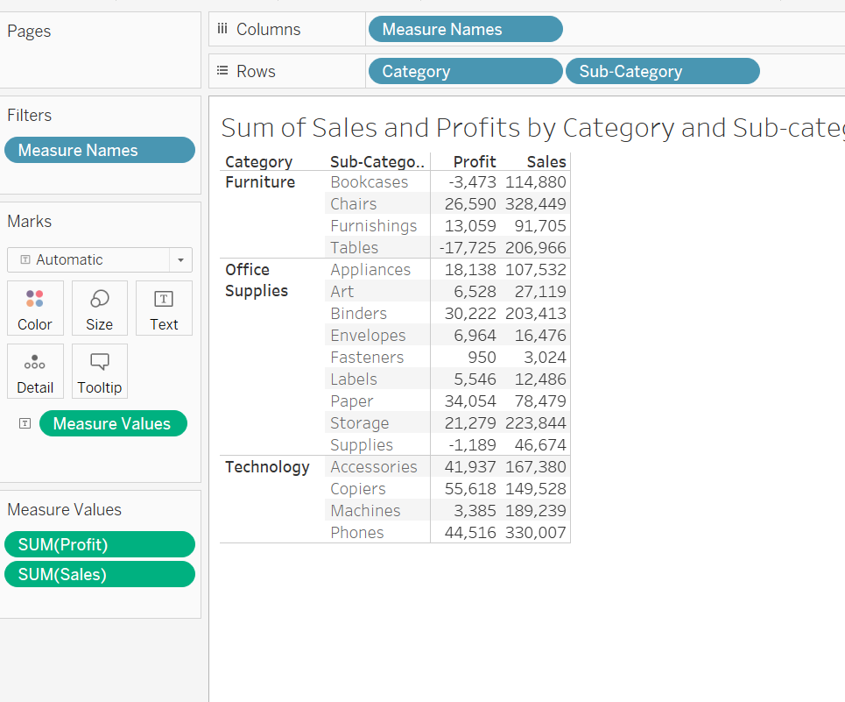

b. Use Sum of all the measurements, Category, and Sub-Category to create a cross table:

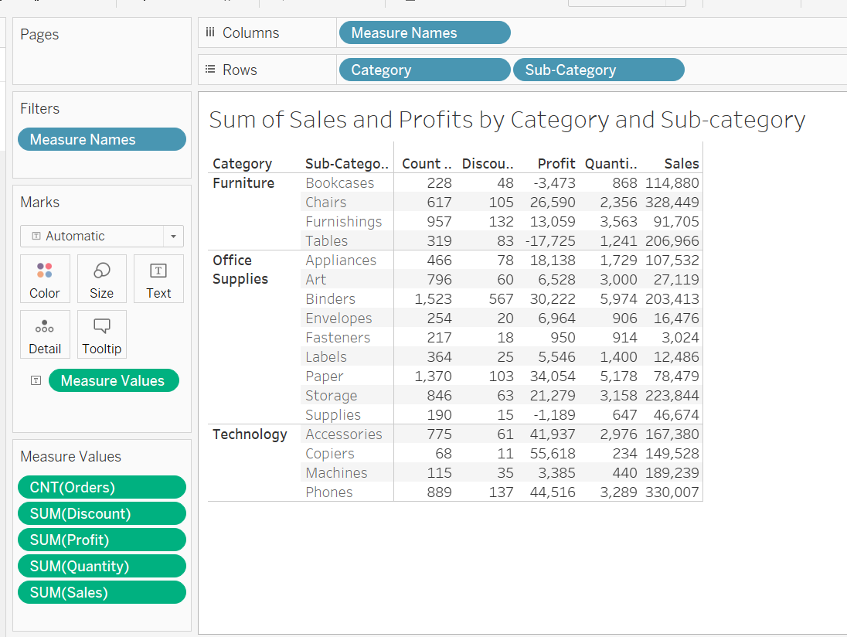

3. Filter the Data:

(1). Filter the categorical dimensions; (category and sub-category)

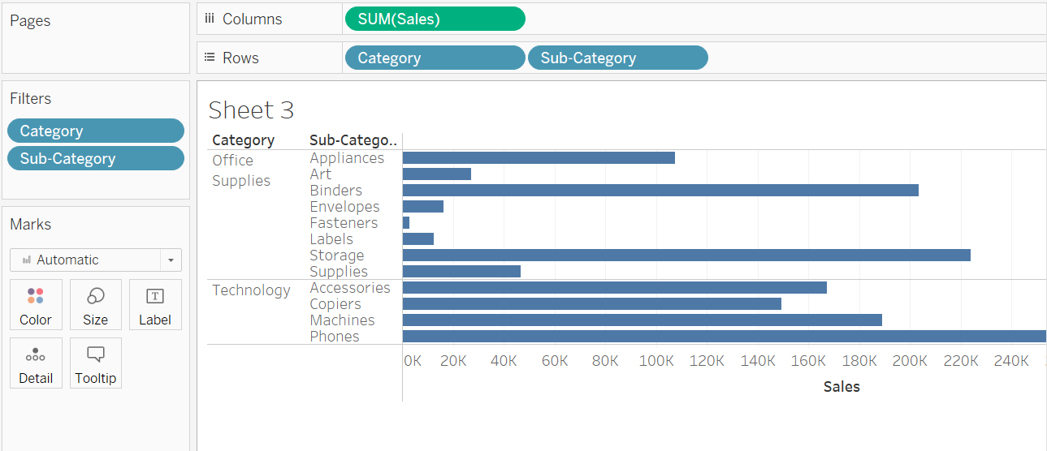

(2). Filter the measurements;

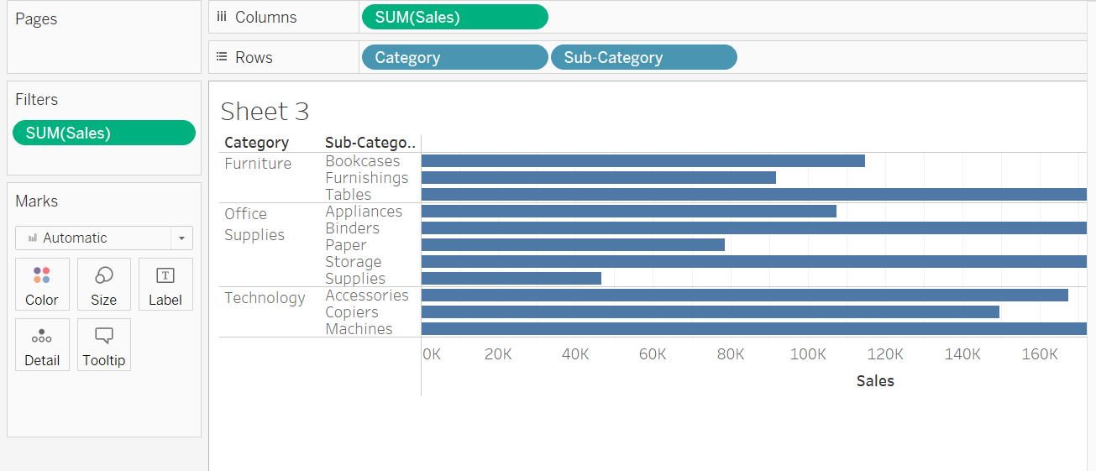

(3). Use Region as the additional Filter option on the side;

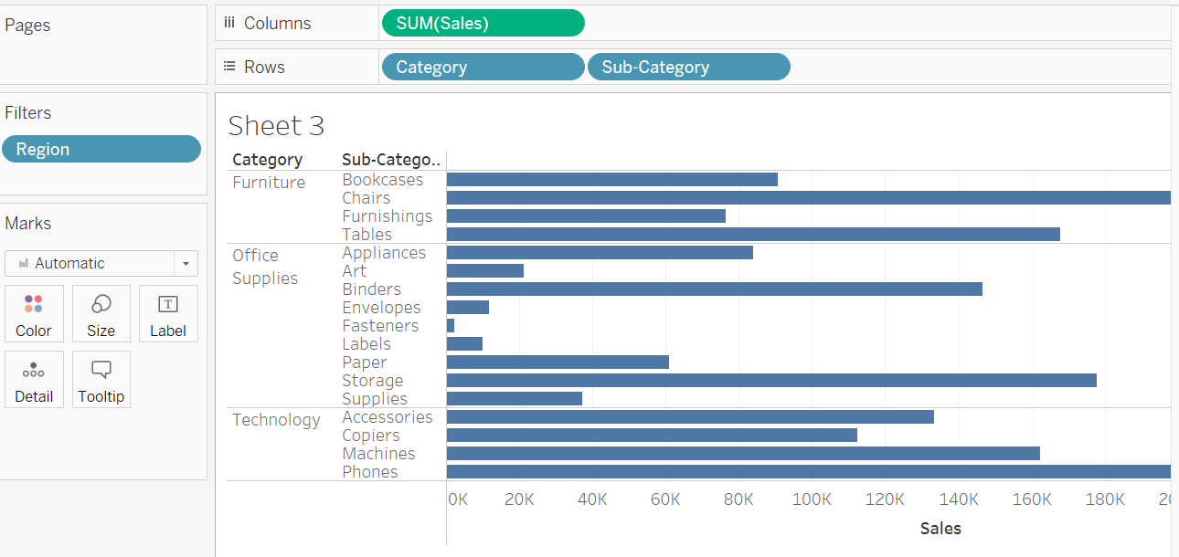

4. Computed Sort and Manual Sort;

(1). Sort bar charts by values;

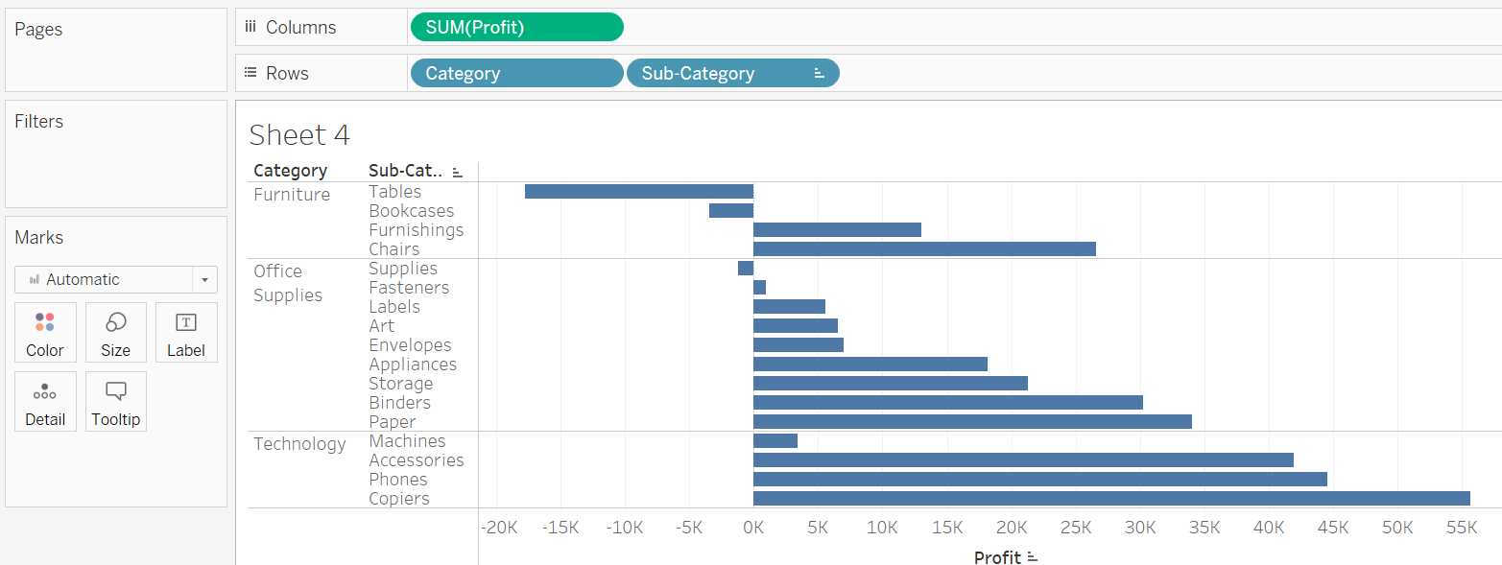

(2). Sort bar charts by two categories;

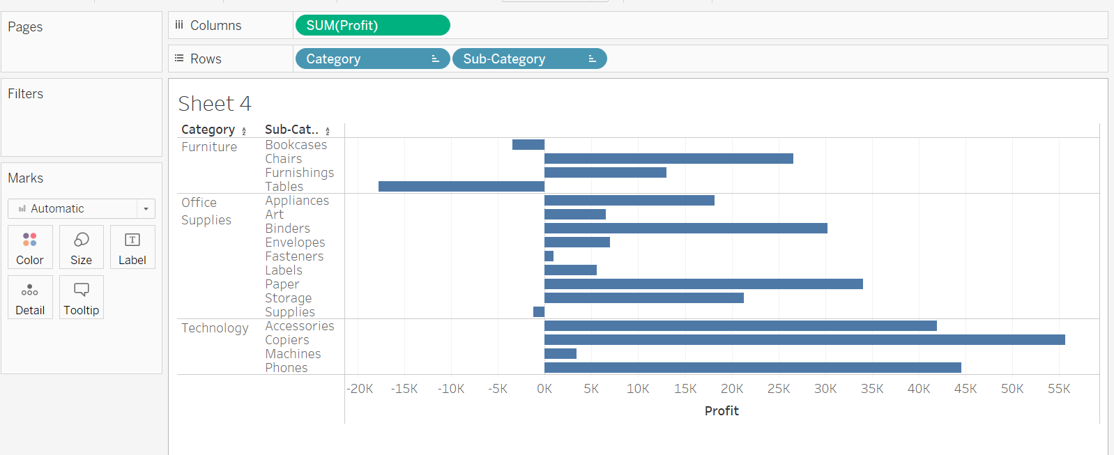

(3). Add additional criteria (Sum of quantity) to the existing sorting;

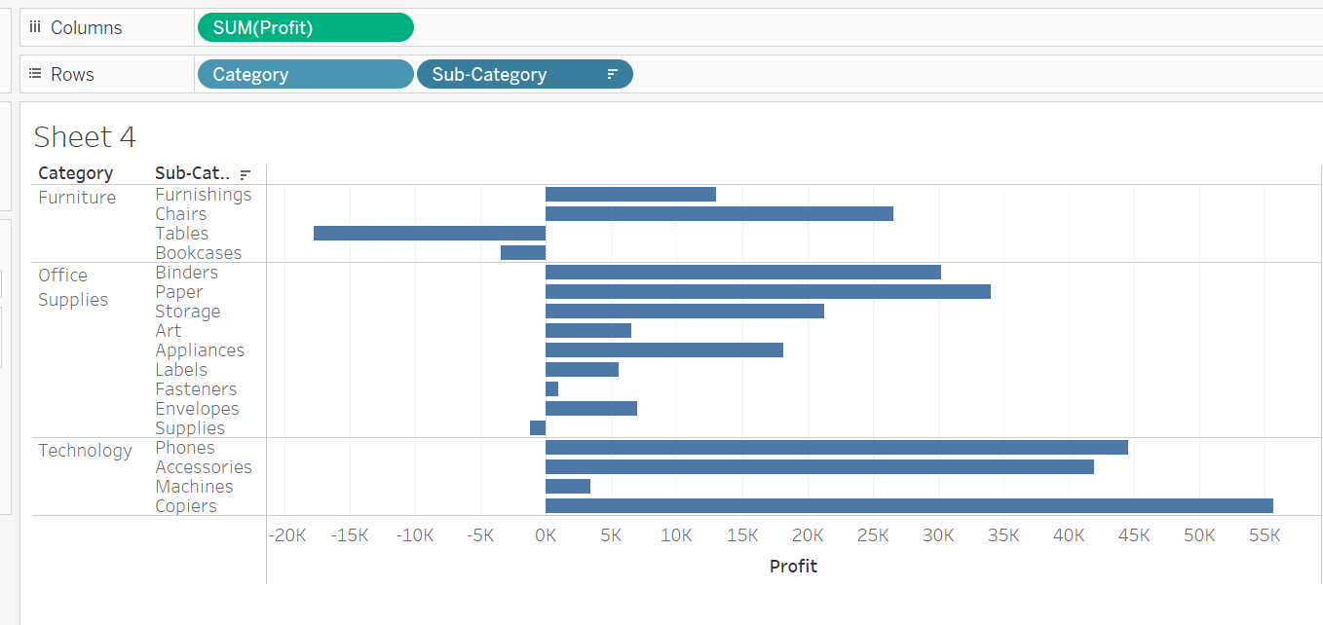

(4). Manual Sorting;

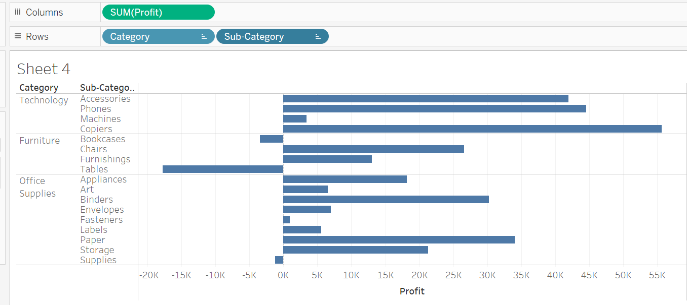

5. Share the views in the dashboard:

(1). Insert views into the dashboard;

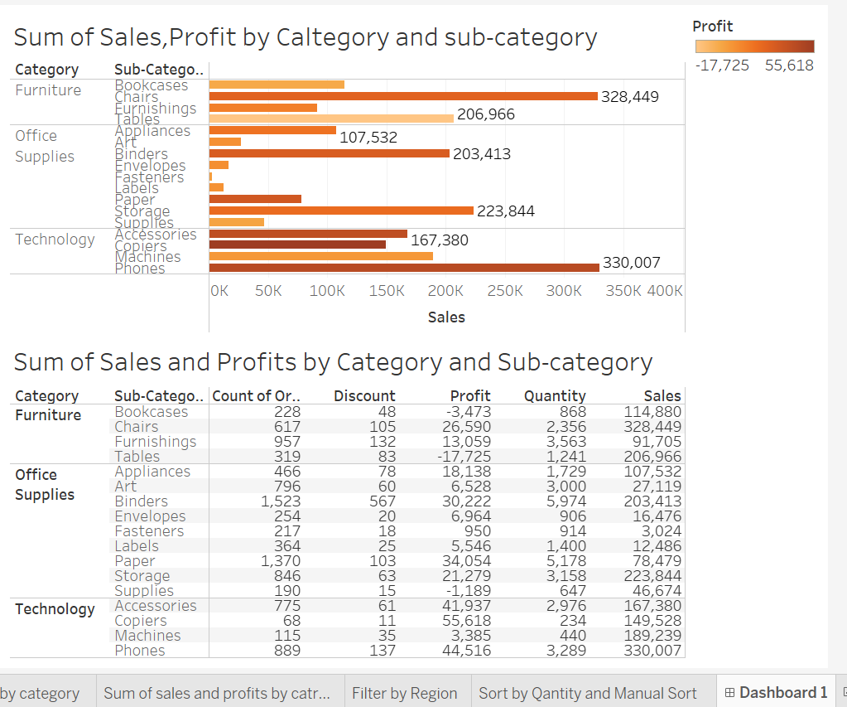

(2). Use one view to filter the other;

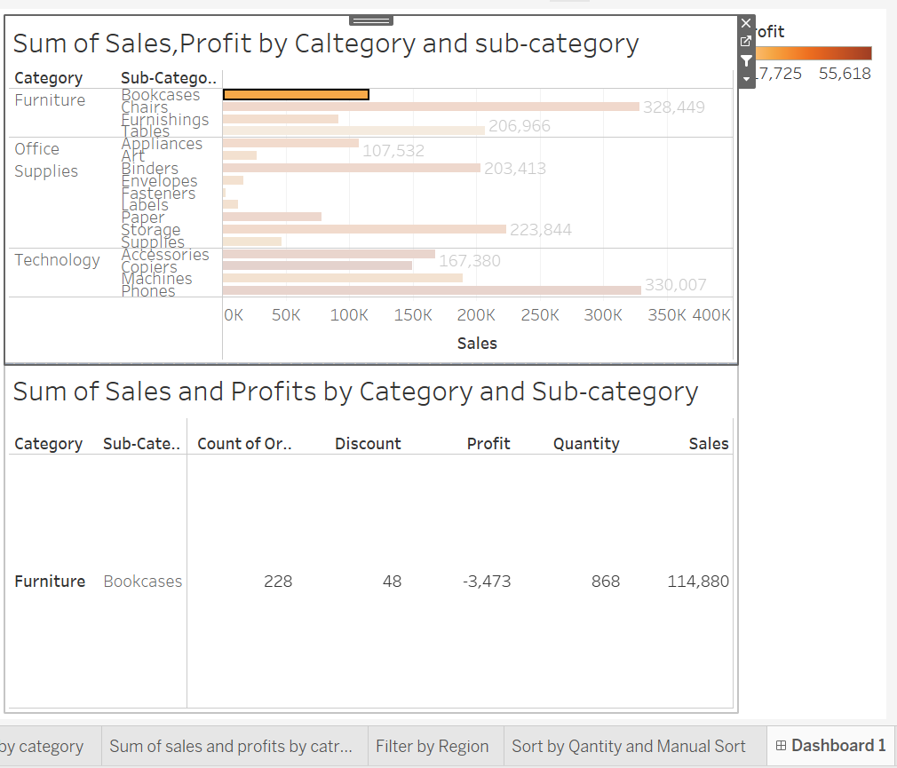

(3). Share and save the dashboard file;

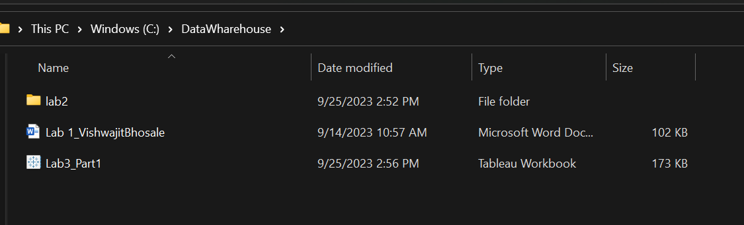

6. Edit and Save a Data Source:

Use the hurricane.xlsx;

(1). Create a folder and assign fields to the folder;

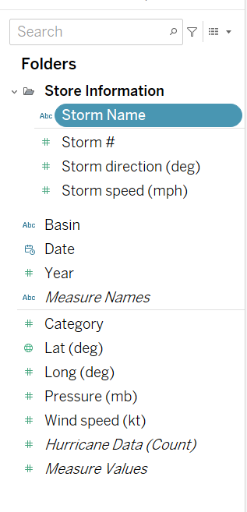

(2). Change dimension to measures, or change measures to dimension (storm #):

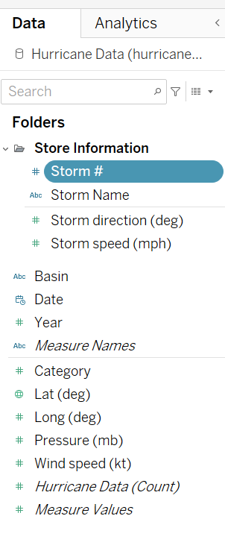

(3). Set the default properties of the fields;

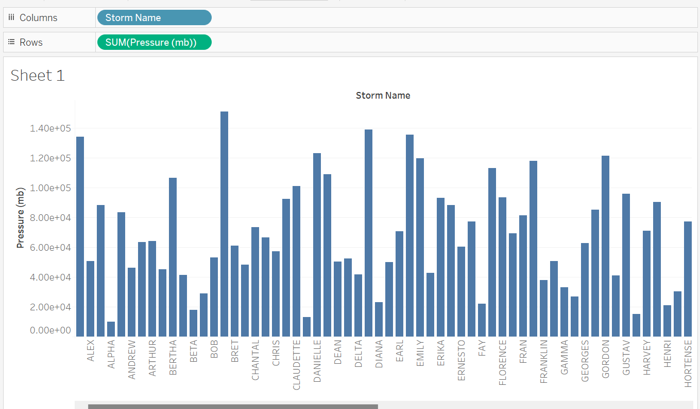

(4). Rename a field;

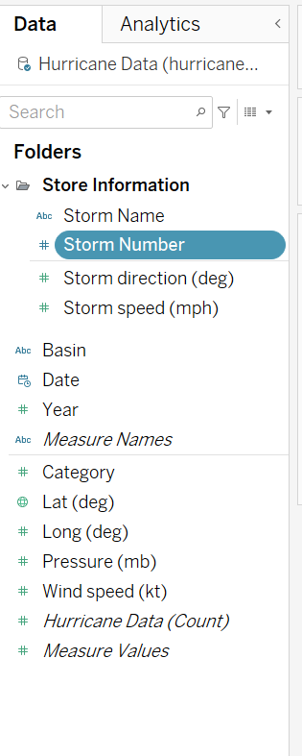

(5). Save the data source locally or to the server;

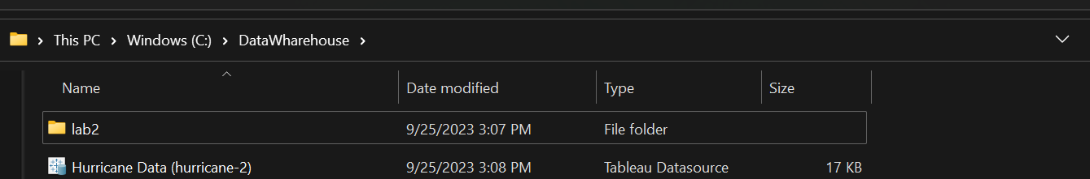

7. Update the View with New Data:

(1). Live connection;

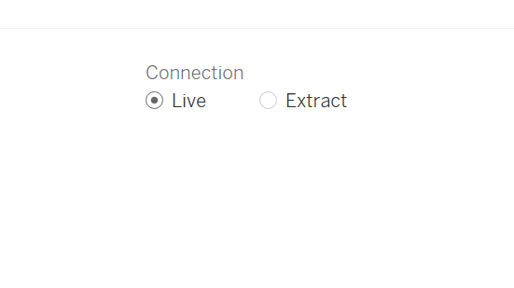

(2). Automatically change the views by changing data;

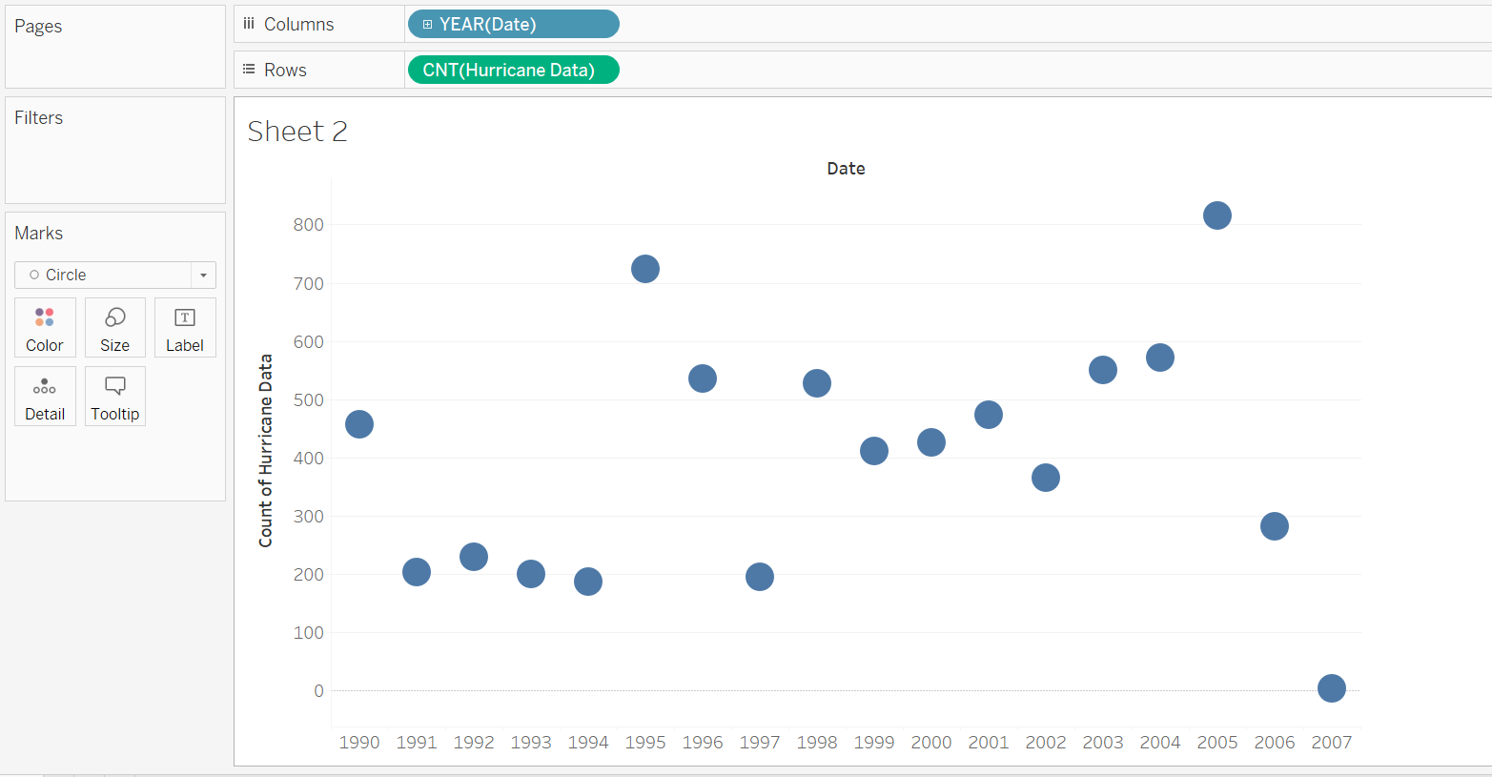

(3). Structure change will apply to the views directly;

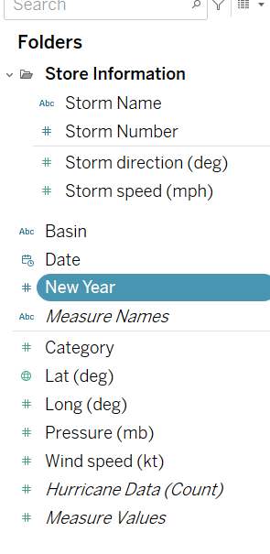

8. Use Groups to organize Data:

(1). Use Group to categorize Product “Model Name”; Use rename to change the name of the group;

(2). Use Find to discover the keywords for categorization; Use the other to include the remaining items into one group;

(3). Model Sum of Quantity by Model Groups:

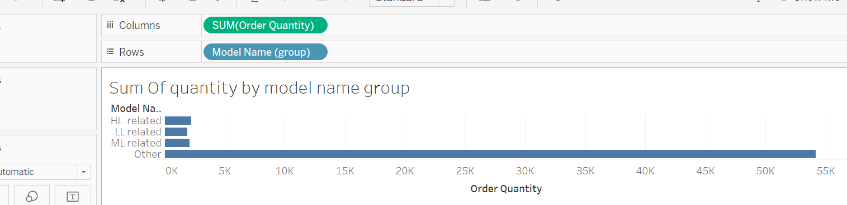

(4). Group the items in the View by labels (Use product line and sum of the sales amount):

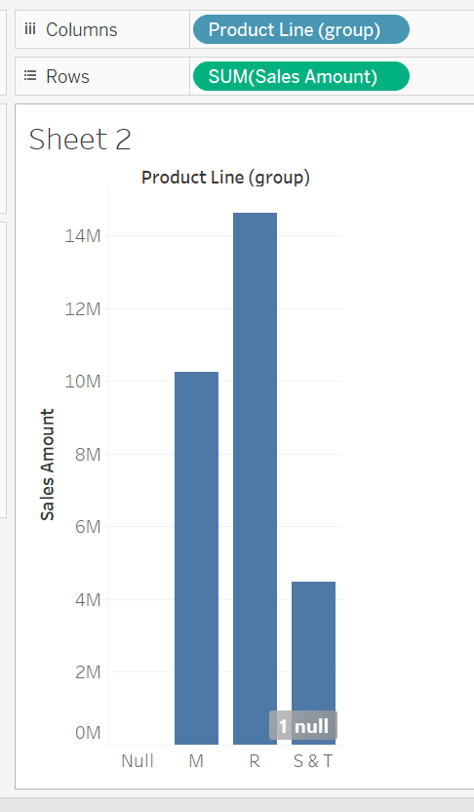

(5). Compare different groups using bars by different colors (use Size, sum of order quantity):

